Hala Hany Mohammed

4221235

C1

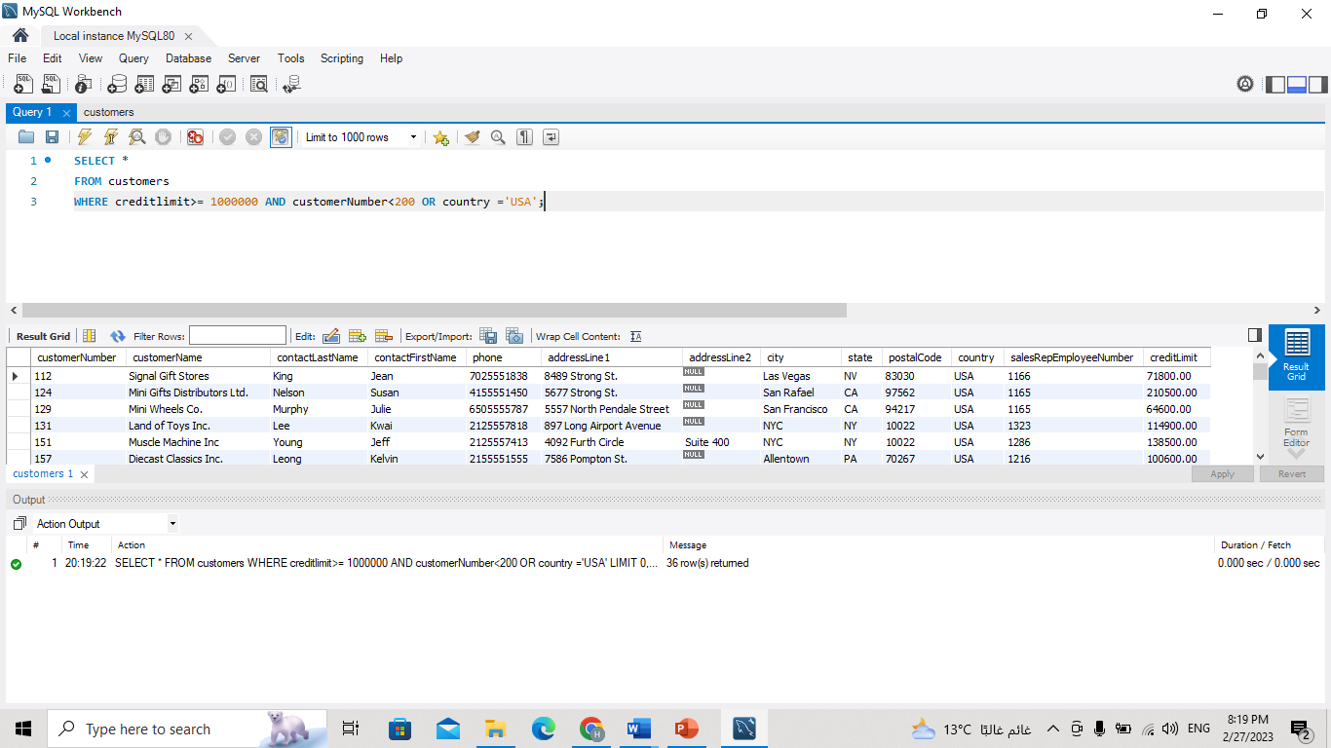Get all customers with creditLimit more than or equal to 1000000 and customerNumber less than 200 or country is USA.

Get all customers and calculate new credit column (credit Limit + 2000) order the query by new credit DESC.

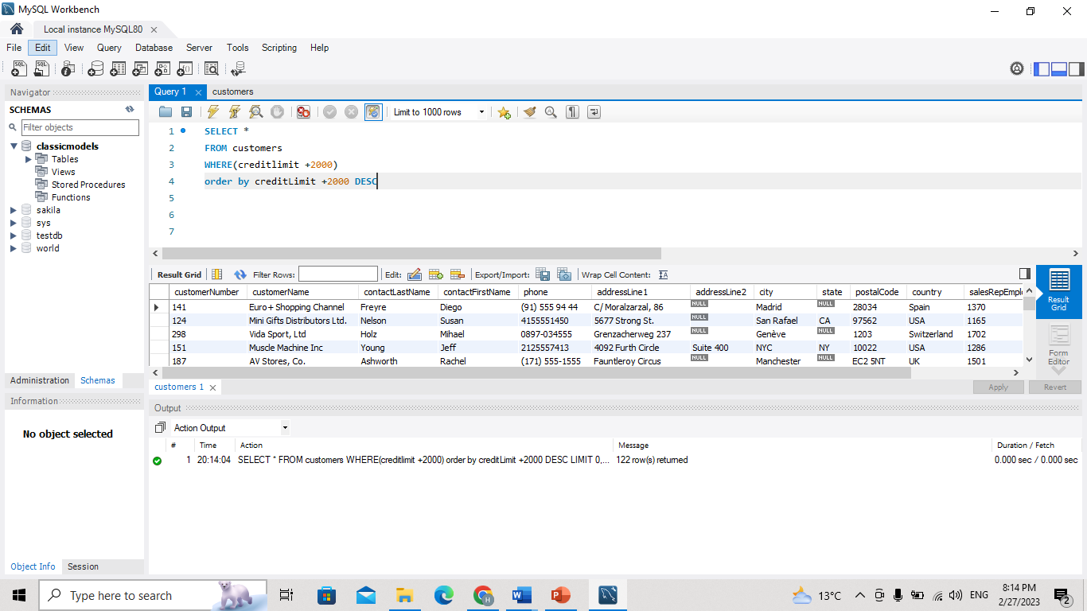

Get 3 customers that have the highest credit Limit

