Credit Approval and Loan Management System (CALMS)


Software Requirements Specification

October 30, 2026

Sunga, Glenn Jr.

Prepared for
CPE 304/304L – Software Design
Instructor: Engr. William C. Dionisio

Revision History

Date | Description | Author | Comments
Sep 12, 2026 | Version 1.0: client SRS for GR8 Lending (internal staff system) | Sunga, Glenn Jr. | First approved baseline, 116 functional requirements
Oct 30, 2026 | Version 2.0: rewritten in the CPE 304/304L template; adds the public website, My GR8, Kuwa assistant, live chat, Windows and Android apps | Sunga, Glenn Jr. | Reflects the system as built and demonstrated

Document Approval

The following Software Requirements Specification has been accepted and approved by the following:

Signature | Printed Name | Title | Date
 | Sunga, Glenn Jr. | CEO
 | Engr. William C. Dionisio | Instructor, CPE 304/304L

Table of Contents

Revision History ii
Document Approval ii
1. Introduction 1
1.1 Purpose 1
1.2 Scope 1
1.3 Definitions, Acronyms, and Abbreviations 2
1.4 References 3
1.5 Overview 4
2. General Description 5
2.1 Product Perspective 5
2.2 Product Features 5
2.3 User Characteristics 6
2.4 General Constraints 7
2.5 Assumptions and Dependencies 7
3. Specific Requirements 9
3.1 External Interface Requirements 9
3.1.1 User Interfaces 9
3.1.2 Hardware Interfaces 9
3.1.3 Software Interfaces 10
3.1.4 Communications Interfaces 10
3.2 Functional Requirements 10
3.2.1 Loan Application Intake 11
3.2.2 Document Management and Data Encoding 12
3.2.3 Credit Bureau Integration 13
3.2.4 Automated Risk Assessment 14
3.2.5 Workflow Routing and Review Queues 15
3.2.6 Counter-Offer and Borrower Acceptance 16
3.2.7 Digital Approval and Loan Agreement 17
3.2.8 Application Tracking 18
3.2.9 Notification Management 18
3.2.10 Loan Disbursement 19
3.2.11 Loan Accounts and Repayment 20
3.2.12 Reporting and Analytics 21
3.2.13 Audit Trail and Compliance Logging 22
3.2.14 User and Access Management 22
3.2.15 Public Website and Online Application 23
3.2.16 Borrower Self-Service: Track and My GR8 24
3.2.17 Kuwa Assistant and Live Agent Chat 25
3.2.18 Website Inbox for Staff 26
3.2.19 Multi-Platform Access 26
3.3 Use Cases 27
3.3.1 UC-01 Apply for a Loan Online 27
3.3.2 UC-02 Track an Application 28
3.3.3 UC-03 Use My GR8 28
3.3.4 UC-04 Ask Kuwa or Talk to a Live Agent 28
3.3.5 UC-05 Encode and Verify an Application 29
3.3.6 UC-06 Assess Credit and Decide 29
3.3.7 UC-07 Issue and Record a Counter-Offer 29
3.3.8 UC-08 Execute the Agreement and Release the Loan 29
3.3.9 UC-09 Post a Payment 30
3.3.10 UC-10 Review Reports and the Audit Log 30
3.3.11 UC-11 Manage Users, Products and Rules 30
3.4 Classes / Objects 31
3.4.1 Application 31
3.4.2 Borrower 31
3.4.3 LoanProduct 31
3.4.4 Document 31
3.4.5 Verification 32
3.4.6 Assessment 32
3.4.7 Decision 32
3.4.8 CounterOffer 32
3.4.9 Agreement 32
3.4.10 LoanAccount 32
3.4.11 Payment 33
3.4.12 User 33
3.4.13 AuditEntry 33
3.4.14 WebApplication 33
3.4.15 LiveChat 33
3.5 Non-Functional Requirements 33
3.5.1 Performance 34
3.5.2 Reliability 34
3.5.3 Availability 34
3.5.4 Security 34
3.5.5 Maintainability 35
3.5.6 Portability 35
3.6 Inverse Requirements 36
3.7 Design Constraints 36
3.8 Logical Database Requirements 37
3.9 Other Requirements 37
3.9.1 Business Rules 37
3.9.2 Usability 38
3.9.3 Compliance 38
3.9.4 Scalability 38
4. Analysis Models 39
4.1 Architecture Design 39
4.2 Database Design 40
4.3 Entity Relationship (ER) Diagram 40
4.4 Use Case Model Survey 41
4.5 Use Case Diagrams 41
4.6 Activity Diagrams 42
4.7 Sequence Diagrams 44
4.8 Class Diagrams 45
A. Appendices 46
A.1 Appendix 1: Root Cause Analysis 46
A.2 Appendix 2: Risks and Mitigation 46
A.3 Appendix 3: Feature Traceability 46

1. Introduction
This Software Requirements Specification (SRS) describes the Credit Approval and Loan Management System (CALMS) that CPE-3C Group 2-3 built for GR8 Lending Company. It states what the system must do, how well it must do it, and the limits within which it was designed, so that the system can be designed, built, tested and accepted against one agreed baseline. The document follows the IEEE 830 structure prescribed for CPE 304/304L.

1.1 Purpose
The purpose of this SRS is to define the complete external behavior of CALMS: the functions it performs for each kind of user, the data it keeps, the interfaces it uses, and the quality levels it must meet. It serves as:
- the agreement between GR8 Lending Company and the development team on what the system delivers;
- the reference for software design, database design and implementation;
- the baseline for testing, user acceptance and the class defense;
- the source document for future maintenance and enhancement.
Intended audience. GR8 Lending's management and process owners (Sections 1 and 2); the loan, credit, disbursement, servicing and compliance staff who will use the system (Sections 2.3 and 3.3); the development and maintenance team (Sections 3 and 4); and the CPE 304/304L instructor and panel, who evaluate the specification against the delivered system.

1.2 Scope
Product. The product is the Credit Approval and Loan Management System (CALMS), made up of five deliverables that share one back end and one database:
- CALMS staff app - the web application used by GR8 personnel to process a loan from intake to full repayment (28 screens);
- GR8 public website - the borrower-facing site: loan information and calculator, online application, application tracking, the My GR8 borrower page, forms and downloads;
- Kuwa - a virtual assistant on the website, answered by the Google Gemini API, with hand-off to a live GR8 staff member;
- CALMS for Windows (installer) and CALMS for Android (APK) - the staff app in its own window;
- CALMS back end - a REST API over a PostgreSQL database that enforces every rule in this document.
What CALMS does. CALMS captures a loan application once (at the branch or online), stores and verifies the supporting papers with a maker-checker control, retrieves a credit report, computes the debt-to-income ratio and risk tier, routes the application to the right underwriter within approval limits, issues and records counter-offers, generates the loan agreement and disclosure statement, releases the loan, creates the loan account and amortization schedule, posts payments, and keeps a sealed audit log of every action. Borrowers can apply, track their application, answer offers, send missing papers and report payments online.
What CALMS does not do. CALMS is not a core banking or general ledger system, not a payment gateway (it records payments made through the accepted channels but does not move money), not a collection or recovery platform, and not a credit bureau. Kuwa answers questions only; it never sees a borrower's records and never makes or changes a credit decision.
Objectives and benefits. The measurable goals of CALMS are:
Goal | Measure
Shorter time from application to decision | A complete, verified application reaches an underwriter the same working day; the credit assessment returns a recommendation within 30 seconds of the credit report
No repeated encoding | Borrower data is typed once; an online application becomes a CALMS application in one action
Consistent credit decisions | Every decision records the rule-set version it used; overrides need a written reason
Visibility of every application | Staff and borrowers see the current stage, handler and time in stage at any moment
Complete traceability | 100% of status changes, decisions, document views and payments are in the sealed audit log
Compliance | Recorded consent before any credit check; disclosure statement before signing; five-year retention

1.3 Definitions, Acronyms, and Abbreviations
Term | Meaning
CALMS | Credit Approval and Loan Management System, the system specified here
GR8 | GR8 Lending Company, the client
SRS | Software Requirements Specification (this document)
Application (APP-) | A loan application inside CALMS, numbered APP-YYYY-NNNN
Online application (W-) | An application submitted on the public website, numbered W-YYYY-NNNN, until staff encode it into CALMS
Loan account (LN-) | The account opened when a loan is released, numbered LN-YYYY-NNNN
Maker-checker | A control in which data entered by one user takes effect only after a different user verifies it
Counter-offer | Approved terms (amount or term) that differ from those requested; the borrower may accept or decline
DTI | Debt-to-income ratio: total monthly debt payments, including the new loan, divided by gross monthly income
LTV | Loan-to-value ratio: loan amount divided by the appraised value of collateral
Risk tier | Low, Moderate or High, assigned from configurable thresholds
Rule set | The versioned, published credit policy (limits, thresholds, papers) applied by the rules engine
FinScore | The credit bureau interface; in this release a stand-in service with the same behavior as the real API
Amortization schedule | The list of installments with due dates and amounts
Kuwa | GR8's virtual assistant (an owl) on the public website
My GR8 | The borrower's own page on the website, opened with a one-time code sent to their mobile number
Live chat | A conversation between a website visitor and a GR8 staff member, started from Kuwa
RBAC | Role-based access control
MFA | Multi-factor authentication (password plus authenticator code)
TOTP | Time-based one-time password, the six-digit code from an authenticator app
PWA | Progressive web app: a website that can be installed and opened offline
API / REST / JSON | Application programming interface; the HTTP request style and data format CALMS uses
DPA | Data Privacy Act of 2012 (Republic Act No. 10173)
CIC | Credit Information Corporation
SEC | Securities and Exchange Commission, regulator of lending companies
FR / BR / NFR | Functional requirement / business rule / non-functional requirement, as numbered in Section 3

1.4 References
Document | Identifier / date | Publisher / source
IEEE Recommended Practice for Software Requirements Specifications | IEEE Std 830-1998 | IEEE
Systems and software engineering - Requirements engineering | ISO/IEC/IEEE 29148:2018 | ISO/IEC/IEEE
Lending Company Regulation Act of 2007 | Republic Act No. 9474 | Congress of the Philippines; SEC
Truth in Lending Act | Republic Act No. 3765 | Congress of the Philippines
Data Privacy Act of 2012 and its IRR | Republic Act No. 10173 | National Privacy Commission
Anti-Money Laundering Act, as amended | Republic Act No. 9160 | Anti-Money Laundering Council
Electronic Commerce Act of 2000 | Republic Act No. 8792 | Congress of the Philippines
CALMS Software Requirements Specification v1.0 (client copy) | Sep 2026 | CPE-3C Group 2-3
CALMS source code, README and docs/ARCHITECTURE.md | github.com/lollapalooza842/CALMS | CPE-3C Group 2-3
GR8 Lending credit policy, product terms and operating procedures | 2026 | GR8 Lending Company
Gemini API documentation | 2026 | Google (ai.google.dev)

1.5 Overview
Section 2 describes CALMS in general terms: where it fits, what it does, who uses it, and the constraints and assumptions that shaped it. Section 3 states the specific requirements: external interfaces (3.1); functional requirements grouped into 19 features, each with inputs, processing, outputs and error handling (3.2); use cases (3.3); the main classes (3.4); non-functional requirements (3.5); inverse requirements (3.6); design constraints (3.7); database requirements (3.8); and business rules and other requirements (3.9). Section 4 presents the analysis models: architecture, database design, ER diagram, use case model, activity, sequence and class diagrams. The appendices hold the root cause analysis, the risk register and the requirement traceability summary. Every requirement has a unique identifier (FR-nnn, BR-nnn, NFR-nnn) and a priority: High (needed for a loan to move), Medium (needed for control or service), or Low (convenience).

2. General Description
This section describes the general factors that affect CALMS and its requirements. It states no requirements of its own; it makes those in Section 3 easier to understand.

2.1 Product Perspective
GR8 Lending Company processes salary, personal and SME loans at its Malolos branch. Before CALMS, credit reports were read by hand, risk ratios were computed in spreadsheets, papers moved between desks in folders, approvals were signed one desk at a time, and borrowers called to ask where their application was. The root cause, worked out with the 5 Whys in Appendix A.1, was the absence of one system that captures, checks, decides, releases and records a loan.
CALMS is a new, self-contained system that replaces that paper process. It is a web application served from the cloud (Render) with its data in a managed PostgreSQL database (Supabase). Staff reach it through a browser, the installable web app, the Windows app or the Android app; borrowers reach the public website and My GR8 through any browser. CALMS exchanges data with outside services for credit reports, AI answers, e-mail and SMS (Section 3.1.3), and is designed so each can be replaced through configuration. Figure 1 in Section 4.1 shows the parts and how they connect.

2.2 Product Features
CALMS provides the following features. Each is specified in Section 3.2.
# | Feature | Summary
1 | Loan application intake | Staff create applications for salary, personal and SME loans; drafts; consent; duplicate check
2 | Documents and data encoding | Checklist per product; PDF/JPG/PNG uploads with versions; entries checked by a second user
3 | Credit bureau integration | Credit report retrieved only with consent; parsed tradelines; every inquiry logged
4 | Risk assessment | DTI, LTV, risk tier, recommendation and credit memo from the published rule set
5 | Workflow and queues | My Queue per person, review queue, desk assignment, 48-hour escalation
6 | Counter-offers | Different terms offered side by side; borrower answer recorded with proof
7 | Approval and agreement | Approval limits, endorsement upward, agreement and disclosure, signed copy locked
8 | Application tracking | Stage, handler, time in stage and full history for staff; Track page for borrowers
9 | Notifications | In-app notices, e-mail through templates, preferences, delivery records
10 | Disbursement | Payout verification, net proceeds, loan account and schedule on release
11 | Loan accounts and repayment | Flat or diminishing interest; payments split penalty, interest, principal; reversals; statements
12 | Reporting | Pipeline, approvals, releases, aging and productivity reports; PDF and spreadsheet export
13 | Audit trail | Append-only, hash-sealed log of every action; search and export for auditors
14 | Users and access | Accounts, roles, approval limits, MFA, password policy, idle sign-out
15 | Public website and online application | 3D home page, loans and calculator, Apply with uploads and e-signature, forms
16 | Borrower self-service | Track by reference; My GR8 with phone-code sign-in, offers, papers, payments
17 | Kuwa assistant and live chat | Gemini answers; hand-off to staff; staff alerts on every page; mini window
18 | Website inbox for staff | One screen for online applications, call-backs and My GR8 requests, with next steps
19 | Multi-platform access | Installable web app, offline copies, Windows and Android apps, phone layouts, graphics setting

2.3 User Characteristics
CALMS has nine staff roles and two kinds of outside users. All staff are GR8 employees with ordinary computer skills; most are comfortable with phones and spreadsheets but not with technical software, so screens use the words of the trade, explain errors in plain language, and need no more than 30 minutes of training per role. Borrowers range from salaried employees to small business owners, many on mid-range Android phones with mobile data.
User class | Responsibilities in CALMS | Access
Sales Agent | Endorses borrowers; conveys counter-offers and records the answer with proof; answers live chats | Own borrowers' applications only
Loan Processor | Encodes applications, uploads and verifies papers (maker-checker), encodes online applications, prepares agreements | Create/update applications; no approval or release
Underwriter | Runs the credit assessment and decides within an approval limit, or endorses upward; issues counter-offers | Credit data; decisions up to own limit
Lead Underwriter | Balances the review desks; decides above underwriters' limits | As Underwriter, plus assignment
Disbursement Officer | Verifies payout details and releases loans | Disbursement queue and release only
Loan Account Officer | Posts and reverses payments, statements and clearances; handles payments reported online | Loan accounts and payments
Operations Manager | Oversees the branch, decides the largest loans, reads reports | Read across modules; final approval level
Compliance Auditor | Reviews the audit log, decisions and consent records | Read-only, everything
System Administrator | Manages users, roles, products, rules, templates and system health | Configuration; cannot approve loans or alter audit records
Borrower | Applies online, tracks the application, uses My GR8 | Own applications and accounts only, by mobile number and code
Website visitor | Reads loan information, uses the calculator, asks Kuwa, requests a call-back | Public pages only

2.4 General Constraints
- Regulation. The system must satisfy the Lending Company Regulation Act, the Truth in Lending Act (disclosure before signing), the Data Privacy Act (consent, purpose, access, retention) and anti-money laundering record keeping.
- Platform and budget. It runs on free or low-cost cloud tiers (Render web service, Supabase PostgreSQL); the free web service sleeps when idle and takes up to a minute to wake.
- Technology chosen with the client. Node.js and Express for the back end, PostgreSQL for data, and plain HTML, CSS and JavaScript pages (no front-end framework), so the screens stay light and readable.
- Security policy. No secret (database password, API key, mail password) may be stored in the code or the repository; secrets live only in the server's environment settings.
- External services. The credit bureau, Gemini, e-mail and SMS each have rate limits and costs; the system must work, in a reduced way, when any of them is unavailable.
- Devices. Staff and borrowers use ordinary laptops and phones; no special hardware may be required.

2.5 Assumptions and Dependencies
- Offices and borrowers have internet access; staff screens keep working on saved copies during short outages.
- GR8 provides its credit policy, product terms, charges and approval limits for the rule set, and keeps them current.
- GR8 holds valid accounts for the credit bureau, the Gemini API, an e-mail sender and an SMS sender, and enters their keys in the server settings.
- Borrower consent to credit checks and data processing can be validly given online (typed name, ticked consents and drawn signature) under the Electronic Commerce Act.
- The borrower signs the printed loan agreement in writing; CALMS stores and locks the signed copy.
- Existing paper loans are encoded or migrated by GR8 before go-live.
- The free hosting tier is acceptable for the demonstration; production use assumes a paid, always-on tier.

3. Specific Requirements
This section states the requirements that guide the design, implementation and testing of CALMS. Each requirement is uniquely numbered, testable and given a priority. Requirements FR-001 to FR-116 carry over from SRS version 1.0; FR-117 onward cover the borrower-facing website and the additional platforms added in version 2.0.

3.1 External Interface Requirements

3.1.1 User Interfaces
Staff app. A left side rail lists only the drawers the signed-in role may open, with counts (My Queue, Website, Live chat, Notifications). Each screen has a title, the work area, and a status line for messages. A western "frontier" look with Kuwa the owl is the default; a plain classic look can be chosen per user. On screens narrower than 820 px the rail becomes a top bar and a bottom tab bar (four drawers and More). Keyboard: Ctrl+K opens Find from anywhere; all controls are reachable with Tab and have visible focus.
Public website. A full-screen 3D home page (an "8" made of beads over a lake) with a five-view scroll journey into the About page; pages for Loans (with calculator and questions), Apply (a step-by-step form with uploads and a drawn signature), Track, My GR8 and Downloads. A bottom bar with the menu and the Kuwa orb on phones. Settings: sound, dark mode, tips, motion and graphics quality (Low by default).
Kuwa. A full-screen chat with a glowing orb, typed-out answers, suggested chips, voice input and voice output (optional), a live-agent mode with the agent's card, and a minimized window that keeps the chat on screen.
Common rules. Messages and errors in plain language naming the field and the fix; amounts in pesos with two decimals; dates in Philippine time; contrast and text sizes meeting WCAG 2.1 AA; reduced-motion settings respected.

3.1.2 Hardware Interfaces
- Desktop and laptop computers (Windows 10/11, macOS or Linux) with a current browser, or the CALMS for Windows app.
- Android phones (Android 7 or newer) for the CALMS app; any smartphone browser for the website.
- A camera or scanner to capture papers (PDF, JPG or PNG, up to 10 MB each).
- Printers for agreements, disclosure statements, statements of account and clearances (A4 or Letter PDF).
- No special hardware: the 3D scene adapts its resolution to the device.

3.1.3 Software Interfaces
Interface | Purpose | Data exchanged | Behavior if unavailable
PostgreSQL 15+ (Supabase) | System of record | All records, through parameterized SQL over TLS | API answers 503; screens show saved copies
Google Gemini API | Kuwa's answers on the website | Question, short history and GR8 facts; answer text (no borrower data) | Built-in answers for common questions; tries the next model
FinScore credit bureau (stand-in) | Credit report and score | Name, ID number, birth date (with consent); score and tradelines | Retries; application goes to manual review
E-mail (Gmail SMTP via Nodemailer) | Staff and borrower e-mail | Templated messages without sensitive data | Queued in the outbox and retried
SMS (Semaphore) | My GR8 sign-in codes | Mobile number and a one-time code | Practice code in demo mode; sign-in unavailable otherwise
Browser platform | Service worker, IndexedDB, Web Audio, WebGL | Offline copies, saved work, sound, 3D | Pages still work without 3D or sound
Electron 44 / Android WebView | Desktop and Android apps | The same pages and API as the browser | Use the website in a browser

3.1.4 Communications Interfaces
- All traffic uses HTTPS with TLS 1.2 or higher; HTTP Strict Transport Security is sent.
- The front end calls a REST API with JSON bodies (`/api/...` for staff, `/api/public/...` for the website).
- Staff sessions use a signed, HttpOnly, Secure, SameSite cookie; borrower sessions use a separate cookie.
- Screens refresh by polling: live chat every 2 seconds, staff chat alerts every 5 seconds, lists every 20 seconds, the side rail every 2 minutes.
- E-mail through SMTP over TLS; SMS and Gemini through their HTTPS APIs.
- A content security policy allows scripts only from the CALMS server itself.

3.2 Functional Requirements
Each feature below gives its purpose, inputs, processing, outputs and error handling, followed by its numbered requirements. Priority: H = high, M = medium, L = low.

3.2.1 Loan Application Intake
3.2.1.1 Introduction
Staff create, complete and submit loan applications in one form for the selected product (salary, personal or SME). An application may also arrive from the public website (Feature 15) and be encoded in one action.
3.2.1.2 Inputs
- Borrower identity: name, birth date, government ID type and number, mobile, e-mail, address
- Employment or business details, income and other debts
- Product, amount, term and purpose; endorsing sales agent (if any)
- Signed consent form
3.2.1.3 Processing
- Checks every field against the product's limits and the ID format (PhilSys, TIN, SSS, driver's license, passport)
- Refuses a second active application of the same product for the same borrower (same normalized name or ID)
- Saves a draft at any time; assigns the APP- number on submission
- Writes the application and its audit entry in one transaction
3.2.1.4 Outputs
- Application record with status Draft or Submitted and a unique APP- reference
- Stage history entry and audit entry
- Item on the next person's My Queue
3.2.1.5 Error Handling
- A missing or badly formatted field is named with the fix; submission is refused
- A duplicate shows the existing application's reference
- A lost connection keeps the draft on the device and sends it when back online
3.2.1.6 Requirements
ID | Requirement: the system shall... | Pri.
FR-001 | Generate a unique application reference number (APP-YYYY-NNNN) for every submitted application. | H
FR-002 | Support salary, personal and SME loan applications with the field set of the selected product. | H
FR-003 | Validate all mandatory fields and refuse submission until each is supplied in the right format. | H
FR-004 | Allow an application to be saved as a draft and resumed later. | M
FR-005 | Time-stamp the borrower's consent and block the application from advancing until the signed consent form is on file. | H
FR-006 | Record creation and submission times and the identity of the encoder. | H
FR-007 | Prevent a duplicate active application of the same product for the same borrower. | H
FR-008 | Link each agent-sourced application to the endorsing sales agent. | M
FR-009 | Record the borrower's consent to credit investigation and data processing by reference to the signed consent form. | H

3.2.2 Document Management and Data Encoding
3.2.2.1 Introduction
CALMS stores each borrower's papers against the application's checklist and has a second loan processor check every encoded entry against the paper it came from (maker-checker).
3.2.2.2 Inputs
- Papers: ID, pay stubs, certificate of employment, bank statements, proof of billing or address, DTI/SEC registration, financial statements, business permit
- Encoded entries
3.2.2.3 Processing
- Shows the product's checklist with what is in and what is missing
- Stores each upload with its SHA-256 hash as a new version
- Shows each entry beside its source paper for the verifier
- Moves the application to review only when every paper is in and every entry is verified
3.2.2.4 Outputs
- Stored documents with versions
- Verification outcome per entry (ok or flagged with reason)
- Status Encoded, Verified or Returned for Correction
3.2.2.5 Error Handling
- Wrong file type or over 10 MB: refused with the limit stated
- The encoder trying to verify: refused (maker-checker)
- Returned entries go back to the encoder's queue with the reasons
3.2.2.6 Requirements
ID | Requirement: the system shall... | Pri.
FR-010 | Accept document uploads in PDF, JPG and PNG. | H
FR-011 | Keep a configurable checklist per product and show which papers are outstanding. | H
FR-012 | Allow the loan processor to encode the information on each paper. | H
FR-013 | Validate each entry against its expected format (ID numbers, dates, amounts). | H
FR-014 | Display encoded data beside the source document on one screen. | M
FR-015 | Require verification by a user other than the encoder before underwriting. | H
FR-016 | Return the application to the encoder with the field and reason when a discrepancy is found. | H
FR-017 | Record the encoder and verifier and the time of each action. | H
FR-018 | Reject uploads over the maximum size or of an unsupported type. | M
FR-019 | Store documents protected and linked to their application; never at a public address. | H
FR-020 | Keep every superseded version of a re-uploaded document. | M

3.2.3 Credit Bureau Integration
3.2.3.1 Introduction
CALMS retrieves the borrower's credit report through the bureau interface, so nobody reads printed reports.
3.2.3.2 Inputs
- Name, ID number, birth date
- Recorded consent
3.2.3.3 Processing
- Refuses the inquiry without consent
- Calls the bureau; retries on failure
- Parses tradelines, public records and payment history
- Keeps the report unaltered and logs the inquiry
3.2.3.4 Outputs
- Credit report, score and tradeline summary
- Inquiry log entry with time, user and response
3.2.3.5 Error Handling
- No consent: the request is refused and the reason shown
- Bureau down after retries: the application is routed to manual review
3.2.3.6 Requirements
ID | Requirement: the system shall... | Pri.
FR-021 | Retrieve credit reports from the bureau through a secure API. | H
FR-022 | Block any inquiry without a valid consent record. | H
FR-023 | Parse tradelines, public records and payment histories into structured data. | H
FR-024 | Attach the retrieved report to the application unaltered. | M
FR-025 | Log every inquiry with time, requesting user and response. | H
FR-026 | Retry a failed inquiry and route to manual review if the service stays unavailable. | M

3.2.4 Automated Risk Assessment
3.2.4.1 Introduction
The rules engine computes the risk figures and recommends a decision from the published rule set, replacing spreadsheets and hand-written memos.
3.2.4.2 Inputs
- Verified income or cash flow, other debts
- Credit score and report
- Requested amount and term
- Active rule set (thresholds, limits)
3.2.4.3 Processing
- Computes the monthly payment, DTI (and LTV where collateral is declared)
- Assigns Low, Moderate or High risk
- Recommends auto-approve, auto-decline (with the rule broken) or manual review
- Writes a credit memo and records the rule-set version
3.2.4.4 Outputs
- Assessment record: DTI, LTV, tier, outcome, reason, memo, rule version
3.2.4.5 Error Handling
- Missing verified income: assessment refused until entries are verified
- Rule set unavailable: the last active version is used and noted
3.2.4.6 Requirements
ID | Requirement: the system shall... | Pri.
FR-027 | Compute the debt-to-income ratio for every application. | H
FR-028 | Compute the loan-to-value ratio where collateral is declared. | M
FR-029 | Assign a risk tier from configurable thresholds. | H
FR-030 | Recommend automatic approval when every auto-approval criterion is met. | M
FR-031 | Recommend automatic decline when a mandatory rule is broken, stating the rule. | H
FR-032 | Route all other applications to manual underwriting. | H
FR-033 | Generate a credit memo with the profile, metrics and basis of the recommendation. | M
FR-034 | Let administrators change rules, ratios and thresholds through the interface without code changes. | H
FR-035 | Record the rule-set version applied to each decision. | H

3.2.5 Workflow Routing and Review Queues
3.2.5.1 Introduction
Each person sees what is waiting on them, oldest first; work moves between desks by rule and is escalated when it waits too long.
3.2.5.2 Inputs
- Status, risk tier, amount, approval limits
- Desk assignments
- Escalation threshold (default 48 hours)
3.2.5.3 Processing
- Builds My Queue per role and person
- Lets the lead underwriter assign work with a reason
- Escalates items past the threshold to the supervisor
- Blocks moves whose prerequisites are missing
3.2.5.4 Outputs
- My Queue and Review queue items
- Assignment and escalation records
- Status: Draft, Submitted, Under Review, Approved, Awaiting Borrower, Accepted, Declined by Borrower, Rejected, Funded
3.2.5.5 Error Handling
- Assigning to the person who encoded it: refused
- Skipping a step: refused with the missing prerequisite named
3.2.5.6 Requirements
ID | Requirement: the system shall... | Pri.
FR-036 | Route applications by risk tier, product and amount. | H
FR-037 | Keep a work queue for each role and each user. | H
FR-038 | Allow the lead underwriter to reassign an application between underwriters. | M
FR-039 | Allow an authorized user to override a recommendation within the role's limits. | H
FR-040 | Require and record a justification for every override. | H
FR-041 | Escalate to the supervisor any application inactive beyond the threshold. | M
FR-042 | Return a rejected application to its loan processor with the reason. | M
FR-043 | Prevent advancing to a stage whose prerequisites are incomplete. | H

3.2.6 Counter-Offer and Borrower Acceptance
3.2.6.1 Introduction
When approved terms differ from those requested, the borrower receives a counter-offer and the application waits for the answer.
3.2.6.2 Inputs
- Requested and approved terms
- Assigned sales agent (or loan processor for walk-ins)
- Borrower's answer and proof, or the answer sent from My GR8
3.2.6.3 Processing
- Raises a counter-offer when terms differ
- Shows requested and offered terms side by side with the monthly payment and total cost
- Holds the application in Awaiting Borrower
- Records the answer with channel, time and proof; a decline returns it to underwriting
3.2.6.4 Outputs
- Counter-offer record (numbered per application)
- Answer record with proof
- Status Accepted by Borrower or back to review
3.2.6.5 Error Handling
- Recording without proof: refused
- Recording for another agent's borrower: refused
- Changing an answered offer: refused; a new offer must be issued
3.2.6.6 Requirements
ID | Requirement: the system shall... | Pri.
FR-044 | Raise a counter-offer whenever approved amount, term, rate or charges differ from those requested. | H
FR-045 | Show requested and approved terms side by side with the amortization and total cost. | H
FR-046 | Assign the counter-offer to the borrower's sales agent and notify them. | M
FR-047 | Notify the borrower of every counter-offer and of the final outcome. | M
FR-048 | Hold the application in Awaiting Borrower and block agreement and release meanwhile. | H
FR-049 | Allow the assigned agent to record the answer as accepted or declined. | H
FR-050 | Require proof of the borrower's answer before it is accepted. | H
FR-051 | Record the agent, time and channel of the answer. | H
FR-052 | Prevent recording an answer for an application not assigned to that agent. | H
FR-053 | Release the application to the agreement step upon acceptance. | H
FR-054 | Return a declined offer to underwriting for a further offer or rejection. | M
FR-055 | Allow successive counter-offers until accepted, rejected or withdrawn. | M
FR-056 | Keep every counter-offer and its answer, including superseded ones. | M
FR-057 | Prevent altering an answered counter-offer. | H

3.2.7 Digital Approval and Loan Agreement
3.2.7.1 Introduction
Credit decisions are made within approval limits and recorded with the approver's identity; the loan agreement and disclosure are generated, signed by the borrower and locked.
3.2.7.2 Inputs
- Decision, amount, term, remarks
- Approver's credentials and authenticator code
- Signed agreement scan
3.2.7.3 Processing
- Checks the approver's limit; above it, endorses to the next level (Lead Underwriter, then Operations Manager)
- Blocks anyone from deciding what they encoded
- Generates the agreement and Truth-in-Lending disclosure as PDF
- Locks the uploaded signed copy
3.2.7.4 Outputs
- Decision record with approver, time and signature
- Agreement and disclosure PDFs
- Locked signed agreement
3.2.7.5 Error Handling
- Over the limit: approval refused, endorsement offered
- Release attempted before locking: refused
3.2.7.6 Requirements
ID | Requirement: the system shall... | Pri.
FR-058 | Support electronic approval records signed by authenticated personnel. | H
FR-059 | Generate the loan agreement and disclosure statement for printing. | H
FR-060 | Require the signed agreement to be uploaded before release. | H
FR-061 | Record who uploaded the signed agreement and the borrower's signing date. | M
FR-062 | Verify the approver with multi-factor authentication. | H
FR-063 | Record approver, decision, remarks and time for every approval. | H
FR-064 | Enforce approval limits by role and escalate amounts above them. | H
FR-065 | Prevent a user from approving an application they encoded or submitted. | H
FR-066 | Generate the disclosure statement of charges before signing. | H
FR-067 | Lock the signed agreement against modification and keep it as the record copy. | H

3.2.8 Application Tracking
3.2.8.1 Introduction
Every application's stage, handler and history are visible to the people entitled to see them.
3.2.8.2 Inputs
- Reference number
- Stage history
3.2.8.3 Processing
- Shows current stage, handler or queue, time in stage and next action
- Shows the full history with each actor
3.2.8.4 Outputs
- Application detail and timeline
- Track page for borrowers (Feature 16)
3.2.8.5 Error Handling
- Unknown reference: "no application has that number"
3.2.8.6 Requirements
ID | Requirement: the system shall... | Pri.
FR-068 | Provide tracking of every application. | H
FR-069 | Show current status, handler or queue, time in stage and next action. | H
FR-070 | Show the complete stage history with every user who acted. | M
FR-071 | Show a status change to other authorized users within 20 seconds (2 seconds for live chat). | M
FR-072 | Let a sales agent view the status of the borrowers they endorsed. | M

3.2.9 Notification Management
3.2.9.1 Introduction
People are told about events that need their attention, through the channels they choose.
3.2.9.2 Inputs
- Event
- Recipient and contact details
- Template
- Preferences
3.2.9.3 Processing
- Writes in-app notices; queues e-mails in an outbox and retries
- Uses editable templates
- Leaves sensitive data out of e-mail and SMS
3.2.9.4 Outputs
- Notification, delivery record
3.2.9.5 Error Handling
- Failed delivery: retried on schedule, then marked failed
3.2.9.6 Requirements
ID | Requirement: the system shall... | Pri.
FR-073 | Notify on submission, deficient papers, decision, counter-offer and answer, signature, release, due installment and escalation. | H
FR-074 | Deliver staff notices in the app and by e-mail (SMS where configured). | M
FR-075 | Notify borrowers by e-mail or SMS and alert the assigned agent. | M
FR-076 | Use message templates editable by the administrator. | M
FR-077 | Record delivery status and retry failed deliveries. | M
FR-078 | Let users set their own preferences, except mandatory notices. | L
FR-079 | Exclude sensitive personal and credit data from e-mail and SMS. | H

3.2.10 Loan Disbursement
3.2.10.1 Introduction
Approved, accepted and signed loans are released to verified payout details, and the loan account opens.
3.2.10.2 Inputs
- Locked agreement
- Payout channel and details
- Product charges
3.2.10.3 Processing
- Lists loans ready for release
- Checks payout details against the borrower's ID
- Computes net proceeds
- Records the release, opens the loan account and builds the schedule in one transaction
3.2.10.4 Outputs
- Disbursement record, status Funded, loan account (LN-) and schedule
3.2.10.5 Error Handling
- Unaccepted counter-offer or unlocked agreement: excluded from the queue
3.2.10.6 Requirements
ID | Requirement: the system shall... | Pri.
FR-080 | Present a queue of approved loans awaiting release. | H
FR-081 | Exclude applications with an unaccepted counter-offer. | H
FR-082 | Require payout details verified against the borrower's identity before release. | H
FR-083 | Compute net proceeds after the product's charges. | H
FR-084 | Notify the core banking or accounting system of each release (export). | L
FR-085 | Set the status to Funded upon release. | H
FR-086 | Record amount, reference, channel, time and releasing officer. | H
FR-087 | Create the loan account and amortization schedule upon release. | H

3.2.11 Loan Accounts and Repayment
3.2.11.1 Introduction
Each released loan is followed installment by installment; payments are posted, applied and, when wrong, reversed.
3.2.11.2 Inputs
- Principal, rate, term, interest method
- Payment amount, date, channel, reference
3.2.11.3 Processing
- Builds the schedule (flat or diminishing)
- Applies a payment to penalty, then interest, then principal, oldest due first
- Classifies aging; flags past due
- Posts reversals as new entries
3.2.11.4 Outputs
- Schedule, balance, payment history with receipts, aging, statement of account, clearance
3.2.11.5 Error Handling
- Missing reference for non-cash payments: refused
- Editing a posted payment: refused; reversal required
3.2.11.6 Requirements
ID | Requirement: the system shall... | Pri.
FR-088 | Generate the amortization schedule on release, printable and e-mailable. | H
FR-089 | Support flat and diminishing-balance interest per product. | H
FR-090 | Record payments by cash, bank deposit, GCash, salary deduction and cheque. | H
FR-091 | Apply each payment to installments and update the balance at once. | H
FR-092 | Compute late penalties by the product's rules. | M
FR-093 | Classify accounts as Current, 1-30, 31-60, 61-90 or over 90 days past due. | M
FR-094 | Flag delinquent accounts and notify the account officer, without collection actions. | M
FR-095 | Generate a statement of account on request. | M
FR-096 | Prevent editing or deleting a posted payment; require a reversal. | H
FR-097 | Mark a loan Fully Paid at zero balance and issue a clearance. | M

3.2.12 Reporting and Analytics
3.2.12.1 Introduction
Managers see the branch's pipeline and portfolio and export what they need.
3.2.12.2 Inputs
- Period, report type, filters
3.2.12.3 Processing
- Builds the report from live data
- Exports to PDF or spreadsheet (CSV)
3.2.12.4 Outputs
- On-screen report, export file, KPI figures
3.2.12.5 Error Handling
- No data for the period: an empty report saying so
3.2.12.6 Requirements
ID | Requirement: the system shall... | Pri.
FR-098 | Report volume, approval and decline rates, turnaround, aging, collections and productivity. | H
FR-099 | Show KPI figures suited to the user's role. | M
FR-100 | Show where applications wait longest (bottlenecks). | M
FR-101 | Export reports to PDF and spreadsheet. | M
FR-102 | Generate regulatory reports on demand and on schedule. | M
FR-103 | Restrict reports to what the user's role permits. | H

3.2.13 Audit Trail and Compliance Logging
3.2.13.1 Introduction
Every action leaves a permanent, tamper-evident record.
3.2.13.2 Inputs
- User actions and system events
3.2.13.3 Processing
- Writes each change with its audit entry in the same transaction
- Seals each entry with a hash of the one before
- Blocks updates and deletes on the log in the database
3.2.13.4 Outputs
- Searchable, exportable audit log; seal check result
3.2.13.5 Error Handling
- Any attempt to change or delete an entry fails and is itself logged
3.2.13.6 Requirements
ID | Requirement: the system shall... | Pri.
FR-104 | Keep a tamper-resistant log of all system activity. | H
FR-105 | Log sign-ins, data changes, status changes, decisions and overrides, document views and downloads, bureau inquiries, payments and reversals, and configuration changes. | H
FR-106 | Record user, record affected, before and after values, address and time for each entry. | H
FR-107 | Prevent any role, including the administrator, from changing or deleting audit records. | H
FR-108 | Keep audit records for at least five years. | H
FR-109 | Let the compliance auditor search, filter and export the log without changing it. | H

3.2.14 User and Access Management
3.2.14.1 Introduction
The administrator controls who may use CALMS and what each person may do.
3.2.14.2 Inputs
- Account details, role, approval limit
- Credentials and authenticator
3.2.14.3 Processing
- Creates, edits and deactivates accounts
- Enforces RBAC on every request
- Requires MFA for approval, release and admin roles
- Applies the password policy and idle sign-out
3.2.14.4 Outputs
- Active account, role assignment, change log
3.2.14.5 Error Handling
- Five failed sign-ins: account locked until unlocked
- Weak or reused password: refused with the rule
3.2.14.6 Requirements
ID | Requirement: the system shall... | Pri.
FR-110 | Allow the administrator to create, modify and deactivate accounts. | H
FR-111 | Enforce role-based access across all modules, functions and reports. | H
FR-112 | Enforce MFA for roles with approval, disbursement or admin authority. | H
FR-113 | Enforce the password policy (NFR-016). | H
FR-114 | End a session after the configured idle time (default 15 minutes). | H
FR-115 | Deactivate rather than delete accounts. | H
FR-116 | Log every change to roles, permissions and limits. | H

3.2.15 Public Website and Online Application
3.2.15.1 Introduction
GR8's public website explains the loans and lets a borrower apply online without visiting the branch.
3.2.15.2 Inputs
- Product, amount, term, purpose
- Identity and contact details, income details
- Photos or scans of papers
- Ticked consents and a drawn signature
3.2.15.3 Processing
- Calculates the monthly payment and total cost on the Loans page
- Checks the application with the same rules as staff intake
- Stores it as an online application (W- reference) with its papers
- Rate-limits submissions per connection
3.2.15.4 Outputs
- W- reference shown to the borrower
- Online application on the staff Website screen and the loan processor's My Queue
3.2.15.5 Error Handling
- Invalid field: named with the fix
- Too many submissions: asked to wait
- Server waking up: the page waits and retries
3.2.15.6 Requirements
ID | Requirement: the system shall... | Pri.
FR-117 | Provide a public home page, loan information, calculator and frequently asked questions. | M
FR-118 | Accept online applications for each product with the same validation as staff intake. | H
FR-119 | Accept papers (PDF, JPG, PNG) with the online application. | H
FR-120 | Capture the borrower's consents and a drawn signature with the online application. | H
FR-121 | Give each online application a unique W- reference. | H
FR-122 | Offer a call-back request ("Let's talk") with the preferred way to reach the person. | M
FR-123 | Offer the borrower forms (checklist, consent, salary deduction authority, how to pay) as PDFs. | L
FR-124 | Let the visitor choose sound, dark mode, motion and graphics quality; default graphics to Low. | L

3.2.16 Borrower Self-Service: Track and My GR8
3.2.16.1 Introduction
Borrowers follow their application and manage their loan without calling the branch.
3.2.16.2 Inputs
- Reference number and last four digits of the mobile (Track)
- Mobile number and a one-time code (My GR8)
- Offer answer, a missing paper, or a payment report
3.2.16.3 Processing
- Shows the stage of the application, following a W- reference to its APP- record
- Sends a one-time code by SMS, limited per connection and per number
- Shows the borrower's applications, offers, missing papers, schedule and receipts
- Creates a request for staff for each action the borrower takes
3.2.16.4 Outputs
- Track view; My GR8 page; staff requests on the Website screen
3.2.16.5 Error Handling
- Wrong code: refused; too many tries: blocked for a while
- Another person's reference or account: refused
3.2.16.6 Requirements
ID | Requirement: the system shall... | Pri.
FR-125 | Let anyone with a reference and the matching mobile digits see the application's stage. | H
FR-126 | Sign borrowers in to My GR8 with a one-time code sent to their mobile number. | H
FR-127 | Show the borrower only their own applications and accounts. | H
FR-128 | Let the borrower accept or decline a counter-offer online, recorded by staff (FR-049). | M
FR-129 | Let the borrower send a missing paper, filed by staff as a new version. | M
FR-130 | Let the borrower report a payment, posted by staff after checking (FR-090). | M
FR-131 | Show the schedule, payments and receipts of each loan account. | M
FR-132 | Limit code requests and sign-in attempts per connection and per number. | H

3.2.17 Kuwa Assistant and Live Agent Chat
3.2.17.1 Introduction
Kuwa answers common questions on the website and passes the visitor to a person when needed.
3.2.17.2 Inputs
- Visitor's question (typed or spoken)
- Visitor's first name for a live chat
3.2.17.3 Processing
- Sends the question with GR8's public facts to the Gemini API; falls back to built-in answers
- Offers a live agent when the question needs a person
- Opens a live chat that every staff page announces with a chime, a card, the Live chat count and the tab title
- Keeps the chat across pages; allows a small window
3.2.17.4 Outputs
- Typed-out answers; live chat transcript with the Kuwa conversation
3.2.17.5 Error Handling
- AI unavailable: built-in answers; visitor gone 10 minutes: chat closed
3.2.17.6 Requirements
ID | Requirement: the system shall... | Pri.
FR-133 | Answer visitors' questions about GR8's loans, papers, costs and process through the Gemini API. | M
FR-134 | Never give Kuwa access to borrower records or let it make or change a decision. | H
FR-135 | Fall back to built-in answers when the AI service is unavailable. | M
FR-136 | Offer a hand-off to a live agent and start a live chat with the Kuwa transcript. | H
FR-137 | Alert staff on every staff page when a chat is waiting or a visitor writes again (sound, card, counts). | H
FR-138 | Let one staff member join a chat, exchange messages and end it. | H
FR-139 | Close chats whose visitor has been gone for 10 minutes. | L
FR-140 | Let the visitor shrink the chat to a window that stays on screen. | L

3.2.18 Website Inbox for Staff
3.2.18.1 Introduction
One staff screen gathers everything customers do on the website and says what to do next.
3.2.18.2 Inputs
- Online applications, call-backs, My GR8 requests, live chats
3.2.18.3 Processing
- Lists each item with its status and age
- Shows an online application in full with papers and signature
- Encodes an online application into CALMS in one action (loan processors)
- Shows each item's progress from Received to Released and the next step, who does it and a link to it
3.2.18.4 Outputs
- Website screen; Website and Live chat counts; My Queue items for loan processors
3.2.18.5 Error Handling
- Encoding a duplicate or closed application: refused with the reason
- A role without the right: told who does the step
3.2.18.6 Requirements
ID | Requirement: the system shall... | Pri.
FR-141 | Show online applications, call-backs and My GR8 requests to the roles that act on them. | H
FR-142 | Encode an online application into a CALMS application with its papers and consent in one transaction. | H
FR-143 | Let staff mark items called, done or not acted on, with a note the borrower sees. | M
FR-144 | Show each online application's progress and its next step with a link. | M
FR-145 | Put waiting online applications on the loan processor's My Queue. | H
FR-146 | Count site visits by page and device for management. | L

3.2.19 Multi-Platform Access
3.2.19.1 Introduction
Staff use CALMS on the device at hand, including when the connection drops.
3.2.19.2 Inputs
- Device and connection state
3.2.19.3 Processing
- Installs as a web app; keeps copies of pages; saves changes made offline and sends them later
- Ships as a Windows installer and an Android app
- Lays screens out for phones; lowers 3D detail on slow devices
3.2.19.4 Outputs
- Installed apps; offline copies; queued work sent once
3.2.19.5 Error Handling
- A queued change already applied is not applied twice (idempotency key)
3.2.19.6 Requirements
ID | Requirement: the system shall... | Pri.
FR-147 | Be installable as a progressive web app on computers and phones. | M
FR-148 | Open visited screens and keep unsent work when offline, sending it once when back online. | M
FR-149 | Provide a Windows installer that opens CALMS in its own window. | M
FR-150 | Provide an Android app that opens CALMS, keeps the sign-in and supports uploads. | M
FR-151 | Provide phone layouts for the staff app (bottom tab bar) and the website. | H
FR-152 | Reduce 3D detail automatically when frames are slow. | L

3.3 Use Cases
The eleven use cases below cover every actor's main goals. Figure 3 (Section 4.5) shows them together.

3.3.1 UC-01 Apply for a Loan Online
Item | Description
Actors | Borrower
Precondition | Borrower has the papers; website reachable
Main flow | 1. Borrower opens Apply and picks a product, amount and term.  2. Borrower enters identity, contact and income details.  3. Borrower attaches photos of the papers.  4. Borrower ticks the consents and draws a signature.  5. System validates, stores the online application and shows the W- reference.
Alternate flows | 3a. A paper is not at hand: the borrower submits without it; staff ask for it later.  5a. A field is invalid: the system names it; the borrower corrects it.
Postcondition | Online application waiting on the Website screen and My Queue
Requirements | FR-117 to FR-121

3.3.2 UC-02 Track an Application
Item | Description
Actors | Borrower
Precondition | Borrower has a W- or APP- reference
Main flow | 1. Borrower opens Track and enters the reference and mobile digits.  2. System finds the application (following W- to APP-).  3. System shows the current stage on the boardwalk, with dates.
Alternate flows | 2a. No match: the system says no application has that number.
Postcondition | None (read only)
Requirements | FR-125, FR-068, FR-069

3.3.3 UC-03 Use My GR8
Item | Description
Actors | Borrower; Loan Processor or Loan Account Officer
Precondition | Borrower's mobile is on file
Main flow | 1. Borrower requests a code and enters it.  2. System shows the borrower's applications and accounts.  3. Borrower answers an offer, sends a paper or reports a payment.  4. System records a request for staff.  5. Staff act on it; the borrower sees the result and note.
Alternate flows | 1a. Wrong code: refused; after repeated tries, blocked for a while.
Postcondition | Request handled and visible to the borrower
Requirements | FR-126 to FR-132, FR-143

3.3.4 UC-04 Ask Kuwa or Talk to a Live Agent
Item | Description
Actors | Visitor; Sales Agent, Loan Processor or other staff
Precondition | Website open
Main flow | 1. Visitor asks Kuwa a question.  2. System answers through Gemini.  3. Visitor asks for a person and gives a first name.  4. System opens a live chat; every staff page alerts staff.  5. A staff member answers; they exchange messages; either side ends the chat.
Alternate flows | 2a. AI unavailable: built-in answer.  4a. No staff available: the visitor may leave a call-back request instead.
Postcondition | Chat transcript kept
Requirements | FR-133 to FR-140

3.3.5 UC-05 Encode and Verify an Application
Item | Description
Actors | Loan Processor (maker), second Loan Processor (checker)
Precondition | Signed consent available
Main flow | 1. Maker encodes the application (or encodes an online application in one action).  2. Maker uploads the papers until the checklist is complete.  3. Checker compares each entry with its paper and verifies.  4. System moves the application to Under Review.
Alternate flows | 3a. An entry differs: the checker returns it with the reason; the maker corrects it.  3b. The maker tries to verify: refused.
Postcondition | Application Under Review
Requirements | FR-001 to FR-020, FR-142

3.3.6 UC-06 Assess Credit and Decide
Item | Description
Actors | Underwriter, Lead Underwriter, Operations Manager
Precondition | Application Under Review
Main flow | 1. Underwriter runs the credit assessment.  2. System retrieves the report and computes DTI, tier and the recommendation with a memo.  3. Underwriter approves, rejects or issues different terms, with remarks and authenticator code.
Alternate flows | 3a. Above the limit: endorsed to the next level.  3b. Overriding the recommendation: a justification is required.
Postcondition | Decision recorded; next step queued
Requirements | FR-021 to FR-043, FR-058 to FR-065

3.3.7 UC-07 Issue and Record a Counter-Offer
Item | Description
Actors | Underwriter; Sales Agent (or Loan Processor for walk-ins); Borrower
Precondition | Approved terms differ from requested
Main flow | 1. System raises the counter-offer with both sets of terms.  2. Agent tells the borrower.  3. Agent records the answer with proof (or the borrower answers in My GR8).  4. On acceptance the application goes to the agreement step.
Alternate flows | 3a. Declined: back to the underwriter for a new offer or rejection.
Postcondition | Accepted by Borrower, or back to review
Requirements | FR-044 to FR-057

3.3.8 UC-08 Execute the Agreement and Release the Loan
Item | Description
Actors | Loan Processor; Disbursement Officer
Precondition | Accepted or approved as asked
Main flow | 1. Loan processor generates the agreement and disclosure.  2. Borrower signs; the processor uploads and locks the signed copy.  3. Disbursement officer verifies payout details and releases net proceeds.  4. System opens the loan account and schedule.
Alternate flows | 3a. Payout details do not match the ID: release refused.
Postcondition | Funded; loan account open
Requirements | FR-059 to FR-067, FR-080 to FR-087

3.3.9 UC-09 Post a Payment
Item | Description
Actors | Loan Account Officer
Precondition | Loan account open
Main flow | 1. Officer opens the account and enters amount, date, channel and reference.  2. System applies it (penalty, interest, principal) and issues a receipt.  3. System updates the balance and aging.
Alternate flows | 1a. Payment reported in My GR8: the officer checks it arrived, then posts it.  2a. Wrong payment: the officer posts a reversal with a reason.
Postcondition | Balance updated; receipt issued
Requirements | FR-088 to FR-097, FR-130

3.3.10 UC-10 Review Reports and the Audit Log
Item | Description
Actors | Operations Manager, Compliance Auditor
Precondition | Signed in
Main flow | 1. User opens Reports or the Audit log.  2. User filters by period, person or record.  3. System shows results and the seal check.  4. User exports to PDF or spreadsheet.
Alternate flows | 3a. Seal check fails: the broken entry is shown for investigation.
Postcondition | Report or export produced (logged)
Requirements | FR-098 to FR-109

3.3.11 UC-11 Manage Users, Products and Rules
Item | Description
Actors | System Administrator
Precondition | Signed in with MFA
Main flow | 1. Administrator adds or edits a user, role and approval limit.  2. Administrator edits a product or rule and publishes it as a new version.  3. Administrator edits templates and checks system health.
Alternate flows | 1a. Deactivating: the account is kept, not deleted.
Postcondition | Configuration changed and logged
Requirements | FR-034, FR-076, FR-110 to FR-116

3.4 Classes / Objects
The main classes of the domain model are below. Each maps to a table (Section 4.2) and to the API routes that act on it. Figure 7 shows how they relate.

3.4.1 Application
Item | Description
3.4.1.1 Attributes | reference, borrower, product, amount, termMonths, purpose, status, statusSince, checkState, agent, encodedBy, assignedTo
3.4.1.2 Functions | submit(); advance(status) - checks prerequisites; assign(underwriter, reason); escalate()
References | FR-001 to FR-009, FR-036 to FR-043

3.4.2 Borrower
Item | Description
3.4.2.1 Attributes | fullName, birthDate, idType, idNumber, mobile, email, address
3.4.2.2 Functions | mask() - hides the ID number unless revealed with a reason
References | FR-001, FR-127

3.4.3 LoanProduct
Item | Description
3.4.3.1 Attributes | name, minAmount, maxAmount, termsMonths, monthlyRate, interestMethod, processingFee, latePenalty, requiredDocs
3.4.3.2 Functions | checklist(); schedule(amount, term) - flat or diminishing
References | FR-011, FR-089

3.4.4 Document
Item | Description
3.4.4.1 Attributes | application, slot, version, fileName, mimeType, sizeBytes, sha256, uploadedBy
3.4.4.2 Functions | upload(file) - new version; open() - logged view
References | FR-010 to FR-020

3.4.5 Verification
Item | Description
3.4.5.1 Attributes | application, verifier, outcome, checks, flags
3.4.5.2 Functions | verify(); returnEntries(flags)
References | FR-015 to FR-017

3.4.6 Assessment
Item | Description
3.4.6.1 Attributes | application, report, ruleVersion, dti, ltv, score, tier, outcome, why, memo
3.4.6.2 Functions | run() - computes metrics and recommendation
References | FR-027 to FR-035

3.4.7 Decision
Item | Description
3.4.7.1 Attributes | application, kind, amount, termMonths, remarks, isOverride, decidedBy, signature
3.4.7.2 Functions | decide(); endorse(level)
References | FR-039, FR-040, FR-058 to FR-065

3.4.8 CounterOffer
Item | Description
3.4.8.1 Attributes | application, n, amount, termMonths, status, issuedBy
3.4.8.2 Functions | issue(); recordAnswer(answer, channel, proof)
References | FR-044 to FR-057

3.4.9 Agreement
Item | Description
3.4.9.1 Attributes | application, amount, termMonths, disclosedOn, signedOn, signedDoc, lockedAt
3.4.9.2 Functions | generate(); disclose(); lock(signedCopy)
References | FR-059 to FR-067

3.4.10 LoanAccount
Item | Description
3.4.10.1 Attributes | number, application, principal, monthlyRate, interestMethod, termMonths, releasedOn, closedOn
3.4.10.2 Functions | balance(); aging(); statement(); clearance()
References | FR-087 to FR-097

3.4.11 Payment
Item | Description
3.4.11.1 Attributes | account, receipt, amount, paidOn, channel, reference, allocation, reverses, postedBy
3.4.11.2 Functions | post() - allocates; reverse(reason)
References | FR-090, FR-091, FR-096

3.4.12 User
Item | Description
3.4.12.1 Attributes | username, fullName, role, approvalLimit, mfaSecret, failedAttempts, isActive
3.4.12.2 Functions | signIn(); verifyCode(); deactivate()
References | FR-110 to FR-116

3.4.13 AuditEntry
Item | Description
3.4.13.1 Attributes | at, user, kind, action, record, before, after, ip, prevSeal, seal
3.4.13.2 Functions | write() - in the same transaction as the change; verifySeal()
References | FR-104 to FR-109

3.4.14 WebApplication
Item | Description
3.4.14.1 Attributes | reference, product, amount, applicant details, consents, signature, status, application
3.4.14.2 Functions | encode() - creates Borrower, Application, Documents; close(note)
References | FR-117 to FR-121, FR-142

3.4.15 LiveChat
Item | Description
3.4.15.1 Attributes | token, name, transcript, status, agent, visitorSeenAt, agentSeenAt
3.4.15.2 Functions | take(agent); say(text); close(); pulse() - alert counts
References | FR-136 to FR-139

3.5 Non-Functional Requirements
Each requirement is stated in measurable terms and verified as noted. "Normal conditions" means a 10 Mbps connection and the server already awake.

3.5.1 Performance
ID | Requirement | Verified by
NFR-001 | A staff screen shall load within 3 seconds under normal conditions; the public home page shall show its first view within 4 seconds on a mid-range phone with Low graphics. | Browser timing, 10 runs
NFR-002 | Live chat messages shall reach the other side within 2 seconds; other status changes shall appear within 20 seconds without reloading. | Two-browser test
NFR-003 | The credit assessment shall return a recommendation within 30 seconds of the credit report. | Timed test
NFR-004 | The system shall serve at least 50 concurrent staff users without a response time above 2 seconds for 95% of requests. | Load test
NFR-005 | A 12-month management report shall be generated within 10 seconds. | Timed test
NFR-006 | A 10 MB upload shall complete within 15 seconds under normal conditions. | Timed test
NFR-045 | The 3D scenes shall keep at least 30 frames per second on a mid-range phone with Low graphics, lowering their resolution automatically when slower. | Phone test

3.5.2 Reliability
ID | Requirement | Verified by
NFR-022 | No committed transaction shall be lost through a power or connection failure; each change and its audit entry commit together or not at all. | Fault test
NFR-023 | The database shall be backed up daily and backups kept at least 30 days. | Provider settings
NFR-024 | Recovery point objective at most 24 hours; recovery time objective at most 8 hours. | Restore drill
NFR-025 | Backup restoration shall be tested at least quarterly and the result recorded. | Drill record
NFR-026 | Work entered while offline or during an interrupted session shall be kept on the device and sent once, never twice. | Offline test
NFR-046 | Outgoing e-mail shall be retried until delivered or marked failed after the configured attempts. | Outbox check

3.5.3 Availability
ID | Requirement | Verified by
NFR-007 | Production availability shall be at least 99.5% per month (99.9% during business hours) on an always-on hosting tier. | Uptime monitor
NFR-008 | Planned maintenance shall be outside business hours, under 4 hours a month, announced 3 days ahead. | Change log
NFR-009 | The failure of the bureau, AI, e-mail or SMS service shall not make the system unavailable; affected functions shall degrade and retry. | Fault test
NFR-047 | A health check endpoint shall report the state of the database and each outside service. | /api/health

3.5.4 Security
ID | Requirement | Verified by
NFR-010 | Data shall be encrypted at rest by the database provider (AES-256). | Provider settings
NFR-011 | All communication shall use HTTPS with TLS 1.2 or higher, with HSTS. | TLS scan
NFR-012 | MFA (TOTP) shall be required for approval, disbursement and administrative roles. | Sign-in test
NFR-013 | Role-based access shall be checked on the server for every request. | Role test matrix
NFR-014 | Staff functions shall be reachable only by authenticated staff; borrowers sign in to My GR8 only, see only their own records, and cannot reach any staff function. | Access tests
NFR-015 | Passwords shall be stored with an adaptive salted hash (bcrypt). | Code review
NFR-016 | Passwords shall have at least 12 characters with mixed character types; recent passwords shall not be reused. | Policy test
NFR-017 | An account shall lock after 5 consecutive failed sign-ins until unlocked by the procedure. | Sign-in test
NFR-018 | A staff session shall end after 15 minutes of inactivity (configurable 5 to 60). | Idle test
NFR-019 | Documents shall be served only to authorized users through authenticated requests, never at a public address, and every view shall be logged. | Access tests
NFR-020 | Production data shall not be copied to test environments unless masked. | Procedure
NFR-021 | A security test shall be done before go-live and yearly, with no open critical or high findings. | Test report
NFR-048 | Secrets (database URL, session secret, API keys, mail password) shall exist only in server environment settings, never in code or the repository. | Repository scan
NFR-049 | Pages shall be served with a content security policy allowing scripts only from the CALMS server; public endpoints shall be rate limited. | Header check

3.5.5 Maintainability
ID | Requirement | Verified by
NFR-035 | The system shall be modular: one route file per area on the server, one stylesheet and script per screen. | Code review
NFR-036 | Rules, thresholds, limits, checklists, charges and templates shall change through configuration, not code. | Admin test
NFR-037 | All source shall be kept in a Git repository with a documented release procedure. | Repository
NFR-038 | The system shall come with a README, architecture notes, page index, demo script and user guides. | Documents
NFR-039 | External interfaces shall be documented and covered by the automated smoke test. | npm test
NFR-050 | Database changes shall be numbered migration scripts that can be run again safely. | Fresh setup

3.5.6 Portability
ID | Requirement | Verified by
NFR-051 | The staff app and website shall work in the current and previous versions of Chrome, Edge, Firefox and Safari, on Windows, macOS, Android and iOS. | Browser test
NFR-052 | The staff app shall be installable as a PWA, as a Windows app (Windows 10/11, 64-bit) and as an Android app (Android 7+). | Install test
NFR-053 | The back end shall run on any host with Node.js 18 or newer and PostgreSQL 15 or newer, configured only through environment variables. | Fresh deploy
NFR-034 | Every screen shall be fully usable at 360 px width. | Phone test

3.6 Inverse Requirements
The system shall not:
- act as the general ledger or core banking system (it exports release entries only);
- move money or act as a payment gateway; payments are recorded from the channels' own confirmations;
- assign collectors, restructure loans or perform any collection or legal recovery action;
- compute its own bureau score in place of the credit bureau's;
- let Kuwa or any AI service see borrower records, decide a loan, or change any record;
- let any user delete or edit an audit entry or a posted payment, or delete a user account;
- let any user approve an application they encoded, or decide above their approval limit;
- release a loan before the signed agreement is locked and any counter-offer accepted;
- show a borrower another person's application or account;
- put ID numbers, credit details or balances in the body of e-mail or SMS messages;
- store secrets or borrower papers in the code repository or at a public address.

3.7 Design Constraints
Constraint | Source | Effect on design
Node.js 22 with Express 4 back end; PostgreSQL (Supabase); hosting on Render | Agreed with the client; cost | One API server serves pages and data; SQL migrations; environment settings only
Plain HTML, CSS and JavaScript pages, no front-end framework; Three.js for 3D | Agreed design approach | Each screen is its own page with its own script; small downloads
Free hosting tier sleeps when idle | Budget | Screens show saved copies while it wakes; first load may take a minute
Truth in Lending Act | Regulation | Disclosure statement generated before signing; costs shown in pesos
Data Privacy Act | Regulation | Consent before checks; masked IDs; logged views; five-year retention
Electronic Commerce Act | Regulation | Online consent with drawn signature; signed agreement stored and locked
Content security policy (scripts from self only) | Security policy | No inline scripts; third-party scripts bundled locally
Bureau, AI, e-mail and SMS rate limits | Providers | Retries, fallbacks, per-connection limits on public endpoints
Western theme and the Kuwa mascot; classic look optional | Client and group design decision | Shared style sheets; per-user look setting

3.8 Logical Database Requirements
CALMS uses one PostgreSQL database. The tables are listed in Section 4.2; the logical requirements are:
- Formats. Money as numeric with two decimals; rates as decimals; dates and times with time zone, shown in Philippine time; references as text with a fixed pattern (APP-, W-, LN-, receipt numbers).
- Integrity. Foreign keys between all related records; unique references; check constraints on statuses and amounts; every change written with its audit entry in one transaction.
- Append-only records. The audit log, payments and decisions cannot be updated or deleted (database triggers); corrections are new rows (reversals, new offers, new versions).
- Files. Papers are stored in the database as binary with their SHA-256 hash, size and type, linked to their application; up to 10 MB each.
- Retention. Loan, credit and audit records are kept at least five years after the account closes; disposal after that is documented.
- Capacity. The model shall hold at least five years of the branch's volume (about 5,000 applications and 50,000 payments) without redesign.
- Access. Only the API server connects to the database, over TLS, with its credentials kept in environment settings.

3.9 Other Requirements

3.9.1 Business Rules
ID | Rule
BR-001 | Every application carries a unique reference number.
BR-002 | Borrowers have no access to CALMS staff functions; they reach only the public website and their own My GR8 page.
BR-003 | No loan is released until the signed loan agreement is uploaded and locked.
BR-004 | No credit inquiry without recorded, valid consent.
BR-005 | No underwriting until every mandatory paper is in and every entry is verified by someone other than the encoder.
BR-006 | No one approves an application they encoded or submitted.
BR-007 | Approval authority is limited by the user's approval limit; larger amounts go up a level.
BR-008 | Every override carries a justification and the approver's identity.
BR-009 | A counter-offer is issued whenever approved terms differ from those requested.
BR-010 | An unaccepted counter-offer blocks the agreement and release.
BR-011 | Only the assigned agent (or the loan processor for a walk-in) records an offer answer, with proof.
BR-012 | An answered counter-offer is never altered; revisions are new offers.
BR-014 | Release goes only to payout details verified against the borrower's ID.
BR-015 | An application waiting 48 hours at one step is escalated to the supervisor.
BR-017 | A rejected application returns to its loan processor with the reason.
BR-019 | Interest, charges and penalties are computed only by the product's configured rules.
BR-020 | Posted payments are never edited or deleted; corrections are reversals.
BR-021 | A loan account closes only at zero balance including interest and penalties.
BR-022 | Status changes, document movements and decisions are always logged.
BR-023 | No one, including the administrator, modifies or deletes audit records.
BR-024 | Unauthorized users cannot view, retrieve or export borrower records.
BR-025 | Personal data is processed only for the lending purpose and the retention period.
BR-026 | Only one active application per product per borrower at a time.
BR-027 | Online applications become CALMS applications only through a loan processor's encoding.

3.9.2 Usability
ID | Requirement
NFR-030 | A new user can do the basic tasks of their role after at most 30 minutes of training.
NFR-031 | Common tasks take fewer than five actions.
NFR-032 | Borrower documents state amount, term, charges and due dates in plain language.
NFR-033 | Error messages name the field and the correction.
NFR-054 | The website's motion, sound and 3D can be reduced or turned off, and the system follows the device's reduced-motion setting.

3.9.3 Compliance
ID | Requirement
NFR-040 | Implement the Data Privacy Act: recorded consent, purpose limitation, data-subject rights, and breach notification to the NPC within 72 hours.
NFR-041 | Generate the Truth in Lending disclosure statement before the borrower signs.
NFR-042 | Keep customer identification and transaction records as anti-money laundering rules require.
NFR-043 | Keep records and audit trails sufficient for SEC examination and external audit.
NFR-044 | Produce electronic records and signatures that satisfy the Electronic Commerce Act.

3.9.4 Scalability
ID | Requirement
NFR-027 | Add branches, users, products and payment channels through configuration.
NFR-028 | Allow more API server instances behind the host's load balancer (no state kept in server memory that matters for correctness).
NFR-029 | Hold five years of growth without redesigning the data model.

4. Analysis Models
The models below were used to derive and check the requirements in Section 3. Each states the requirements it traces to.

4.1 Architecture Design
CALMS is a three-tier web system (Figure 1). Clients are the public website, the staff app in a browser or installed as a web app, the Windows app (Electron) and the Android app (WebView); all load the same pages. The application tier is one Node.js/Express server on Render that serves the static pages and the REST API. The API checks the session and role on every request (FR-111), applies the rules engine (FR-027 to FR-035), writes every change with its audit entry in one transaction (FR-104, NFR-022), produces PDFs, and runs background jobs: the e-mail outbox, the 48-hour escalation and health checks. The data tier is PostgreSQL on Supabase. Outside services are reached only from the server: Gemini for Kuwa, Gmail for e-mail, Semaphore for SMS codes and the FinScore bureau (a stand-in in this release). A service worker in each client keeps copies of the pages and queues work made offline (FR-147, FR-148).
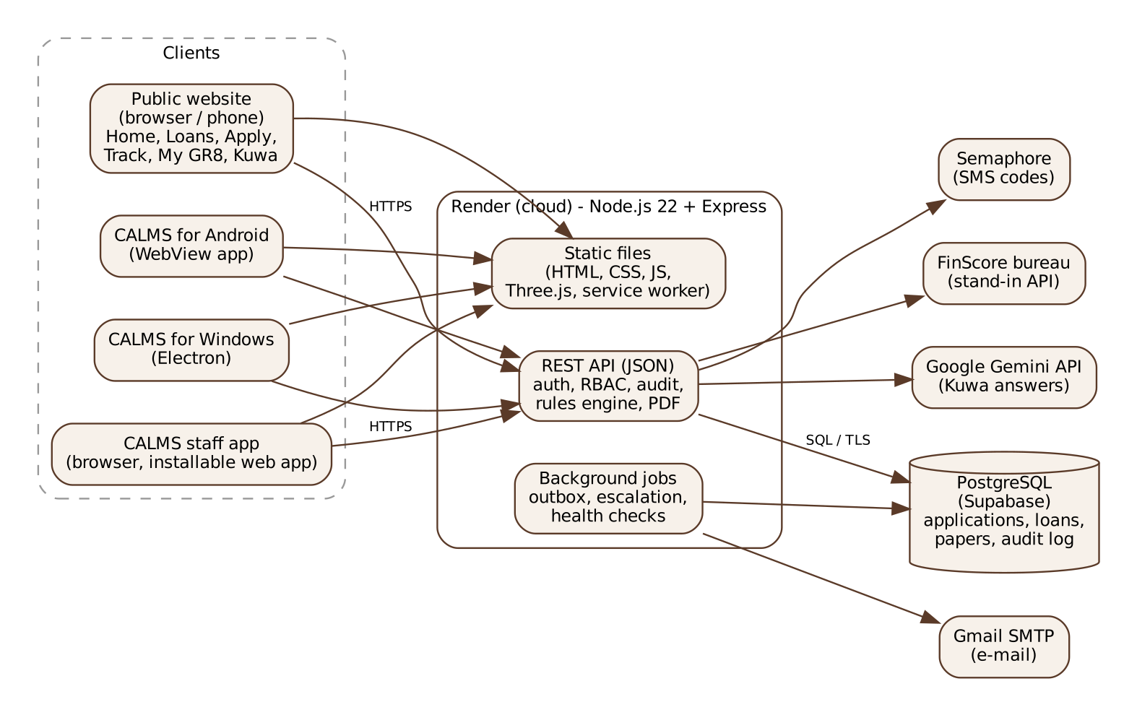
Figure 1. CALMS architecture: clients, application tier, data tier and outside services

4.2 Database Design
The database has 38 tables created by 15 numbered migration scripts. The main ones, grouped by area:
Area | Tables | Requirements
People and access | users, password_history, settings, notification_reads | FR-110 to FR-116
Intake | borrowers, loan_products, applications, application_stages, counters, documents, document_files | FR-001 to FR-020
Verification | verifications, corrections | FR-015 to FR-017
Underwriting | rule_sets, bureau_reports, assessments, decisions, assignments, escalations | FR-021 to FR-043, FR-058 to FR-065
Offers and agreement | counter_offers, offer_answers, agreements | FR-044 to FR-067
Servicing | disbursements, loan_accounts, installments, payments, issued_papers | FR-080 to FR-097
Messages and system | message_templates, outbox, health_checks, idempotency_keys | FR-073 to FR-079, FR-148
Audit | audit_log (append-only, hash-sealed) | FR-104 to FR-109
Website | web_applications, web_application_files, talk_requests, borrower_codes, web_requests, web_request_files, live_chats, live_messages, site_visits | FR-117 to FR-146

Every table has a surrogate key; business references (APP-, W-, LN-, receipt numbers) are unique. Statuses are text with check constraints. Database triggers stop updates and deletes on audit_log, payments and decisions. Each audit entry stores the hash of the previous entry (prev_seal) and its own (seal), so a changed or removed entry breaks the chain and shows in the auditor's seal check.

4.3 Entity Relationship (ER) Diagram
Figure 2 shows the main entities and their one-to-many relationships (crow's foot on the many side). An application belongs to one borrower and one product and is encoded by one user; it has many documents, verifications, assessments, decisions and counter-offers, at most one agreement and at most one loan account. A loan account has many installments and payments. An online application becomes at most one application when encoded.
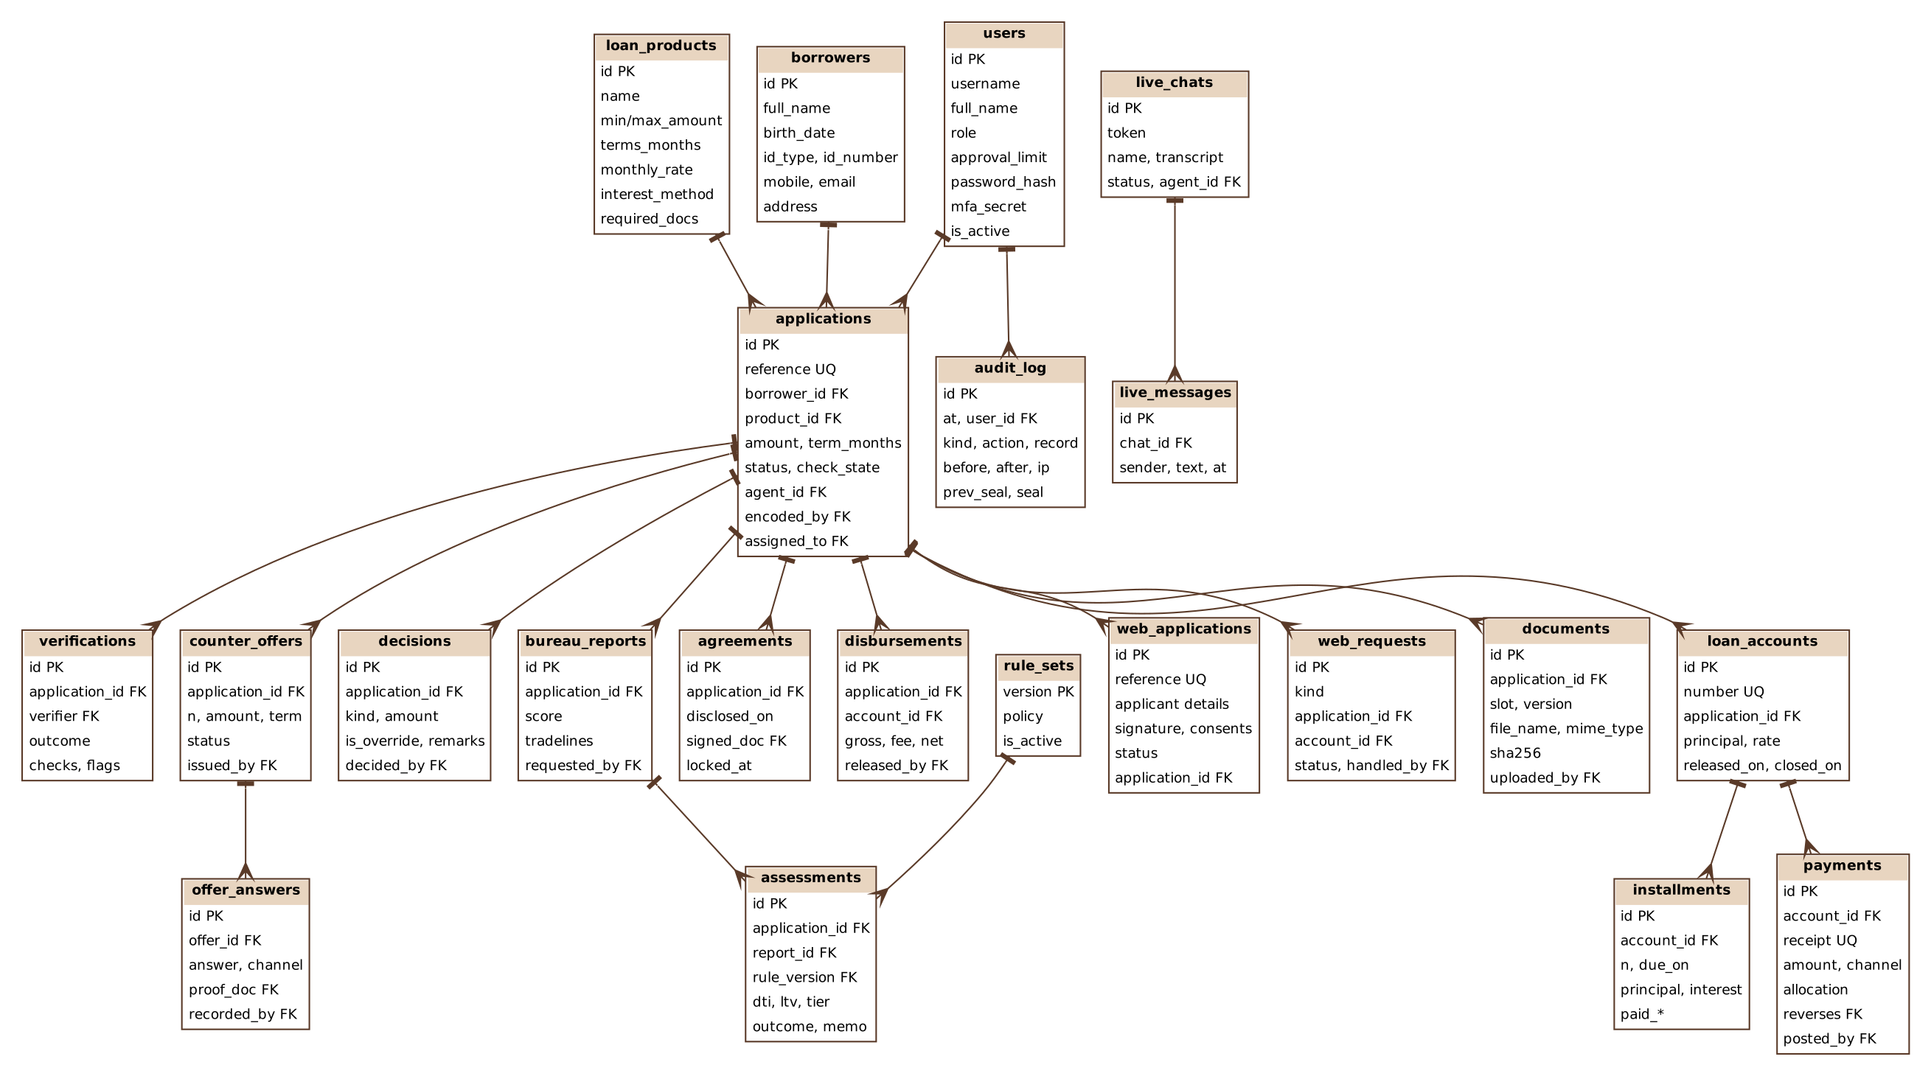
Figure 2. Entity relationship diagram of the main CALMS tables

4.4 Use Case Model Survey
Actor | Use cases | Description
Borrower / Visitor | UC-01, UC-02, UC-03, UC-04 | Applies online, tracks the application, uses My GR8, asks Kuwa or a live agent
Sales Agent | UC-04, UC-07 | Answers live chats; conveys counter-offers and records the answer
Loan Processor | UC-04, UC-05, UC-08 | Encodes and verifies (maker-checker); prepares and locks the agreement
Underwriter / Lead Underwriter | UC-06, UC-07 | Assesses credit, decides within limits, issues counter-offers, assigns desks
Disbursement Officer | UC-08 | Verifies payout details and releases the loan
Loan Account Officer | UC-03, UC-09 | Posts and reverses payments, including those reported in My GR8
Operations Manager / Compliance Auditor | UC-06, UC-10 | Final approval level; reports; audit review
System Administrator | UC-11 | Users, roles, limits, products, rules, templates, health

4.5 Use Case Diagrams
Figure 3 places the eleven use cases inside the CALMS boundary with the actors that take part in each. Borrower-facing use cases are at the top; the internal loan process runs top to bottom.
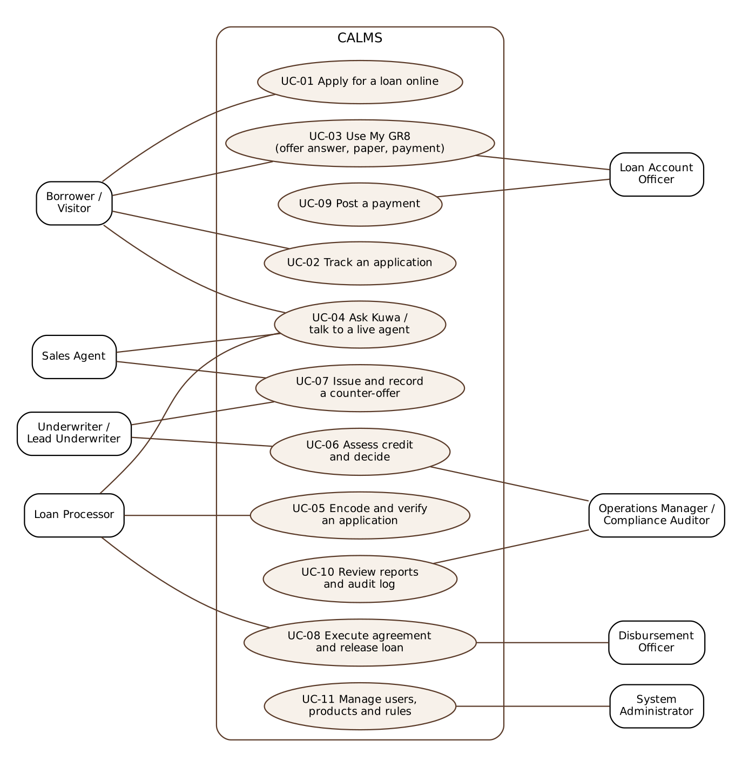
Figure 3. CALMS use case diagram

4.6 Activity Diagrams
Figure 4 follows one loan from application to full payment, with each decision point. The loops show the controls: incomplete papers and returned entries go back to the loan processor (FR-015, FR-016), amounts above a limit go up a level (FR-064), a declined counter-offer goes back to the underwriter (FR-054), and payments repeat until the balance is zero (FR-097).
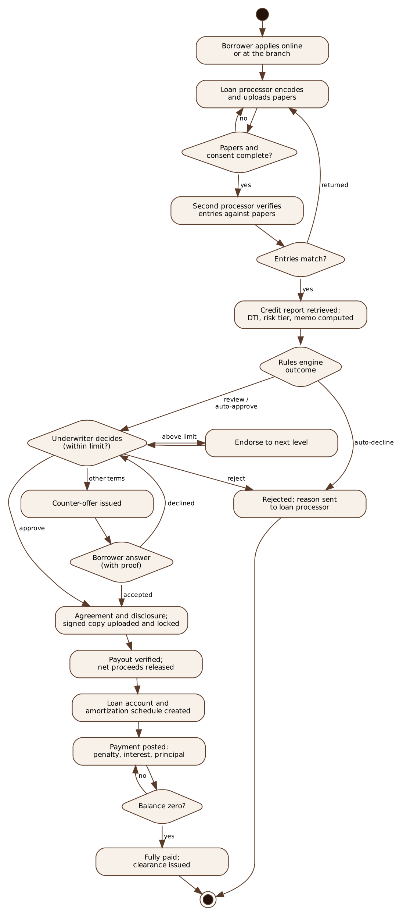
Figure 4. Activity diagram: from application to full payment

4.7 Sequence Diagrams
Figure 5 shows an online application from the borrower's phone to a CALMS application (FR-118 to FR-121, FR-142, FR-125). Figure 6 shows a Kuwa question and the hand-off to a live agent, including the staff alert loop (FR-133 to FR-138).
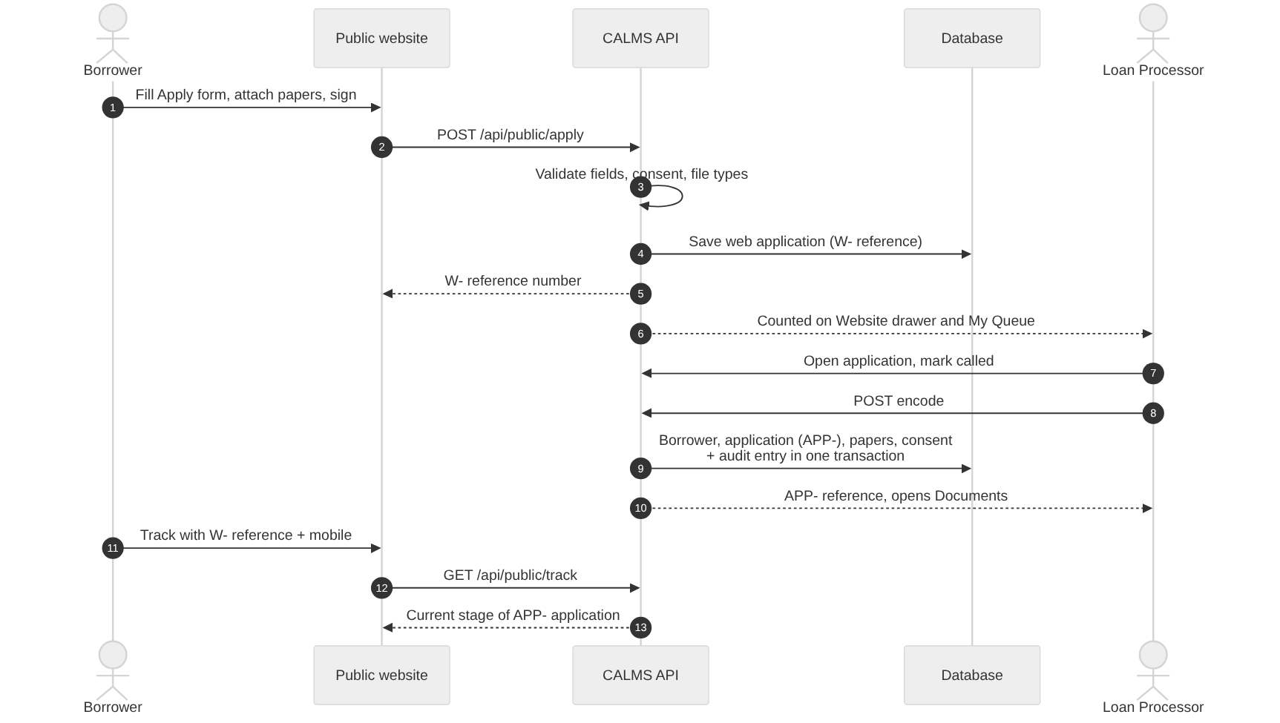
Figure 5. Sequence: online application, encoding and tracking
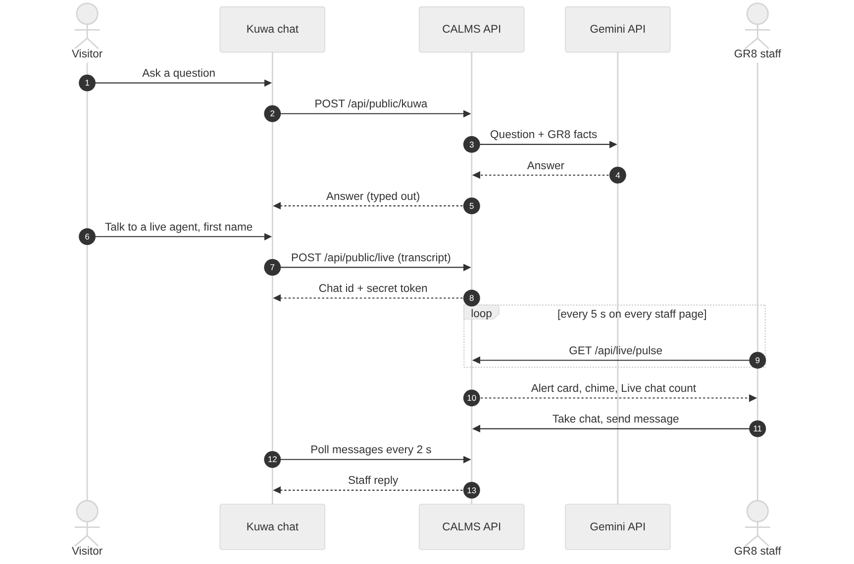
Figure 6. Sequence: Kuwa answer and live agent hand-off

4.8 Class Diagrams
Figure 7 shows the domain classes of Section 3.4 with their main attributes, operations and multiplicities.
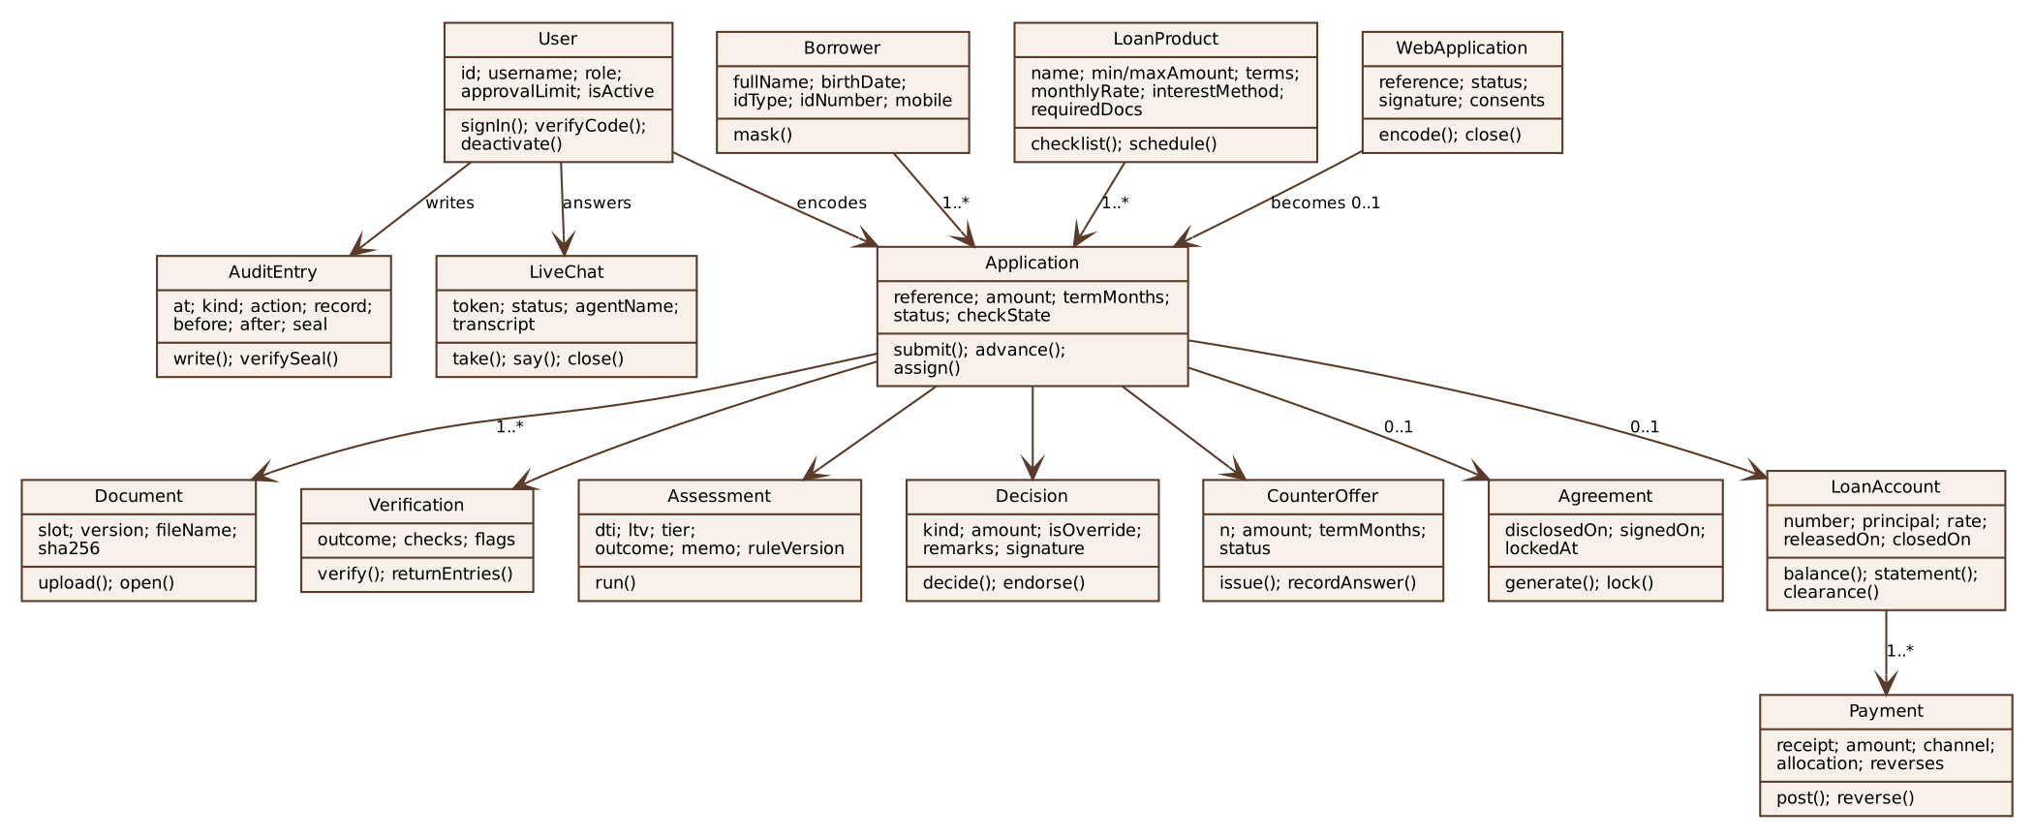
Figure 7. Class diagram of the CALMS domain

A. Appendices
The appendices give background and traceability. They are not part of the requirements, except where a requirement refers to them.

A.1 Appendix 1: Root Cause Analysis
Symptom (client): loan approval takes too long and checking a client is tedious. The 5 Whys:
Why | Because
1 | Every application must be checked by hand before it can move to the next step.
2 | Credit history is read and interpreted by hand from printed bureau reports.
3 | The borrower's figures must be typed into a spreadsheet to compute the risk ratios.
4 | Papers are carried between desks with no shared record of where they are.
5 | Each decision needs a hand-written credit memo that is reviewed again before approval.

Root cause: the absence of one system that captures, checks, assesses, routes, approves and records a loan. CALMS addresses each "why" in turn: maker-checker encoding (1), bureau integration (2), the rules engine (3), queues and tracking (4), and the generated credit memo (5).

A.2 Appendix 2: Risks and Mitigation
Risk | Mitigation
Staff resist the new process | Training per role, the demo script, a parallel run during the switch
Borrower disputes an answer recorded for them | Proof required for every answer; borrower notified of every offer; offers kept
Encoding errors | Format checks, side-by-side view, second-user verification, logged corrections
Bureau, AI, e-mail or SMS service down | Retries, fallbacks, manual review route, built-in Kuwa answers
Connection or power loss | Offline copies, saved drafts, one-time sending of queued work
Unauthorized access to borrower data | MFA, RBAC on every request, masked IDs, logged views, rate limits
Wrong automated recommendation | Rules tested at acceptance; human decision for moderate and high risk; overrides justified
Data loss | Daily backups with tested restoration
Free hosting sleeps during a demo | Open the site early; Windows app sample-data mode as fallback
Scope creep | Change control with written client approval

A.3 Appendix 3: Feature Traceability
Feature (3.2) | Requirements | Main screens | Main API routes
1-2 Intake, documents | FR-001 to FR-020 | New application, Documents, Encode and verify | /api/applications, /verification
3-4 Bureau, assessment | FR-021 to FR-035 | Credit assessment | /api/applications/:ref/assessment
5 Queues | FR-036 to FR-043 | My Queue, Review queue | /api/queue, /api/review-queue
6 Counter-offers | FR-044 to FR-057 | Counter-offers, Record answer | /api/offers
7 Approval, agreement | FR-058 to FR-067 | Decision, Loan agreement | /api/applications/:ref/decision, /agreement
8 Tracking | FR-068 to FR-072 | Application detail, Applications | /api/applications/:ref
9 Notifications | FR-073 to FR-079 | Notifications, My profile, System | /api/me, outbox job
10-11 Release, accounts | FR-080 to FR-097 | Disbursement queue, Release loan, Loan accounts, Post payment | /api/disbursements, /api/loan-accounts
12-13 Reports, audit | FR-098 to FR-109 | Reports, Audit log | /api/reports, /api/audit
14 Users | FR-110 to FR-116 | Users and roles, Products and rules | /api/users, /api/products-rules
15-16 Website, My GR8 | FR-117 to FR-132 | Home, Loans, Apply, Track, My GR8, Downloads | /api/public/apply, /track, /me
17 Kuwa, live chat | FR-133 to FR-140 | Kuwa chat, Live chat | /api/public/kuwa, /api/public/live, /api/live
18 Website inbox | FR-141 to FR-146 | Website, Visitors | /api/website, /api/visits
19 Platforms | FR-147 to FR-152 | All (service worker), Windows and Android apps | sw.js, desktop/, android/

