Abandoned - Game Documentation

**Game Description**

**Title: Abandoned**

**Genre: Action-Adventure, Platformer**

**Platform: Windows**

**Description:**

**Welcome to the enigmatic world of "Abandoned," a video game that plunges players into a post-apocalyptic landscape where every choice could mean life or radioactive oblivion. As the brilliant nuclear physicist protagonist, you'll navigate a perilous 2D side-scrolling platformer set within an abandoned research facility. Crafted by a team of visionary storytellers, artists, and game designers, "Abandoned" delivers an emotionally charged journey filled with themes of resilience and hope. Featuring breathtaking visuals, a meticulously crafted soundscape, and immersive gameplay, "Abandoned" redefines storytelling in video games.**

**Asset Description**

**Game Assets:**

**Main Char:**

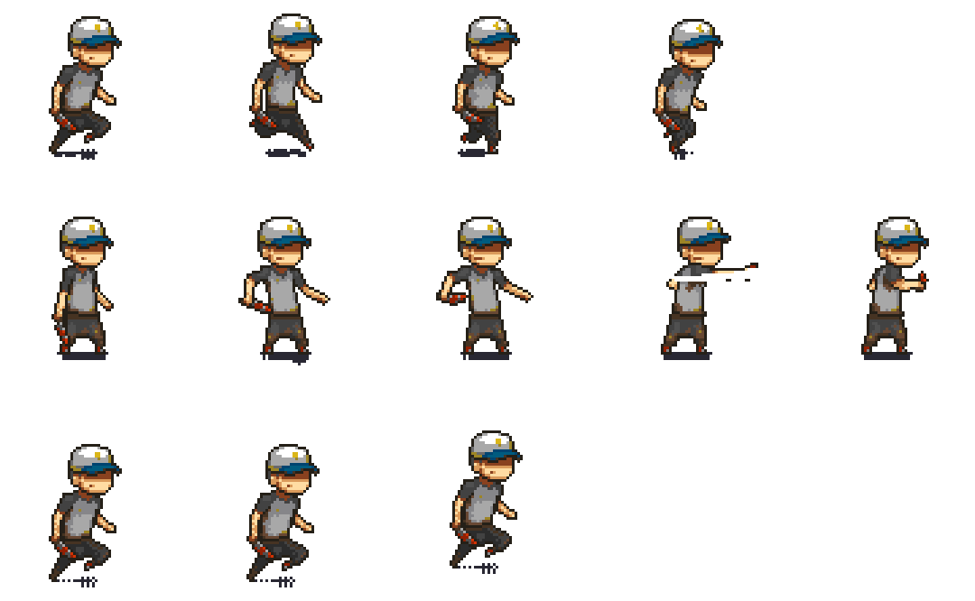

**Enemy Char:**

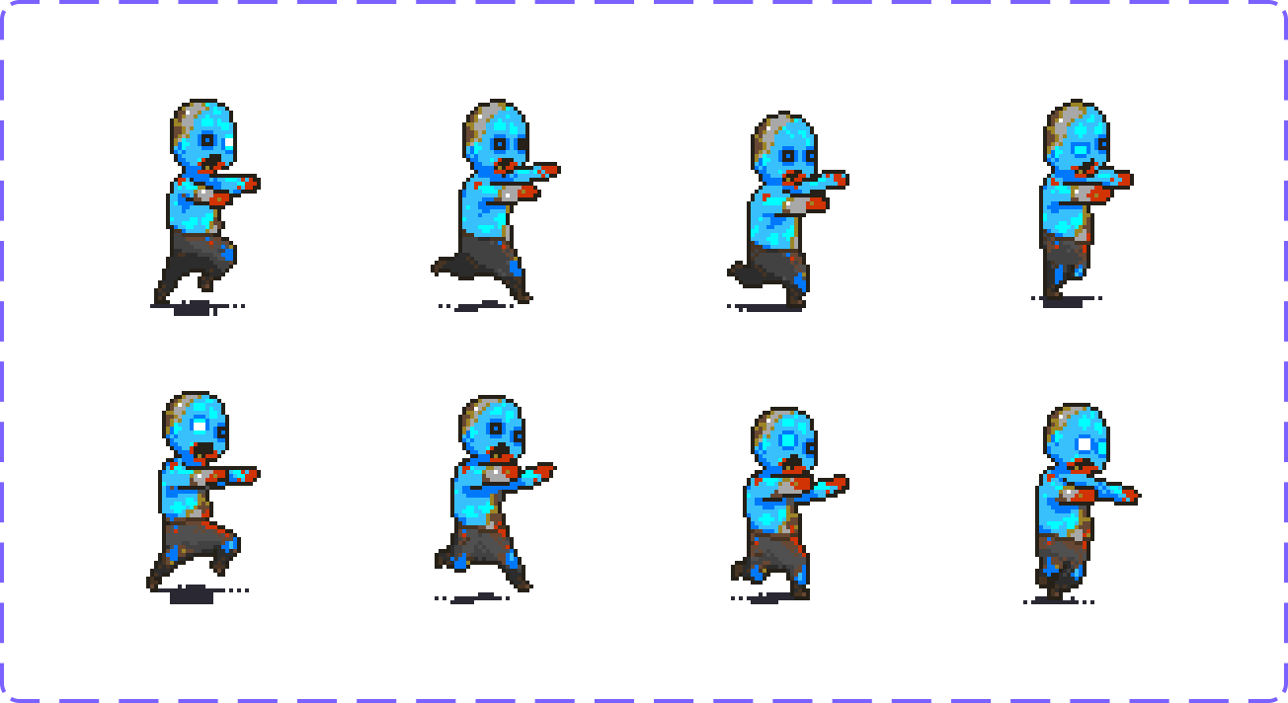

**Portion:**



**Platform:**

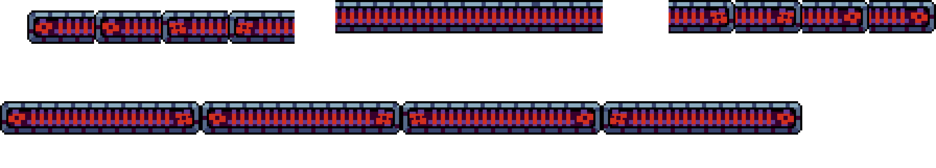

**Every pixel, texture, character design, and interactive element was meticulously sculpted to perfection using FIGMA. This meticulous approach ensures a cohesive visual experience that pays attention to every detail.**

**Game Engine:**

**"Abandoned" runs on the Unity Engine, a versatile, industry-leading game development platform known for its adaptability and capacity to bring complex game worlds to life. Unity's capabilities empower the "Abandoned" team to seamlessly integrate assets, optimize performance, and create a captivating and immersive gaming experience.**

Rules

**Gameplay:**

Level

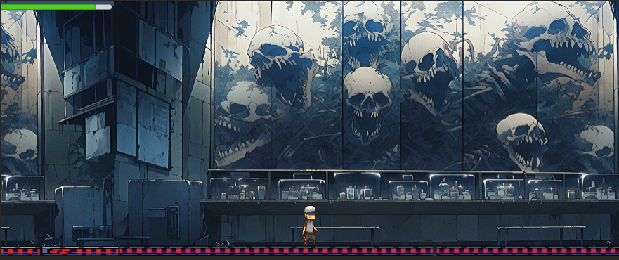

**Assume the role of the brilliant nuclear physicist and confront the ticking clock of a deadly radioactive outbreak in a 2D side-scrolling platformer.**

**Your mission is crystal clear: escape the facility before radiation claims you. Navigate through a world teeming with challenges, collect power-ups, and face escalating difficulties to deepen the gameplay.**

**The choices you make are pivotal, shaping the narrative and the protagonist's personal journey.**

**Engage in in-game conversations with the charismatic visual novel character, Ryan Gosling, adding layers of depth and nuance to your experience.**

**Mechanics**

**Key Mechanics:**

**Exploration: "Abandoned" places a strong emphasis on exploration, inviting players to uncover diverse areas within the facility. Solve environmental puzzles, interact with objects, and tackle formidable obstacles that demand wit and agility.**

**Melee Combat: Engage in thrilling combat sequences against a variety of adversaries. Your combat choices have far-reaching consequences, influencing the narrative in profound ways.**

**Decision-Making: Your choices at critical junctures wield substantial influence over the storyline, character development, and ultimately, the game's outcome. The game celebrates your agency in shaping your experience.**

**Power-Ups: "Abandoned" introduces a progression system based on collecting power-ups. As you advance, unlock enhancements and abilities that enrich your gameplay experience.**

Levels

**Game Levels:**



**"Abandoned" offers two meticulously crafted levels in its public beta release, each presenting a unique environment, challenges, and atmospheric intricacies.**

**The game dynamically adjusts its difficulty curve to ensure consistent player engagement. Successfully escape the facility to claim your well-earned reward.**

**Level Backgrounds:**

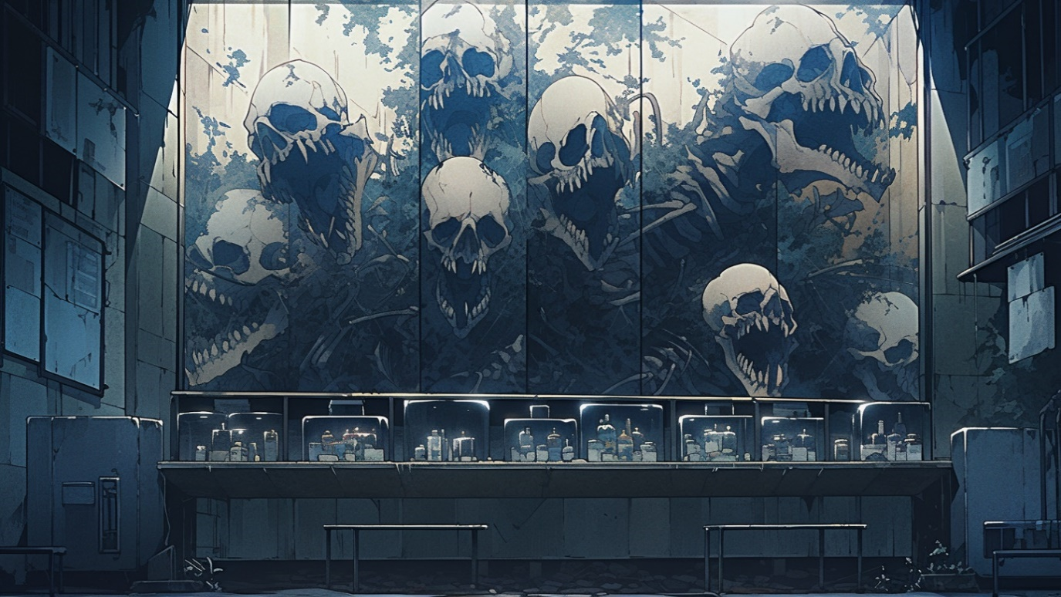

**The game's levels unfold against the haunting backdrop of a dystopian factory. Dilapidated industrial structures, smog-choked skies, and forsaken machinery create a desolate and eerie atmosphere, reinforcing the post-apocalyptic narrative.**

**Level Platforms:**



**Platform design within each level is painstakingly crafted to present a formidable challenge. Navigate an array of platform types, including crumbling walkways, swinging structures, and perilous traps that demand precision and timing.**

**Health Bars and Health Power-Ups**

**Health Bars:**



**A prominent health bar interface element is displayed at the top or bottom of the screen, offering real-time feedback on your character's health status.**

**As your character takes damage from foes or environmental hazards, the health bar steadily depletes, serving as a critical indicator of your well-being.**

**Health Power-Ups:**



**Discover strategically placed health power-ups, often resembling medical kits or radiation antidotes, scattered throughout the game. These power-ups enable you to replenish your health and strategize your path to victory.**

**The placement of health power-ups introduces an element of decision-making, as you weigh the risk of collection against immediate threats.**

Conclusion

**"Abandoned" is more than a game; it's a journey that propels you into a world teetering on the edge of oblivion. From meticulously crafted assets to a compelling narrative and intricate gameplay mechanics, "Abandoned" showcases the dedication and passion of its development team. As you navigate the treacherous facility, make critical choices, and engage in thrilling combat, you'll become part of a gripping post-apocalyptic story.**

**The haunting factory backdrop, dynamic level design, and thoughtful inclusion of health mechanics and power-ups create a gaming experience that challenges your skills and intellect while drawing you into a world that's both hauntingly beautiful and bleak. Your journey to escape the facility and unlock its mysteries is filled with tension, excitement, and moments of profound choice.**

**"Abandoned" invites you to explore the power of video games as a medium for immersive storytelling. It's an experience that will keep you on the edge of your seat, eager to uncover the secrets of this forsaken world and emerge victorious against all odds.**