# ***3 Introduction***

This proposal outlines the concept, inspiration, and creative goals behind *Antillery*, a senior capstone project that aims to turn the artillery game genre on its warhead. However, before venturing into the goals and technical aspects of the project, we should cover some introductory details, including a broad view of the historical context and concept of *Antillery*.

## 3.1 Project Overview

*Antillery* is a satirical take on the beloved artillery game format. Inspired by the iconic "*Worms*" franchise created by Team17, *Antillery* maintains the same strategic, turn-based, destructively chaotic gameplay typical of an artillery-type game while introducing peace-oriented mechanics that border on disruptive and destructive in their own right. In addition to the traditional arsenal of artillery, *Antillery* arms players with a new category of "eco-friendly" and "nonviolent" weaponry and tools–eco-friendly, restorative, or passive-aggressive, but still disruptive and impactful in battle.

## 3.2 Historical and Conceptual Context

### 3.2.1 Disclaimer: Source Material Limitations

Because artillery games occupy a relatively narrow space in gaming history, academic sources on the genre are limited. Much of the historical content regarding early gaming culture comes from enthusiast communities rather than formally rigorous scholarly sources.

This paper relies on "Scorched Parabolas: A History of the Artillery Game" by Dr. Matt Barton, a respected gaming historian whose work balances scholarly depth and subject matter familiarity. Originally published in Volume 4 of Armchair Arcade, Barton's article offers a grounded look at the genre's growth, from early mainframe simulations to later commercially successful franchises (Barton).

Though not a peer-reviewed academic source, Barton's writing is sufficiently rigorous for the needs of the introductory portion of this paper (Barton).

### 3.2.2 A Brief History of Artillery Games

#### 3.2.2.1 Text & Vector-Based Simulation: Origin Story of Artillery "Games"

The earliest artillery games emerged as text-based simulations on mainframe computers in the 1960s. While primitive compared to today's games, these early experiments in electronic entertainment established many of the core mechanics defining the genre for decades (Barton).

The earliest simulations were developed using BASIC and were entirely text-based, requiring players to imagine the evolving battlefield. Players took turns entering parameters such as barrel angle and firing velocity. After processing the simulation, the mainframe would print the results, detailing hits, misses, and the conditions of the battlefield. These early simulations had a limited player base of mainframe operators who implemented and circulated their new features.

Although direct visual records of mainframe-era artillery games are scarce, their design legacy persisted. By the early 1980s, successors like Artillery Duel (1983) began introducing simple vector graphics and visual interfaces on home consoles (MobyGames).

Even with their limited complexity and audience, these early simulations established the core mechanics that later artillery games would develop further.

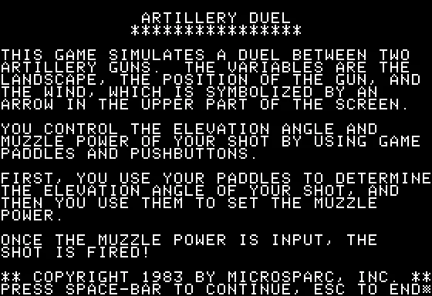

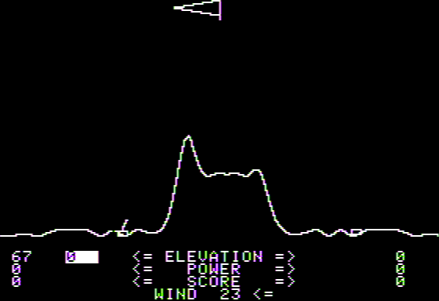

**Figure 3.2.2.1.** *Artillery Duel* (1983) (MobyGames).

#### 3.2.2.2 *Scorched Earth*: Evolving Artillery Through Endless Customization

*Scorched Earth* was released in 1991 and marked a pivotal moment, breathing new life into the artillery genre (Barton). Unlike its text-based predecessors, it was in full color, real-time, and standardized many of the hallmark conventions of artillery games, much like what Super Mario Bros. did for platformers (Barton).

*Scorched Earth* expanded significantly on the foundational mechanics of earlier artillery games by implementing over thirty weapons, ranging from conventional missiles to napalm. Much of its acclaim came from its level of strategic depth, afforded by its fully destructible terrain, customizable parameters such as wind and gravity, and a robust in-game economy.

This landmark artillery title introduced several design ideas that became hallmarks of the genre today. Its focus on dynamic strategy through choice and customization shaped the landscape of future artillery games. These principles influence some of the design objectives of Antilery.

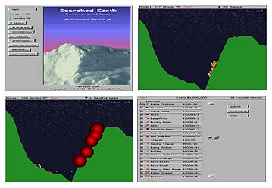

**Figure 3.2.2.2.** Scorched Earth (1991) UI and terrain interaction (Barton).

#### 3.2.2.3 *Worms*: Giving the Artillery Genre a New Backbone

Worms, released by Team17 in 1995, marked a turning point in the artillery game genre. While its gameplay preserved core projectile mechanics, its presentation, a squad of cartoon worms wielding bazookas, shifted the genre from simulation to satirical multiplayer chaos.

Creator Andy Davidson entered the game, called initially Total Wormage, into a competition by Amiga Format magazine. Though it did not win, it caught Team17’s attention, which went on to publish it across multiple platforms (Nuttall 26; Barton). Worms emphasized player mobility, absurdity, and personality, unlike its tank-centric predecessors. Worms could walk, jump, and swing across terrain using ninja ropes and parachutes, adding momentum and physical comedy to a genre previously rooted in physics realism. Barton observed, “The worms can do much more than tanks,” describing moments of dramatic acrobatics (Barton).

Its tone embraced British comedic absurdity, transforming once-serious combat into a stage for slapstick and satire. Exploding sheep, banana bombs, and absurd weapons blurred the line between threat and punchline. Cheeky voice lines like “First blood!” and “This worm is an ex-worm!” gave the game personality and flair, establishing a new kind of identity for artillery games, one dripping in irony, theatricality, and joyful nonsense (Barton).

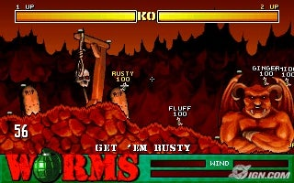

**Figure 3.2.2.3.** *Worms* (1995) featuring destructible terrain and satirical visuals (LaFlame).

## 3.3 Antillery Comes Marching In

With this historical and conceptual background in place, the following sections transition from analysis to proposal, exploring Antillery’s game mechanics, audience considerations, technical development plan, and capstone justification. Each component builds toward a complete implementation strategy for a playable, satirical artillery game by the end of the academic term.