

Politecnico di Torino

# Energy management for IoT application Report laboratory session 2

Author: Grottesi Lorenzo

## Introduction

The goal of the lab is the reduction of power consumption related to a dataset made by images. The report is divided in two parts in the first one the simple optimization of the images is treated. Then in the second part the image optimization is discussed considering an OLED display. In particular the image will be adapted through a function *“displayed_image()”* that shows an emulation of the original picture in the OLED device. The goal of the second OLED optimization will be in the adaptation of the image considering a dynamic voltage scaling (DVS). For both activities, the image distortion must satisfy a given threshold constraint (1%, 5%, 10%).

## Functions overview

Before exploiting the power consumption algorithm, some function has been written and tested.

* ImgPwr(): reports the power consumption of the input RGB image.
* ImgDist(): report the distance among two RGB images considering the LAB coordinates.
* Icell(): transform the RGB input into a 3 dimensional current matrix. Each point is the current required by each pixel of the panel.
* panelPower(): given the Icell matrix and the working voltage returns the overall power consumption.

In order to save power some transformations must be applied. In particular for the bare image optimization, three algorithms have been written:

* Hungry blue
* Histogram equalization
* Brightness scaling

The solution of the whole dataset will be described later on. A dedicated discussion will be treated for each function.

For the OLED emulation power consumption, the transformations used are slightly different. In this scenario what is required is to adapt the image to the voltage supply. Three functions have been written:

* LCDBrighnessCompensation
* LCDContrastEnhancement
* LCDConcurrentBrightnessContrast

The solution for the whole dataset will be described later on. A dedicated discussion will be treated for each function.

## Dataset evaluation

Before performing the dataset optimizations, a previous test was applied to check the power and distortion overview. The test aims to extract the energy and distance of all images of the dataset. The distance has been computed considering two metrics: LAB distance and SSIM. The overall flow is depicted in figure below. It has been applied for each image of the dataset.

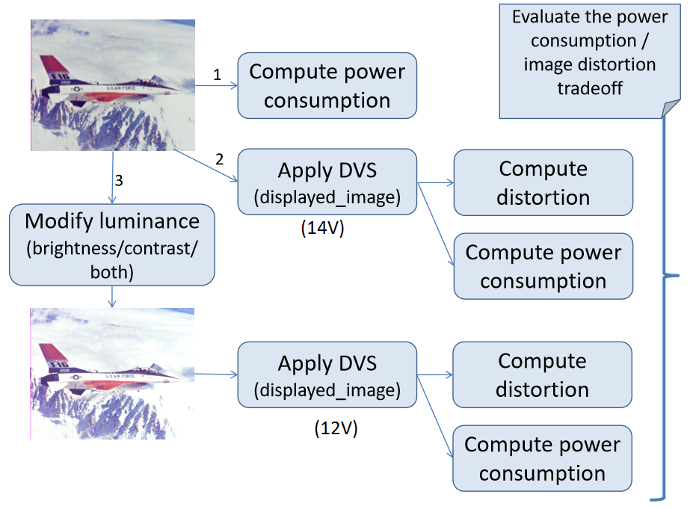

Figure 1 - Dataset test flow

The single image is read and the power consumption is computed. The image is emulated using a 14V OLED display, the panel power and the distances are computed. From the starting image, a transformation is applied to bring it at 12V, here again is emulated, the power and distances are extracted. Figure 2 reports the two different power consumptions 14V and 12V for all images of the dataset. As possible to imagine the 12 V curve is always below the 14V one. Figure 3 reports the two metrics of distance, from these is possible to highlight that the SSIM metrics is more stable for the 14V emulation and more sensible to 12V. For both metrics the DVS increase led to more distance. The summary is referred to *“datasetEnergyDistance.m”* Matlab file.

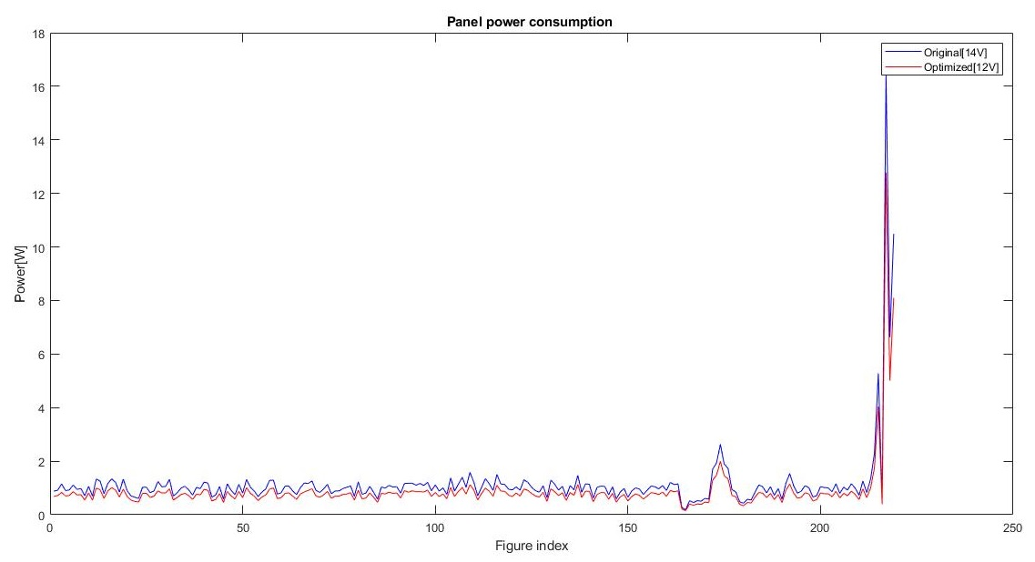

Figure 2 - Panel power consumptions

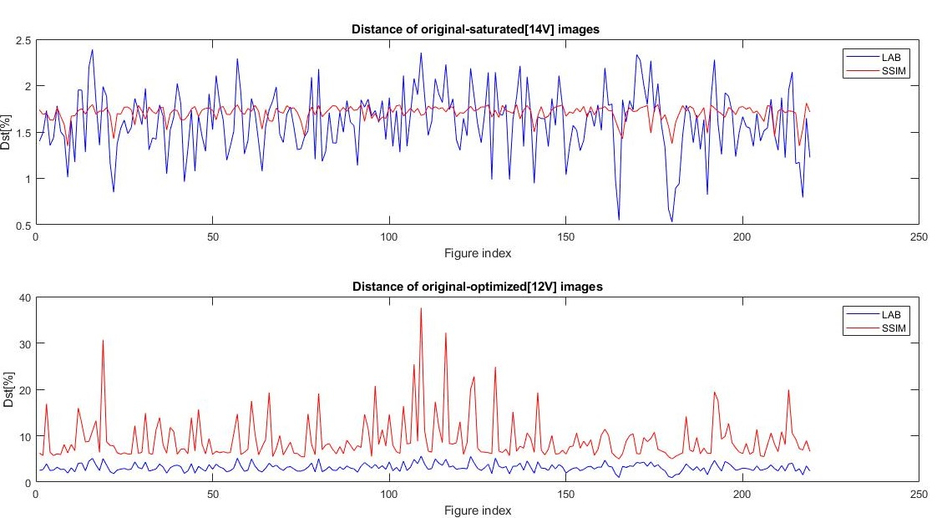

Figure 3 - Distances of 14V and 12V from original picture

## Hungry blue

This algorithm bases reduces the percentage of blue of the input image. The figure below shows the application of the algorithm with the 20% of reduction. From the color distribution is possible to see that the red and green distributions are unaffected while the blue shifts to the left.

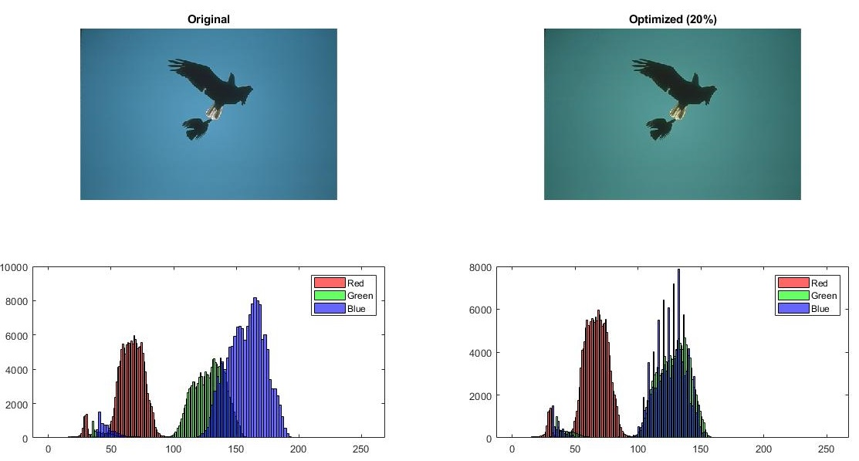

Figure 4 - Hungry blue 20% optimization, 7.24% power saved

## Brightness scaling

This function optimizes the power consumption reducing the brightness of the image and rising the saturation to compensate.

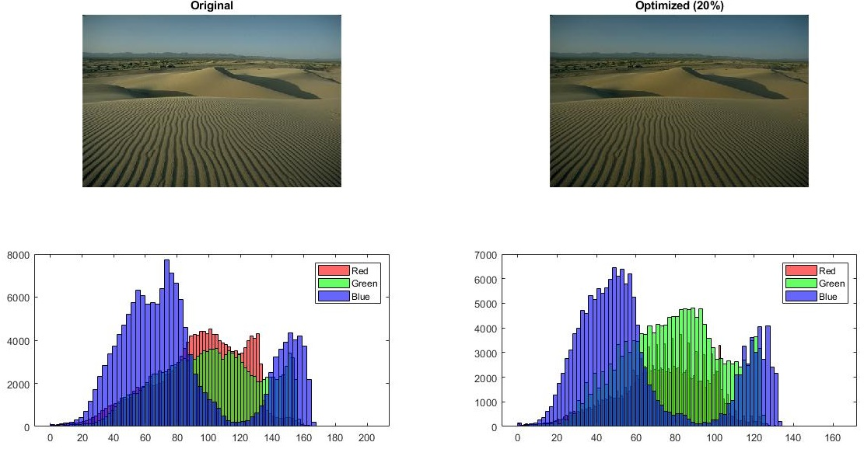

Figure 5 - Scaling 20% of brightness, 18.25% power saved

## Histogram equalization

Despite the other two this function does not act on single pixel rather than the overall distribution. Is important to highlight that this transformation could increase the power consumption instead of decreasing. The real advantage is present when, as in figure 6 the color distribution is more concentrated on the highest values.

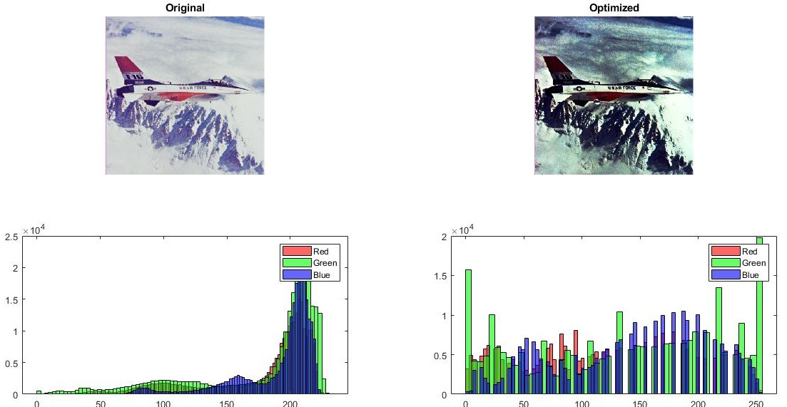

Figure 6 - Histogram equalization, 26.5% power saved

## Image power optimization

In order to optimize the power consumption of all dataset, an algorithm has been written. In particular the diagram, fig. 7, represents the transformations applied to a single image. Firstly, the image is read, the power consumption extracted. Then, a set of transformations are applied. First one is the histogram equalization. If the transformed image presents an acceptable distortion, and a positive power saving, the transformation is kept. If not, the transformation is dropped. Then the hungry blue is applied to the temporary image. The algorithm extracts the average of red, green and blue of the temporary image. When the blue average goes above the other two, a proportional reduction is applied. Again, if the transformation has an acceptable distance and positive power saving the transformation is kept. Otherwise, is dropped. Lastly the brightness scaling is applied. This time the scaling percentage is not extracted by the image, rather, the optimal percentage is obtained performing many attempts. The scaling starts with a 1% factor, the image is recomputed and power-distance are extracted. If the transformation respects the constraint and power reduces, another attempt is performed scaling by another 1%. The brightness scaling is repeated until a non valid transformation is obtained. Table 1 reports the average power saving of the dataset considering the three constraints given.

Table 1 - Dataset power saving results

|  |  |  |  |
| --- | --- | --- | --- |
|  | 1%  distance | 5%  distance | 10% distance |
| Average dataset saving | 7,00% | 16,63% | 23,54% |

The algorithm uses the SSIM as distance metric. The algorithm is implemented in *“ImageEnergySaving.m”*

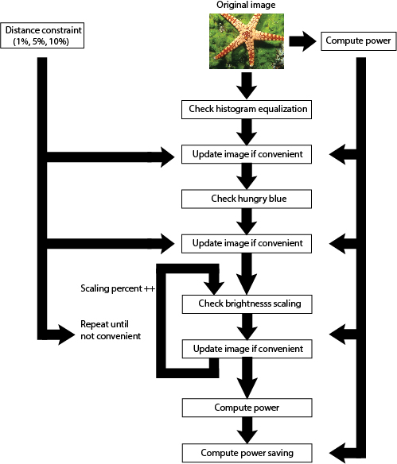

Figure 7 - Image optimization algorithm

## OLED power optimization

The power optimization of the OLED device is implemented through 3 main functions. The brightness scaling, contrast enhancement and both. In particular the main idea is to reduce the brightness of the OLED and compensate the image distance using these functions.

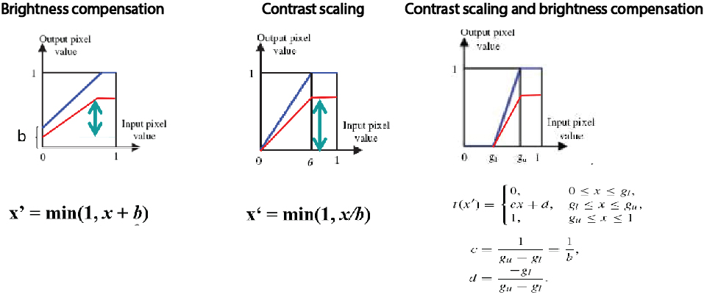

Figure 8 - Pixel transformations

In order to improve the power – distance trade off is important to carefully relate the scaling factors with the DVS. To find the relation the luminance formula has been used.

Considering the brightness in a value [0, 1], is possible to create a model using the DVS input voltage. Knowing that the maximum voltage allowed by the emulator is possible to write the brightness as

Using this formula is possible to relate the luminance with the DVS voltage.

For brightness compensation

K depends on value of the current pixel x (range in [0,1]). So, considering the brightness relation and an average value of x the constant became

Applying the same formulation for contrast scaling, the scaling factor results

Using these relations, the two values *gu* and *gl* for concurrent brightness and contrast are modeled as

Having the transformation functions and the relation with the DVS, the algorithm for the optimization of the whole dataset has been written. The flow of operation performed for a single image a reported in the figure below.

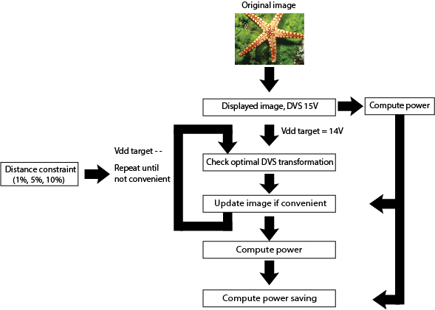

Figure 9 - OLED power optimization flow

The algorithm simply checks which of the three transformations discussed are the optimal for the input image. The optimality is checked using a power - distance plain. In particular the power space considered is not the power saving, rather the percentage of power not saved. In formula

Using this metrics is possible to create a plaint power – distance in which the optimal solution is the one closest to the origin.

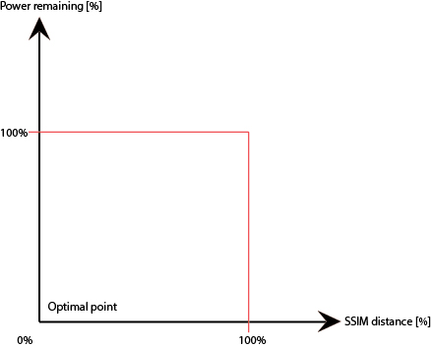

Figure 10 - Optimization plain

The three transformations are applied and the one presenting the less Euclidian distance in the plain is considered, the other are dropped.

The table below report the results for the algorithm.

Table 2 - OLED optimization results

|  |  |  |  |
| --- | --- | --- | --- |
|  | 1%  distance | 5%  distance | 10% distance |
| Average dataset saving | 11,84% | 26,67% | 36.57% |