

Politecnico di Torino

# Energy management for IoT application Report laboratory session 3

Author: Grottesi Lorenzo

## Introduction

The goal of the laboratory is to create and study a model for a battery system. The creation of the model is performed using Simulink environment. In particular the battery has been simulated improving its electrical model, fig. 1. In order to stress the battery a pack of 4 sensors has been created, each one present a specific workload supporting two states: SLEEP and ACTIVE. Furthermore, a memory module and a transmission module are implemented. The whole power demand is handled by a DC bus, which interfaces the loads with power supply.

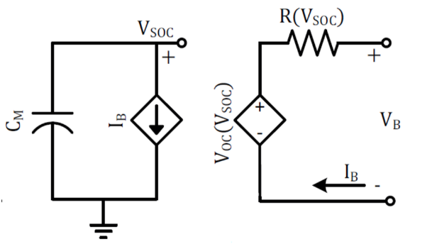

Figure 1 - Battery model

In order to improve the battery system, a Photovoltaic cell has been connected and interfaced with the system. The DC bus, senses the power demand and adapts the supply between the PV and battery. Furthermore, when the PV power exceeds the current power demands the remaining energy is harvested on the battery. Is important to highlight that both PV cell and battery, present a DCDC converter as interface to the bus. The efficiency of the converters will be stored digitizing the datasheet curves. Photovoltaic cell is assuming to work always at its maximum power point.