DIGITAL SYSTEMS ELECTRONICS

Academic year 2023-2024

LABORATORY NR. 1

DUE DATE: March 25, 2024
DELIVERY DATE: March 24, 2024

GROUP 03

CONTRIBUTIONS:
- El Amrani Dawid 100%
- Ielmini Giovanni 100%
- Di Carolo Pierfelice 100%
- Pavone Lorenzo 100%

The members of the group listed above declare under their own responsibility that no part of this document has been copied from other documents and that the associated code is original and has been developed expressly for the assigned project.

Contents
This report is relative to the first laboratory experience of this course.
The purpose of this lab session was to familiarize with the programs we will use for the rest of the course, Quartus Prime and Modelsim, and to use them to implement simple circuits on the FPGA board DE1-SoC.

We tested three circuits: one allowed us to control the LEDs on the board using the switches, and the other two were multiplexers.
- Controlling the LEDs
- Design entry:
the circuit under exam is very simple. We are using switches 0 to 9 as inputs and LEDs 0 to 9 as outputs. Every switch controls the correspondent led. As the design is pretty simple we only have one file other than the testbench.
- Functional simulation:
in order to test the design, before implementing it on the board, we wrote a testbench (very simple, as well). We assigned different combinations of ON and OFF switches and checked if the design responded in the right way.
- Synthesis:
we tested the code with ModelSim. The picture below represents the output and input wave. As the input represents the switches combination (1 being the switch turned on) we expect two identical waveforms, which is exactly what we obtained.
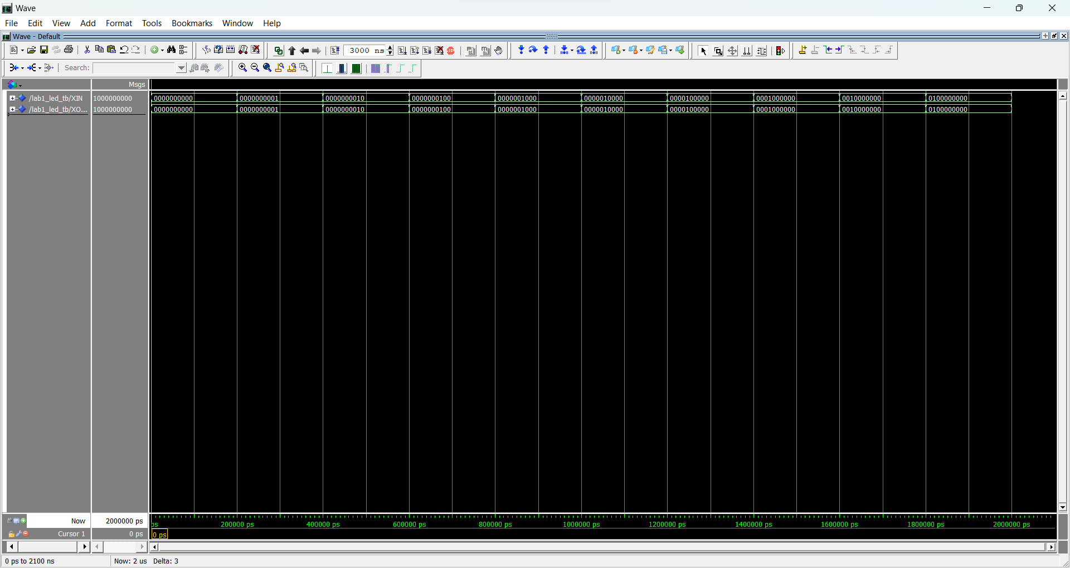

- Comments:
the design, being the first of the course, was pretty trivial and we didn’t encounter any particular difficulty.

- 2-to-1 Multiplexer
- Design entry:
in this case, the DUT is a 2-to-1 multiplexer. This particular design contemplates two four-bit input signals (a and b), a single-bit selection input signal (s), and a four-bit output signal (m). The latter will be one of the inputs, depending on the value of the selection signal.
We associated 9 switches to the three input signals (1 for s, 4 each for a and b), and 4 LEDs to the output c. We used boolean logic to assign the output value depending on the selection as follows:
m(3) <= (NOT (s) AND x(3)) OR (s AND y(3));
This means that when we have s = 0 we copy the value in the 3rd spot of x into the third spot of m, while we do the same thing with y instead of x when s = 1.
We did this for every one of the 4 positions of m (thus having four lines with the position ranging from 3 to 0).
As this is still an easy design we only have one VHDL file other than the testbench.
- Functional simulation:
in the testbench, since what we want to verify is the correct response to the inputs of our choice, we set the two inputs a and b to fixed values, and change s over time.
- Synthesis:
the picture below represents the waveform of the two inputs, the selection and the output.
When the selection value (s, last row in the picture) is equal to 0 we obtain (as expected) for the output (m, third row in the picture) the same value as the input (x, first row in the picture), while we obtain (y, second row in the picture) when the selection value is equal to 1.
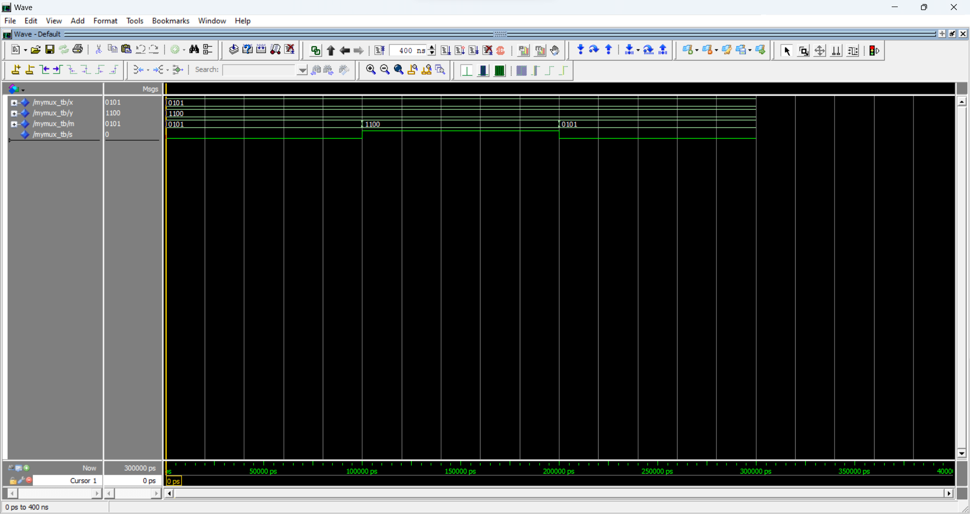
- Comments:
the design wasn’t difficult as it didn’t require more than the basic theory of FPGAs and VHDL.
- 5-to-1 Multiplexer
- Design entry:
the device we are analyzing is a 5-to-1 multiplexer. We have five 3-bit input values (x, y, u, v, w), hence we need a 3-bit selection input (we need log₂(n) selection bits). As output, we expect a 3-bit value (one of the 5 input values, depending on the selection input).
We associated three switches to the selection input, three to x and three to y, defining the other 3 input values as constants.
We divided the topology in four 2-to-1 multiplexers, each with a single bit selection input. The first one is selecting between u and v, and the second one is selecting between w and x, both with s(0). The third one is choosing between the outputs of the first one and the second one, with s(1), and is returning as output (that we will call c) one of the two. The last multiplexer is selecting between c and y with s(2).
- Functional simulation:
in the testbench, since what we want to verify is the correct response to the inputs of our choice, we set the two inputs x and to fixed values, and change the three selection bits over time.
- Synthesis:
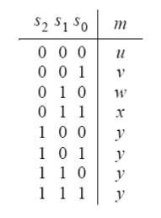
as this was the assignment, in the picture below there is shown the behavior in time of the selection input and of the output.

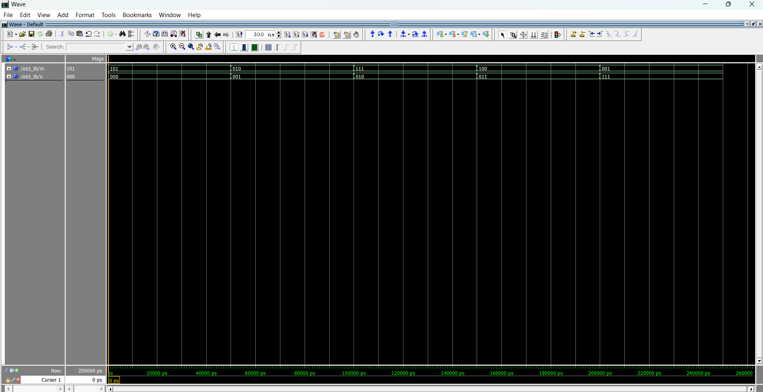
The second picture is the result of the testbench code given in point 4 of the lab. The results are identical to those presented in the assignment. Both testbench are correct and show that our project works.
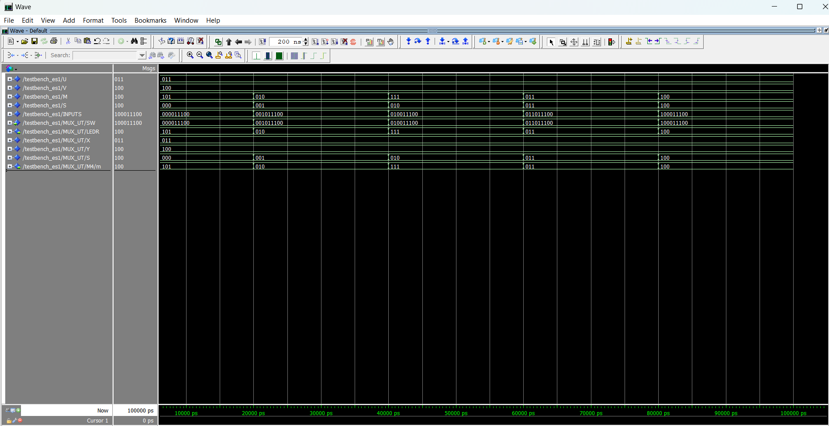
- Comments:
the design wasn’t difficult as it didn’t require more than the basic theory of FPGAs and VHDL.

