DIGITAL SYSTEMS ELECTRONICS

Academic year 2023-2024

LABORATORY NR. 2

DUE DATE: April 5, 2024 (extended)
DELIVERY DATE: April 5, 2024

GROUP 03

CONTRIBUTIONS:
- El Amrani Dawid 100%
- Ielmini Giovanni 100%
- Di Carolo Pierfelice 100%
- Pavone Lorenzo 100%

The members of the group listed above declare under their own responsibility that no part of this document has been copied from other documents and that the associated code is original and has been developed expressly for the assigned project.

Contents
This report is relative to the second laboratory experience of this course.
The purpose of this lab session was to learn how to connect already existing units and various logic circuits. In particular, we had to use the 7-segment display. The first design was focused on learning how to use the 7-segment display, while the next three used the display in different manners using various logic functions.
- Controlling a 7-segment display
Design entry:
For this circuit, pretty trivial, we needed only one file: the top level entity.
The entity ‘decoder’ is declared with two ports: ‘SW’, which is an input port representing a 3-bit vector, and ’HEX0’, which is an output port representing a 7-bit vector. Inside the architecture two internal signals are declared ‘c‘ a 3-bit vector(assigned to SW), and ‘h’, a 7-bit vector(assigned to HEX0). Inside the process block, there's a conditional statement that assigns values to h based on the value of c. Depending on the value of c, a 7-bit vector is assigned to h, representing which of the seven segments must be on to display a certain character between "H", "E", "L", "O", or all segments off if c doesn't match any of the specified cases.

Functional simulation:
In the testbench, the process block simulates the behaviour of the input switches (SW) over time. It sets the value of s to different values at specific times using WAIT FOR statements. This simulates the changing inputs to the display controller.
The output signals (h) will change accordingly, allowing you to observe how the display responds to different input patterns.

Synthesis:
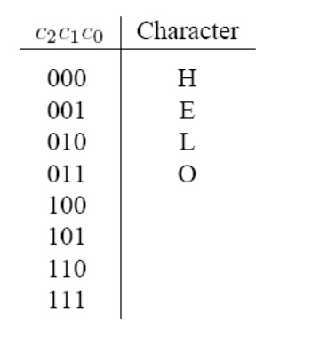
We tested the code with ModelSim. The picture below represents the output and input wave. As we expected, each of the 4 codes (plus the blank), present in the table, is associated with the corresponding sequence of the display segments turned on (0) or off (1) which represent each letter.

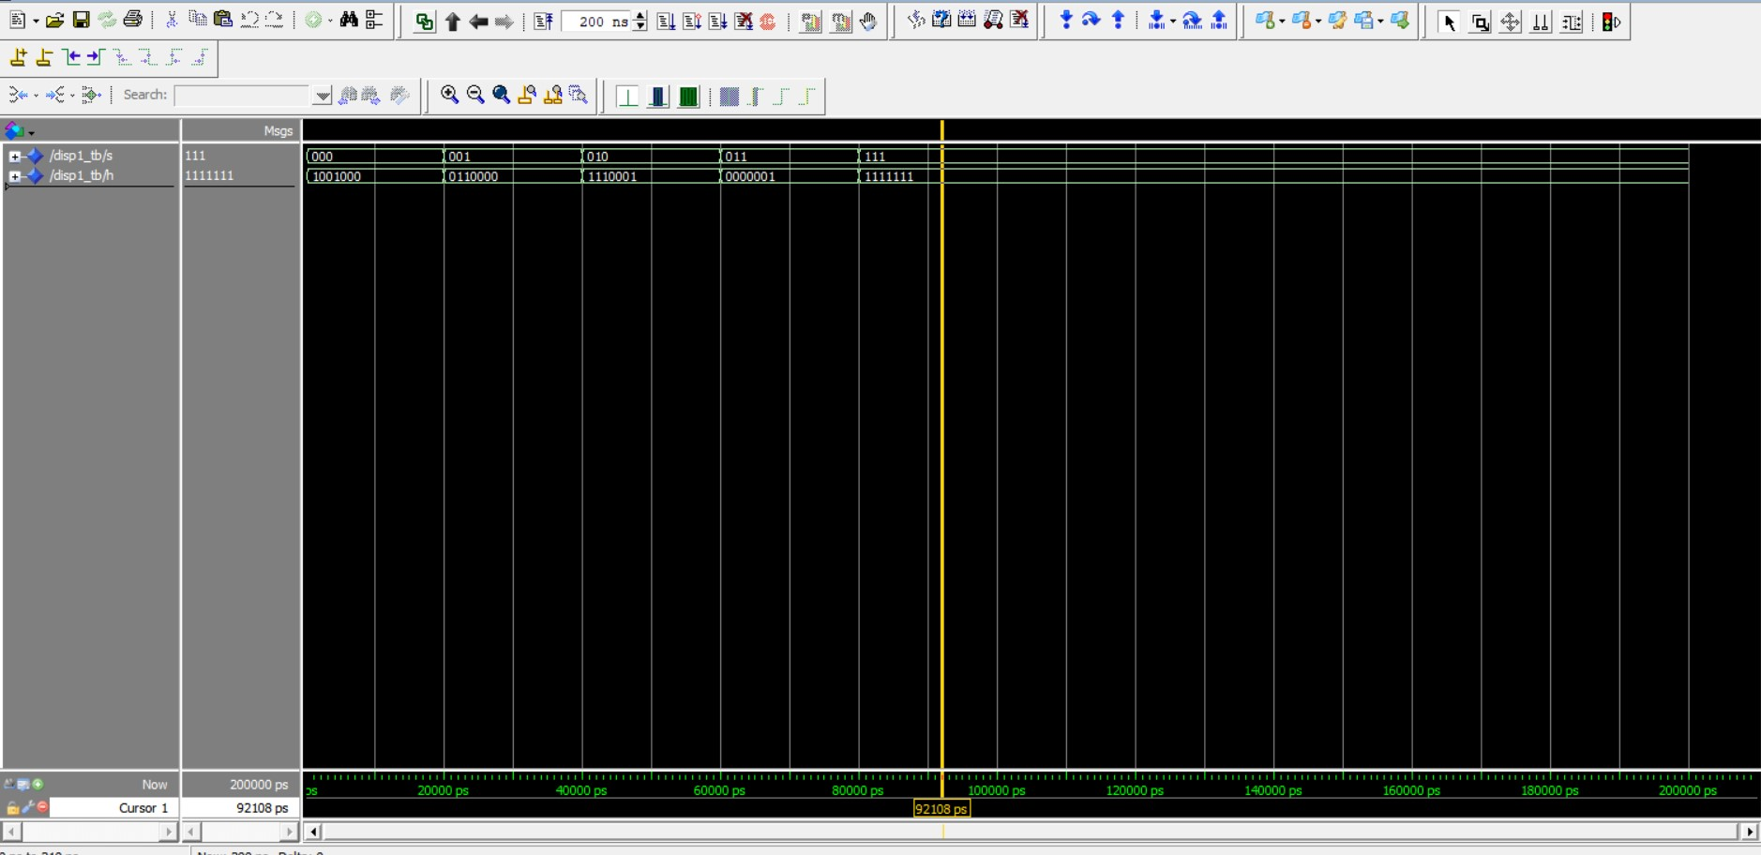

Comments: We could not perform the time simulation, since we had problems with implementing the project on ModelSim with .vho and .sdo
- Multiplexing the 7-segment display output
Design entry:
For this project we used a separate VHDL file for each building block.
The top level entity file is ‘part2’: it has inputs (SW) and outputs (HEX0, HEX1, HEX2, HEX3, HEX4). SW is a 5-bit vector input, and HEX0 through HEX4 are 7-bit vector outputs. In the architecture the behaviour of part2 is made by three components: mux, decoder7 and shifter, these components are essentially subcircuits that perform specific functions.
The multiplexer's role is to choose which input will be propagated to the output based on the selection vector. In the process block each letter is associated with a combinational 3-bit input.
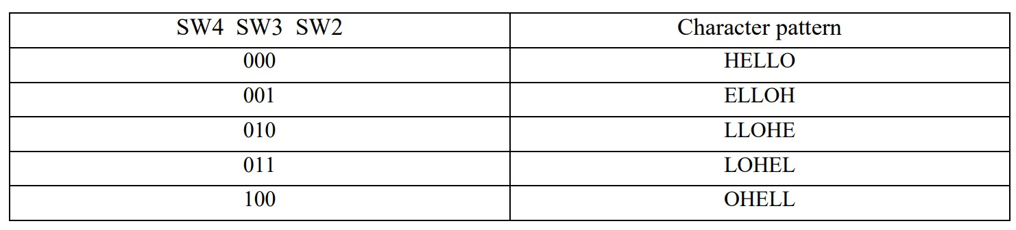
The shifter receives as inputs a 15-bit vector (that corresponds to the 5 letters that compose the word chosen by the mux) and a 3-bit selection vector, and returns as output a 15-bit vector, that is basically the input word, but with the letters shifted as shown in the truth table here on the left.
The role of the component decoder7 is the same as the one done by the precedently explained “display1”. The only difference is that decoder7 has 7 letters instead of 4.

Functional simulation:
In the testbench the signals sel1, sel2, h0, h1, h2, h3, and h4 are declared.
sel1 and sel2 are used to simulate the switches (SW) inputs to part2.
h0, h1, h2, h3, and h4 are used to capture the outputs of the part2 entity.
The part2 component is instantiated (uut), connecting its ports with signals declared in the testbench.
The input switches SW(1 DOWNTO 0) are connected to sel1, and SW(4 DOWNTO 2) are connected to sel2.
The output ports HEX0 through HEX4 are connected to h0 through h4, respectively.
Inside the architecture, there's a process block.
Within this process, different combinations of inputs (sel1 and sel2) are applied to the part2 entity.

Synthesis:
We tested the code with ModelSim. The picture below represents the output and input wave. As we expected in the first row we can see the word “HELLO”, in the second one we can see “LOHEL”, in the third one “EPPOC” because the sel1 corresponds to CEPPO and sel2 corresponds to the second switch mode in the truth table.
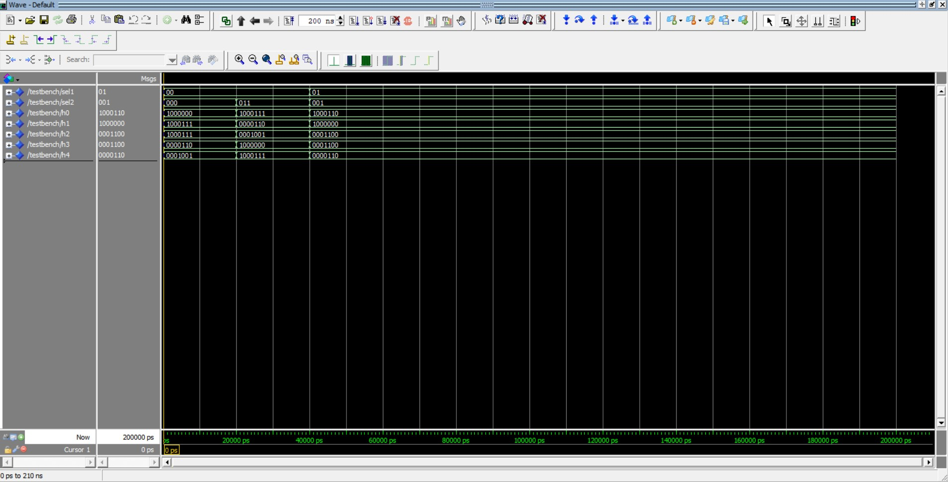

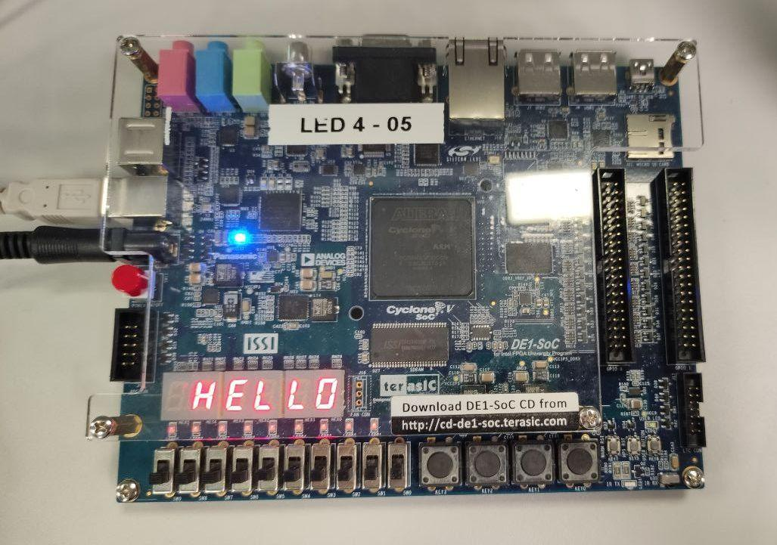

Comments: We could not perform the time simulation, since we had problems with implementing the project on ModelSim with .vho and .sdo

- Binary to Decimal converter
- Design entry:
In this part we used different files for each component:
- The first one is the comparator file, which receives the 4-bit binary number we want to convert into decimal and gives out as output ‘1’ if the number is 10 or bigger, and ‘0’ if it is not;
- The circuit_A file, composed of a 3-bit input and a 3-bit output vector, plays the role of setting the inputs of the multiplexers that will be propagated to the units display if the number is bigger than 9 (we subtract 2 from the three least significant bits);
- The mux3 file defines the multiplexer relative to the most significant bit. It receives as selection input the output of the comparator and chooses which value to propagate to the unit's display;
- The mux file defines the three multiplexers relative to the other three bits of the number we are converting. It receives the same selection input of mux3, but instead of having the corresponding bit and ‘0’ as inputs, it has the corresponding bit and the corresponding output of circuit_A;
- The circuit_B file plays the role of propagating the output of the comparator to the tens display;
- The last file defines the seven segment display, a file that receives a 4-bit binary number and shows it on the unit's display.

- Functional simulation:
In the testbench, we declare V, the 4-bit input binary number, and H0 and H1, the outputs.
We assign to V different values and check if the outputs (the seven segments strings related
to the tens, H1, and the units, H0, display) are correct, separating the assignments thanks
to “wait for” statements.

- Synthesis:
We tested the code with ModelSim. The picture below represents the output and input wave. As we expected every number corresponding to the bit sequence is correctly represented on the 2 displays. The first row represents the units display, the second one the tens display, and the last one the input.

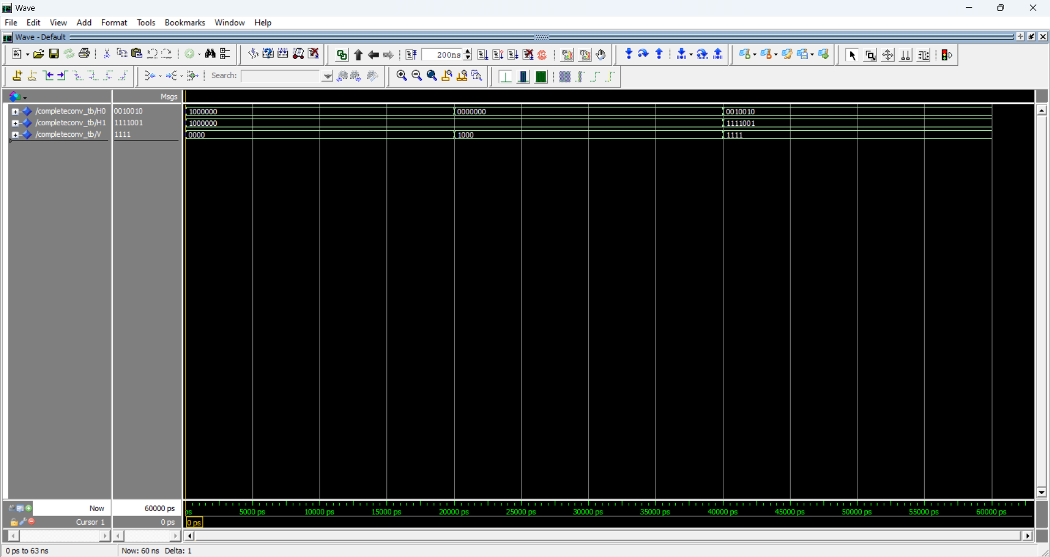
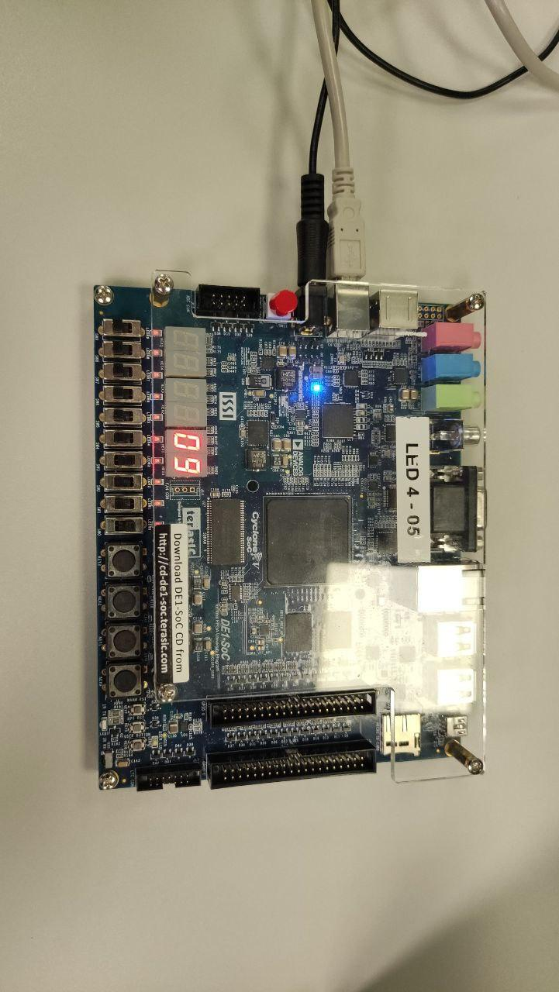
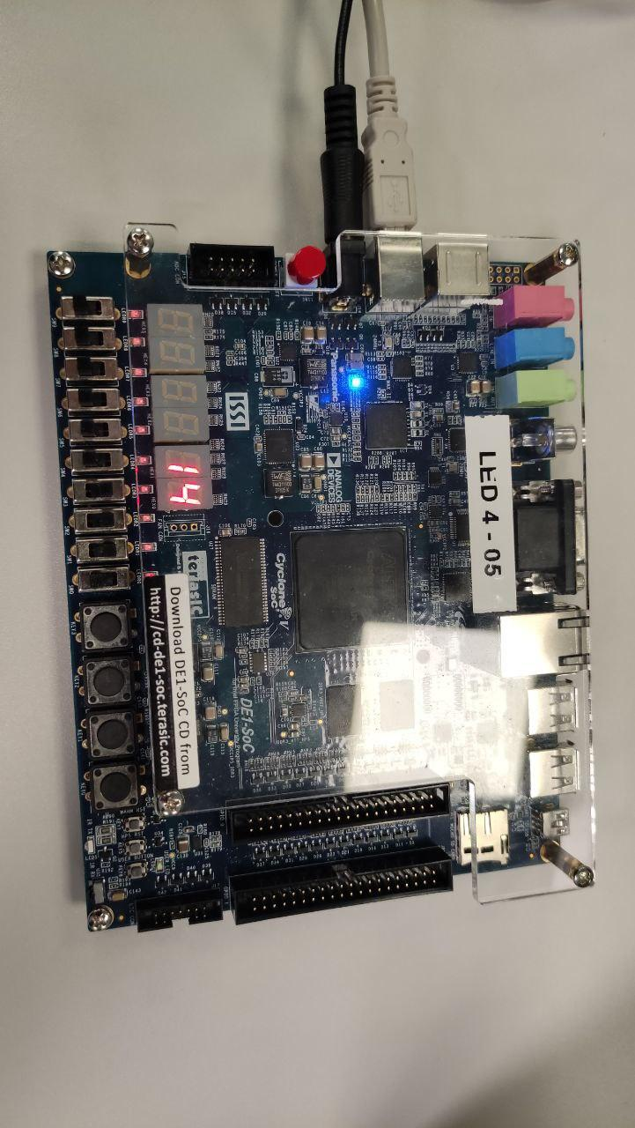

- Comments:
We could not perform the time simulation, since we had problems with implementing the project on ModelSim with .vho and .sdo

- Binary-to-BCD Converter
- Design entry:
To achieve this converter, we took advantage of several building blocks:
- The top level entity is “bintobcd” and converts a 6-bit binary input (SW) first in bcd and then shows it as decimal in the two output displays H0 and H1.
- The first component is the comp file, which receives the 6-bit binary number we want to convert into decimal and returns as output its tens value, confronting it with the numbers 10, 20, 30, 40, 50 and 60;
- The second one is the adjuster file, which subtracts the tens from the starting binary number giving us the unit value;
- The mux3 file defines the multiplexer relative to the most significant bit. It receives as selection input the output of the comparator and chooses which value to propagate to the unit's display;
- The last file is the display: we talked about this component earlier, and it shows a 4-bit binary number on the seven segment output display.

- Functional simulation:
In the testbench we define the signals input, h0, and h1 to simulate inputs and capture outputs. The process generates different input patterns for the bintobcd module, and
each input pattern is applied for a duration of 5 ns using the WAIT FOR statement, allowing the module to process the input and produce the corresponding outputs. The general approach of the completed design is the following: the comp finds the tens of the binary input, while the adjuster finds the units. The display component converts the BCD representation into two signals that control two seven-segment displays, showing the corresponding numbers.

- Synthesis:
We tested the code with ModelSim. The picture below represents the output and input wave. As we expected every number corresponding to the bit sequence
is correctly represented on the 2 displays. The first row represents the input, the second one the units display and the last one the tens display.

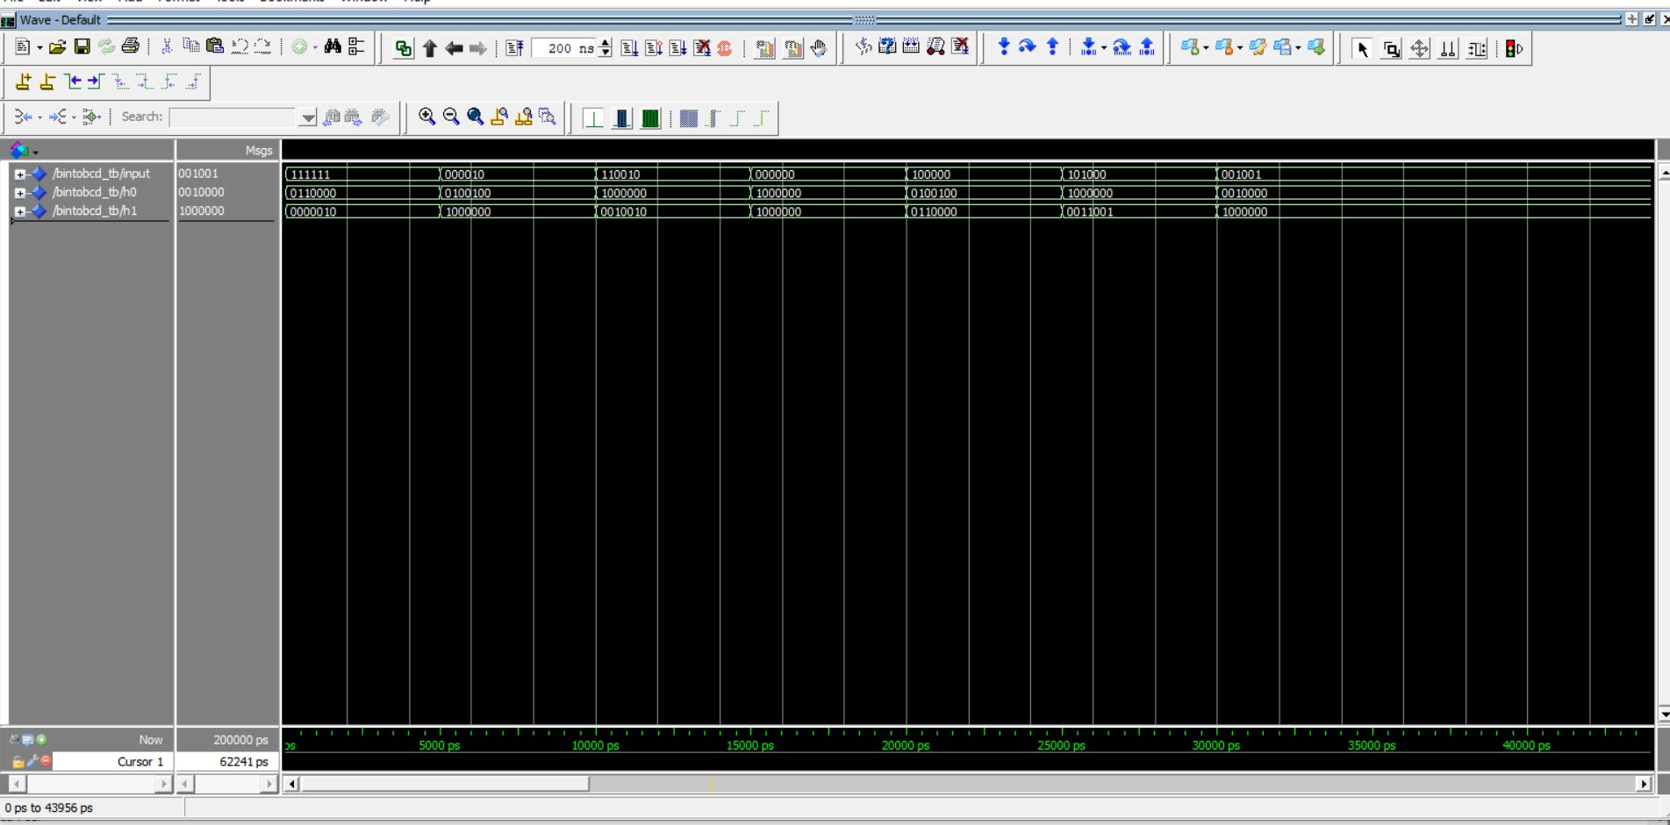

- Comments:
We could not perform the time simulation, since we had problems with implementing the project on ModelSim with .vho and .sdo

