DIGITAL SYSTEMS ELECTRONICS

Academic year 2023-2024

LABORATORY NR. 4

DUE DATE: April 22, 2024
DELIVERY DATE: April 22, 2024

GROUP 03

CONTRIBUTIONS:
- El Amrani Dawid 100%
- Ielmini Giovanni 100%
- Di Carolo Pierfelice 100%
- Pavone Lorenzo 100%

The members of the group listed above declare under their own responsibility that no part of this document has been copied from other documents and that the associated code is original and has been developed expressly for the assigned project.

Contents
This report is relative to the fourth laboratory experience of this course.
The purpose of this lab session was to learn the operation of latches, flip-flops, registers and counters.
- Gated SR-latch

- Design entry:
The circuit under exam is a gated SR latch works. The part1 entity defines the input ports (Clk, R, S) and the output port (Q), these ports represent the clock, reset and set signals, and the output signal. In the architecture the keep attribute is used to ensure that signals R_g, S_g, Qa, and Qb are retained in the final result of VHDL code synthesis.

- Functional simulation:
The testbench “tb” has two processes: the clock process generates a clock signal with a period of 10 ns (5 ns high, 5 ns low), the set-reset process simulates the behaviour of the set and reset inputs (s and r), it sets s and r to different values at different time intervals. As requested here are the plots of the RTL viewer and the Technology Map viewer.

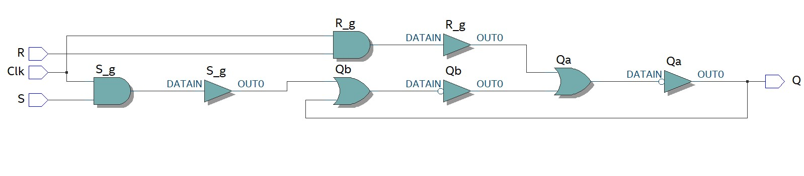

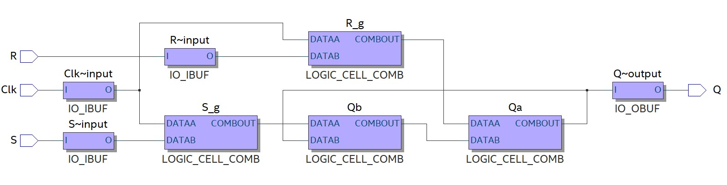

- Synthesis:
We can see that the waveform below follows the behaviour of a gated SR latch.
In fact, with clk = ‘0’ we are in memory mode; while with clk = ‘1’ the circuit works normally.
With the s command (s = ‘1’ and r = ‘0’), we set the output to 1, while with the r command (s = ‘0’ and r = ‘1’), we reset the output to 0. We have two more configurations: the memory mode with clk = ‘1’, which is achieved with both s and r at zero, and the forbidden configuration (s = ‘1’ and r= ‘1’), which we tried to simulate at the end, getting the banner shown in the second picture.

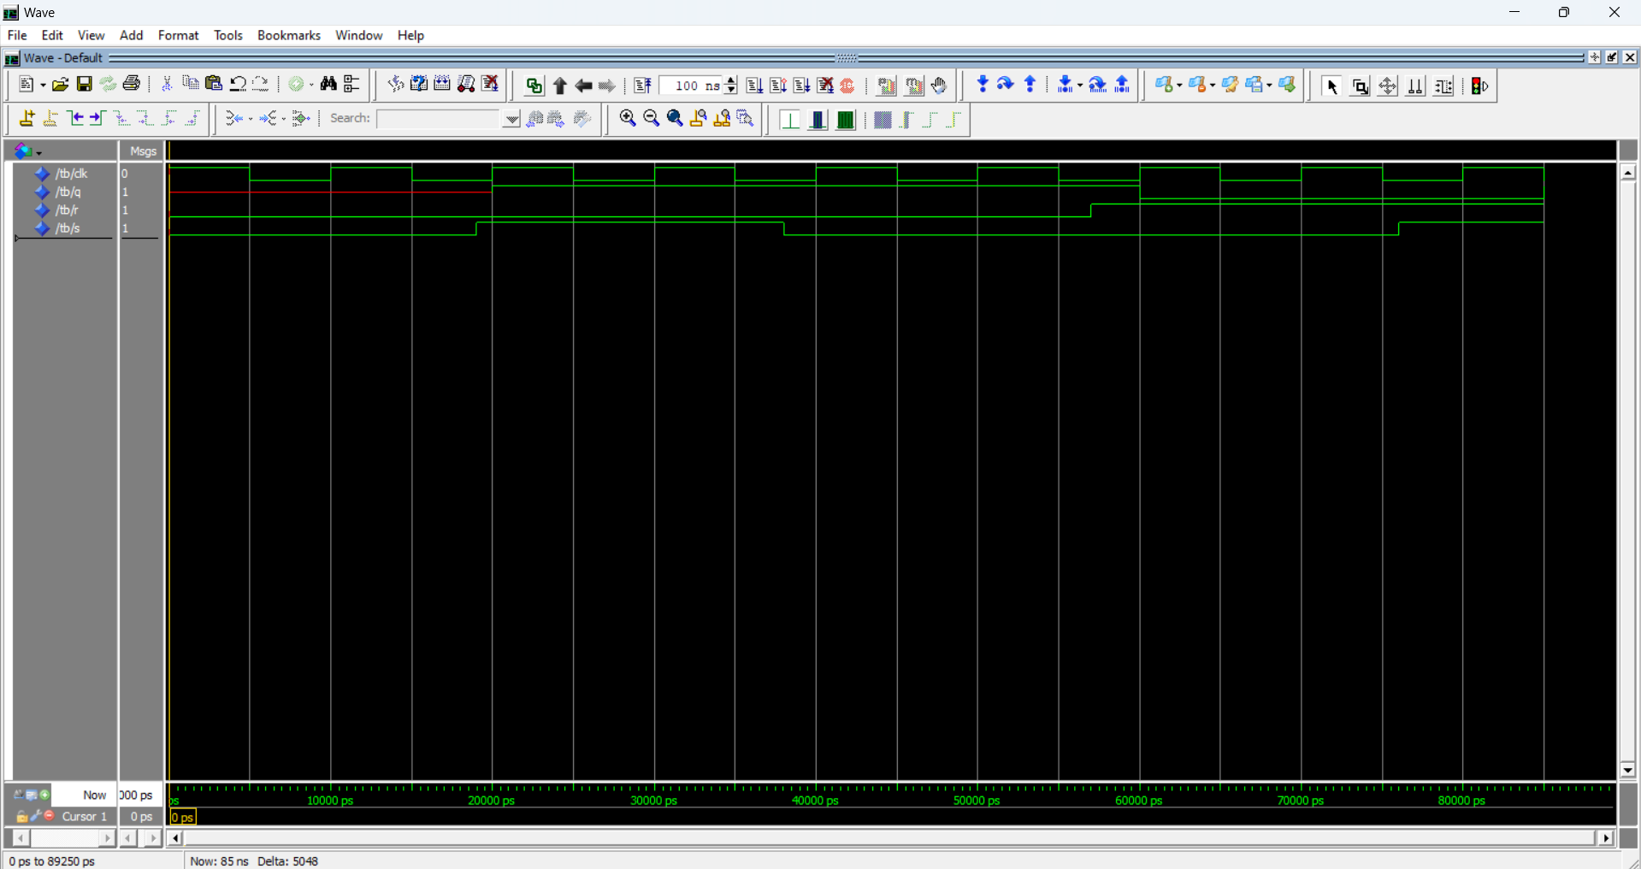

- 16-bit synchronous counter
- Design entry:
The top-level entity is “sync_count” which takes as input KEY (a single-bit vector) and SW (a two-bit vector) and returns as output HEX3, HEX2, HEX1, and HEX0 (each a 7-bit vector representing a 7-segment display). Also, it makes use of the component “count_4” that receives a clock, an enable and a clear as input and returns as output: cr7 (that represents the most significant bit of the 4-bit counter), q (that represents the least significant bit) and disp (that controls the segments of the 7-segment display), and also contains itself other two components:
- “toggle_ff”, the three input ports control its behaviour: ‘enable’ enables or disables the flip-flop, ‘clock’ synchronises the flip-flop's state change and ‘clear’ resets the flip-flop.
In its behaviour if clear is low, the flip-flop is reset, setting q to high, if there's a rising edge of the clock and clear is inactive, the flip-flop toggles its state based on enable, and the resulting value is stored in a temporary signal t_tmp, which is then assigned to output q.
- “display” receives a 4-bit input number and prints it on the seven-segment display of the FPGA board, in its hexadecimal form.

- Functional simulation:
In the testbench we declared signals h3, h2, h1, and h0 to store the output values of the 7-segment displays, moreover, the clock signal ck is connected to KEY(0), the enable signal en is connected to SW(1), and the clear signal cl is connected to SW(0).
We generate a clock cycle with a period of 10 ns, then we change the clear every 20 seconds for 3 times and then leave it set to 1, same reasoning for enable except that it is changed only 2 times (the first after 40 ns) and such as clear it’s left set to 1. As requested here is the plot of the RTL viewer.
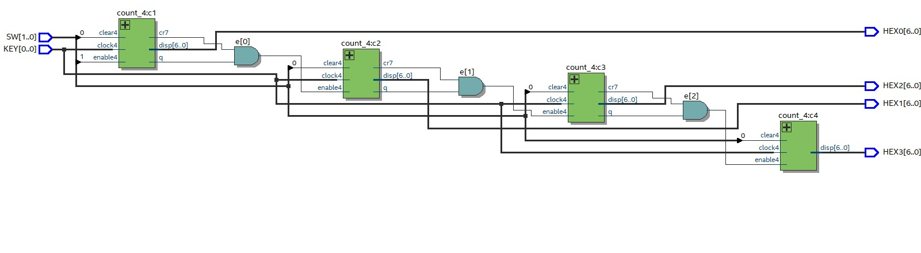

- Synthesis:
The result, shown in the pictures below, is exactly what we expected, in fact when the clock, enable and clear are high the counter starts to work. In the first picture we can appreciate the first three displays changing values, while in the second picture the timing simulation is depicted.

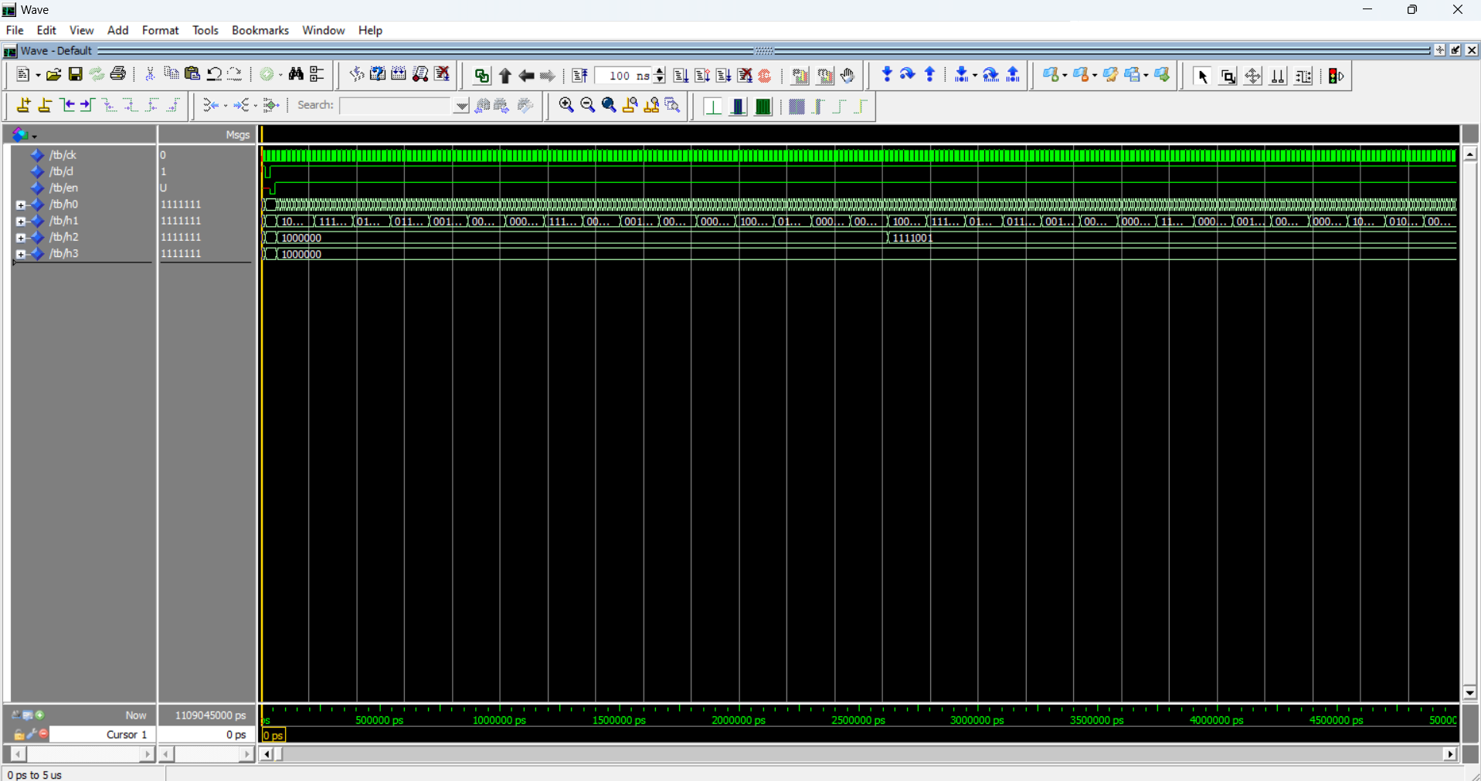
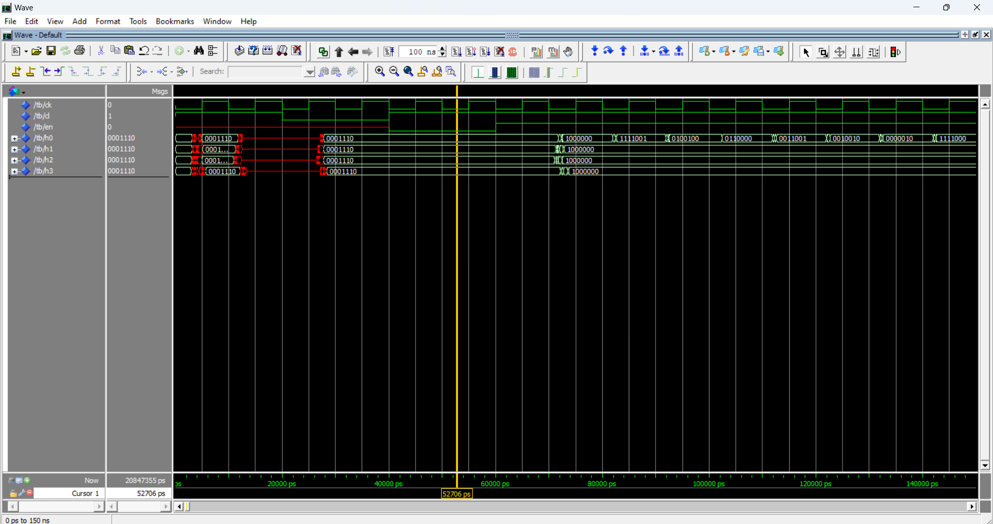

For what concerns the Fmax, we obtained that the maximum operating frequency of the circuit is 397.77 MHz at 0° C, and 396.98 MHz at 85° C.

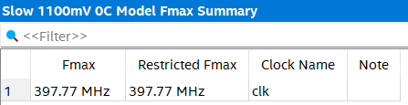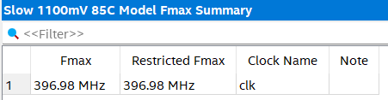

- Comments:
Comparing “count_4”, the 4-bit version of the counter, that we used in the top level entity, and figure 4, as it was requested to do, we found out there are no differences between the two.
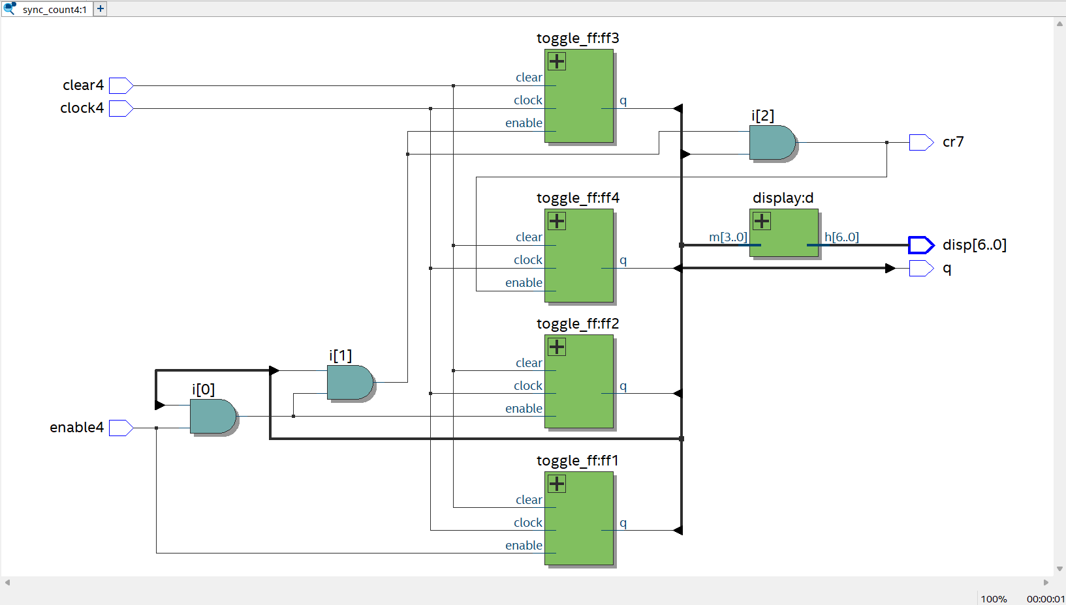

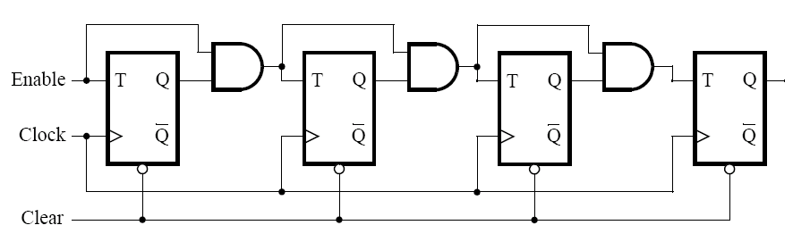

- 16-bit synchronous counter v. 2
- Design entry:
This time, we implemented the same circuit as point 2, but approaching the coding in a different way.
We simplified the code, in such a way that the specification could be based on the statement: Q <= Q+1.

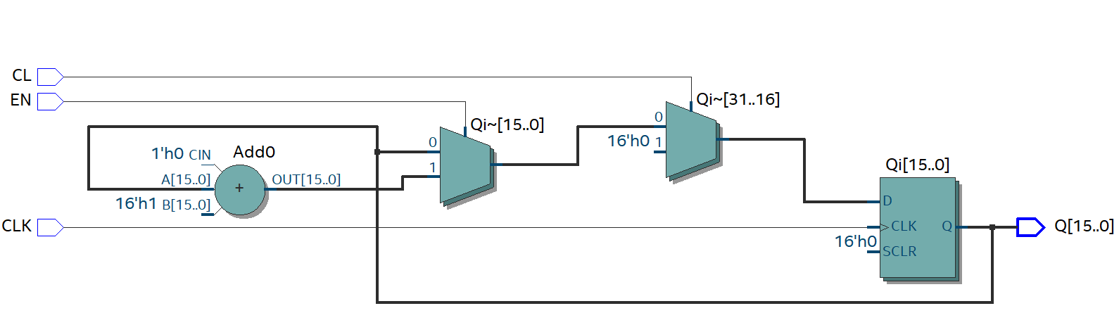

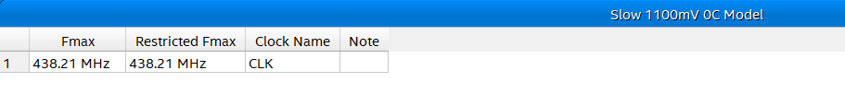
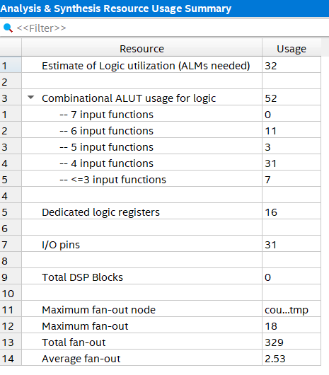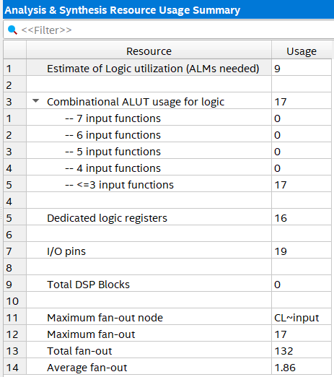
16-bit synchronous counter LE’s 16-bit synchronous counter Q=Q+1 statement

We can easily see the difference, the first logic circuit based on the ex.2 has more logic elements, also the frequency is different, in fact the second circuit has a lower Fmax rather than the first one.

- Flashing digits from 0 to 9
- Design entry:
The top-level entity is ‘flashing digits’ it receives as input the 2-bit vector SW and CLOCK_50, the 50 MHz clock signal provided on the DE1 board, and as output HEX0, the signal that controls the 7-segment display. The top-level entity makes use of several components:
- ‘counter1s’ is designed to act as a counter that increments every second; EN,CLK and CL are the input signals while T is the output signal indicating when one second has elapsed. The Qi signal represents the number of clock cycles elapsed, inside the process CLK, the counter increments when the EN signal is high and the CL signal is low (indicating no reset), and the T output signal is set to '1' when the counter reaches the value corresponding to one second and is set back to '0' otherwise. When the CL signal is high, indicating a reset condition, the counter is reset to zero and the T signal is cleared.
- ‘counter0to9’ is designed to count from 0 to 9 sequentially; EN, CLK and CL are the input signals while Q is the output signal representing the count value. Inside the process CLK, the counter increments when the EN signal is high and the CL signal is low (indicating no reset), when the counter reaches the value of 9, it resets to 0. The output Q is assigned the value of Qi converted to a standard logic vector, representing the count value.
- ‘seven_segment’ is a component that converts a 4-bit digit into signals to control the segments of a 7-segment display.

- Functional simulation:
In the testbench file we have divided it into two processes, the first one is dedicated to the clock which has a period of 20 ns (50 MHz frequency), in fact it’s set first to 0 and then set to 1 after 10 ns ,and reset to 0 after another 10 ns. In the second process section we have worked on the switch vector, composed of two values. We have first set the vector as ‘10’ to put the circuit in an ENABLE state, then after 40 ns we have set the vector ‘01’ to put the circuit in a RESET state. In the last row before the end of the architecture we have set the device under test with the portmap.

- Synthesis:
The result, shown in the picture below, is exactly what we expected. As we can see from the waveform, the number shown on the display is maintained for 1 second and then changes to the next one.

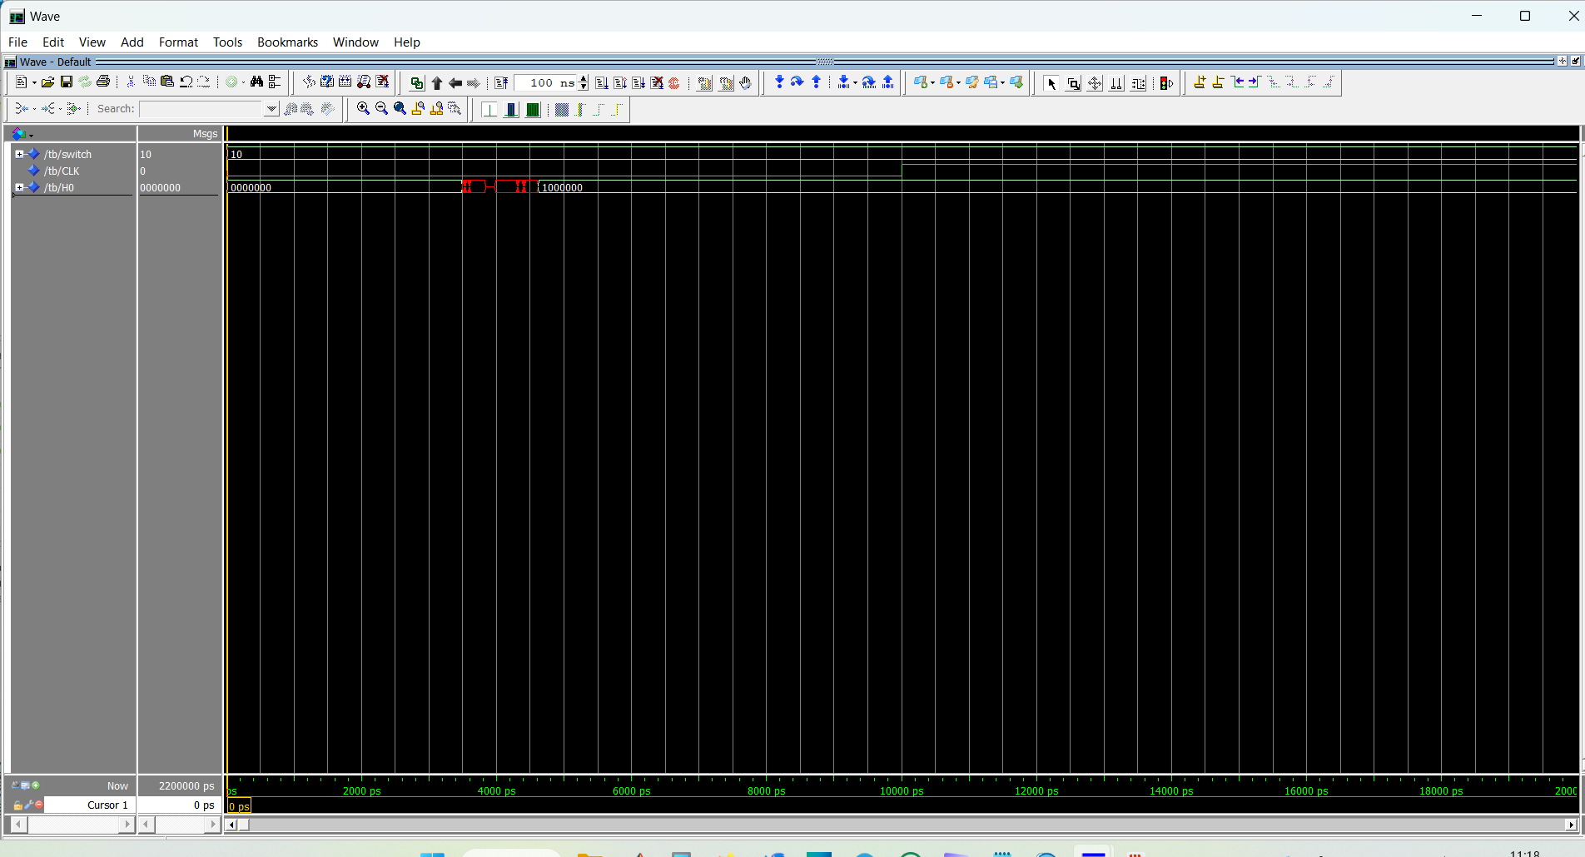
In the second picture, we can see the results of the timing simulation. The delays of the displays are minimal and aren’t noticeable to the human eye as they’re less than half a clock period which means less than 5 ns.

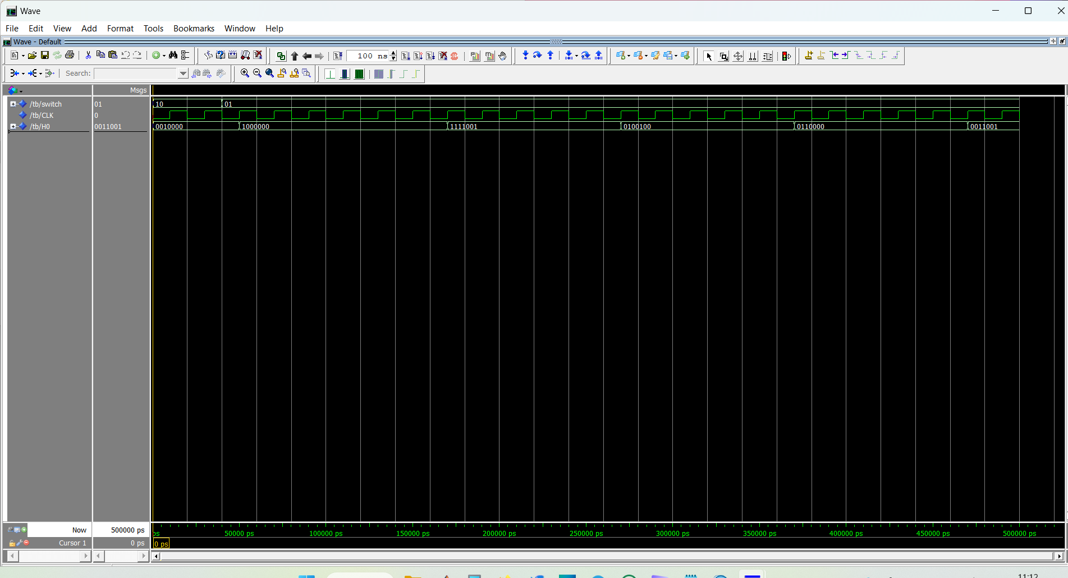

Comments:
Here’s the schematic circuit that we have used before implementing VHDL code.
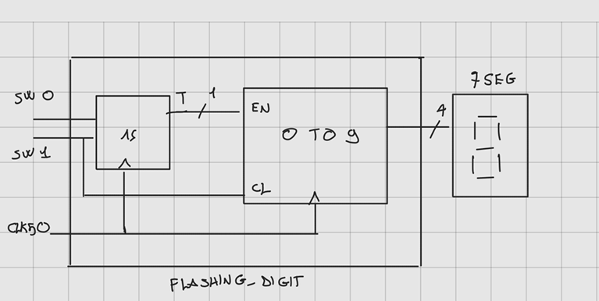

- Reaction timer
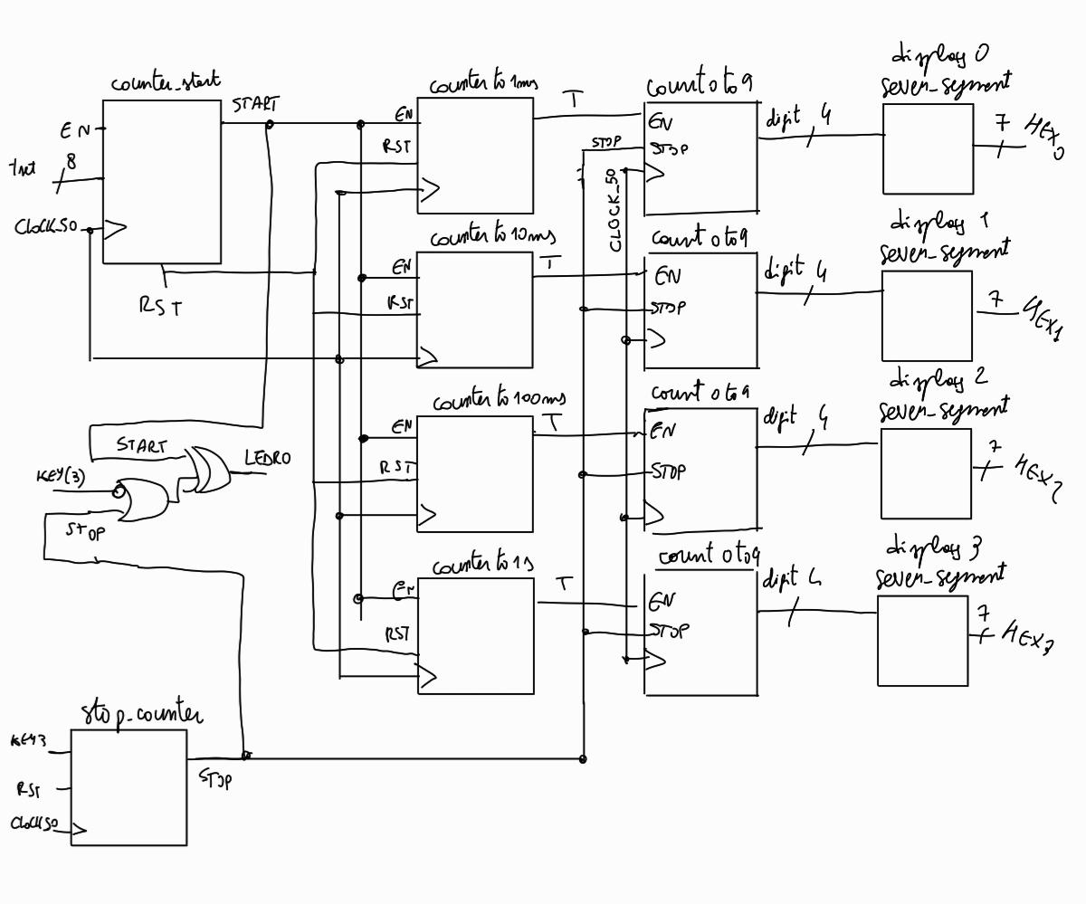
- Design entry:
The circuit under exam is a reaction timer (whose circuit is designed in the picture above): after having reset it and having chosen an amount of time to start it the user presses a button to stop the counter.
The top-level entity is “reaction_timer”: it takes the inputs (switches, keys, clock_50) and gives as outputs 4 displays (HEX) and one LED. It first calls “counter_start” which is a simple counter that takes, in addition to what we’ve already described for previous exercises, an 8-bit unsigned value from the switches which gives the amount of time between the pressing of reset and the turning on of the LED. We then call another counter 4 times. This counter is the same as the “counter_1s” we used previously but this time we also give it a 26-bit time value for 1 ms, 10 ms, 100 ms and 1s. Each one of them drives a display. The output value of these counters is sent to the counter0to9 which we also already described in the previous exercise. We also have a device (“stop_counting”) that gives us a constant value (stop) unrelated to the clock to stop the reaction timer and see the value of the reaction on display. The LED is driven as follows: “start XOR (NOT(KEY(3)) OR stops)”. We then call the displays with the component “seven_segment” which we used in all our labs to show the number on the HEX display.

- Functional simulation:
In the testbench (tb) we have different processes for the clock, the reset, the enable and the stop. Notice that we used shorter times for our tb as a millisecond is equal to fifty thousand clock periods.
- Synthesis:
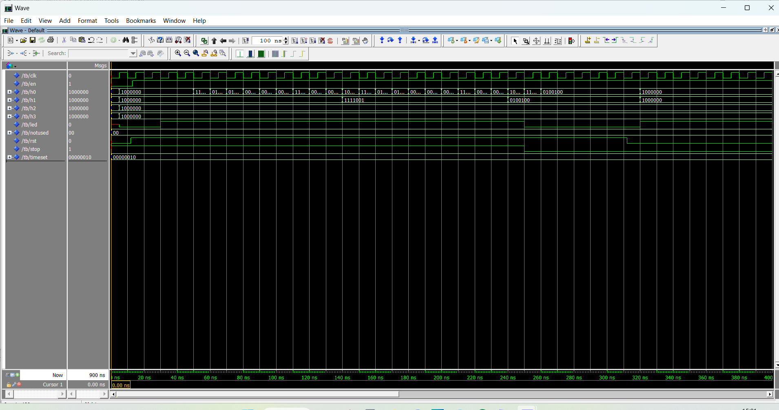
In the first picture, we can see that everything is working correctly: as we enable the circuit the LED turns on after two clock periods as specified with the signal “timeset”. Then the displays start to count and we see that they’re working correctly. Finally, as we press the key to stop the timer the LED turns off and the displays stop. After pressing reset it starts again as expected.
In the second picture, we can see the results of the timing simulation. The delays of the displays are minimal and aren’t noticeable to the human eye as they’re less than half a clock period which means less than 5 ns.
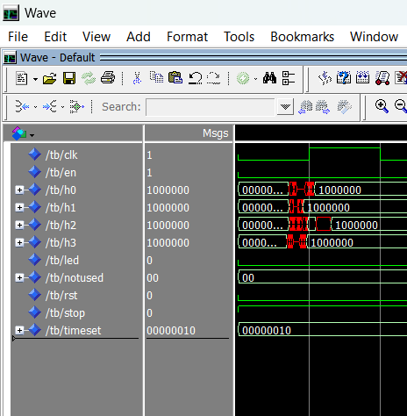
The design works perfectly on the FPGA too.

