DIGITAL SYSTEMS ELECTRONICS

Academic year 2023-2024

LABORATORY NR. 6

DUE DATE: May 6, 2024
DELIVERY DATE: May 6, 2024

GROUP 03

CONTRIBUTIONS:
- El Amrani Dawid 100%
- Ielmini Giovanni 100%
- Di Carolo Pierfelice 100%
- Pavone Lorenzo 100%

The members of the group listed above declare under their own responsibility that no part of this document has been copied from other documents and that the associated code is original and has been developed expressly for the assigned project.

Contents
This lab aims to test our digital design skills by developing a circuit of several blocks such as memories, data path, and CU to solve a realistic problem.
- A simple digital filter
The digital filter has an input signal START that starts processing when set to 1.
The first thing the circuit does is read 1024 values, given as input DATA_IN to memory A, and save them, sequentially, in the memory, one per clock cycle, synchronously with the rising edges of the clock.
When memory A is full, the circuit starts writing values in memory B, reading the content of mem_A and elaborating it as follows:

To avoid losses of information, we want to make this sum in 11 bits, giving an 11-bit result, and only then reduce it back to 8 bits to make it fit into mem_B.
In case the sum will not be representable on 8 bits, we will saturate the result: we’ll write
“10000000” when the result is too small, and “01111111” when it is too big.
When mem_B is full as well, an output signal DONE is set to ‘1’ and the circuit is ready to restart the process.

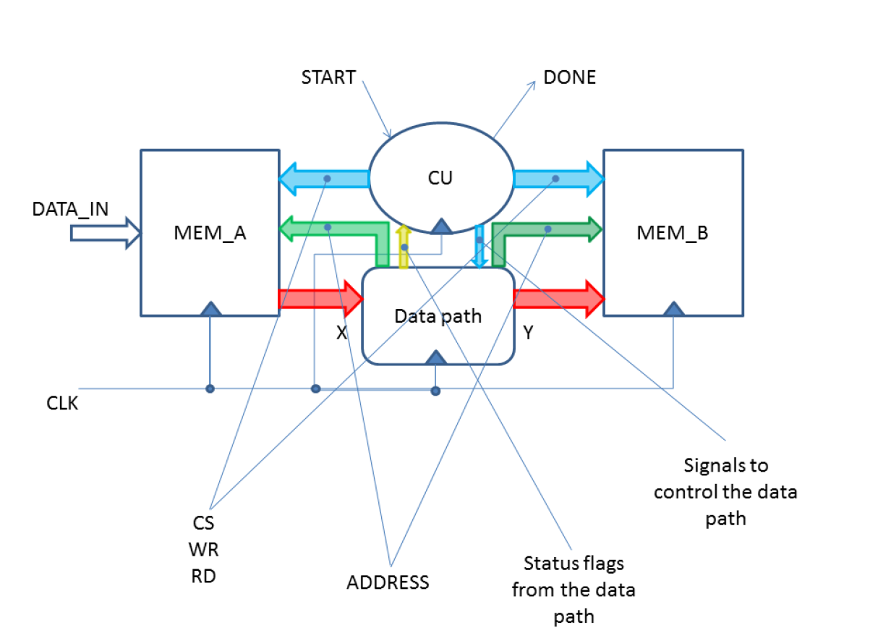
- Design Description:

First of all, we noticed the top-level entity is made of 4 elements: the two memories, the control unit, and the datapath.

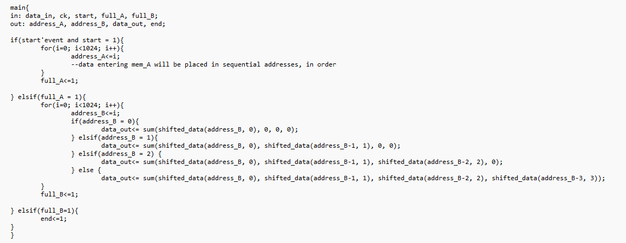
We focused on the algorithm, writing the pseudocode, recognizing the digital components needed (respecting the constraints given in the assignment, such as using only one adder and no multipliers), and drawing the datapath and its ASM chart.
This is what we came up with:

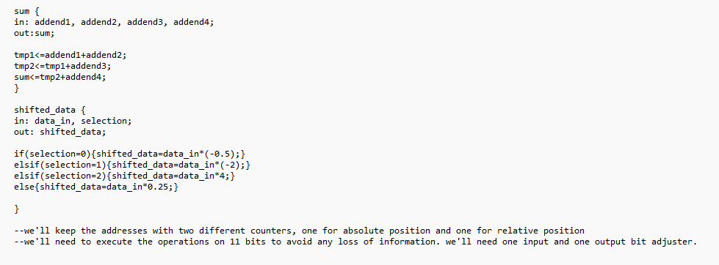

1. DATAPATH
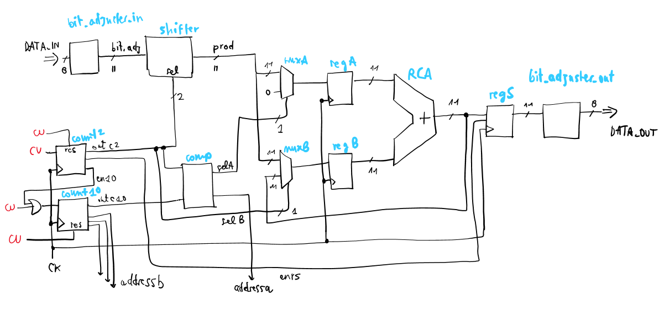

As shown in the picture, the elements needed in the datapath are:
- When filling in mem_A, we only need a 10-bit counter (count10), enabled by the Control Unit, that tells memory A the address (from 0 to 1023) where to save the current DATA_IN;
- When filling in mem_B, we need far more components.
First of all, we need two counters: one, the same 10-bit counter as before, keeps track of the absolute address, basically “n” in the precedent equation, that is the address we want to fill in mem_B, while the other, a 2 bit counter (count2), enables the first and keeps track of the relative address, basically the address we want to read from mem_A. Thanks to this secondary counter, we can get the addresses “n”, “n-1”, “n-2” and “n-3” for each “n” value, which will change, as a consequence, every four clock cycles.
To avoid any loss of information, we need bit_adjuster_in, a component that expands the datum read from mem_A from 8 to 11 bits.
Then, the programmable shifter achieves the multiplication: depending on the selection input (given by count2), the component multiplies the input by four different values.
The sum is made by a complex organisation of multiplexers, registers, and a ripple-carry adder. For each “n”, we want to read one by one the four outputs of the shifter and sum them progressively, updating the result once per clock cycle, in such a way that after four clock cycles we have the sum of the values ready at the output of the RCA.
The first value is sent to register B by the two multiplexers, both driven by the output of count2, while the other three values are sent to register A to be summed to the partial results. At the fifth clock cycle, the register at the output of RCA gives the processed result.
The last step is to reduce the result back to 8 bits so that it can be stored in mem_B, that is the purpose of bit_adjuster_out, which also checks for potential overflows, and to give mem_B the address where the result must be stored, through count10.
This process is repeated for 1024 times, until mem_B is full, and the CU is notified.

2. MEMORIES
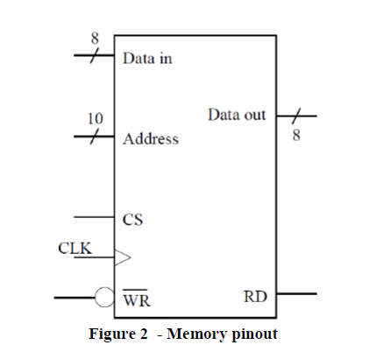
We used a single component for both mem_A and mem_B.
They have 1 kByte of memory each, used to store 1024 samples, represented as 8-bit wide 2’s complement values. We created an array called “remember” of 1024 signed values called “number”.
In each position we saved a data.
The two memories are piloted by the CU, which using the signal CS enables the memory, and using WR and RD decides the operation to be done (writing or reading).
In the VHDL description of the memories, we wrote two separate processes, one (synchronous) for writing and one (asynchronous) for reading.

3. CONTROL UNIT
For the control unit (described in the file “control_unit”), we have 4 states. Firstly we are in the STANDBY state which takes all outputs to 0. Then when START goes to one on the next clock cycle we enter the FILL_A state. Here we bring the CS_A and WR_A to 1 in order to write the DATA_IN coming from outside into MEM_A. Then while FULL_A (which is the input telling us that MEM_A is full when equal to 1) is equal to 0 we stay in this state, when FULL_A goes 0 → 1 then we switch to the next state: FILL_B. This state changes WR_A to 0 while putting to 1 RD_A, CS_B, and WR_B in order to stop the writing in MEM_A and start the reading of the data of MEM_A and the writing of it in MEM_B (after the data has been processed as requested). We stay in this state until FULL_B goes to 1 then we switch to the last state: COMPLETED. This state brings everything to zero except for DONE which goes to 1. The picture below shows the ASM chart of our Control Unit as described above:

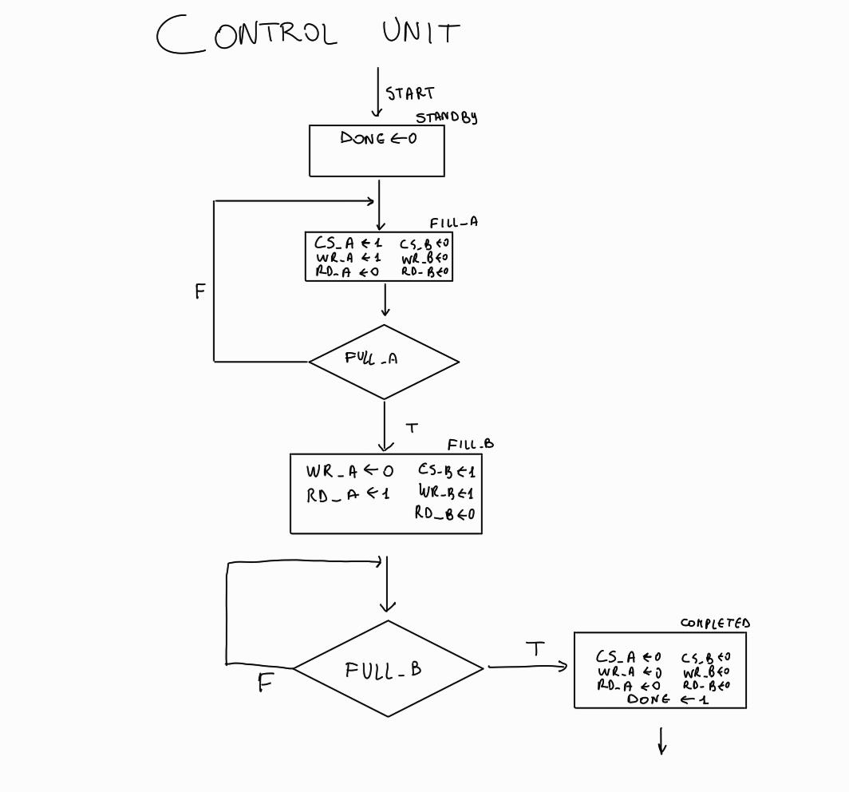
In our code, we have three processes:
- future_state is run at every rising edge of the clock or when START changes. If START=0 then our current state X is set to STANDBY, otherwise it is set to the next state Y;
- next_state_assignment is run when START, FULL_A or FULL_B change. This process assigns to the next state Y the value we want for the next clock cycle. The state changes happen as already described above. After COMPLETED or if we are in other situations we go to STANDBY;
- state_meaning assigns the outputs we want for every state as already described above.

4. DESIGN VALIDATION
First, we drew by hand the expected waveform of the complete circuit, as requested by the assignment:

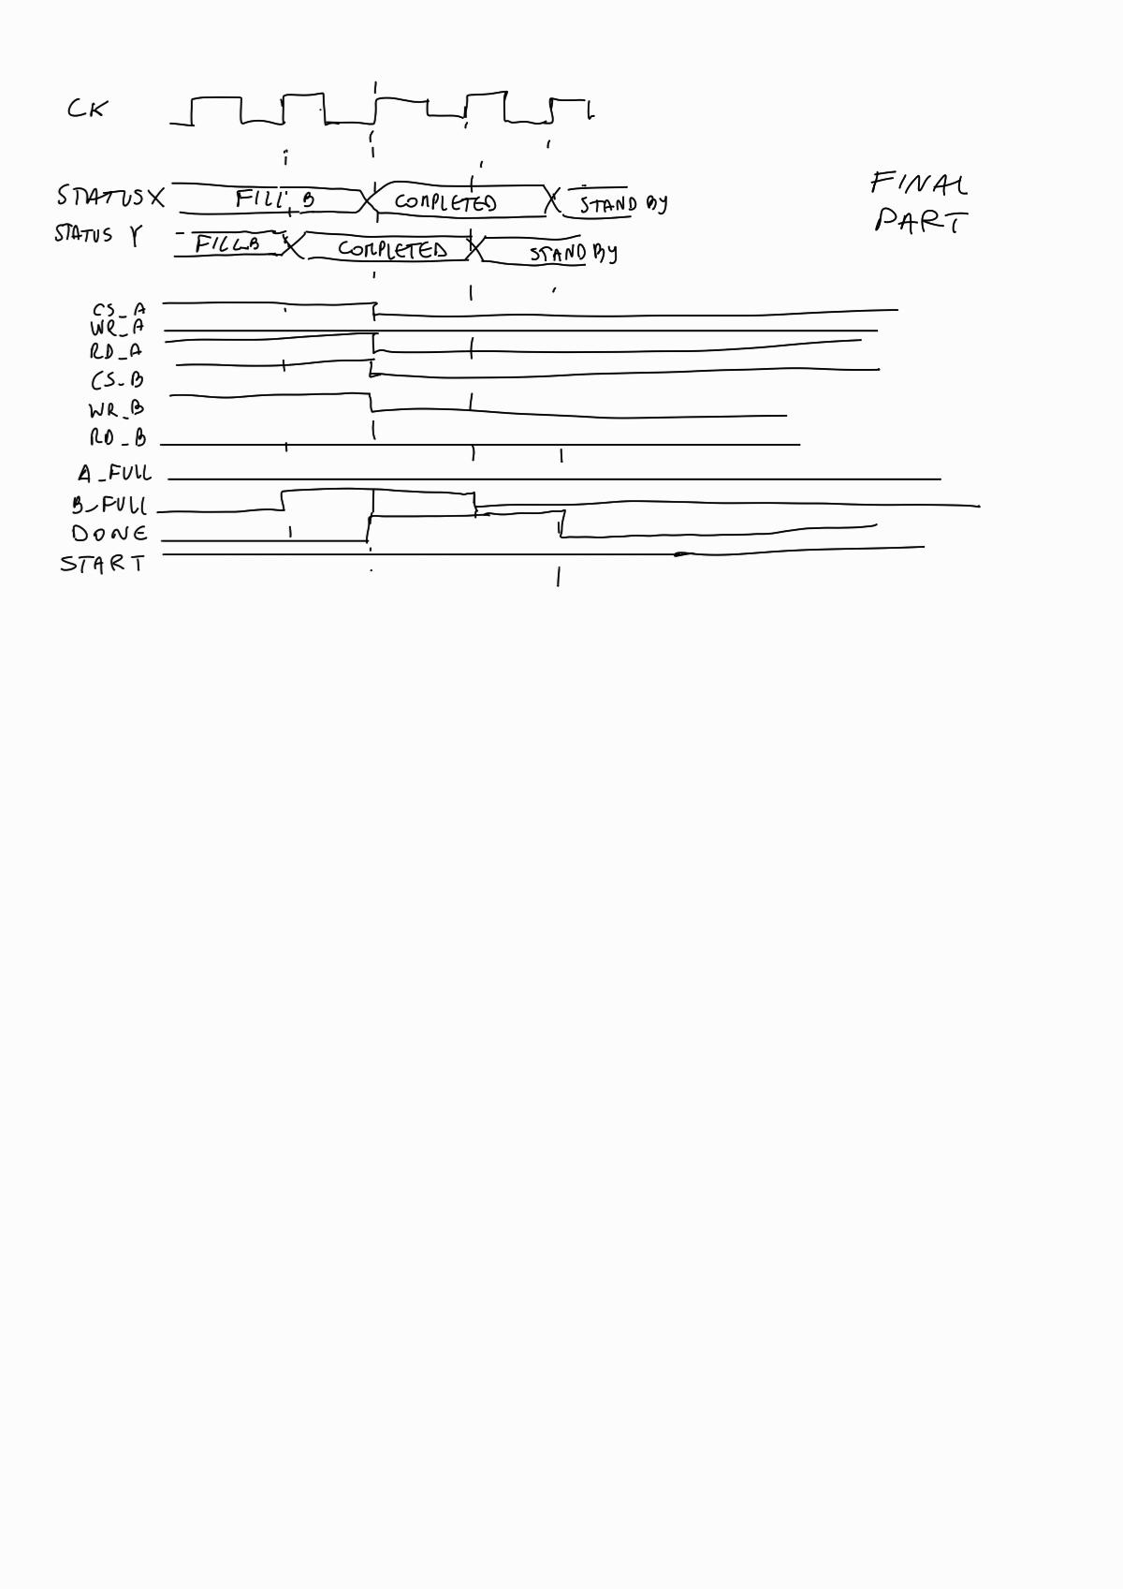
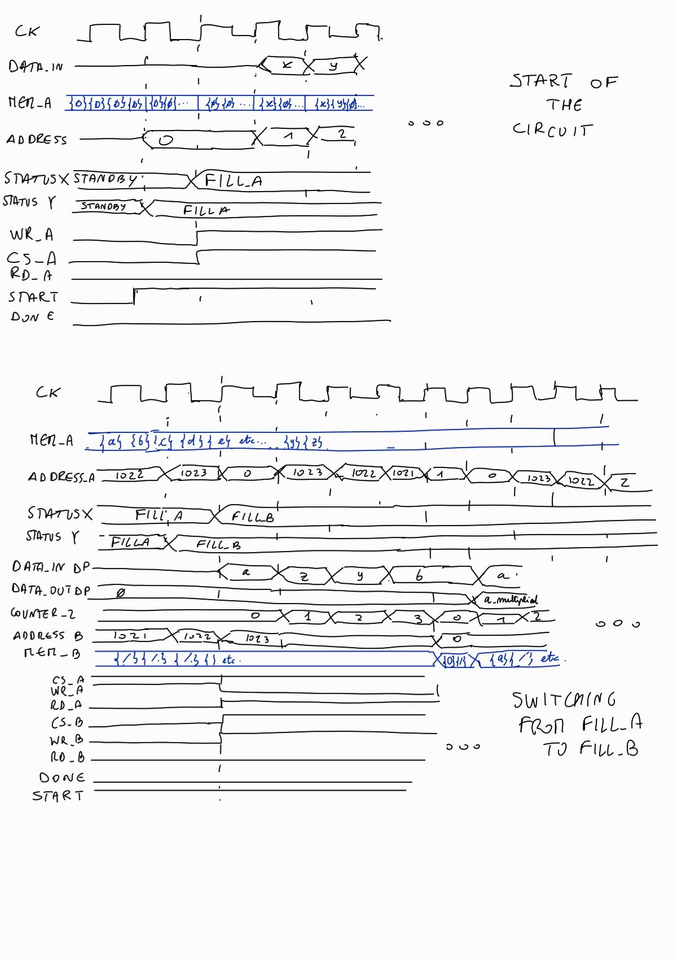

Then, we tested the most crucial components of the circuit with ad-hoc test benches: we created tbs for the comparator, the shifter, the datapath and the CU.
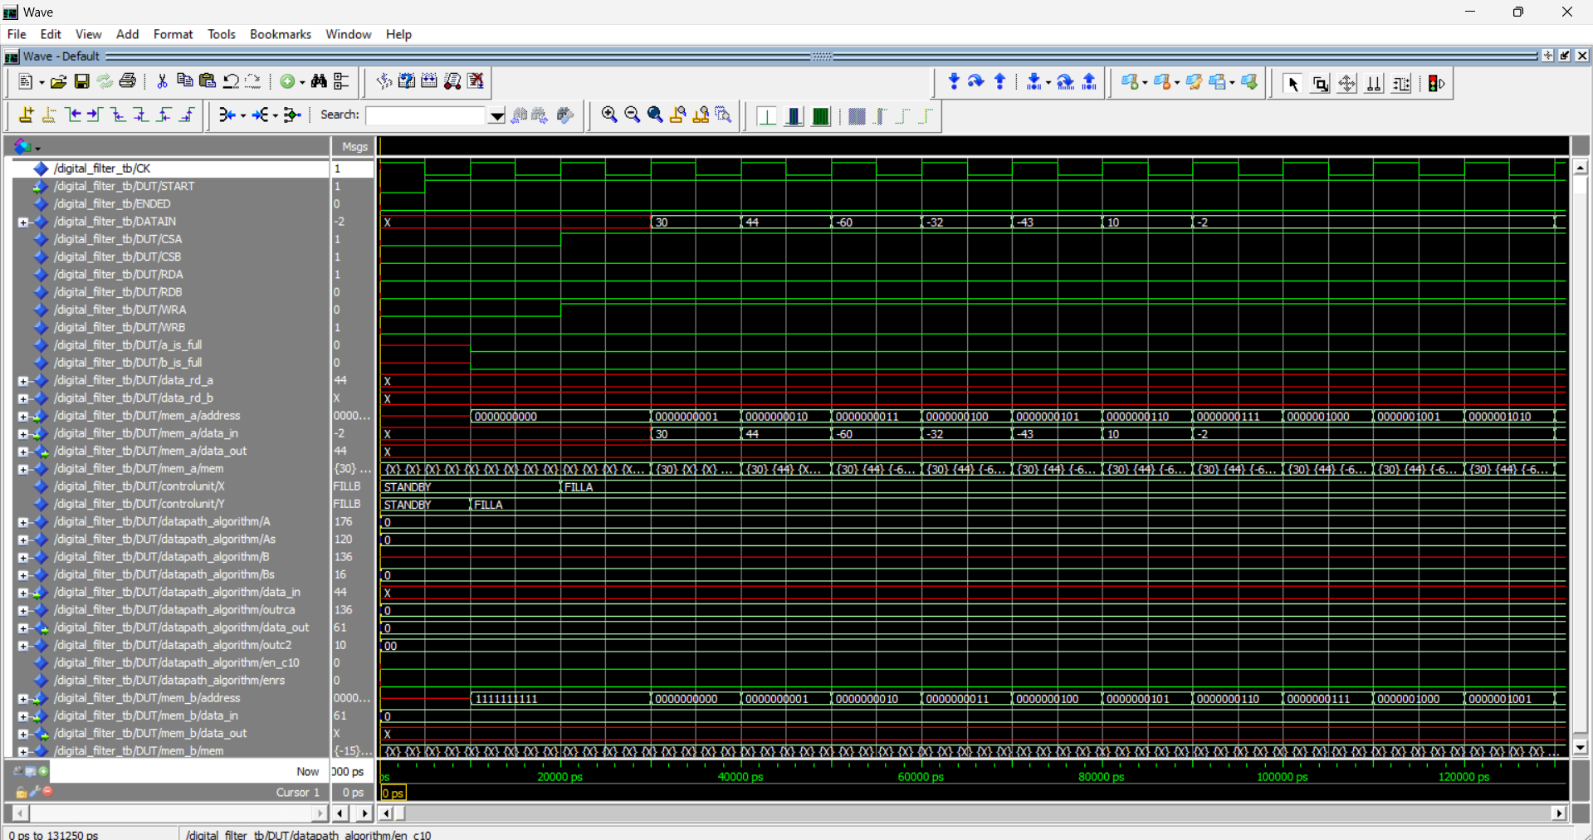
Finally, we tested the whole digital_filter, and we chose three highlights of the simulation to be shown in the report: the START (we start to fill mem_A), the switching from FILL_A to FILL_B, and the END.
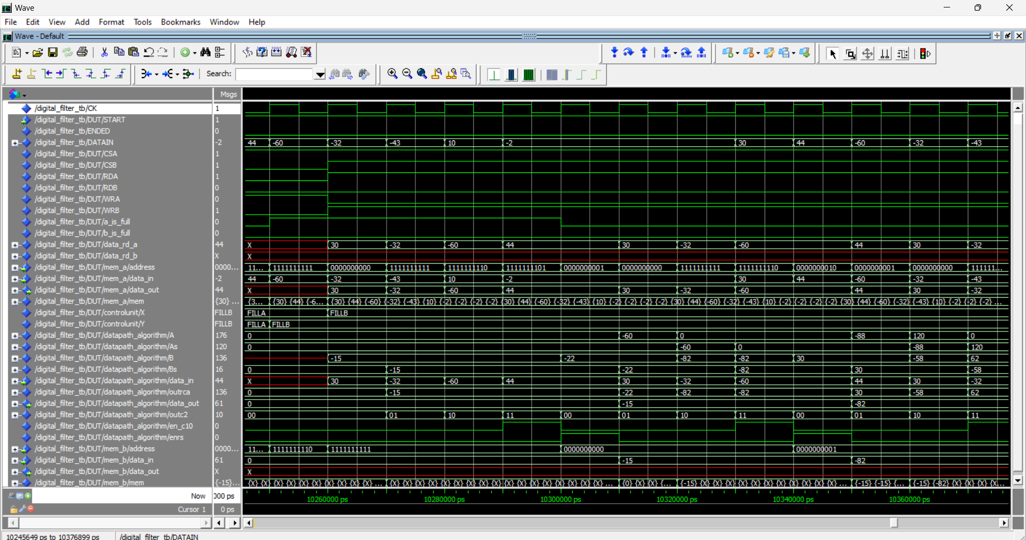

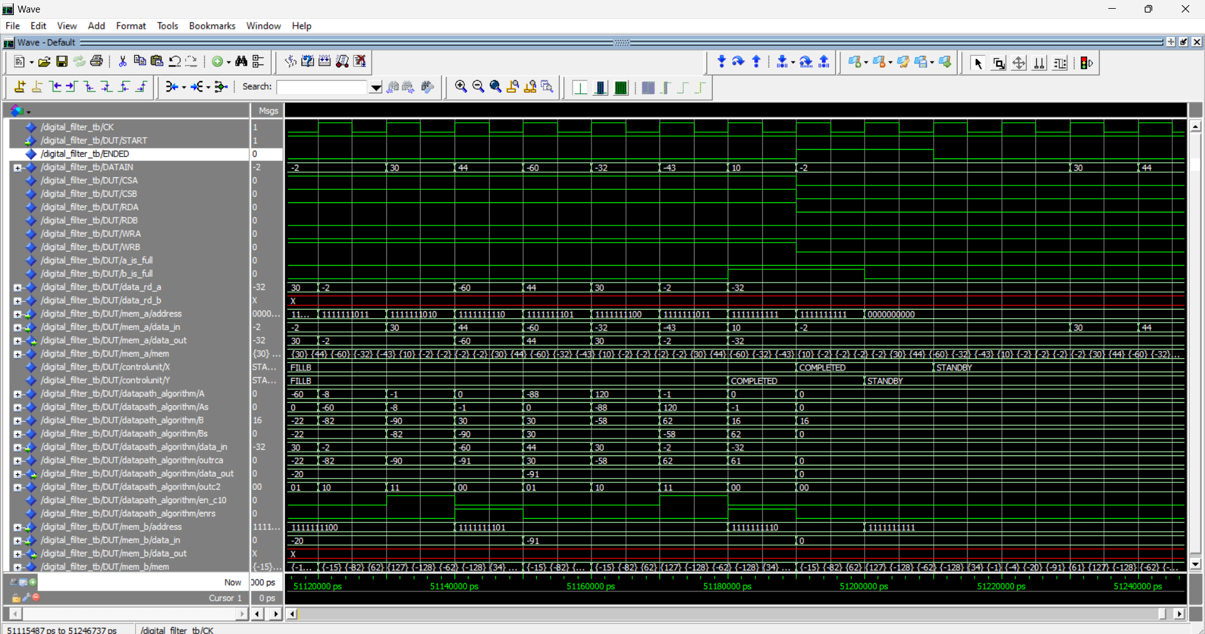

The results of the simulation are in line with what we expected to have.

