DIGITAL SYSTEMS ELECTRONICS

Academic year 2023-2024

LABORATORY NR. 8

DUE DATE: May 27, 2024
DELIVERY DATE: May 27, 2024

GROUP 03

CONTRIBUTIONS:
- El Amrani Dawid 100%
- Ielmini Giovanni 100%
- Di Carolo Pierfelice 50%
- Pavone Lorenzo 0%

The members of the group listed above declare under their own responsibility that no part of this document has been copied from other documents and that the associated code is original and has been developed expressly for the assigned project.

Contents
This report is relative to the eighth laboratory experience of this course.
The purpose of this lab session was to learn how to generate and measure a square waveform.

- Timer, Counter Register Polling
This is the first project of this lab, where we had to use the TIM3 Counter to generate a 2 kHz square waveform on the PA10 pin (identified by the code D2).
We were requested to perform polling on the counter register, toggling the output value when we read the correct value on the register.
In the STM32CubeIDE tool we configured PA10 as a GPIO output, and we selected the Internal Clock as source for TIM3 Counter, without enabling output compare (leaving all the ‘channel’ fields empty).
Since the internal clock runs at 16 MHz, we had to make the output pin toggling frequency way lower: in fact, to achieve a 2 kHz wave, we need PA10 to toggle every 1 kHz. As suggested, we selected the maximum value for the ARR register (since we were not using it), and we tried different values for the prescaler, trying to get the most stable square wave possible. In the end, we chose 499 as the value of the PSC register.
With this configuration, to the generated code we had to add: a line to enable the counter and an if statement, to toggle the output and reset the counter value when the desired value was reached.
This value is a direct consequence of PSC: to have a toggle every 1 kHz, we want it to be 8.
As requested, we tried to implement the if statement both with the “==” and the “>=” conditions, and noted how the wave was more precise in the latter case.
The result is shown in the following picture:
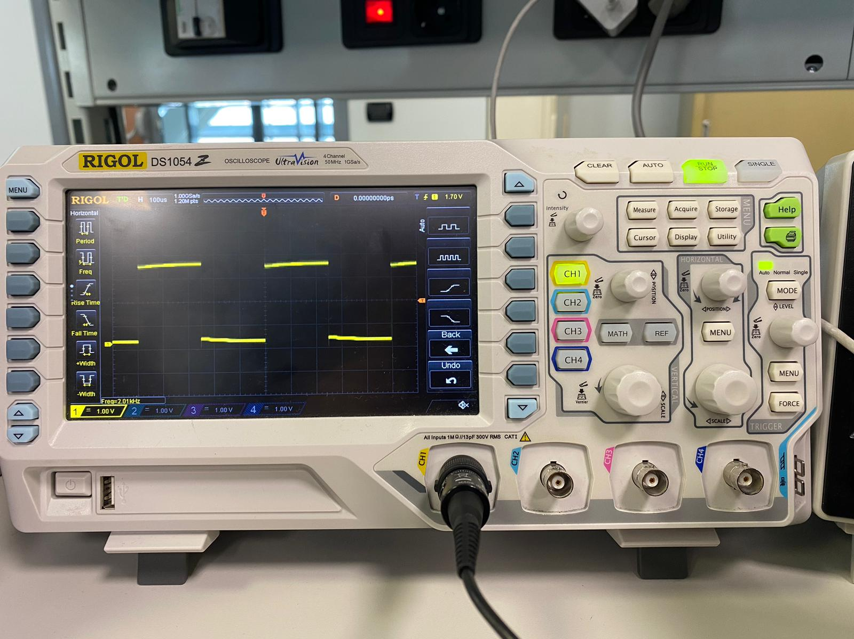

- Timer, Compare Flag Polling
This time, instead of performing polling on the value of the counter register, we had to perform it in a more efficient way, on the value of the UIF flag.
This value, initialised at 0, turns on when the value of CNT reaches the value of ARR. Keeping the same settings as before, we had to change the value of the auto-reload register to 8, and execute the toggling (and the reset of the UIF flag) when the flag turned to 1.
The result is shown in the following picture:
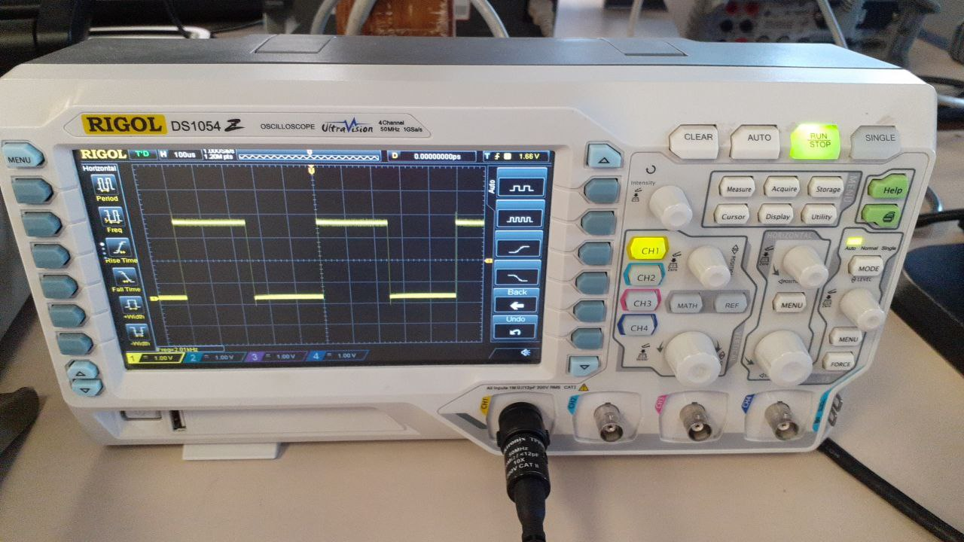

To achieve a square wave with a frequency of 4 MHz, it was sufficient to modify the values of PSC and ARR: we set the prescaler to 0 and the auto-reload register to 4.
Unfortunately the maximum frequency we managed to obtain was of 200 kHz probably for a limitation of our board as we could easily control the frequency up to that limit and as the instrumentation can measure over this value.
- Timer Output Compare Function
The request of the third project of the lab was to generate two square waves, a 2.5 kHz signal on PA10 pin and a 12.5 kHz signal on PB10 pin, exploiting the OC unit.
Each timer in the STM32 has multiple channels that can be configured separately, and by means of the OC unit, we can set different configuration options for each of them.
For the two waves, we used, respectively, channel 1 and 2 of TIM3, selecting the output compare no output mode, since we configured PA10 and PB10 as outputs.
After turning on the counter and initialising the needed registers, we have two conditions to check in the loop, one for each wave. We performed polling on the OC flags of channels 1 and 2, contained in the Status Register. Whenever one of the two switches to high value, we want to toggle the respective output, update the respective CCR value and reset the flag.
We opted for PSC = 0, hence CCR1 = 3200 (for the 2.5 kHz wave) and CCR2 = 640 (for the 12.5 kHz wave).
The results are shown in the following picture:
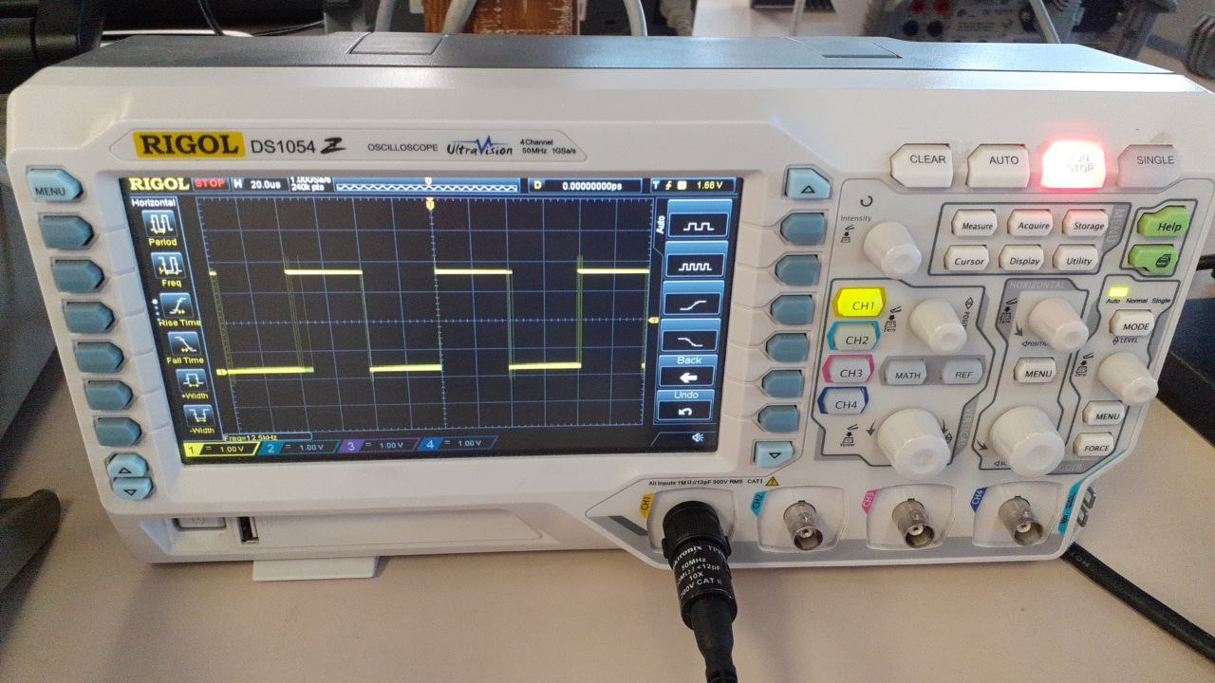
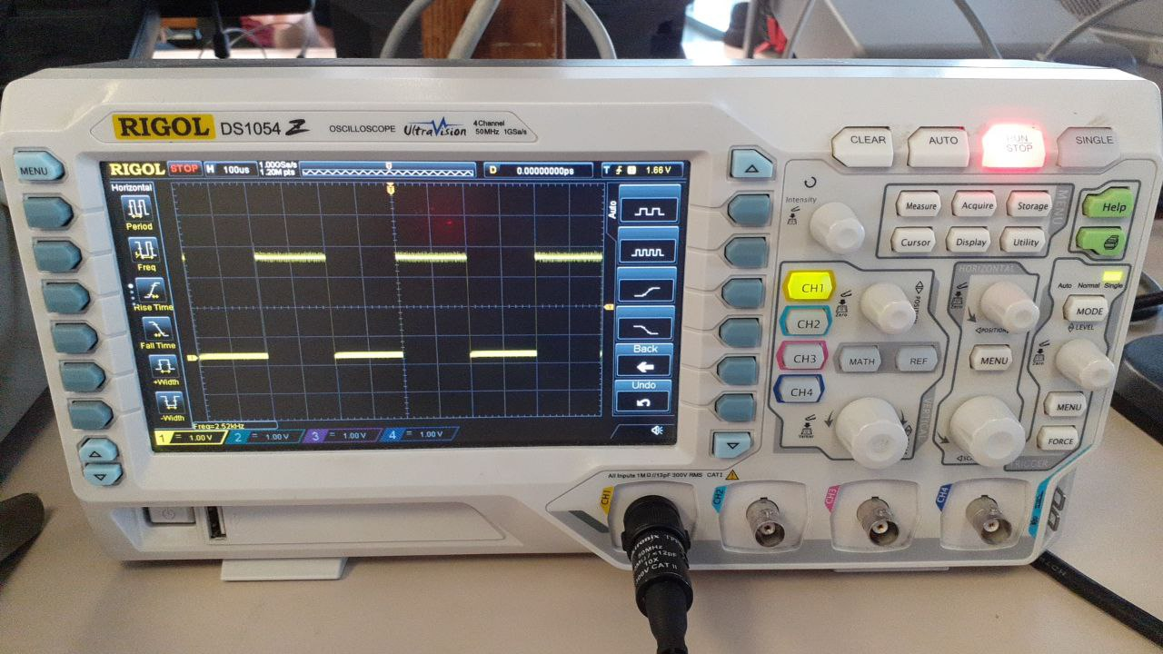

- Timer Output Compare Function, with automatic pin toggling
This project is almost equivalent to the precedent one, except for the fact that this time we had to exploit the automatic pin toggling option.
Configuring the TIM3 counter, we selected the output compare channel # mode, and directly configured pins PA6 and PA7 as channel 1 and 2 outputs.
The code is the same as before, with the two conditions we checked, but this time we don’t have to toggle the output, because the channels are programmed to do so automatically.
The results are shown in the following picture:
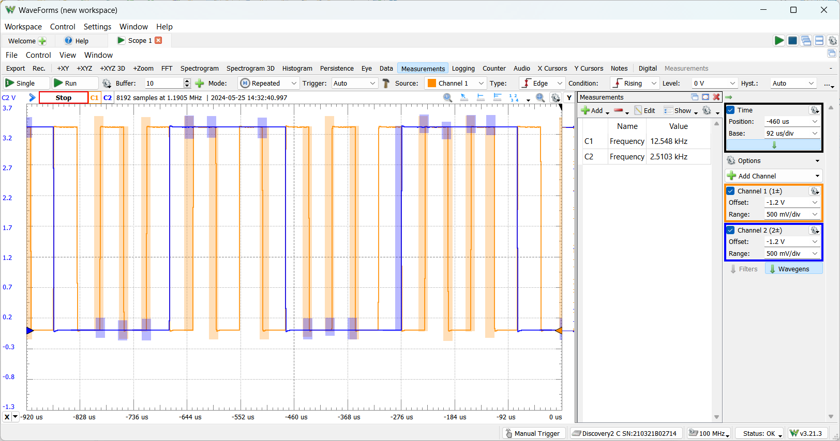

- Timer Output Compare Function with Variable frequency

In the last assignment we had to add the possibility to change the frequency of the generated wave through a potentiometer between 800 Hz and 4.5 kHz. We set the timer as in the previous exercise and activated the ADC on pin A1 as requested by the assignment.

LL_ADC_WriteReg(ADC1, CR2,LL_ADC_ReadReg(ADC1, CR2) | (0x1)); // turns on the ADC
LL_ADC_WriteReg(ADC1, CR2,LL_ADC_ReadReg(ADC1, CR2) & ~(0x200)); //these set the EOC to 0 automatically at the end of conversion
LL_ADC_WriteReg(ADC1, CR2,LL_ADC_ReadReg(ADC1, CR2) | (0x40000001)); // starts conversion
This sets the ADC as requested by the text by exploiting its registers. We then created an int variable adc_rd in which we saved the value read with the adc with an if statement:
if(LL_ADC_ReadReg(ADC1, SR) & 0x2){
adc_rd = LL_ADC_ReadReg( ADC1, DR); //adc_rd goes from 0 to 253
LL_ADC_WriteReg(ADC1, SR,LL_ADC_ReadReg(ADC1, SR) & ~(0x2));
}

Using the debugger we’ve seen what is the value read by the ADC for the biggest value turning the potentiometer all to its maximum. As it was 253 we then used this value to generate a function for the generation of the square wave. In fact when the frequency wanted is 800 Hz adc_rd is equal to 0 and we want to write in the register 10000 (which is equal to 16 MHz/ 2*800 Hz). When we want a frequency of 4.5 kHz we do the same as before and we obtain the coefficient to use as follows:
10000 - (m * adc_rd) = 16000000/4500 * 2. After testing it one time we corrected slightly the value. We used it to automatically toggle the output pin (like in the previous exercise):
if(LL_TIM_ReadReg(TIM3, SR) & 0x2){
LL_TIM_WriteReg(TIM3, CCR1, LL_TIM_ReadReg(TIM3, CCR1) + (10000-(32.6*adc_rd)));
LL_TIM_WriteReg(TIM3, SR, LL_TIM_ReadReg(TIM3, SR) & ~(0x2));
}

The value of the OC registers for the for frequency requested are written in the following table:
Frequency | OC register value
800 Hz | 61189
1.2 kHz | 42918
3.0 kHz | 30613
4.5 kHz | 26978

Below are the pictures of the waves obtained for 800 Hz and 4.5 kHz.
