DIGITAL SYSTEMS ELECTRONICS

Academic year 2023-2024

LABORATORY NR. 9

DUE DATE: June 10, 2024
DELIVERY DATE: June 10, 2024

GROUP 03

CONTRIBUTIONS:
- El Amrani Dawid 100%
- Ielmini Giovanni 100%
- Di Carolo Pierfelice 100%
- Pavone Lorenzo 100%

The members of the group listed above declare under their own responsibility that no part of this document has been copied from other documents and that the associated code is original and has been developed expressly for the assigned project.

Contents
This report is relative to the ninth laboratory experience of this course.
The purpose of this laboratory session is to learn how to manage several tasks on the NUCLEO processors by the means of interrupts.

- Interrupt-based variable frequency square waveform generator
In this exercise we had to implement a square waveform generator with the possibility to change the frequency via a potentiometer, just as the previous lab, but this time using interrupts.
To do this we firstly activated channel 1 of TIM3 in ”Output Compare No Output” mode with the internal clock as clock source. We left the prescaler at 0, counter period at 65535 and the mode of the “Output Compare No Output” to frozen. Most importantly we enabled in the “NVIC settings” the TIM3 global interrupt.
To receive the value from the potentiometer we activated the ADC on pin PA1 and the same settings of the previous lab and we also activated PA10 as a GPIO output where we are going to generate the wave.
In the “main.c” file we only had to enable the timer and the ADC just as in the previous lab:
LL_TIM_WriteReg(TIM3, CR1, LL_TIM_ReadReg(TIM3, CR1)|0x1 );
LL_TIM_WriteReg(TIM3, CCR1, 10000);
LL_TIM_WriteReg(TIM3, DIER, LL_TIM_ReadReg(TIM3, DIER) | 0x2); LL_ADC_WriteReg(ADC1, CR2,LL_ADC_ReadReg(ADC1, CR2) & ~(0x200));
LL_ADC_WriteReg(ADC1, CR2,LL_ADC_ReadReg(ADC1, CR2) | (0x01)); LL_ADC_WriteReg(ADC1, CR2,LL_ADC_ReadReg(ADC1, CR2) | (0x40000001));
Also the ADC part in the while is the same as the previous lab. The only change is the toggle part which we removed from the while and we put in the “TIM3_IRQHANDLER” function of the “stm32f44xx_it” file that has, apart from the toggling of the pin and the setting of the timer, the two lines request in the assignment:
if(LL_TIM_IsActiveFlag_CC1(TIM3)){
LL_TIM_ClearFlag_CC1(TIM3);
LL_GPIO_WriteReg(GPIOA, ODR, LL_GPIO_ReadReg(GPIOA, ODR) ^ 0x400);
LL_TIM_WriteReg(TIM3, CCR1, LL_TIM_ReadReg(TIM3, CCR1) + (10000-(32.6*adc_rd)));
}
Disabling the preemption priority we still have some jitter even though the waves are more stable as shown in the pictures below.
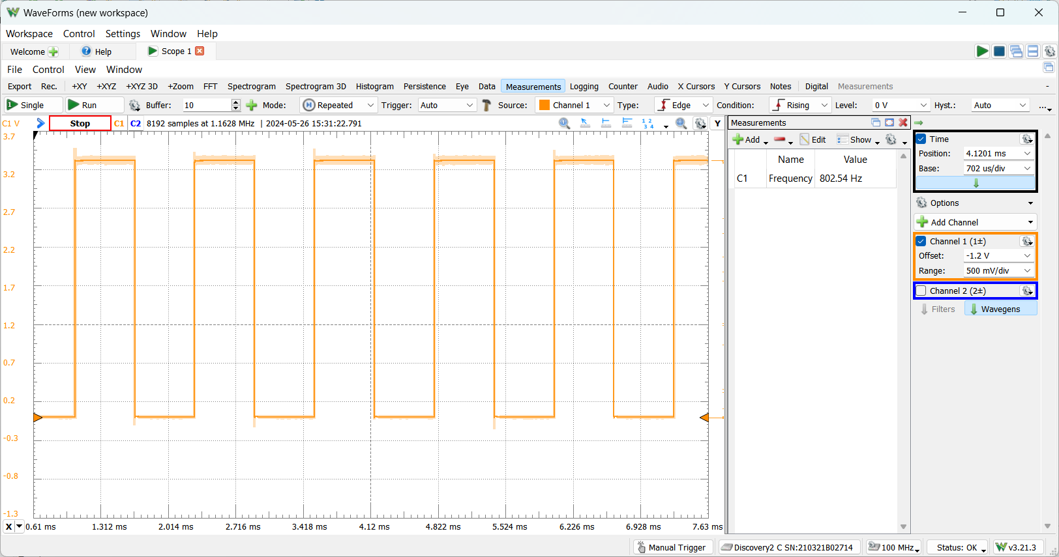

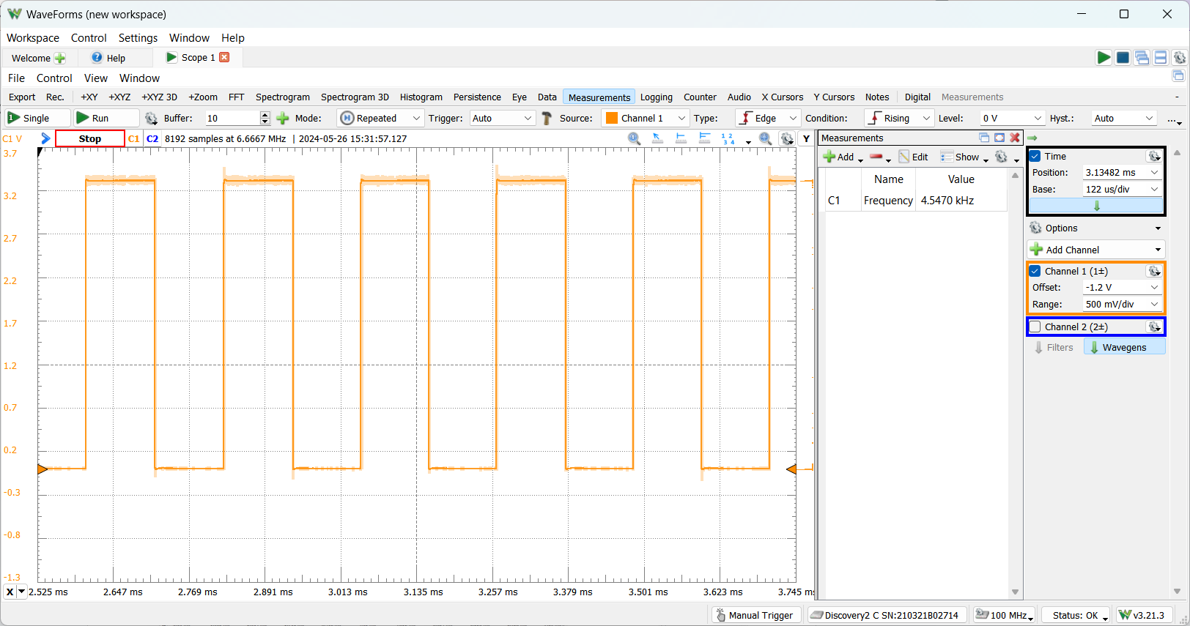

- Three interrupts
In this exercise we had to manage three different interrupts in order to generate three different waveforms on channel 1, 2 and 3 of the TIM3.
To do this we firstly activated 3 channels of TIM3 in the same way of the previous exercise. We then activated 3 GPIO output on PA6, PA7 and PA10.
In the “main.c” file we only had to enable the timer and the interrupt enabler using the following lines:
LL_TIM_WriteReg(TIM3, CR1, LL_TIM_ReadReg(TIM3, CR1)|0x1 );
LL_TIM_WriteReg(TIM3, DIER, LL_TIM_ReadReg(TIM3, DIER) | 0x1E);

We then wrote the part of the code involved with the generation of the waveforms in the interrupt handler part in the “stm32f44xx_it” file. The structure of the “if” statement is the same as before:
if(LL_TIM_IsActiveFlag_CC1(TIM3)){
LL_TIM_ClearFlag_CC1(TIM3);
LL_GPIO_WriteReg(GPIOA, ODR, LL_GPIO_ReadReg(GPIOA, ODR) ^ 0x400);
LL_TIM_WriteReg(TIM3, CCR1, LL_TIM_ReadReg(TIM3, CCR1) + 8000);
}
We only changed the value in the CCR1 register in order to have the waveforms at the frequencies requested. As we have a prescaler of 0 to get a 1 ms period we need a value of 8000, to get 2 ms we need 16000 and for 4 ms we need 32000.
As shown in the picture below the waves are pretty stable.
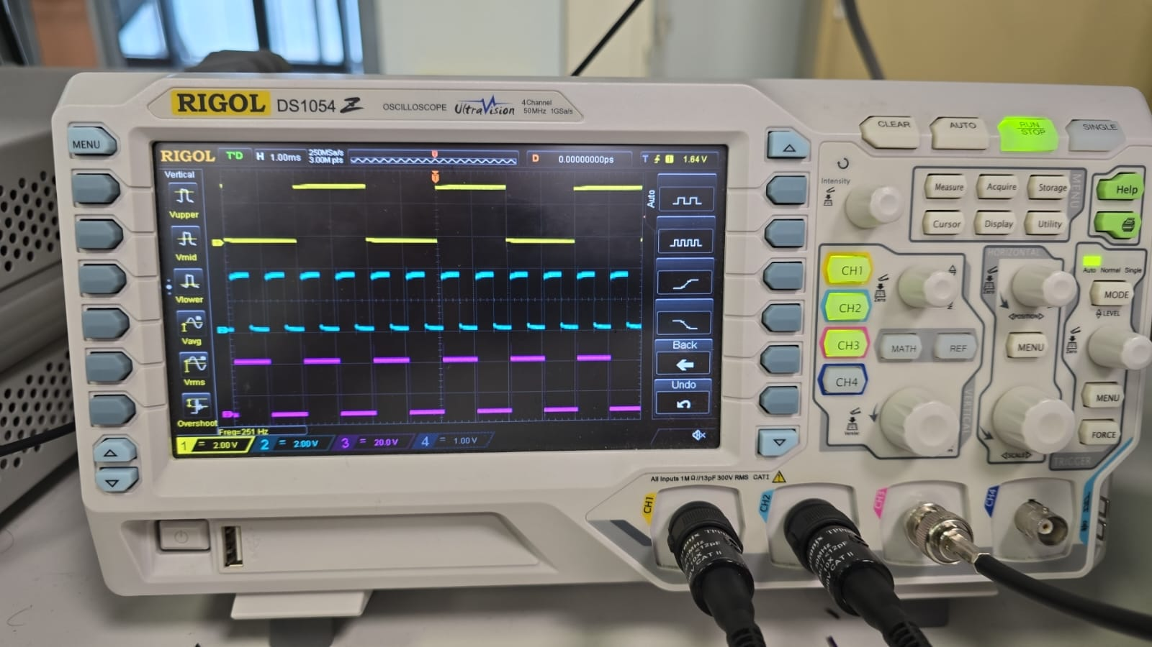

- Four interrupts
For this exercise we had to modify the previous project by adding a LED that turns on when the pushbutton is pressed. To do this we add PA5 as GPIO output for the LED, and PC13 as GPIO_EXTI13 in order to use the pushbutton with the interrupt option.
The “main” file remains unchanged while we added the instruction for the pushbutton in the “EXTI15_10_IRQHandler” function, that handles its interrupt:
LL_GPIO_WriteReg(GPIOA, ODR, LL_GPIO_ReadReg(GPIOA, ODR) ^ 0x20);
The waveforms appear stable as before and they don’t look affected by pushing the button.

- Five interrupts
For this exercise we were requested to modify the previous project by adding a fifth interrupt.
We configured TIM4 in interrupt mode, setting PSC to 1999 and ARR to 3999 (frequency of 2 Hz), in order to trigger the ADC and have a new conversion every 500 ms.
The input voltage, decided through a simple voltage divider with a potentiometer, defined the frequencies of the three output square waves, on CH1, CH2 and CH3 of TIM3.
To achieve a variable frequency, we must increment CCR1, CCR2 and CCR3 with different values.
We calculated the values in the main while, exploiting adc_rd (the reading of the input voltage), and we updated the CCR values in the TIM3 ISR.

The following pictures show the results we obtained at the minimum and maximum input voltage (so the minimum and maximum frequencies for the three channels):
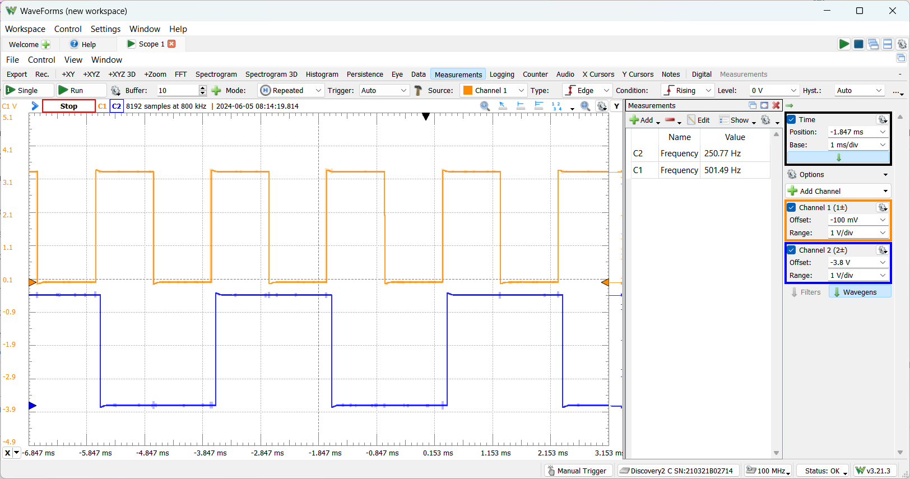

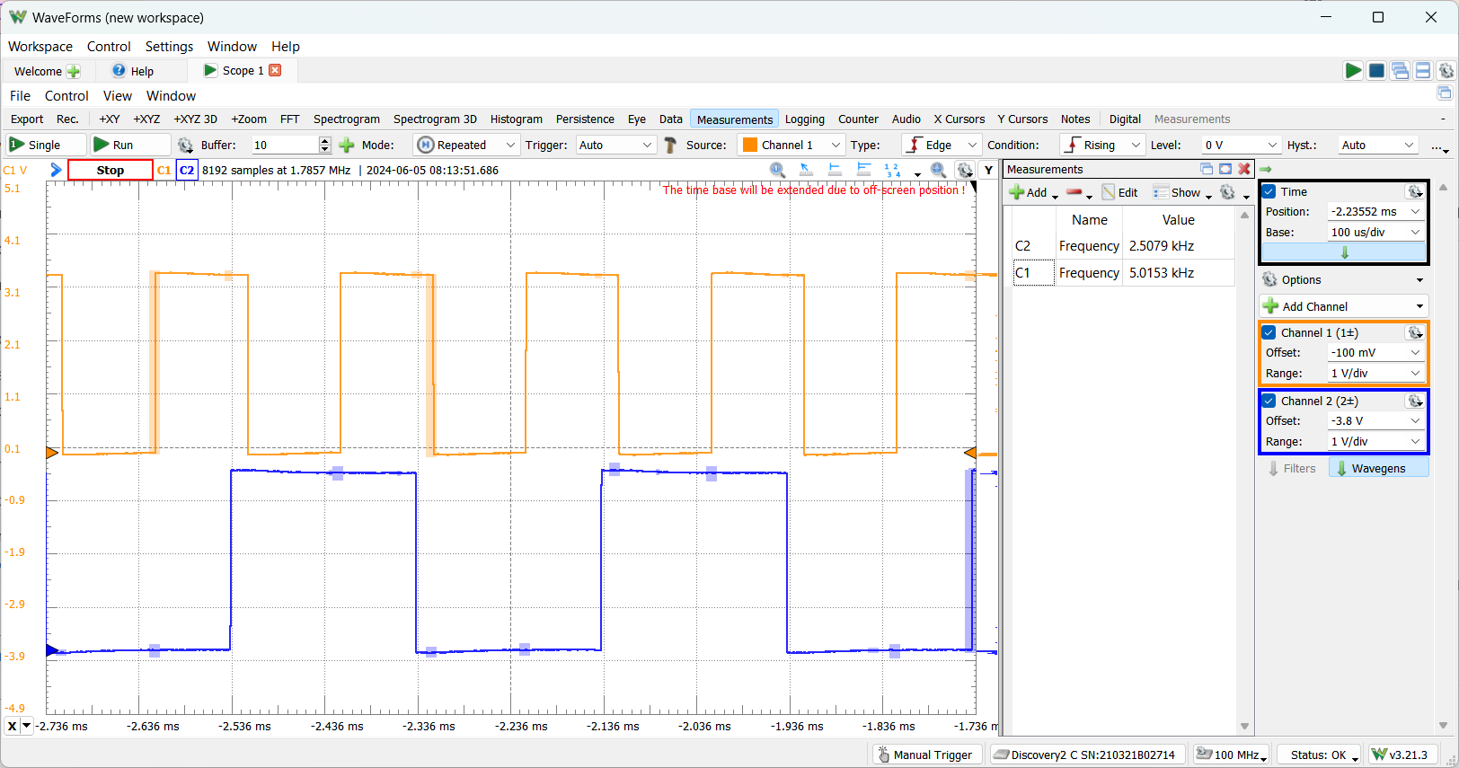

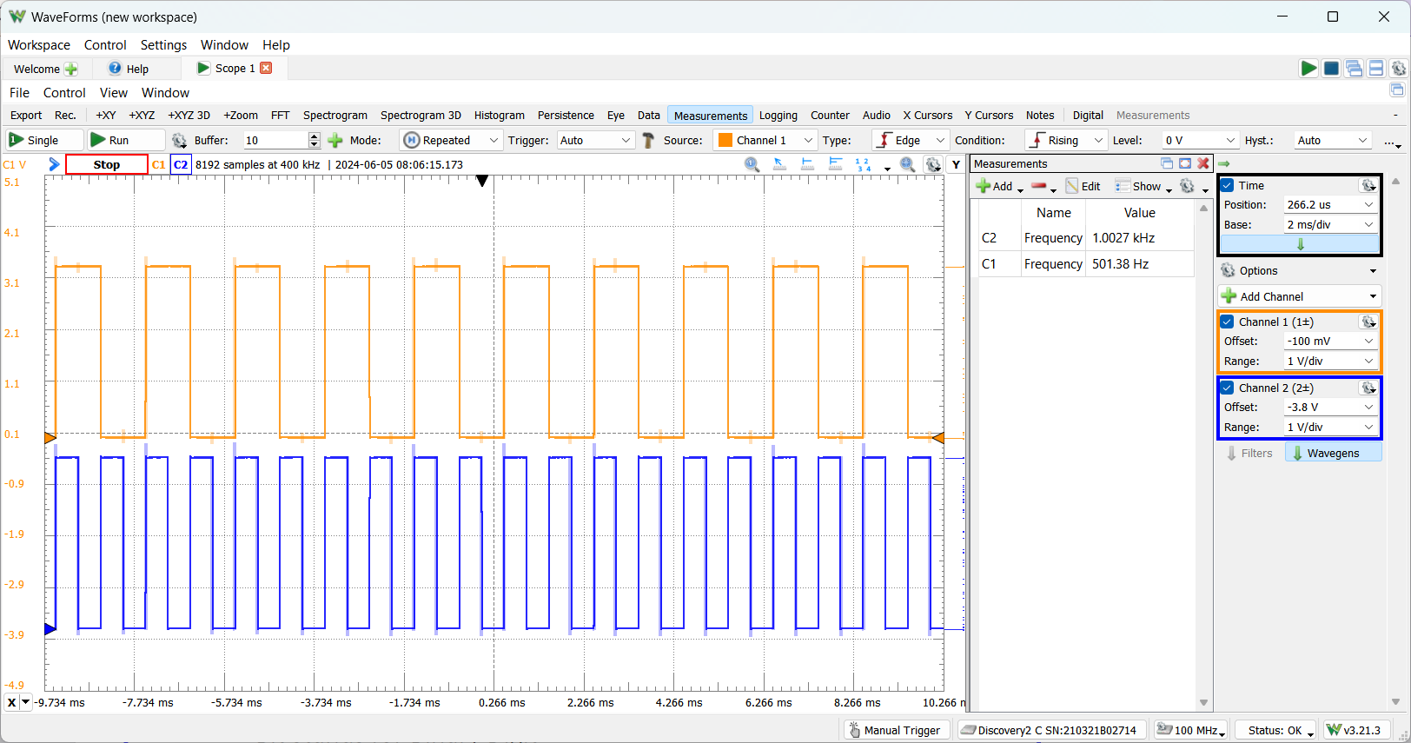
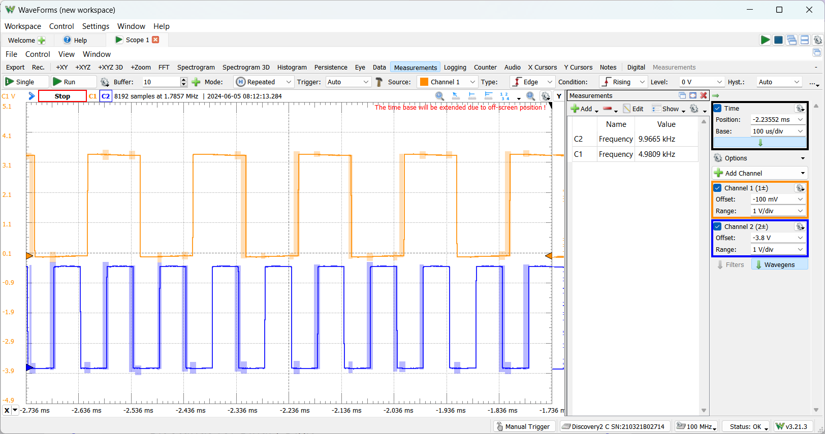

As expected, we have a 1 kHz-10 kHz excursion for CH1, a 500 Hz-5 kHz excursion for CH2 and a 250 Hz-2.5 kHz excursion for CH3.

Finally we had to convert every 100 ms instead of 500. In order to do this we modified the CCR register leaving the PSC=999 and setting the ARR to 799. As we decrease the period we would expect that turning the potentiometer results in a faster transition but this is not really visible probably because it is too fast.

