DIGITAL SYSTEMS ELECTRONICS

Academic year 2023-2024

LABORATORY NR. 10

DUE DATE: June 10, 2024
DELIVERY DATE: June 10, 2024

GROUP 03

CONTRIBUTIONS:
- El Amrani Dawid 100%
- Ielmini Giovanni 100%
- Di Carolo Pierfelice 100%
- Pavone Lorenzo 100%

The members of the group listed above declare under their own responsibility that no part of this document has been copied from other documents and that the associated code is original and has been developed expressly for the assigned project.

Contents
The purpose of this laboratory session is to learn how to use the input compare function of the Timer and to learn using the Pulse Width Modulator (PWM).

- Measure of the frequency and duty cycle of an external square waveform
For this first exercise, our aim was to measure the frequency and the duty cycle of an external square waveform. For this purpose, we exploited the input compare function of the timer TIM3.
We needed to enter the ISR of the timer on both rising edges and falling edges: the former to determine the frequency of the input waveform, calculating the distance between two consecutive rising edges, the latter to determine the duty cycle of the input waveform, calculating how much of the period is spent on the HIGH value.
Since we had no output signal, we had to analyse the correctness of our code using the debugger.

Unfortunately we couldn’t manage to see the values with the debugger as the code would keep running and wouldn’t enter the part we needed. This is strange as the code seems to work since the next exercise requires to read the wave frequency and use it to modify the DC of another wave, and we managed to make it work.

- Square wave generation

For this project, after introducing the input capture function, we used the Pulse Width Modulation for the first time.
The aim of the project was to calculate the frequency of an input waveform, thanks to the input capture function of the TIM3, and generate an output signal on TIM4 exploiting PWM, with frequency of 10 kHz and duty cycle varying between 25% and 75%, depending on the frequency captured by TIM3.

First of all, we configured TIM3. We turned on the input capture, specifying to enter the ISR only on the rising edges (we were not interested in the DC this time), where we calculated the frequency of the input signal.

Then, we configured TIM4. We turned on the PWM function, with PSC=0, ARR=1599 (to enter the ISR 100 thousand times per second) and Pulse=799 (the initial DC had to be 50%).
In the ISR of TIM4 we exploited the value precedently calculated (freq) to determine the desired DC of the output signal, and then updated the Pulse value in the CCR1 register.
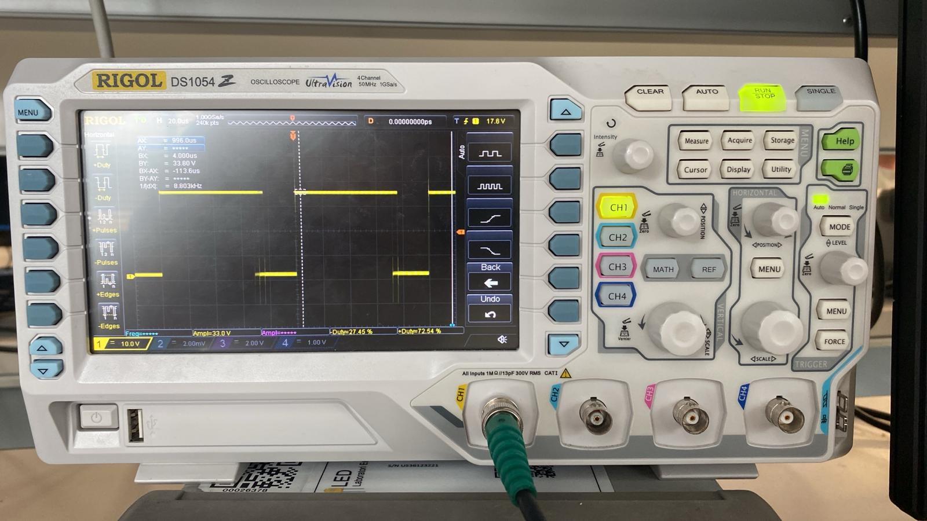

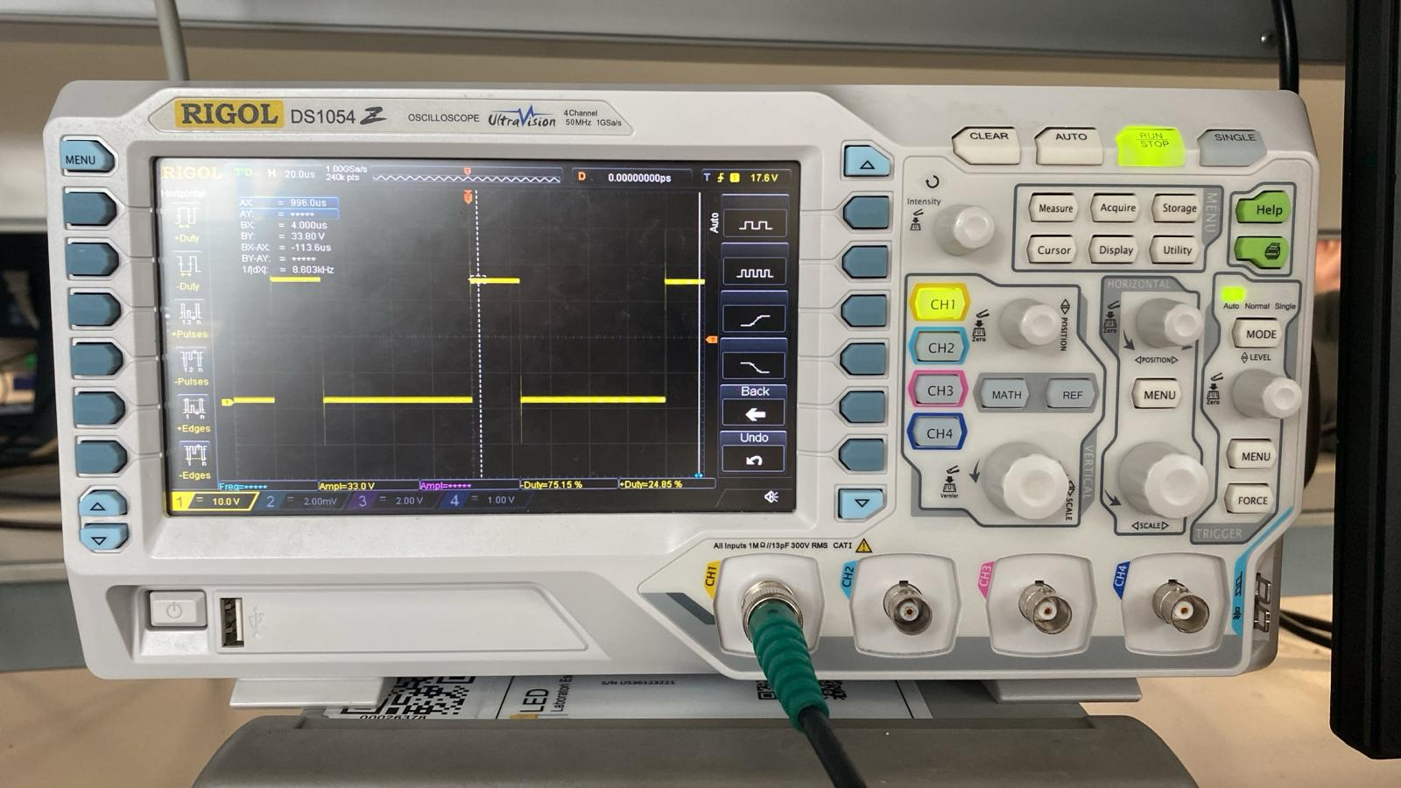

These are the results of the output waveform shown on the laboratory oscilloscope, when the input wave frequency was set to the boundaries of the “accepted” values: 12 kHz in the first case and 800 Hz in the second.
- LED dimmer
For this project we had to gradually increase the brightness of the LED of the board from fully switched off to fully switched on in one second.
To perform this effect, we needed to modify the DC of the waveform on the PIN connected to the LED, in such a way that we saw a different power expressed on the LED during each cycle.
In addition to that, we also had to use the HAL (Hardware Abstraction Layer) approach.

At first we set the pin PA5 as output of the PWM generation mode, we chose PSC=9 in order to get a counter increment rate of hundreds of kHz and ARR=15 in order to get a frequency of the PWM of hundreds of Hz, following the given instruction.

In the main file we activated the generation of the PWM by means of the HAL_TIM_PWM_Start function, then, inside the infinite loop, we wrote two ‘for’ statements used to make the LED change.
In the first one we counted from i=0 to i=16 (our period) to vary the brightness from the
minimum to the maximum and in the second one from i=16 to i=0, to obtain the opposite
effect.
The code inside the two loops is the same, we used the __HAL_TIM_SET_COMPARE
function to modify the duty cycle and we introduced a delay of (1000/16) ms (with the function
HAL_Delay(t)) to obtain the overall one second transition.

Using an oscilloscope to see we obtained a square wave with a variable duty cycle and a frequency of 100 kHz, as expected.

Eventually we halved the prescaler and doubled the period values (PSC= 4, ARR=31),
maintaining the same frequency as before, and extended the range of the index i to 32 (and
therefore adjusting the delay to (1000/32) ms, this resulted in a smoother transition of the
LED brightness.
- Sine wave generation
In this last exercise we had to generate a 50 Hz sine waveform with the NUCLEO board, by
using the DMA feature together with the PWM.
We followed the steps proposed in the document, so we set in the pinout view the channel 1
of timer TIM3 in PWM mode and we chose its parameters in order to get a 10 kHz PWM
signal (PSC=0, ARR=1599). Then in the DMA Configuration window we set the following
parameters for the TIM3_CH1/TRIG DMA: Memory to Peripheral direction and Circular
mode.

After that we included the “math.h” library and modified the given code according to our
needs. We used a for statement going from i=0 to i=200 in which we calculated the LUT
values: the argument of our sine is $2π⋅\left(i/200\right)$ , we added one to this quantity in order to avoid
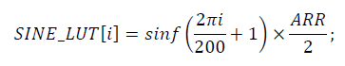
negative values and multiplied it by the ARR/2 to obtain the right amplitude.

Finally we used the function to start the DMA, after that channel 1 of TIM3 is started in the
desired mode, the circular buffer is pointed by SINE_LUT and it has length equal to 200
words.

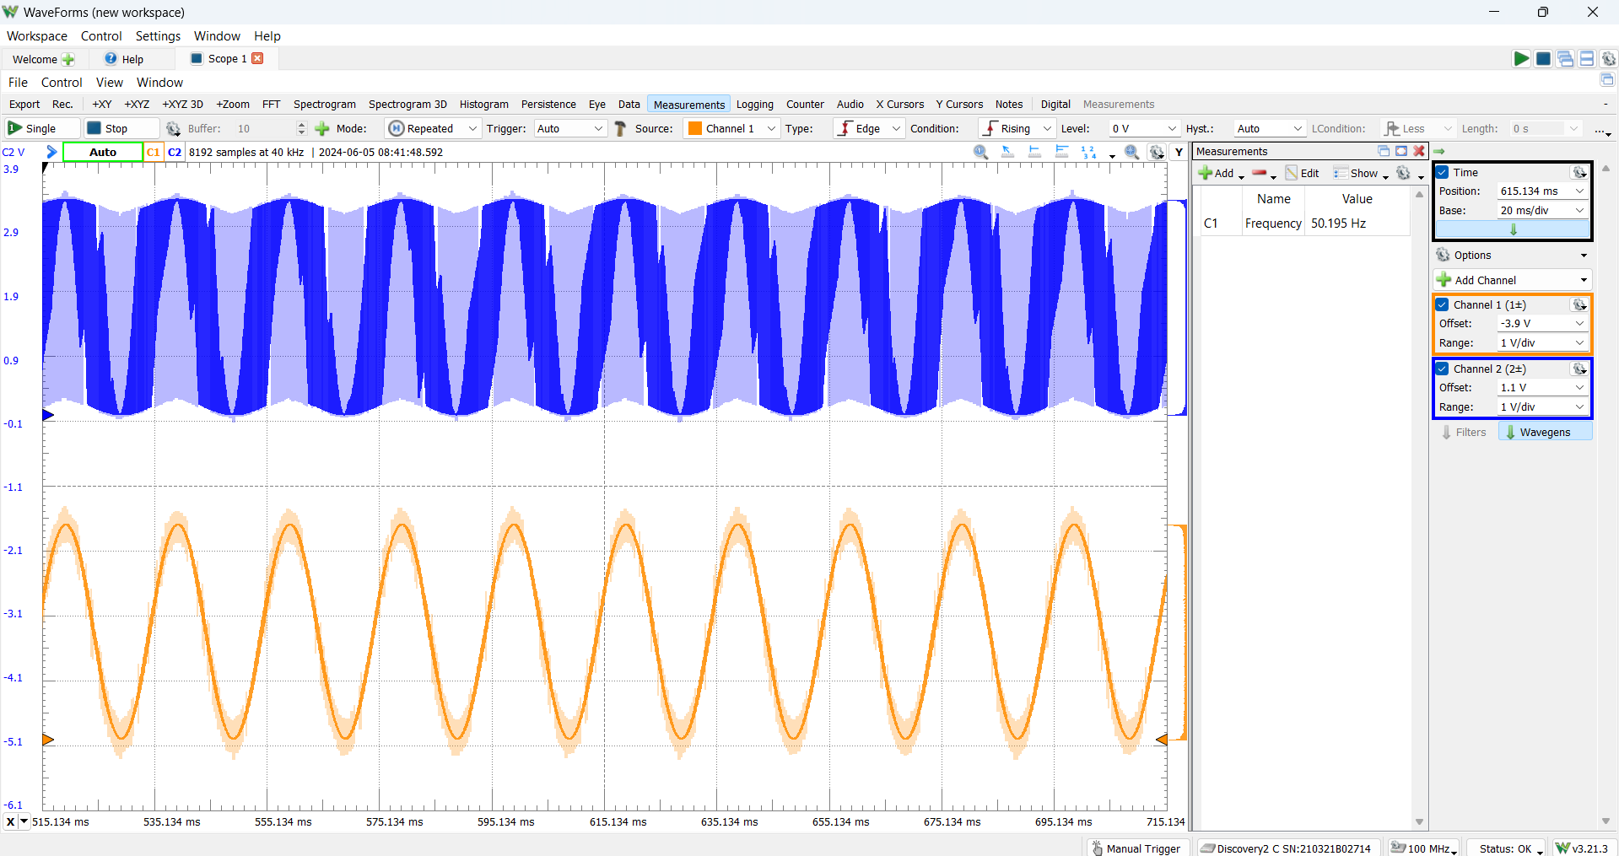
In the following picture we can see the results we obtained: in blue, the output waves of the board, pretty disturbed and jittered, and, in orange, the filtered signal, much more precise.

