


Electronics for Embedded Systems
Department of Electronics and Telecommunications (DET)
Politecnico di Torino

Experiment Title: | Lab 1 – Introduction to Quartus Prime and FPGA Programming
Course: | Electronics for Embedded Systems
Group: | B04
Student Names and IDs: | Lorenzo Pavone (362884), Pietro Sanna (348797), Samuele Martello (360819), Andrei Ciornei (361150)
Date of Experiment: | 28/10/2025
Date of Submission: | 24/12/2025
Instructor: | Prof. Claudio Passerone

Abstract
This laboratory activity focused on the introduction to the Intel Quartus Prime environment and the FPGA design flow. We implemented a simple 2-input AND gate in VHDL to go through the steps of synthesis, simulation, and programming on the DE1-SoC board. A key part of the experiment was the timing analysis. We observed how different pin assignments and SDC constraints affect the propagation delay (tpd​). Using the Timing Analyzer and the Floorplan view, we verified that the routing length between logic elements and I/O pins significantly impacts the circuit speed. The design was finally validated on hardware using switches and LEDs.

1. Introduction
The objective of this lab was to learn the complete design flow using Quartus Prime, from VHDL coding to the generation of the configuration bitstream. We used a basic combinational circuit (AND gate) to focus on the toolchain capabilities rather than design complexity. We specifically analyzed the effect of physical constraints on timing performance. By manually changing pin assignments and applying timing constraints, we observed how the fitter places logic cells and routes signals. We measured the propagation delays in different configurations to understand the relationship between physical placement and signal timing. Functional verification was also performed via RTL simulation in ModelSim.

2. Materials and Methods
- Hardware:
  - Altera DE1-SoC Development Board (Cyclone V 5CSEMA5F31C6 FPGA)
  - USB-Blaster II programmer
  - PC running linux (Fedora 43)
- Software:
  - Intel Quartus Prime Lite 24.10
  - ModelSim-Altera for RTL simulation
  - Tcl pin assignment script (pin_assignment_DE1_SoC.tcl)
Procedure:
- Created a new Quartus project and defined the top-level entity DE1_SoC_top_level.vhd.
- Described the AND gate using VHDL and wrote a simple testbench to verify functionality.
- Performed RTL simulation in ModelSim to confirm correct logic operation. (Figure 1)
- Assigned input and output pins using the Pin Planner based on the DE1-SoC schematic.
(Figure 2)
- Checked the floorplan and manually moved the logic element to different areas.
- Applied timing constraints using an SDC file, starting from 20 ns and decreasing to 5 ns, and recorded the timing results.
- Programmed the FPGA and verified the output using on-board LEDs.
- File efes_pld_lab1_implementation.pdf
- File efes_pld_lab1_slides.pdf

3. Results
We ran synthesis multiple times with different pin configurations. As shown in Table 1, the propagation delay varies significantly depending on where the pins are located relative to the logic array block (LAB). When we applied tight constraints, the fitter tried to place the logic closer to the pins. Without constraints, the tool defaulted to a central placement or whatever was easiest to route. The resource usage was negligible (1 LE, 3 pins). The simulation (Figure 1) confirmed the logic was correct before we moved to the physical implementation.

4. Discussion
The results show a clear link between physical placement and timing. When the input and output pins were far apart (e.g., opposite sides of the chip), the routing path was longer, causing a higher delay. We noticed that providing a timing constraint forces the Quartus fitter to optimize the path. However, if the constraint is too tight (like the 5 ns test case with far pins), the tool fails to meet timing because the physical distance makes it impossible. Using the Floorplan view helped us visualize this: we could actually see the long routing lines across the chip. This confirms that for complex designs, managing constraints and pinout is just as important as the code itself.

5. Conclusions
This lab allowed us to set up the toolchain and run a complete FPGA flow. Although the circuit was trivial, the exercise was useful to understand synthesis, simulation, and timing analysis. We verified that routing delay is a real factor in FPGA performance. These basics will be necessary when we start working on sequential circuits and more complex architectures in future labs.

6. References
- Laboratory instructions
- Intel Corporation, Quartus Prime Lite User Guide, 2023.
- Altera DE1-SoC Board Reference Manual, Terasic, 2022.

Appendix A – VHDL Code
library IEEE;
use IEEE.STD_LOGIC_1164.ALL;
entity DE1_SoC_top_level is
Port (
SW0, SW1 : in STD_LOGIC;
LEDR0 : out STD_LOGIC
);
end DE1_SoC_top_level;
architecture Behavioral of DE1_SoC_top_level is
begin
LEDR0 <= SW0 AND SW1;
end Behavioral;

Appendix B – Figures and Tables

Timing results for different pin assignments
Table 1
Configuration | Input 1 pin | Input 2 pin | Output pin | Constraint (ns) tpd | Tpd (measured) | Comments
No pin assignment, no constraint | Auto | Auto | Auto | - | 6.2 ns | Automatic placement near center
Assigned near pins | SW0 → PIN_AB12 | SW1 → PIN_AC12 | LEDR0 → PIN_V16 | 20 ns | 5.8 ns | Close routing
Assigned far pins | SW0 → PIN_AB12 | SW1 → PIN_AG26 | LEDR0 → PIN_V16 | 20 ns | 13.5 ns | Long routing paths
Far pins, 10 ns constraint | SW0 → PIN_AB12 | SW1 → PIN_AG26 | LEDR0 → PIN_V16 | 10 ns | 11.2 ns | Still met constraint
Far pins, 5 ns constraint violated | SW0 → PIN_AB12 | SW1 → PIN_AG26 | LEDR0 → PIN_V16 | 5 ns | 5.5 ns (fail) | Constraint violated (Slow model)
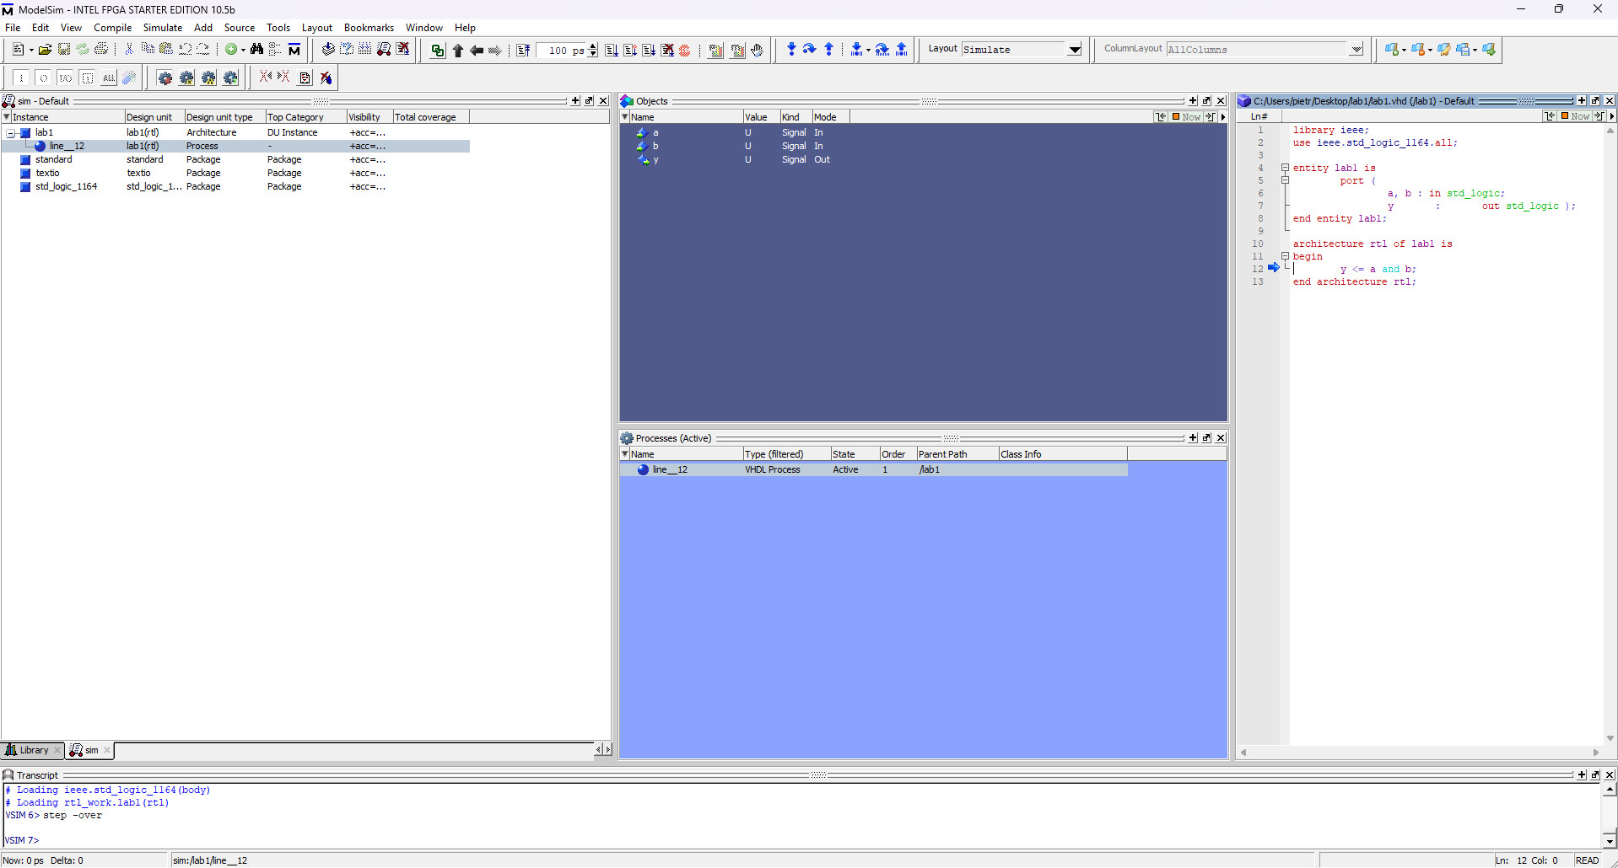
Figure 1

Figure 2
