


Electronics for Embedded Systems
Department of Electronics and Telecommunications (DET)
Politecnico di Torino

Experiment Title: | Lab 2 – Nios II System Implementation and UART Software Communication
Course: | Electronics for Embedded Systems
Group: | B04
Student Names and IDs: | Lorenzo Pavone (362884), Pietro Sanna (348797), Samuele Martello (360819), Andrei Ciornei (361150)
Date of Experiment: | 11/11/2025 and 17/11/2025
Date of Submission: | 21/12/2025
Instructor: | Prof. Claudio Passerone

Abstract
This laboratory activity introduces the basic hardware–software co-design flow for a Nios II embedded processor implemented on an FPGA platform. The main objective of the experiment is to verify the correct configuration and operation of a simple Nios II system and its interaction with the host computer through the JTAG UART interface. The methodology consists of designing the hardware system using the system integration tool, compiling and programming the FPGA, and developing a simple C software application executed by the embedded processor. The software sends a text message to the host PC, allowing verification of correct execution and communication through the Nios II Console. The experimental results show that the program was correctly executed on the FPGA and that the expected output message was successfully displayed on the console for some specific configuration. This confirms proper processor configuration, memory access, and peripheral communication.
In conclusion, the laboratory provides a clear introduction to the Nios II development workflow, demonstrating the fundamental steps required to build, program, and verify an embedded system on FPGA. The acquired knowledge represents a solid foundation for more advanced designs involving peripherals, interrupts, and real-time applications.

1. Introduction
In this experiment, we implemented a customizable embedded system using the Nios II soft-core processor. The primary goal was to explore the interaction between the embedded software and the external world without using dedicated hardware controllers for the UART. Instead, we used a "bit-banging" approach (Software UART) to manage communication via GPIO pins. This allowed us to analyze the timing constraints of the processor and determine the maximum reliable baud rate that the Nios II/e core can sustain while manually sampling the RX line.

2. Materials and Methods
- Hardware
  - FPGA development board with Nios II soft-core processor
  - JTAG interface for programming and communication
  - Micro SD Card containing the preloader
- Software
  - Quartus Prime development environment
  - Platform Designer / system integration tool
  - Nios II Software Build Tools
  - Nios II Console

3. Experimental Setup and Procedure
During the laboratory session, we used a complete VHDL project provided beforehand (uarthwsw), which already included all internal FPGA component interconnections. Our first step consisted of programming the board using this pre-configured project.
BSP Generation: A Board Support Package (BSP) was generated to interface the C standard library with the specific hardware map.
The subsequent step involved developing C code using the Eclipse-based IDE integrated within Quartus Prime. This tool allows for compiling and uploading the C code directly onto the FPGA.
Specifically, three C sub projects were developed.
The first served as a basic "printf" test to verify the output console.
The second implemented an infinite loop where a variable was incremented each cycle, with the result sent via JTAG_UART every eight clock cycles to monitor signal variations on an oscilloscope.
The third subproject focused on UART reception to determine the maximum reliable baud rate for data transmission from the host PC to the FPGA. The software included a function to send data to the UART peripheral to verify the connection, followed by an infinite loop for data retrieval. The receiveUart() function, originally designed as a bit-by-bit "for" loop, was subsequently unrolled to improve performance. Further baud rate optimizations could be achieved by refining the code, for instance, by better utilizing the alt_timestamp_start() function for timing management.
Characters were sent from the PC terminal and the decoded output was printed to the Nios II Console. The baud rate was gradually increased to find the maximum reliable speed before data corruption (Project 5).

4. Results
The Nios II soft processor system was successfully instantiated on the FPGA. The initial verification (Project 1) confirmed the correct operation of the JTAG link, with the message "Hello !" correctly displayed on the Eclipse console.
Before deploying the UART receiver, the timing accuracy of the alt_timestamp driver was validated. A test loop was configured to toggle a GPIO pin with a target semi-period of 1 ms. As shown in Figure 2 (Appendix B), the oscilloscope analysis revealed a measured pulse width of approximately 1 ms. This result confirmed that the timer resolution was sufficient for generating the sampling intervals required for low-speed UART communication.
For the Software UART implementation (Project 4):
- Functionality: At the base speed of 300 baud, the system correctly decoded all ASCII characters sent from the PC terminal.
- Waveform Analysis: Using the oscilloscope on the designated test pins (GPIO), we verified that the sampling instants fell within the valid data valid window.
- Performance Limits (Project 5): The system operated reliably at standard baud rates of 300, 1200, and 2400 baud. At 4800 baud, the receiver began to produce errors. The breakdown occurred because the time required for the C instructions (loop overhead, pin reading, masking) became comparable to the bit period, causing the sampling window to drift.

5. Discussion
The results highlight the critical trade-off between software flexibility and hardware performance. While the Nios II/e processor successfully emulated a UART interface at low speeds, it lacked the execution speed to handle higher baud rates.The breakdown at 4800 baud is consistent with the limitations of the Nios II/e core, which executes instructions sequentially. For higher speeds, interrupt-driven I/O or a higher-performance core would be required to reduce latency. This experiment underscores the necessity of dedicated hardware peripherals (Hardware UART) for high-speed, reliable communication in embedded systems, leaving the CPU free for data processing.

6. Conclusions
The laboratory activity successfully demonstrated the complete workflow for designing and testing a simple Nios II-based embedded system on FPGA. The correct execution of the software application and the expected console output validated both the hardware configuration and the software development process. The limitations of the "bit-banging" approach were identified experimentally, showing that while software GPIO manipulation is flexible, it is constrained by the processor's execution speed and instruction overhead. The experiment provided practical experience with software compilation and runtime verification. These concepts form the basis for future laboratory activities involving advanced peripheral and real-time embedded systems.

7. References

- Laboratory Instructions
- Quartus Prime User Guide
- Intel Corporation, Quartus Prime Lite User Guide, 2023.
- Altera DE1-SoC Board Reference Manual, Terasic, 2022.

Appendix A – C Code
Project code 1
#ifdef PROJECT1
int main()
{
printf("Hello!\n");
return 0;
}
#endif

Project code 2
#ifdef PROJECT2
int main()
{
int val = 0x01;
IOWR_ALTERA_AVALON_PIO_DATA(NIOS_UARTTX_BASE, val);
int i = 0;
while(1){
val +=1;
IOWR_ALTERA_AVALON_PIO_DATA(NIOS_HEADER_CONN_BASE, val);
int ticksPerSec = alt_timestamp_freq();
int n = 1000;
int nticks = (ticksPerSec / 1000000) * n;
alt_timestamp_start();
i++;
while (alt_timestamp() < nticks) {}
printf("%d \n", i);
}
return 0;
}
#endif

Project code 4 main
#define BAUD_RATE 4800
char receiveUart(int, int);
int sendUart(char c, int);
void delayBit(int);
int main()
{
int ticksPerSec = alt_timestamp_freq();
int nticks = ticksPerSec / BAUD_RATE;
printf("Tick per sec : %d\n", ticksPerSec);
printf("Nticks: %d\n", nticks);
int nticks_half = ticksPerSec / (BAUD_RATE * 3);
printf("Nticks half: %d\n", nticks_half);
int i = 0;
int val = 0x01;
IOWR_ALTERA_AVALON_PIO_DATA(NIOS_UARTTX_BASE, val);
char * s = "Hello world";
while(*s != '\0'){
sendUart(*s,nticks);
s++;
}
char data[10000];
while(1){
while(IORD_ALTERA_AVALON_PIO_DATA(NIOS_UARTRX_BASE) == 1);
data[i] = receiveUart(nticks,nticks_half);
if(i == 5) break;
i++;
}
data[i+1] = '\0';
printf("%s", data);
return 0;
}

Project code 4 receiveUart() for loop
char receiveUart(int nticks, int halfTicks){
alt_timestamp_start();
while (alt_timestamp() < halfTicks) {}
unsigned char data = 0;
for(int i = 0; i< 8; i++){
int rx = IORD_ALTERA_AVALON_PIO_DATA(NIOS_UARTRX_BASE);
if(rx)
data |= (1<<i); // data = data | 1 position 1

delayBit();
}
return data;
}

Project code 4 receiveUart() loop unroll
char receiveUart(int nticks, int halfTicks){

alt_timestamp_start();
while (alt_timestamp() < halfTicks) {}

unsigned char data = 0;
alt_timestamp_start();
while (alt_timestamp() < nticks) {}

if(IORD_ALTERA_AVALON_PIO_DATA(NIOS_UARTRX_BASE))
data |= (1<<0); // data = data | 1 alla posizione i
alt_timestamp_start();
while (alt_timestamp() < nticks) {}

int rx = IORD_ALTERA_AVALON_PIO_DATA(NIOS_UARTRX_BASE);
if(rx)
data |= (1<<1); // data = data | 1 alla posizione i
alt_timestamp_start();
while (alt_timestamp() < nticks) {}
rx = IORD_ALTERA_AVALON_PIO_DATA(NIOS_UARTRX_BASE);
if(rx)
data |= (1<<2); // data = data | 1 alla posizione i
alt_timestamp_start();
while (alt_timestamp() < nticks) {}
rx = IORD_ALTERA_AVALON_PIO_DATA(NIOS_UARTRX_BASE);
if(rx)
data |= (1<<3); // data = data | 1 alla posizione i
alt_timestamp_start();
while (alt_timestamp() < nticks) {}
rx = IORD_ALTERA_AVALON_PIO_DATA(NIOS_UARTRX_BASE);
if(rx)
data |= (1<<4); // data = data | 1 alla posizione i
alt_timestamp_start();
while (alt_timestamp() < nticks) {}
rx = IORD_ALTERA_AVALON_PIO_DATA(NIOS_UARTRX_BASE);
if(rx)
data |= (1<<5); // data = data | 1 alla posizione i
alt_timestamp_start();
while (alt_timestamp() < nticks) {}
rx = IORD_ALTERA_AVALON_PIO_DATA(NIOS_UARTRX_BASE);
if(rx)
data |= (1<<6); // data = data | 1 alla posizione i
alt_timestamp_start();
while (alt_timestamp() < nticks) {}
rx = IORD_ALTERA_AVALON_PIO_DATA(NIOS_UARTRX_BASE);
if(rx)
data |= (1<<7); // data = data | 1 alla posizione i
alt_timestamp_start();
while (alt_timestamp() < nticks) {}
return data;
}

Project code 4 sendUart()
int sendUart(char c, int nticks){
int val = 0x00;
IOWR_ALTERA_AVALON_PIO_DATA(NIOS_UARTTX_BASE, val); // start bit
delayBit(nticks); //3333 = 1/ 300 when 300 is baud rate
for(int i = 0; i < 8 ; i++){
if (c & 0x01) //Check if lsb is equal to 1
val = 0x01;
else
val = 0x00;
IOWR_ALTERA_AVALON_PIO_DATA(NIOS_UARTTX_BASE, val);
delayBit(nticks);
c >>= 1; //right shift for the next lsb
}
val = 0x01;
IOWR_ALTERA_AVALON_PIO_DATA(NIOS_UARTTX_BASE, val); // End bit
delayBit(nticks);
return 1;
}
This function was not needed for the project but was used as a test for the communication

Appendix B – Figures and Tables
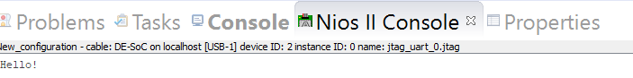

Output project code 4

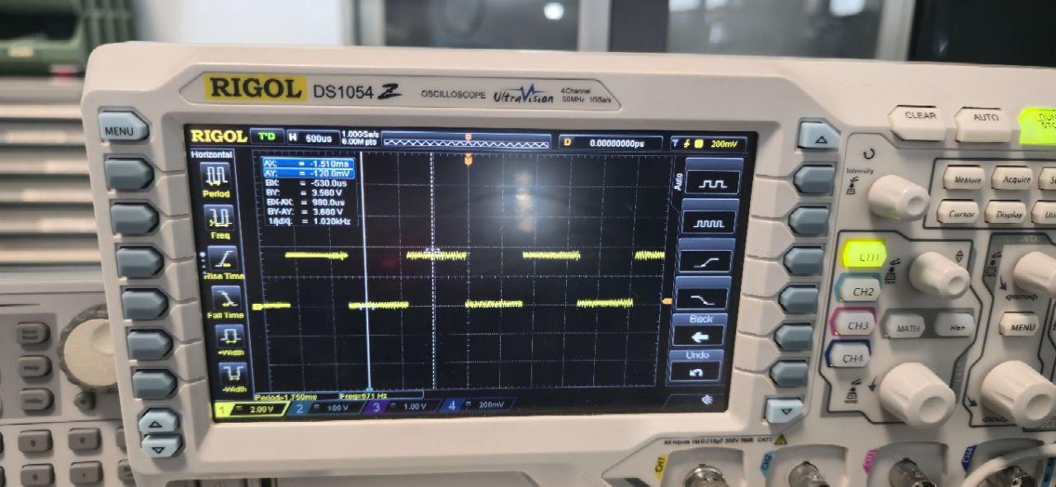
Oscilloscope capture showing the verification of the software timer (Project 2). The GPIO pin is toggled with a software-defined delay.

