


Electronics for Embedded Systems
Department of Electronics and Telecommunications (DET)
Politecnico di Torino

Experiment Title: | Lab 3 – Nios II Hardware UART Interface
Course: | Electronics for Embedded Systems
Group: | B04
Student Names and IDs: | Lorenzo Pavone (362884), Pietro Sanna (348797), Samuele Martello (360819), Andrei Ciornei (361150)
Date of Experiment: | 25/11/2025
Date of Submission: | 24 /12/2025
Instructor: | Prof. Claudio Passerone

Abstract
In the previous lab, we built a UART interface using software (bit-banging). In this lab, we switched to using the dedicated hardware UART peripheral inside the Nios II system. The main task was to write C code to control this peripheral by accessing its registers directly (Memory-Mapped I/O), without using the standard Altera drivers. We calculated the correct divisor values to set the baud rate and wrote a polling loop to send and receive data. We verified that the hardware handles the timing correctly, but the software still needs to check the Status Register flags (TRDY and RRDY) to avoid errors.

1. Introduction
The goal of this session was to learn how to control a hardware peripheral at the register level. In Lab 2, the CPU had to do everything, including timing the bits. Here, we used the Altera UART core, which handles the shifting and timing automatically. Our job was to interface with it using C pointers. We needed to understand the register map—specifically where to write data (TXDATA), where to read it (RXDATA), and how to set the speed (DIVISOR). We also wanted to see the difference between this method and the software-only approach from the last experiment.

2. Materials and Methods
- Hardware
  - FPGA development board with Nios II soft-core processor
  - JTAG interface for programming and communication
  - Micro SD Card containing the preloader
- Software
  - Quartus Prime development environment
  - Platform Designer / system integration tool
  - Nios II Software Build Tools
  - Nios II Console
Methodology: To force direct register manipulation, the default altera_avalon_uart_driver was disabled in the Board Support Package (BSP). Access to registers was performed using pointers to base addresses defined in system.h and standard offsets (e.g., *(base_addr + offset)). The baud rate was set by writing to the DIVISOR register using the formula: Divisor=(Fclk​/BaudRate)−1.

3. Experimental Setup and Procedure
System Configuration The provided hardware design uarthwsw was programmed onto the FPGA. A crucial step was setting Switch SW9 to position 1; this activates a multiplexer in the Verilog top-level that connects the physical UART pins to the hardware peripheral instead of the GPIOs used in Lab 2.
Baud Rate Configuration (Project 2) The system clock is 50 MHz. We calculated and verified the values for the DIVISOR register:
- 115200 Baud: Target Divisor ≈433.
- 2400 Baud: Target Divisor ≈20832. A C program was written to write these values to the Divisor register (Offset 4) and verify the readback value.
Data Transmission (Project 3 & 4) We implemented a function to transmit characters. The logic required polling the TRDY (Transmit Ready) bit in the STATUS register. Data was written to the TXDATA register only when TRDY=1. We tested this by sending ASCII strings ("My name is...") to the PC terminal.
Data Reception (Project 5) For reception, the software polled the RRDY (Receive Ready) bit in the STATUS register. Upon detecting RRDY=1, the program read the value from RXDATA (clearing the ready flag) and echoed it to the Nios II console.

4. Results
Register Access and Baud Rate The direct access to memory-mapped registers functioned correctly. Reading the default DIVISOR value confirmed the pre-set 115200 baud rate. Changing the divisor to 20832 successfully switched the communication speed to 2400 baud, validated by the correct display of characters on the PC terminal configured at the matching speed.
Transmission Analysis During the transmission of continuous strings (Project 3), monitoring the STATUS register revealed:
- TRDY (Bit 6): Dropped to 0 immediately after writing to TXDATA, indicating the buffer was full.
- TMT (Bit 5): Remained 0 while the shift register was active and returned to 1 only after the full frame (Start+Data+Parity+Stop) was shifted out. This confirmed the double-buffering mechanism of the peripheral.
Reception and Error Handling The reception loop correctly echoed characters typed on the terminal. In a specific test case (Project 5, point 3), we inserted a delay in the reading loop while sending multiple characters. The STATUS register showed the ROE (Receive Overrun Error) bit asserted. This confirmed that without a hardware FIFO, failing to read the RXDATA register before the next character arrives leads to data loss.
5. Discussion
This lab showed the clear advantage of hardware peripherals: the code is simpler because we don't need to count clock cycles for bit timing. The UART core guarantees the baud rate is stable. However, using polling (busy-waiting) is not ideal. The CPU spends 99% of its time just reading the status register, waiting for a "Ready" flag. In a real application, this blocks the processor from doing anything else. A better design would use Interrupts (IRQ) so the CPU can run other tasks and only stop when data actually arrives. Also, unlike the Baud Rate, we noticed we couldn't change the Parity or Stop Bits via software. Those are hard-coded in the FPGA hardware design (Platform Designer).

6. Conclusions
In this lab, we successfully configured and controlled a memory-mapped peripheral on the Nios II processor. We verified the mechanisms for status polling, baud rate generation, and error detection.
Our results confirm that while hardware peripherals offer robust communication, they require careful software management of status flags to prevent overrun errors. A solid grasp of these low-level interactions is key to writing efficient drivers for embedded systems.

7. References
- Laboratory Instructions
- Quartus Prime User Guide
- Intel Corporation, Quartus Prime Lite User Guide, 2023.
- Altera DE1-SoC Board Reference Manual, Terasic, 2022.

Appendix A – C Code
Project code 2
#ifdef PROJECT2
int main()
{
volatile int* rxdata = (int *) RXADDRESS ;
volatile int* txdata = (int *) TXADDRESS;
volatile int* status = (int *) STATUSADDRESS;
volatile int* control = (int *) CONTROLADDRESS;
volatile int* divisor = (int *) DIVISORADDRESS;
int calculated_divosr = CLOCK_FREQ / BAUD_RATE - 1;
printf("Real divisor: %d, calculated divisor: %d\n", *divisor, calculated_divosr);
int baud_2400 = 2400;
int divisor_2400 = CLOCK_FREQ / baud_2400 - 1;
*divisor = divisor_2400;
printf("Divisor for new baudrate: %d", *divisor);
return 0;
}
#endif

Project code 3
#ifdef PROJECT3
int main()
{
volatile int* rxdata = (int *) RXADDRESS ;
volatile int* txdata = (int *) TXADDRESS;
volatile int* status = (int *) STATUSADDRESS;
volatile int* control = (int *) CONTROLADDRESS;
volatile int* divisor = (int *) DIVISORADDRESS;
int baud_2400 = 2400;
int divisor_2400 = CLOCK_FREQ / baud_2400 - 1;
*divisor = divisor_2400;
printf("Divisor for new baud rate: %d\n", *divisor);
printf("Status register value before: %d\n", *status);
//Wait until the ready bit is one
//TREADY MASK is used to check the tx ready bit in the status register
char *string = "Characters\0";
//int i = 0;
while(1){
if ((*status & TXREADY_MASK)>>6 == 0b1){
//*txdata = 'C'; //;
*txdata = *string;
string++;
if(*string == '\0') break;
//*txdata = 0x67; break;
}
}
printf("Status register value after: %d\n", *status);
return 0;
}
#endif

Project code 4
#ifdef PROJECT4
int main()
{
int* rxdata = (int *) RXADDRESS ;
int* txdata = (int *) TXADDRESS;
int* status = (int *) STATUSADDRESS;
int* control = (int *) CONTROLADDRESS;
int* divisor = (int *) DIVISORADDRESS;
int baud_2400 = 2400;
int divisor_2400 = CLOCK_FREQ / baud_2400 - 1;
*divisor = divisor_2400;
printf("Divisor for new baud rate: %d\n", *divisor);
printf("Status register value before: %d\n", *status);
//Wait until the ready bit is one
//TREADY MASK is used to check the tx ready bit in the status register
char *string = "My name is Pietro\0";
while(1){
if ((*status & TXREADY_MASK)>>6 == 0b1){
*txdata = *string;
string++;
if(*string == '\0') break;
}
}
printf("Status register value after: %d\n", *status);
return 0;
}
#endif
Project code 5
#ifdef PROJECT5
int main()
{
volatile int* rxdata = (int *) RXADDRESS;
volatile int* txdata = (int *) TXADDRESS;
volatile int* status = (int *) STATUSADDRESS;
volatile int* control = (int *) CONTROLADDRESS;
volatile int* divisor = (int *) DIVISORADDRESS;
int baud_2400 = 2400;
int divisor_2400 = CLOCK_FREQ / baud_2400 - 1;
*divisor = divisor_2400;
*control = 0;
printf("Status register value before: %d\n", *status);
char c[1000];
int i = 0;
while(1){
int current_status = *status;
if (current_status & ROE_MASK) {
*status = 0;
}
if (current_status & RXREADY_MASK){
char val = (char) (*rxdata & 0xFF);
c[i] = val;
if(val == '\0') break;
i++;
if (i >= 998) break;
}
}
c[i+1] = '\0';
printf("%s\n", c);
printf("Status register value after: %d\n", *status);
return 0;
}
#endif

Project code 5_2

#ifdef PROJECT5_2
int main()
{
volatile int* rxdata = (int *) RXADDRESS;
volatile int* txdata = (int *) TXADDRESS;
volatile int* status = (int *) STATUSADDRESS;
volatile int* control = (int *) CONTROLADDRESS;
volatile int* divisor = (int *) DIVISORADDRESS;
int baud_2400 = 2400;
int divisor_2400 = CLOCK_FREQ / baud_2400 - 1;
*divisor = divisor_2400;
*control = 0;
printf("Status register value before: %d\n", *status);
char c[1000];
int i = 0;
while(1){
int current_status = *status;
if (current_status & ROE_MASK) {
*status = 0;
}
char val = (char) (*rxdata & 0xFF);
if(val != 0){
c[i] = val;
if (c[i] == '!') break;
i++;
}
if(i== 998) break;
}
c[i+1] = '\0';
printf("%s\n", c);
printf("Status register value after: %d\n", *status);
return 0;
}
#endif

Appendix B – Figures and Tables
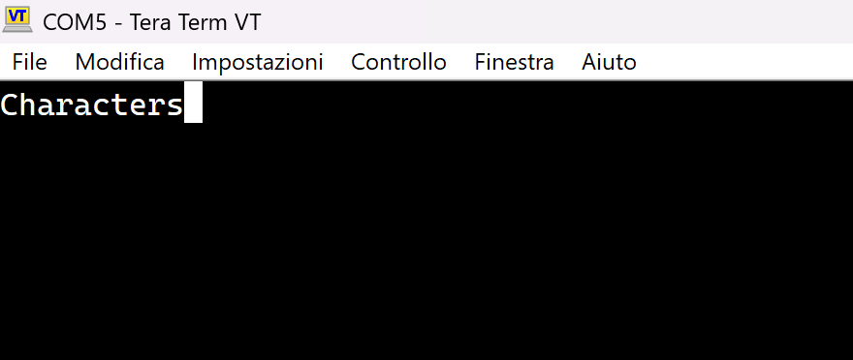
Figure 1

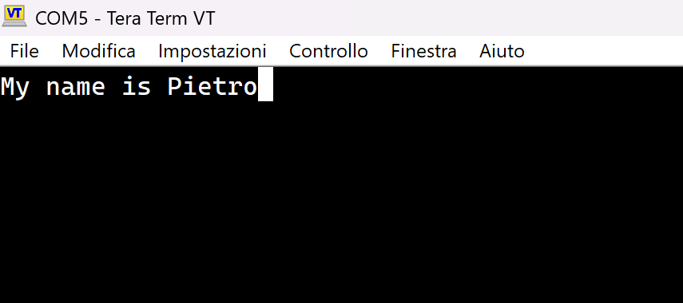
Figure 2

