APAI2025 - LAB02
DNN Definition and Training

Authors: Davide Nadalini, Ilenia Carboni, Alberto Dequino, Luca Bompani, Lorenzo Lamberti, Francesco Conti
Contacts: d.nadalini@unibo.it
Links: GitHub Link (code)

Summary
- PyTorch definition of a NN model;
- Count network’s parameters and MAC operations;
- Data loader for Fashion-MNIST;
- Code for testing a neural network on Fashion MNIST dataset;
- Code for training a neural network on Fashion MNIST;
- Save and load model’s trained weights;
Submission deadline: Oct 17th 2025

How to deliver the assignment
You will deliver ONLY THIS TEXT FILE, no code
- Download this file.
- Fill in the required results.
- Export to pdf format.
- Rename the file to: LAB<number_of_the_lesson>_APAI_<your_name>.pdf
- Use Virtuale platform to load ONLY your .pdf file

LAB STARTS HERE

0. (ONLY LAB1) Access to the local VM
- On the lab’s PCs, open the file explorer and go to This PC, C:/VM_APAI
- Double click on PULP-box.ova
- VirtualBox opens, just click on “Fine”
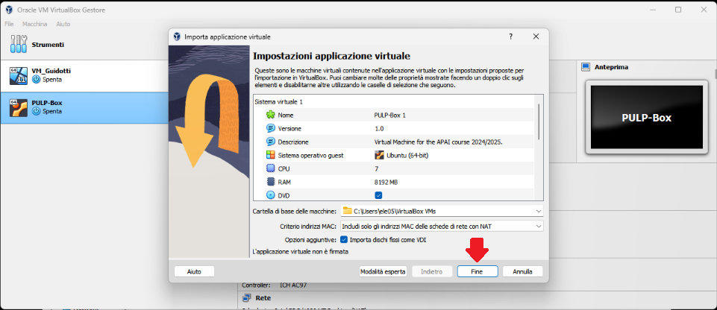
- Wait for the VM to be imported
- Open the VM with “Avvia”
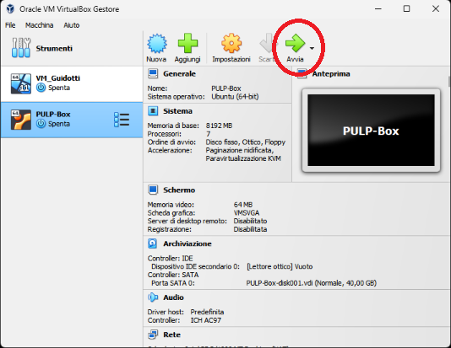
- Password is ‘pulp’

1. (ALL) Open Docker Container with VSCode
- Open a terminal (right click – open a new terminal)
- Go in the APAI-Docker folder: cd APAI-Docker
- Open Docker with VSCode: code .
- Select the pop-up option “Reopen in container”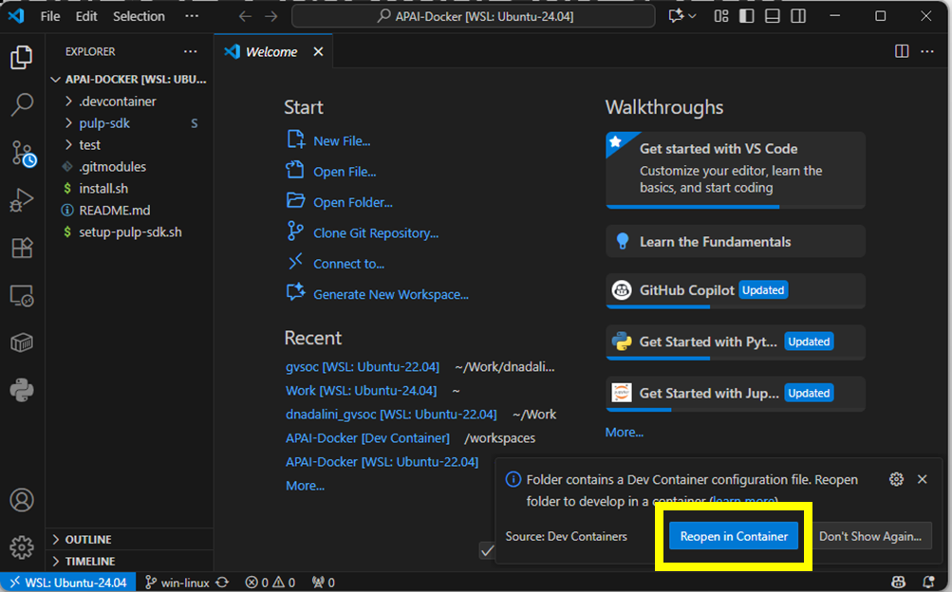
- Clone GitHub repository of today’s lab: git clone https://github.com/EEESlab/APAI25-LAB02-DNN-definition-and-training
- cd APAI25-LAB02-DNN-definition-and-training
- Click on the file to open it in your VSCode
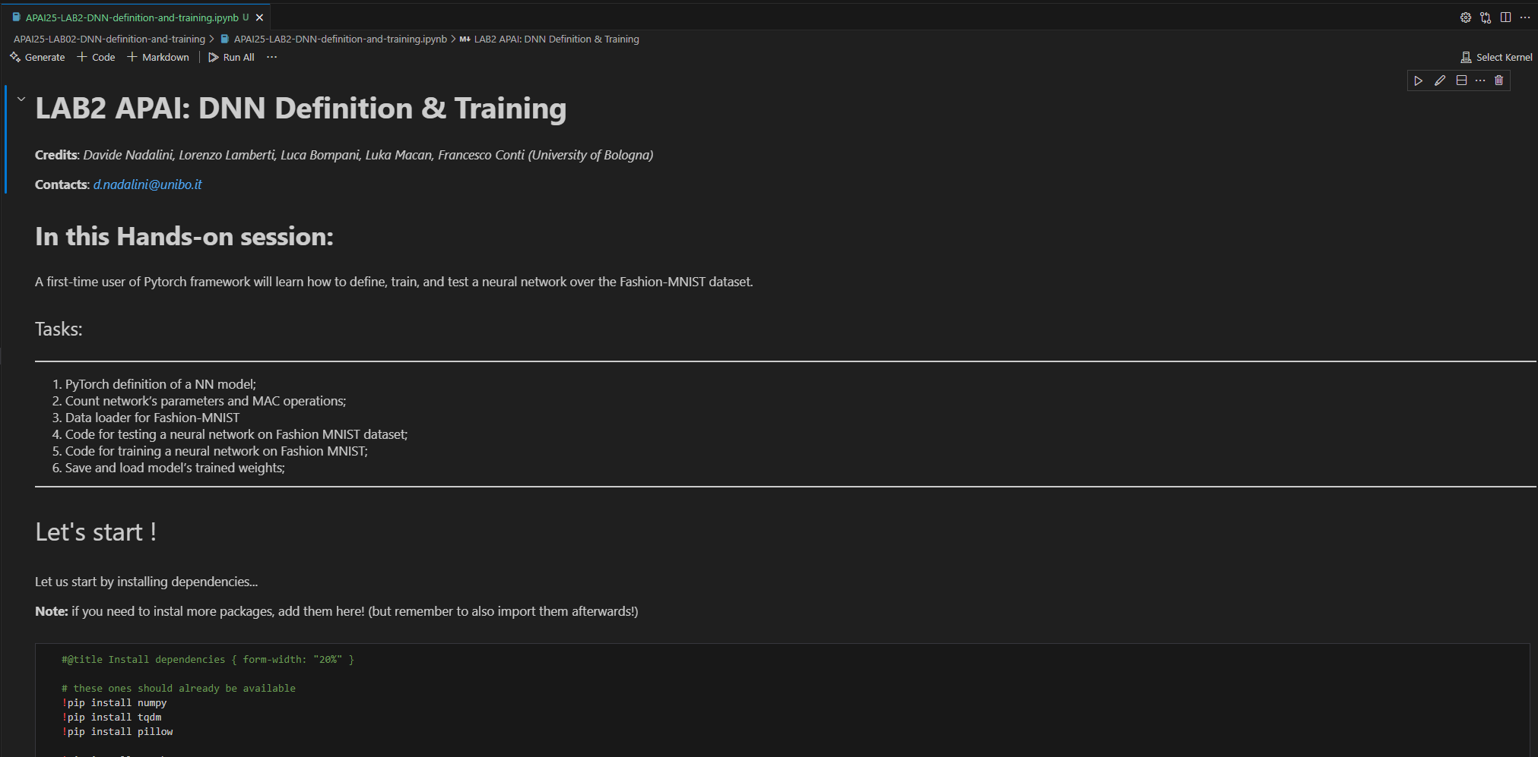
- Tu run every cell, do as in the test that you tried when you set up your Docker, that is: first, click on “Run all”
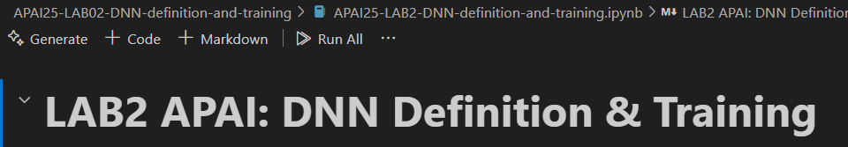
- In case you don’t have it, install the suggested extensions
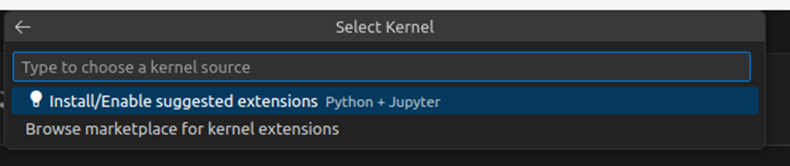
- Then, select the execution kernel
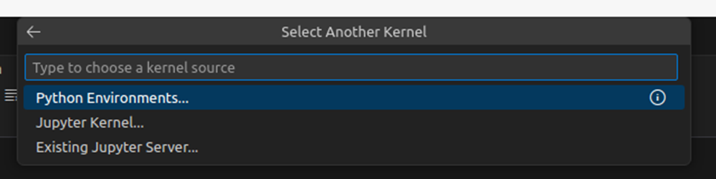
- That is your python
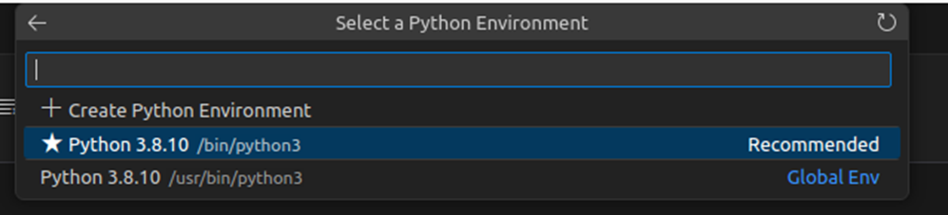
- Now, you should be able to execute even single blocks of code, as in the test (with the arrow on the upper-left corner of every block
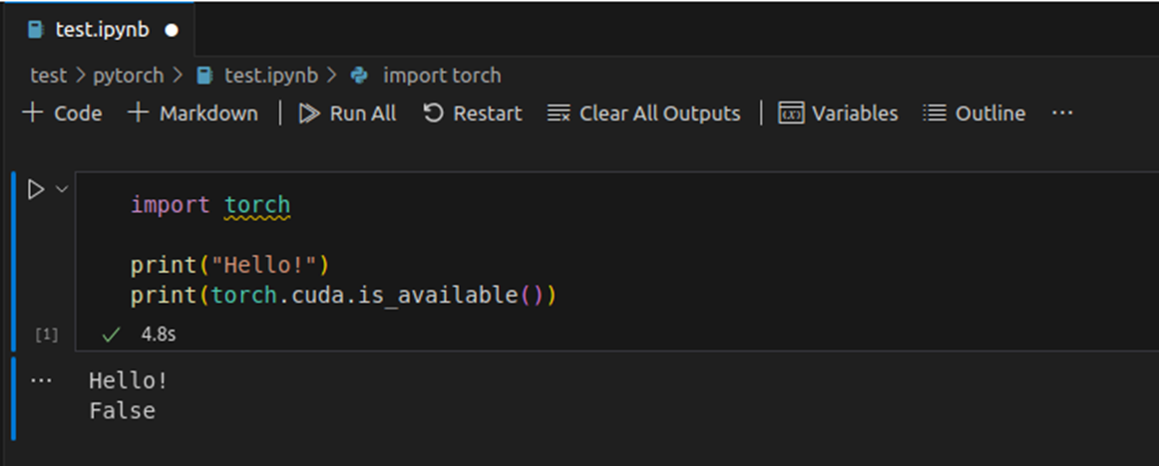

Task 1: CNN topology definition (PyTorch)
Resources: official PyTorch tutorials and documentation, Pytorch tutorial: how to define a NN
Description: PyTorch definition of a CNN topology, following Figure 1.
Output: Code of a NN definition, following Code 1 structure.

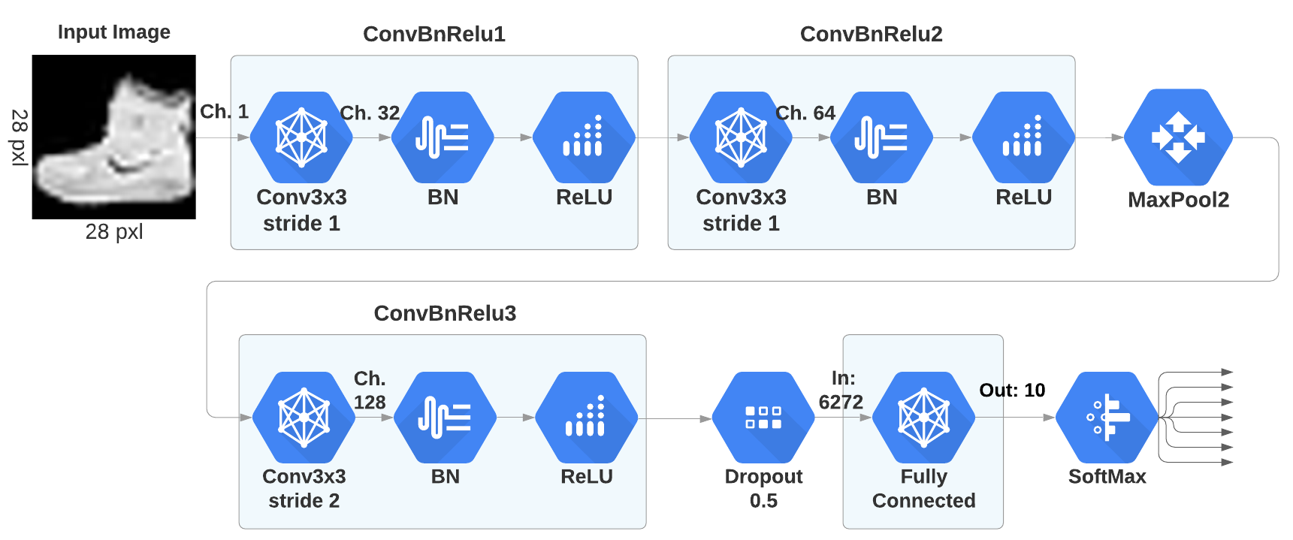
Figure 1: The Custom CNN topology.

class CNN(nn.Module):
def __init__(self):
super(CNN, self).__init__()
conv1 = ...
conv2 = ...
def forward(self, x):
…
return output

net = CNN.to(device)
Code 1.

Task 2: Count network’s parameters and MAC operations
Resources: PyTorch Info, PyTorch Operations counter, PyTroch FLOPs counter
Description: calculate the number of model’s parameters. Calculate the Multiply-Add-Operations (MACs). You can use some external pre-implemented functions from github (see refs).
Output: model size and MAC operations of the NN defined.

Task 3: Define dataset loaders
Resources: quickstart pytorch training, data_tutorial
Description: create dataset and dataloader for Fashion-Mnist for both training and validation sets. We will use these in the training loop. Make use of torchvision.datasets and torch-utils.data.DataLoader

Output: a dataset loader for training and validation sets of Fashion-MNIST.

Sub-Tasks:
- download fashion mnist with torchvision with torchvision.datasets
- define 2 transformations that we will apply to the dataset: transform data to tensor, and normalization of input pixel data
- define the dataset object
- define the dataset loader with torch.utils.data.DataLoader. batch=128.
- Sanity check: you must get 60 k training images, and 10 k validation images

Task 4: Testing a neural network in PyTorch
Resources: quickstart PyTorch,
Description: build a testing loop in order to calculate accuracy of our NN
Output: Code of the testing loop (following Code 3 structure)

Sub-tasks:
- Define an accuracy metric as (num_correct_predictions/total_n_predictions)
- write testing loop, following Code 3 structure.
- Note: Remember to set network to evaluating with net.eval()

Example:

def validate(net, dataloader, accuracy_function, loss_function):
n_images = len(dataloader.dataset)
num_batches = len(dataloader)
net.eval() # set network to eval mode
test_loss, correct = 0, 0
with torch.no_grad():
for batch_idx, data in dataloader:
inputs, labels = data[0].to(device), data[1].to(device)
# Compute prediction (forward input in the model)
…
# calculate accuracy
…
# calculate testing loss
…
# print accuracy and loss
print(f"Test Error: \n Accuracy: {(100*correct):>0.1f}%, Avg loss: {test_loss:>8f} \n")

Task 5: Training a neural network in PyTorch
Resources: quickstart pytorch training, Learning pytorch with examples
Description: training a neural network on MNIST dataset
Output: Code of a training loop, following Code 2 structure

Sub-tasks:
- Define a Cross Entropy Loss Function
- define an SGD optimizer
- write the training loop function, which takes the arguments listed in Code 2
- plot training and validation loss over epochs. this is a good practice to track the training process.
Tips:
- use .to(device) on both model and inputs, in order to use the GPU at training time. This will be much faster than using CPU!
- Use net.train() to set network to training mode before starting the main loop

Example:

def train(net, dataloader, loss_fn, optimizer):
net.train()
for epoch in range(epochs):
for batch_n, (input, label) in enumerate(dataloader):
size = len(dataloader.dataset)
X, y = X.to(device), y.to(device)
# Compute prediction (forward input in the model)
...
# Compute prediction error with the loss function
...
# Backpropagation
optimizer.zero_grad()
...
# optimizer step
...
# print: training loss and accuracy
...
# Test network on validation set
...
# print: validation accuracy, validation loss
...

Task 6: Save and load model’s trained weights
Resources: save and load PyTorch model
Description: You must be able to save and load correctly your model, as you will use it for future LAB sessions.
Output: model size and MAC operations of the NN defined

Sub-tasks:
- Save current model weights
- Load pre-trained weights to an non-initialized NN definition.
- Use the Testing function previously defined to test the new model with pre-trained weights, and get ~90% accuracy.

