APAI2025 - LAB03
DNN Shrinking and Quantization

Authors: Francesco Conti, Ilenia Carboni, Alberto Dequino, Luca Bompani, Lorenzo Lamberti,
Contacts: d.nadalini@unibo.it
Links: GitHub Link (code)

Summary
- Load model’s trained weights of LAB2;
- Reduce network’s size under 5MMAC;
- Re-train the reduced network and verify network’s accuracy;
- Quantize with Brevitas and DeepQuant;
- Export Onnx and analyze the float32 and quantized models with Netron.
Submission deadline: Oct 24th 2025

How to deliver the assignment
For this assignment, you will deliver the pre-run NOTEBOOK (.ipynb) file.
- Upload the .ipynb file to Google Colab.
- Complete the code and run every section.
- Download the completed and pre-run .ipynb file.
- Rename the file to: LAB<number_of_the_lesson>_APAI_<your_name>.ipynb
- Use Virtuale platform to load ONLY your .ipynb file

Setup:
- Open Google COLAB
- Download the .ipynb file of today’s assignment from https://github.com/EEESlab/APAI25-LAB03-DNN-Shrinking-and-Quantization
- Open your .ipynb file with Colab
- Follow the assignment and CAREFULLY read every section of the code to complete today’s lab code
- At the end, upload your PRE-RUN ipynb file on Virtuale

NOTE: We will NOT use our Docker today!

Task 1: Load Pre-Trained Model from LAB2
Resources: The pre-trained model is available at this GitHub link

Description: Define the network topology first (I already coded it for you!) and then 1) download the pre-trained weights from APAI-LAB03 GitHub, and 2) load these weights into the network.

Output: Verify the correct loading by testing our model on the validation set. You must achieve a ~90% accuracy!

Task 2: Reduce the model size below 5MMAC
Resources: 1) torchinfo (to check the network MACs), and 2) the MAC operations formula for a single convolutional layer:
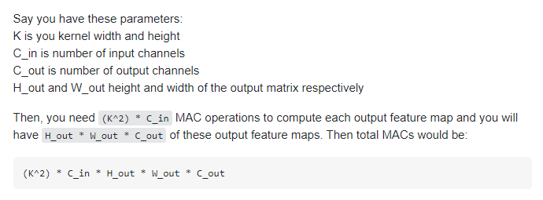
Figure 3. the MAC operations formula

Description: We want to decrease the model size below 5MMAC operations, while keeping a minimal accuracy of 90%.
All the elements in the MAC formula will affect the total MAC count. Therefore, you can shrink the network by reducing any of them. Use the previously implemented tools (torchinfo) to count parameters and MAC operations.
To decrease the model size, you can change the topology in three ways:
- Modify the number of channels in the convolutional layers.
- Add or remove layers
- Play with the “stride” of the convolutional layers.
Suggestion: work on the number of channels of each conv layer! (easiest solution)
Output: a new NN model trained on Fashion MNIST, with less than 5MMACs and at least 90% Accuracy.
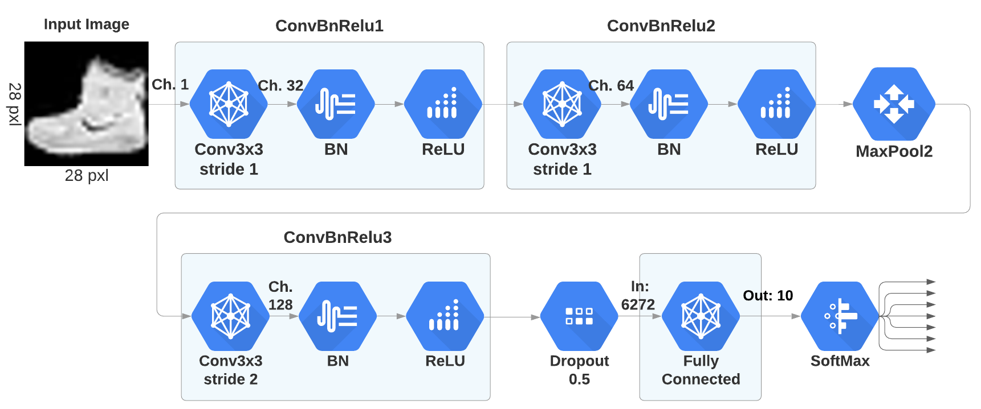
Figure 4. The original Network topology defined in LAB5. Now you must shrink it down!

Task 3: Retrain the network and verify validation accuracy
Resources: same exercise of LAB2 Task 5, but on a different network!

Description: After verifying that your reduced network fits inside the 5MMAC constraint that we gave you, it is time to train it!
In fact, we cannot load the older weights from lab5, since the topology of the network has changed. Therefore, we will apply 2 epochs of training. and we want to verify that the new network still achieves an accuracy of 90%, even if ~3 times smaller
Output: a network with less than 5MMAC that achieves a ~90% accuracy on the Fashion-MNIST dataset.

Task 4: Quantization
Resources:
- 2021 Class: Theoretical Lesson Slides: Quantization

Description: We want to quantize the network from a float32 representation to a fixed-point representation (integer) using Brevitas and DeepQuant, two quantization tools we introduce in this LAB03.
As we studied in class, quantization is a technique that allows us to compress the neural network (i.e., reduce its size) and to accelerate the inference time (float operations vs int operations). We want to quantize the network as follows:
- All activations and weights to 8 bit, biases to 32 bit

Output:
- Complete the Layer Map following instructions, by adding the type of quantized data in place of the comments.

Task5: Export to ONNX format
Resources:
- Onnx Website: ONNX
- Onnx GitHub repository: GitHub - onnx/onnx: Open standard for machine learning interoperability
- Netron (tool for visualizing ONNX models) Netron APP
Quickstart: Netron的操作 how to use Netron to visualize a ONNX model

Description: The trained networks can be exported in ONNX (Open Neural Network eXchange) format for deployment tools. This format is recognized as the official format to export a deep neural network. This format stores all the necessary elements to reload a network:
- topology: number of layers, how they are linked, and their type;
- layer structure: stride, filter dimension, channels, etc..
- parameters: for each layer, all the weights and numeric parameters are stored.
To see what the model looks like, the cell will trigger a download to your local machine and then open a frame into a tool called Netron that can be used to visualize it: just drag the ONNX file and drop it on top of the Netron frame!

Output: Use Netron to analyze the ONNX file of the floating point model and of the TrueQuantized one. What are the differences between them? Answer the following questions:

Float32 model:
- What's the data format of the convolutional layers' weights?
- Is the decimal part of the convolutional weights !=0? Paste here the value of a single weight as an example.
- What's the kernel size of all the convolutions?

Quantized Model:
- What's the size of the input image?
- What's the data format of all the convolutional weights?
- Is the decimal part of the convolutional weights !=0?
Hint: You cannot see the values of weights, differently from the Float32 Model. So reflect on the sequence of operations.
- What's the kernel size of all the convolutions?
- What’s the quantization bitwidth of the convolutional weights?
Hint: Look at the min/max values on the clip operation!

