APAI2025 - LAB04
PULP_NN

Authors: Davide Nadalini, Alberto Dequino, Francesco Conti
Contacts: d.nadalini@unibo.it, alberto.dequino@unibo.it
Links: GitHub Link (code)

Summary
- Subject(s):
  - Parallelization on the PULP architecture
  - Matrix-multiplication
  - 2D conv
  - profiling code execution
- Programming Language: C
- Lab duration: 3h
- 4. Assignment:
  - Time for delivery: 1 week
  - Submission deadline: Oct 31st 2025

How to deliver the assignment
You will deliver ONLY THIS TEXT FILE, no code
- Download this file.
- Fill in the required results.
- Export to pdf format.
- Rename the file to: LAB<number_of_the_lesson>_APAI_<your_name>.pdf
- Use Virtuale platform to load ONLY your .pdf file

LAB STARTS HERE

0. (ONLY LAB1) Access to the local VM
- On the lab’s PCs, open the file explorer and go to This PC, C:/VM_APAI
- Double click on PULP-box.ova
- VirtualBox opens, just click on “Fine”
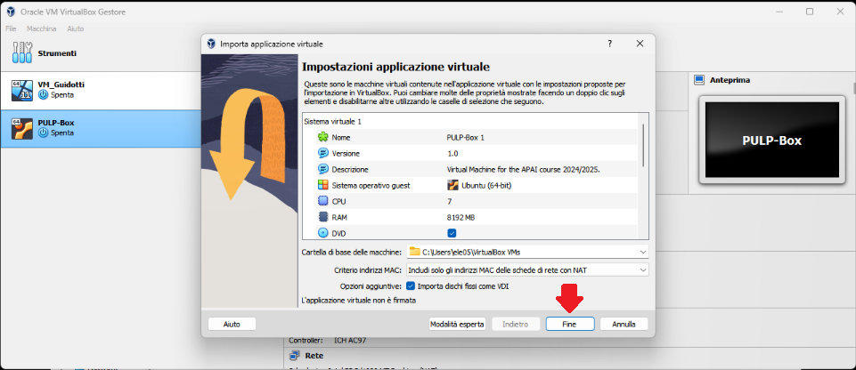
- Wait for the VM to be imported
- Open the VM with “Avvia”
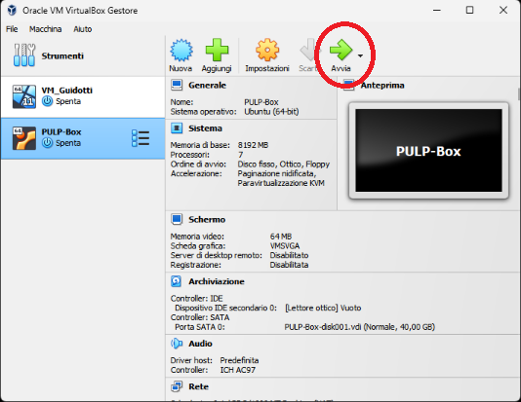
- Password is ‘pulp’

1. (ALL) Open Docker Container with VSCode
- Open a terminal (right click – open a new terminal)
- Go in the APAI-Docker folder: cd APAI-Docker
- Open Docker with VSCode: code .
- Select the pop-up option “Reopen in container”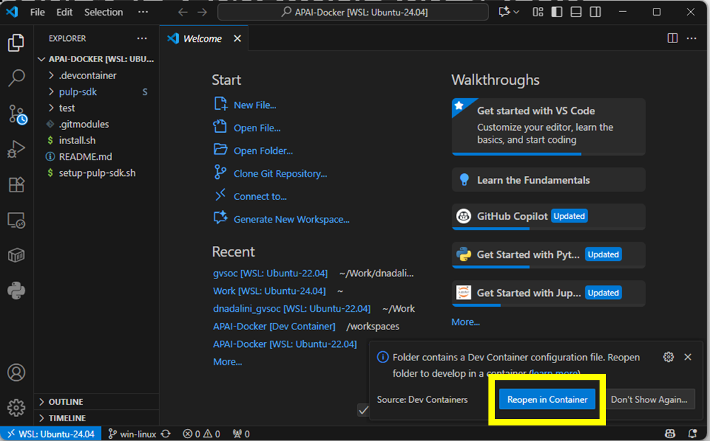
- Setup PULP-SDK: source setup-pulp-sdk.sh
- Clone GitHub repository of today’s lab: git clone https://github.com/EEESlab/APAI25-LAB01-PULP-Embedded-Programming
- cd APAI25-LAB01-PULP-Embedded-Programming
- cd <folder_you_want>
- make clean all run

Task 1: matrix-multiplication
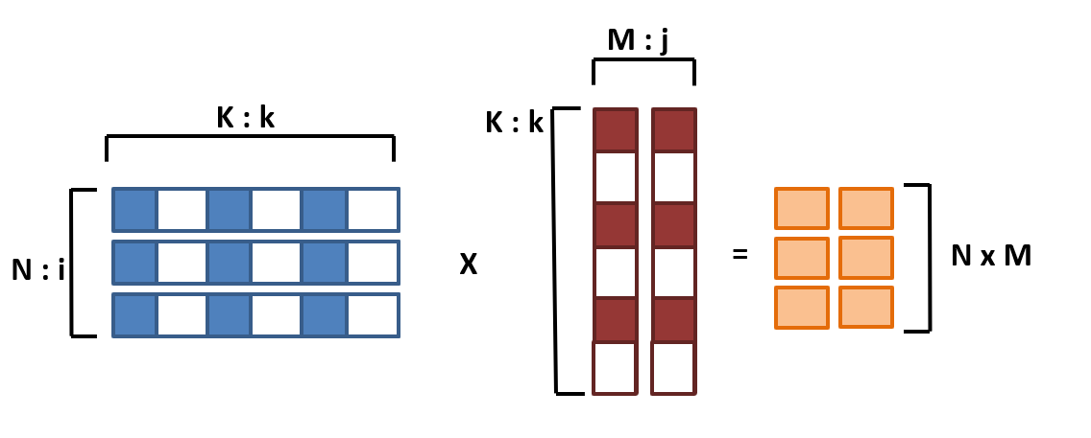
Matrices sizes: N x K * K x M = N x M
Initial sizes: N=32, M=16, K=16

1.0. Setup:
- Open VSCode (code .)
- Go to matmul_parallelization/ folder
- Every time you want to run the code, SAVE your file and write in the terminal :
make clean all run
- Don’t forget to source the sdk on new terminals:
source setup_pulp_sdk.sh

1.1. SPEED-UP and Amdhal's law:
Task Location: matmul_parallelization/cluster.c
Setup: N=32, M=16, K=16
Sub-tasks:
- Enable performance counters. You fill find them in the code → uncomment them
- Fill table below: Calculate execution cycles, and calculate speedup w.r.t. using only one core.
Tip: for executing with different numbers of cores, use the “CORES” flag.
Example: make clean all run CORES=8

CORES | Cycles | Speedup (w.r.t. CORES=1)
1
2
4
8

1.2. Explore different input sizes:
Task Location: matmul_parallelization/cluster.c
Setup:
- 8 CORES
- N=<varying> M=16 K=16
Sub-tasks:
- measure performance of each individual core (Execution cycles, and IPC)

Matrix size: N | Instructions executed (each individual core)
Matrix size: N | 0 | 1 | 2 | 3 | 4 | 5 | 6 | 7
4
8
80
81

Matrix size: N | IPC (each individual core)
Matrix size: N | 0 | 1 | 2 | 3 | 4 | 5 | 6 | 7
4
8
80
81
Answer the following questions:
- Is the workload equally balanced with N=4? Why ?
- Is the workload equally balanced with N=8? Why ?
- Is the IPC higher for N=80 or N=81? Why ?
[ANSWER]:

- measure the overall performance of the GEMM: Cycles, MACs, MAC/Cycles
Tip: Calculate the MACs by hand

N | MACs | Cycles (equal to all cores) | MAC/cycles (equal to all cores)
4
8
80
81
Answer the following questions:
- Why when N=81 the MAC/cycles is lower than when N=80?
[ANSWER]:

1.3. Load stalls & unrolling the MatMul
Task Location:
- matmul_parallelization/cluster.c
- matmul_parallelization/matmuls.c
Setup:
- 8 CORES
- N=32 M=16 K=16
Sub-task:
- Enable the performance counters of our interest. We want to profile:
  - Execution cycles (total)
  - N° instructions executed
  - Load Stalls → missing

Complete the code where you find /* YOUR CODE HERE */ with the right performance counters
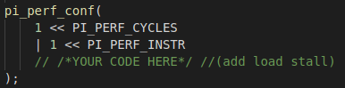
Put your solution below (code)
[HERE]
Tip: Here’s the full list of the performance counters
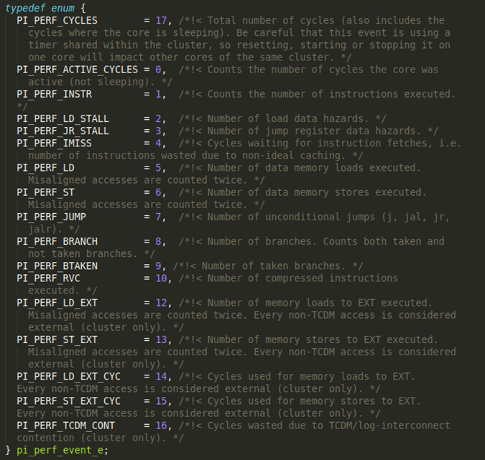
Ref: /rtos/pmsis/pmsis_api/include/pmsis/chips/default.h

- Implement missing code on the gemm_unroll(). Then manually fix the code in order to unroll 2-4-8-16 operations.
- Fill in now the table, comparing the naive gemm() vs. the unrolled version gemm_unroll()

 | stalls | Instructions | Cycles | IPC | MACs | MAC/Cycles
naive
Unrolled 2
Unrolled 4
Unrolled 8
Unrolled 16
Answer the following questions:
- Compare the stalls of “naive” vs. unrolled (2-4-8). Who has more? Why?
- Why Unrolled16 has more stalls than Unrolled8?
[ANSWER]:

1.4. (optional) Data Reuse
Read instructions inside the code

FC | IPC | MACs/cycle
naive
Reuse 2
Reuse 4
Reuse 8

Task 2: Fully Connected Layer
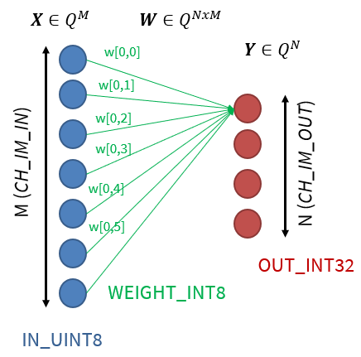

2.0. Setup:
- Open VSCode.
- Go to fully_connected/ folder
- Every time you want to run the code, SAVE your file and write in the terminal :
make clean all run
- Don’t forget to source the sdk on new terminals:
source setup_pulp_sdk.sh

2.1. MACs: FullyConnected without vs. with SIMD
Compare the number of executed instructions in the normal FullyConnected layer and the SIMD version.
- Calculate the number of MACs by hand
- Use perf counter to measure the number of executed instructions
- Change the dotp_u8_i8_i32 function to the dotp_u8_i8_i32_simd and measure the number of executed instructions again
Note: the number of executed MAC operations is dictated by the size of the FullyConnected layer, not the way operations are implemented (non-SIMD/SIMD). The formula to calculate the total number of MAC operations is:

$$MACs = Channels_{in}*Channels_{out}$$

You can find the FullyConnected layer dimensions in the data_allocation.h header file.
TIP: 8-bit SIMD instructions perform 4 MACs in 1 cycle

Cores  (#N) | SIMD | Operations  (MAC) | Instructions  (#N)
1 | No
1 | Yes

What is the ratio of instructions before/after the new SIMD implementation? Why?
[ANSWER]:

2.2. Calculate speedup

Measure the latency of a FullyConnected layer and fill out the table below.
From the measured latency calculate the performance and speedup with regard to the single core latency.

Note: to calculate the performance you will have to divide the total number of MAC operations with the measured latency.

Cores  (#N) | SIMD | Latency  (cycles) | Performance  (MAC/cycle) | Speedup  w.r.t #Cores=1 SIMD=No
1 | No |  |  | 1.0x
1 | Yes
8 | No
8 | Yes

Task 3: Convolution Layer

3.0. Setup
- Open VSCode.
- Go to convolution/ folder
- Every time you want to run the code, SAVE your file and write in the terminal :
make clean all run
- Don’t forget to source the sdk on new terminals:
source setup_pulp_sdk.sh

3.1. Speedup over multiple cores

Measure the latency of a Convolution layer and fill out the table below. From the measured latency calculate the performance and speedup with regard to the single core latency.

Note: to calculate the performance you will have to divide the total number of MAC operations with the measured latency. The formula to calculate the total number of MAC operations is:

$$MACs = Kernel Height*Kernel Width*Channels_{in}*Height_{out}*Width_{out}*Channels_{out}$$

You can find the Convolution layer dimensions in the data_allocation.h header file.

Cores  (#N) | MACs | Latency  (cycles) | Performance  (MAC/cycle) | Speedup  w.r.t #Cores=1 SIMD=No
1 |  |  |  | 1.0x
2
4
8

