APAI2025 - LAB05
Tiny Transformers, Tiny Stories

Authors: Luca Bompani, Davide Nadalini, Alberto Dequino, Francesco Conti
Contacts: d.nadalini@unibo.it
Links: GitHub Link (code)

Summary
- Subject(s):
  - Attention on the PULP architecture
  - LLama Transformer
  - profiling code execution
- Programming Language: C
- Lab duration: 3h
- 4. Assignment:
  - Time for delivery: 2 weeks
  - Submission deadline: Nov 7st 2025

How to deliver the assignment
You will deliver ONLY THIS TEXT FILE, no code
- Download this file.
- Fill in the required results.
- Export to pdf format.
- Rename the file to: LAB<number_of_the_lesson>_APAI_<your_name>.pdf
- Use Virtuale platform to load ONLY your .pdf file

LAB STARTS HERE

0. (ONLY LAB1) Access to the local VM
- On the lab’s PCs, open the file explorer and go to This PC, C:/VM_APAI
- Double click on PULP-box.ova
- VirtualBox opens, just click on “Fine”
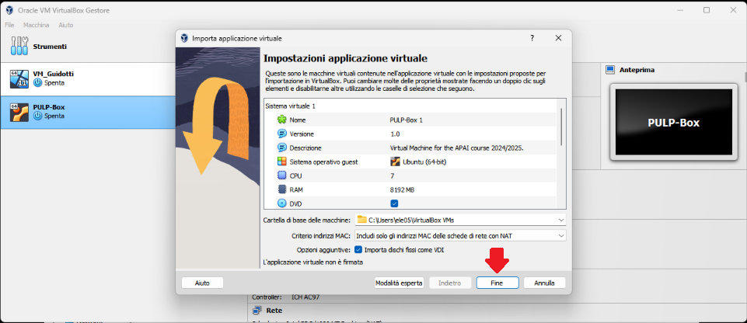
- Wait for the VM to be imported
- Open the VM with “Avvia”
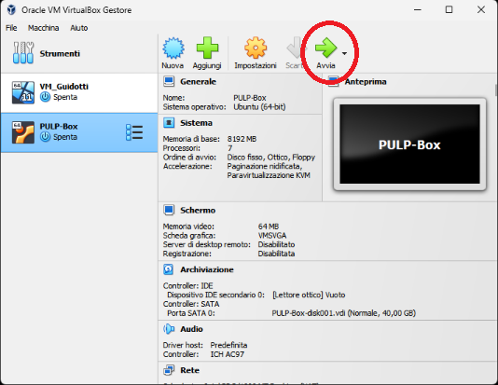
- Password is ‘pulp’

1. (ALL) Open Docker Container with VSCode
- Open a terminal (right click – open a new terminal)
- Go in the APAI-Docker folder: cd APAI-Docker
- Open Docker with VSCode: code .
- Select the pop-up option “Reopen in container”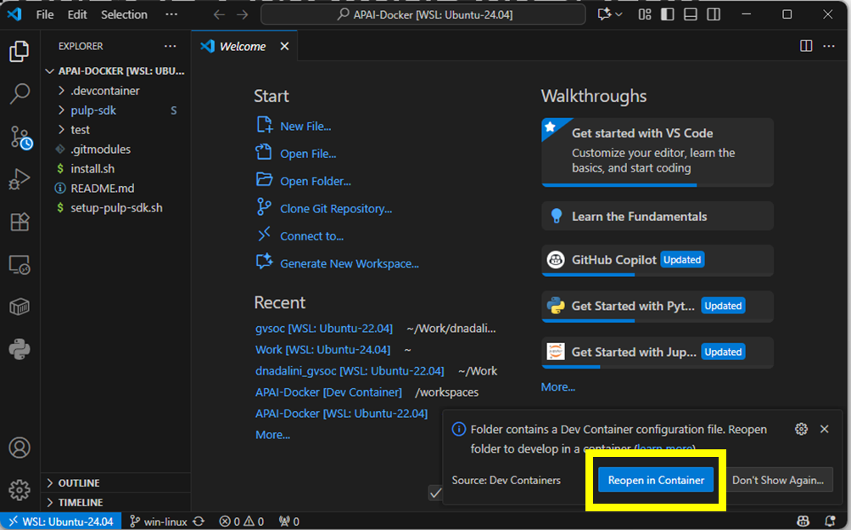
- Setup PULP-SDK: source setup-pulp-sdk.sh
- Clone GitHub repository of today’s lab: git clone https://github.com/EEESlab/APAI25-LAB05-TinyTransformers
- cd APAI25-LAB05-TinyTransformers
- source initialization.sh
- make clean all run

Introduction: LLama2 in tiny pills
Before starting, be sure to “source initialization.sh” in today’s exercise folder.
Starting from the Transformer architecture:
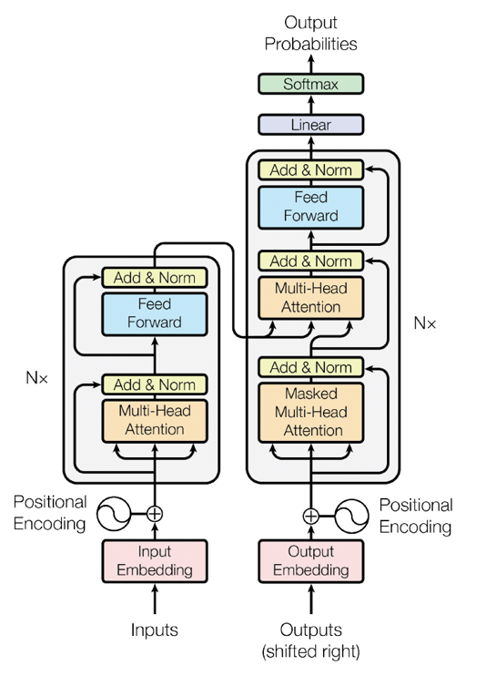
It is commonly divided into two parts: the encoder, on the left, and the decoder, on the right.
This structure was the original one proposed in Attention is All You Need.
For text generation, however, another architecture is more commonly used.
It is called decoder-only and unifies the encoder with the first layers of the decoder, using it for both input encoding and output auto-regression.
Input & Output Embedding
The Transformer we are seeing today is called LLama and it is based on this second approach.

Task 1: Attention
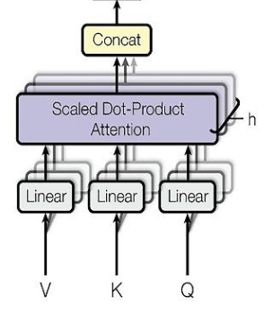
LLAMA2, as all transformers, is based on the attention mechanism. Such a mechanism is based on three tensors, computed from the input data, which are the Value (V), the Key (K) and the Query (Q). These tensors are divided between multiple heads, which provide attention to only a subset of the input features. In particular, LLAMA2 uses grouped query attention, which shares K and V among multiple heads. This means that, given $N^{H}$ attention heads, if every head will feature a different Q tensor, there will be groups of heads sharing the same K and V. The number of different groups of K and V tensors is, then, $N^{KV}$ , which are key-value heads. Instead, every token in the input sequence, which will comprise s elements (i.e., the input which is then transformed into Q, K and V) will feature a size equal to dim. The weights related to Q, K and V, which project the input embedding into the attention block, feature a size of:
$$W^{Q } =dim*dim *\frac{N^{H}}{N^{H}}$$
$$W^{K} =dim*dim * \frac{N^{KV}}{N^{H}}$$
$$W^{v} =dim*dim * \frac{N^{KV}}{N^{H}}$$
Calculate the size of each of these tensors using the formula above (the data values can be found in the conf_and_weights_fp16.h header file):
Your solution here

After computing the size of these weights, let’s implement their computation. In the provided code, substitute the missing parts in the forward function. These weights are stored in the TransformerWeights data structure. In order to execute the attention block, the data should be moved into the Cluster memory, called the L1. To do so, we will use the Cluster DMA, which can move the data between the system level memory (L2) and the Cluster memory (L1). Complete the code in the net.c file to move the weights for the Q, K and V projections in the L1 memory. Note that the weight of K and V are stored in the same matrix, while Q’s ones are separate.
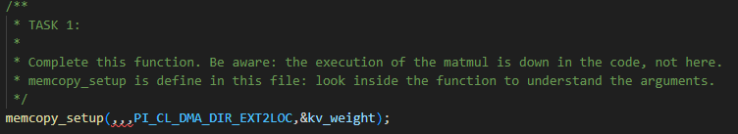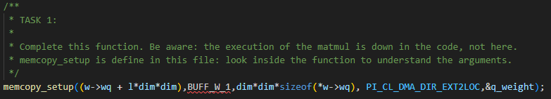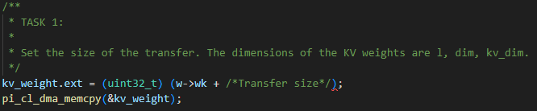
Put a screenshot or copy your code here:
Your solution here

After moving the weights in the L1 memory, the code will then compute their multiplication with the input embedding, obtaining the K V, and Q tensors.
You may have noticed a so-called “KV cache”. This is an optimization to reduce the number of computations during the autoregressive phase. During this phase, the output of TinyLlama is a function of both the input embedding and the previous outputs of the model. During the iterative autoregressive phase, which is the one in which the model generates text related to the input prompt, the model will start generating a single output token per iteration, based on the input and the previously generated outputs. The generation process will start when the input sequence is provided to the model (generating a starting token) and will progress until the model produces a stop token.
During every iteration of this phase, without optimizations, the model should recompute the K and V tensors and the attention matrix based on all the previous tokens in the sequence (i.e., the input and the previous outputs). However, this increases the computation costs a lot. Therefore, the KV cache is a matrix that stores a pre-defined number of previously computed K and V values. The KV cache acts as a shift register, where the oldest K and V values are discarded, keeping the memory cost bounded. Its behaviour is depicted in the image below.
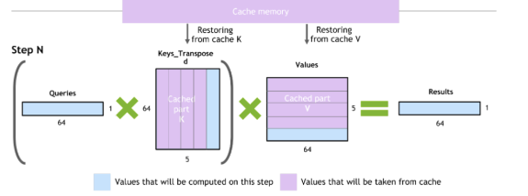
We now have all the elements to perform the attention, which is composed of a series of matrix vector operations. We will now implement missing code concerning the attention block (the Multi-Head Self-Attention or MHSA).
Complete the code in the MHSA.c file: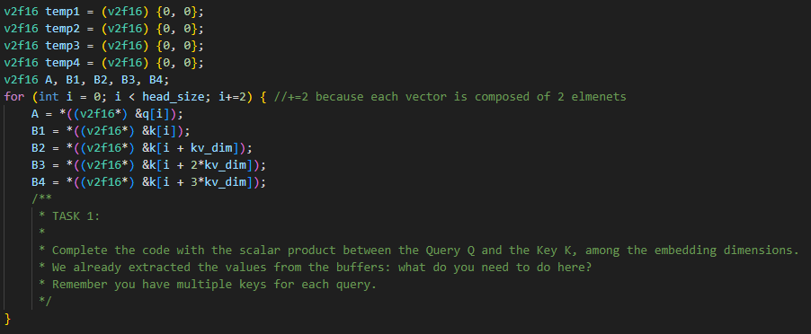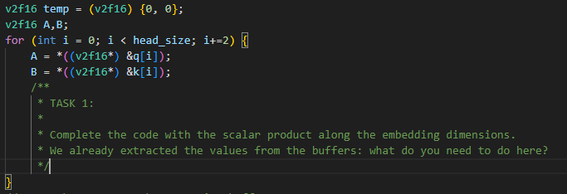
Put a screenshot or copy your code here:
Your solution here

Task 2: Using your transformer
Now, let’s go to TinyLlama’s execution. In every iteration, the transformer will, at first, do a forward step to compute the prediction with respect to its inputs and the previous tokens (stored in the KV cache). Then, the model will sample the correct token among the outputs of the current inference. Finally, it will do the decoding. Following the scheme of the transformer architecture, complete the code in the “net_step()” function of net.c file. Try to read their source code to gain more insights of the inner mechanisms on how the model actually works.
To complete this exercise, simply call the correct function for each location.
First, uncomment this code:
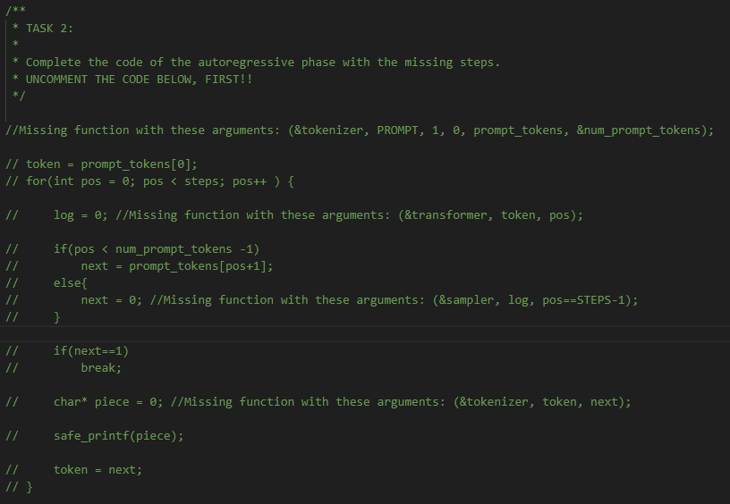
Then, complete it with the missing functions:
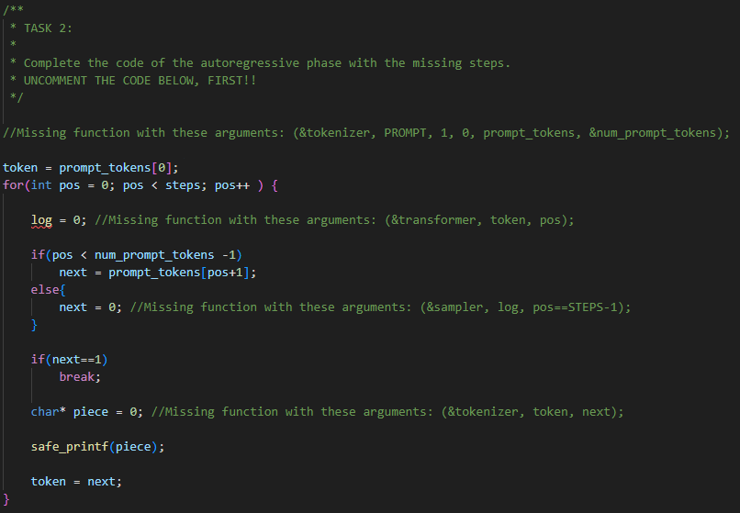
All the functions are already declared and defined in the various .c files included in this laboratory.
Put a screenshot or copy your code here:
Your solution here

After completing the task, activate profiling for layer l ==0 using the RESET_STATS(),START_STATS() and STOP_STATS() macros defined in the stats.h header.
You must also enable them by uncommenting the following line in the main folder’s Makefile:
# APP_CFLAGS += -DSTATS
Answer the following questions:
What is the number of cycles to compute the K, Q, and V tensors? You can see there are many of them (autoregressive mode), please report one of the values. Your solution here
What is the number of cycles necessary for the calculation of the attention? If you look at the numbers of every iteration, do you notice a change in their value? Your solution here

Answers must be commented on.
Try to give an explanation of the obtained results.

Task 3: Run the model
With the previous steps, we then completed the code of our TinyLlama. In this step, we will generate a story with our transformer! To do so, run “make clean all run”.
Run the full model and copy the story that has been generated:
Your solution here

