LABORATORY EXERCISE 9

SEARCH AND FILTERING SYSTEM

Learning Objectives
By the end of this laboratory exercise, students should be able to:
- Implement client-side search filtering using jQuery for dynamic user experience.
- Develop server-side search functionality using CodeIgniter's database queries.
- Create a responsive search interface using Bootstrap components.
- Integrate AJAX techniques to display search results without page reload.
- Understand the differences between client-side and server-side search approaches.

Prerequisite student experiences and knowledge
Before starting this exercise, students should have:
- Completed Laboratory Exercise 8 (Real-time Notifications with jQuery).
- Solid understanding of CodeIgniter's MVC architecture and database operations.
- Proficiency in writing jQuery and JavaScript code for DOM manipulation.
- Experience with AJAX requests and handling JSON responses.
- Familiarity with Bootstrap form components and grid system.
- Knowledge of SQL queries, particularly LIKE operators for search functionality.

Background
An effective search system is crucial for any Learning Management System (LMS) to help users quickly find relevant courses and content. This exercise focuses on implementing a dual-approach search system: client-side filtering for immediate feedback and server-side searching for comprehensive results. jQuery provides the tools for dynamic client-side filtering, while CodeIgniter's database class enables efficient server-side search using SQL LIKE queries. The combination creates a seamless user experience where search results update in real-time without page refreshes, enhancing the overall usability of the application.

Materials/Resources
- Personal Computer with Internet Access
- XAMPP/WAMP/LAMP server installed
- CodeIgniter Framework
- Visual Studio Code or any code editor
- Git and GitHub Account
- Web Browser (Chrome, Firefox, etc.)
Laboratory Activity
Step 1: Project Setup
- Open your existing ITE311-LASTNAME CodeIgniter project.
- Ensure your database has a courses table with sample data for testing search functionality.
- Verify that your course listing page is functional from previous exercises.

Step 2: Create Search Controller Method
- Navigate to your Course.php controller in app/Controllers/.
- Add a new method named search():
  - This method should accept GET or POST requests with a search term parameter.
  - Use CodeIgniter's Query Builder to search the courses table using LIKE queries.
  - Return the results as JSON for AJAX requests or render a view for regular requests.
- Implement the search logic
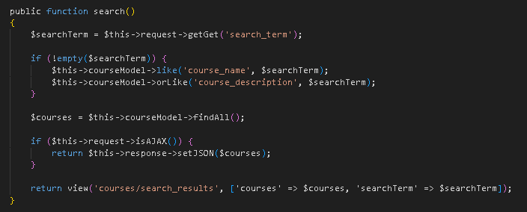

Step 3: Add Search Route
- Open app/Config/Routes.php.
- Add routes for the search functionality:
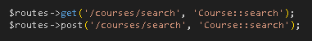

Step 4: Create Search Interface
- Modify your courses view file (app/Views/courses/index.php).
- Add a search form with Bootstrap styling
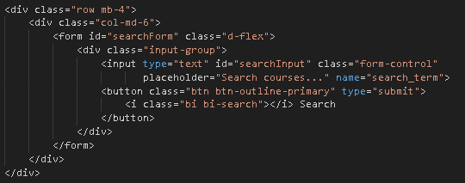

Step 5: Implement Client-Side Filtering with jQuery
- Add jQuery script for instant client-side filtering
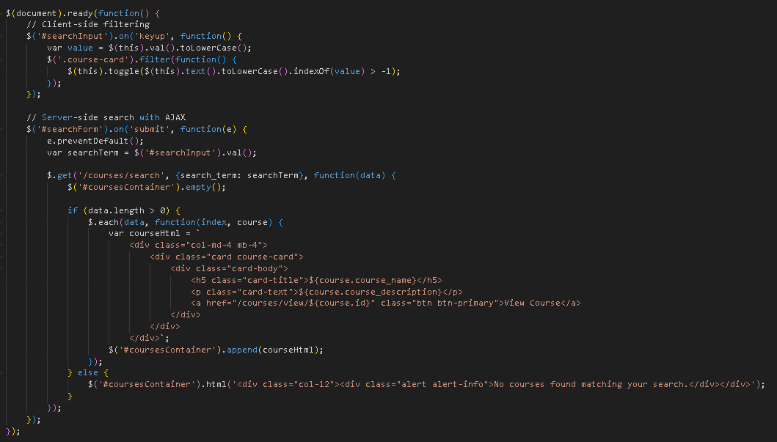

Step 6: Update Courses View Structure
- Modify your courses listing to work with the search functionality
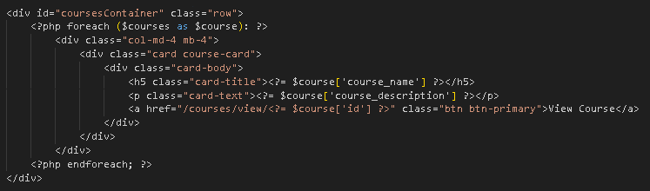
- To simulate real-time updates, you can set an interval to fetch notifications every 60 seconds (optional advanced task).

Step 7: Test the Search Functionality
- Load the courses page in your browser.
- Test the client-side filtering by typing in the search box courses should filter instantly.
- Test the server-side search by submitting the form results should load via AJAX without page refresh.
- Verify that both empty search results and successful searches display appropriate messages.

Step 9: Push to GitHub
- Stage and commit your search functionality
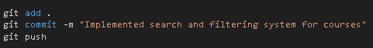

Output / Results
- Screenshot of the courses page with the search interface implemented.
- Screenshot showing filtered courses during client-side search.
- Screenshot of browser Developer Tools Network tab showing AJAX request to server-side search.
- Screenshot of search results displaying when no courses match the search term.
- Screenshot of GitHub repository with the latest commit.

QUESTIONS:
- What are the advantages and limitations of client-side filtering compared to server-side search?

Client-side filtering is faster and smoother because it uses data already loaded in the browser, giving instant results without contacting the server. However, it struggles with large datasets, can expose sensitive data, and becomes outdated unless the page is refreshed.

Server-side search handles large data better, is more secure, and always returns updated results, but it is slower because it needs to send a request to the server each time.

- How does using AJAX for search improve the user experience compared to traditional form submission?

Client-side filtering is faster and smoother because it works instantly in the browser, but it struggles with large or sensitive data. Server-side search is more secure and accurate for big datasets but requires server requests. Using AJAX improves the user experience by updating search results without reloading the page, making the process quicker and more seamless.

- What security considerations should be taken when implementing search functionality with user input?

Client-side filtering is fast and smooth but only works well for small, non-sensitive data, while server-side search handles large datasets securely but is slower. Using AJAX improves user experience by updating results instantly without reloading the page. When implementing search, always sanitize user input, use parameterized queries, and avoid exposing sensitive data to prevent SQL injection and other attacks.

Output / Results

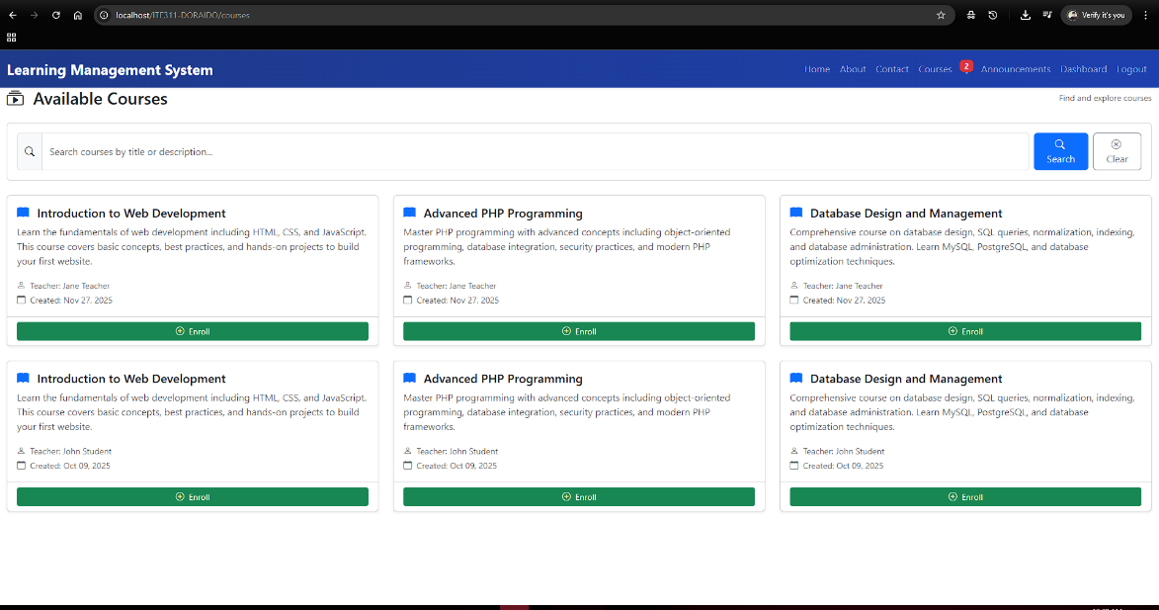

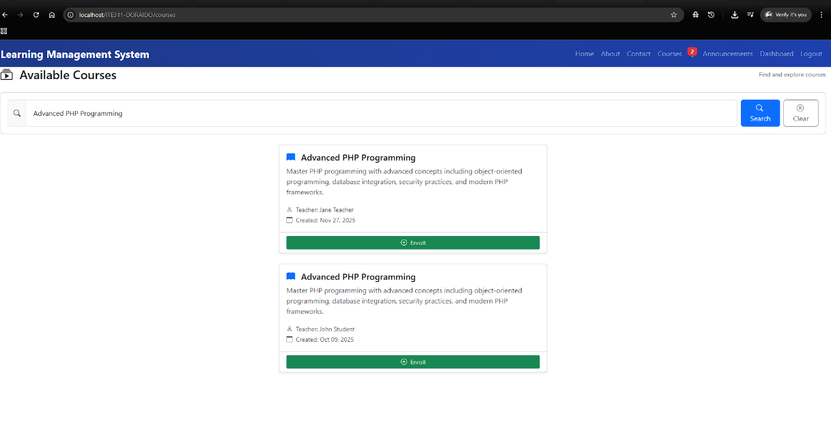

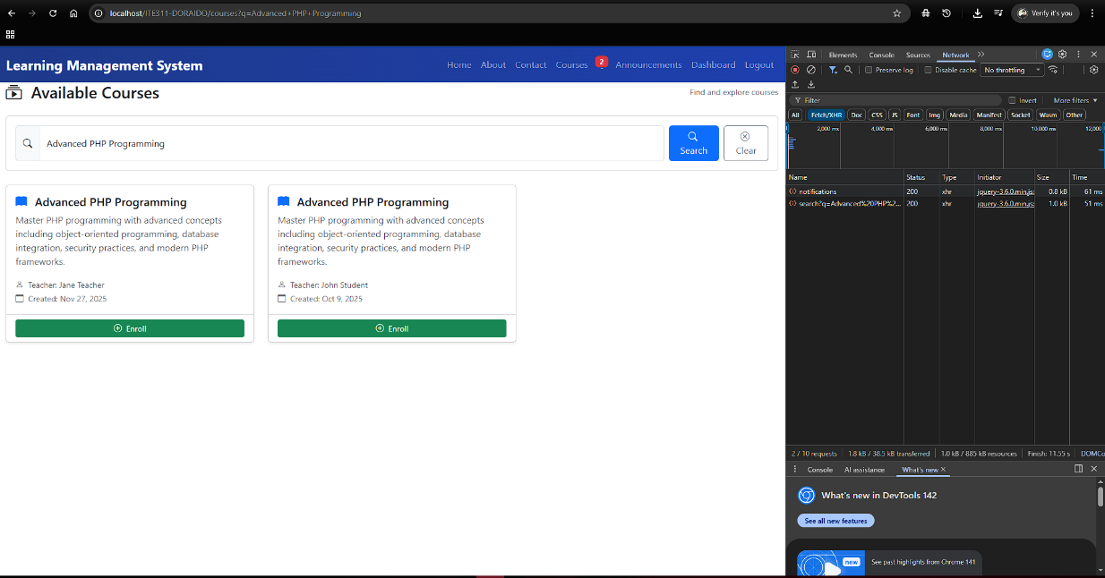

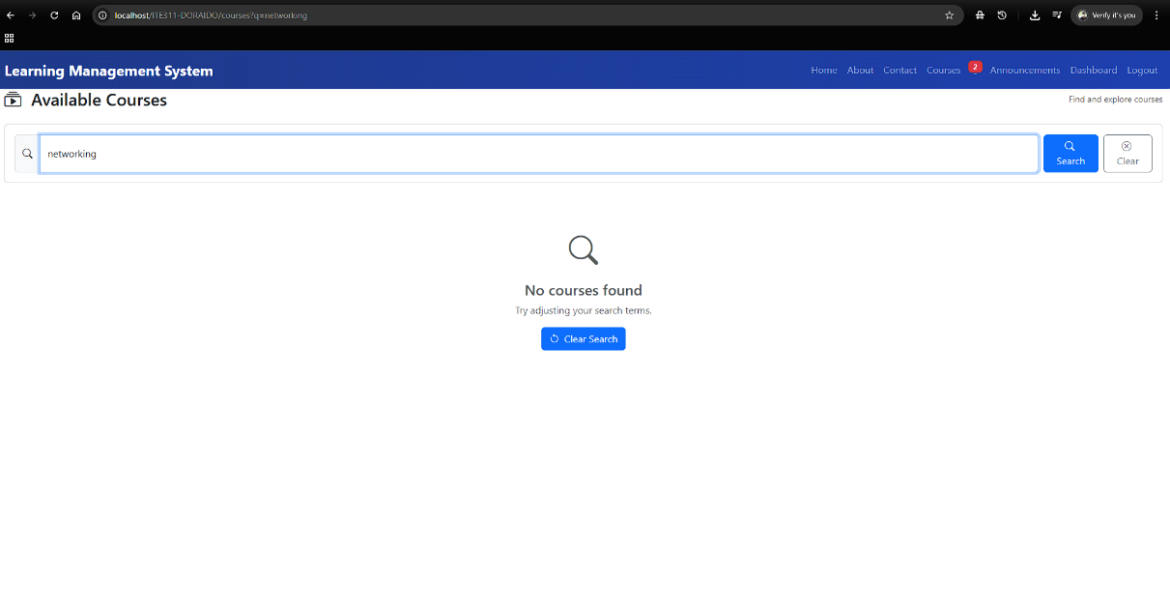

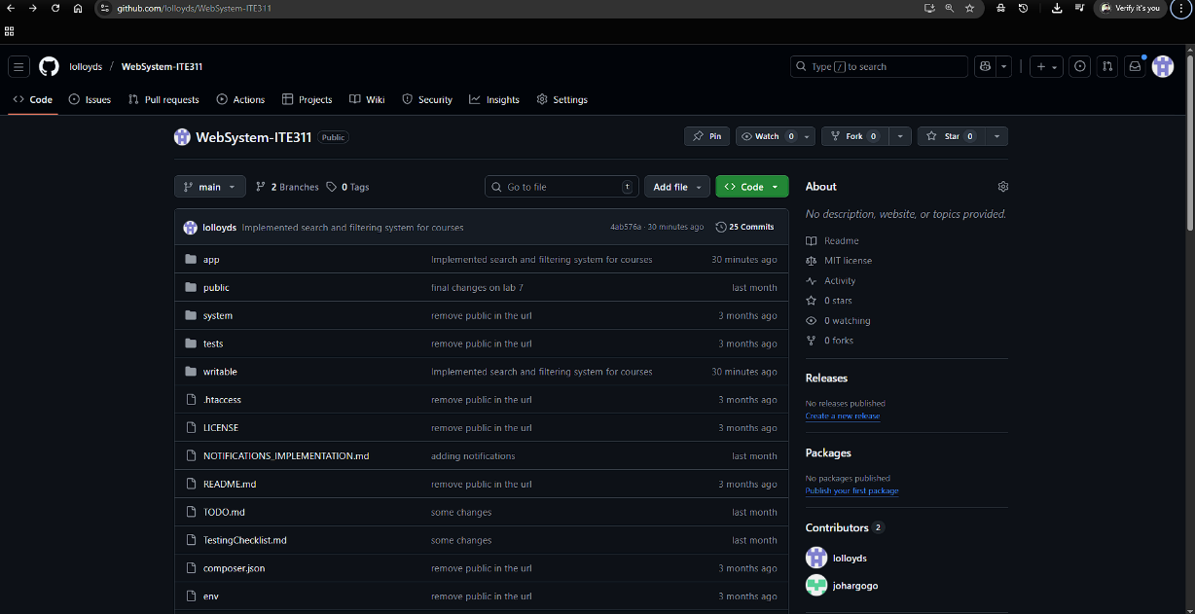

Conclusion
Client-side filtering is fast and smooth because it works directly in the browser, but it struggles with large or sensitive data. Server-side search is more secure and handles bigger datasets but is slower since it needs server requests. Using AJAX improves the user experience by loading search results instantly without refreshing the page. When handling user input, the system must protect against SQL injection, sanitize inputs, and avoid exposing sensitive data.

