# Unit: ITSFT-406-1504

Programming for Computer Games

## Home Assignment 1 Designing and creating a basic 2D game

### Notes:

1. This is a guided Home Assignment
2. There will be review days, where your lecturer will guide you on your assignment completion. It is strongly suggested that you adhere to the review days to avoid assignment cramming and avoid losing marks.
3. You may refer to websites, forums, etc. for this assignment but you must include a reference (Harvard style) at the end of the assignment.
4. The final documentation should be uploaded on Turnitin by

**Monday 18 December 2017 12:00pm**

1. The program files must be uploaded (last commit) on Github, also by **Monday 18 December 2017 12:00pm** and the link shared with your lecturer.

### There will be no printed assignment submission, just soft copy.

***Scenario:***

### You have been asked to design and develop a 2-player ball game.

The game should have a Play Area, with borders and 2 goal scoring posts. 2 players should guard their own goal and try to score in the opposing player’s goal by reflecting a ball into the goal.

The player who reaches a set amount of score first wins and the game goes to another level, presenting the same play area, but increasing difficulty such as obstacles and increased ball movement. Scoring in Level 2 should be higher than Level 1 and include static obstacles.

Level 3 should be similar to Level 2 but having moving obstacles. There should be at least 3 levels in the game.

The players’ scores should be shown in UI Text and at the end of the last level, the player with the highest score wins.

The game should have 1 Menu Screen (Start or Quit), 3 Game Levels, 1 End Screen showing the scores and who won.

Player 1 should be controlled by the keyboard while player 2 should be controlled using the mouse.

For the game you can make use of any type of assets.

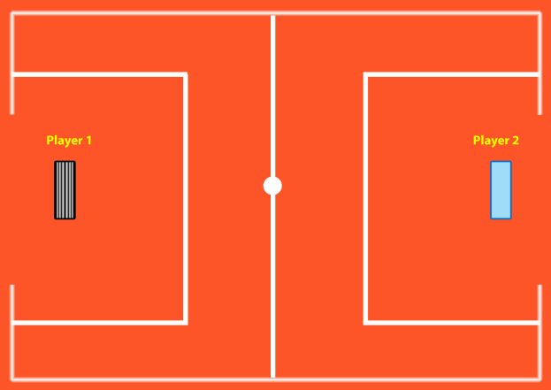

Above is a sample of how the Play Area should

Question 1 (AA1, AA2): *14 marks*

* 1. Select 2 game engines *(1 mark)* and list 4 reasons *(1.5 marks each)* why one particular game engine was selected (giving advantages of the game engine) and why the other was not selected.

Unity3D:

* The First Advantages is because it doesn’t require a high learning curve.
* The Unity has a very high community support and it is used by a lot of people you can find videos on YouTube that might inform you with an error.
* The Third Feature is that is the multiplatform where you can publish your game over 20 platforms such as iOS, Windows Prime and more.
* The Forth feature is that it’s free for beginners and students which is why that this feature helps people use game engine.

I choose Unity3D because it is the best engine with the new users since it doesn’t require a high learning curve. Also since there is the free version you can create a simple game and if you don’t understand a part the community might have already fixed the problem you just need to research.

*7 marks*

2. Select 2 programming languages *(1 mark)* used in game development and choose one to support the game engine chosen and list 4 of its features *(1.5 marks each)*

The program is C# this program is used in unity which is used for coding and adding points or rules or physics.

C# feature:

The First feature is that it is portable executable the file C# can contain classes but in java there is only one class/

The Second feature is that it is multiplatform it can run on windows, mac and Linux.

The Third feature is its simplicity to other programs.

The forth feature is its fast speed it is very smooth and requires less resources to run it.

*7 mark*

Question 2 (SE1): *10 marks*

Prepare detailed design documents for the game:

1. One Game design document (State Diagram) should contain an overview of the whole game, from the Start Menu till the end showing correctly the interactions between the scenes

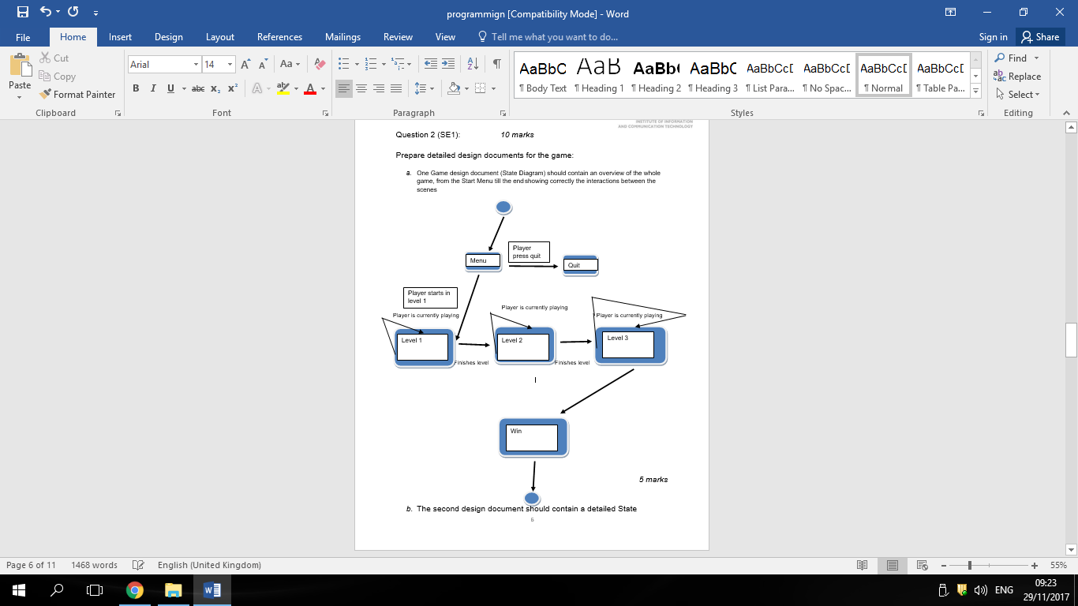

*5 marks*

1. The second design document should contain a detailed State Diagram of either Level 2 or Level 3 of the game showing correctly all events and interactions happening in the scene

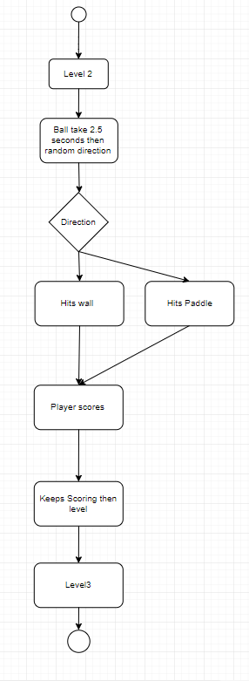

*5 marks*

Question 3 (KU 4)

In not less than 100 words, explain why compression is needed when using media assets such as images, videos and audio. Provide examples.

The reason for compression audio and images is usually to organize while also decreasing the file size so that there won’t be waste of storage. For example that the videos sounds and images that are all needed have a very large number in data usage and maybe you don’t have enough space in your computer or pen drive, this is used to reduce the redundant data in the sources needed and you will have space. The software which is mostly used for compression is called Winrar, it is free and you don’t need to buy it since the company that made it made a mistake and we have full access

Question 4 (KU1, KU 5, KU6, KU7, KU8) *25 marks*

Implement the game in Unity and C# as explained in the scenario and as described in the Game Design Documents above using the techniques you have learnt so far and researching others. Some programming techniques which you are expected to use include:

* Proper variables
* Scripts assigned to proper GameObjects
* Decision-making
* In-built methods and functions
* User-created Methods
* UI Text and Buttons
* Scene Management
* GameObjects and or prefabs
* FindObjectOfType
* Sprites (as players and background)
* Physics2D (Colliders, Triggers, Rigidbody, Materials, velocity)
* Input by mouse and keyboard

In your program you are expected to:

1. Make use of proper assets and arrange their settings to suit your needs. Images need to have their resolutions or pixels per unit properly set and not scaled.

Assets should be properly used and properly called programmatically when needed

*(5 marks)*

1. Program different input devices and methods for your game

*(5 marks)*

1. The game should be free from defects, as such you are expected to carry out proper programming and debugging using C# and Unity IDEs.

The whole program should work as expected according to the lecturer’s standards.

*(10 marks)*

1. Make use of GitHub for version control as one way to address resolution issues during development. You are expected to have at least 10 commits (with proper comments) over a span of 3 weeks (21 days), making sure to keep track of the review dates below

Also upload your part of the assignment by the review date given below on Turnitin, to be able to address issues during documentation and design

*(5 marks)*

Reviews:

Reviews will be held periodically to help you in your assignment. There will be a total of 3 reviews before the Assignment Final Submission as follows:

|  |  |  |
| --- | --- | --- |
| **Review Date Questions to review** | | |
| **1** | Week ending 1 December 2017 | 1, 2, 3 |
| **2** | Week ending 8 December 2017 | Part of Q 4 |
| **3** | Week ending 15 December 2017 | Part of Q 4 |

Adhering to the review dates will benefit you in the end as it is attached to Question 4d.

**Assignment Rubric**

|  |  |
| --- | --- |
| **Criteria and tasks** | **Marks** |
|  |  |
| **KU 1: Select a game engine and programming language** |  |
| Carry out proper programming and debugging using C# and Unity IDEs | **5** |
|  |  |
| **KU 4: State the relevance of compression settings in media assets** |  |
| Explain why compression is needed in media assets | **5** |
|  |  |
| **KU 5: Identify suitable resolutions for images of various types** |  |
| Make use of proper assets and arrange their settings to suit your needs. | **2** |
| Assets should be properly called programmatically when needed | **3** |
|  |  |
| **KU 6: Select asset types and settings for a range of media assets for a game design** |  |
|  |  |
| Make use of the techniques mentioned in Question 4 to implement the Game Design in Question 2 | **5** |
|  |  |
| **KU 7: Identify resolution issues for the development platforms** |  |
| Use Turnitin and GitHub for assignment submission by the assigned review dates | **5** |
|  |  |
| **KU 8: Identify appropriate input devices and methods for the**  **development platforms** |  |
| Use different input devices and methods | **5** |
|  |  |
| **AA 1: Compare game engines** |  |
| Select 2 game engines | **1** |
| Compare the differences between game engines | **6** |
|  |  |
| **AA 2: Compare programming languages** |  |
| Select 2 programming languages used for computer games | **1** |
| Compare the difference between the languages | **6** |
|  |  |
| **SE 1: Design and specify the details of the game to be developed including a state machine** |  |
|  |  |
| Create a State Diagram showing an overview of the whole game | **5** |
| Create a detailed State Diagram of Level 2 or Level 3 showing all interactions and events in the game | **5** |
|  |  |
| **TOTAL MARKS:** | **54** |
|  |  |