Synchronous - Running everything in order

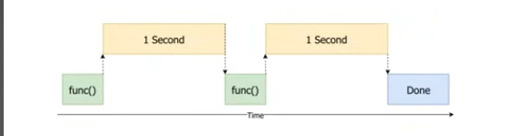

CPU bound and I/O bound tasks

Cpu bound tasks

-data crunching

i/o tasks

-read and write

We benefit from threading when performing i/o tasks

-threading – gives the illusion of performing things parallel

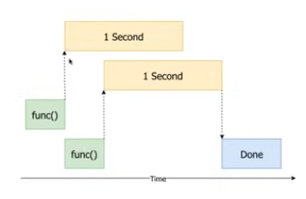

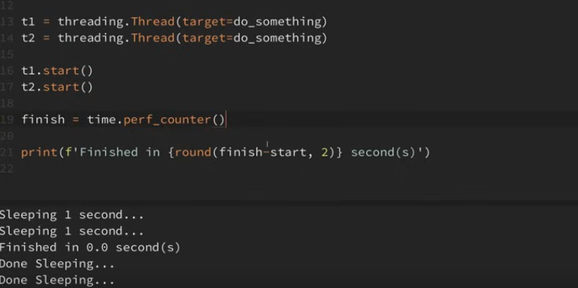

Program continued to run the code, even while asleep and calculated then printed the finished time. After 1 second it then continued the two threads, which is why two Done sleeping texts were printed. All of these are performed in 1 second