Servo Response Measurement Report
Leg A through Leg H | Video-based angle tracking
Result. Across the eight recordings, measured travel averaged 112.1 deg. The commanded range was 0-180 deg, so the video measurement captured about 62% of the commanded travel.

Summary
Leg | Travel (deg) | Top speed (deg/s) | Start (s) | Settled (s) | Movement (s)
A | 113.2 | 274 | 4.40 | 4.87 | 0.47
B | 112.3 | 268 | 4.43 | 4.93 | 0.50
C | 112.5 | 270 | 4.27 | 4.77 | 0.50
D | 112.7 | 273 | 3.73 | 4.23 | 0.50
E | 112.2 | 270 | 3.17 | 3.63 | 0.47
F | 113.1 | 271 | 4.97 | 5.47 | 0.50
G | 109.4 | 267 | 4.53 | 5.00 | 0.47
H | 111.3 | 269 | 4.07 | 4.57 | 0.50
The angle sign records rotation direction; travel values in the table use magnitude. Timing starts at detected motion, not at the unrecorded controller command.

Conclusions
Although the system worked correctly and the software was validated as a potentially valid method for analyzing response quality, the leg dimensions used were not adequate to see a significant measurement discrepancy. Which in the one hand is good, because it means that the size and shape of the legs we choose to use for the biped project should not be massively impactful at least on the speed of the servo response at the scale we wish to work with. On the other hand, to make a proper analysis and study of the servos capabilities we should repeat the experience with a larger more significant variation of legs.
It is also worth noting that the quality of the analysis will be impacted by the quality of the video recorded, mainly the framerate, this study was made at roughly 30FPS, which is not much, but a repeat with 120FPS would see a significant improvement in resolution (well within normal smartphone capabilities), that alongside a more significant change in the moment of inertia with a larger more massive leg would be more interesting.

Leg A response
Design Straight rectangular link, 100 mm long and 22 mm wide.
Measured travel: 113.2 deg (negative direction) | Top speed: 274 deg/s | Movement time: 0.47 s | Window: 4.40-4.87 s
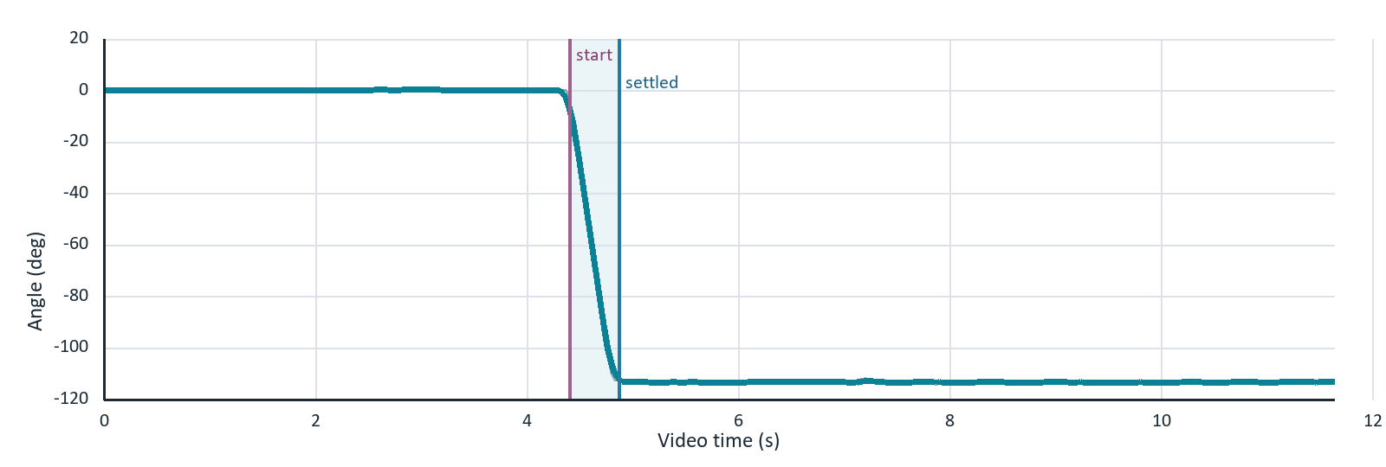
Gray: frame-level angle. Cyan: 5-frame moving average. Shaded region: detected movement window.

Leg B response
Design Straight rectangular link, 80 mm long and 22 mm wide.
Measured travel: 112.3 deg (negative direction) | Top speed: 268 deg/s | Movement time: 0.50 s | Window: 4.43-4.93 s
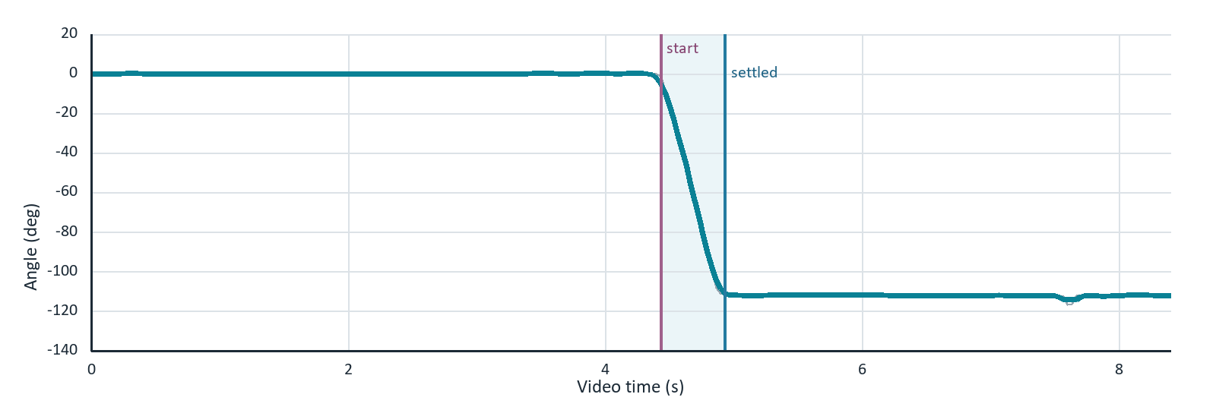
Gray: frame-level angle. Cyan: 5-frame moving average. Shaded region: detected movement window.

Leg C response
Design Straight rectangular link, 60 mm long and 22 mm wide.
Measured travel: 112.5 deg (negative direction) | Top speed: 270 deg/s | Movement time: 0.50 s | Window: 4.27-4.77 s
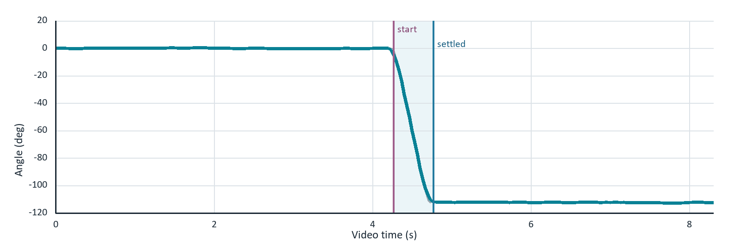
Gray: frame-level angle. Cyan: 5-frame moving average. Shaded region: detected movement window.

Leg D response
Design Straight rectangular link, 60 mm long and 28 mm wide. This agrees with the approximate 3 cm width.
Measured travel: 112.7 deg (negative direction) | Top speed: 273 deg/s | Movement time: 0.50 s | Window: 3.73-4.23 s
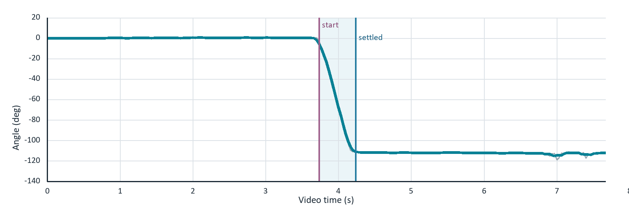
Gray: frame-level angle. Cyan: 5-frame moving average. Shaded region: detected movement window.

Leg E response
Design Perforated truss link with a 100 mm overall drawing length. Simil leg A, but with weight reduction.
Measured travel: 112.2 deg (negative direction) | Top speed: 270 deg/s | Movement time: 0.47 s | Window: 3.17-3.63 s
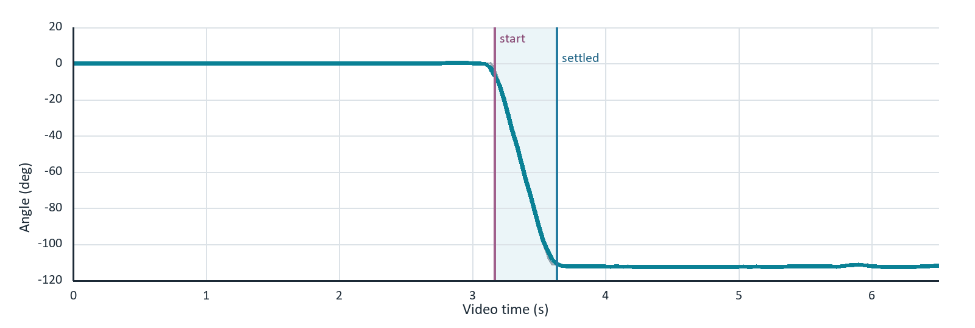
Gray: frame-level angle. Cyan: 5-frame moving average. Shaded region: detected movement window.

Leg F response
Design Waisted link with thicker pivot regions and a thin center. The schematic shows 100 mm overall length, 78 mm between the pivot center marks, 22 mm diameter ends, a 10 mm center section, and R35 transitions.
Measured travel: 113.1 deg (negative direction) | Top speed: 271 deg/s | Movement time: 0.50 s | Window: 4.97-5.47 s
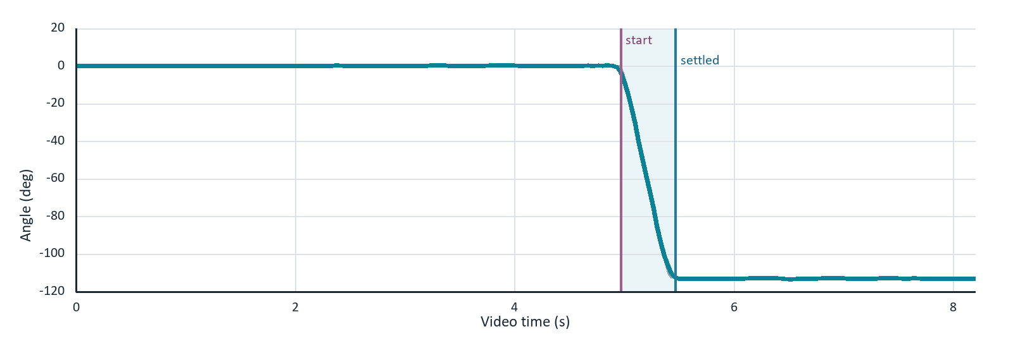
Gray: frame-level angle. Cyan: 5-frame moving average. Shaded region: detected movement window.

Leg G response
Design Curved link. The schematic labels 78 mm on the straight line between the attachment centers, R80 for the main curved profile, and R11 at the lower end.
Measured travel: 109.4 deg (negative direction) | Top speed: 267 deg/s | Movement time: 0.47 s | Window: 4.53-5.00 s
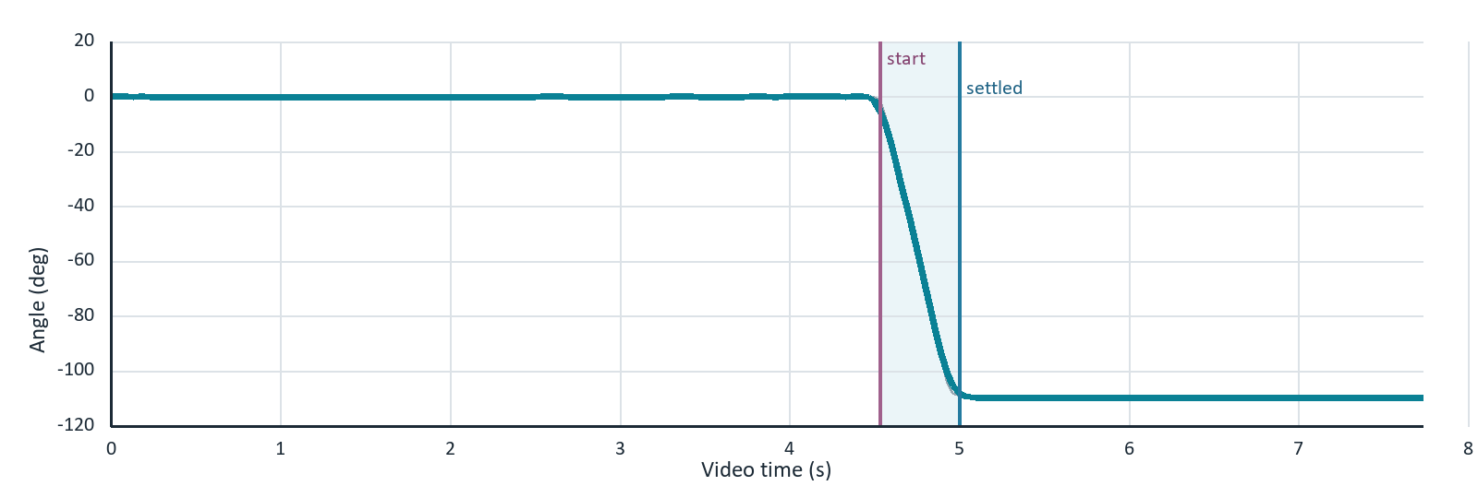
Gray: frame-level angle. Cyan: 5-frame moving average. Shaded region: detected movement window.

Leg H response
Design Tapered link with a 100 mm drawing length, 33 mm at the wide end, and 11 mm at the narrow end.
Measured travel: 111.3 deg (negative direction) | Top speed: 269 deg/s | Movement time: 0.50 s | Window: 4.07-4.57 s
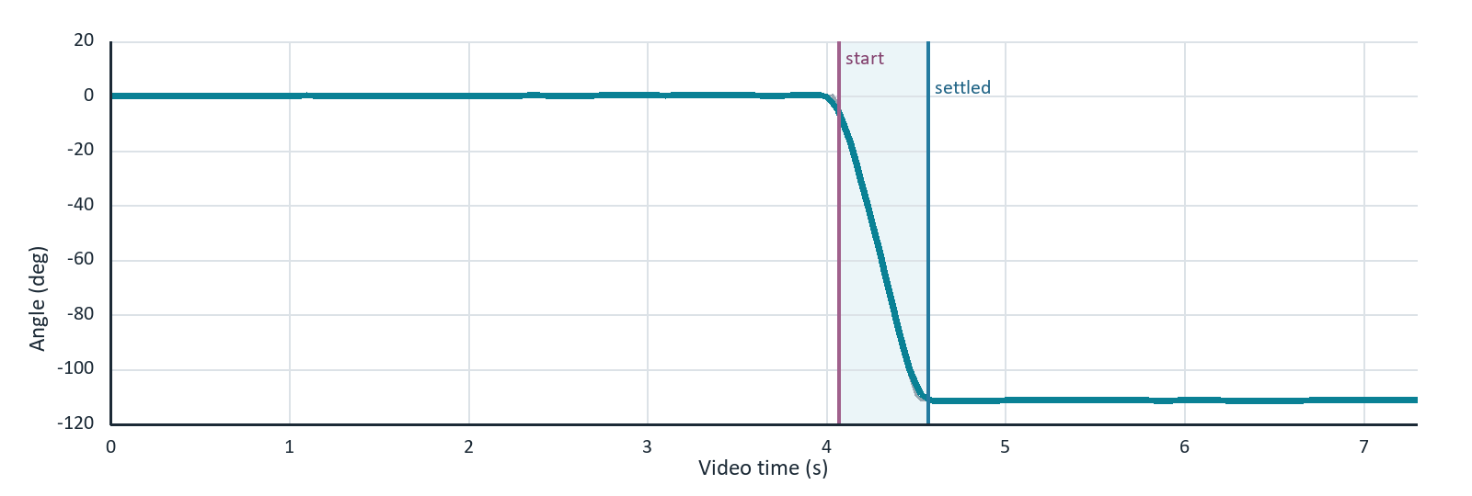
Gray: frame-level angle. Cyan: 5-frame moving average. Shaded region: detected movement window.

Measurement method
Each CSV contains one angle measurement per video frame. The report uses video time as the clock and applies the same rules to every recording.
1 | Angle trace. The tracked angle was smoothed with a centered 5-frame moving average to reduce marker jitter.

2 | Baseline. The initial angle was the median of the first 1.0 second. The final angle was the median of the last 1.0 second.

3 | Movement start. Start was the first of five consecutive frames at least 3 deg from the initial baseline.

4 | Settled time. Settling began at the first point within 2 deg of the final angle that remained in that band for at least 0.5 seconds.

5 | Movement duration. Duration equals settled time minus movement start time.

6 | Top speed. Peak angular speed is the largest absolute central-difference slope of the smoothed trace between start and settling.

Interpretation limit
The recordings do not contain the exact time when the 180 deg command was sent. The report therefore measures visible mechanical response from detected motion to settling. It does not measure command latency. Peak speed is an estimate from video samples and depends on frame rate, marker tracking, and the smoothing window.

Leg geometry schematic
Dimension check The rectangular links read 100 x 22 mm, 80 x 22 mm, 60 x 22 mm, and 60 x 28 mm. The two differences from the initial notes are Leg E's 15 mm marked end height and Leg G's 78 mm straight-line attachment spacing. Leg H is marked 33 mm to 11 mm.
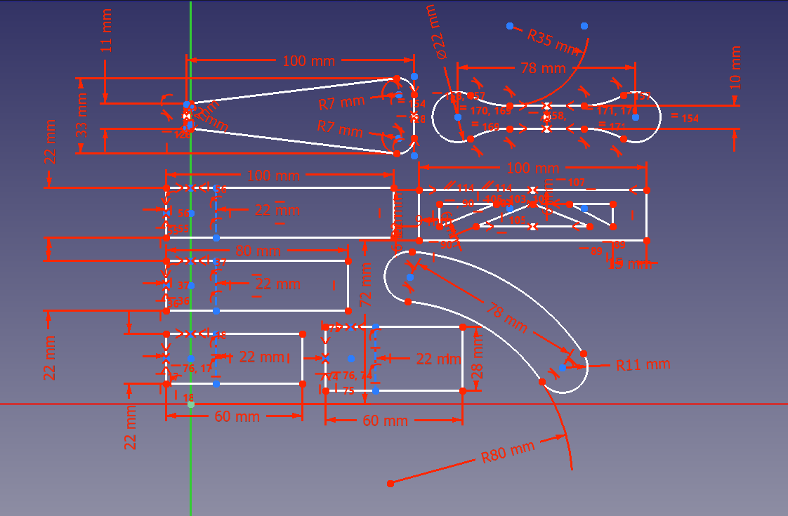
Original dimensioned CAD screenshot supplied with the test notes

