HOWTO Build MSGViewer

MSGViewer is a Netbeans project, built on a OpenSuSE Linux System. So if you use something else, it may differ in some details.

Requirements

Get Oracle Java 8 JDK: http://www.oracle.com/technetwork/java/javase/downloads/index.html

Get Netbeans https://netbeans.org/
Install Subversion Plugin.

Compile
Start Netbeans.

Goto Team => Subversion => Checkout

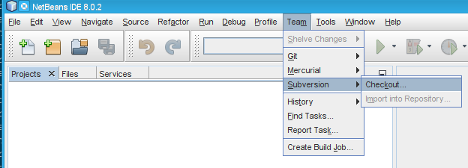

Use this URL: svn://svn.code.sf.net/p/msgviewer/code/Main/trunk/MSGViewer

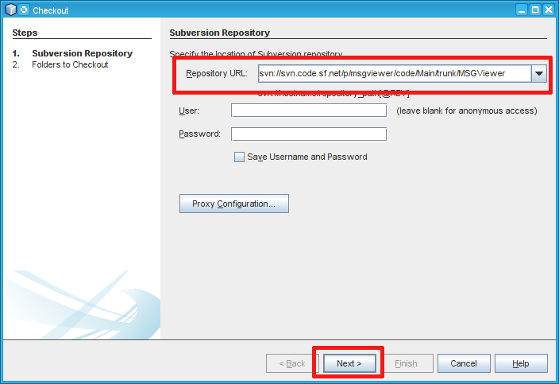

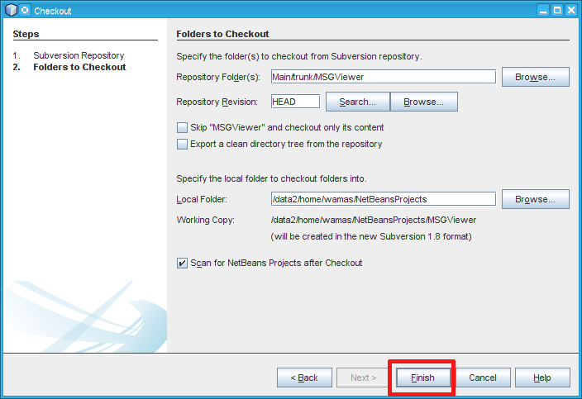

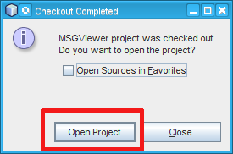
Now the project should be created an you can press compile, and or run to run MSGViewer.

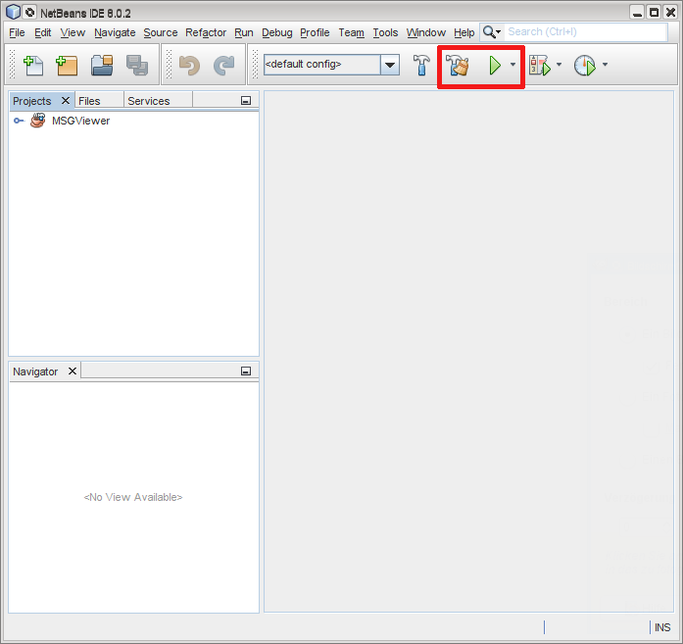

After compiling the project you sill get a subfolder called dist. There are the jar files located:

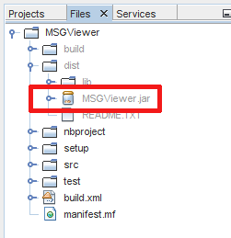
You can start MSGVIew by command line:

java -jar NetBeansProjects/MSGViewer/dist/MSGViewer.jar

Troubleshooting

The java plattform was not found, because it has the wrong naming. On Linux it is called „JDK 1.8“ by default, on Windows „JDK_1.8“ by default. You can edit this in you project settings, or name you java plattform as expected.

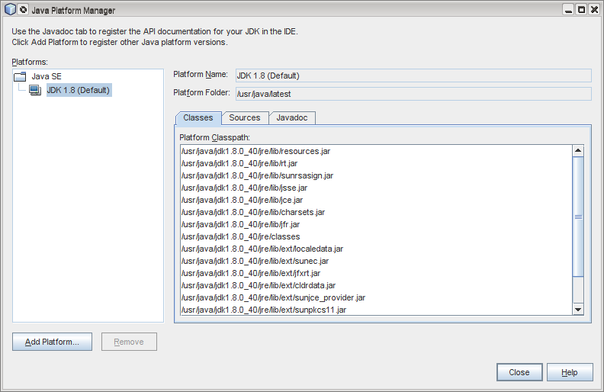

Building the Linux RPM
I've created some scripts and symlinks to make my life easier. All required stuff is in the setup/linux folder in the project directory.
You will need 7z for creating the zip files.

~> cd ~/NetBeansProjects/MSGViewer/setup/linux
~/NetBeansProjects/MSGViewer/setup/linux> ./make_zip

7-Zip [64] 9.20 Copyright (c) 1999-2010 Igor Pavlov 2010-11-18
p7zip Version 9.20 (locale=de_DE.UTF-8,Utf16=on,HugeFiles=on,8 CPUs)
Scanning
Creating archive MSGViewer-1.9.zip
Compressing MSGViewer-1.9/MSGViewer.jar
Compressing MSGViewer-1.9/lib/CommonsLangPlugin.jar
Compressing MSGViewer-1.9/lib/FrameWorkMinimized.jar
Compressing MSGViewer-1.9/lib/JerichoHtmlPlugin.jar
Compressing MSGViewer-1.9/lib/ShellExec.jar
Compressing MSGViewer-1.9/lib/commons-lang3-3.1.jar
Compressing MSGViewer-1.9/lib/jericho-html-3.1.jar
Compressing MSGViewer-1.9/lib/joda-time-1.6.jar
Compressing MSGViewer-1.9/lib/log4j-1.2.12.jar
Compressing MSGViewer-1.9/lib/mail.jar
Compressing MSGViewer-1.9/lib/msgparser.jar
Compressing MSGViewer-1.9/lib/poi-3.2-FINAL-20081019.jar
Compressing MSGViewer-1.9/lib/tnef-1.3.1.jar
Everything is Ok

Now you have all required files in the output directory. Now we will need some symlinks for the rpmbuild command.

~/NetBeansProjects/MSGViewer/setup/linux> cd
~> mkdir -p rpmbuild/SOURCES rpmbuild/SPECS
~> cd rpmbuild/SOURCES
~/rpmbuild/SOURCES> ln -s ~/NetBeansProjects/MSGViewer/setup/linux/output/MSGViewer.tar.gz .
~/rpmbuild/SOURCES> cd ..
~/rpmbuild> cd SPECS/
~/rpmbuild/SPECS> ln -s ~/NetBeansProjects/MSGViewer/setup/linux/msgviewer.spec .

Building the RPM:
~/rpmbuild/SPECS> rpmbuild -bb msgviewer.spec
Executing(%prep): /bin/sh -e /var/tmp/rpm-tmp.ByPFjh
+ umask 022
+ cd /data2/home/wamas/rpmbuild/BUILD
+ cd /data2/home/wamas/rpmbuild/BUILD
+ rm -rf MSGViewer
+ /usr/bin/gzip -dc /data2/home/wamas/rpmbuild/SOURCES/MSGViewer.tar.gz
+ /bin/tar -xf -
+ STATUS=0
+ '[' 0 -ne 0 ']'
+ cd MSGViewer
+ /usr/bin/chmod -Rf a+rX,u+w,g-w,o-w .
+ exit 0
Executing(%build): /bin/sh -e /var/tmp/rpm-tmp.MacNcY
+ umask 022
+ cd /data2/home/wamas/rpmbuild/BUILD
+ /usr/bin/rm -rf /data2/home/wamas/rpmbuild/BUILDROOT/MSGViewer-1.9-1.x86_64
++ dirname /data2/home/wamas/rpmbuild/BUILDROOT/MSGViewer-1.9-1.x86_64
+ /usr/bin/mkdir -p /data2/home/wamas/rpmbuild/BUILDROOT
+ /usr/bin/mkdir /data2/home/wamas/rpmbuild/BUILDROOT/MSGViewer-1.9-1.x86_64
+ cd MSGViewer
+ exit 0
Executing(%install): /bin/sh -e /var/tmp/rpm-tmp.0zWn9E
+ umask 022
+ cd /data2/home/wamas/rpmbuild/BUILD
+ cd MSGViewer
+ install -d -m 755 /data2/home/wamas/rpmbuild/BUILDROOT/MSGViewer-1.9-1.x86_64/opt/MSGViewer/lib
+ install -d -m 755 /data2/home/wamas/rpmbuild/BUILDROOT/MSGViewer-1.9-1.x86_64/usr/share/applications
+ install -d /data2/home/wamas/rpmbuild/BUILDROOT/MSGViewer-1.9-1.x86_64/opt/MSGViewer
+ install -d /data2/home/wamas/rpmbuild/BUILDROOT/MSGViewer-1.9-1.x86_64/MSGViewer/lib
+ install -m755 MSGViewer.jar /data2/home/wamas/rpmbuild/BUILDROOT/MSGViewer-1.9-
.x86_64/opt/MSGViewer/MSGViewer.jar
+ install -m644 lib/CommonsLangPlugin.jar lib/FrameWorkMinimized.jar lib/JerichoHtmlPlugin.jar lib/ShellExec.jar lib/commons-lang3-3.1.jar lib/jericho-html-3.1.jar lib/joda-time-1.6.jar lib/log4j-1.2.12.jar lib/mail.jar lib/msgparser.jar lib/poi-3.2-FINAL-20081019.jar lib/tnef-1.3.1.jar /data2/home/wamas/rpmbuild/BUILDROOT/MSGViewer-1.9-1.x86_64/opt/MSGViewer/lib/
+ install -m755 MSGViewer /data2/home/wamas/rpmbuild/BUILDROOT/MSGViewer-1.9-1.x86_64/opt/MSGViewer/MSGViewer
+ install -m755 msg2mbox /data2/home/wamas/rpmbuild/BUILDROOT/MSGViewer-1.9-1.x86_64/opt/MSGViewer/
+ install -m755 msg2eml /data2/home/wamas/rpmbuild/BUILDROOT/MSGViewer-1.9-1.x86_64/opt/MSGViewer/
+ install -m644 MSGViewer.desktop /data2/home/wamas/rpmbuild/BUILDROOT/MSGViewer-1.9-1.x86_64/usr/share/applications
+ install -m644 icon.png /data2/home/wamas/rpmbuild/BUILDROOT/MSGViewer-1.9-1.x86_64/opt/MSGViewer
+ /usr/lib/rpm/brp-compress
+ /usr/lib/rpm/brp-suse
calling /usr/lib/rpm/brp-suse.d/brp-99-compress-vmlinux
calling /usr/lib/rpm/brp-suse.d/brp-99-pesign
No buildservice signing certificate
Creating /data2/home/wamas/rpmbuild/OTHER/MSGViewer.cpio.rsasign
1 block
Processing files: MSGViewer-1.9-1.noarch
Provides: MSGViewer = 1.9-1 application() application(MSGViewer.desktop) osgi(com.sun.mail.javax.mail) = 1.4.4 osgi(org.apache.commons.lang3) = 3.1.0
Requires(interp): /bin/sh /bin/sh
Requires(rpmlib): rpmlib(CompressedFileNames) <= 3.0.4-1 rpmlib(PayloadFilesHavePrefix) <= 4.0-1
Requires(post): /bin/sh
Requires(postun): /bin/sh
Requires: /usr/bin/env
Checking for unpackaged file(s): /usr/lib/rpm/check-files /data2/home/wamas/rpmbuild/BUILDROOT/MSGViewer-1.9-1.x86_64
Wrote: /data2/home/wamas/rpmbuild/RPMS/noarch/MSGViewer-1.9-1.noarch.rpm
Executing(%clean): /bin/sh -e /var/tmp/rpm-tmp.UJAcKa
+ umask 022
+ cd /data2/home/wamas/rpmbuild/BUILD
+ cd MSGViewer
+ /usr/bin/rm -rf /data2/home/wamas/rpmbuild/BUILDROOT/MSGViewer-1.9-1.x86_64
+ rm -rf filelists

Building the Source RPM:
~/rpmbuild/SPECS> rpmbuild -bs msgviewer.spec
Wrote: /data2/home/wamas/rpmbuild/SRPMS/MSGViewer-1.9-1.src.rpm

