HOWTO

Associate MSGViewer with Outlook MSG Files on KDE4

- Open KDE systemsettings, submenu File Associations
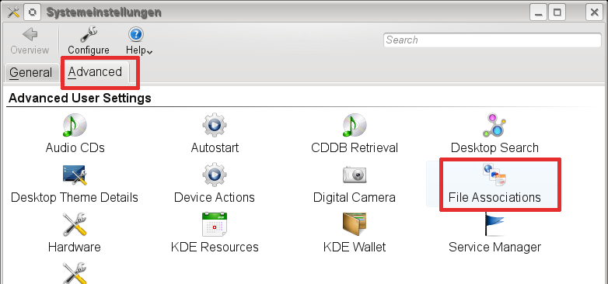
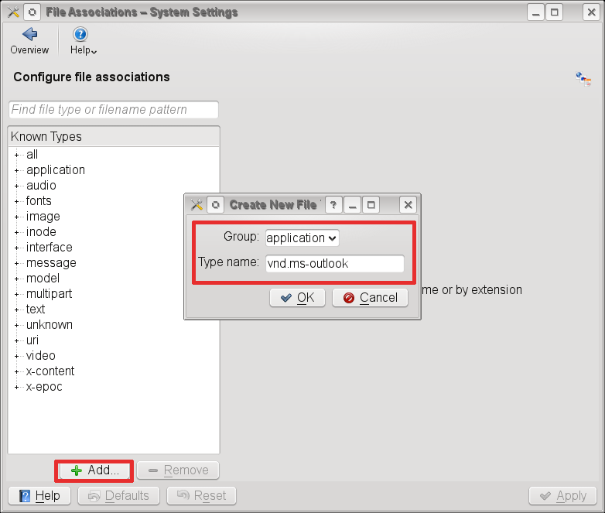
- Add the new mime type application/vnd.ms-outlook to your mime types

- Select your new added mime type, add a description, a file association and a command.
In this case we used the command msgviewer which is a shellscript, that starts MSGViewer. You can download the shellscript on the project page.

