Android Studio Project

# AndroidManifest.xml

#### 文件读写/震动 权限：

*<manifest>*

<uses-permission android:name="android.permission.READ_EXTERNAL_STORAGE" />

<uses-permission android:name="android.permission.WRITE_EXTERNAL_STORAGE" />

<uses-permission android:name="android.permission.VIBRATE" />

*</manifest>*

#### 全面屏适配

*<application>*

<meta-data android:name="android.max_aspect" android:value="2.2" /><!--O/V-->

<meta-data android:name="notch.config" android:value="portrait|landscape"/><!--小米-->

<meta-data android:name="android.notch_support" android:value="true"/><!--华为-->

*</application>*

# 绘制刘海区

#### 使用 API 28 (Android P)：

Project Structure -> Compile Sdk Version : API 28

#### 添加代码：

Activity.java -> onCreate()

shibaInu.util.DeviceHelper.displayNotch();

# 其他

#### VIVO手机调试安装

在gradle.properties 中添加：

android.injected.testOnly=false

# 支持ARM64

**Player Settings Panel > Settings for Android > Other Settings > Configuration**

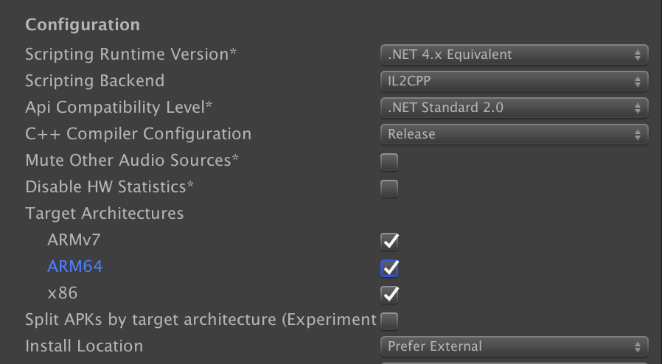

Link：

<https://developer.android.com/distribute/best-practices/develop/64-bit?hl=zh-cn>

**Settings:**

Preferences > External Tools > Android SDK / NDK

# Could not produce class with ID xxx

Find Class with ID:

<https://docs.unity3d.com/2018.1/Documentation/Manual/ClassIDReference.html>

Append Class

to [ Assets/Link.xml ]

or [ Assets/Resources/Link.xxx ] ( Editor Class, Save File or Prefab )

# error: resource style/Theme.AppCompat.Light.NoActionBar

在build.gradle 中添加

dependencies **{**  
 implementation 'com.android.support:appcompat-v7:28.0.0'  
**}**

# Android 8: Cleartext HTTP traffic to *** not permitted

在AndroidManifest.xml配置文件的<application>标签中直接插入

android:usesCleartextTraffic="true"