EES 3310/5310 Lab #3

Exercises with the MODTRAN Model

Lauryn Gayles

Lab: Wed. Jan. 24. Due: Wed. Jan. 31

Table of Contents

Fill in R code for the exercises (I have put the comment # TODO in all of the code chunks where you need to do this) and then fill in the answers where I have marked **Answer:**. Be sure to write explanations of your answer and don’t just put numbers with no text.

## Exercise 4.1: Methane

Methane has a current concentration of 1.7 ppm in the atmosphere and is doubling at a faster rate than CO2.

1. **Would an additional 10 ppm of methane in the atmosphere have a larger or smaller impact on the outgoing IR flux than an additional 10 ppm of CO2 at current concentrations?**

* **Hint:** See the suggestion in the lab-03-instructions document.

modtran_400_17.txt = run_modtran("my_modtran_file.txt", co2_ppm = 400, ch4_ppm = 1.7) #run with different values  
modtran_410_17.txt = run_modtran("my_modtran_file.txt", co2_ppm = 410, ch4_ppm = 1.7) #run with different values  
modtran_400_117.txt = run_modtran("my_modtran_file.txt", co2_ppm = 400, ch4_ppm = 11.7) #run with different values  
  
  
  
modtran_400_17 <- modtran_400_17.txt$i_out #isolate the IR flux   
print(modtran_400_17) #print

## [1] 298.6712

modtran_410_17 <- modtran_410_17.txt$i_out #isolate the IR flux   
print(modtran_410_17) #print

## [1] 298.5455

modtran_400_117 <- modtran_400_117.txt$i_out #isolate the IR flux   
print(modtran_400_117) #print

## [1] 295.561

**Answer:** *Put your answer here.* Be sure to explain your reasoning and show data, plots, etc. to explain how you came up with your answer.

The additional 10 ppm of methane has a larger impact than an additional 10 ppm of CO2. We can see the decrease in the IR flux was much greater with the additional methane than the additional CO2.

1. **Where in the spectrum does methane absorb? What concentration does it take to begin to saturate the absorption in this band? Explain what you are looking at to judge when the gas is saturated.**

* **Hints:**  
  See the hints in the lab-03-instructions document.

ch4_list = c(0,1, 2, 4, 8, 16, 32, 64, 128) #creating a list to go through the different numbers  
  
for (ch4 in ch4_list) {  
mod_data = run_modtran(co2_ppm = 0, ch4_ppm = ch4, trop_o3_ppb = 0, strat_o3_scale = 0, h2o_scale = 0, freon_scale = 0)  
p = plot_modtran(mod_data, descr = str_c(ch4, 'ppm ch4')) #setting the the variables to 0   
plot(p) # you could also say print(p) here.  
}

## Warning: Using `size` aesthetic for lines was deprecated in ggplot2 3.4.0.  
## ℹ Please use `linewidth` instead.  
## This warning is displayed once every 8 hours.  
## Call `lifecycle::last_lifecycle_warnings()` to see where this warning was  
## generated.

## Warning: The `size` argument of `element_line()` is deprecated as of ggplot2 3.4.0.  
## ℹ Please use the `linewidth` argument instead.  
## This warning is displayed once every 8 hours.  
## Call `lifecycle::last_lifecycle_warnings()` to see where this warning was  
## generated.

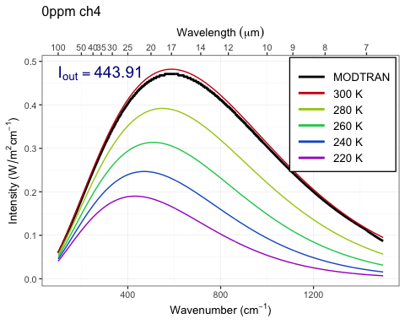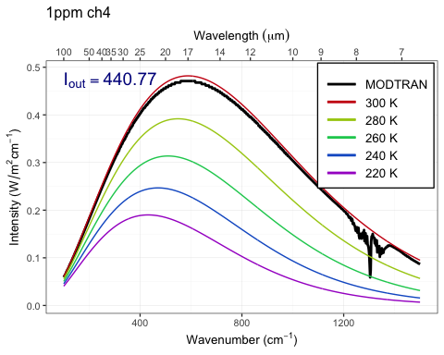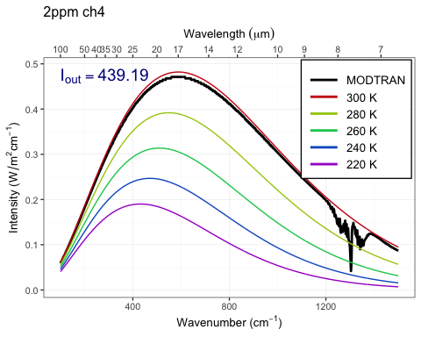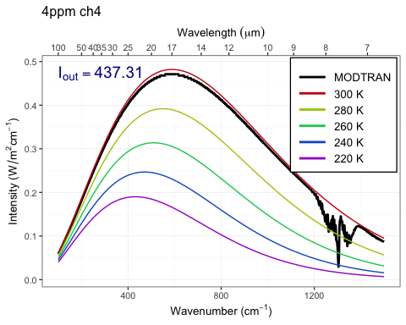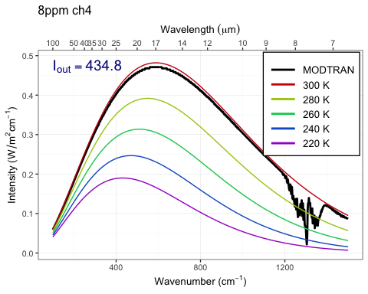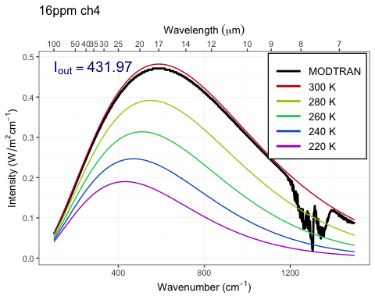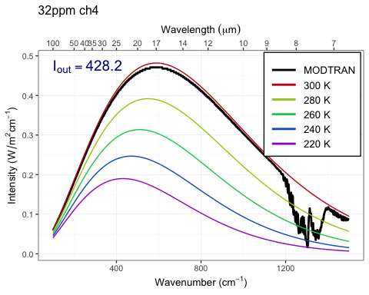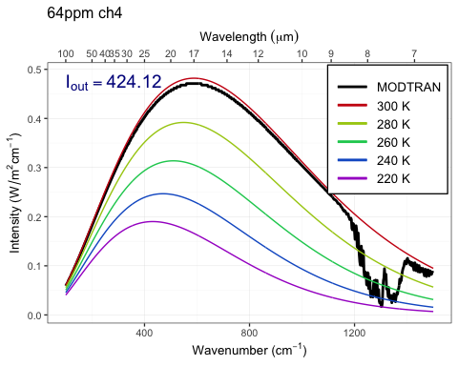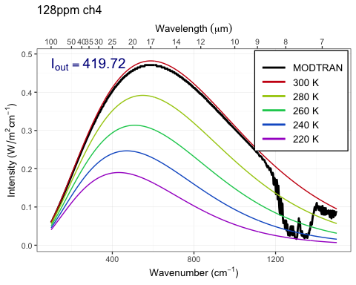

**Answer:**

1300 cm-1 is the wavelength where methane absorbs. The ppm for methane seems to be around 16 ppm.

1. **Would a doubling of methane have as great an impact on the heat balance as a doubling of CO2?**

* **Hint:** See the suggestion in the lab-03-instructions document.

m = run_modtran("my_modtran_file.txt")  
m1 = run_modtran("my_modtran_file.txt", ch4_ppm = 3.4)  
m2 = run_modtran("my_modtran_file.txt", co2_ppm = 800, ch4_ppm = 1.7)  
  
  
  
modtran <- m$i_out #isolate the IR flux   
print(modtran_400_17) #print

## [1] 298.6712

modtran_1 <- m1$i_out #isolate the IR flux   
print(modtran_410_17) #print

## [1] 298.5455

modtran_2 <- m2$i_out #isolate the IR flux   
print(modtran_400_117) #print

## [1] 295.561

plot_modtran(m, descr = "Baseline spectrum")

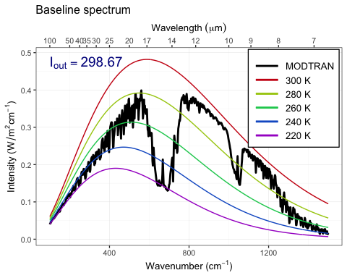

plot_modtran(m1, descr = "Doubled CO2")

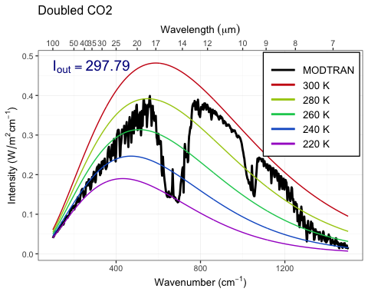

plot_modtran(m2, descr = "Doubled CH4")

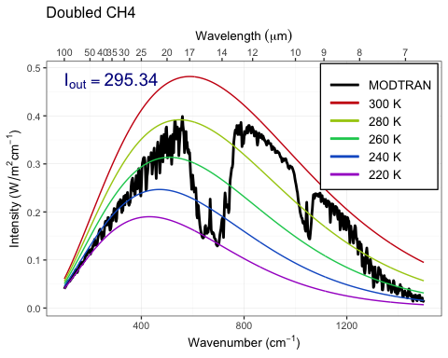

**Answer:**

Doubling CO2, wavelength decreases by -3.3 W/m2. Doubling CH4, wavelength decreases by -0.88 W/m2. The increase in CO2 has a larger effect because there is more CO2 present in the atmosphere.

1. **What is the “equivalent CO2” of doubling atmospheric methane? That is to say, how many ppm of CO2 would lead to the same change in outgoing IR radiation energy flux as doubling methane? What is the ratio of ppm CO2 change to ppm methane change?**

matching_methane = 13 # the ppm after trial and error   
modtran_match_ch4 = run_modtran(file.path(data_dir, "ex_4_1_ch4_match.txt"),  
 co2_ppm = 400, ch4_ppm = matching_methane)  
  
print(modtran_match_ch4) #priting data to see teh results

## $spectrum  
## # A tibble: 1,100 × 12  
## k lambda pk pl sk sl srk srl tk tl  
## <dbl> <dbl> <dbl> <dbl> <dbl> <dbl> <dbl> <dbl> <dbl> <dbl>  
## 1 2 5000. 9.70e-10 3.88e-13 2.20e-10 8.81e-14 0 0 3.74e-5 1.49e-8  
## 2 4 2500 3.47e- 9 5.56e-12 4.92e-10 7.87e-13 0 0 1.25e-4 1.99e-7  
## 3 6 1667. 8.13e- 9 2.93e-11 3.55e-10 1.28e-12 0 0 2.66e-4 9.58e-7  
## 4 8 1250 1.45e- 8 9.31e-11 2.07e-10 1.32e-12 0 0 4.62e-4 2.96e-6  
## 5 10 1000 2.22e- 8 2.22e-10 6.68e-11 6.68e-13 0 0 6.97e-4 6.97e-6  
## 6 12 833. 3.05e- 8 4.39e-10 8.25e-13 1.19e-14 0 0 9.58e-4 1.38e-5  
## 7 14 714. 4 e- 8 7.83e-10 1.10e-16 2.17e-18 0 0 1.26e-3 2.46e-5  
## 8 16 625 5.08e- 8 1.3 e- 9 6.33e-21 1.62e-22 0 0 1.60e-3 4.08e-5  
## 9 18 556. 6.13e- 8 1.98e- 9 2.23e-19 7.23e-21 0 0 1.92e-3 6.22e-5  
## 10 20 500 7.64e- 8 3.05e- 9 2.23e-19 8.92e-21 0 0 2.40e-3 9.58e-5  
## # ℹ 1,090 more rows  
## # ℹ 2 more variables: int <dbl>, trans <dbl>  
##   
## $co2  
## co2mx   
## 400   
##   
## $ch4  
## ch4rat   
## 13   
##   
## $i_out  
## [1] 295.3411  
##   
## $alt  
## [1] 70  
##   
## $sensor_direction  
## [1] down  
## Levels: up down  
##   
## $profile  
## # A tibble: 33 × 7  
## Z P T H2O O3 CO2 CH4  
## <dbl> <dbl> <dbl> <dbl> <dbl> <dbl> <dbl>  
## 1 0 1013 300. 18756. 0.0287 400 13   
## 2 1 904 294. 14381. 0.0315 400 13   
## 3 2 805 288. 11540. 0.0334 400 13   
## 4 3 715 284. 6559. 0.035 400 13   
## 5 4 633 277 3476. 0.0356 400 13   
## 6 5 559 270. 2683. 0.0377 400 13   
## 7 6 492 264. 1726. 0.0399 400 13   
## 8 7 432 257 1086. 0.0422 400 13   
## 9 8 378 250. 661. 0.0447 400 13   
## 10 9 329 244. 365. 0.05 400 12.9  
## # ℹ 23 more rows  
##   
## $h_tropo  
## [1] 17  
##   
## $t_tropo  
## [1] 194.8  
##   
## $t_ground  
## [1] 299.7  
##   
## $atmosphere  
## [1] "TROPICAL MODEL"

**Answer:** _

The answer is 13 ppm which is achieved thorugh trial and error. the iout is 295.3411.

## Exercise 4.3: Water vapor

Our theory of climate presumes that an increase in the temperature at ground level will lead to an increase in the outgoing IR energy flux at the top of the atmosphere.

1. **How much extra outgoing IR would you get by raising the temperature of the ground by 5°C? What effect does the ground temperature have on the shape of the outgoing IR spectrum and why?**

* **Hint:** See the hint in the lab-03-instructions document.

modtran_baseline = run_modtran() #run the baseline modtran   
modtran_plus_5 = run_modtran(delta_t = 5) #change the temperature variable   
  
p_baseline = plot_modtran(modtran_baseline, descr = "Baseline spectrum") #plot  
p_5_deg = plot_modtran(modtran_plus_5, #plot   
 descr = "Ground temperature raised 5K")  
plot(p_baseline) #print the plot



**Answer:**

We can see in the grpah that an increase in the ground temperature causes a raise in the spectrum as a whole.

1. **More water can evaporate into warm air than into cool air. Change the model settings to hold the water vapor at constant relative humidity rather than constant vapor pressure (the default), calculate the change in outgoing IR energy flux for a 5°C temperature increase. Is it higher or lower? Does water vapor make the Earth more sensitive to CO2 increases or less sensitive?**

* **Note:** By default, the MODTRAM model holds water vapor pressure constant, but you can set it to hold relative humidity constant instead with the option h2o_fixed = "relative humidity", like this: run_modtran(file_name, delta_t = 5, h2o_fixed = "relative humidity").

modtran_vp = run_modtran(delta_t = 5, h2o_fixed = "vapor pressure") #run modtran with temp change being 5   
modtran_rh = run_modtran(delta_t = 5, h2o_fixed = "relative humidity") #run modtran with temp change being 5   
  
i_base = modtran_baseline$i_out #getting the i out data   
i_water_vapor = modtran_vp$i_out  
i_humidity = modtran_rh$i_out  
  
p_water_vapor = plot_modtran(modtran_vp, descr = "Constant vapor pressure",   
 i_out_ref = i_base)  
p_humidity = plot_modtran(modtran_rh, descr = "Constant relative humidity",   
 i_out_ref = i_base)  
plot(p_water_vapor)

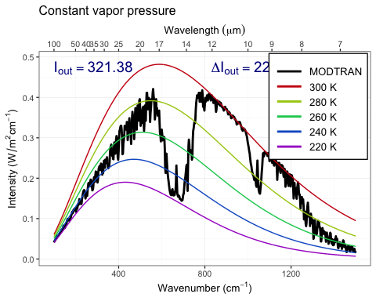

plot(p_humidity) #plotting the data

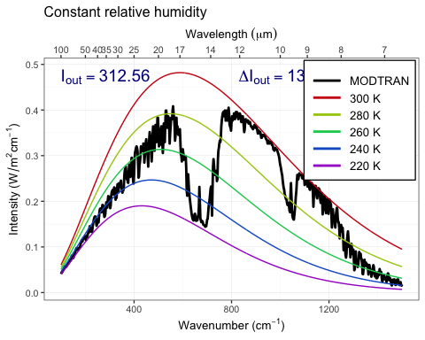

**Answer:**

The increase in temp has an increase effect on iout when the fixed variable is water vapor. The environment is more sensitive to co2 changing when the humidity remain the same.

1. **Now see this effect in another way.**
   * **Starting from the default base case, record the total outgoing IR flux.**
   * **Now double CO2. The temperature in the model stays the same (that’s how the model is written), but the outgoing IR flux goes down.**
   * **Using constant water vapor pressure, adjust the temperature offset until you get the original IR flux back again. Record the change in temperature.**
   * **Now repeat the exercise, but holding the relative humidity fixed instead of the water vapor pressure.**
   * **The ratio of the warming when you hold relative humidity fixed to the warming when you hold water vapor pressure fixed is the feedback factor for water vapor. What is it?**

i_base = modtran_baseline$i_out  
  
modtran_800co2 = run_modtran(co2_ppm = 800) #run modtran with co2 at 800 ppm   
i_vapor_double = modtran_800co2$i_out #get the iout value   
  
dt_vp = 0.76  
modtran_vp_dt = run_modtran(file.path(data_dir, "ex_4_3_vp_dt.txt"),  
 co2_ppm = 800, delta_t = dt_vp) #run modtran with co2 at 800 ppm  
i_vp_dt = modtran_vp_dt$i_out #get the iout value  
  
modtran_2x_rh = run_modtran(file.path(data_dir, "ex_4_3_2x_co2_rh_.txt"),#run modtran with co2 at 800 ppm  
 co2_ppm = 800, h2o_fixed = "relative humidity")  
i_2x_rh = modtran_2x_rh$i_out  
  
dt_rh = 1.21  
modtran_rh_dt = run_modtran(file.path(data_dir, "ex_4_3_rh_dt.txt"),  
 co2_ppm = 800, delta_t = dt_rh,   
 h2o_fixed = "relative humidity")  
i_rh_dt = modtran_rh_dt$i_out  
  
feedback = dt_rh / dt_vp  
  
print(feedback) # print to see all values

## [1] 1.592105

**Answer:** *Put your answer here.*

The answer is 1.592 for the feedback factor. This shows the the ratio of the temp change with relative humidity fixed to that of the temp change with water vapor fixed.