NeatWork: A user guide
Agua Para la Vida

A decision support program for the design of gravity water distribution networks
Developed by Agua Para la Vida and LOGILAB for free distribution to non-profit water supply agencies.
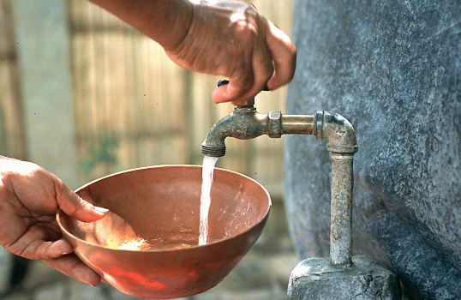
Agua Para la Vida: http://bldgsci07.ced.berkeley.edu/aplv/
Logilab: http://ecolu-info.unige.ch/logilab/
What is new about NeatWork
For what kind of distribution networks ?
NeatWork is a computer program specifically fashioned for the design of entirely gravity-driven water distribution networks for rural areas. These networks need to adapt to two characteristics in particular:
- The driving level differences between the tank and the faucets may be minimal (the practical limit may be as low as 2 meters) and
- The consumers generally need no water pressure at the exit of their faucets.
Minimum pipe cost design
NeatWork gives ready access to a truly minimum material cost design consistent with a comprehensive set of operating constraints and of restrictions on available material, both specified by the designer. This access requires little prior experience of the designer. It is achieved by
  - First, presenting the designer with an optimized (lowest cost) solution that respects all the chosen constraints albeit in part in a statistical sense.
  - Second allowing the designer to test that solution by simulating the operation of the design under a comprehensively large number of operating scenarios, the results of which are conveniently compiled and statistically presented.
NeatWork allows the designer to modify locally the proposed design whenever the solution is judged deficient in some particular, or if additional constraints (such as redundancy) are desired. The modified design can also be tested in the same way. The steps for this retouching of the generally optimum solution are made easier by an influence diagram. The process can also be applied to any pre-existing design.
The optimization is carried out for branching or arborescent networks only. Any number of loops can then be added to any design and the simulation handles loops conveniently. But the relative advantages of loops (such as their fail-safe features) are left to the designer to weigh against the cost penalty since these cannot be incorporated rationally in a cost-minimizing scheme.
Minimum pipe cost vs. uniform faucet output
To summarize: There is generally (as is shown later) a conflict between the requirements of minimum pipe cost on one hand and a sufficiently uniform faucet output especially when the maximum number of faucets used is a fraction of the total number available. NeatWork handles this conflict by making the irreducible trade-off explicitly and easily accessible to the designer.
NeatWork is the second version of a distribution network design tool that has been extensively tested in the field by Agua Para La Vida.
Acknowledgements
Conception: G. Corcos, C. Huizenga & J.-P. Vial.
Implementation and interface: F. Babonneau, Laurent Drouet.
Optimization tool: Mosek by Erling Andersen: EKA Consulting ApS
The University of Geneva is thanked for its financial support in the development of Version 2. Version 3 is part of the research program Supprem.
Version 3.0 is a beta version. Comments are welcome.
Contacts:
Frederic.babonneau@hec.unige.ch
Laurent.drouet@hec.unige.ch
Jean-philippe.vial@hec.unige.ch
Agua Para La Vida
Agua Para La Vida is a N.G.O with presence in Nicaragua, the United States and France. Its goal is to assist the cooperative development and protection of their drinking water systems by rural communities. To this effect, Agua Para La Vida
- Maintains a pilot center in Nicaragua,
- Diffuses technical material such as NeatWork that it develops for technical and for pedagogical purposes.
- The pilot center that is manned almost entirely by Nicaraguan residents has multiple functions. It undertakes drinking water projects at the request of villages. It endeavors to protect the soils, which allow the replenishment of the springs on which the water supply depends. It encourages hygiene education and (especially babies and infant) health monitoring, both destined to maximize the benefits of clean water. The center also facilitates its own duplication by running a small technical school, which forms, through a two to three year work-study curriculum, water projects technicians from among selected rural residents.
Technical material especially appropriate for use by technicians and engineers engaged anywhere in similar activities as APLV’s pilot center is developed by a few engineers and scientists who work in Europe and the United States as well as Nicaragua on a voluntary basis. The Nicaragua operation serves as a field trial center both for appropriate design techniques and for special pedagogical tools but the technical material which results (in the form of written material and programs) is offered to other N.G.Os as well.
An Overview
Gravity Driven Distribution Networks: Few tools, demanding requirements
Neatwork is a specialized network designing tool adapted to two realities of water development in poor rural communities:

- Mechanized and electric power are generally either unavailable, or unduly expensive and they raise in addition serious maintenance problems.
- In the building by communities themselves of drinking water systems manpower is usually not compensated, maintenance can be made inexpensive and the main expense is the initial material cost, notably that of network piping. Material cost acts as one of the two major limitations on the construction of these systems, (the other one being the need for the contribution of (usually external) technical and administrative skills).
As a result:
- Neatwork deals only with gravity-driven distribution networks.
- Neatworks puts a high priority on finding both minimum material cost and operationally satisfactory solutions.
Now, as we shall show more quantitatively later, the minimum cost requirement conflicts with the requirement of dependable delivery under all uses scenarios. For instance:
- If the design is adequate for use by all faucets in the same time it will be more than adequate for use by only a fraction of the faucets, but then the system is clearly oversized (and therefore excessively costly) since all faucets will not be used simultaneously.
- In case of fractional (and unspecified or random) use of the faucets the sensitivity of a given faucet output to the combination of other faucets opened simultaneously can be systematically eliminated but only by methods which can raise seriously the cost of the network.
Thus a design which yields acceptable flow rates for all faucets under almost all use scenarios at lowest cost requires both sophisticated control by the designer of the optimizing module and from the simulator a very comprehensive performance analysis. This is what Neatwork offers.
In general, already available distribution system analyzing tools, while they are capable of a number of sophisticated answers corresponding to modern delivery requirements are not able to help the designer in his seach for the rustic characteristics demanded by the simple networks we are addressing. They deal with other needs (e.g. the requirements for pressure at the delivery sites, externally imposed flow rates at hydrants, comprehensive fail-safe alternate circuits, predictable daily and seasonal demand cycles, water quality propagation rates, etc..). They do not deal with barely possible energy potentials and unpredictable use scenarios.
A summary of the key design and simulation features
Given that there is a conflict between adequate supply and minimum cost of the distribution system, how, briefly is this conflict first spelled out and second resolved in the design?

- System Capacity and system uniformity.

- The capacity is defined by the peak hours use pattern of the communities. Note that these patterns are partly the result of the designer’s perception of the communities’ living habits and partly the result of the adaptation of the communities to a brand new access to water. Ultimately the designer will follow some explicit norms. For instance the present norms of APLV are that whatever daily water allocation is chosen for a village, half of that allocation should be available during the first two waking hours of the day. The design will adjust to this peak usage rate which will be averaged over the two hours period. This means ( in the example) that the product of the average faucet flow rate and of the maximum number of faucets open on the average during that time should equal half the daily supply. Given the total number of faucets installed, this yields the maximum fraction of this total which needs to be open simultaneously (once the average faucet flow rate has been selected). This gives rise to the first two design parameter, the average target faucet flow rate and the maximum fraction of simultaneously open faucets.
- The peak hours supply averaged over all the faucets has to be associated with a flow rate for all faucets which falls almost always within acceptable bounds. An excessively slow flow rate and a complete failure to flow can only be accepted as very infrequent events for any faucet. An excessively large flow rate is also undesirable. Yet the use pattern ( i.e. the combination of open faucets) is almost completely random within a narrow time frame. But for a network near minimum pipe cost, the specific combination of open faucets has a definite influence on the flow of each faucet. Note that faucets are treated in Neatwork as either open or closed. Practically this is found satisfactory even with faucets that can regulate the output.

b) The Design and Simulation tools

The optimization module
The initial design will then first (in the design or optimizing module) make use of a statistical logic to avoid over sizing while respecting the supply norms:
For an arborescent network it will size the initial conduit out of the tank so as to handle only the desired maximum flow rate, that is the maximum number of open faucets times the desired average faucet flow rate . On the other hand it will size the ultimate conduit leading to an individual faucet so as to provide the full desired flow rate when that faucet is open. For intermediate segments of pipes between branching nodes it will provide for a flow rate capacity that will depend on some estimated fraction of the number of faucets supplied by that segment, (that fraction being based on the probability distribution of the dependant faucets being open). This estimate is chosen to fall between unity on the high side (relevant to the ultimate segment) and the allowed fraction of open faucets on the low side (relevant to the initial segment). But in order to accommodate idiosyncrasies of particular configurations, the fairing between the two end values is made part of a one parameter design curve: The higher the value of this parameter the more flow is allowed in the intermediate segments, and so in general the more abundant the supply at all faucets and the more expensive the system. This third parameter is called the Service Quality. Its final value can only be chosen after probing with the simulation module and might be called a first (global) tuning tool. Once chosen together with the other two parameters the design tool provides the absolute minimum pipe cost solution.
In the simulation module
This part of the program solves for the flow out of open faucets for any combination of open faucets, and for any design, including the recommended minimum cost solution, for any open faucet fraction including the one chosen in the design module,
It also allows the calculation of flow rates after loops (with pipes of chosen diameters) have been added to the design.
The simulation program can solve sequentially in a short time for the flow in a large number (typically 500) of specific open faucets configurations chosen at random. Its output includes several statistical and non- statistical quantities of interest. From which are immediately available, the % of cases for any faucet of flow below and above predetermined values, the average flow for each faucet and for the average of faucets, the maximum and minimum flow for each faucet, the corresponding nodal pressures, water velocities and other quantities of interest. These can be compared to the designer’s norms. The comparison allows the designer either to stop- when the design has been proven adequate in all respects or to tune the design either by altering the value of the service quality factor in the design module or by altering some specific pipe or orifice diameters in the neighborhood of the deficient faucet. The flow through the tuned network is then analyzed anew and the process repeated until the answer is judged satisfactory.
One may be content with the solution achieved by merely finding (though successive simulations) the lowest value of service quality consistent with the desired norms of faucet variability. Or one may attempt to reach a still lower cost by means of the local tuning just mentioned, at a somewhat lower value of the service quality parameter.
In that sense the ultimate steps of the design are not automatic but require some skillful search by the designer, though the scope of that search has been much reduced and the designer’s hand is guided through the search.
An introductory example
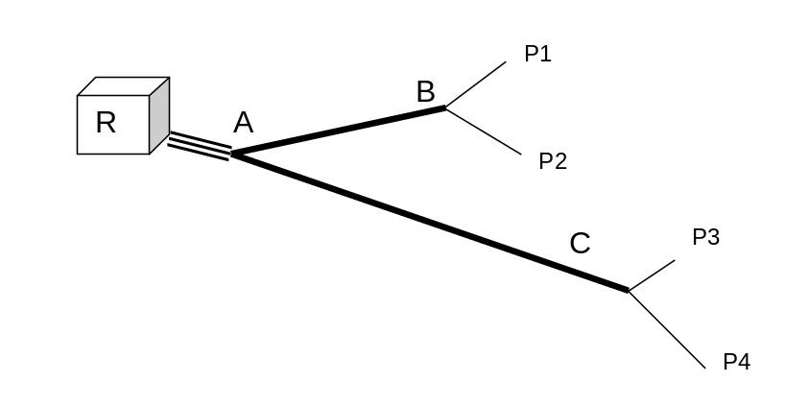
The above figure represents a system with one reservoir R, three connecting branches (RA, AB, AC), four branches leading to a faucet (BP1, BP2, CP3, CP4), and four faucets. The topography of the system is described by two sets of basic data. The branches from R and between nodes are called segments and all the end points of segments are called nodes.

- Node data
Node ID | Height | Nature | Nb. of Faucets
R | 0 | Tank
A | -10 | Branching Node
B | -15 | Branching Node
C | -20 | Branching Node
P1 | -12 | Faucet | 1
P2 | -9 | Faucet | 1
P3 | -18 | Faucet | 1
P4 | -19 | Faucet | 1
- Segment data
Segment ID | From node | To node | Length
1 | R | A | 20
2 | A | B | 50
3 | A | C | 70
4 | B | P1 | 12
5 | B | P2 | 8
6 | C | P3 | 9
7 | C | P4 | 11

A design specifies for each segment the reference of the pipe to be installed and for each faucet the orifice to be set. A pipe is characterized by its internal diameter, its material (PVC or Iron), and the maximal pressure it can accommodate. An orifice is a simple ring upstream of a faucet to be inserted into the pipe. An orifice is characterized by its internal diameter.
The data sets for a design reproduce the relevant topography and add the chosen design features such as pipe and orifice diameters.
- Node data for the design (note that orifices relate only to specific faucet segments)
Node ID | Height (m) | Nature | Orifice (m)
R | 0 | Reservoir
A | -10 | Branching node
B | -15 | Branching node
C | -20 | Branching node
P1 | -12 | Faucet | none
P2 | -9 | Faucet | 0.0040
P3 | -18 | Faucet | none
P4 | -19 | Faucet | none
- Segment data for the design
Segment ID | From node | To node | Length (m) | Diameter
1 | R | A | 20 | 0.0670
2 | A | B | 50 | 0.0400
3 | A | C | 70 | 0.0340
4 | B | P1 | 12 | 0.0182
5 | B | P2 | 8 | 0.0182
6 | C | P3 | 9 | 0.0182
7 | C | P4 | 11 | 0.0182

The internal diameter of a pipe determines the friction loss (or head loss) along the pipe. The larger the diameter, the smaller the head loss, but the relation is nonlinear. Orifices have the same influence, but the quantitative formula for the head loss is different. When the internal diameters are fixed, the exact flows in the network can be computed.
Since the head loss in a pipe is directly proportional to the length of the pipe, it is possible to achieve intermediary values of total head losses by splitting a segment in two components and assigning to each component a pipe with its own diameter. Instead of just one column for the pipe diameter in the segment data table, one has four columns. The first two columns give the length and the diameter of the first component of the segment; the last two columns give the same information for the second segment component.
A summary of input and output in the two modules:
The design module requires as inputs:
- The topography of the network, i.e. the origin, branching sequence and all end points of the network with the elevation of all nodes and the length of all segments between them. The number of faucets at each terminal node must also be specified.
- A set of design parameters specifying faucet target flow, fraction of open faucets and service quality. A rough approximation to the spring water temperature should also be specified.
- Two parameter files, one for pipes, (available internal diameters, maximum working pressure, cost and equivalent Moody roughness factor or nature of pipe material), and one for orifices (available diameters). In addition the type of faucets used is specified through a faucet loss constant.This unfamiliar constant is important enough to justify an elaboration found below.
- Specification of constraints if any, such as specified (preexisting) pipe diameters along some segments.
The output of the design module is a design file that reproduces the topographic data and recommends pipe diameters for each segment and orifice diameters for some terminal segments.
Typically the design module will choose one type of pipe for the entire length of a segment. Occasionally it will suggest two diameters for the same segment with two complementary lengths. In that case the length of the longer section is chosen to be an integral multiple of the commercial length of pipe units. The length of the shorter section is adjusted to add up to the total length of the segment. This rule minimizes the number of required pipe cuts.
Terminal nodes involve one or more faucets. Private faucets are usually single. Multiple faucets are often found on public water stands. In Neatwork multiple faucets belonging to the same terminal node P are separately listed as P_a, P_b,P_c…etc.
For orifices, the design recommends two sets of diameters : ideal diameters- the computed choice, and the nearest diameter given as available in the data base.
The simulation module requires as an input:
- 1) A design which may be the output of the optimized design module or a modified version of this design or any other design (including designs with loops) in which the same quantities are specified. The choice of the ideal or of the available orifices needs to be made.
- 2) A set of simulation parameters such as the fraction of open faucets and the number of randomly chosen alternate faucet choices desired. The minimum and maximum desirable flow rates for each faucet is also specified at this stage.
The output of the simulation module is presented as statistics derived from individually computed simulations. We have:
- Main statistics on faucet flows
- Percentiles at faucets
- Water velocities in pipe segments
- Node pressures

Faucet resistance and faucet constants
The usual distribution network is required to deliver water with substantial pressure. So the head loss through ordinary faucets is usually a negligible quantity. But unaided gravity networks as a rule deliver water through faucets whose outlet is at atmospheric pressure, The head loss through the faucet then becomes an important factor not only because the required head must necessarily exceed it but also because it has a large effect on the variation of the flow out of any given faucet with the combination of other faucets opened in the same time. It is therefore important to choose a faucet constant that represents accurately the head loss incurred by the faucets you select.
The simple formula used by Neatwork for faucet head loss is
h_{fau}=q²/α

where α is a constant which varies a lot with the faucet size and type. α is called the faucet coefficient in the program. The measured value of α (faucet wide open) is generally not available. It is given given below for few cases:

Type of Faucet | Nominal size | Brand | α (m^5/sec^2
Globe | 1/2” | Standard Arrow  (U.S.) | 1.83E-8
Globe | 1/2” | B&K  (U.S) | 1.08E-8
Ball Valve  (1/4 turn) | 3/8” pipe fitting & 3/8” ball hole | 3/8 ”hole  used with ½”pipe | 1.3E-7

Note
- First that the units of α are meters to the fifth power divided by seconds squared).
- Second that for self similar faucets ( exactly identical in construction except for their scale) , α is, according to dimensional analysis :
α=β(Re)Q^2/(ghfaucetd^4)
where g is the gravitational constant and β(Re) is non-dimensional and almost a constant. Therefore the loss constant of a 3/8” faucet of the globe, Standard Arrow type would be approximately 5.8E-8. And that of a 3/4 ”faucet 3.6E-7.

- Third that is is clearly important to determine α for the faucets you happen to be using. This can be done simply and with satisfactory accuracy as follows:

A demonstration of the relation between pipe cost and faucet variablity.
Qualitatively that relation is clear: The larger the loss through the faucets, the smaller the corresponding friction loss through the network of pipes leading from the tank to the faucets since the total available head is fixed. Therefore that part of the total head loss due to opening a given faucet which affects flows through pipes serving more than one faucets is smaller. This decreases the variability of flow of any given faucet.
But to achieve this lower loss on the common part of the network one needs to use there larger pipe diameters and these are more expensive.

We can conveniently quantify this inverse relation between pipe cost and faucet flow variability by changing the faucet constant for any given network.
Consider for instance the network stored under the name taptest(a) and taptest(b):
These are identical except for the value of α, the faucet coefficient.
To be completed

Making it work

Installation procedure
The file neatwork.zip contains a windows version of NeatWork 3. Unzip it into a new folder.
This folder will contain the following files:
- NeatWork.jar: executable java file.
- SOLVER.DLL: solver library.
- mosek2_1.dll and pthreadvse.dll: Mosek solver libraries.
and folders
- db: repository of data bases.
- projects: repository of topographies, designs and simulations.
Double-click on the NeatWork.jar file to launch NeatWork. You need a Java Virtual Machine at least version 1.3.0. If launching by double-click doesn’t work, from the command prompt and in the NeatWork directory type :
java –jar NeatWork.jar

File system
A project involves three types of files:
- Topography files with suffix “.tpo”, e.g., Net5.tpo
- Design files with suffix “.dsg”, e.g., Net5.dsg
- Simulation files with suffix “.sim”, e.g., Net5(1).sim, Net5(2).sim,…
The user can open topography and design files from appropriate menus. Simulation files are not directly accessible. NeatWork creates them when a simulation is performed on a specific design. They are automatically saved when the design is saved, and receive the name of the design file with a number in parenthesis corresponding to the number of the simulation. A design file contains a link to all child simulation files: opening a design file gives direct access to all child simulation files.
The project files are contained in the folder “project”.

Brief tutorial by menus

Launching NeatWork
Double-clicking on “NeatWork.jar” launches the software which first display the window:
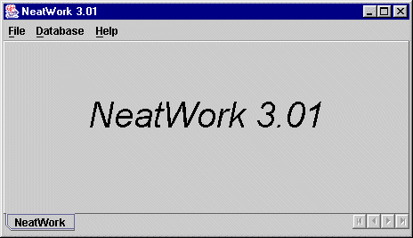

Menu “Database”: edit the database file
For convenience, NeatWork saves in a local database a full set of available pipes with their characteristics. When building a design, the user will be asked to select a subset of pipes that are available for the project under study. You can edit the database. To add a new line: select a line first, and press the leftmost button; to delete a line: select the line and press the second button; to reset original data: press next button; to validate changes: press the rightmost button.
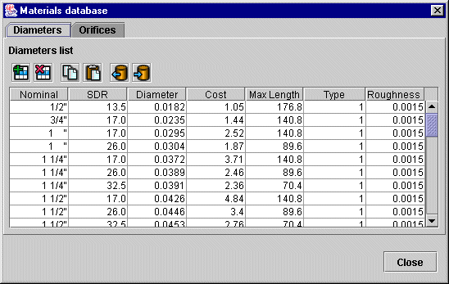
The principle for the orifice database is the same, but the database is much simpler.

Menu “File”: topography and design

Submenu “New Topography”
The “New Topography” submenu in the file menu opens a dialog box with the list of existing topos (files with suffix “.tpo” in the project folder). Entering its name and validating will create an empty topo.

Submenu “Open Topography”
The “Open Topography” submenu in the file menu opens a dialog box with the list of existing topos (files with suffix “.tpo” in the project folder).
To open an existing topo, select the file in the dialog box. The name of the file will automatically appear in the window right to “filename”.

Open the menu file,
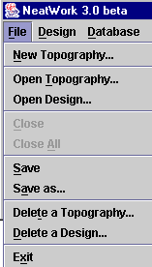
and choose Open Topography
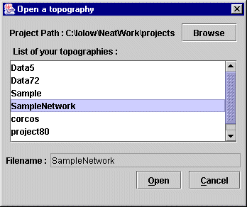

Press the open button. You obtain the following windows:
In the “Tables” tag, the “Node list” and the “Arc list” are displayed in two editable windows. If you click on the “Text” tag, the same information is displayed as it is recorded, i.e., a simple text file in ASCII format. The text format displays the technical data associated with the topo. The “Treeview” tag displays a graphical view of the network if it is a tree.

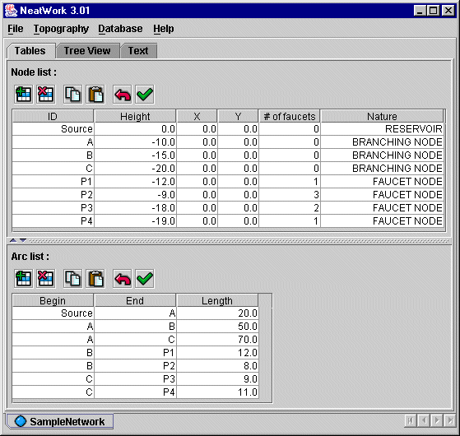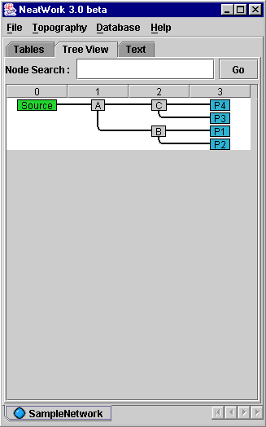
To modify an element of the table, select the cell, erase the current information, print the new data, press enter and validate the new data by pressing the button . Three other buttons stand left to the validate button. The two leftmost buttons allow adding and deleting a new line, while the rightmost button commands an undo operation. When adding a new line, NeatWork automatically set default values. Don’t forget to edit those values.
In all tables in NeatWork, you can click on the header and sort data by column. Moreover, stroking “CTRL”+”C” will copy the whole data content in the clipboard.
The two buttons will respectively copy and paste the whole data content in the clipboard. The stored format of data in clipboard is compatible with excel, so you can edit data with excel, in respect of standard format.
The topo file can also be edited in the “text” window. It is recommended that only advanced users take advantage of this opportunity. Undesirable characters (e.g., semi-columns instead of columns) can make the file unreadable for NeatWork but this option can be useful to edit a large network.
Clicking on nodes in the “Tree View” will show the path from the reservoir to this node. Recall that a topo must be a tree. If you accidentally enter loops, NeatWork will signal it. NeatWork will not save a topo file with a loop.

Submenu “Open Design”
The design file is an extension of the topo file. We have to use the “make design” procedure in order to create a design file. When clicking on the submenu “Open a design” you get the dialog box:
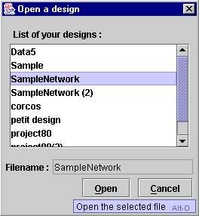
Selecting SampleNetwork opens the window
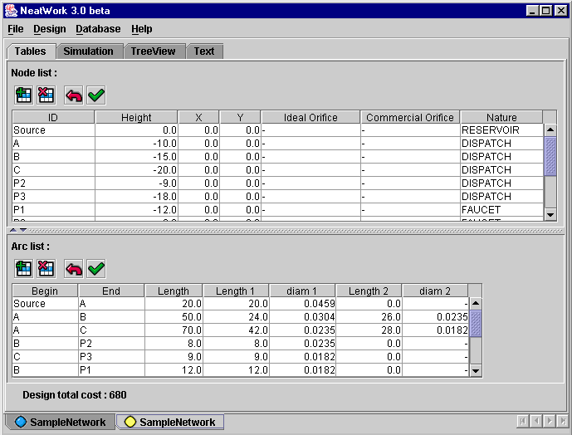
In the “Node list” some node names are completed with a suffix “_a”, “_b”, etc. This corresponds to terminal nodes with multiple faucets. In the example P2 has three faucets. This is recorded as three independent nodes P2_a, P2_b and P2_c. Similarly in the node list there are additional arcs from the common source P2 to P2_a, P2_b and P2_c with an arbitrary length 1 meter. (This length is small enough to have no incidence in the performance; the friction and the cost are negligible.)
The total cost of the design appears at the bottom.
By clicking on the menu “Design” you will display the parameters that were used to build the opened design.
Clicking on the submenu “Building Parameters” yields the window:
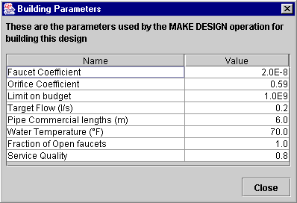
Clicking on the submenu “Building Load Factor” yields the window (To know more about load factors, have a look at the last section “Quality of service and load factor”):
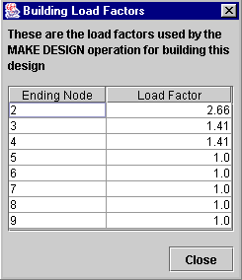
The submenu “Extract topography” generates topography of this design.

Menu “Topography”
The 3 sub-menus of the “Topography” menu are “Quick Check”, “Network summary” and “Make Design”
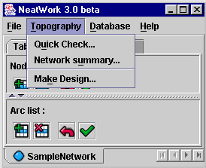

Quick Check
This feature checks whether individual faucets have any chance to deliver a minimal flow. The test is very crude: the loss of potential energy (drop in altitude) should at least match the loss at the faucet. This test is useful to point out potential problems in topographies with little variations in altitude.
In “SampleNetwork” we get
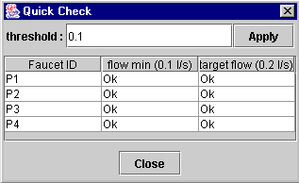
To further illustrate the use of “Quick Check”, let us change the altitude of node P3 from -18 to -1. The “Quick Check” window reveals that no design can deliver the target flow 0.2 l/s. However, the “quick check” answer does not exclude the possibility that the faucet delivers a minimal flow of 0.1 l/s. You can choose the threshold with the text editor.

Network summary
This submenu provides a summary of the main characteristics of the topography.
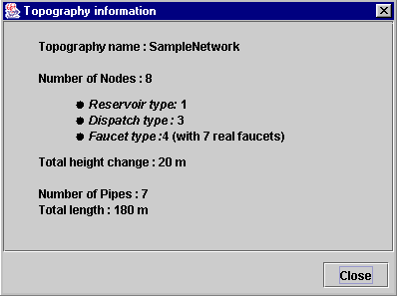

Make Design
To make a design on an open topography, click on the submenu “Make Design”. (If several topos are open, the command applies to the topography in the active window.)
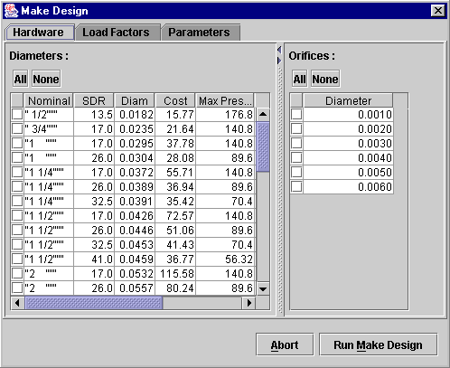
To activate the “Run Make Design” command, you must select which pipes can be used. The command opens a window with the full set of pipes and commercial orifice available in the database. You can select all of them or any subset of them. (Here, we clicked on the button “All” which makes available for the project the complete set of pipes and commercial orifices available in the database.

If you click on the tab “Parameters” you get the set of default parameters.
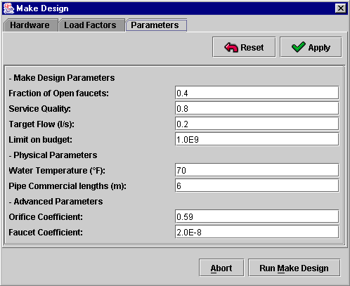
Let us review the list.
- “Fraction of open taps“: forecasted number of faucets that are simultaneously open at the peak hour.
- “Service Quality“: for detailed information, see section of advanced features.
- “Target Flow“: desired flow at any faucet under any circumstances.
- “Limit on budget“: the value in the right gives the budget available for the project. The “Make Design” computes a design compatible with the budget constraint. If the budget constraint is tight, the resulting design may not perform well.
- “Water temperature“.
- “Pipe commercial lengths“: if a single type of pipe is used on an arc, the link will be made of several pipes of commercial length, plus a fraction a fraction of the commercial length to adjust to the total length of the arc. If NeatWork needs two different types of pipes (it is never optimal to use more than two types of pipes on a given arc), the longest section will be made of multiples of the commercial length. The required fraction of commercial length will be assigned to shortest section.
- “Orifice Coefficient“: coefficient in the orifice loss. This value is experimental.
- “Faucet Coefficient“: coefficient in the formula giving the faucet loss. This coefficient may change with the type of faucet in use.
If you click on “Run Make Design” with the default parameters, you get the design:
Note that the arc from A to C is made of two different types of pipe. The longest section (42 m) is a multiple of the commercial length (7 times 6 m), while the shortest section requires 4 full pipe (6 m) plus 4 additional meters to match the total length (4*6+4=28).

Transcribe a design
Suppose you want to test and analyze an existing design. The “New Topography” and the “Make Design” commands allow you to build the file.

Simulation Pane
The simulation tool applies to actual designs. For this reason it is only accessible from the window displaying a design. The figure below reproduces the upper part of the design window.
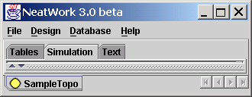
Click on the tag “Simulation” to get
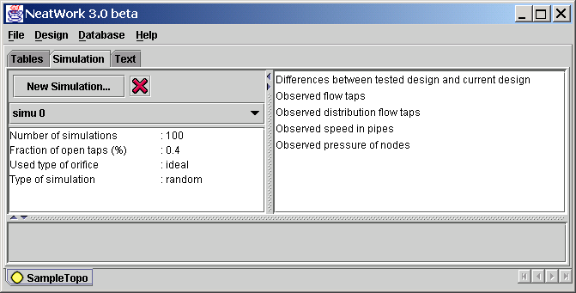
The sub-window on the left displays the current parameters for the simulation. Those parameters can be changed at the start of a new simulation. The sub-window displays information on all the simulation that have been performed (and saved) on the given design.

Launching a simulation
Click on “New Simulation”. You’ll get
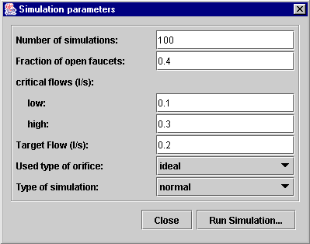
You can change any of the displayed parameters. An individual simulation runs consists of setting at random which faucets are open. Each faucet has an equal probability of being open, and this probability is equal to the “fraction of open faucets”. If the design has sufficiently many faucets, the actual fraction of open faucets in the simulation ---a random value--- is likely to be very close to the parameter value “fraction of open faucets”.
The next three parameters are reference values to help the analysis of a simulation. Target flow is the ideal amount that should flow out when a faucet is open, independently of the configuration of open faucets. Of course, the actual flow at a given faucet is not independent of the configuration of open faucets in the network. In some simulation runs, the flow may be low, in some other the flow may be high. The parameters “low” and “high” are threshold values bracketing the target flow. A flow between those two extreme values is considered acceptable. A flow below “low” or above “high” is critical. The three parameters “low”, “target” and “high”, are set by the user. In principle, the target flow parameter in the simulation is the same as the target flow that was used in the design, but this is not mandatory. These parameters are only use to compute statistics.
The diameters of the orifice used by the simulation are determinate by the tag “Used type of orifice”. Ideal orifice will give nearest results of the target flow from which the design has been built than the commercial one. This one will give nearest results of reality.
There are three type of simulation:
- Normal: Simple Monte-Carlo simulation : the simulation is done n times with a random configuration of open/close faucets in respect of the fraction of open faucets.
- Tap by tap : A simulation is realized for each faucet and this faucet will be the only one opened.
- Custom : The user determines its own configuration of open/close faucet.

Analyzing the results

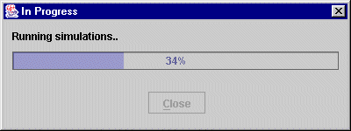
NeatWork gives you statistical results computed with realized simulations.

Flows at faucets
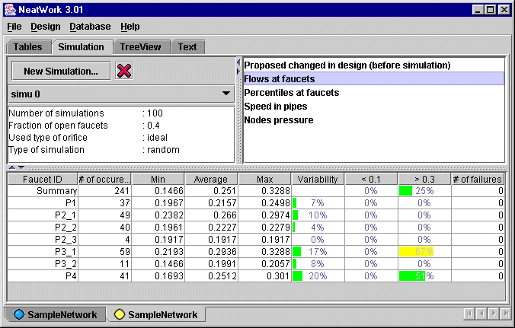
Flows at faucets gives you summary on observed flows at faucets during the simulations.
# of occurrences is the number of occurrences where that faucet which has been chosen. Note: multi-faucets nodes are displayed by total number of opened faucets at this node. For example here, the case of the node P2, we have P2_1 for only one opened faucet, P2_2 for exactly two opened faucets, and so on.
Min is the minimum observed flow.
Average : the average of observed flows.
Max is the maximum observed flow.
Variability is (in %) the ratio between average and standard deviation.
< 0.1 is (in %) the fraction of observed simulation where the flow was below the threshold 0.1.
> 0.3 is (in %) the fraction of observed simulation where the flow was above the threshold 0.3.
# of failure is the number of simulation where the faucet was opened and no flow was observed.

Percentiles on flow distribution

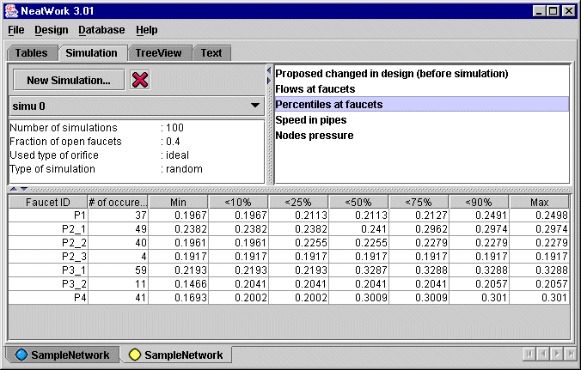
“Percentiles” gives an insight of the flow distribution. Note: you can stroke “CTRL+C” after having selected the table to copy the content in the clipboard and make graph with excel.

Speed in pipes
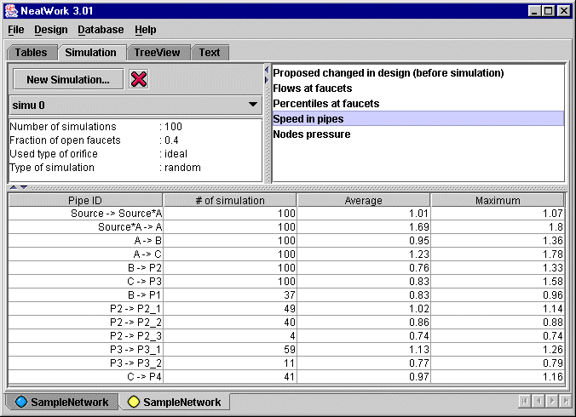
“Speed in Pipes” gives you the average speed and the maximum speed in pipes during simulations. Values are in meter per second.

Node pressures
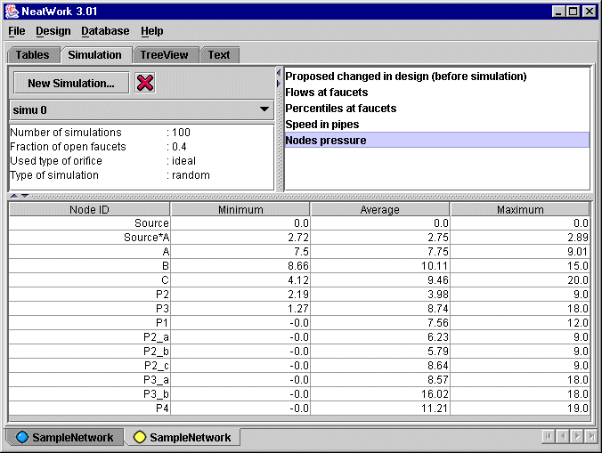
“Nodes Pressure” gives you minimal, maximal and average pressure at each node of the network.

Advanced features

Setting the target flow and the fraction of open faucets
THIS SECTION IS PURE IMAGINATION. GILLES CORCOS AND MATTHIEU LECORRE SHOULD PROVIDE INFORMATION.
The choice of these values is critical in the design and analysis of a network. They are objectives assigned by the designer that define a reasonable use of the water resource. Recall that that the source fills the reservoir at a certain rate. Let us assume that at the end of the dry season when the rate is at its lowest, the flow is enough to fill the reservoir in one day. It is also assumed that this rate is enough to cover the daily needs of the community. (Note that these figures may vary from one region to another. They may also change in time. Fixing them is almost a political choice out of the scope of NeatWork.)
The flow out depends on the water consumption, which is unevenly distributed during the day. The peak period is in the morning, and last say x hours. (A value x = 2 is reasonable.) The designer has to decide the fraction of the reservoir that can be depleted during the peak period. On the other hand, the designer has to decide on the value of a reasonable flow at a faucet. The flow has to be large enough not to make the consumer impatient. It must not be too large to avoid waste. Some water distribution systems use simple faucet with only two positions, open and close, with no intermediary settings. NeatWork applies to network with this type of faucet, though its results may be useful for other networks.
Given these preliminary considerations, consider that the simple network of our example is made for a community of 10 households with a daily consumption (allowance) of 200 liters per day. The daily community consumption is 2000 liters. We take this figure to be the reservoir capacity. Assume that we allow the peak hour allowance is one third of the capacity reservoir, i.e., 666 liters.
From operational considerations, the flow at the faucets is set to 0.2 l/s.
From these data we want to infer the average number of faucets that are simultaneously open. I believe that it can be derived by probabilistic consideration on the uses of the faucets. The open/close process at a faucet is a random process. One may assume that it is a Poisson process, whose mean is the total consumption at one faucet during the peak hour, say 666 / 7 liters, about 100 liters. Under these assumptions it is possible to compute the average number of faucets that are simultaneously open.

Quality of service and load factor
The main issue in making a design is to account for the random process of open/close faucets. It would be relatively easy to conceive a least cost design for a network in which the faucets are all in the open state.
To understand the concept of load factor and service quality let us start with the extreme case where the design should meet the requirement that all faucets are simultaneously open. It is easy to determine the necessary flow in each branch: suppose that there are n faucets downstream that branch and let f be the target flow at each faucet; then the flow in the branch is n times f. Given the flow in a branch, the friction loss in the branch is a direct function of the diameter of the pipe. The problem of finding a least cost design is the one of selecting appropriate pipes so that the total friction loss along the paths from the reservoir to each faucet be equal the loss in potential energy (proportional to the drop in vertical elevation) minus the friction loss at the faucet.
The operational conditions are not so simple. It is never the case that all faucets are simultaneously open. In the peak hour, one can expect that at most a fraction r of the total number of faucets is open. This fraction is interpreted as the probability that a faucet be open at the critical peak hour, which makes the open/close process a random phenomenon. It follows that the flow in each branch is also random.
To get around that difficulty and to produce a design, we have to replace the random flow in the branch by some typical value. The mean value is a reasonable choice when there are many faucets downstream the branch. But when there are few faucets this choice is inappropriate. Take the extreme case of the pipe ending at a faucet. If the faucet is open, the flow is f; if the faucet is closed the flow is zero. In the latter there is no friction loss for any pipe. Therefore, the proper flow to consider is f and not the mean r f.
Similarly, when there are two dependent faucets, there are three possible cases, 0, 1 or 2 open faucets, with probabilities (1 – r)², 2 r (1 – r) and r ² and flows in the branch 0. f and 2 f. By the same token as in the single faucet case, a zero flow is not relevant for the design process and we must consider that at least one faucet is open. The probabilities that one or two faucets are open given that at least one faucet is open are the conditional probabilities 2 (1 – r) / ( 2 – r ) and 2 / (2 – r). To further illustrate the point, we display the flow conditional probability distribution in a branch with 6 dependent faucets and a probability r = 0.4 per faucet to be open.

Open faucets | 1 | 2 | 3 | 4 | 5 | 6
Flow in the branch | f | 2 f | 3 f | 4 f | 5 f | 6 f
Conditional probability | 0.1958 | 0.3263 | 0.2900 | 0.1450 | 0.0387 | 0.0043
Cumulative Probability | 0.1958 | 0.5220 | 0.8120 | 0.9570 | 0.9957 | 1

Which flow should be selected in the design process? The conditional mean of the distribution is a sensible choice. In the above example this would give 2.517 f. However, we must keep in mind that a design based on that choice will not necessarily perform well under any circumstances. In the search of a good design, one has to try other values. To guide the choice of trial values, we have introduced the concept of quality of service. To illustrate the concept, suppose that the design flow is set to 3 f in the above example. Looking at the table displaying the conditional probability distribution, we realize that the value 3 f is large enough to cover “flow demand” 81% of the time. We say that the quality of service of 3 f is 0.81.
Since we may want to choose a flow between two discrete values, say between 2 f and 3 f, we define the quality of service by linear interpolation. Reciprocally, if we impose a quality of service 0.7, the corresponding flow will be
2 f + f (0.7 – 0.522) / (0.821 – 0.522) = 2.61 f.
We name load factor the coefficient 2.61 that appears in the right hand-side of the equation.
The service quality is a user free parameter in NeatWork. When you click on “Make design” you get the window
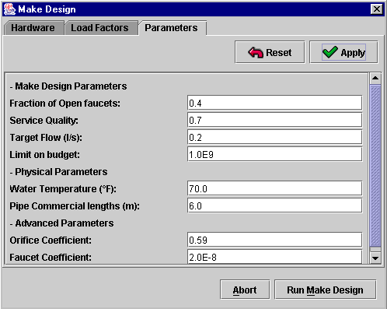
The chosen service quality is 0.8. NeatWork automatically computes the load factor on each branch. It is displayed in the “Load Factors” window
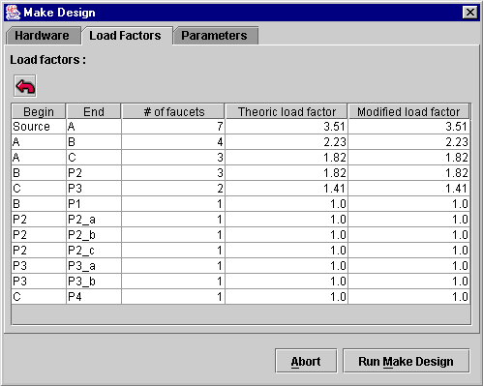
For branches leading to a single node, the load factor is 1 as predicted. For the branch from the reservoir to node A with 7 subsequent faucets, the load factor is 3.51. If you lower the service quality, you decrease the load factor. For instance for a service quality 0.6, you get
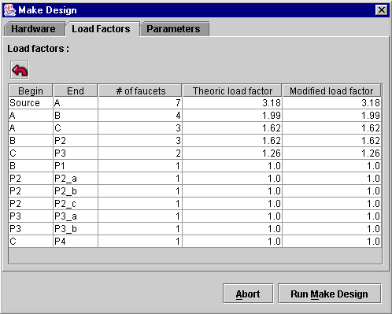
For the initial branch the load factor dropped to 3.18.
You can edit the load factors individually in order to get a more user-convenient design.

Annexe
Credits
NeatWork is a freeware system for the design and the analysis of gravity driven water distribution systems. The user provides data: topography, available pipes and orifices, environmental and operational data; the design module determines a least cost design to meet the users’ requirements; the simulation module determines the system performance in simulated operation modes.
NeatWork was developed to meet the needs of Agua Para La Vida, a non-governmental agency operating in Nicaragua. It has been extensively tested on the field and has been effectively used in the building and the evaluation of several projects. NeatWork is meant to design drinkable water distribution systems obeying strong operational constraints: the system involves no external devices (pumps, valves); the system requires minimal maintenance and management operation.
G. Corcos, co-founder of Agua Para La Vida, first formulated the problem. He reviewed the physical laws of low speed flows and performed hand-made checks on simple water-distribution systems. G. Corcos and J.-P. Vial split the analysis into two modules: a design module producing a least cost design, and a simulation tool. Version 0 was purely Excel based. The design module used a simple heuristic, while the actual flows in the designed network are determined as the optimal solution of a minimum energy optimization problem. Excel Solver was used to solve the optimization problem, but it lacks power and stability to handle any network but the very small ones.
In Version 1, the optimization problem underlying the simulation is solved by a dedicated algorithm due to J.-P. Vial. Both the heuristic and the optimization algorithm were programmed in Matlab 4.0. C. Huizinga, the other co-founder of Agua Para La Vida, integrated the Matlab engines within the Excel environment of Version 0. He also improved the heuristic in the design module. Version 1, under the name of Distrib, has been extensively tested and used on the field.
In Version 2, the design problem is reformulated as a linear programming problem. E. Andersen graciously made available the powerful nonlinear solver Mosek to perform the optimization component in the design and simulation modules. F. Babonneau with the help of J.-P. Vial, developed a Java interface for the new approach.
Version 3 keeps the core of Version 2, but proposes an interface in java for increased portability and convenience use. L. Drouet, with the collaboration of F. Babonneau, is responsible for the new interface. Version 3 can run on various platforms; it can also be launched on a remote server. Version 3 will additionally serve as a modeling and model-solving tool in distance learning program on sustainable development.

NeatWork exhaustive features

Design
- NeatWork designs water distribution systems to match user-defined operating conditions (target flow at faucets and fraction of open faucets).
- NeatWork computes designs that minimize the total pipe costs. On gravity driven system, this cost is a significant share of the total costs. Saving on those costs is a premium.
- NeatWork selects pipes from a user-defined database. NeatWork designs minimize the use of fractions of pipe commercial sizes.
- NeatWork handles a budget constraint on the total pipe costs. If the constraint is tight, NeatWork selects a design that match the budget and achieve operations capabilities as close as possible to the user-defined goals.
- NeatWork design module is triggered by three parameters: the faucet target flow, the fraction of open faucets and the service quality level. Each of these user-defined parameters influences the least cost design.
- NeatWork lets the user tune additional parameters such as ambient temperature, type of pipes (PVC, iron), corrosion…
- NeatWork allows the user to force the use of certain pipes on any given branch. NeatWork finds for the remaining branches the least cost design that achieves operations capabilities as close as possible to the user-defined goals. This feature is particularly useful when planning an extension of an existing distribution system.
- NeatWork generates a tree representation of the topography, which facilitates analyses of system behavior.
- NeatWork uses in its search for an optimal design an anticipated flow load on each branch. This load is determined by the service quality level and by the fraction of open faucets. The user may modify manually the anticipated load on each individual branch.

Simulation
- NeatWork simulates the flows for any configuration of open/closed faucets.
- NeatWork generates Monte-Carlo samples of open/closed faucet configurations and automatically simulates the flows for each configuration.
- NeatWork provides extensive statistics on flows, pressures and speeds: minimum, average, maximum, coefficient of variability, percentiles…
- NeatWork provides visual aides to locate problematic faucet nodes.
- NeatWork saves simulations attached to a given design in a project fashion.

Loops
- NeatWork can simulate flows on water distribution systems with loops. NeatWork has no restriction on the number of loops. The flow directions on branches in a loop are automatically computed.
- NeatWork can perform the same Monte-Carlo analysis on network with loops as on tree networks.
- NeatWork cannot make designs on topography with loops.
The Faucet coefficient
One of the most striking features of gravity driven network is the considerable impact of faucet losses. It is thus of the utmost importance the parameter α be chosen accurately. This parameter is seldom provided by the manufacturer but there is a simple experiment to compute its value with reasonnable accuracy.
The experiment is as follow. A tank of volume V₀ is connected by a vertical pipe down below to the faucet. The difference of altitude between the bottom of the tank and the faucet is l. The initial water level in the tank is h₀. The faucet is then open and the time necessary to empty the tank is measured. Let T be this time. The parameter α given by the formula:
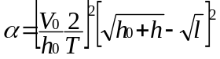
This formula reflects the friction in the pipe. This is reasonnable if l is small (say 3 meters) and the pipe diameter not too small.
The derivation of the formula is as follows. At time time t, the volume in the tank and the water level are V(t) and h(t). The flows at faucet is f(t).
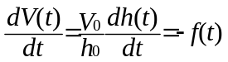
On the other hand, neglicting the friction losses in the pipe, the faucet flow satisfies :
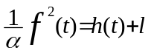
Thus
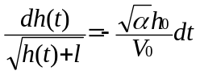
The formula for α follows by direct integration and the limit conditions.
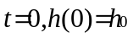
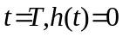
Friction formulae for pipe flow in distri bution networks.
The quantity of interest for calaculations by Neatwork of head losses by fricition is h_{f}/L the head loss per unit length of pipes for all the pipes utilized.

That quantity is related to three others by the relation:

h_{f}/L =0.0826 Q²f/d⁵, (1)

where Q, the flow rate is expressed in m³/sec. and d, the diameter of the pipe in meters. The numerical constant has the units of acceleration, (m/sec²). The variable f is dimensionless and is a function of two other dimensionless parameters , the Reynolds number R_{e} and the ratio ε/d of an apparent pipe wall roughness to the pipe diameter. The Reynolds number can be written as

R_{e}= a*10⁶Q/d (2)

It is a property of the fluid (a non-dimensional version of its viscosity) . Once the fluid has been specified the constant a depends only on its temperature. For water here are a few values of a:

An approximate formula for a ( with T in degrees Centigrade) is:

a=1.267*[(293/(T+273)^8.98]exp{-4700(((1/(T+273))-(1/293))}

Note: for a given region (say either Nepal or Nicaragua) it is sufficiently accurate to use only one value of a.

f is a complicated function (see below) of the Reynolds number Re and of the (equivalent) roughness factor ε/d. Its base is empirical. The effect of roughness is in principle only a function of the pipe diameter and of the nature of the pipe wall. On the other hand roughness is hard to characterize and quantify and if the pipe is subject to corrosion or calcification it varies importantly with time. Thus the choice of a value for a given pipe is substantially subjective. This implies that one must give the user of the program the possibility of a choice of ε for a given pipe wall. But it also means that if f depends importantly on ε/d, its value is uncertain.

The form of f which is generally accepted as fitting the experimental data ( the Moody diagram) best is the Colebrook formula:

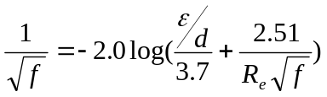 (3)

All other representations of f should be viewed as approximations to (3) . In other words (3) should serve as a reference. The fact that (3) is implicit is not much of an obstacle for its computation especially since it has at least one good and explicit first approximation.

On the other hand the direct use of (3) in our new distribution program raises problems because instead of satisfying head loss equations for each segment we use an equivalent energy minimum principle which requires that the integral of that equation be made explicit. Now 3) is not integrable in explicit form. As a result we have approximated (3) by functions which are easily integrable , i.e.

f= A(ε/d)R_{e}^{B(ε/d)} (4)

Note that the exponent of R_{e} does not depend on the flow rate Q. To each value of ε/d corresponds a pair of values of A and B. These have been chosen to minimize the error made on substituting (4) for (3) within the Reynolds number range which is of interest for small drinking water distribution systems (5000<R_{e},500,000, in general but the range is restricted further for each pipe diameter). The maximum deviations from (3) do not exceed 7% ( which translate to less than 3.5% for the flow rates of any pipe segment. Typical deviations are far less.

Now combining all the above we get :

h_{f}/L = .0826A*(a*10⁶)^{B}Q^{(2+B)}d^{-(5+B)} (5)
so that for a pipe of a given diameter and wall properties and for a given approximate water temperature one gets:
h_{f}/L=CQ^{2+B(ε/d)}
where
C=0.0826(a10⁶)^{B}A(ε/d)d^{-(5+B(ε/d))}

The values of A and B are given by

From these values one can use linear interpolation formulae which are adequate to calculate A and B for any value of ε/d within the range presented. This is what Neatwork does.

For smooth pipes like PVC, roughness factors are quite small and they increase only moderately with time ( calcium deposits tend to leave streaks which affect little the effective roughness ). For that reason while one could derive values of A and B from the data above ( with ε varying from .0015mm to .0025mm) it is also possible to simplify the friction calculations by choosing a composite curve, i.e. one which borrows slightly higher values of ε/d for low Reynolds numbers than for higher ones. In any event the effect of roughness is minimal for PVC. On the other hand in both conduction lines and distribution networks elbows, tees, sudden expansions and contractions of pipes are relatively frequent. Since for smooth pipes the skin friction values are far better known than for rough pipes, it is logical in the former case to correct (on the average) for these additional so-called minor losses. Thus the chosen values of A and B for PVC take the minor losses into account and yield friction losses about 4.5% above those for smooth pipes (without minor losses) according to the Colebrook formula up to a Reynolds number of about 200,000 (and a decreasing overestimate beyond that Reynolds number). They are

A=.235; B=-.219

This gives in the end for PVC and for water as a fluid:
h_{f}/L= αq^{1.781}/d^{4.781}
d=α^{0.2452}q^{0.3725}/h_{f}/L^{0.2092}
q=(1/α)^{0.5615}d^{2.684}h_{f}/L^{.5615}
where:
α= 9.42E⁻⁴a^{(-.219)}
Notes:
Most of the alternate pipe friction formulae are less accurate than the above. In addition to the Colebrook expression, only the Blasius approximation,
f=0.3164/R_{e}^{.25}
( for smooth pipes and R_{e}<100,00) and the Swamee- Jain approximation take the Reynolds number explicitly into account . This means not only that the others cannot be used for fluids other than water, but also that the temperature variations (which say between Nepal and Nicaragua would lead to nearly 14% variations in head loss for smooth pipes) are neglected. Their fit to the Moody data usually also require ad-hoc choices of a disposable constant. On the other hand The Swamee-Jain formula
f=1.325/(ln (ε/3.7d+5.74/R_{e}^{.9})²)
which is explicit is somewhat better than our own approximations but it is not easily integrated either and so it is awkward to use in our program. It is useful however as a first approximation in the evaluation of f by the Colebrook formula which is used for comparison purposes.
In Summary:
Neatwork does not offer a choice of alternate formulas for the calculation of head loss by friction because it considers that nothing is gained by this freedom. For smooth pipes these losses are on a solid experimental footing and for rough pipes these alternate formulations only hide what is a physical indeterminacy.
History
V 3.12 - Forthcoming soon…
V 3.11
  - New proposed pipe with the last recorded node.
  - Input for Celsius temperature.
V 3.1
  - Adding distant treatment feature.
V 3.01
  - Statistics for multi-faucets node.
  - Constraints on pipes.
  - Fixing a bug in orifice assignment.
  - Fixing faucet coefficient.
V 3.0
  - Creation of a file Manager, a project Manager
  - Adding Network summary, Quick check, TreeView, Simulation panel
  - Including building parameters with a new design
  - Fixing few bugs
V 3.0 bêta
  - Changes in the core of NeatWork 2 for a better modularity
  - Introduction of the Project concept : definition of basic structures (Project, Network, Topography, Design) and main operation (Make Design, Simulation)
  - New data flows between basic structures
  - Hardware database management
File Association
Jar (Java ARchive) is a form of Java executable program. On Win32 systems the Java 2 Runtime Environment's installation program will register a default association for Jar files so that double-clicking a Jar file on the desktop will automatically run it with javaw -jar. Dependent extensions bundled with the application will also be loaded automatically. This feature makes the end-user runtime environment easier to use on Win32 systems.
In case if a Jar file does not run by double-clicking, you can associate the .jar file extension with Java interpreter to make it executable by clicking.
Here is how to associate files with .jar extension to the Java interpreter, java or javaw, in Windows environment.
In Windows File Explorer, select Tools->Folder Options...
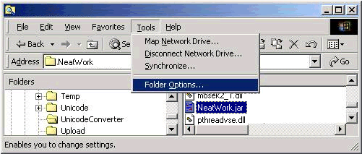
Click File Types tab and select JAR Executable Jar File option. Click Advanced or Change.
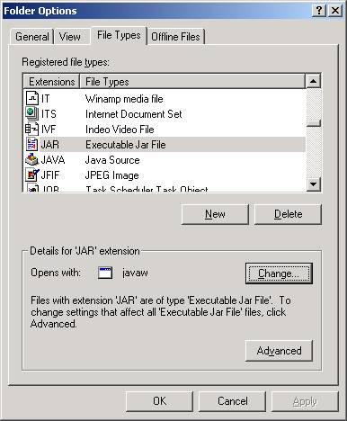
In the Edit File Type dialog box, select open in Actions box and click Edit...
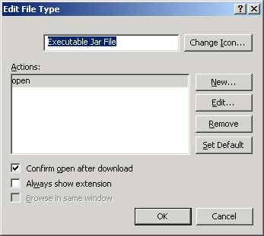
If you have JRE 1.3 installed on your machine, the interpreter java or javaw is usually found at C:\Program Files\JavaSoft\JRE\1.3.1\bin.
Type C:\Program Files\JavaSoft\JRE\1.3.1\bin\javaw.exe -jar %1 in Application used to perform action field and click OK.
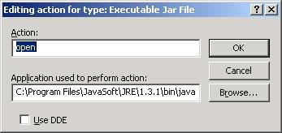
Done. You now can launch .jar program by double-clicking it.

