# Setting up files/projects

Set relative path for files so that you don’t have the long C:/…./pic.png and it doesn’t work when copying project to another file.

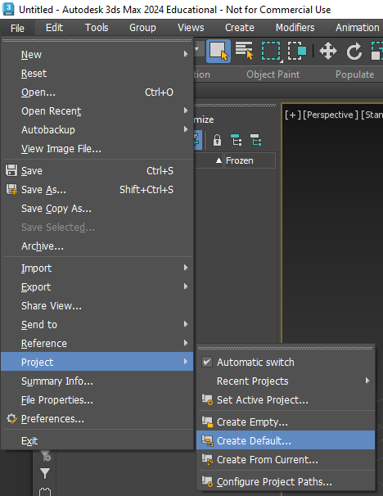  
Setting up new project in the folder I want it in

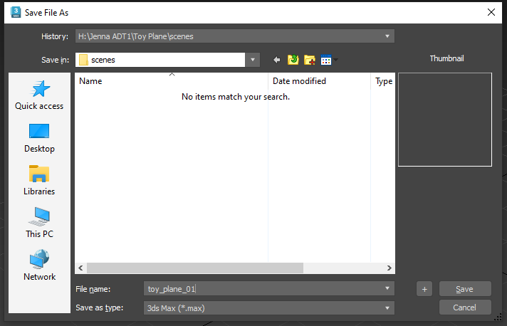  
When saving the actual model, it will show in scenes folder auto made by create default step

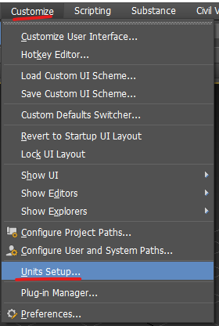  
Change units to cm from inch. Keep on generic so there is no, 5cm or 74cm around, it will just say 5 units long or something. PC at home will remember, PC at poly wont cause deep freeze is active.

# Basic movement/controls

Alt+W will take out to orthographic views  
press again to zoom into the active view with yellow surround  
T = top view P = perspective U = orthographic

Some views don’t have hot keys. right click the view you’re on to show all other views

to see edges press F4

show/hide grid press G

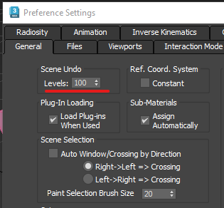  
number of undos available. WARNING Spamming will crash 3Ds. More undo’s will take more ram storage

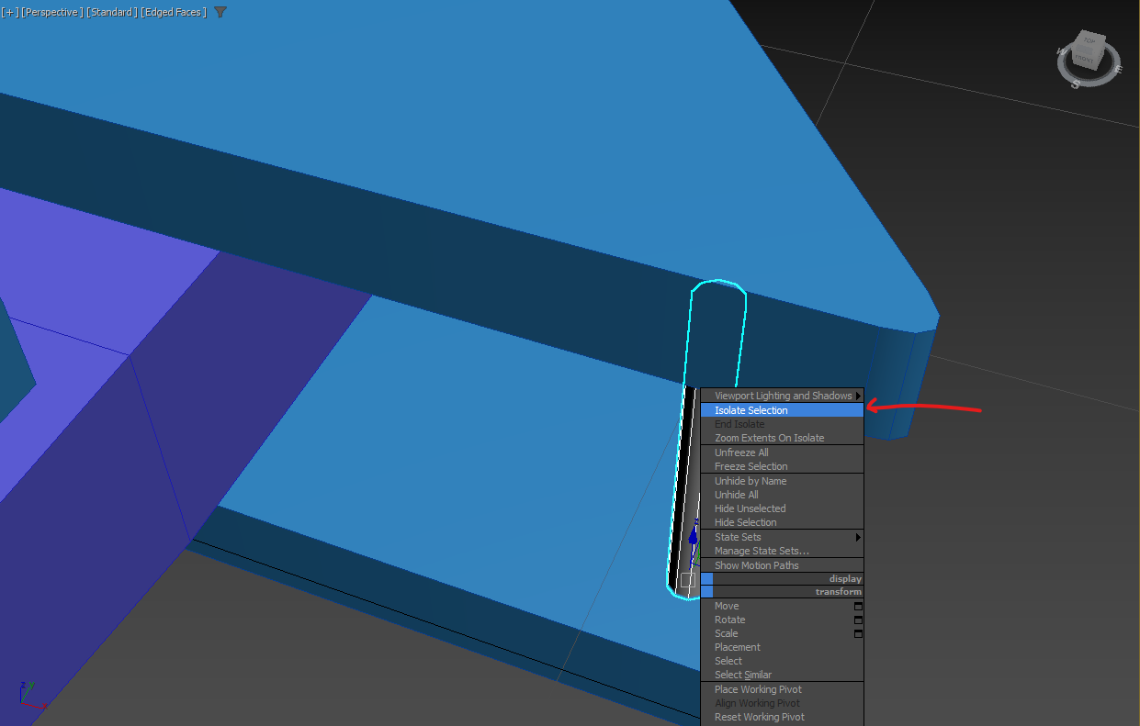  
to temporarily hide all objects but the selected one, right click a selected object and click on “isolate selection”. Or shortcut is Alt + Q. This is especially helpful when optimising later on

selecting things without accidentally moving them at the same time (Q)

# Basic shapes and altering

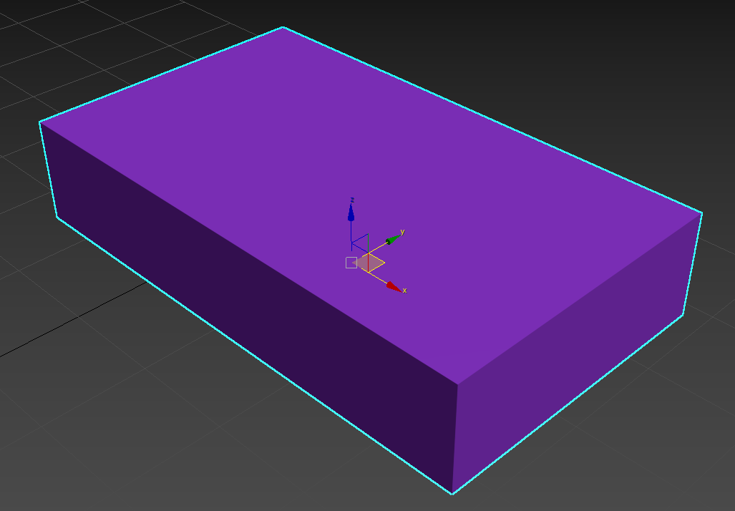  
Select and Move tool, shortcut W  
grab each arrow for single axis movement  
grab box between arrows for plane movement  
grab white box at origin for full free movement (note to self, don’t recommend)

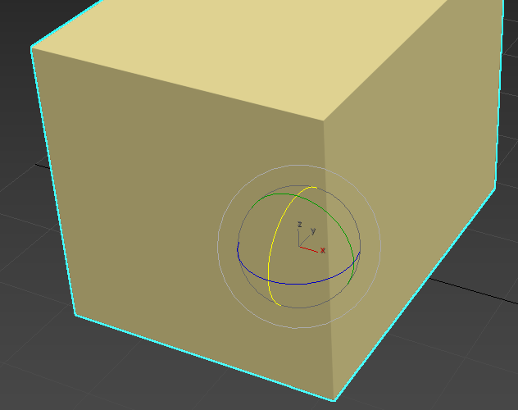  
rotate (E)   
has single axis movement or free rotation  
unknown if has 2 axis rotation at one time???

angle snap (A) is best friends with rotate tool  
default is 5 degrees, can change somewhere???

click hold to show multiple versions of scaling.   
the others are weird so just use uniform (arrow pointing)

cloning objects is super easy.   
be in move mode, hold shift, drag a movement axis  
copy is basic non linking, changes to original will have no effect on clone  
instance allows you to change original and this changes clone ????  
reference is????

## Snapping toggle

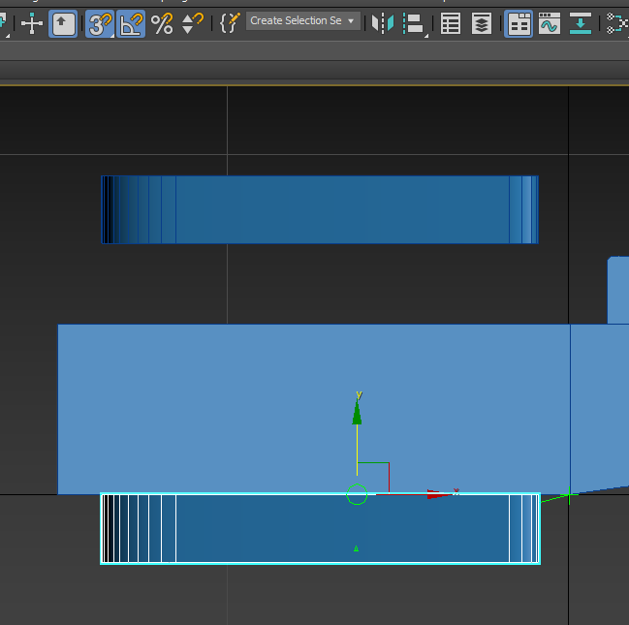  
its useful tool but it should ONLY be on when we need it.   
It allows movement to snap to objects around when in move mode.  
It has different modes, but using 3d mode is “easiest” as you can just be in a 2D view to stop it moving in the 3rd direction. Green cross shows where its snapping to

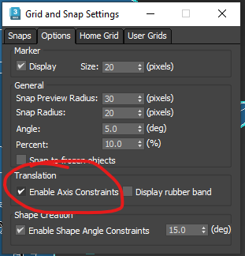  
right click snap toggle and select where you want to snap to, vertex is easiest to work with  
axis constraints will stop the thing youre moving snapping onto the exact location and will only move on the axis you are moving, essentially stops free movement

## Moving pivot points

turn on snapping (S), go to hierarchy tab, select “affect pivot only”  
large wireframe arrows should show over widget  
turn on settings in snapping toggle area

simply drag the axis you want to move to any vertex on the plane you want it to be against

if you ever mess up and cant find the pivot, just reset with one of the above

# Non-basic shapes and modifications

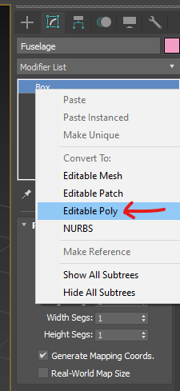  
making a shape not just a simple shape

making a segment on an object that isn’t exactly quarters, or halves etc  
very imprecise, only measured by eye

making exact locations for new segments. Select ALL the edges you want to connect it to

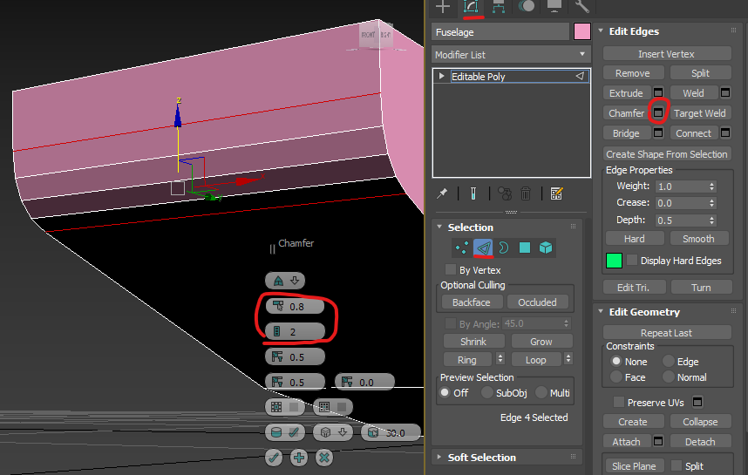  
how to make a chamfer on an edge. Select the edge first, then the chamfer settings and only change the “area” of chamfer and the number of edges.  
WARNING too many edges WILL crash 3Ds

inset allows us to make a face the same shape but smaller (inset) in the original face

extrude allows faces to be pushed/pulled on the axis that is 90 deg to the face

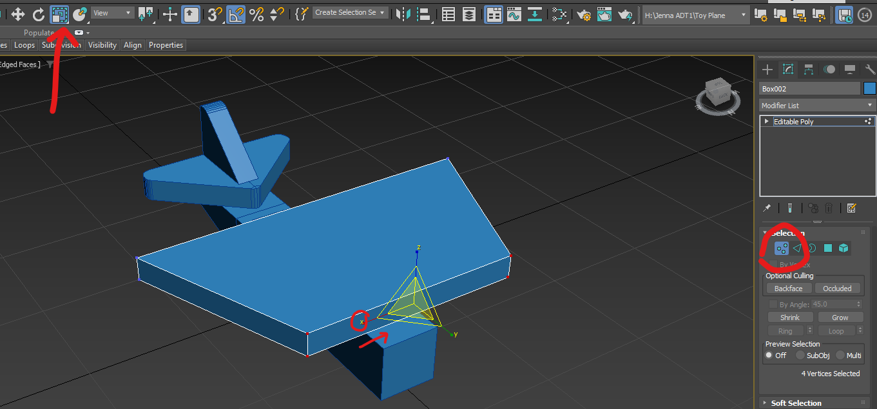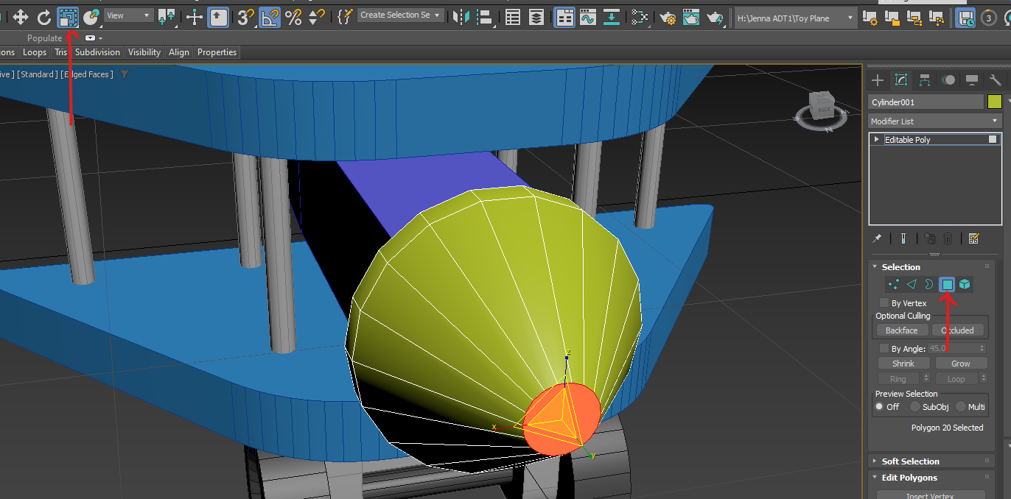  
scale can be used to push/pull many things.  
selecting multiple vertices can be used to make trapezoids with squares  
selecting a face can shrink a cylinder to a cone

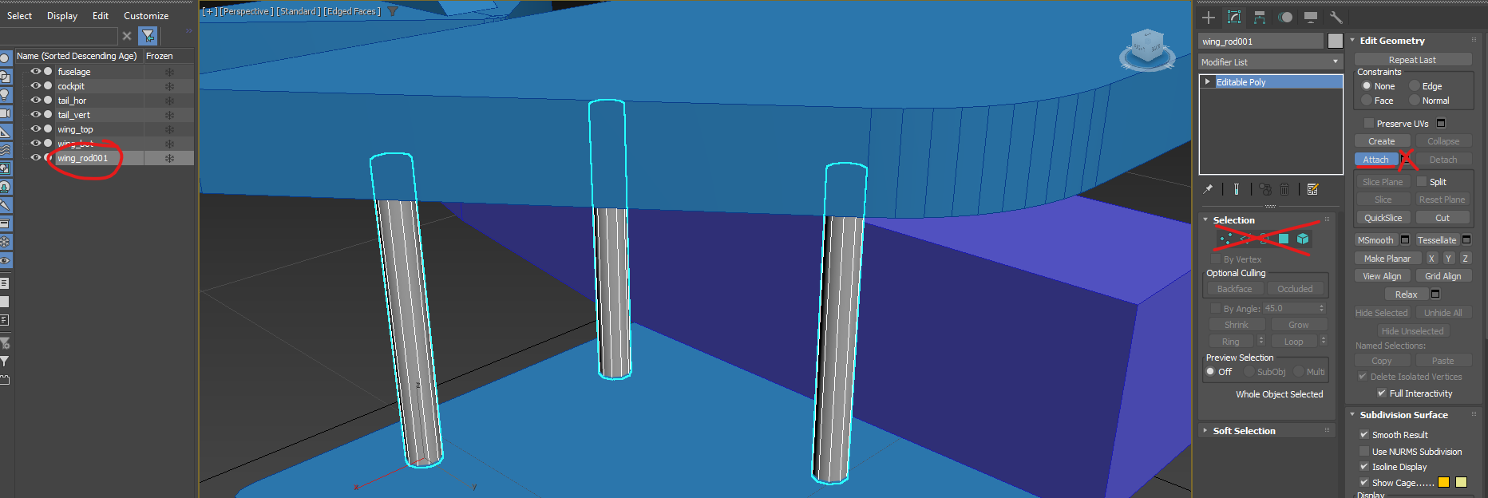  
you can attach shapes together that you want “grouped” (grouping is something else tho)  
reasons could be, dupe objects, combining objects that touch  
be top level, click “attach” NOT settings, then click each object you want to attach  
click “attach” again once done  
to modify individual objects that are attached, use the element selector

when using any tool’s setting button, and you want to do multiple of the same tool  
just press the + symbol instead of the tick

ends of objects that are never going to be rendered (inside of another object) should be deleted. This optimises the model and saves resources

## Symmetry modifier

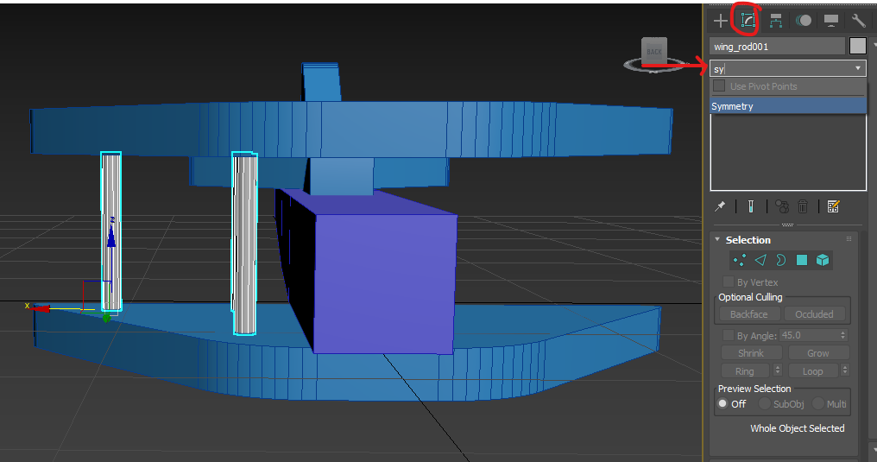   
make sure in top-level selection of the object you want to mirror  
find symmetry mod in modify tab

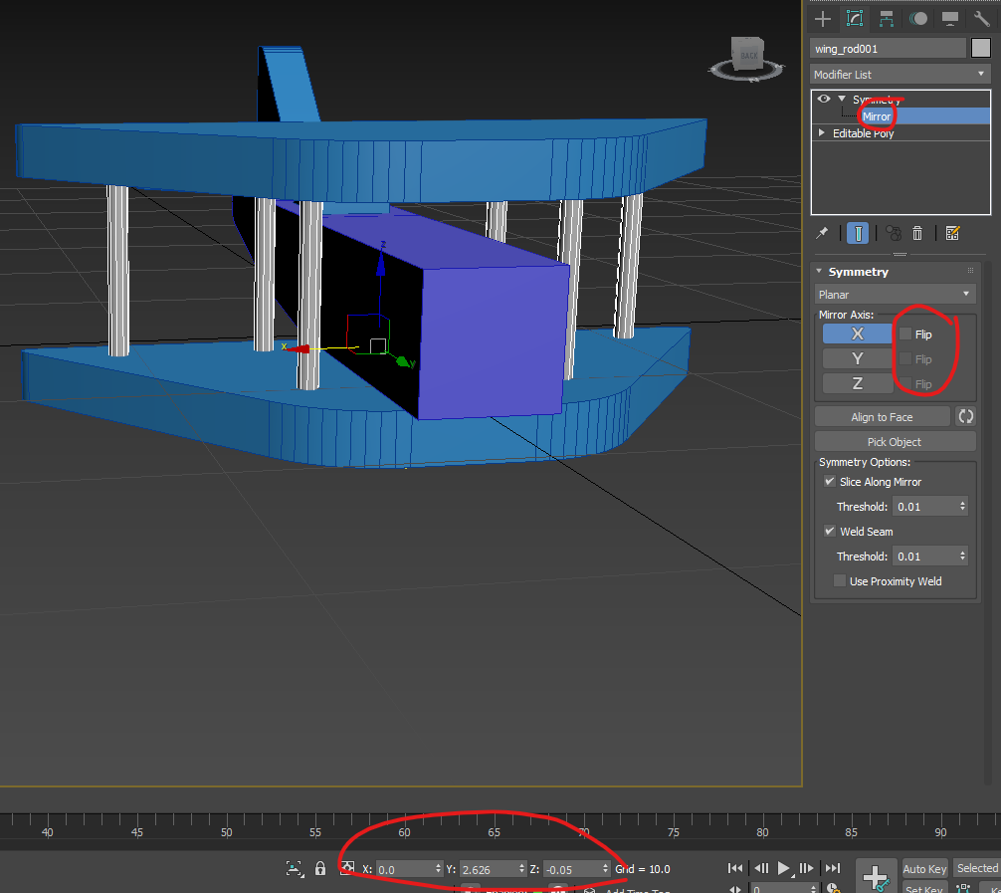   
expand symmetry mod, select the mirror plane  
rotate mirror plane to correct axis with the X Y Z buttons, use flip buttons if stuff dissappears  
move plane to correct place on the mirroring axis (other axis wont matter)

when happy with mirror, right click symmetry mod, then click “collapse all”

a big scary box will show but its ok, just click “yes”

# Unwrapping a finished model

use “attach” and join all pieces if they touch  
different objects in a full scene shouldn’t be attached

you MUST be in top level to apply the unwrap modifier

click button, new window is good

set up screen like this, or UV editor on second screen

ctrl + A to select all, then flatten mapping

should look like this (but all green, red is selected stuff), click the button top right to remove grid

get better grid shading

select all and move away from checkered zone for manual sorting

have polygon selected, and element select enabled  
click on an old object in perspective view  
move all elements into checkered zone

find a seam (green line) that should be on a rounded/smooth area  
click on 3d view, find in 2d view  
deselect, the select only 1 edge of seam  
click “stitch: custom”

when seams are solved move to the side and start again with the next object

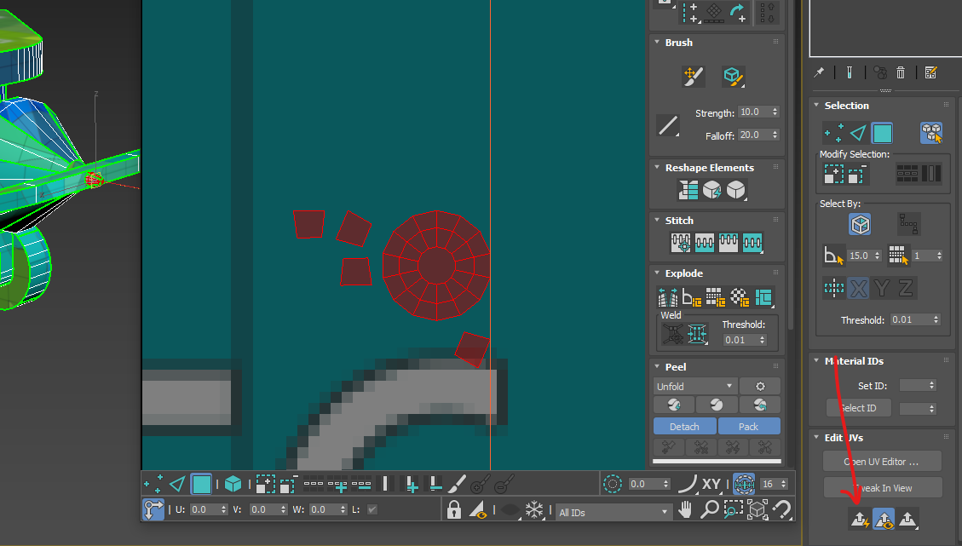  
USE THIS BUTTON WITH CARE  
if a shape is completely exploded and it has way too many polygons to fix manually  
the shape should have at least one open end, works amazing on cylinders with no ends  
make sure there are no faces that are 90 deg to each other (nose of cone to the sides of cylinder)  
if it does, PLEASE split them off first, this will fix a lot of issues later  
select whole shape and click “quick planar map” (arrow pointing)  
find the side that would take a seam best and make a seam with “break” button under “explode”  
either use relax or straighten to get it to look correct again  
NOTE sometimes lone vertices will be joined

# No screenshot notes

Taking screenshots while in any view  
shift + win + S   
in that ORDER specifically

How to move around perspective view  
mouse scroll = zoom  
alt + ctrl + scroll hold + move mouse forward/back = smooth zoom  
mouse click/hold is pan  
alt + mouse hold is rotate  
can also use cube top right  
Z to zoom on object selected, if none selected, zooms on whole scene

# Completed work

plane model complete without textures