ECE324 Assignment 5
Benjamin Cheng - 1004838045

Baseline
1. Overfitting
As the assignment suggests, the baseline model fails to overfit due to lack of parameters. After 1000 epochs the max accuracy obtained on the overfitting dataset was 94%. The following figure shows the loss and accuracy across these 1000 epochs, using the suggested hyperparameters (learning rate = 0.001, batch size = 64).

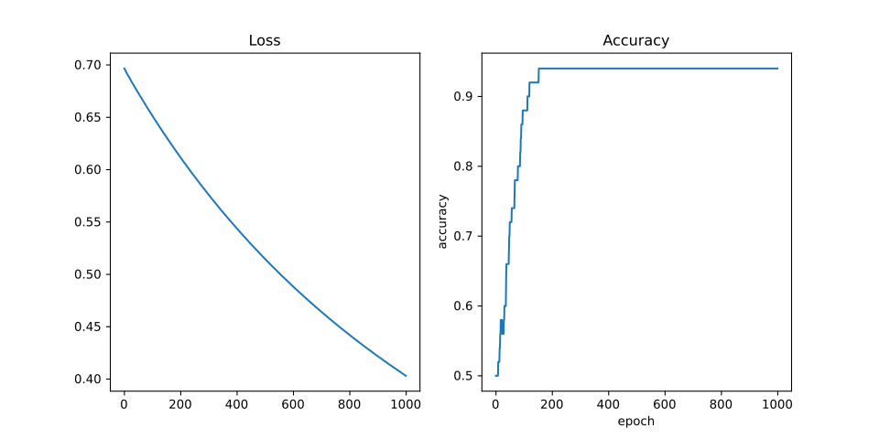
2. Full Training Data
Using the hyperparameters given in the assignment produces the following training curves. The final test accuracy achieved was 88.7%.
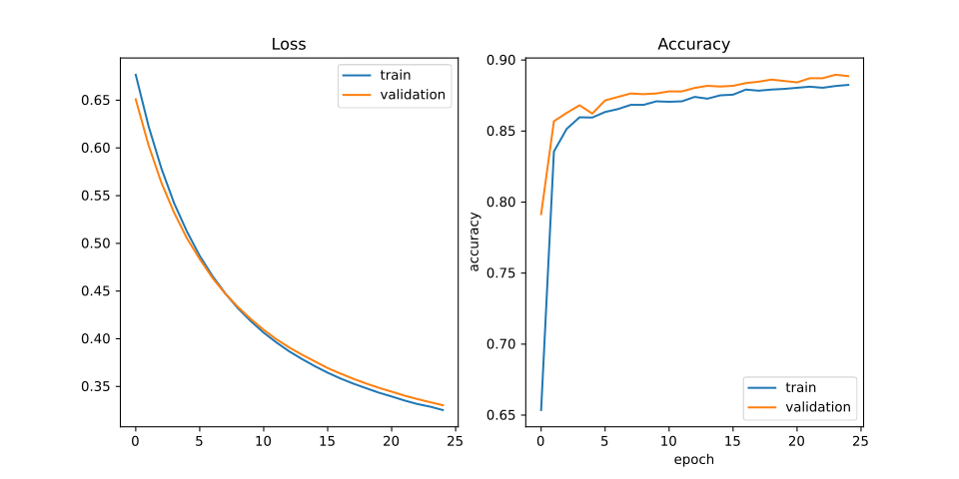
CNN
1. Overfitting
The CNN is able to overfit very quickly to the overfitting dataset. The following curves were produced using exactly the hyperparameters specified.
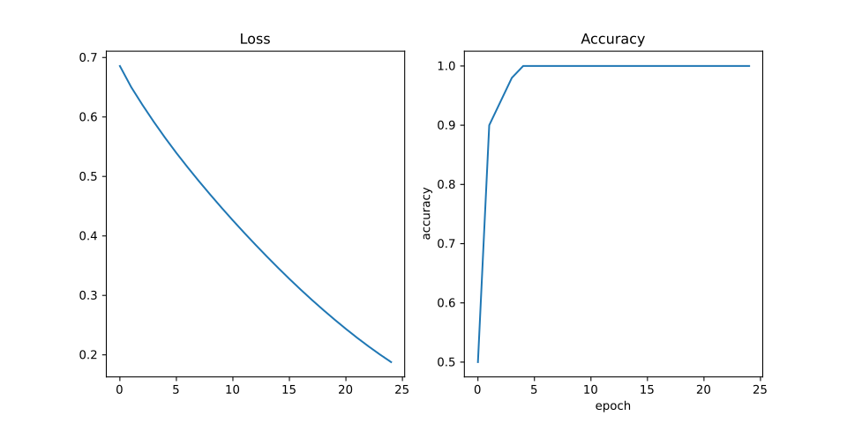
2. Full Training Data
Using the hyperparameters given in the assignment produces the following training curves. The final test accuracy achieved was 91.9%.

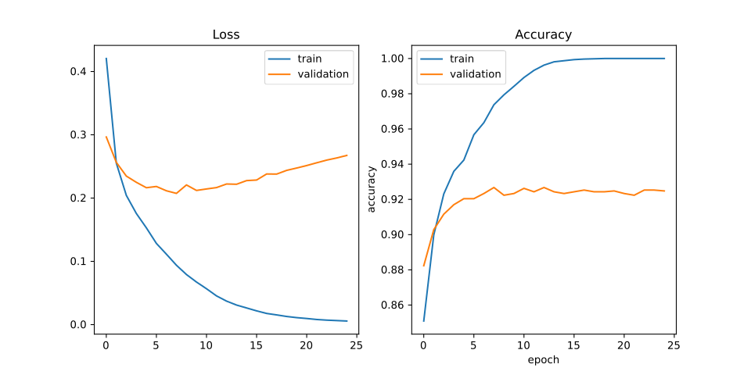

RNN
1. Overfitting
The RNN is able to overfit, but only after the 30th epoch. The following training curves were generated with the given hyperparameters, with the exception of 50 epochs.

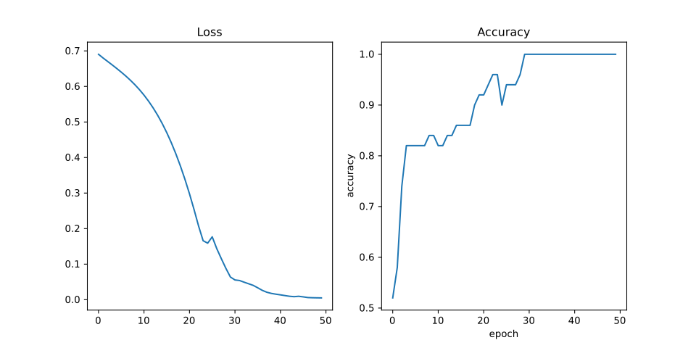
2. Full Training Data
Using the hyperparameters given a final test accuracy of 92.8% was obtained.

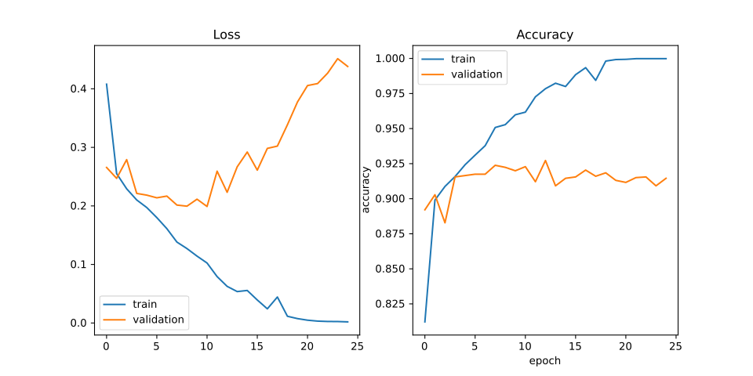
Section 8
1.
 | Train |  | Validation |  | Test
 | Loss | Accuracy | Loss | Accuracy | Loss | Accuracy
Baseline | 0.324 | 883 | 0.331 | 89.0 | 0.332 | 88.7
CNN | 0.005 | 100 | 0.275 | 92.3 | 0.275 | 91.9
RNN | 0.002 | 100 | 0.356 | 92.8 | 0.423 | 92.8

The RNN performed the best due to its sequential nature fitting well for a sentence, which is made up of words where order is important. There was not a significant difference between the validation and test accuracies since we were given only one set of hyperparameters to use. If hyperparamater tuning were to be done, we are in essence manually setting “weights” to fit the validation data. This would likely cause a discrepency where the test accuracy is lower than the validation.

2. The baseline model averages the word vectors in the sentence. Despite the goal of the word vectors to be able to allow arthimetic on words, it shouldn’t be a surpise that it doesn’t perform well on a sentence since we can’t use one word to describe a sentence. In addition all sense of the ordering of the words are removed.

3.
The three scenarios are shown in the table below. The letters correspond to the same scenarios in the assignment.

 | Train |  | Validation |  | Test
 | Loss | Accuracy | Loss | Accuracy | Loss | Accuracy
a) | 0.002 | 100 | 0.356 | 92.8 | 0.423 | 92.8
b) | 0.019 | 99.5 | 0.312 | 92.1 | 0.353 | 91.4
c) | 0.041 | 98.5 | 0.282 | 88.7 | 0.311 | 88.1

To compare the sentence lengths given by BucketIterator to Iterator, I computed the standard deviation of each batch, averaging the standard deviation over all batches. The only difference was that the training batches had an average std. of 0.500 using just an Iterator but 0.494 with BucketIterator. This is likely because both iterators sort by length and do not shuffle.

Based on the results we can see that clearly the RNN with padding and the BucketIterator performs the best. We can see that not using pack_padded_sequence decreases accuracy across the board. This is because we are looking at the hidden state after the RNN is fed padding vectors. Although it could learn to ignore these, it may take more training samples than given/more epochs. By using Iterator we also decrease accuracy across the board. Even though the standard deviation difference is only existant in the training batches, the small effect that has on the training may have propogated to poor results in validation and testing.

4. The kernels are likely detecting certain patterns in the words by looking at a range of words based on the kernel size. By having the second dimension of the word be the embedding size, the convolution layer is forced to look at the entirety of the word vector. The maxpooling operation collapses the embedding size into one dimension. If the convolution layer is detecting certain patterns, the presence of these patterns over the embedding size doesn’t have much intuitive meaning, since the prescence or amount of this pattern can be represented in one number. Thus the information dropped here isn’t comparable to the baseline model.

5.
Subjective: Apples are delicious
Model baseline: subjective (0.997)
Model cnn: subjective (1.000)
Model rnn: subjective (0.647)

Objective: Rome is the capital of Italy
Model baseline: objective (0.036)
Model cnn: objective (0.000)
Model rnn: objective (0.015)

Borderline: Wayland is better than Xorg
Model baseline: subjective (0.966)
Model cnn: subjective (0.990)
Model rnn: subjective (0.943)

Borderline: Art is subjective
Model baseline: subjective (0.893)
Model cnn: objective (0.012)
Model rnn: objective (0.062)

The three models don’t always agree with each other. It appears that the cnn and rnn are in agreement for all but the baseline disagrees. This is somewhat expected since the cnn and rnn are expected to perform better than the baseline. The first two cases were correct and all models got it correct. The last two are a bit unclear. For example I think Wayland is objectively better than Xorg by technical standards, but usability is a bit lacking in Wayland since some applications don’t support it, making it possibly subjective depending on interpretation. Nevertheless, the cnn model appears to be performing the best since it is more certain about the first two.

6.
a) Approximately 4 hours over 4 days.
b) Figuring out how to use torchtext for the bot was a bit difficult.
c) Learning how to use GRU with pack_padded_sequence.
d) The instructions were very unclear at times. The overfitting to debug section says not to proceed forward without hitting 100% accuracy, but also says the baseline model is not expected to do so. The main.py skeleton file wasn’t provided and we were told to only use the hyperparameters given, without any tuning.
e) The diagrams showed what we were going to implement very clearly.

