ECE367 PS2
Benjamin Cheng (1004838045)

Q2.8a
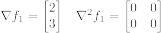
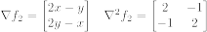

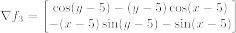

Q2.9b

Function 1:
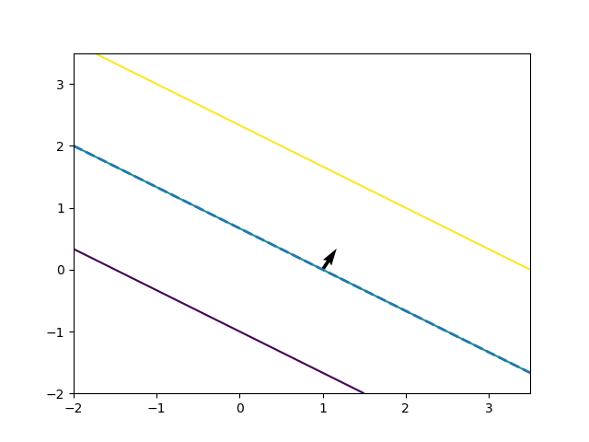
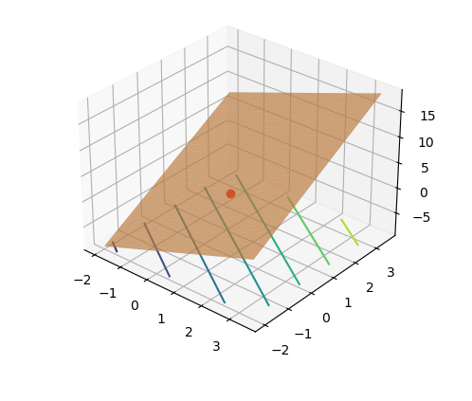
Function 2:
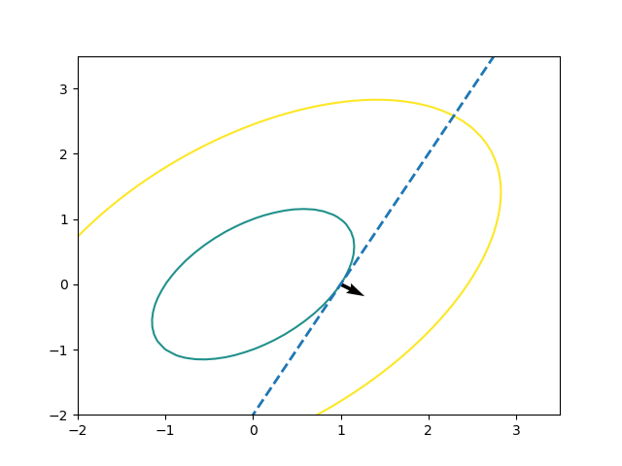
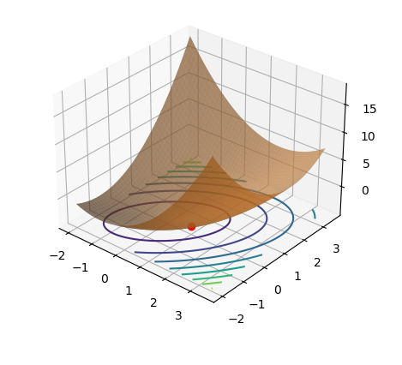

Function 3:
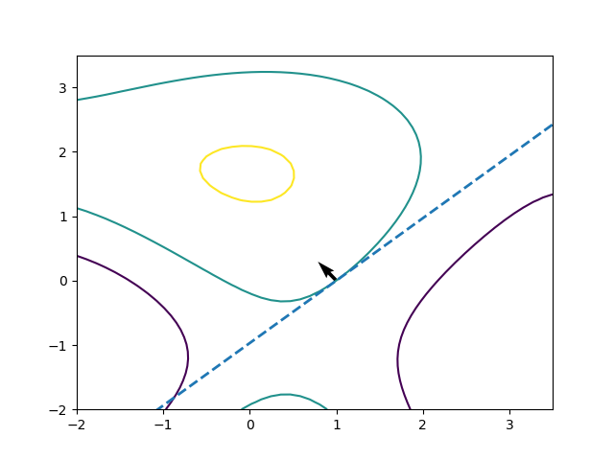
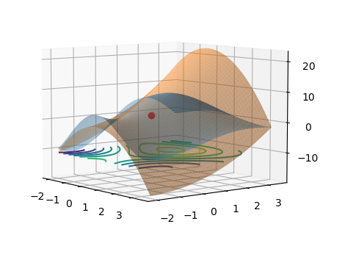
Q2.9c

Function 1 (-.7, 2):

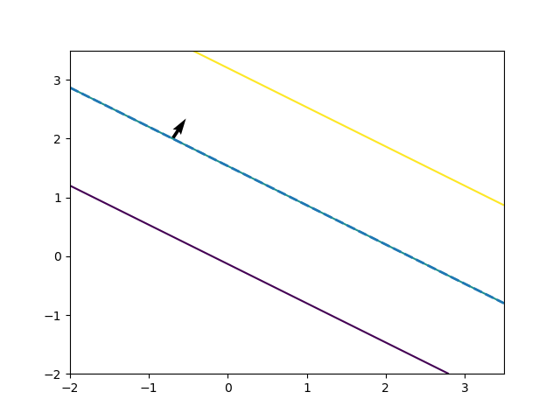
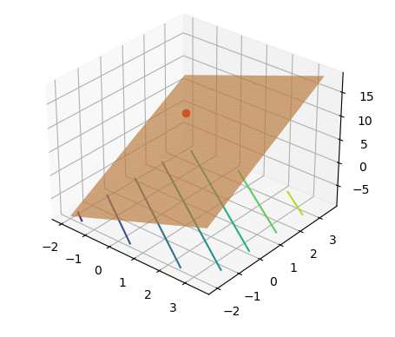

Function 2 (-.7, 2):
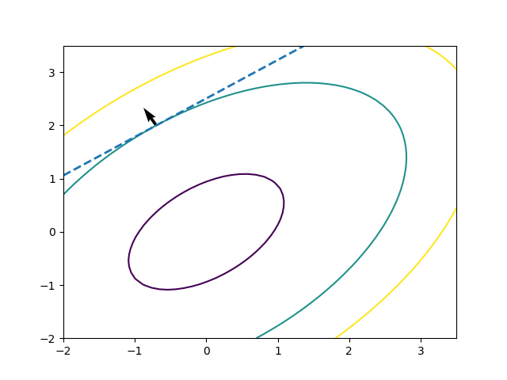
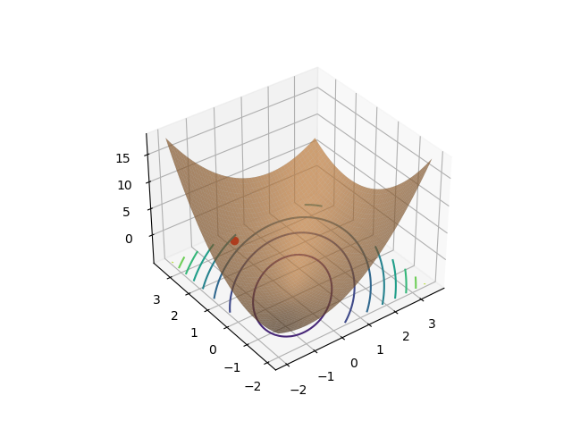
Function 3 (-.7, 2):
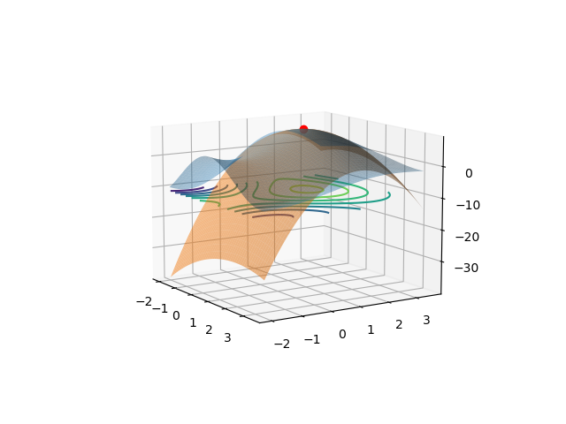
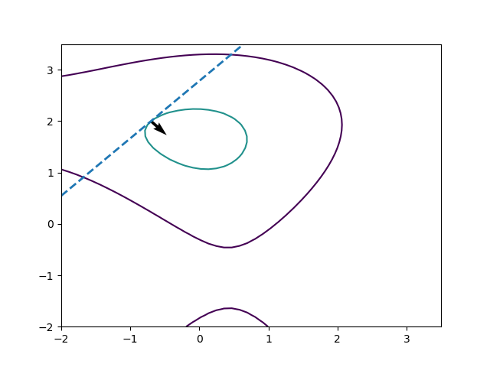

Function 1 (2.5, -1)
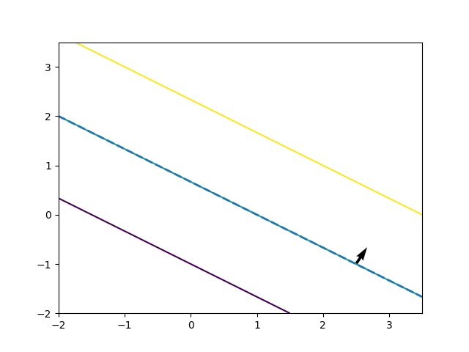
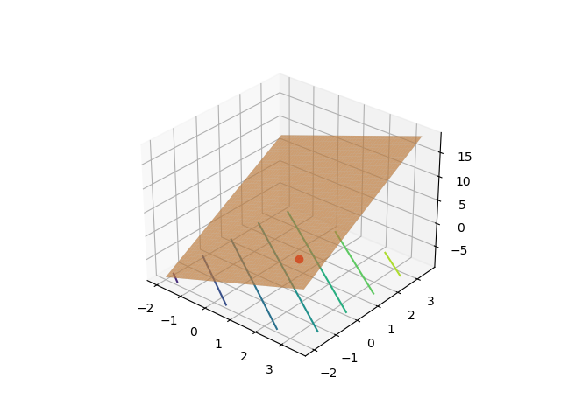

Function 2 (2.5, -1)

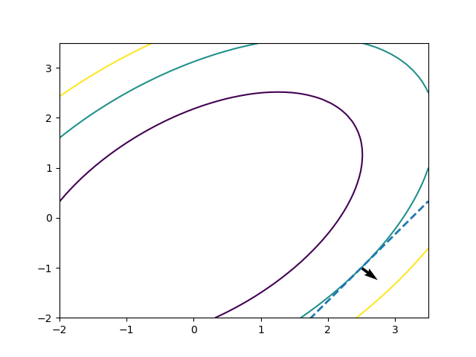
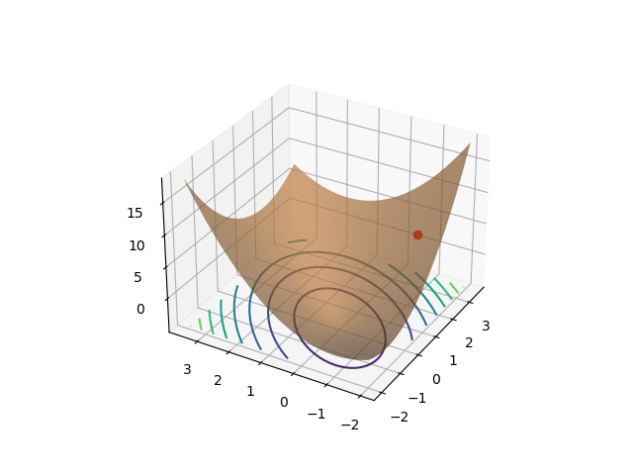
Function 3 (2.5, -1)
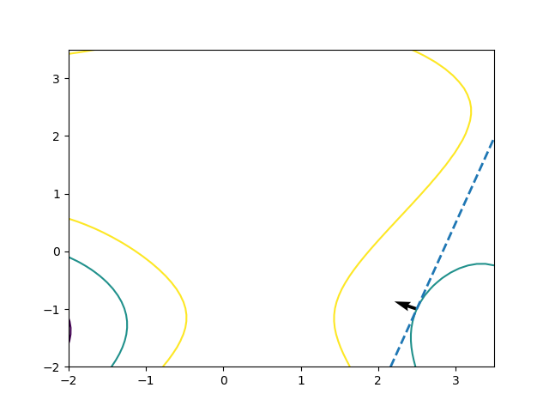
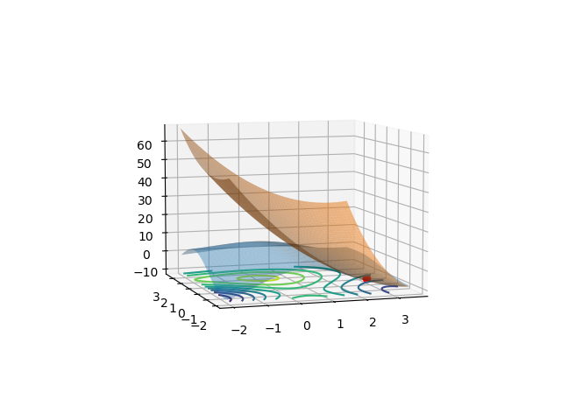
Source (Python):
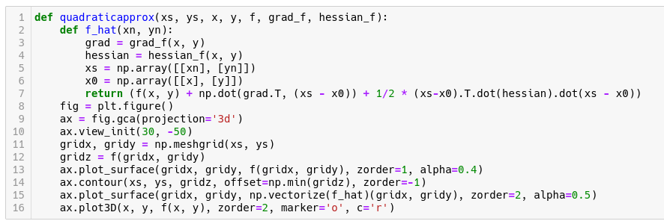
Levelset and specific functions to be plotted (incl. gradients and hessians) are as in PS1.

Q2.9d
Functions 1 and 2 are always accurate, which is why all the points look like they have only one surface visible. This is because function 1 is a plane, which is exactly equal to a plane. The hessian is zero for this case because a plane perfectly models the function. Function 2 is quadratic in x and y, which is perfectly fitted by the 2nd order approximation, which is also quadratic in x and y. However function 3 is only approximately accurate for values close to the approximation point. This is because function 3 is not linear or quadratic in x or y. Recalling Taylor Series for single variable functions, sine and cosine need to be approximated by infinite polynomial terms. Thus function 3 is only accurately approximated by a 2nd order approximation for a small area around the approximation point.

Q2.9
The J matrix is loaded and the link matrix A is computed using the following Python code:
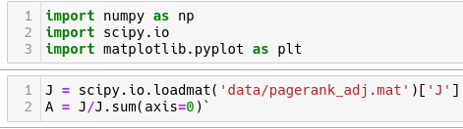

Q2.9a
The link matrix in the PageRank matrix has the property that the element in the i-th row and j-th column represents the probabilty that a link will be followed from the i-th page to the j-th page under the assumption that all links on a page are equally likely to be clicked on. The sum of the columns is essentially summing over j, which is all the pages that i links to. This results in 1.

Source (Python):
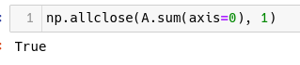
Q2.9b
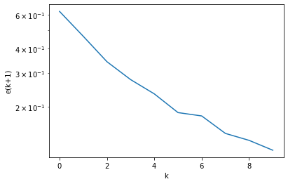
Source (Python):
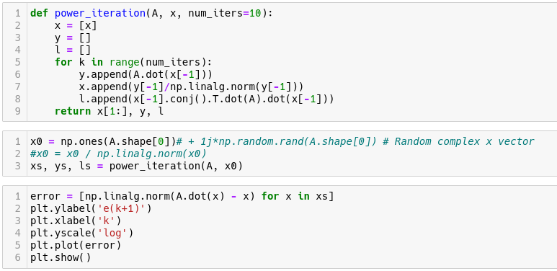

Q2.9c
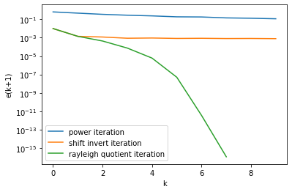
The Rayleight Quotient error follows a trend similar to the one displayed in OptM. It is equal to the first 2 iterations of Shift Invert Iteration, which is expected since they are the same for those two. The Power Iteration error decreasing very slowly in comparison, as shown in OptM. However, the error in Shift Invert Iteration doesn’t decrease exponentially (should appear linear due to logarithmic scale), as shown in by Calafiore. The Rayleigh Quotient Iteration was stopped after 8 iterations (k=7) due to further iterations resulting in numerical inaccuracies causing singular matricies.

Source(Python):
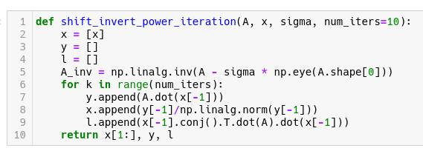
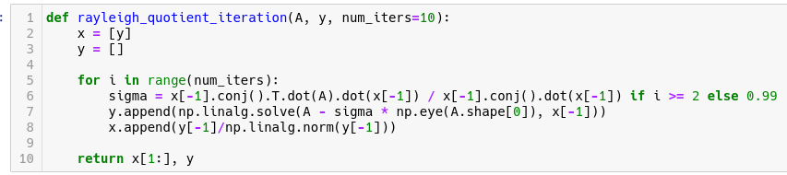

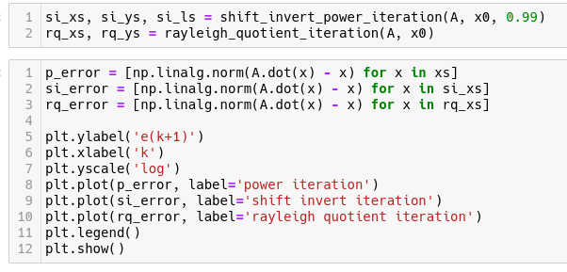
Q2.9d
Taking the eigenvector from the last iteration of the Rayleight Quotient Iteration gives the PageRank scores of all pages. After sorting the vector, the following pages were determined (index, URL):

Top 5:
1. 424, http://www1.hollins.edu/homepages/hammerpw/qrhomepage.htm
2. 987, http://www1.hollins.edu/homepages/hammerpw/qrcourses2.htm
3. 986,http://www1.hollins.edu/homepages/hammerpw/qrcourses.htm
4. 985, http://www1.hollins.edu/homepages/hammerpw/qractivities.htm
5. 930, http://www1.hollins.edu/homepages/godardrd/homepage.htm

Bottom 5 (Starting from last):
1. 1, http://www1.hollins.edu/
2. 48, http://www.hollins.edu/academics/library/libtoc.htm
3. 5, http://www1.hollins.edu/Docs/GVCalendar/gvmain.htm
4. 10, http://www1.hollins.edu/Docs/comptech/comptech.htm
5. 23, http://www1.hollins.edu/security/Default.htm

These links are all broken but they appear to be somewhat resonable. The top 4 are under a professor’s (assuming hammerpw is someone’s name) site, which would likely lead to each other and to other resources. The 5th one is another professor’s homepage. The absolute lowest score has the homepage, but it seems like there are two homepages, one under www1 and one onder www. It is possible that the ww1 homepage is a legacy one that is no longer linked anywhere except a few outliers. It is quite weird that the actual homepage isn’t on the top 5 list, but many professors don’t link to the University website on their page (see https://www.comm.utoronto.ca/~sdraper/ as an example).

Source (Python)
