Elicitation Handling Technical Design
Version: 1.0
Date: March 18, 2026

1. Purpose
This document defines a minimal and maintainable elicitation architecture for MCP tool execution using three modules: SessionManager, ElicitationHandler, and RedisModule.

2. Scope and Constraints
Single responsibility per module with explicit interfaces.
Form-mode elicitation must pause execution and resume using user input delivered asynchronously.
Timeout behavior must be enforced using asyncio.wait_for to avoid unbounded waits.
Redis Streams are used for reliable response delivery and acknowledgement semantics.

3. Architecture Overview
SessionManager owns MCP client lifecycle and callback wiring. ElicitationHandler manages pending Futures by elicitation_id. RedisModule encapsulates stream operations and pending-state persistence.
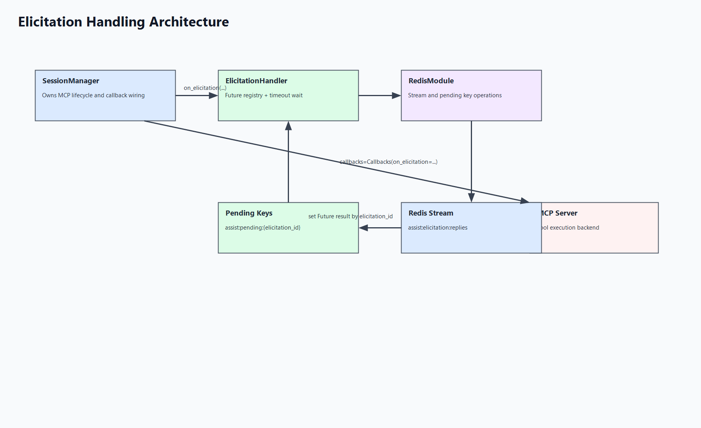
Figure 1: Session-manager-centric elicitation architecture.

4. Runtime Flow (Form Mode)
1) SessionManager receives on_elicitation callback from MCP adapter.
2) SessionManager calls ElicitationHandler.wait_for_form_response(elicitation_id, payload, timeout).
3) ElicitationHandler stores pending metadata in Redis and creates an asyncio.Future.
4) UI submits response; API pushes payload to Redis stream with elicitation_id.
5) ElicitationHandler consumer reads stream message and resolves the matching Future using set_result.
6) SessionManager resumes MCP tool flow using returned payload.
7) If timeout expires first, TimeoutError is raised and handled by caller policy.

5. Module Contracts
SessionManager: execute_tool(message), on_elicitation callback, MCP client creation with callbacks.
ElicitationHandler: start(), stop(), wait_for_form_response(...), internal stream consumer and future resolution.
RedisModule: push/read/ack reply stream methods, pending key set/clear/list methods.

6. Reliability Notes
Use consumer groups and acknowledgements to avoid reply loss.
Always clear pending entries after completion or timeout.
Keep timeout configuration explicit and environment-driven.

