1. This solution helps users to obtain information of all ATMs of the city.

The user can log to the the system under his credentials or create new account.

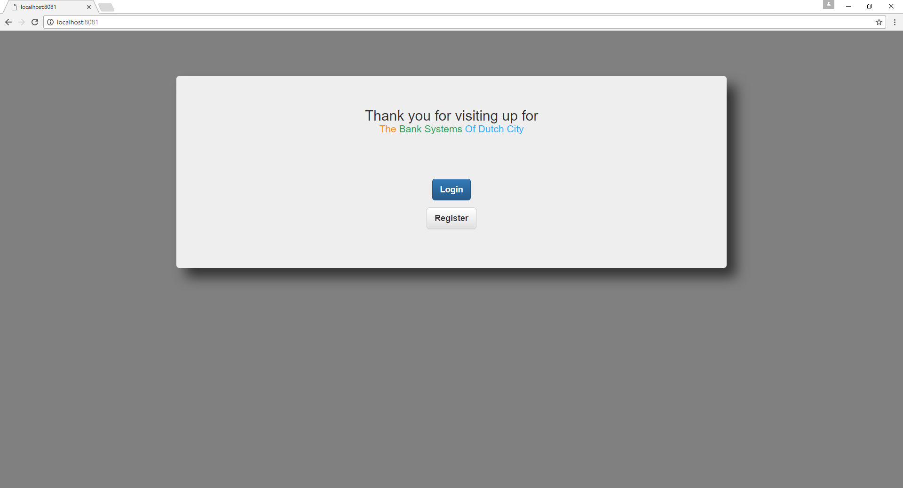

1. Login page.

There are several options. First off all you can log in to the system. If the user forgot password there is a possibility to recover it and get it by email.

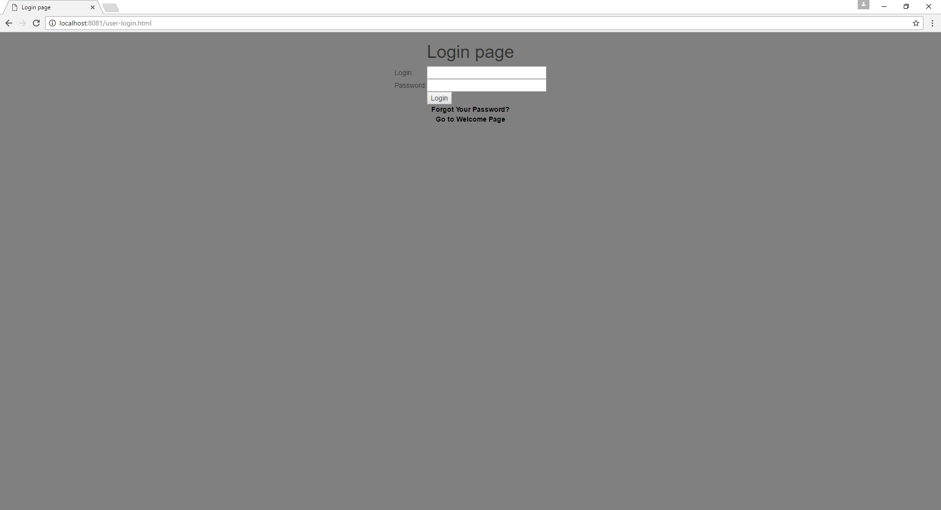 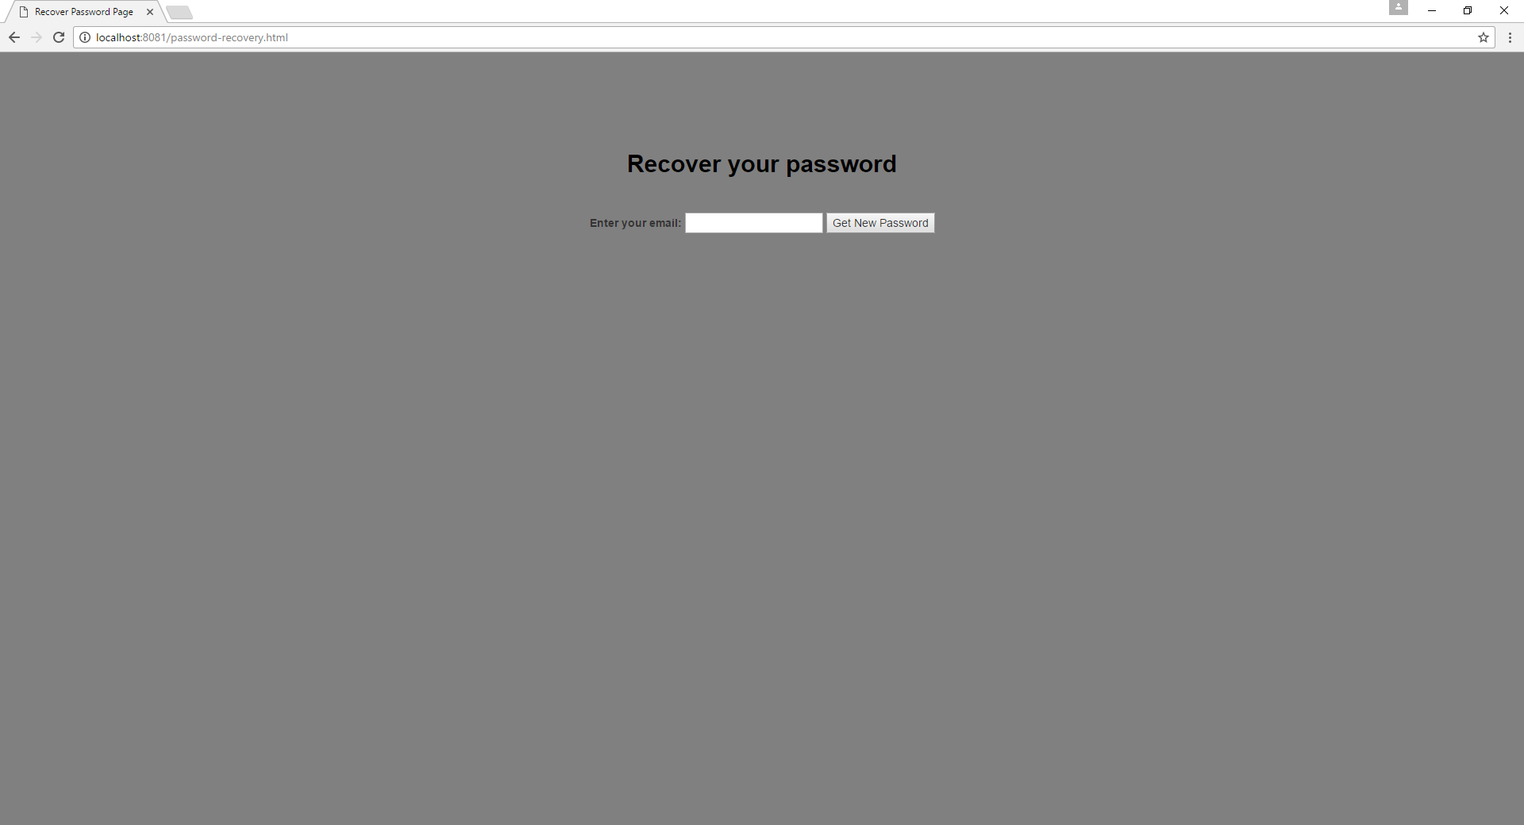

At this stage provided input validation of data. If your email not in db, user will get warning :

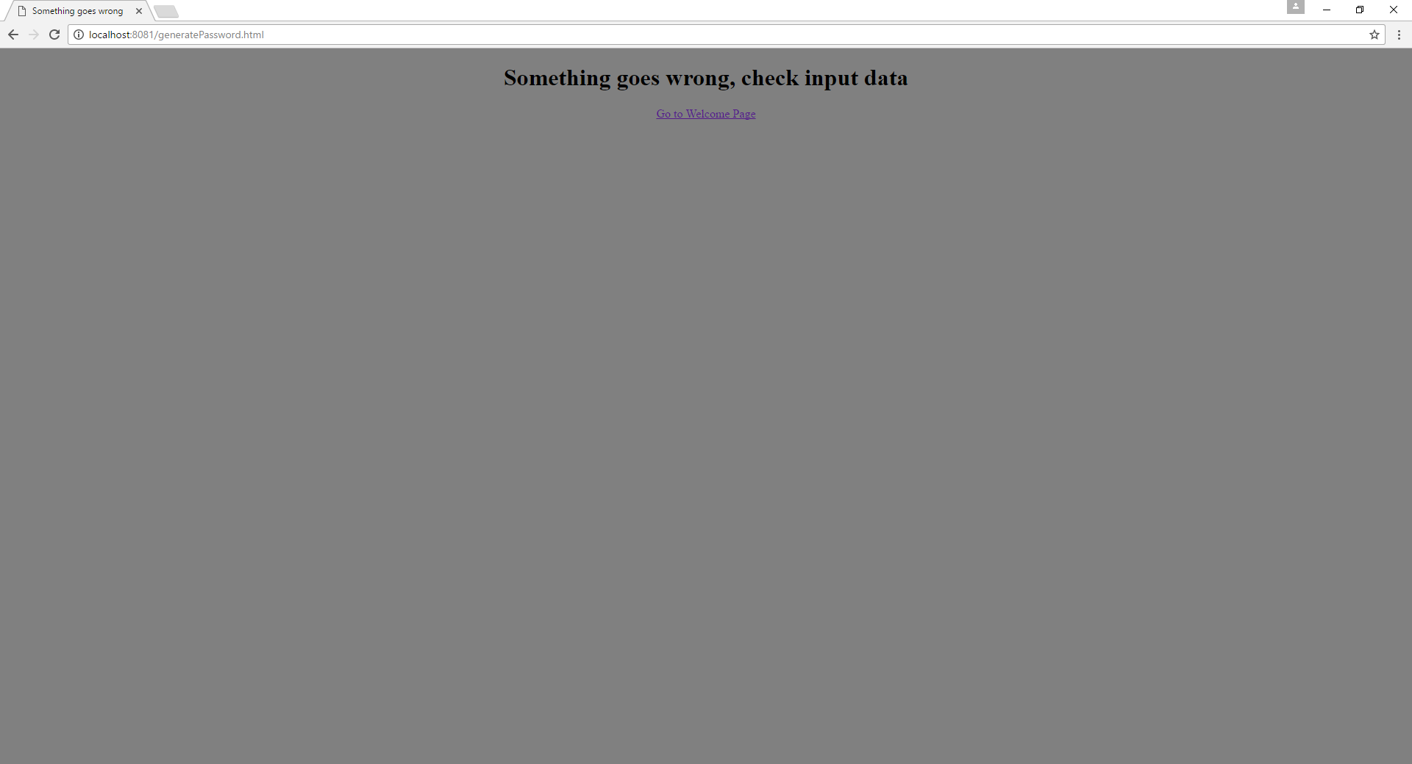

And if the input email validation is ok, the new password will be generated and sent to user email.

1. Register page

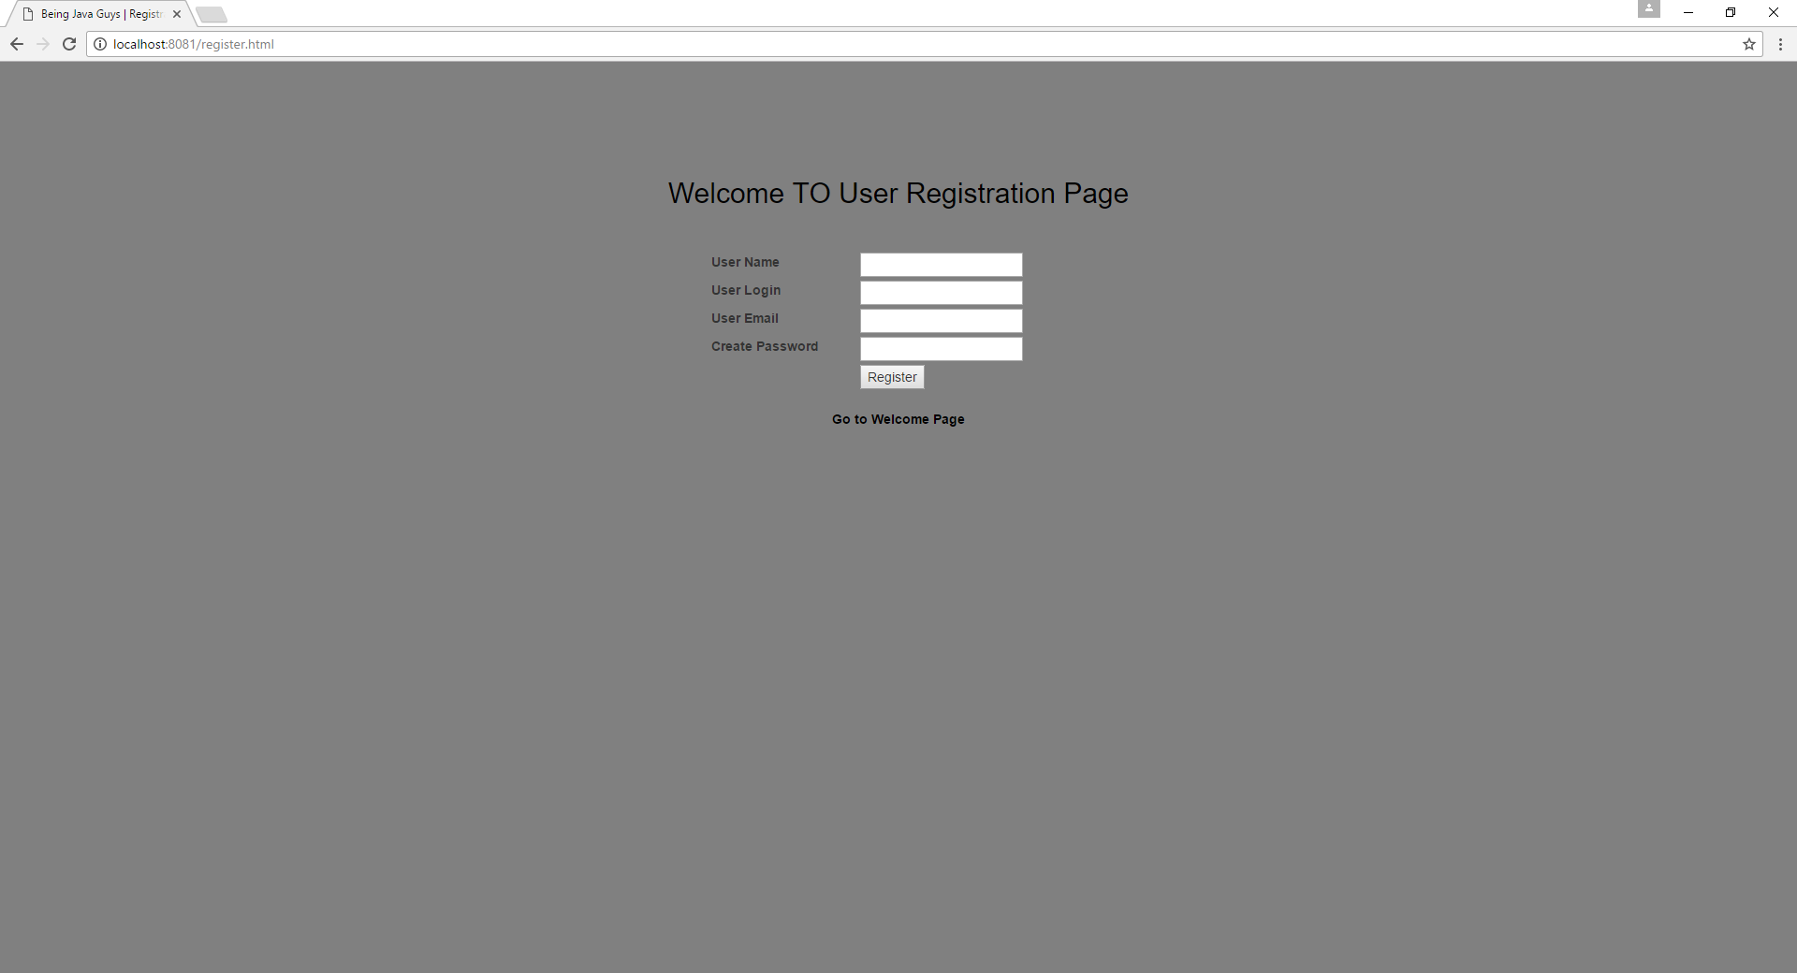

If client uses system for a first time, there is a possibility to create his personal account. Validation of the input data also provided.

1. Success login page

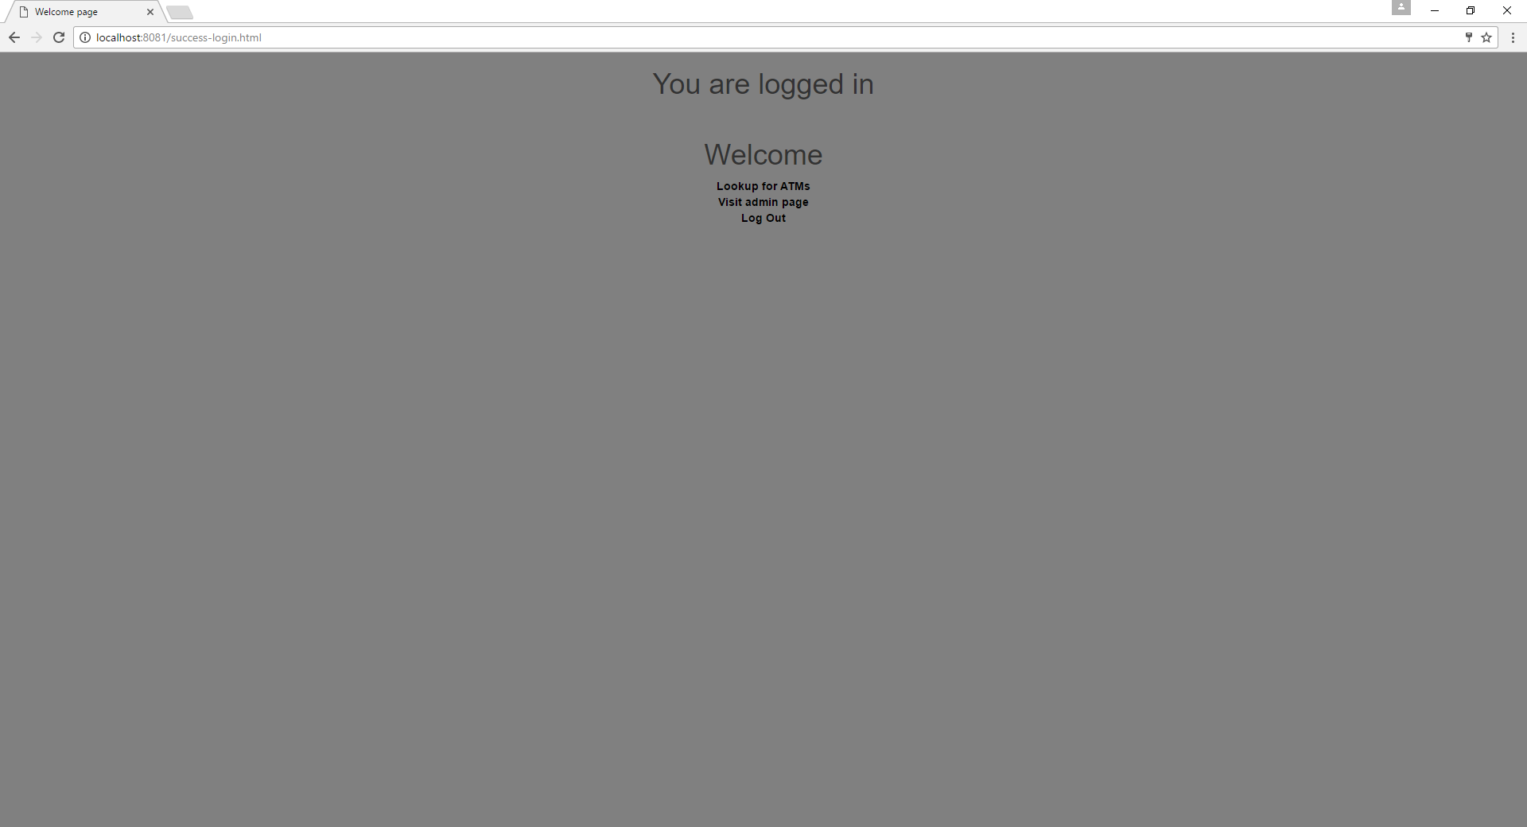

Now user can navigate throw the system. If the user obtains admin wrights there appear additional functionality. Admin can see all the users and alter there status.

1. Admin page

Admin can alter existing user and delete them:

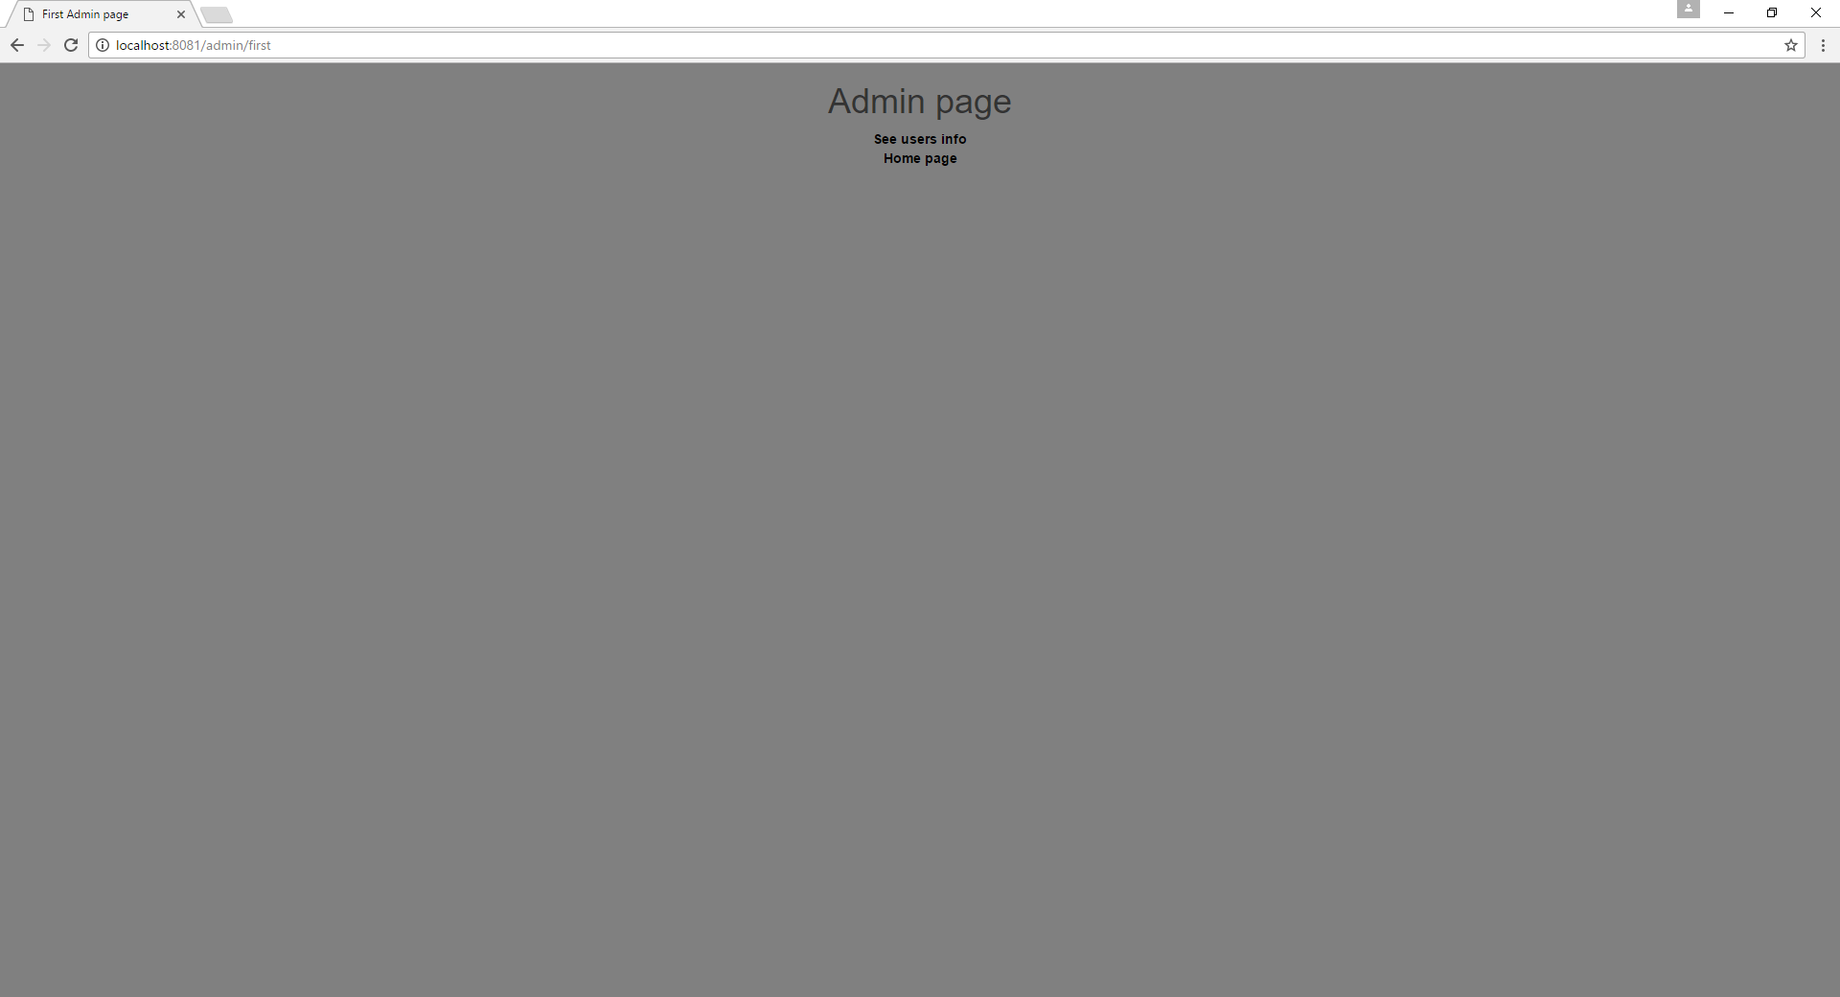

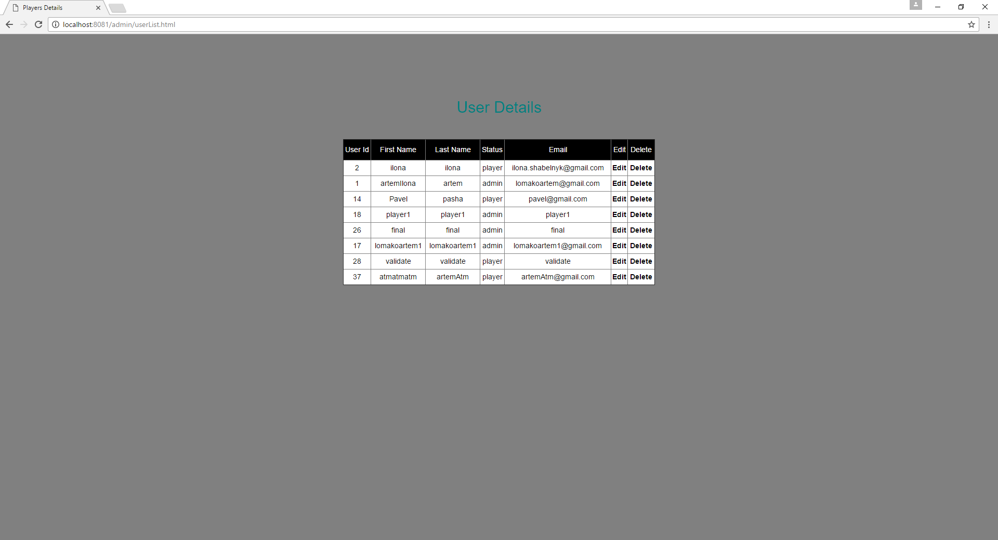

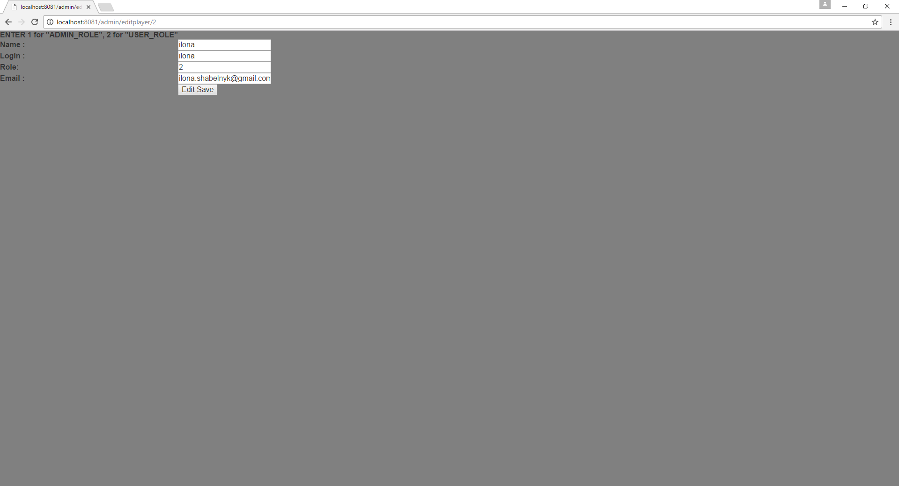

1. ATMs page

On this step, all the logged users have possibility to view information about ATMs

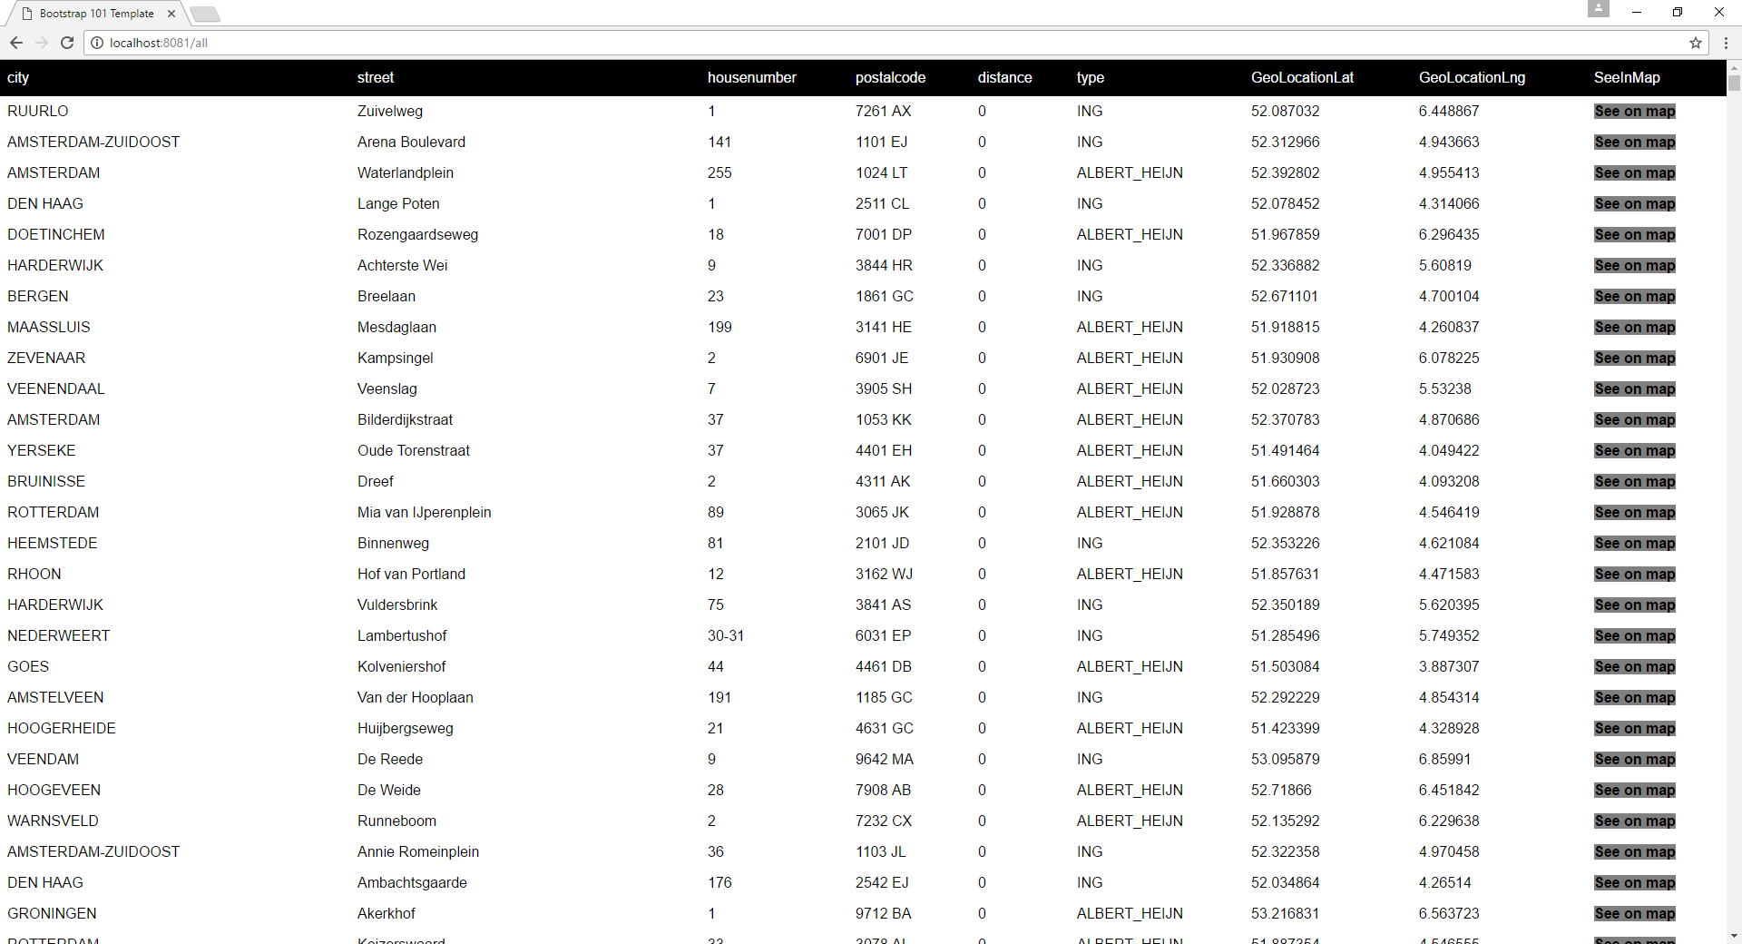

And view the selected ATM on the map:

