CS473/673 Project II – Design Document
Social Web Spider

Team Members:
James Oravec:
James.Oravec@gmail.com
Cell 702-353-5444
Ernesto Pavon
Pavone87@gmail.com
702-719-9295
Ryan Lombardo
lombar40@unlv.nevada.edu
Shawn Cannon
ShawnCannon07@yahoo.com

Introduction
How is this design document organized?
This main page describes the system design in terms of packages, classes, relationships, and behavior. Several attached worksheets address specific aspects of the overall system design, such as user interface and database design. The final design may vary slightly, as needing during the development process.
What are the most important facts that a developer should know about this design?
The project is setup in different portions based on the software engineer working on the different aspects of the project. Each software engineer helps provide documentation for their portion..
What are the prioritized goals of this design?
- Correctness
- Feasibility
- Understandability
- Modularity
- Testability
- Implementation phase guidance
- Extensibility
- Efficiency
UML Structural Design
- UML Structural Design is illustrated in various diagrams through out this document. To avoid redundancy, we've only included the diagrams once.
UML Behavioral Design
  - UML Behavioral Design is used to help describe how our system's behavior will work in details. To keep our large document more succint, we've included many diagrams which help illustrate our project, but only included them once throughout the document.
UML Design Checklist
Correctness: How do you know that this design is correct?
We have been testing our work as we’ve been developing it, thus we have been able to get feedback as we’ve been working. The design may change as the project continues, however what we have here is the foundation for our project.
Feasibility: What indicates that this design can be implemented and tested with the planned amount of time and effort?
In the project plan, we gave estimates for each portion of the project and who is to work on which features. Each developer will be responsible for implementing and testing their portion of the project.
Understandability: What makes this design understandable?
The descriptions, diagrams, screenshots, etc, give enough information that the reader should be able to have an intuitive understanding of how the program works.
Implementation phase guidance: Does the design suggest reasonable implementation tasks?
By breaking down each portion of the project into use case diagrams and showing various aspects of the project, it is made clear which tasks need to be accomplished in order for the project to work.
Modularity: How have concerns been separated and addressed in distinct modules?
During the project plan, we broke the main project into sections for each developer. This allows them to work on their own particular module, and break their main functionality down so that it can be reused within the needs for the project.
Extensibility: How can new features can be easily added later?
We are using standard technologies like Maven and Spring Roo. By using these technologies, we are able to utilize many of the conventions that they provide.
Testability: What makes this system easy to test?
The system will be broke down in such a way that we will be able to provide unit tests for various portions of our project.
Efficiency: Does the system consume an acceptable amount of time, storage space, bandwidth, and other resources?
We mentioned the consumption of resources in our project plan and how we can assign priorties to threads related to the system down the road. Our initial version does not consider this in detail, as this is just the alpha version.
Has the design been communicated to the development team and other stakeholders?
Yes, the project plan and design has been shared and created by our team members. Since the portions of the project have been assigned and people provided details for their section, it is implied that everyone is okay with their assigned tasks. Feedback has also been encouraged amongst the team during this development process.

Additional Design Information

Database management, picture handling, file sharing

- Database Usage and File Handling
- Design
The database management and handling of files between users will be handled with three classes that represent the domain class (called document), the controller and the database. The controller will handle setting things up for the presentation layer. Whereas the Document will handle the state of our objects and will communicate with the database. Below is a sequence diagram showing this relation:

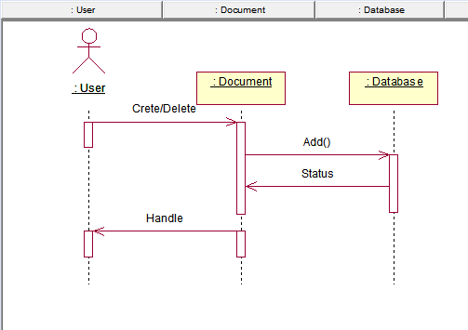

With the creation of a Document object, a reference counter to that object is initialized to one. After the user shares or other people reference the object, the reference counter is incremented. So when a user delete an object, it will only decrement the reference counter. Only when the reference counter reaches zero, will the object actually be deleted from the database.

Users will be able to upload images as part of creating their documents. This is not the only way to create Documents however, users can also create them by using the spider to obtain images from other websites. Each time any of these two events happens a new object is created along with its reference counter and added to the database.

Sharing will be handled by incrementing the reference counter rather than creating new objects in the database. A user can choose to share their documents with any number of other users. When other users reference the document, they are added as users of the document (unless the original user later disallows it), and the reference counter is incremented.

Users can check their images by categories, each file will be created with a name and category which can be queried by either name or category. So users can select which images they want to see, and only those satisfying the specific query will be shown. The presentation logic will be handled by the Controller.

For presentation, the controller will handle which view to present depending on user requests. In essence, the user will request a view, for example, pictures of a specific category to be shown. The Document will receive this request and fetch it from the database, it will then pass it to the Controller so it can return the view to show to the user.

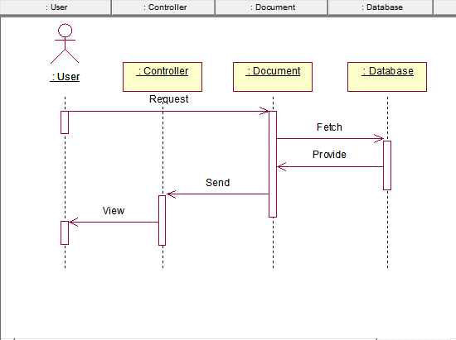

- Correctness:
Keep a reference counter to any database object. When the reference counter reaches zero, the object is removed from the database. Since the object is removed when the reference counter reaches zero, we know it will never be removed when someone has a reference to it.

- Feasibility:
The design gets the job done with the required functionality at a fairly simple level. We have avoided fancy features to try to ensure essential functionality works as it should. Having a minimal amount of code helps testability and readability.

- Understandability
By thinking of the user interaction with the system and following the use cases (provided in a different document), the design shows a fairly simple approach to deal with the features required. Each class has a self-contained purpose and is documented appropriately. As long as each entity does its job, the system should work as required.

- Implementation Phase Guidance
The design describes a fairly accurate approach of the implementation at a high level. Following the design gives us the essential functionality, but there are other tasks to consider such as handling blob files with the database, ensuring correct access of files between users, and handling blob files among others. The design still shows us the overarching design which allows us to build the framework of our system.

- Modularity
We are using different classes to handle their own respective tasks. We are separating the presentation layer from the domain layer and have tried to keep as few dependencies as possible while keeping the design simple. Our domain object is in charge of the domain logic and communicates with the database and the controller, while the controller can communicate with the domain layer to get data in order to present it to the user. Each class has its own set of unique tasks.

- Extensibility
New features can be added by extending the Document class. This will allow for different type of objects to be created. Doing this requires no changes in other User modules or database changes which makes it simple to add new features.

- Testability
By having as few dependencies as possible, we can create a system that is easy to test and deploy. We plan to create unit tests and integration tests to go along with our project to ensure correctness.

- Efficiency
We have tried to provide a way to manage big files with the least amount of resources by using reference counter to keep references to our data objects. That way we do not have to create duplicates in our database.

Security

Overview
- What are the most important facts that a developer should know about the security of this system?
  - The system will be designed to prevent unauthorized access and modification to data by unauthorized users or users who do not have the permissions granted in order to execute a modification.
- What are the ranked goals for security in this system?
  - Data security
  - Abuse prevention
  - Intrusion prevention
  - Auditability
Security mechanisms
- What application security mechanisms will be used?
  - Values input into every field are validated before use
  - Usernames and passwords are required for access
  - Passwords are stored encrypted
  - Verification of user email address
  - Users are given roles that define their permissions. Those roles are: Admin and User
  - Compromised or abused accounts can be quickly disabled by administrators.
  - Administrators can review user permissions
Security Checklist
- Protection of data: To what extent has this been achieved?
  - Access to the website requires login which prevents unauthenticated modifications. Only administrators are granted access to modify user and profile information freely while users are only allowed to modify their own data.
- Prevention of abuse: To what extent has this been achieved?
  - Users must verify their e-mail in order to access the website, giving an extra layer of abuse prevention. Users can also be disabled by admins via the profile edit page which will lock any abusive users out.

User Interface
Overview
- What are the most important facts that a developer should know about the user interface of this system?
  - The user interface is designed to be user friendly while supplying all the requested data in an easily readable manner. The UI should be consistent throughout the website.
- What are the ranked goals for the user interface of this system?
  - Consistency and familiarity
  - Understandability and learnability
  - Safety
  - Task support and efficiency
Metaphors, Exemplars, and Standards
- What is the central metaphor of this UI design?
  - ?
- What existing systems have user interfaces similar to the UI you want to build? What specific aspects are similar?
  - The UI is based off a UI created for us by Spring Roo. The UI is a typical UI seen around several websites and includes a header, footer, menu, and content section.
- What UI design standards, guidelines, and styles are you following?
  - We are sticking to the Spring MVC website guidelines and using the UI provided to us by Spring Roo. All webpages are jspx files which are modeled by the MVC.
Task Models
- What types of users will use this system?
  - The core user will be the basic website user
  - The secondary user will be an administrator with extended access to the website
- What types of tasks will those users perform?
  - Users will be able to:
    - Sign up for an account
    - Reset/request their login
    - Change their password
    - Customize their profile
    - View all profiles
    - View other users files
    - Upload files manually to their account
    - Crawl websites
    - Delete their files
    - Share their files
  - Admins will be able to do all the functions of users with the addition of:
    - Disable user accounts
    - Change any user’s profile and user information
    - Change user access
Content Model / Interaction Contexts
- Login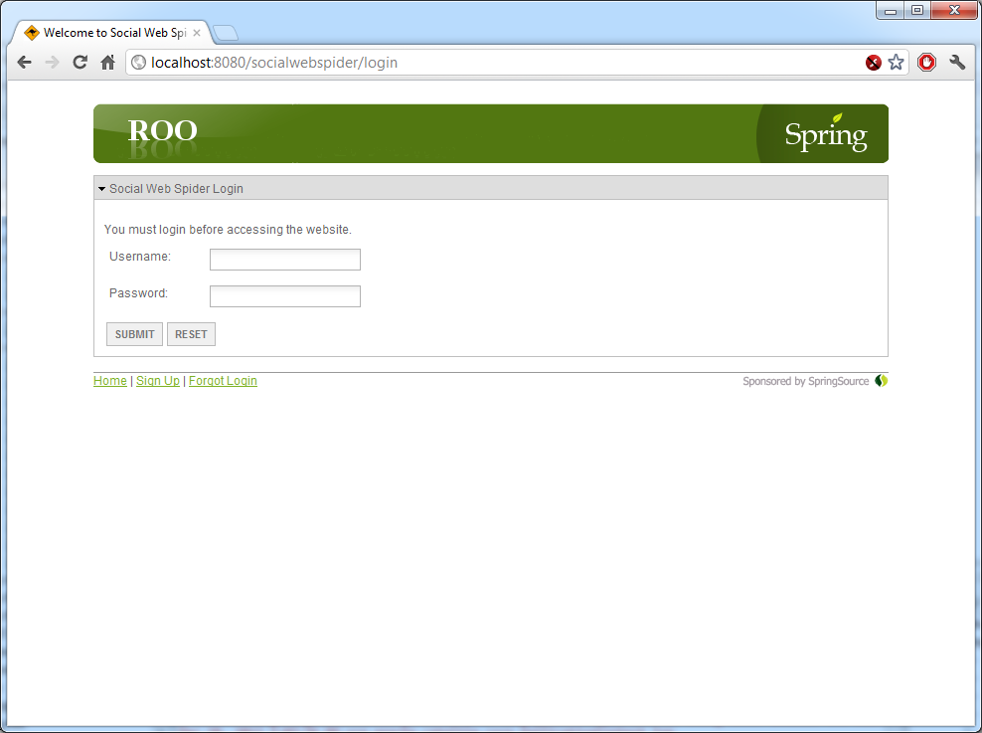
  - Message Area: You must login before accessing the website
  - Username: Username the user provided upon signup
  - Password: Password the user provided upon signup
  - Sign Up: Link to sign up for the website
  - Forgot Login: Link to request/reset login information
- Sign Up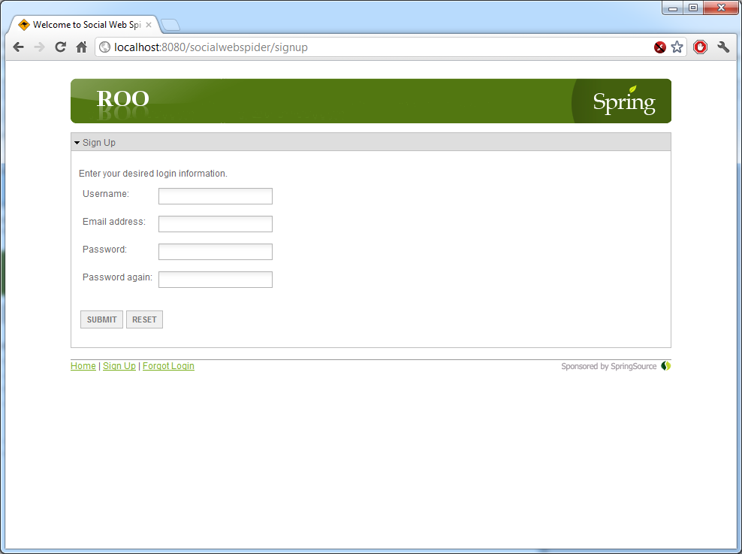
  - Username: Desired username
  - Email address: Desired username
  - Password: Desired password
  - Password again: Repeat of desired password for verification
- Forgot Login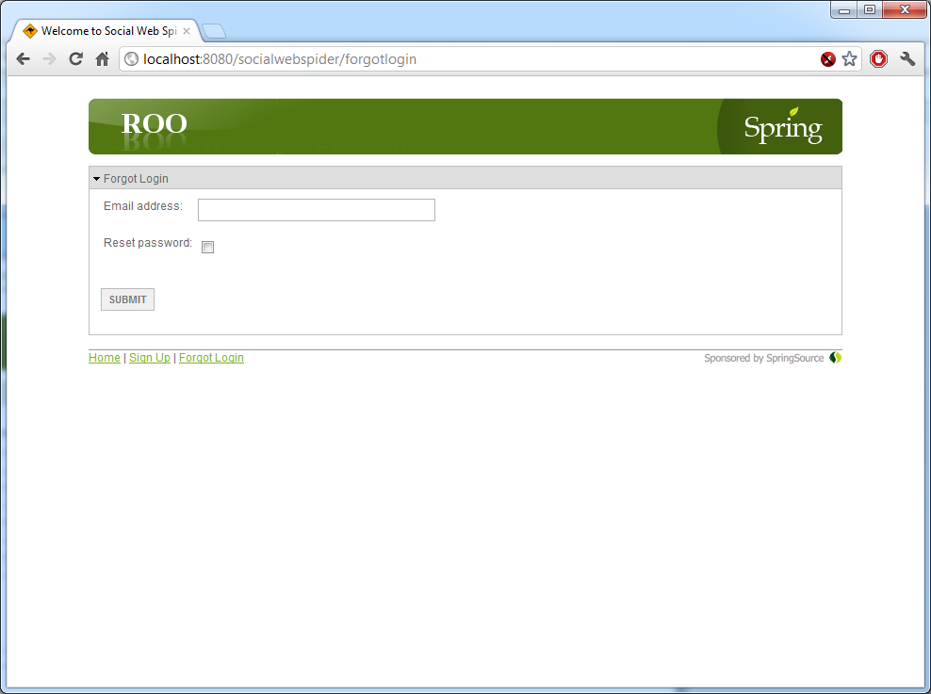
  - Email address: User’s email address for their account
  - Reset password: Check box to indicate if they’ve forgotten their password and would like it reset
- Home Page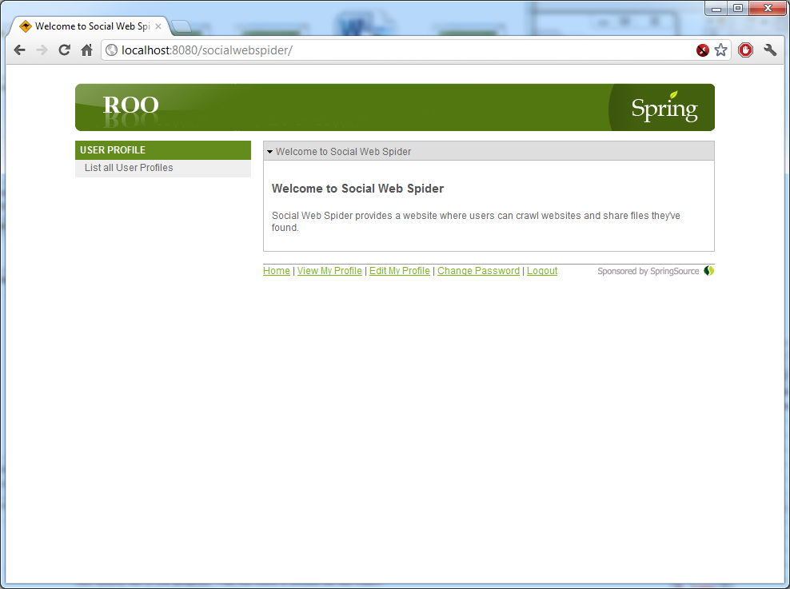
  - Menu bar: Gives users navigation throughout the website’s main functions
  - Content: Displays important information about the website
  - Footer: Gives users links to essential user modification pages
    - View My Profile: Links the user to their own profile
    - Edit My Profile: Links the user to edit their own profile
    - Change Password: Links the user to change their password
- View User Profiles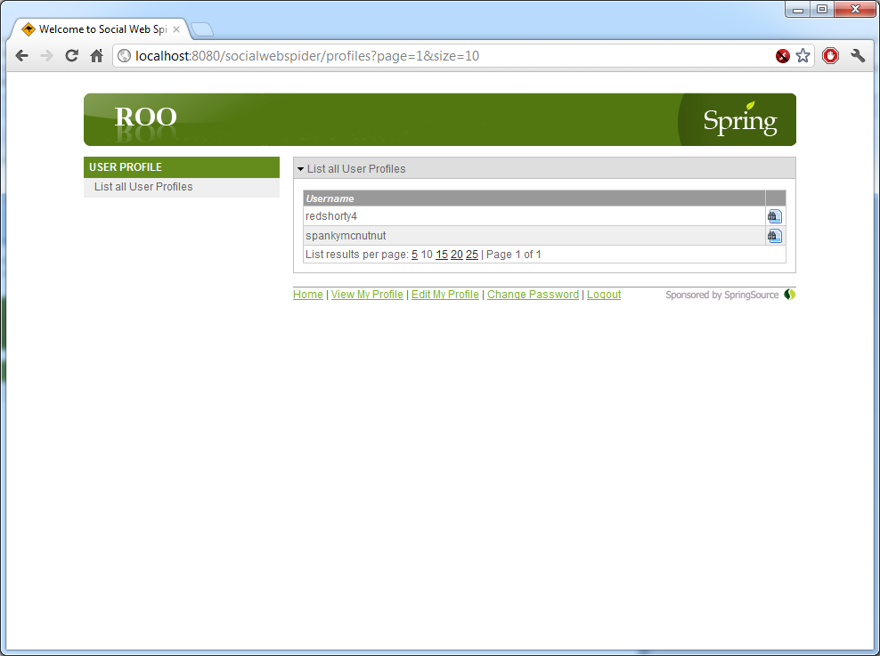
  - List all User Profiles: Lets the user navigate through all the user profiles and gives a link to view the selected profile
  - Username: Username associated to the user profile
- View Profile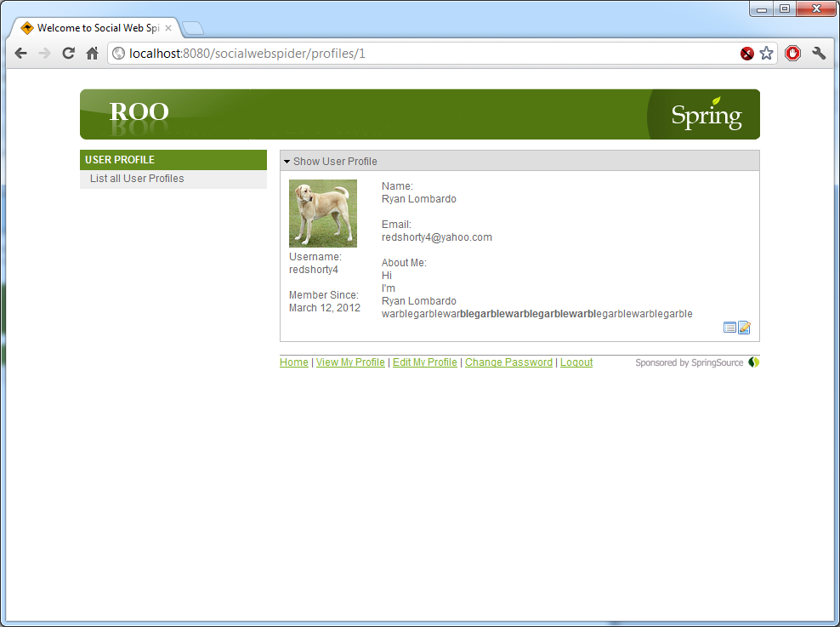
  - Avatar: User’s selected avatar image
  - Username: User’s username
  - Member Since: Date the user signed up and activated their account
  - Name: User’s provided name
  - Email: User’s email address
  - About Me: User’s provided content about themselves
  - *NYE* View Files: View the user’s files
- Change Password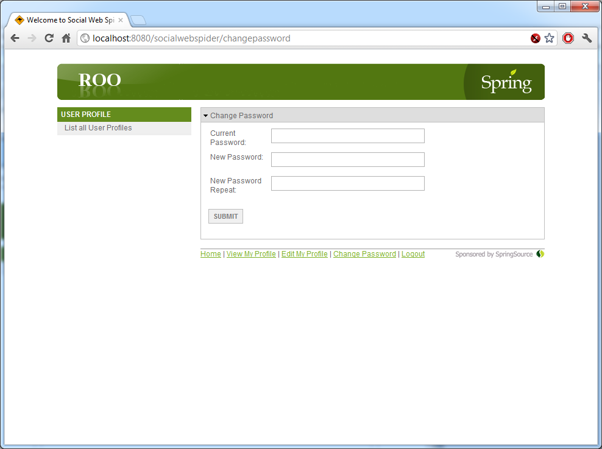
  - Current Password: User enters their current password for verification
  - New Password: User enters new desired password
  - New Password Repeat: User enters their new desired password again for verification
- Edit Profile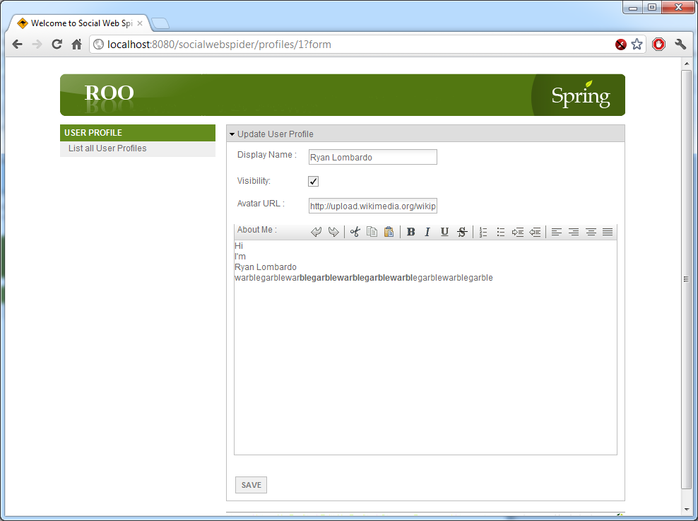
  - Display Name: Name the user wishes to display on their profile
  - Visibility: Visibility of their profile. Checked: Public. Unchecked: Private
  - Avatar URL: URL to the user’s desired avatar
  - About Me: Section for the user to enter in information about themselves

Design Architecture

Overview

What are the most important facts that a developer should know about this system architecture?
This architecture uses Maven, Spring Roo, MySQL, and should be able to run with TomCat. Users will login into our project via a web interface and security will be handled by Spring Security. Our system will also utilize Crawler4J for webspidering functionality.
What software architecture style is being used?
Single web service: app-server, database.
What are the ranked goals of this architecture?
- Ease of integration
- Extensibility
- Capacity matching
Components
What are the components of this system?
The components of this system will be defined in the UML Model, upon completion of the project.
The components of this system are listed below by type:
- Presentation/UI Components
  - C-00: Login Screen
  - C-01: User Profile
  - C-02: Social Networking
  - C-03: Spider Results

- Application Logic Components
  - C-10: Spider (crawler4j)
  - C-11: Spider Controller
  - C-12 Folder Manipulation
  - C-13 Blob Handler
  - C-14 UUID Factory
- Data Storage Components
  - C-20: MySQL Database
  - C-21: Temp crawler4j config directories
  - C-22: Temp image output directories
Deployment
How will the components be deployed to processes and machines?
Everything will run on one machine and the deployment is meant to be self inclusive. Since this is an alpha version, the deployment will only be on developer machines and we will not be providing an installer. Developers who will want to run our project will need to have enough understanding of Maven, Spring Security and Spring Roo to achieve this.

What aspects/resources of their environment are shared?
Our project will have access to all of the resources of the developers machine. We are not doing any load balancing or limiting or prioritizing of work done by our project in this initial stage.
How are requests allocated to redundant or load-balanced servers?
This does not apply to our project, as it is running only on one machine.
What alternative deployment configurations are possible?
This is the only possible deployment, and is the only intended one for this project.

Integration
How will components be integrated? Specifically, how will they communicate?
Each developer is assigned their portion of the project. They are to allow enough flexibility that their code and work will be able to work with others. The project plan states what each developer is responsible for. Integration of repositories is planned to occur offline as well as in group sessions a few days prior to the deadline. Portions of the project that work closely together should/will be integrated sooner than later.
What architectural mechanisms are being used to ease future extensions or modifications?
Our source code for the project and repositories will be on GitHub. This will allow other developers to make copies of our work and continue the project or modify it to meet their needs. As long as the developers have an understanding of Maven, Spring Roo and Spring Security they should be able to extend or make modifications easily to our project. By using crawler4j, our project can also be updated with newer versions of the open source crawler project as the newer versions become available.

Architectural Scenarios
Our system runs on a single system in development mode, thus there are no special requirements for start up, shutdown, or load balancing.

Architecture Checklist
Ease of integration: Have mechanisms been provided for all needed types of integration?
Yes. Our system is being developed to allow the integration.
Extensibility: What types of components can be added later and how?
There are no plans to add components ourside the scope of this project.
Capacity matching: How has this architecture matched component resource needs to machines?
This does not apply to our project, as it will only run on one developer system at a time.
Has the architecture been communicated to the development team and other stakeholders?
Yes, everyone understands. Feedback is welcome.
Design – Source Code Organization and Build System

Overview
What are the most important facts that a developer should know about this source code organization and build system?
We are using standard source layouts provided by Maven and Spring Roo. Files such as CSS, internationalation file, javascript files, etc should appear in their natural locations.
What are the ranked goals of this source code organization and build system?
- Compatibility with standard build processes
- Separation of files by type
- Separation of version-controlled files from files generated by the build process
- Platform independence

Key Directories and Files in Developer Working Copies
Path | Description
src/main/java | Application/Library sources
src/main/resources | Application/Library resources
src/main/scripts | Application/Library scripts
src/main/webapp | Web application sources
src/test/java | Test sources
src/test/resources | Test resources

Build Targets
Our project does not have varying build targets.

Build Configuration Options
Our project does not have varying build configurations.

Source Code Organization and Build System Checklist
Separation of files by type: Are files separated by type?
Yes. Except that application JSP and HTML files are in the same directory, which is convenient because sometimes we change an HTML file to be a JSP file. Other files utilized are jar files, controlled by Maven, java files created and maintained by Spring Roo and our own java files.
Separation of version-controlled and non-version controlled files: To what extent has this been achieved?
We use GitHub to control our projects. We specify which versions of dependencies through the Maven pom.
Compatibility with standard build processes: To what extent has this been achieved?
We do not use Ant, however we do use Maven. Maven helps get us the dependencies we need. Other than that, everything else runs on the same development machine, so no special build process is needed.
Platform independence: To what extent has this been achieved?
This has not been considered, we assume we are using Windows 7 for the platform, using Spring Source Tool kit, and running the other required programs mentioned in the project plan.
Have these implementation decisions been communicated to the development team and other stakeholders?
Yes, everyone understands. Feedback is welcome.

Additional References and Diagrams (For full size images please reference Google Docs):

User Class Diagram:
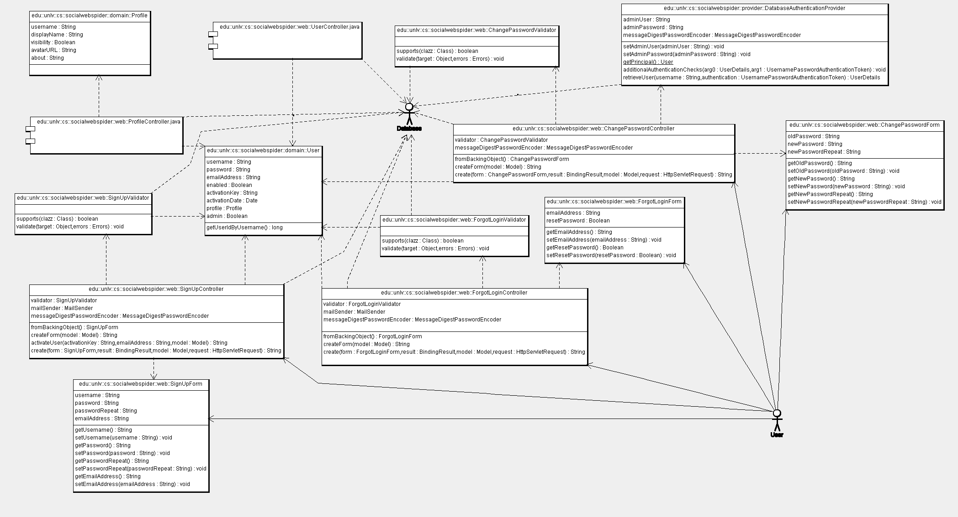

User Use Case:
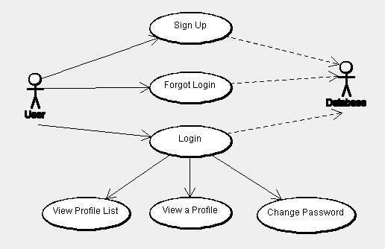

Sign Up Sequence Diagram:
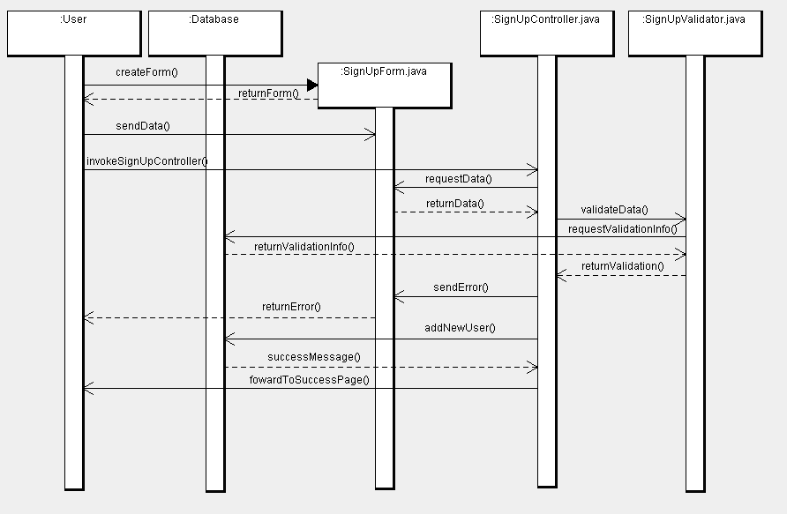

Example Document View:
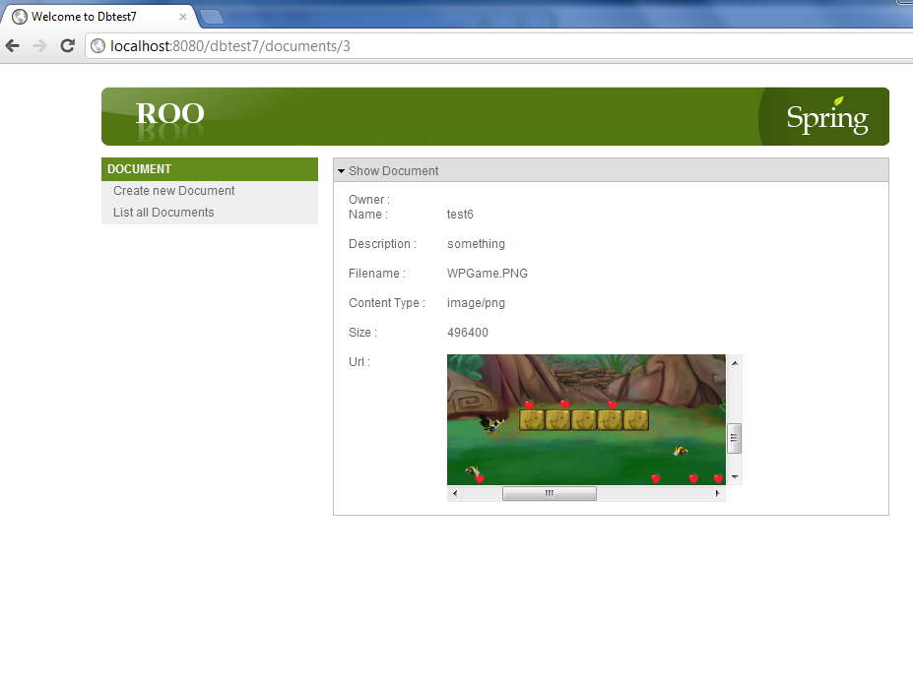
Example Document Input:
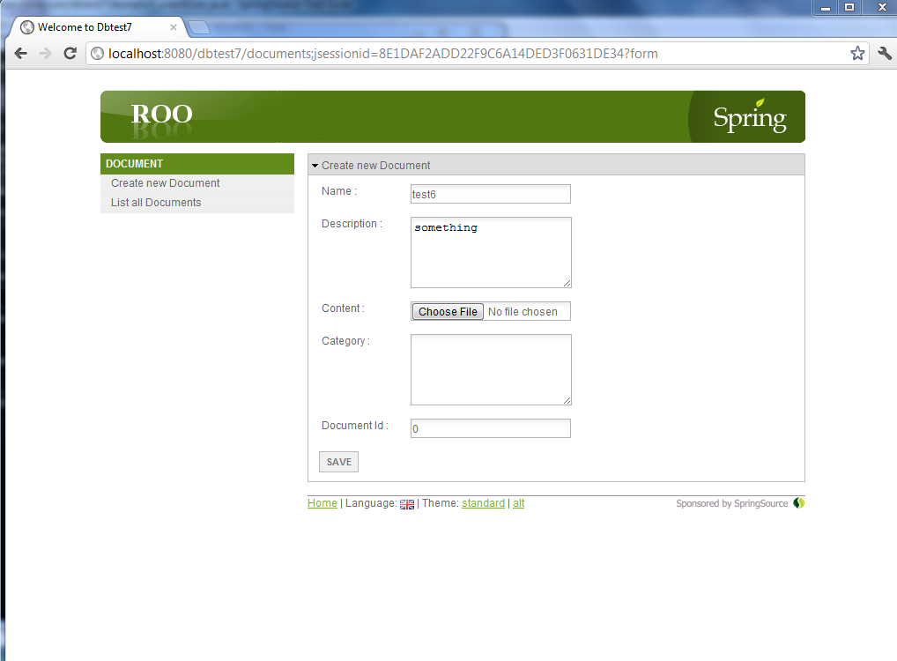

BlobHandler:
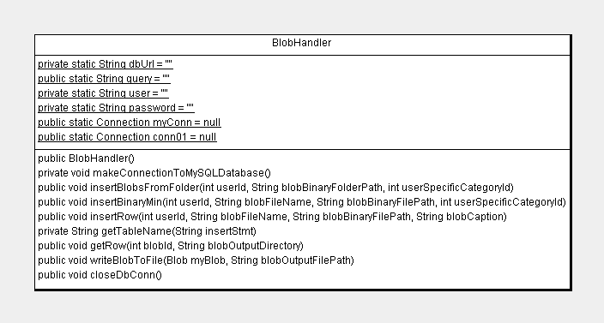

Spider Classes:
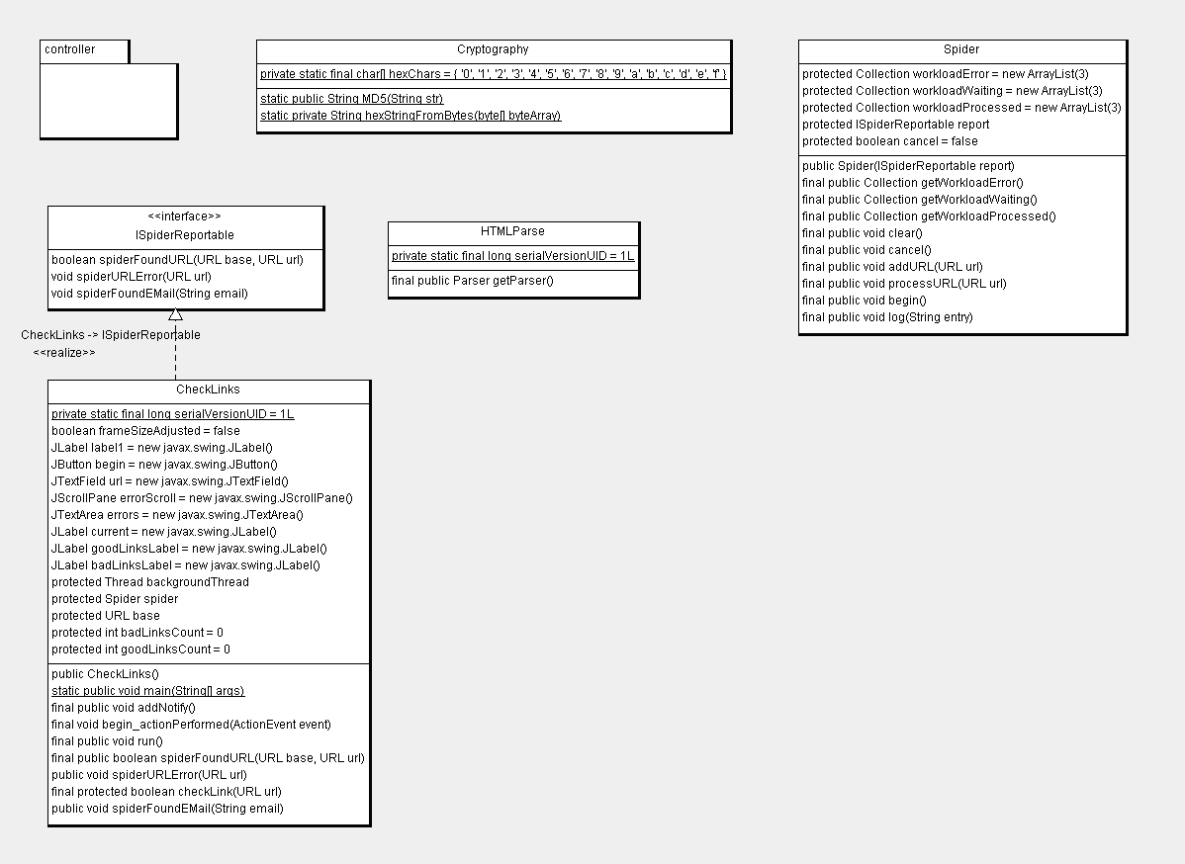

Spider Controller:
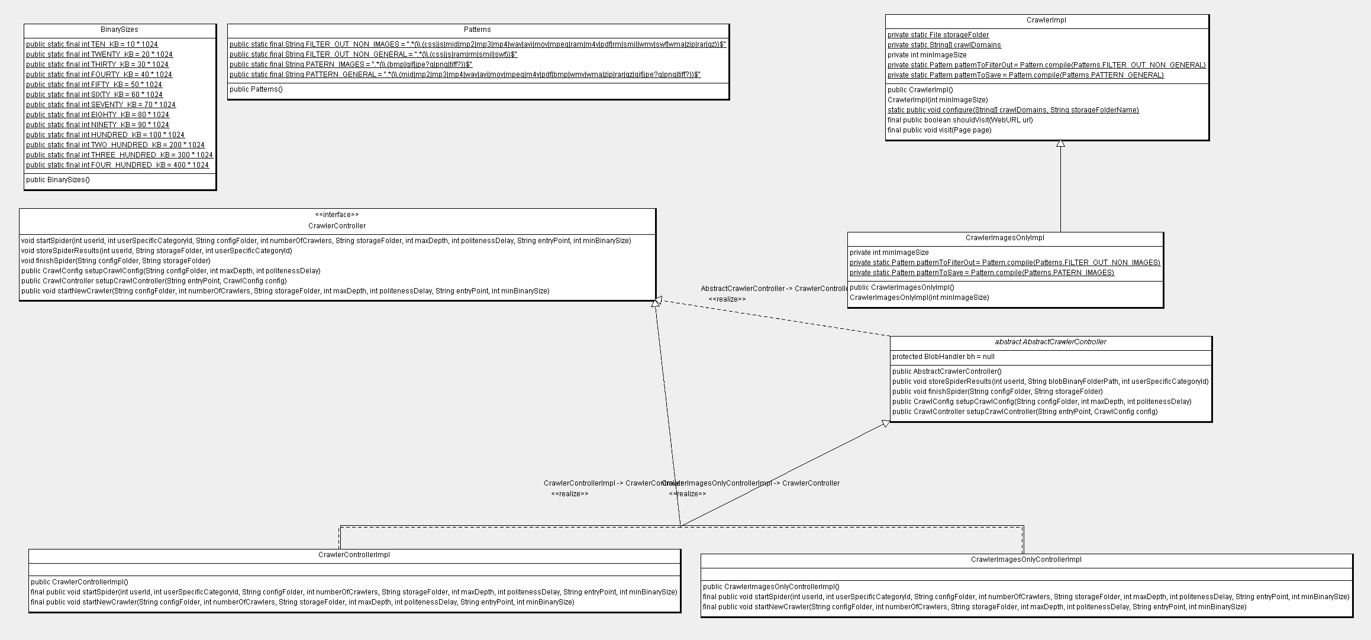

FolderManip:
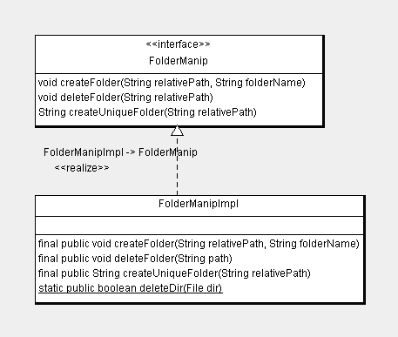
UUID Factory:
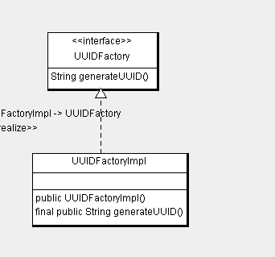

User Class Diagram2:
