ImportantSampling

T Xu

N <- 1000 #number of loans.  
PosNames <- paste("Loan",1:N,sep="")  
beta <- rep(0.3,N) #factor loading  
LGD <- rep(0.5,N)   
PD <- rep(0.01,N)  
EAD <- rep(100,N)  
  
port <- data.frame(PosNames,PD,LGD,EAD,beta,stringsAsFactors = F)  
head(port)

## PosNames PD LGD EAD beta  
## 1 Loan1 0.01 0.5 100 0.3  
## 2 Loan2 0.01 0.5 100 0.3  
## 3 Loan3 0.01 0.5 100 0.3  
## 4 Loan4 0.01 0.5 100 0.3  
## 5 Loan5 0.01 0.5 100 0.3  
## 6 Loan6 0.01 0.5 100 0.3

To simulate the Portfolio Loss Distribution, single factor model is used here, where the credit risk is determined by systematic factor $Z$, along with idiosyncratic risk $ε$

$$V_{i}=β_{i}Z+\sqrt{1−β_{i}^{2}}ε_{i}$$

where Z ~ N(0,1), $ε$ ~ N(0,1)

Recall that Expected Loss $E[Loss]=PD*LGD*EAD$. During the simulation, for each scenario

$$Loss=LGD*EAD*1_{Default}$$

$$1_{Default}=\left\{\begin{matrix}1, & & Default \\ 0, & & Non-Default\end{matrix}\right.$$

In Monte Carlo method, only $1_{Default}$ is simulated, and the loan will be Default if asset value $V$ falls below than Default boundary that $V_{i}<b_{i}=N^{−1}(PD_{i})$

## Naive Monte Carlo

Systematic factor simulations are drawn from its original distribution $Z$ ~ $N(0,1)$, and Portfolio loss will be the sum of position losses, and all the scenario are equally weighted as $1/M$

###  
simMC <- function(port,M){  
 N <- nrow(port)  
 Z <- (rnorm(M,mean=0))  
 LossMC <- matrix(,M,1)  
 for (m in 1:M){  
 e <- rnorm(N,mean=0,sd=1)  
 V <- beta*Z[m] + sqrt(1-beta^2)*e  
 default_flag <- V < qnorm(PD)  
 LossMC[m] <- sum(default_flag * port$EAD * port$LGD)  
 }  
 return (data.frame(Loss=LossMC,Weights=1/M))  
}

## Importance Sampling

Credit risk cares mostely about tail risk, that a portfolio can suffer extemre credit event with less than 1%. Naive Monte Carlo is inefficient as all scenario are equally weighted which requires significant number of simulation to reach a desired level of convegence. Importance Sampling can improve the variance convergence by shifting the weight more on tails during simulation. In Importance Sapling Monte Carlo, simulations of Z is drawn from a shifted distribution $N(μ,1)$, so that mean of the distirubtion can be shifted to desired distribution. For example, $μ=−3$ is used below representing about 99.86% level of loss.(the lower Z value, the higher probability that loss will occur.)

simIS <- function(port,M,mu){  
 N <- nrow(port)  
 Z <- (rnorm(M,mean=mu))  
 LossIS <- matrix(,M,1)  
 for (m in 1:M){  
 e <- rnorm(N,mean=0,sd=1)  
 V <- beta*Z[m] + sqrt(1-beta^2)*e  
 #default_treshold <- (qnorm(PD)-Z*t(beta))/sqrt(1-beta^2)  
 default_flag <- V < qnorm(PD)  
 LossIS[m] <- sum(default_flag * port$EAD * port$LGD)  
 }  
 weights <- exp(-mu*Z+mu^2/2)/M  
 return (data.frame(Loss=LossIS,Weights=weights))  
}

library(Hmisc)

## Loading required package: grid  
## Loading required package: lattice  
## Loading required package: survival  
## Loading required package: splines  
## Loading required package: Formula  
##   
## Attaching package: 'Hmisc'  
##   
## The following objects are masked from 'package:base':  
##   
## format.pval, round.POSIXt, trunc.POSIXt, units

q = c(0.5,0.9,0.95,0.99,0.999,0.9999)  
lossplot <- function(LossRes){  
 LossAmt <- LossRes$Loss  
 LossWgt <- LossRes$Weights  
 Ecdf(LossAmt,weights = LossWgt,datadensity='density',xlim=c(0,10000),ylim=c(0.9,1),q=q)  
}  
  
lossquantile <- function(LossRes){  
 LossAmt <- LossRes$Loss  
 LossWgt <- LossRes$Weights  
 return(wtd.quantile(LossAmt,weights=LossWgt,probs=q,normwt=T,type='i/n'))  
}  
  
LossBench <- simMC(port,100000)  
LossMC <- simMC(port,10000)  
LossIS <- simIS(port,10000,-3)  
  
Benchmark <- lossquantile(LossBench)  
NaiveMC <- lossquantile(LossMC)  
ImportanceSampling <- lossquantile(LossIS)  
df <- data.frame(Benchmark,NaiveMC,ImportanceSampling)

## Comparison

The following table shows the comparison of qifferent quantile using NaiveMC and ImportanceSampling, here the results from 100,000 simulations are used as a benchmark, and use 10,000 simulations for NaiveMC and ImportanceSampling respectively.

t(df)

## 50.00% 90.00% 95.00% 99.00% 99.90% 99.99%  
## Benchmark 340.0 1055 1391 2268 3641 5117  
## NaiveMC 337.7 1043 1395 2264 3425 4500  
## ImportanceSampling 369.9 1045 1400 2235 3684 5253

From 3 plots we can see that: 1) ImportanceSampling has better convergence than NaiveMC to Benchmark results on Loss Quantiles, espexially on quantiles above 99% 2) ImportanceSampling generate more samples at extreme losses above 2000.

lossplot(LossBench)

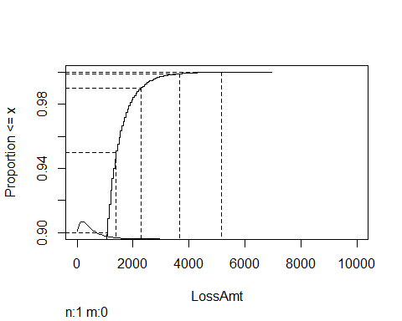

lossplot(LossMC)

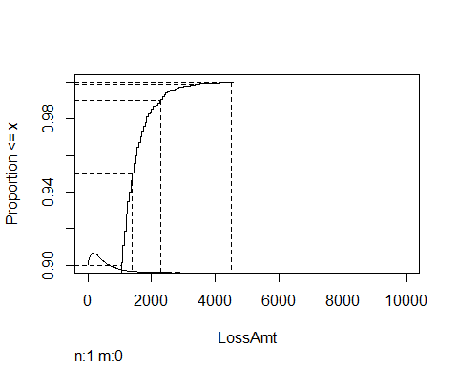

lossplot(LossIS)

