Property Insights: Test Report
What was tested, how, and what happened, for every requirement in the brief
Item | Detail
Version tested | Commit d3954ca on branch fix/reduced-motion-animations. The tests ran on these files just before they were committed, and none has changed since.
Test date | 5 November 2026
Environment | A separate Docker Compose stack built from that code, with both model sets, on Windows 11 and Docker Desktop. The public demo stayed up and wasn't changed. It only saw a health request, and the two new browser tests run once to confirm they fail on the old code; neither saves anything.
Browser | Chromium through Playwright 1.64.1, with axe-core 4.14.0
Walkthrough video | walkthrough/property-insights-walkthrough-2026-11-05.mp4 (3 min 16 s, silent, captioned): see Appendix C

Contents
1. Summary
2. Defects found and fixed
3. How the tests were run
4. Requirements coverage
5. Technical requirements: test cases and evidence
5.1 Next.js implementation
5.2 UI/UX requirements
5.3 State management and data flow
5.4 Code quality and organisation
6. Functional requirements: test cases and evidence
6.1 Task 1: the model API
6.2 Task 2: the portal
6.3 App 1: Property Value Estimator (Python backend)
6.4 App 2: Property Market Analysis (Java backend)
6.5 Technical constraints and deliverables
Appendix A: every automated test
Appendix B: every measured check
Appendix C: the walkthrough video
Appendix D: how to run the suites

1. Summary
All 356 tests and checks that ran passed, and every requirement in the brief has test evidence. The first run found 2 real defects; both are fixed and re-tested (section 2).
- Technical requirements: 14 of 15 met in full. TR-2b is met on the automated checks, with the manual screen-reader pass still to do.
- Functional lines of the brief: 30 of 30 met in full.

Suite | Tool | Tests | Pass | Fail | Skip
ml-api unit and API tests | pytest, both model kinds | 60 | 60 | 0 | 0
estimator-api tests | pytest, with the model stubbed | 37 | 37 | 0 | 0
market-api tests | JUnit, MockMvc, Java 21 | 52 | 52 | 0 | 0
portal unit tests | Vitest | 67 | 67 | 0 | 0
Browser tests | Playwright and axe, Chromium | 38 | 37 | 0 | 1
Browser tests, one backend stopped | Playwright, run twice | 2 | 2 | 0 | 0
Gateway smoke checks | The checks in CI's compose job | 18 | 18 | 0 | 0
Measured checks for this report | Playwright and direct measurement | 74 | 74 | 0 | 0
Static checks and builds | Ruff, ESLint, tsc, Maven, next build, npm audit, nginx -t | 9 | 9 | 0 | 0
Total |  | 357 | 356 | 0 | 1
The one skip is resilience.spec.ts in the normal browser run. It needs a backend stopped, so it ran twice separately (the next row).

2. Defects found and fixed
The first run of these tests found 2 real defects. Both are now fixed, and the results in the rest of this report are from the re-test of the fixed code. Each fix is committed, as its status below shows, but the branch isn't merged into main. The public demo still runs the old build, so it keeps both defects until it is rebuilt.

D-1: The portal's data cache saved no backend calls
Item | Detail
Severity | Medium
Affects | TR-1d, TR-3c
First run | After loading /market/data 5 times and /market/what-if 3 times, each already loaded once, market-api served 8 filter-option calls, 8 property calls and 3 model-info calls, by its own request counters. The portal's fetch cache gained 22 entries over the same loads. On the estimator, 3 more loads of /estimator made 3 new model-info calls in estimator-api's log.
Effect | The configured lives (5 minutes for aggregates, 10 minutes or an hour for model info) had no effect, so every page load called the backends again. Visitors weren't likely to notice on this dataset, because market-api has its own working cache and answers in milliseconds. The unused entries piled up on the container's in-memory /app/.next/cache until it restarted, and the README and ADR 0005 described this cache as working.
Cause | portal/src/lib/api/client.ts sent a new random X-Request-ID on every call, and Next.js puts request headers in its cache key (it leaves out only traceparent and tracestate), so no two calls shared a key. Taking the header off cached calls made the cache hit, which confirms this.
Fix | Cached calls no longer send X-Request-ID. The backends make their own ID for those calls, and uncached calls still send one. ADR 0005 and the README now say so.
Re-test | AC-25: After 5 loads of /market/data and 3 of /market/what-if (each already loaded once): 0 calls for filter options, 0 for properties, 0 for model info; the fetch cache grew by 0 entries. AC-73: 3 more loads of /estimator: 0 new model-info calls in estimator-api's log (6 before). A new browser test (E2E-18) counts market-api's calls across three reloads. It passes now, and failed on the old code with 3 new calls. A new unit test checks that cached calls send identical headers.
Status | Fixed and re-tested; commit 2c6099c

D-2: A mouse click on Estimate price could be lost after typing an invalid value
Item | Detail
Severity | Low
Affects | TR-3b
First run | With an invalid School rating typed and the button clicked straight away, no error summary appeared and the button had moved 26 px.
Effect | The first click showed the field's own message but not the summary, and focus didn't move. A second click worked, and so did pressing Enter. Nothing was lost, and it only happened when the value was invalid.
Cause | The form validates when a field loses focus (mode: "onTouched"). Pressing the mouse button blurred the field, its message appeared and pushed the button down, and the release landed outside it.
Fix | Pressing Estimate price or Reset no longer takes focus from the field (onMouseDown in estimate-form.tsx), so the field isn't validated until the click has landed. The keyboard works as before.
Re-test | AC-69: error summary shown: true; the button moved 1 px while pressed. AC-74: School rating back to 7.6 (it started at 7.6); the button moved 1 px while pressed. A new browser test (E2E-03) clicks both buttons straight after a bad value. It passes now, and failed on the old code. The 1 px is the button's own pressed style.
Status | Fixed and re-tested; commit 47a2bfa

What this run didn't cover
- Screen readers: no manual pass with NVDA or Narrator. Automated checks can't replace it.
- Other browsers and real devices: only Chromium was used. Phone and tablet widths were set in a desktop browser window.
- These commits in CI: CI runs on main and on pull requests, and hadn't run them when this report was written. The suites above are the same ones CI runs, run locally. The latest CI run on main (commit 8b0a250) passed (AC-72).
- Dependency scans: npm audit ran and found nothing. CI's pip-audit and OSV-Scanner image scan weren't repeated here.
- Load and performance: no load tests were run.

3. How the tests were run
Everything ran against a separate copy of the app, built from the tested code and published on its own port, so stopping containers and saving test data couldn't affect the public demo. Failures were caused for real by stopping ml-api, estimator-api or market-api, or by a proxy that made one endpoint fail, and browser requests were held mid-flight to catch loading states on screen. Screenshots were taken during these runs.
ID prefix | What it is
Unit | A group of tests in one service's suite. Appendix A lists each test by name.
E2E-nn | A Playwright browser test in portal/e2e, through the gateway.
SM-nn | A gateway smoke check: the requests CI's compose job makes, on both Host headers.
AC-nn | A check written for this report that measures something directly: raw HTML, network requests, computed styles, container state or backend counters.
ST-nn | A static check or build, such as lint, type check or the production build.

ID | Static check or build | Result
ST-01 | ml-api: ruff check and ruff format --check | All checks passed; 20 files already formatted | Pass
ST-02 | estimator-api: ruff check and ruff format --check | All checks passed; 20 files already formatted | Pass
ST-03 | market-api: full Maven build and tests on Java 21 | BUILD SUCCESS; 52 tests, 0 failures | Pass
ST-04 | portal: ESLint on the whole project | Exit code 0, no findings | Pass
ST-05 | portal: TypeScript type check | Exit code 0, no errors | Pass
ST-06 | portal: production build with no backend URLs set | Compiled; all 13 routes dynamic (none prerendered from backend data) | Pass
ST-07 | portal: audit of shipped dependencies | found 0 vulnerabilities | Pass
ST-08 | gateway: nginx configuration test | syntax is ok; test is successful | Pass
ST-09 | Both model sets build and start healthy | 9 containers healthy in 42 s (with Docker's build cache) | Pass

4. Requirements coverage
Every requirement, the tests behind it, and the result. Sections 5 and 6 show each test's expected and actual outcome.

Technical requirements
ID | Requirement | Evidence | Result
Next.js implementation
TR-1a | Use App Router | AC-01, E2E-27, ST-06 | Met
TR-1b | Implement server components and client components appropriately | AC-02, AC-03, AC-04 | Met
TR-1c | Use React Server Components for initial data loading | AC-05, AC-06, AC-07, AC-08, AC-09 | Met
TR-1d | Implement proper data fetching strategies | AC-10, AC-11, AC-12, AC-46, ST-06, AC-25, AC-73, E2E-18, 1 unit group | Met
TR-1e | Create custom hooks for shared functionality | AC-13 | Met
UI/UX requirements
TR-2a | Create responsive layouts using Tailwind CSS | AC-14, AC-15, AC-16, E2E-30, E2E-20, AC-63 | Met
TR-2b | Implement accessible UI components following WCAG guidelines | AC-17, AC-18, AC-19, AC-20, AC-21, E2E-26, E2E-08, E2E-09, E2E-10, E2E-11, E2E-12, E2E-13, E2E-31, E2E-32, E2E-33, E2E-34, E2E-35, E2E-36, E2E-37, E2E-38 | Met on automated checks
TR-2c | Use appropriate loading states and error boundaries | AC-22, AC-23, AC-24, AC-26, AC-27, AC-28, AC-29, E2E-39, E2E-40, E2E-28 | Met
TR-2d | Create smooth transitions between pages and application states | AC-32, AC-33, AC-34, AC-68, AC-21 | Met
TR-2e | Design a cohesive UI that follows modern design principles | AC-35 | Met
State management and data flow
TR-3a | Implement appropriate client-side state management | AC-36, AC-37, AC-38, AC-39, AC-34, 2 unit groups | Met
TR-3b | Handle form state effectively with validation | AC-40, AC-41, AC-42, AC-69, AC-74, AC-70, E2E-03, E2E-02, 2 unit groups | Met
TR-3c | Create efficient data fetching patterns | AC-43, AC-44, AC-45, AC-09, AC-46, AC-25, AC-73, E2E-18, 2 unit groups | Met
TR-3d | Properly manage API communication and error states | AC-47, AC-48, AC-49, AC-50, AC-52, AC-53, AC-27, AC-30, AC-31, E2E-04, E2E-22, 2 unit groups | Met
Code quality and organisation
TR-4a | Structure the codebase following Next.js best practices | AC-54, AC-55, AC-56, ST-04, ST-05 | Met

Functional requirements and constraints
ID | Requirement | Evidence | Result
Task 1: the model API
T1-1 | predict accepts housing features and returns price predictions, single and batch | AC-58, SM-03, SM-04, 3 unit groups | Met
T1-2 | model-info returns model coefficients and performance metrics | AC-59, 2 unit groups | Met
T1-3 | health is a simple health check endpoint | AC-60, SM-01, SM-02, 1 unit group | Met
T1-4 | Python 3.12+, FastAPI, scikit-learn | AC-61 | Met
T1-5 | Build, containerise and deploy a regression model | ST-09, AC-71, 1 unit group | Met
T1-6 | Source on GitHub, a Dockerfile, and live through Swagger/OpenAPI | AC-57, SM-05, SM-06, AC-72, 1 unit group | Met
Task 2: the portal
P-0 | Two independent applications with different backends, both able to use the model | E2E-39, E2E-40, AC-51, AC-54, SM-08, SM-15 | Met
P-1 | A shared layout with navigation between applications | E2E-25, E2E-27 | Met
P-2 | Next.js App Router for routing between and within applications | AC-01, E2E-27 | Met
P-3 | A consistent design system across both applications | AC-35 | Met
P-4 | Loading and error states handled at the layout level | AC-22, AC-28, AC-29, AC-24 | Met
App 1: Property Value Estimator (Python backend)
E-1 | A form for property details: all fields from the model | E2E-01, AC-07 | Met
E-2 | Client-side validation with appropriate error messages | E2E-02, AC-40, 1 unit group | Met
E-3 | Prediction results as a table and a chart | E2E-01, E2E-05 | Met
E-4 | A history of previous estimates | AC-11, E2E-06, E2E-09, 1 unit group | Met
E-5 | A comparison view for several properties side by side | E2E-07, AC-37, 2 unit groups | Met
E-6 | The Python backend handles form submissions | AC-10, SM-08, 1 unit group | Met
E-7 | Integrates with the regression model container | SM-08, SM-09, SM-10, 1 unit group | Met
E-8 | Data validation and error handling | AC-52, 3 unit groups | Met
App 2: Property Market Analysis (Java backend)
M-1 | An interactive dashboard with property market visualisations | E2E-14, E2E-16, AC-06 | Met
M-2 | Filters for analysing different property segments | E2E-15, AC-36, 2 unit groups | Met
M-3 | A what-if analysis tool using the model | E2E-21, E2E-23, SM-15, SM-16, 2 unit groups | Met
M-4 | Data export options: CSV and PDF | AC-67, E2E-17, E2E-19, SM-18, 1 unit group | Met
M-5 | Responsive data tables with sorting and filtering | E2E-17, E2E-20, AC-45, 1 unit group | Met
M-6 | REST API endpoints for market analysis | SM-13, SM-14, SM-17, 2 unit groups | Met
M-7 | Aggregate statistics from the housing dataset | AC-64, 3 unit groups | Met
M-8 | Integrates with the ML model container | SM-15, SM-16, 2 unit groups | Met
M-9 | Caching for performance optimisation | AC-65, AC-66, 3 unit groups | Met
Technical constraints and deliverables
C-1 | Python 3.12+, FastAPI, Java 21, Spring Boot 3.4.4 | AC-61, AC-62 | Met
C-2 | Source on GitHub, and able to show it live | AC-72, AC-71 | Met

5. Technical requirements: test cases and evidence

5.1 Next.js implementation

TR-1a: Use App Router
Every route lives in src/app, with nested layouts and per-section loading, error and not-found files. There is no pages folder.
ID | Test | Expected | Actual | Result
AC-01 | All routes use the App Router | src/app holds the routes; no src/pages or pages folder | src/app has 8 pages, 3 layouts, 4 route handlers; pages folder present: false | Pass
E2E-27 | shell.spec.ts: navigation between and within the apps marks the current page | Links move between and within the apps, and the current page is marked | All its assertions passed | Pass
ST-06 | portal: production build with no backend URLs set | The build lists every route as an App Router route | Compiled; all 13 routes dynamic (none prerendered from backend data) | Pass

Route | Kind
/ | Page
/estimator/compare | Page
/estimator/history/[id] | Page
/estimator/history | Page
/estimator | Page
/market/data | Page
/market/what-if | Page
/market | Page
/api/health | Route Handler
/api/market/export/[format] | Route Handler
/api/market/what-if/sensitivity | Route Handler
/api/market/what-if | Route Handler

TR-1b: Implement server components and client components appropriately
Pages and layouts are Server Components. "use client" appears only on the interactive parts: the form, charts, filters, table, sliders and the error boundaries Next requires to be client. import "server-only" keeps the backend clients off the browser.
ID | Test | Expected | Actual | Result
AC-02 | Every page and layout is a Server Component | 0 page.tsx or layout.tsx files start with "use client" | 0 of 11; 42 client files in total, all interactive parts | Pass
AC-03 | The backend API layer is marked server-only | lib/api/client, estimator, market and env import server-only | src/lib/api/client.ts, src/lib/api/env.ts, src/lib/api/estimator.ts, src/lib/api/market.ts, src/lib/api/problem-response.ts, src/lib/api/status.ts | Pass
AC-04 | No server code reaches the browser bundle | None of the backend URLs or fetch wrapper strings appear in client JavaScript | searched 36 client chunks for 5 strings; found: none | Pass

TR-1c: Use React Server Components for initial data loading
Pages are async and fetch on the server, then pass data down as props. These checks read the raw HTML before any JavaScript runs, then watch what the browser fetches.
ID | Test | Expected | Actual | Result
AC-05 | /market/data arrives with its homes in the HTML | Prices are in the server's HTML, before any JavaScript runs | 12 price values in the raw HTML | Pass
AC-06 | /market arrives with its figures in the HTML | KPI labels and chart titles are in the server's HTML | Median price: true; Price against living area: true | Pass
AC-07 | /estimator arrives with the model's training ranges | The form's hints carry the training range from the server | "Training data:" in HTML: true; model version present: true | Pass
AC-08 | /estimator/history arrives with the saved estimates | A seeded estimate's label is in the server's HTML | "Maple Court family home" in HTML: true | Pass
AC-09 | First load needs no client-side data fetch | 0 data calls from the browser on server-rendered pages, and no call reaches a backend directly | /market: 0 data calls, 0 backend calls; /market/data: 0 data calls, 0 backend calls; /estimator: 0 data calls, 0 backend calls; /estimator/history: 0 data calls, 0 backend calls | Pass

TR-1d: Implement proper data fetching strategies
Reads go through Server Components with Suspense streaming, writes through Server Actions with revalidatePath, and live what-if calls through Route Handlers with TanStack Query. The data cache is set per kind of data: model info for an hour (App 1) or 10 minutes (App 2), market aggregates for 5 minutes, and history and status not at all. Defect D-1 stopped it working in the first run; AC-25, AC-73 and the browser test below show it working now.
ID | Test | Expected | Actual | Result
AC-10 | A write goes through a Server Action | Submitting the form POSTs to the page with a Next-Action header | POST /estimator with Next-Action | Pass
AC-11 | The saved estimate shows at once (no stale cache) | History is never cached: the new estimate is on the next load | 1 row found for the new label | Pass
AC-12 | Interactive calls go through a Route Handler | The browser POSTs to the portal's /api route, never to market-api | 1 POST to /api/market/what-if; 0 to market-api | Pass
AC-46 | The page streams | The shell's first bytes come before the end of the response | first bytes at 285 ms (has <html>: true), complete at 303 ms, 102829 bytes | Pass
ST-06 | portal: production build with no backend URLs set | With no backend URLs set, the build still succeeds: nothing is prerendered from backend data | Compiled; all 13 routes dynamic (none prerendered from backend data) | Pass
Unit | client.test.ts: caching | The wrapper passes the cache options to fetch, with identical headers each time | 2 of 2 passed | Pass
AC-25 | The portal's data cache saves backend calls | Pages reloaded within the cache's life (5 minutes for aggregates, 10 for model info) make no new calls to market-api | After 5 loads of /market/data and 3 of /market/what-if (each already loaded once): 0 calls for filter options, 0 for properties, 0 for model info; the fetch cache grew by 0 entries | Pass
AC-73 | The estimator's model info comes from the data cache | Reloading /estimator within the hour makes no new calls to estimator-api | 3 more loads of /estimator: 0 new model-info calls in estimator-api's log (6 before) | Pass
E2E-18 | market.spec.ts: reloading the page reuses the portal's data cache instead of calling market-api again | Three reloads make no new calls to market-api | All its assertions passed | Pass

TR-1e: Create custom hooks for shared functionality
Six shared hooks live in src/hooks, and each app has its own. The table shows how many components use each one, counted from the source.
ID | Test | Expected | Actual | Result
AC-13 | Custom hooks are reused across components | Each of the 11 hooks is used by at least one component outside its own file | All 11 hooks are used outside their own file (table below) | Pass

Hook | Folder | What it does | Used by | Exercised by
useUrlState | src/hooks | Filters, sort and baseline kept in the address | 5 | E2E filter, sort and what-if tests
useDebouncedValue | src/hooks | One request per pause while a slider moves | 1 | AC-43
useFileDownload | src/hooks | Exports through fetch, with failures shown on the page | 1 | AC-49, AC-67
useFormatters | src/hooks | Prices, numbers and dates, the same on server and client | 12 | E2E result and table tests
useHydrated | src/hooks | Keeps the form read-only until React has attached | 2 | E2E form tests
usePrefersReducedMotion | src/hooks | Turns chart animation off when asked | 7 | AC-21
useCompareTray | features/estimator/hooks | Reads and changes the compare tray | 3 | AC-37, AC-38
useCompareTrayHydrated | features/estimator/hooks | Hides the tray until storage has been read | 2 | AC-38
useWhatIf | features/market/hooks | Debounced, cached what-if pricing | 1 | AC-43, AC-44
useSensitivity | features/market/hooks | The Ridge set's sensitivity line | 1 | E2E the Ridge set adds the sensitivity line
useMarketFilters | features/market | The page's filters, shared through context | 1 | AC-34

5.2 UI/UX requirements

TR-2a: Create responsive layouts using Tailwind CSS
Tailwind 4 grids change at its breakpoints (sm:grid-cols-2 lg:grid-cols-4), and the what-if price moves above the sliders on a phone. The data table scrolls inside its own box. Widths were set in a desktop Chromium window, not on real phones.
ID | Test | Expected | Actual | Result
AC-14 | No page scrolls sideways at any width | 0 px overflow on 8 pages at 320, 375, 768, 1024 and 1280 px | 40 combinations, 0 with overflow | Pass
AC-15 | The headline figures reflow with the width | Grid columns grow from 1 on a phone to 2 on a tablet and 4 on a desktop | 375 px: 1, 768 px: 2, 1280 px: 4 | Pass
AC-16 | What-if layout changes with the width | Price above the sliders on a phone, beside them on a desktop | 375 px: price above = true; 1280 px: beside = true | Pass
E2E-30 | shell.spec.ts: fits a 375 px phone without sideways scrolling | No sideways scrolling on six pages at 375 px | All its assertions passed | Pass
E2E-20 | market.spec.ts: fits a phone: the table scrolls inside its box | The page stays put while the table scrolls inside its box | All its assertions passed | Pass
AC-63 | The portal's stack | Next.js with the App Router, React, Tailwind CSS | next 16.4.4, react 19.3.0, tailwindcss ^4 | Pass

Sideways overflow measured on every page at every width (AC-14):
Page | 320 px | 375 px | 768 px | 1024 px | 1280 px
/ | 0 px | 0 px | 0 px | 0 px | 0 px
/estimator | 0 px | 0 px | 0 px | 0 px | 0 px
/estimator/history | 0 px | 0 px | 0 px | 0 px | 0 px
/estimator/compare | 0 px | 0 px | 0 px | 0 px | 0 px
/market | 0 px | 0 px | 0 px | 0 px | 0 px
/market/data | 0 px | 0 px | 0 px | 0 px | 0 px
/market/what-if | 0 px | 0 px | 0 px | 0 px | 0 px
/no-such-page | 0 px | 0 px | 0 px | 0 px | 0 px

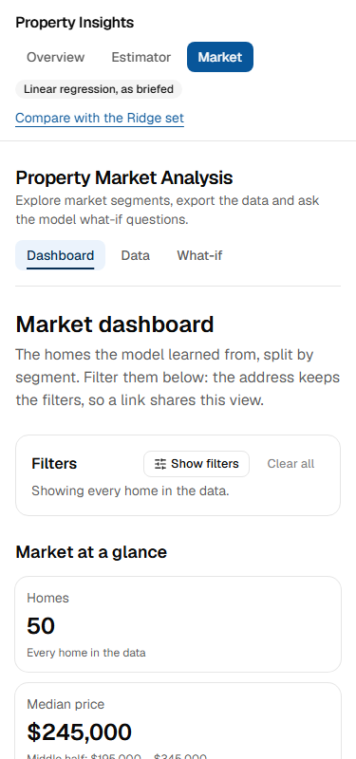  Figure 1. Market dashboard at 375 px. | 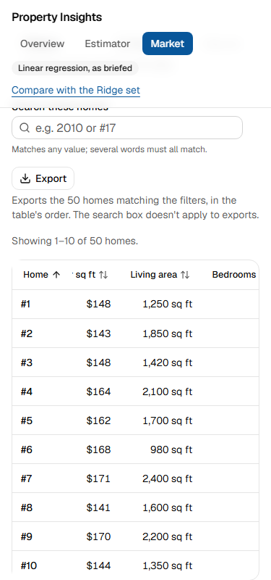  Figure 2. Data table at 375 px: it scrolls inside its box with the home number pinned. | 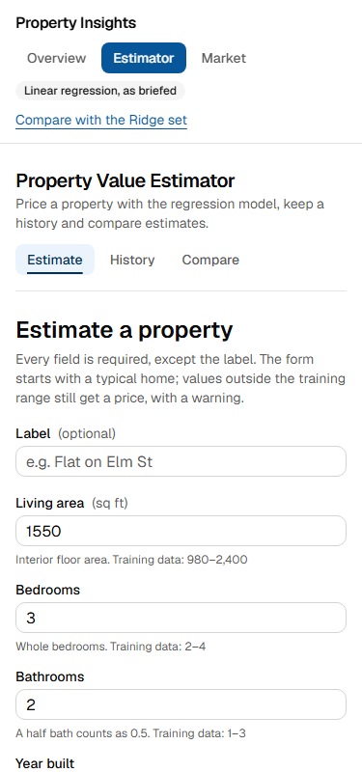  Figure 3. Estimate form at 375 px.

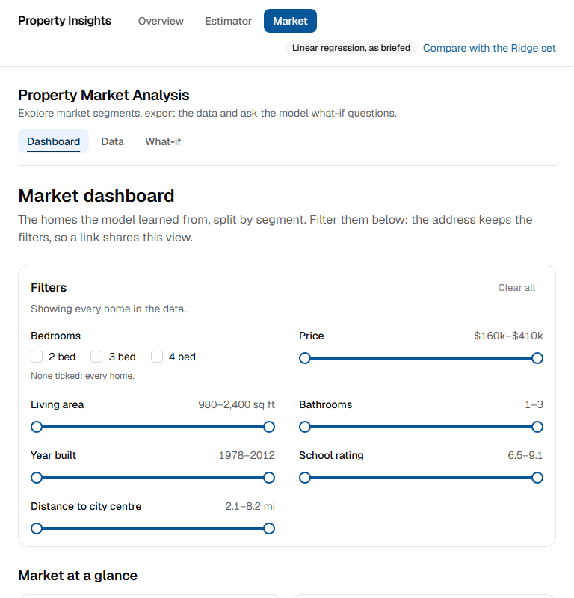
Figure 4. Market dashboard at 768 px. Page: /market
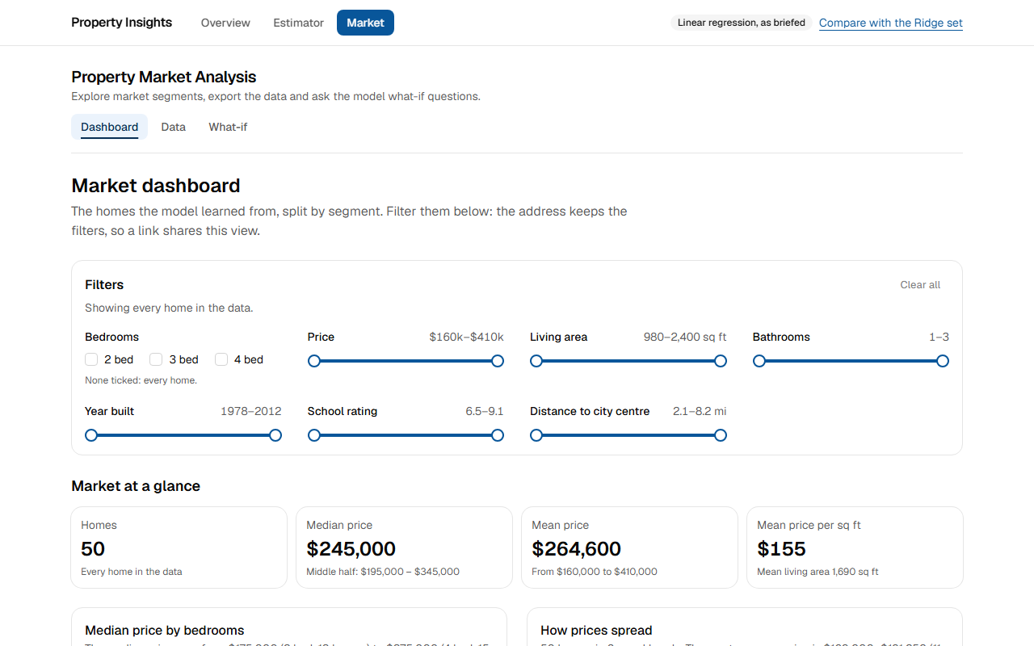
Figure 5. Market dashboard at 1280 px. Page: /market

TR-2b: Implement accessible UI components following WCAG guidelines
Radix primitives, a skip link, labelled landmarks, aria-current, linked field errors, status announcements, focus management, and a table view for every chart. axe was run at WCAG 2.2 AA, and keyboard-only tests check focus at every stop. A manual screen-reader pass (NVDA or Narrator) hasn't been done, so these results don't claim full WCAG conformance.
ID | Test | Expected | Actual | Result
AC-17 | axe finds no WCAG 2.2 AA violations | 0 violations across every scanned page and state (tags: wcag2a, wcag2aa, wcag21a, wcag21aa, wcag22aa) | 18 scans, 0 violations, 474 rule passes | Pass
AC-18 | Pages expose language, landmarks and one h1 | lang set, one main, labelled navs, one h1, a page title, aria-current on the nav | lang="en"; 1 main landmark; 3 labelled navs (Applications, Property Market Analysis sections, Table pages); 1 h1; title "Market data · Property Insights"; aria-current on 2 links | Pass
AC-19 | Sorting tells assistive technology | The sorted header carries aria-sort | aria-sort="ascending" | Pass
AC-20 | Charts have a text alternative | The drawing is hidden from screen readers and a table is always available | aria-hidden chart wrappers: 1; tables in the figure: 1 | Pass
AC-21 | Animations respect the reduced-motion setting | Dropdown, spinner, skeleton and progress bar: none with reduced motion on, running with it off | With the setting on: all four stopped. With it off: all four ran (table below) | Pass
E2E-26 | shell.spec.ts: the skip link is the first stop and moves focus to the content | Tab lands on the skip link, and Enter moves focus to the content | All its assertions passed | Pass
E2E-08 | keyboard.spec.ts: estimate: Enter submits, an error takes focus, and the result goes to the comparison | The estimate flow works by keyboard alone, with focus visible at every stop | All its assertions passed | Pass
E2E-09 | keyboard.spec.ts: history: delete asks first, Escape keeps the estimate, and focus stays in the table | Delete confirms, Escape cancels, and focus stays put | All its assertions passed | Pass
E2E-10 | keyboard.spec.ts: compare tray: nothing hides behind it, and Clear keeps focus on the page | Nothing focused hides behind the tray | All its assertions passed | Pass
E2E-11 | keyboard.spec.ts: market dashboard: filters and a chart's table | Filters and the chart's table view work by keyboard | All its assertions passed | Pass
E2E-12 | keyboard.spec.ts: market data: sorting, paging and the export menu | Sort, paging and the export menu work by keyboard | All its assertions passed | Pass
E2E-13 | keyboard.spec.ts: what-if: the baseline, a slider and both resets leave focus where it can carry on | Sliders and resets keep focus where the user can carry on | All its assertions passed | Pass
E2E-31 | shell.spec.ts: / | No axe violations on this page | All its assertions passed | Pass
E2E-32 | shell.spec.ts: /estimator | No axe violations on this page | All its assertions passed | Pass
E2E-33 | shell.spec.ts: /estimator/history | No axe violations on this page | All its assertions passed | Pass
E2E-34 | shell.spec.ts: /estimator/compare | No axe violations on this page | All its assertions passed | Pass
E2E-35 | shell.spec.ts: /market | No axe violations on this page | All its assertions passed | Pass
E2E-36 | shell.spec.ts: /market/data | No axe violations on this page | All its assertions passed | Pass
E2E-37 | shell.spec.ts: /market/what-if | No axe violations on this page | All its assertions passed | Pass
E2E-38 | shell.spec.ts: /no-such-page | No axe violations on this page | All its assertions passed | Pass

axe results by page and state (AC-17). The rule count is how many WCAG rules axe could check and found satisfied on that page:
Page or state | Set | Rules passed | Violations
/ | Brief | 21 | 0
/estimator | Brief | 28 | 0
/estimator/history | Brief | 25 | 0
/estimator/compare | Brief | 19 | 0
/market | Brief | 30 | 0
/market/data | Brief | 29 | 0
/market/what-if | Brief | 26 | 0
/no-such-page | Brief | 19 | 0
/estimator (errors showing) | Brief | 28 | 0
/market (filtered) | Brief | 30 | 0
/ | Ridge | 21 | 0
/estimator | Ridge | 28 | 0
/market | Ridge | 30 | 0
/market/what-if | Ridge | 28 | 0
/estimator at 375 px | Brief | 28 | 0
/market at 375 px | Brief | 29 | 0
/market/data at 375 px | Brief | 29 | 0
/market/what-if at 375 px | Brief | 26 | 0

The animation each element reports, with the reduced-motion setting on and off (AC-21):
Element | Reduced motion on | Reduced motion off
Export dropdown opening | none | enter
Export spinner | none | spin
Loading skeleton | none | pulse
Filter progress bar | none | progress

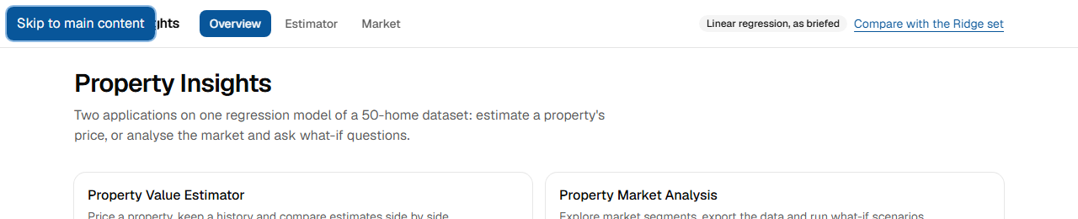
Figure 6. First Tab on any page: the skip link, with a visible style. Page: /
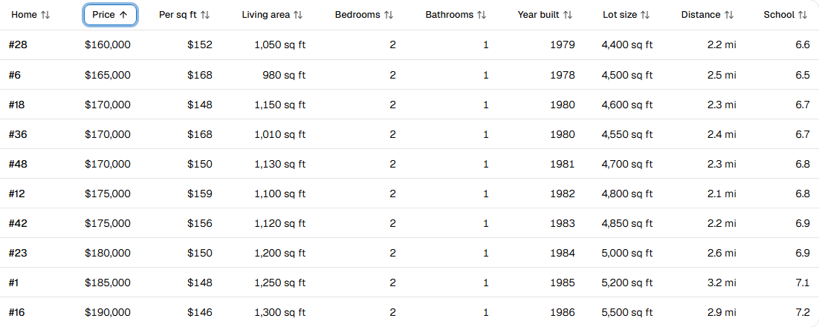
Figure 7. Keyboard sort: the focus ring stays on the header, and the arrow plus aria-sort show the direction. Page: /market/data?sort=price,asc
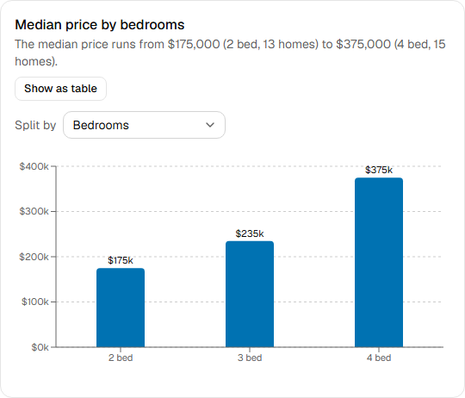  Figure 8. A chart as drawn, with its Show as table button. | 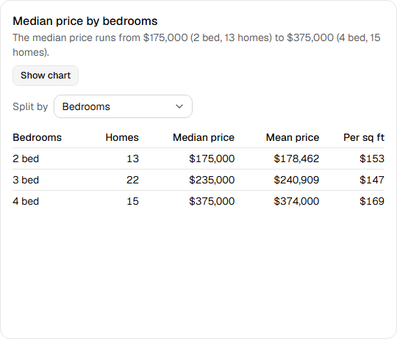  Figure 9. The same chart as a table: every chart has this view.

TR-2c: Use appropriate loading states and error boundaries
Eight loading.tsx skeletons, a Suspense fallback per dashboard widget, inline pending states, three app-level error.tsx files plus global-error.tsx, and a catchError boundary around each widget. To show one widget failing alone, a proxy made one market-api endpoint fail for a production build of the portal.
ID | Test | Expected | Actual | Result
AC-22 | A route shows a skeleton while it loads | market/loading.tsx appears at once with a status message | status text: "Loading the market analysis" | Pass
AC-23 | The form shows when it is working | The submit button reads Estimating… and is disabled until the answer comes | text "Estimating…", disabled: true | Pass
AC-24 | Unknown addresses get a not-found page | HTTP 404 with the page-not-found heading | HTTP 404, heading visible: true | Pass
AC-26 | One failed widget doesn't blank the page | Only that widget shows an error with Try again; the filters and other widgets stay | 1 widget error, filter bar visible: true, 3 charts still drawn | Pass
AC-27 | A widget's Try again recovers it | With the fault removed, Try again re-fetches that widget on the server | headline figures back; 0 widget errors left | Pass
AC-28 | With estimator-api down, only its app is affected | Its own error panel with Try again; navigation and the other app keep working | error panel shown, navigation visible: true, other app clean: true | Pass
AC-29 | With market-api down, only its app is affected | Its own error panel with Try again; navigation and the other app keep working | error panel shown, navigation visible: true, other app clean: true | Pass
E2E-39 | resilience.spec.ts, with estimator-api stopped | Its app shows its own error; the other app and shell keep working | All its assertions passed | Pass
E2E-40 | resilience.spec.ts, with market-api stopped | Its app shows its own error; the other app and shell keep working | All its assertions passed | Pass
E2E-28 | shell.spec.ts: an unknown address gets the not-found page | HTTP 404 and the not-found page | All its assertions passed | Pass

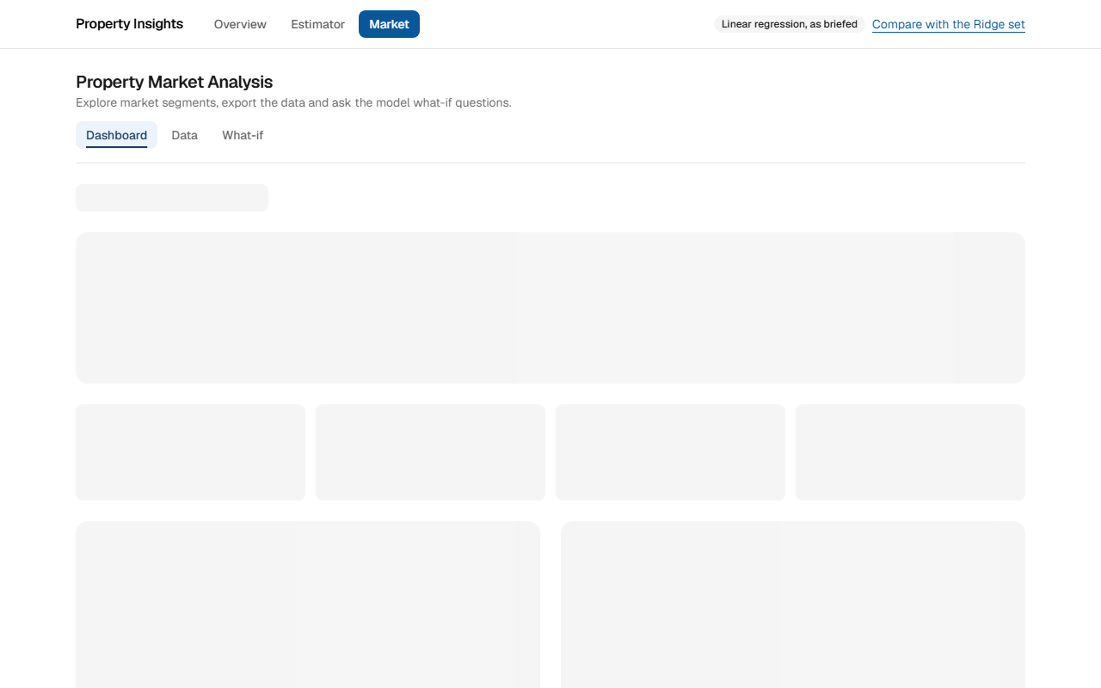  Figure 10. Route loading skeleton (market/loading.tsx), with a screen-reader status, while the page's data is on its way. | 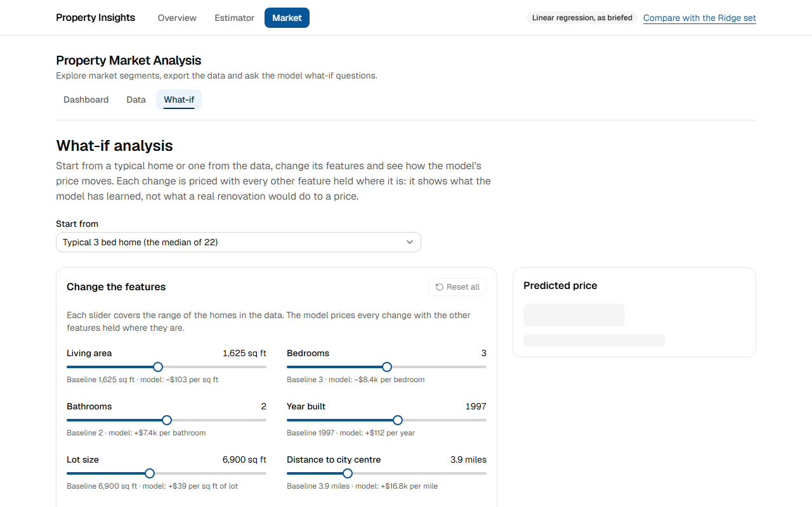  Figure 11. What-if: the sliders are usable while the first price loads behind its own skeleton.


Figure 12. The form while saving: the button says so, spins and can't be pressed twice. Page: /estimator
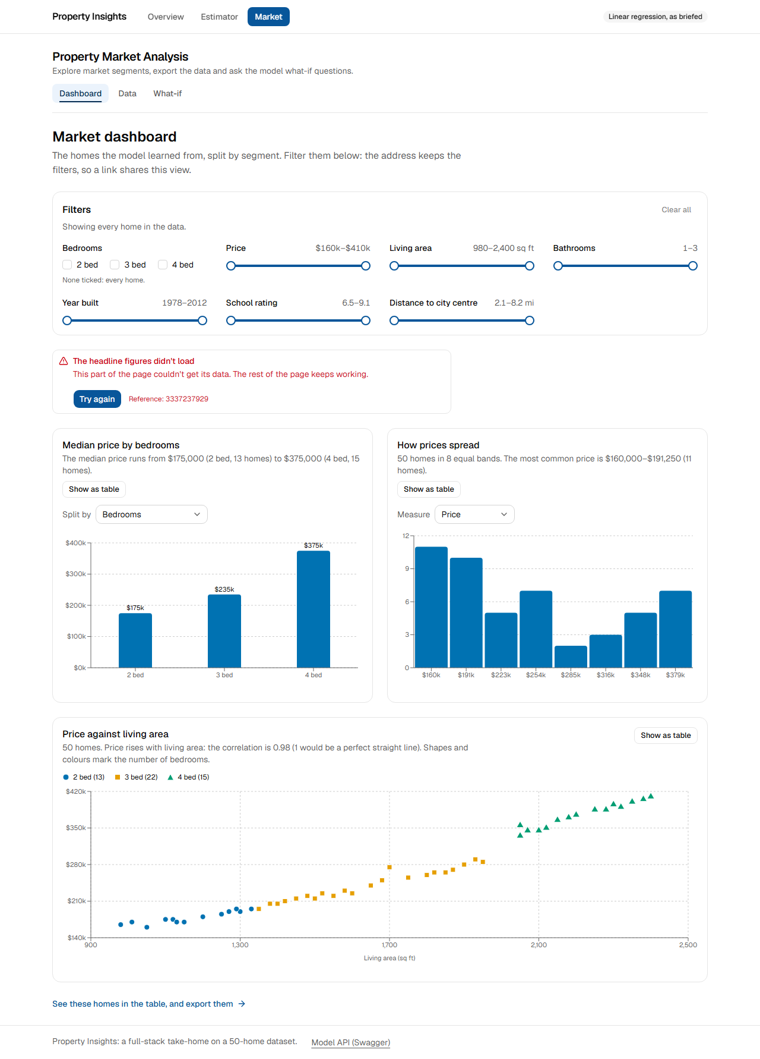
Figure 13. Fault injected on one endpoint: the headline figures fail on their own, with Try again; the filters and all three charts stay. Page: /market
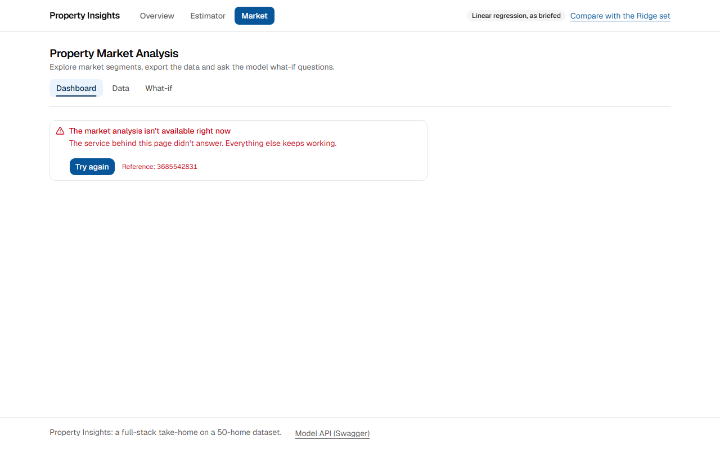  Figure 14. market-api stopped: this app shows its own error panel; the header and the other app still work. | 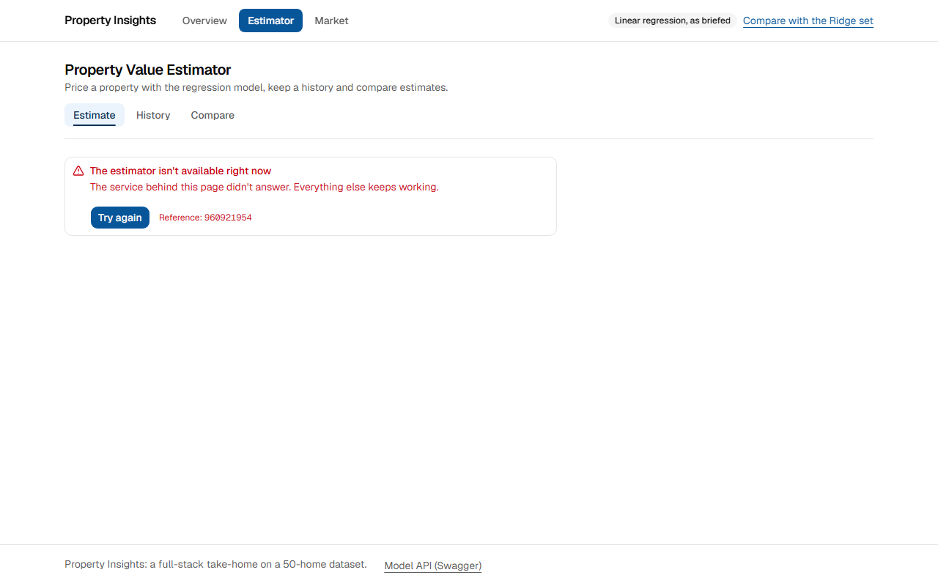  Figure 15. estimator-api stopped: this app shows its own error panel; the header and the other app still work.

Figure 16. Home page with market-api stopped: the service status reports it. | Figure 17. Home page with estimator-api stopped: the service status reports it.

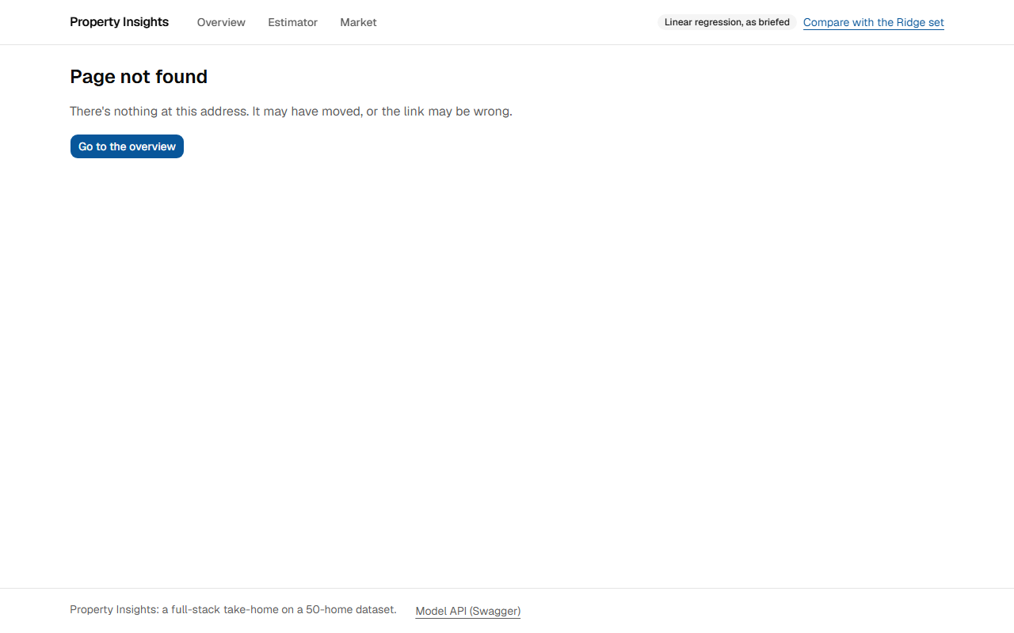
Figure 18. An unknown address gets the not-found page, inside the normal layout. Page: /no-such-page

TR-2d: Create smooth transitions between pages and application states
React's <ViewTransition> crossfades the page when a nav-bar link is followed. Filter changes use useTransition and useOptimistic: the control updates at once while the old results stay on screen, dimmed under a progress bar. Other links, such as the home page's cards, swap without a crossfade by design.
ID | Test | Expected | Actual | Result
AC-32 | Following a nav-bar link crossfades the page | The page-fade and page-rise animations run on navigation | page-fade ran for 180 ms and page-rise for 240 ms | Pass
AC-33 | A filter change updates in place | By design no crossfade: the page-fade animation doesn't run | page-fade didn't run; the only animation was the progress bar (progress) | Pass
AC-34 | A filter change keeps the page on screen | The control updates at once (useOptimistic), old results stay dimmed, aria-busy is true | checkbox ticked: true; results opacity: 0.6; old results still shown: true; aria-busy: true | Pass
AC-68 | Page transitions switch off under reduced motion | The crossfade takes 0 ms when the setting is on | page-fade 0 ms, page-rise 0 ms | Pass
AC-21 | Animations respect the reduced-motion setting | Dropdown, spinner, skeleton and progress bar: none with reduced motion on, running with it off | With the setting on: all four stopped. With it off: all four ran (table below) | Pass

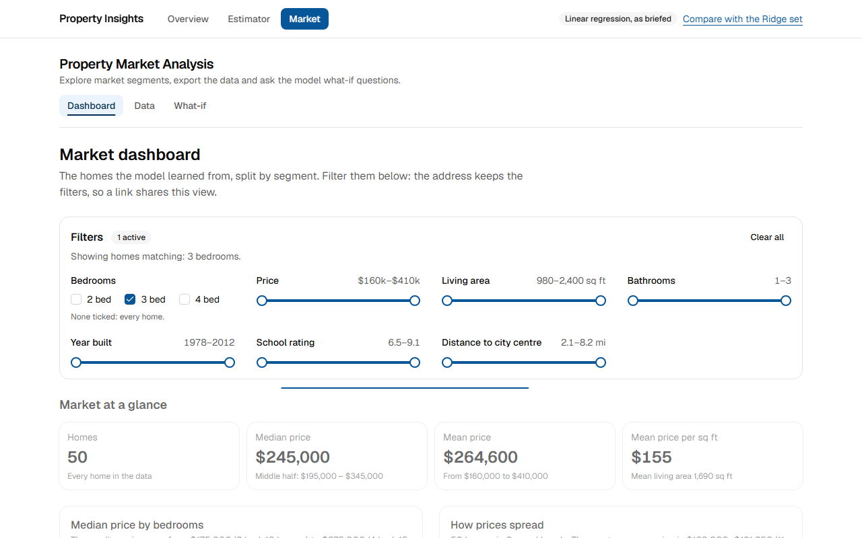
Figure 19. A filter change in progress: the box ticks at once, the old results stay up dimmed under a progress bar. Page: /market
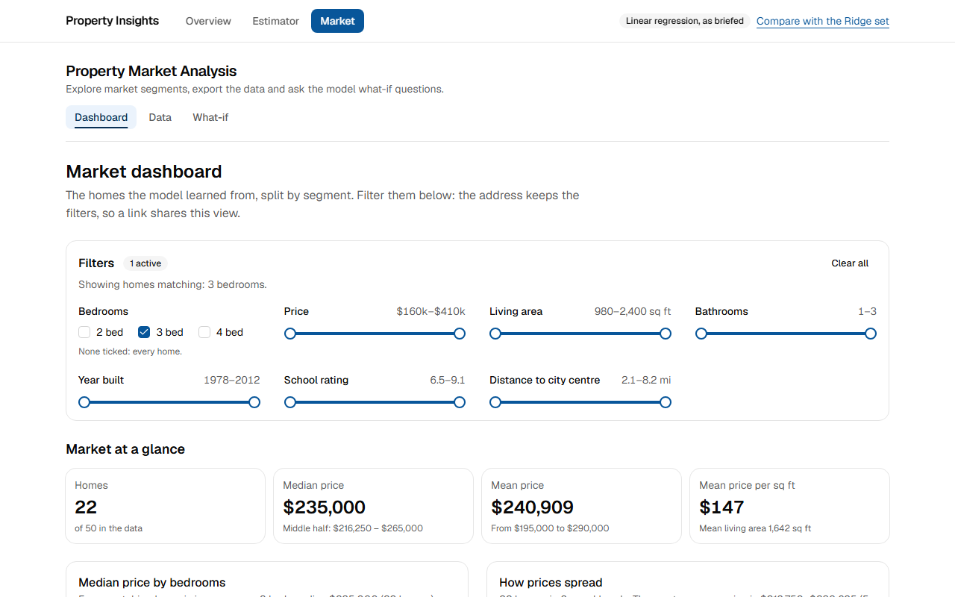
Figure 20. The same page once the server's answer arrives. Page: /market?bedrooms=3

TR-2e: Design a cohesive UI that follows modern design principles
shadcn/ui on Radix, one set of design tokens with a single blue accent, the Geist font, and a colour-blind-safe chart palette, across both apps. The measured check covers consistency. Whether the design is good is a matter of judgement, so the screenshots are here for the reader to judge.
ID | Test | Expected | Actual | Result
AC-35 | Both apps share one design system | The same font, tokens, heading size, header and content width on both apps | Identical on both apps: font Geist, the same primary colour and radius tokens, h1 24px, header 57 px, content width 1152 px | Pass

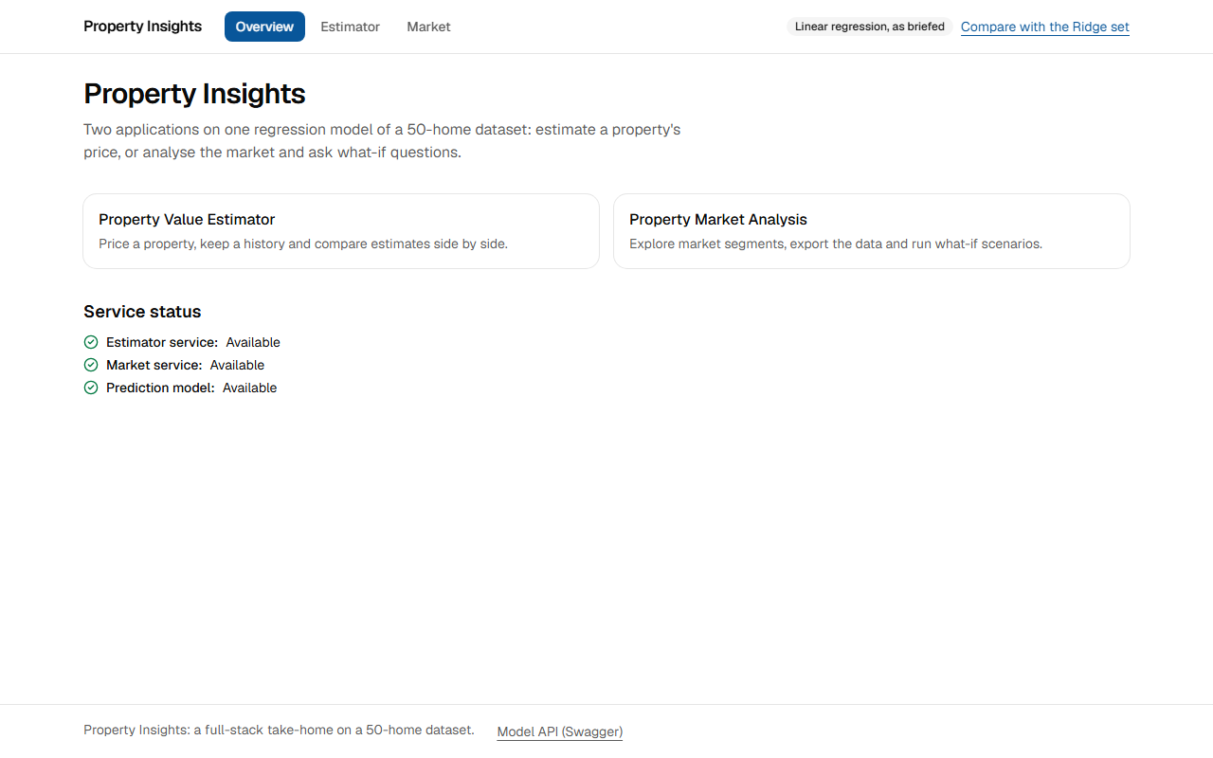
Figure 21. Home page: shared header and navigation, both apps, and live service status. Page: /
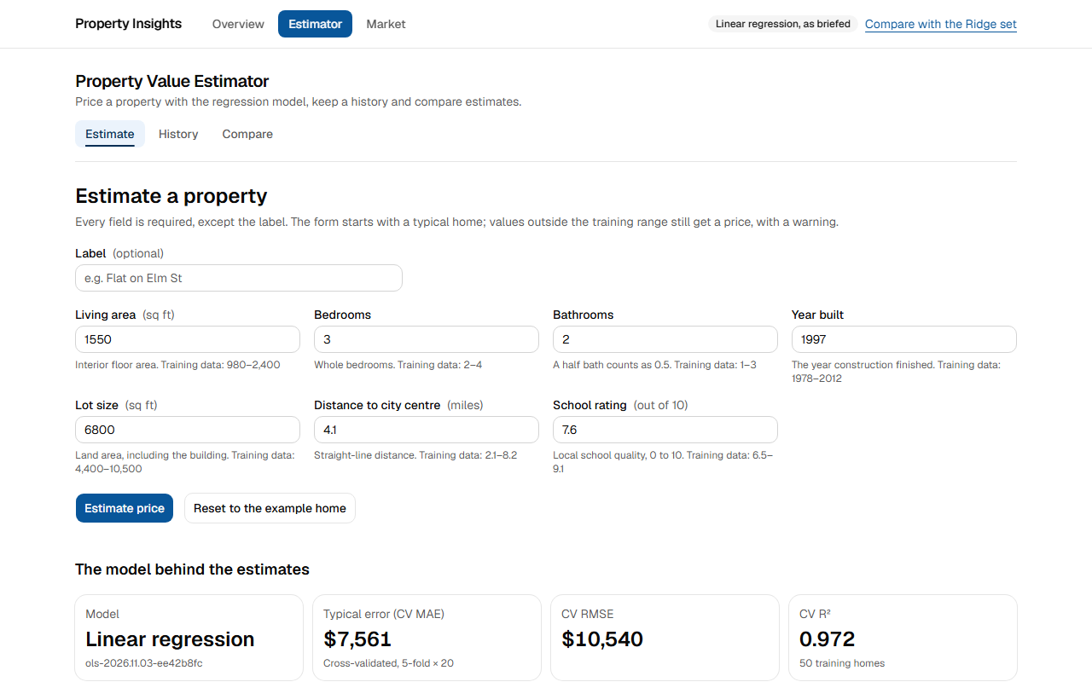
Figure 22. App 1 (Estimator) in the shared layout, with its own section navigation. Page: /estimator
Figure 23. App 2 (Market analysis) in the same layout and design system. Page: /market

5.3 State management and data flow

TR-3a: Implement appropriate client-side state management
Each kind of state has one home: the URL for anything worth sharing, a per-provider Zustand store with localStorage for the compare tray, TanStack Query for data fetched in the browser, Context for the current filters, useOptimistic for instant feedback, and useState for local UI.
ID | Test | Expected | Actual | Result
AC-36 | URL state survives a reload and can be shared | The same filters and sort load from the address alone | "Showing 1–10 of 15 homes.", aria-sort descending; after reload: "Showing 1–10 of 15 homes." | Pass
AC-37 | The compare tray stays in step across tabs | A change in one tab shows in another without a reload | second tab went from "Comparing 1 of 4" to "Comparing 2 of 4" | Pass
AC-38 | The compare tray survives a reload | Tray contents come back from localStorage after hydration | Comparing 2 of 4 after reload | Pass
AC-39 | Damaged stored state is dropped safely | Invalid localStorage content is ignored: no tray, no crash | tray shown: false; page errors: 0 | Pass
AC-34 | A filter change keeps the page on screen | The control updates at once (useOptimistic), old results stay dimmed, aria-busy is true | checkbox ticked: true; results opacity: 0.6; old results still shown: true; aria-busy: true | Pass
Unit | compare-tray.test.ts | The store adds, removes, prunes, and drops bad stored data | 4 of 4 passed | Pass
Unit | filters.test.ts | URL filters parse and round-trip | 10 of 10 passed | Pass

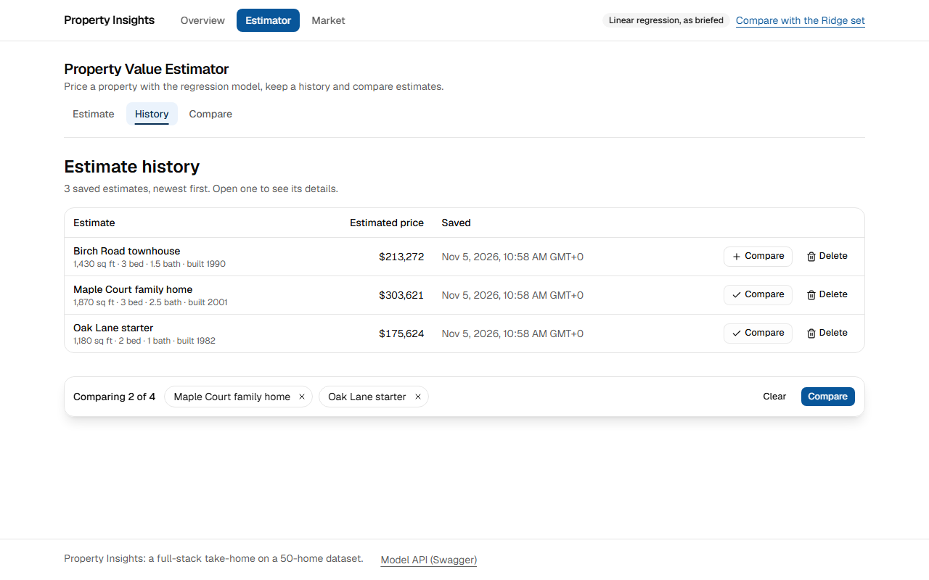
Figure 24. History with two estimates in the compare tray, restored from localStorage after a reload. Page: /estimator/history

TR-3b: Handle form state effectively with validation
React Hook Form with zodResolver, using one Zod schema in the browser and in the Server Action. Errors show inline and in a linked summary, focus moves to the first bad field, and server field errors land on the same fields. Defect D-2 lost a mouse click in one case in the first run; AC-69, AC-74 and the browser test below cover the fix.
ID | Test | Expected | Actual | Result
AC-40 | Invalid input is caught with useful messages | Blank, off-step and out-of-range values each get a message; nothing is sent | 3 fields need attention: "Enter the living area"; "Use steps of 0.5, such as 2 or 2.5"; "Enter at most 10 out of 10" | Pass
AC-41 | Errors are tied to their fields | Focus on the first bad field, aria-invalid set, the message linked with aria-describedby | focused: true; aria-invalid: true; aria-describedby: field-features-square_footage-hint field-features-square_footage-error | Pass
AC-42 | A server refusal lands on the form | The backend's 422 outside-model-domain becomes a plain message; the form keeps its values | alert shown; living area still 4100 | Pass
AC-69 | Clicking submit straight after typing a bad value | The first click submits: the error summary appears and focus moves | error summary shown: true; the button moved 1 px while pressed | Pass
AC-74 | Clicking Reset straight after typing a bad value | The first click resets the form | School rating back to 7.6 (it started at 7.6); the button moved 1 px while pressed | Pass
AC-70 | Clicking submit straight after correcting a value | The first click submits: the estimate is priced and saved | estimate saved: true; the button moved 1 px while pressed | Pass
E2E-03 | estimator.spec.ts: a click straight after typing a bad value isn't lost, though the field's message moves the buttons | The first click submits, or resets | All its assertions passed | Pass
E2E-02 | estimator.spec.ts: summarises invalid fields and moves focus to the first | Summary, focus and aria-invalid are all in place | All its assertions passed | Pass
Unit | schema.test.ts | The shared schema enforces each field's rule | 5 of 5 passed | Pass
Unit | action-result.test.ts | Server failures map to form fields or plain messages | 5 of 5 passed | Pass

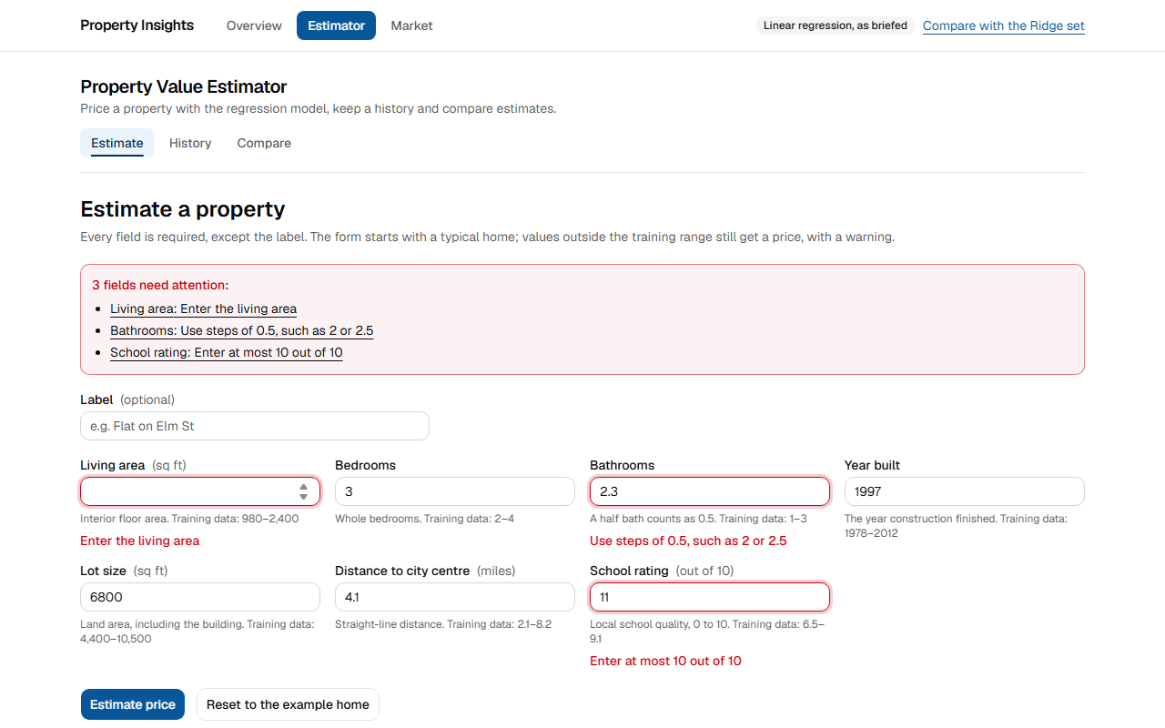
Figure 25. Failed submit: the summary links to each field, each field shows its message, and focus moves to the first. Page: /estimator
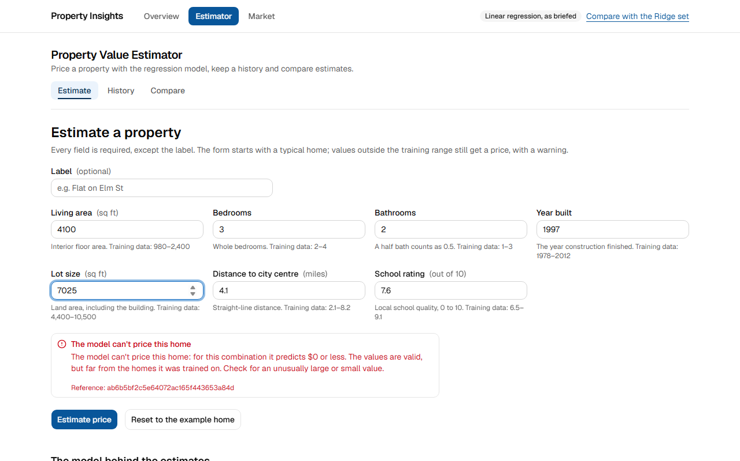
Figure 26. Valid values the model can't price: a form-level message, and nothing saved. Page: /estimator

TR-3c: Create efficient data fetching patterns
Server calls run in parallel with Promise.all and widgets stream separately. Slider moves are debounced by 300 ms, the browser's query cache is keyed by inputs, and the table sorts, searches and pages in the browser. market-api caches its own results, and the portal's data cache saves calls on top of that (D-1 records its fix).
ID | Test | Expected | Actual | Result
AC-43 | Slider moves are debounced | 6 quick key presses make 1 model request | 1 request(s) for 6 key presses | Pass
AC-44 | Going back to a scenario costs nothing | Returning to a priced scenario makes 0 requests (cached by its inputs) | 0 request(s) | Pass
AC-45 | Sort, paging and search need no server call | They work on the rows the page already has | 0 network requests for sort + next page + search | Pass
AC-09 | First load needs no client-side data fetch | 0 data calls from the browser on server-rendered pages, and no call reaches a backend directly | /market: 0 data calls, 0 backend calls; /market/data: 0 data calls, 0 backend calls; /estimator: 0 data calls, 0 backend calls; /estimator/history: 0 data calls, 0 backend calls | Pass
AC-46 | The page streams | The shell's first bytes come before the end of the response | first bytes at 285 ms (has <html>: true), complete at 303 ms, 102829 bytes | Pass
Unit | MarketControllerTest: repeated queries | market-api answers repeats from its cache | 1 of 1 passed | Pass
Unit | WhatIfControllerTest: repeated what-ifs | market-api answers repeats from its cache | 1 of 1 passed | Pass
AC-25 | The portal's data cache saves backend calls | Pages reloaded within the cache's life (5 minutes for aggregates, 10 for model info) make no new calls to market-api | After 5 loads of /market/data and 3 of /market/what-if (each already loaded once): 0 calls for filter options, 0 for properties, 0 for model info; the fetch cache grew by 0 entries | Pass
AC-73 | The estimator's model info comes from the data cache | Reloading /estimator within the hour makes no new calls to estimator-api | 3 more loads of /estimator: 0 new model-info calls in estimator-api's log (6 before) | Pass
E2E-18 | market.spec.ts: reloading the page reuses the portal's data cache instead of calling market-api again | Three reloads make no new calls to market-api | All its assertions passed | Pass

TR-3d: Properly manage API communication and error states
One server-only client adds a request ID and a timeout, and turns every failure into a typed ApiError carrying problem+json. Route Handlers validate bodies and pass problems on, Server Actions return typed results instead of throwing, and retries cover only 5xx and 429, once. The model-down cases stopped the real ml-api container.
ID | Test | Expected | Actual | Result
AC-47 | Errors are problem+json with a request ID | Invalid input answers with application/problem+json and an X-Request-ID header | HTTP 422, application/problem+json, X-Request-ID present: true, request_id in body: true | Pass
AC-48 | Route Handlers refuse bad bodies in the same format | 400 problem+json from the portal, before any backend call | HTTP 400, application/problem+json, detail: "The body must be JSON" | Pass
AC-49 | A failed export is reported in place | The page stays put and shows the failure's detail | alert reads "The export didn't download", then "The market service can't be reached" | Pass
AC-50 | With the model down, what-if says so | The page still opens from market-api's data; the price area shows a message and Try again | message and Try again shown; sliders still present | Pass
AC-52 | A failed estimate saves nothing | Clear message with a reference; history still opens; the total doesn't change | history opens: true; saved total 4 | Pass
AC-53 | What-if recovers when the model returns | A fresh load prices the home again | price shown | Pass
AC-27 | A widget's Try again recovers it | With the fault removed, Try again re-fetches that widget on the server | headline figures back; 0 widget errors left | Pass
AC-30 | estimator app recovers when its backend returns | A reload shows the app with no error | no error panel: true | Pass
AC-31 | market app recovers when its backend returns | A reload shows the app with no error | no error panel: true | Pass
Unit | client.test.ts | The wrapper maps each failure to a typed problem | 8 of 8 passed | Pass
Unit | action-result.test.ts | Each backend failure becomes the right form result | 5 of 5 passed | Pass
E2E-04 | estimator.spec.ts: says when the model can't price a home | A model refusal shows a plain message | All its assertions passed | Pass
E2E-22 | market.spec.ts: the Route Handler checks bodies against the model's limits | An out-of-limits body gets a 400 naming the field | All its assertions passed | Pass

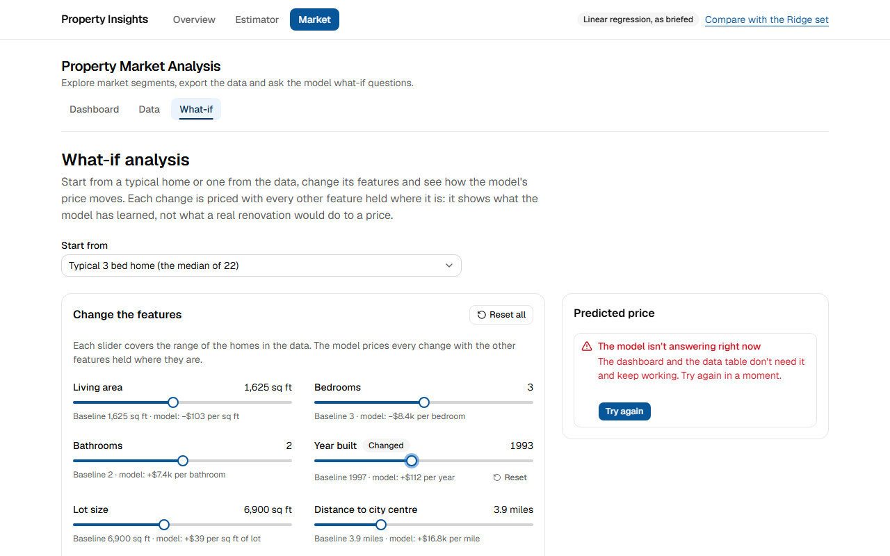
Figure 27. ml-api stopped: the what-if page stays usable, and says the model isn't answering, with Try again. Page: /market/what-if?baseline=typical-3
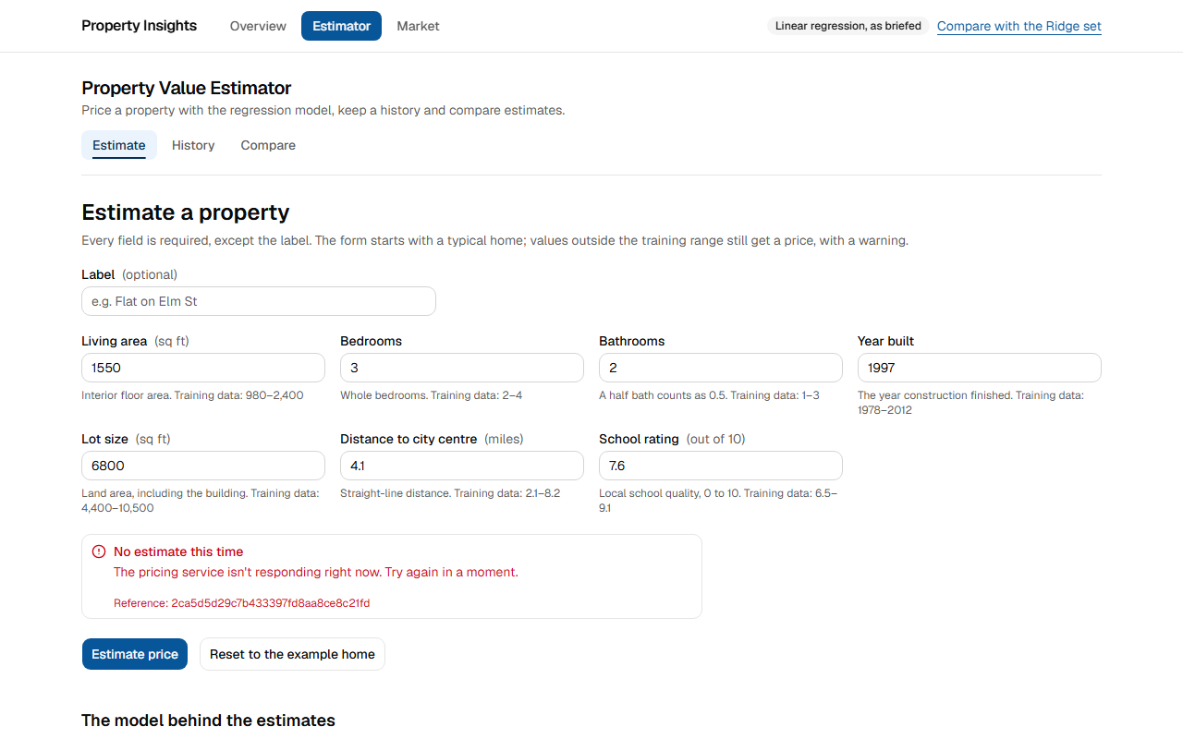
Figure 28. ml-api stopped: the estimator says the pricing service isn't responding, with a reference to quote, and saves nothing. Page: /estimator
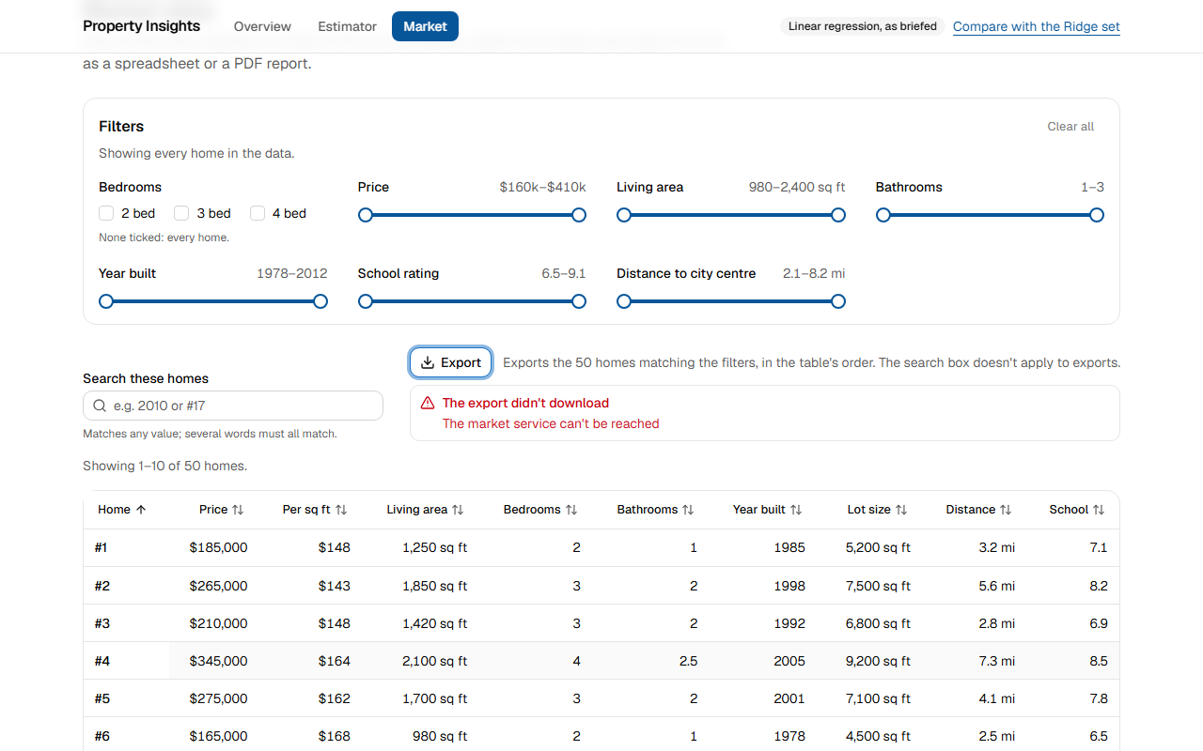
Figure 29. A failed export shows the service's reason on the page, instead of leaving it. Page: /market/data

5.4 Code quality and organisation

TR-4a: Structure the codebase following Next.js best practices
Thin route files, feature folders for each app, a server-only API layer, and shared code in components, hooks and lib. An ESLint rule rejects imports from one app into the other. The lint probe below fed ESLint a cross-app import to confirm that the rule really fires.
ID | Test | Expected | Actual | Result
AC-54 | A lint rule keeps the two apps apart | ESLint refuses cross-app imports and allows an app's own | estimator importing market code refused: true; market importing the estimator API refused: true; market importing its own API allowed: true | Pass
AC-55 | Route files stay thin | Pages only fetch and compose: under 100 lines each, with the logic in features/ | 8 pages, longest 96 lines | Pass
AC-56 | The expected folders exist and hold code | Routes, shared UI, feature folders, hooks, API layer, stores and tests each have their own place | src/app 32, src/components/ui 12, src/components/layout 7, src/components/form 2, src/features/estimator 21, src/features/market 23, src/hooks 6, src/lib/api 10, src/stores 2, e2e 6 | Pass
ST-04 | portal: ESLint on the whole project | Exit code 0 | Exit code 0, no findings | Pass
ST-05 | portal: TypeScript type check | Exit code 0 | Exit code 0, no errors | Pass

Folder in portal/ | What it holds | Files
src/app | Routes only: pages, layouts, loading, error, not-found and Route Handlers | 32
src/components/ui | The design system's primitives (shadcn/ui on Radix) | 12
src/components/layout | Header, navigation, section headers, error panel | 7
src/components/form | Number field and error summary | 2
src/features/estimator | App 1's components, hooks, schema and Server Actions | 21
src/features/market | App 2's components, hooks, filters and models | 23
src/hooks | Hooks both apps share | 6
src/lib/api | The server-only API layer, and the browser's small client | 10
src/stores | The compare tray's Zustand store | 2
e2e | Playwright specs | 6

6. Functional requirements: test cases and evidence

6.1 Task 1: the model API

T1-1: predict accepts housing features and returns price predictions, single and batch
ID | Test | Expected | Actual | Result
AC-58 | Batch predicts the 10 rows of the provided test file | 10 predictions, in input order, with warnings on rows 6 and 8 | HTTP 200, 10 predictions; warnings on rows 6, 8 | Pass
SM-03 | POST /predict on the brief set returns the expected price | The status and value CI's compose job checks for | HTTP 200, contains "predicted_price":250879.73 | Pass
SM-04 | POST /predict on the Ridge set returns the expected price | The status and value CI's compose job checks for | HTTP 200, contains "predicted_price":250932.28 | Pass
Unit | test_api.py: predict | A known home gets the documented price | 2 of 2 passed | Pass
Unit | test_api.py: batch | Order kept, warnings correct, same as single | 2 of 2 passed | Pass
Unit | test_api.py: input validation | Bad fields are listed by name | 22 of 22 passed | Pass

The 10 rows of the provided test file, sent through POST /predict/batch on each set during this run:
Home | Living area | Beds | Baths | Built | Brief set | Ridge set | Warnings on the brief set
1 | 1,550 sq ft | 3 | 2 | 1997 | $250,880 | $250,932 | None
2 | 2,200 sq ft | 4 | 2.5 | 2008 | $364,552 | $359,868 | None
3 | 1,180 sq ft | 2 | 1 | 1982 | $175,624 | $169,243 | None
4 | 1,870 sq ft | 3 | 2.5 | 2001 | $303,621 | $304,654 | None
5 | 1,430 sq ft | 3 | 1.5 | 1990 | $213,272 | $217,619 | None
6 | 2,300 sq ft | 4 | 3 | 2013 | $411,285 | $395,928 | Outside training range: year_built, school_rating
7 | 1,650 sq ft | 3 | 2 | 1999 | $258,496 | $260,407 | None
8 | 1,020 sq ft | 2 | 1 | 1979 | $151,627 | $150,085 | Outside training range: distance_to_city_center
9 | 2,100 sq ft | 4 | 2.5 | 2005 | $351,212 | $348,185 | None
10 | 1,350 sq ft | 3 | 1 | 1988 | $190,339 | $197,014 | None

T1-2: model-info returns model coefficients and performance metrics
ID | Test | Expected | Actual | Result
AC-59 | model-info returns coefficients and metrics | 7 coefficients, cross-validated R², RMSE and MAE | 7 coefficients; CV R² 0.972, RMSE 10540, MAE 7561 | Pass
Unit | test_api.py: model-info | The shape is right for each model kind | 2 of 2 passed | Pass
Unit | test_training.py: training | Coefficients match the analysis, and training is repeatable | 4 of 4 passed | Pass

Read from each running ml-api during this run:
Coefficient or metric | Per | Brief set | Ridge set
Living area | sq ft | −$103 | +$18.73
Bedrooms | count | −$8,448 | +$6,169
Bathrooms | count | +$7,437 | +$16,917
Year built | year | +$112 | +$91.79
Lot size | sq ft | +$39.30 | +$9.29
Distance to city centre | miles | +$16,810 | +$11,880
School rating | 0-10 scale | +$21,062 | +$17,214
Cross-validated R² |  | 0.972 | 0.976
Cross-validated RMSE |  | $10,540 | $10,922
Cross-validated MAE |  | $7,561 | $9,618

T1-3: health is a simple health check endpoint
ID | Test | Expected | Actual | Result
AC-60 | health reports the loaded model | 200 with status and model version | status ok; model loaded: true; version ols-2026.11.03-ee42b8fc | Pass
SM-01 | Brief Host reaches the OLS model | The status and value CI's compose job checks for | HTTP 200, contains "model_version":"ols- | Pass
SM-02 | Ridge Host reaches the Ridge model | The status and value CI's compose job checks for | HTTP 200, contains "model_version":"ridge- | Pass
Unit | test_api.py: health | 200 with a model, unavailable without one | 3 of 3 passed | Pass

T1-4: Python 3.12+, FastAPI, scikit-learn
ID | Test | Expected | Actual | Result
AC-61 | Python, FastAPI and scikit-learn as the brief asks | Python 3.12+, FastAPI, scikit-learn | ml-api: Python 3.12.16, FastAPI 0.162.0, scikit-learn 1.9.1; estimator-api: 3.12.16 0.162.0 | Pass

T1-5: Build, containerise and deploy a regression model
ID | Test | Expected | Actual | Result
ST-09 | Both model sets build and start healthy | Exit code 0 | 9 containers healthy in 42 s (with Docker's build cache) | Pass
AC-71 | The public demo answers | Both public hostnames serve their own model | hsbc.loming.com: HTTP 200, ols-2026.11.03-ee42b8fc; hsbc-ridge.loming.com: HTTP 200, ridge-2026.11.03-ee42b8fc | Pass
Unit | test_training.py: bad data | Training refuses bad datasets | 5 of 5 passed | Pass

T1-6: Source on GitHub, a Dockerfile, and live through Swagger/OpenAPI
ID | Test | Expected | Actual | Result
AC-57 | ml-api offers the four endpoints in Swagger | /predict, /predict/batch, /model-info and /health in the OpenAPI document | /predict, /predict/batch, /model-info, /health | Pass
SM-05 | ml-api Swagger UI is served behind the /ml-api prefix | The status and value CI's compose job checks for | HTTP 200, contains /ml-api/openapi.json | Pass
SM-06 | ml-api OpenAPI document names the /ml-api server | The status and value CI's compose job checks for | HTTP 200, contains "servers":[{"url":"/ml-api"}] | Pass
AC-72 | Source is on GitHub and CI passes on main | A GitHub repository whose latest CI run on main succeeded | loming/property-insights (private); latest CI on main: success, commit 8b0a250, 2026-11-05 | Pass
Unit | test_api.py: OpenAPI | The document lists the brief's endpoints | 3 of 3 passed | Pass

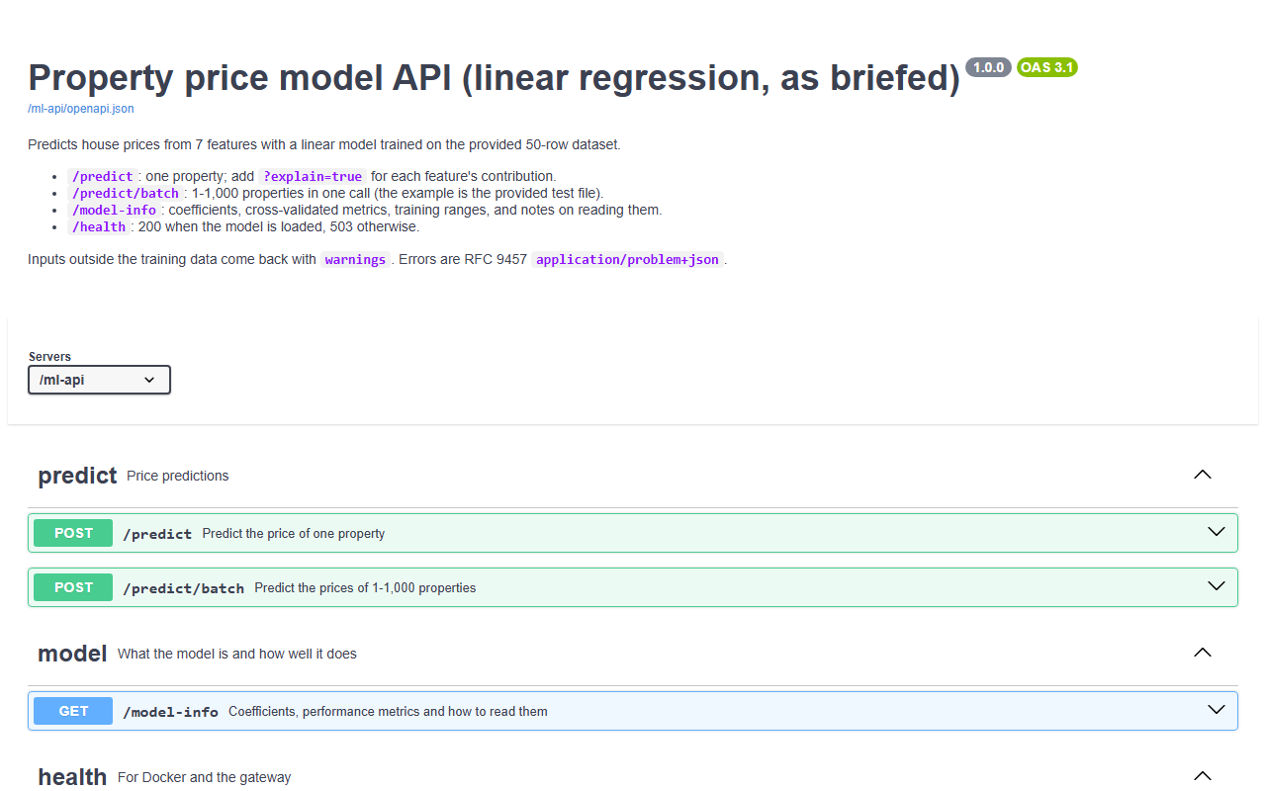
Figure 30. Task 1: ml-api's live Swagger UI behind the gateway. Page: /ml-api/docs

6.2 Task 2: the portal

P-0: Two independent applications with different backends, both able to use the model
ID | Test | Expected | Actual | Result
E2E-39 | resilience.spec.ts, with estimator-api stopped | With estimator-api down, the market app still works | All its assertions passed | Pass
E2E-40 | resilience.spec.ts, with market-api stopped | With market-api down, the estimator still works | All its assertions passed | Pass
AC-51 | The dashboard doesn't need the model | /market loads fully with ml-api stopped | dashboard loaded | Pass
AC-54 | A lint rule keeps the two apps apart | ESLint refuses cross-app imports and allows an app's own | estimator importing market code refused: true; market importing the estimator API refused: true; market importing its own API allowed: true | Pass
SM-08 | Brief estimator saves with the OLS model | The status and value CI's compose job checks for | HTTP 201, contains "model_version":"ols- | Pass
SM-15 | Brief what-if: +500 sq ft moves the price by -51,458.20 | The status and value CI's compose job checks for | HTTP 200, contains "delta":-51458.2 | Pass

P-1: A shared layout with navigation between applications
ID | Test | Expected | Actual | Result
E2E-25 | shell.spec.ts: overview links both apps and reports the services | Both apps are linked, and the status is live | All its assertions passed | Pass
E2E-27 | shell.spec.ts: navigation between and within the apps marks the current page | Navigation works, and the current page is marked | All its assertions passed | Pass

P-2: Next.js App Router for routing between and within applications
ID | Test | Expected | Actual | Result
AC-01 | All routes use the App Router | src/app holds the routes; no src/pages or pages folder | src/app has 8 pages, 3 layouts, 4 route handlers; pages folder present: false | Pass
E2E-27 | shell.spec.ts: navigation between and within the apps marks the current page | Links move between and within the apps | All its assertions passed | Pass

P-3: A consistent design system across both applications
ID | Test | Expected | Actual | Result
AC-35 | Both apps share one design system | The same font, tokens, heading size, header and content width on both apps | Identical on both apps: font Geist, the same primary colour and radius tokens, h1 24px, header 57 px, content width 1152 px | Pass

P-4: Loading and error states handled at the layout level
ID | Test | Expected | Actual | Result
AC-22 | A route shows a skeleton while it loads | market/loading.tsx appears at once with a status message | status text: "Loading the market analysis" | Pass
AC-28 | With estimator-api down, only its app is affected | Its own error panel with Try again; navigation and the other app keep working | error panel shown, navigation visible: true, other app clean: true | Pass
AC-29 | With market-api down, only its app is affected | Its own error panel with Try again; navigation and the other app keep working | error panel shown, navigation visible: true, other app clean: true | Pass
AC-24 | Unknown addresses get a not-found page | HTTP 404 with the page-not-found heading | HTTP 404, heading visible: true | Pass

6.3 App 1: Property Value Estimator (Python backend)

E-1: A form for property details: all fields from the model
ID | Test | Expected | Actual | Result
E2E-01 | estimator.spec.ts: prices the example home, shows the result and saves it to the history | The form prices a home and saves it | All its assertions passed | Pass
AC-07 | /estimator arrives with the model's training ranges | The form's hints carry the training range from the server | "Training data:" in HTML: true; model version present: true | Pass

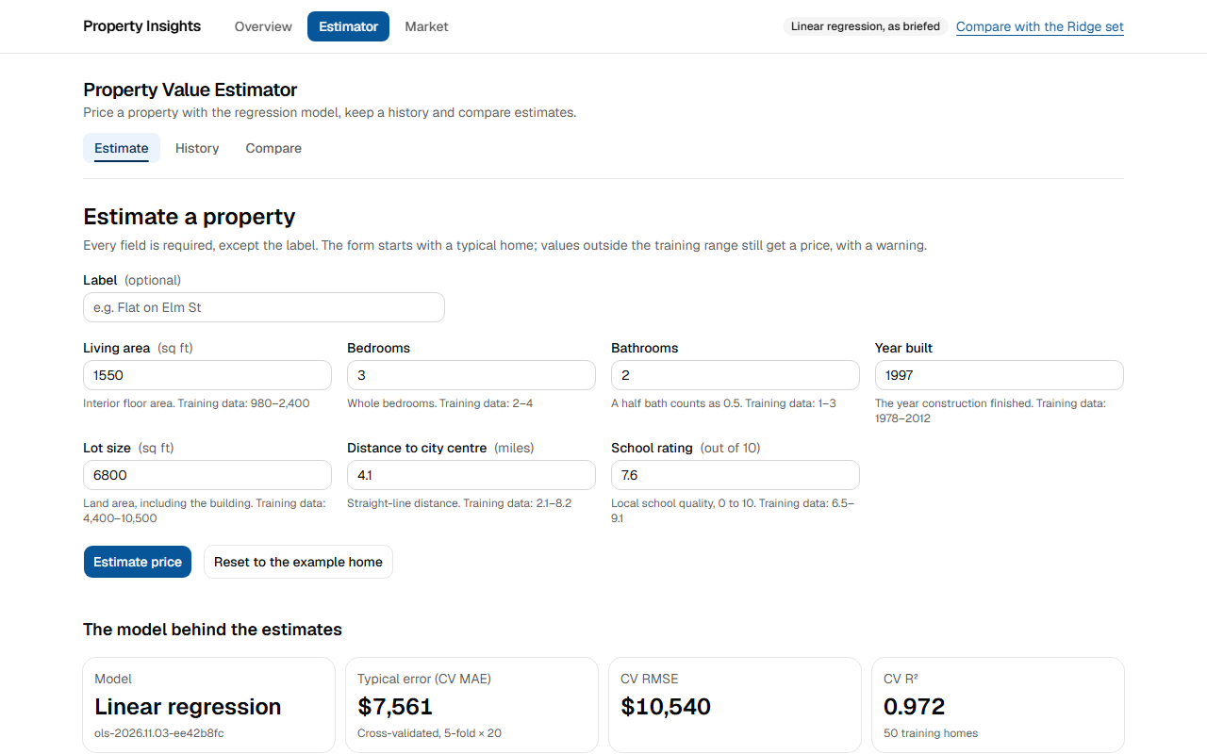
Figure 31. The form opens with a typical home; each field's hint carries the model's training range. Page: /estimator

E-2: Client-side validation with appropriate error messages
ID | Test | Expected | Actual | Result
E2E-02 | estimator.spec.ts: summarises invalid fields and moves focus to the first | Messages say what to enter | All its assertions passed | Pass
AC-40 | Invalid input is caught with useful messages | Blank, off-step and out-of-range values each get a message; nothing is sent | 3 fields need attention: "Enter the living area"; "Use steps of 0.5, such as 2 or 2.5"; "Enter at most 10 out of 10" | Pass
Unit | schema.test.ts | Each field's rule | 5 of 5 passed | Pass

E-3: Prediction results as a table and a chart
ID | Test | Expected | Actual | Result
E2E-01 | estimator.spec.ts: prices the example home, shows the result and saves it to the history | A price, a table and a chart | All its assertions passed | Pass
E2E-05 | estimator.spec.ts: the Ridge set prices the same home and shows what moves the estimate | The Ridge set adds the contribution chart | All its assertions passed | Pass

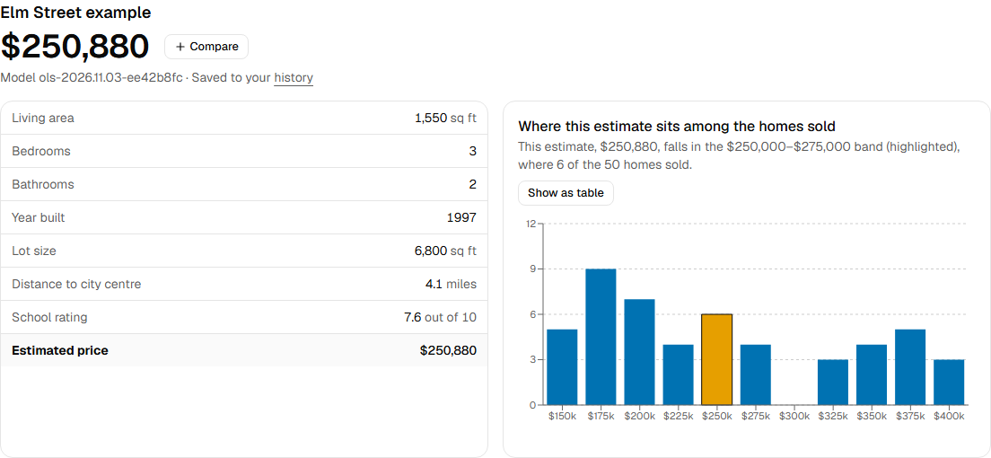
Figure 32. The result: the price, the inputs as a table, and a chart of where the price sits among the 50 sales. Page: /estimator
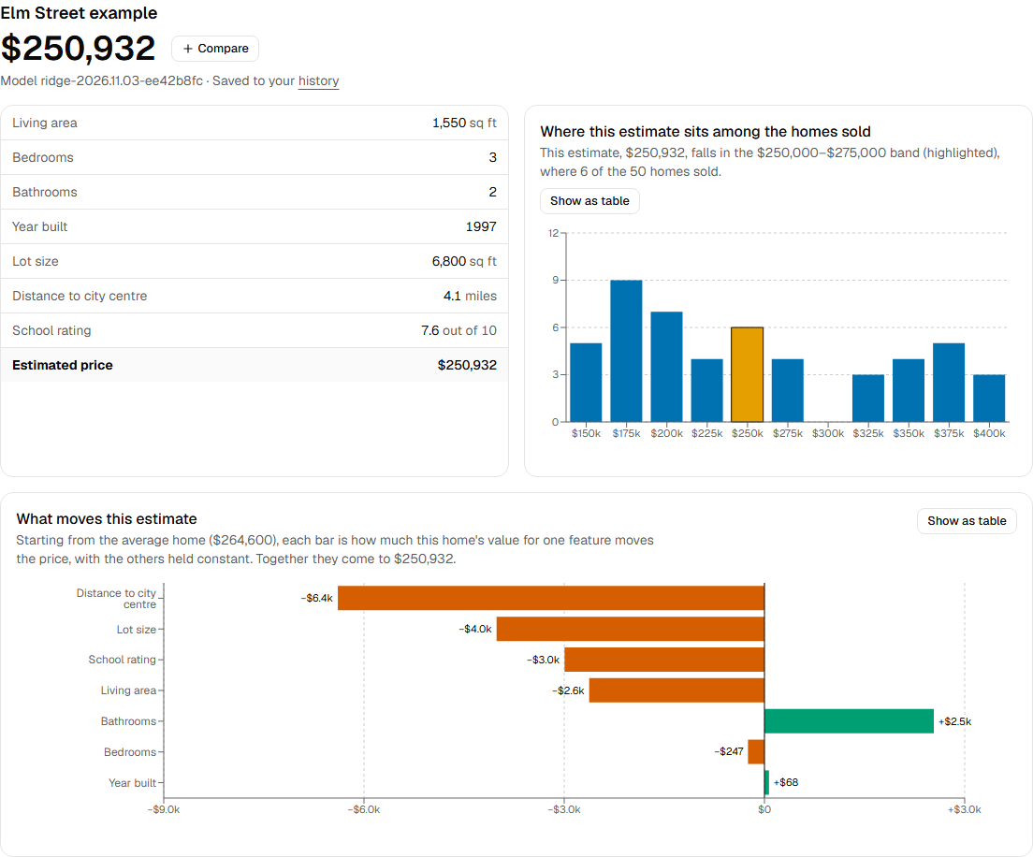
Figure 33. Ridge set: the same home, with what each feature adds to or takes from the price. Page: Ridge set, /estimator

E-4: A history of previous estimates
ID | Test | Expected | Actual | Result
AC-11 | The saved estimate shows at once (no stale cache) | History is never cached: the new estimate is on the next load | 1 row found for the new label | Pass
E2E-06 | estimator.spec.ts: a saved estimate has its own page; an unknown id gets the not-found page | Each estimate has its own page | All its assertions passed | Pass
E2E-09 | keyboard.spec.ts: history: delete asks first, Escape keeps the estimate, and focus stays in the table | Delete asks first | All its assertions passed | Pass
Unit | test_estimates.py: history | Newest first, paged, survives a restart | 5 of 5 passed | Pass

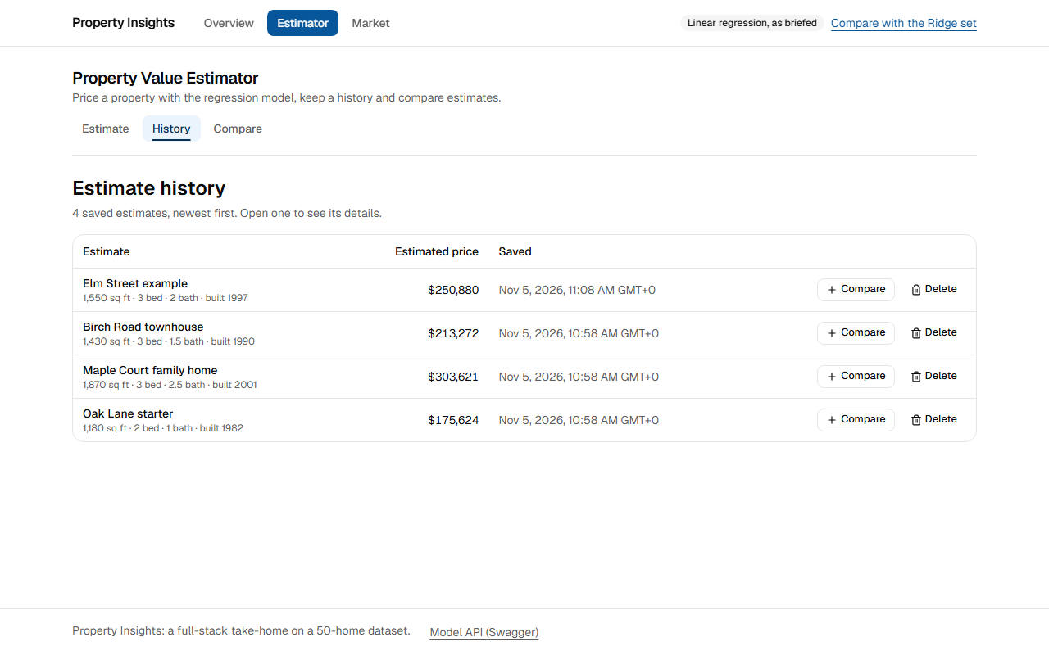
Figure 34. History: every saved estimate, newest first, each with Compare and Delete. Page: /estimator/history

E-5: A comparison view for several properties side by side
ID | Test | Expected | Actual | Result
E2E-07 | estimator.spec.ts: compares two saved estimates, then deletes one | Side by side, with highest and lowest marked; a deleted estimate is reported | All its assertions passed | Pass
AC-37 | The compare tray stays in step across tabs | A change in one tab shows in another without a reload | second tab went from "Comparing 1 of 4" to "Comparing 2 of 4" | Pass
Unit | test_estimates.py: compare | Order kept, missing ids reported | 2 of 2 passed | Pass
Unit | compare-ids.test.ts | Ids in the URL parse safely | 4 of 4 passed | Pass

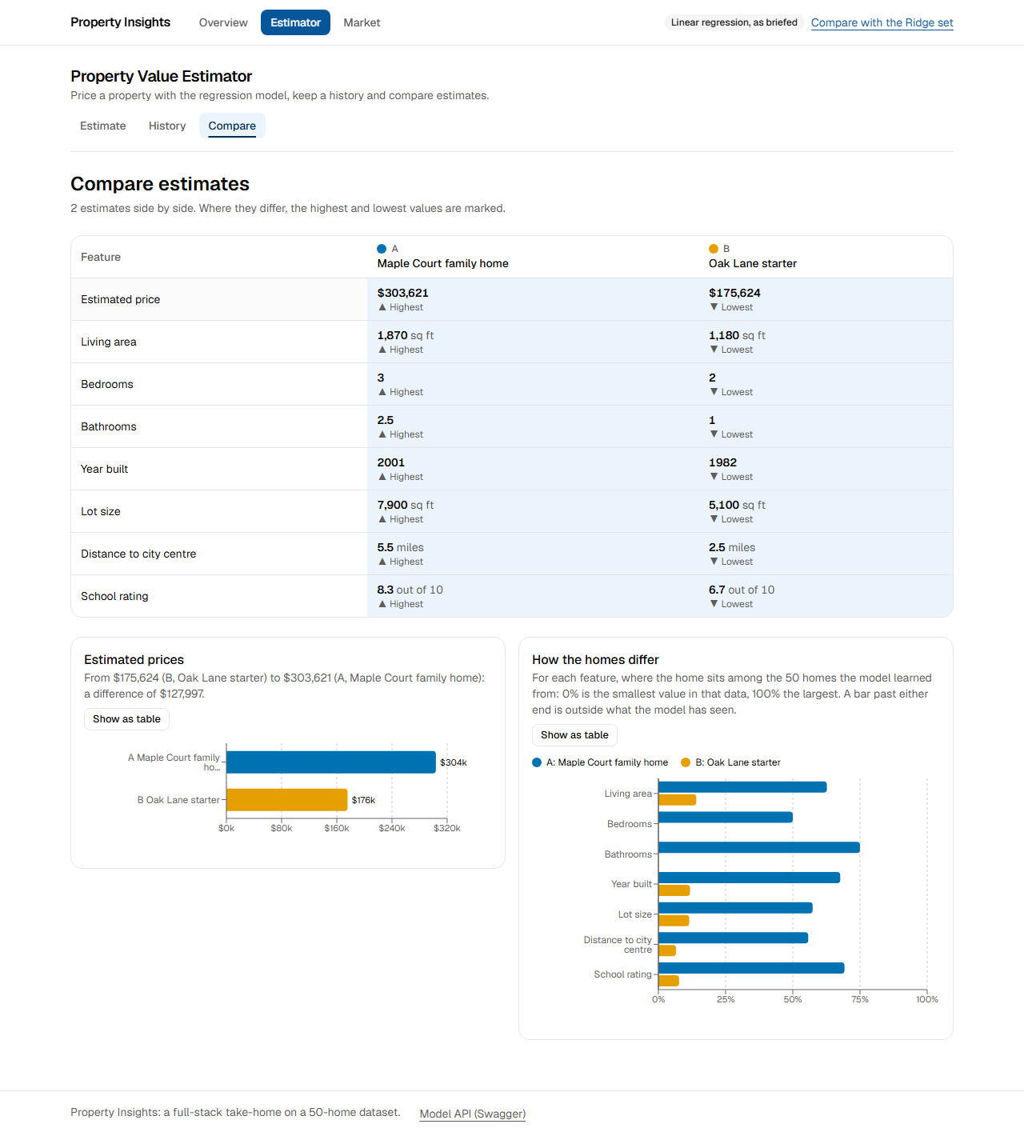
Figure 35. Side-by-side comparison: highest and lowest marked in each row, with the prices and features charted. Page: /estimator/compare?ids=e65c51de-6d07-4fae-a449-830271c62f5d&ids=220e72a1-b97b-403e-80fa-91910d98ac9f

E-6: The Python backend handles form submissions
ID | Test | Expected | Actual | Result
AC-10 | A write goes through a Server Action | Submitting the form POSTs to the page with a Next-Action header | POST /estimator with Next-Action | Pass
SM-08 | Brief estimator saves with the OLS model | The status and value CI's compose job checks for | HTTP 201, contains "model_version":"ols- | Pass
Unit | test_estimates.py: create | Prices through the model and saves | 2 of 2 passed | Pass

E-7: Integrates with the regression model container
ID | Test | Expected | Actual | Result
SM-08 | Brief estimator saves with the OLS model | The status and value CI's compose job checks for | HTTP 201, contains "model_version":"ols- | Pass
SM-09 | Ridge estimator saves with the Ridge model | The status and value CI's compose job checks for | HTTP 201, contains "model_version":"ridge- | Pass
SM-10 | Each set keeps its own history (brief total is 1) | The status and value CI's compose job checks for | HTTP 200, contains "total":1 | Pass
Unit | test_estimates.py: model failures | Each failure maps to a problem, and nothing is saved | 8 of 8 passed | Pass

E-8: Data validation and error handling
ID | Test | Expected | Actual | Result
AC-52 | A failed estimate saves nothing | Clear message with a reference; history still opens; the total doesn't change | history opens: true; saved total 4 | Pass
Unit | test_estimates.py: invalid input | Rejected before any model call | 9 of 9 passed | Pass
Unit | test_system.py: feature limits | The limits match ml-api's | 1 of 1 passed | Pass
Unit | test_system.py: errors | Errors are problems, without internals | 3 of 3 passed | Pass

6.4 App 2: Property Market Analysis (Java backend)

M-1: An interactive dashboard with property market visualisations
ID | Test | Expected | Actual | Result
E2E-14 | market.spec.ts: a shared link's filters apply to the controls and every widget | Every widget reflects the link's filters | All its assertions passed | Pass
E2E-16 | market.spec.ts: says when no home matches | An empty result is explained | All its assertions passed | Pass
AC-06 | /market arrives with its figures in the HTML | KPI labels and chart titles are in the server's HTML | Median price: true; Price against living area: true | Pass

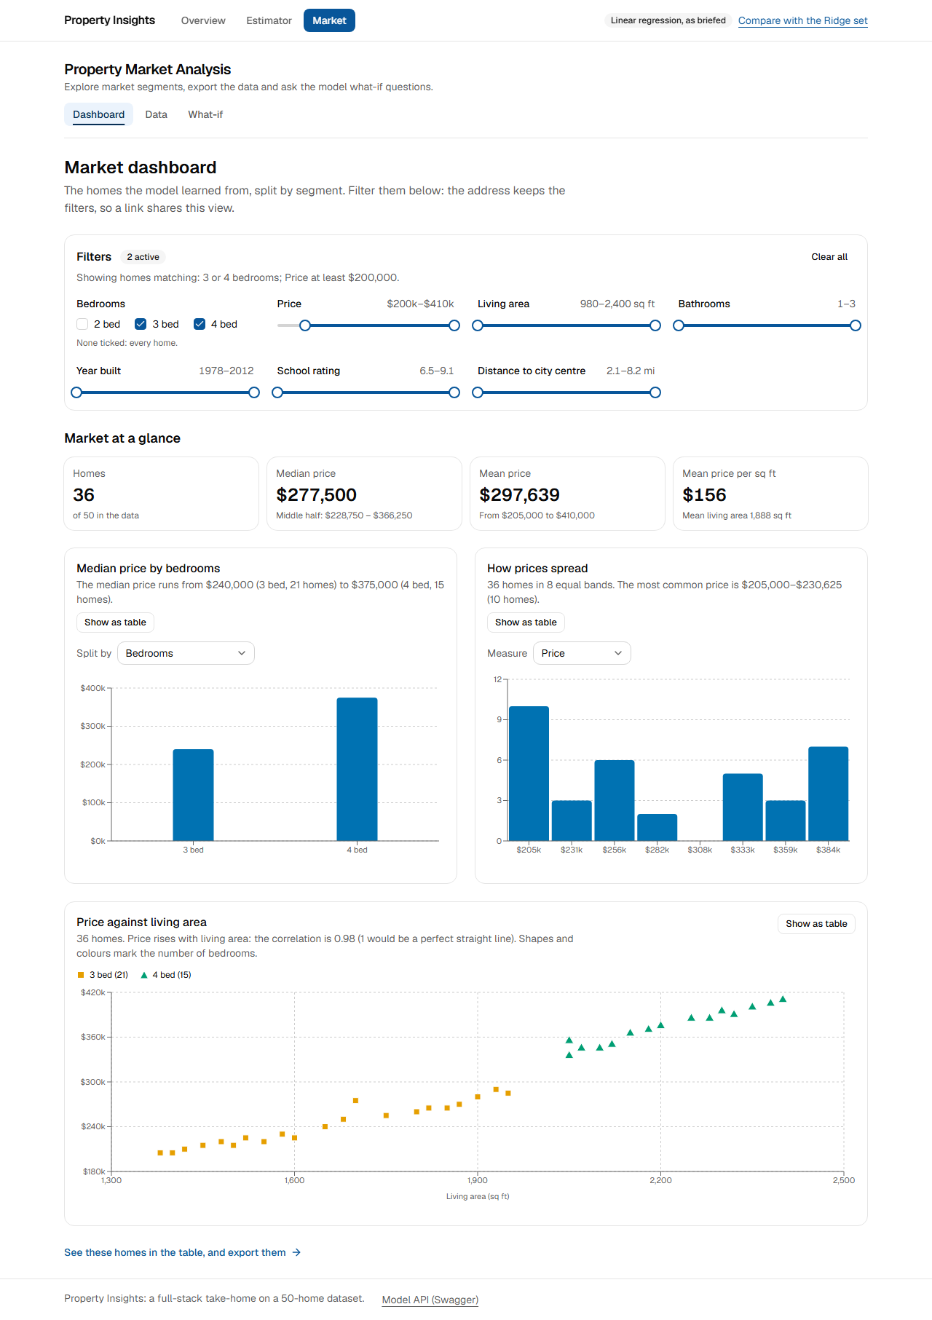
Figure 36. Dashboard with filters from a shared link: 3 and 4 bed, at least $200,000. Page: /market?bedrooms=3&bedrooms=4&min_price=200000

M-2: Filters for analysing different property segments
ID | Test | Expected | Actual | Result
E2E-15 | market.spec.ts: the filter bar rewrites the URL, keeps focus, and clears | The URL changes, focus stays, and Clear works | All its assertions passed | Pass
AC-36 | URL state survives a reload and can be shared | The same filters and sort load from the address alone | "Showing 1–10 of 15 homes.", aria-sort descending; after reload: "Showing 1–10 of 15 homes." | Pass
Unit | filters.test.ts | Filters parse, and bad values drop | 10 of 10 passed | Pass
Unit | MarketFilterTest | Bounds are inclusive; invalid values rejected | 4 of 4 passed | Pass

M-3: A what-if analysis tool using the model
ID | Test | Expected | Actual | Result
E2E-21 | market.spec.ts: prices a change with the other features held constant, and explains it | The change is priced and explained | All its assertions passed | Pass
E2E-23 | market.spec.ts: the Ridge set adds the sensitivity line | The Ridge set draws the price across a feature's range | All its assertions passed | Pass
SM-15 | Brief what-if: +500 sq ft moves the price by -51,458.20 | The status and value CI's compose job checks for | HTTP 200, contains "delta":-51458.2 | Pass
SM-16 | Ridge what-if uses the Ridge model | The status and value CI's compose job checks for | HTTP 200, contains "model_version":"ridge- | Pass
Unit | what-if-model.test.ts | The arithmetic adds up | 6 of 6 passed | Pass
Unit | WhatIfControllerTest | One model call, cached; refusals and outages handled | 8 of 8 passed | Pass

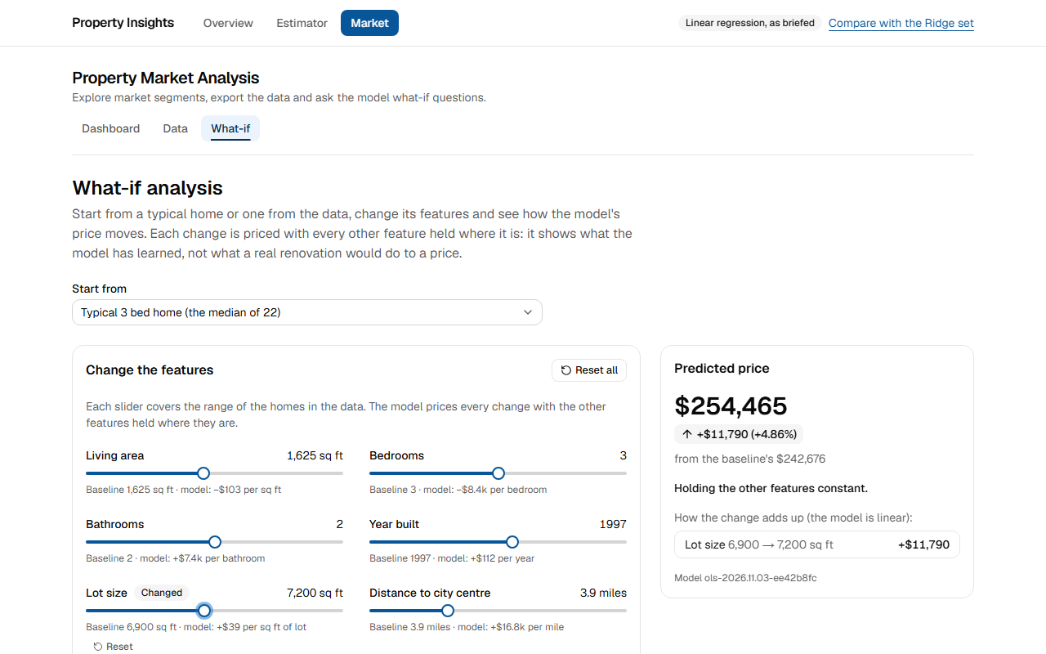
Figure 37. What-if on the brief set: the changed price, with the change added up from each coefficient. Page: /market/what-if?baseline=typical-3
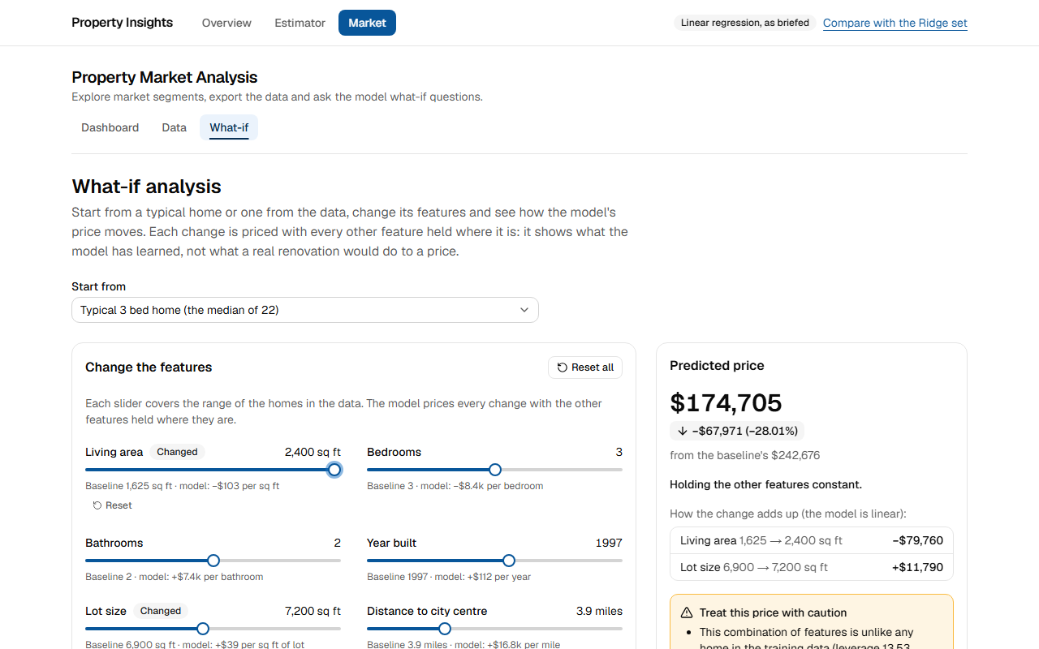
Figure 38. Living area pushed to its maximum: the price falls, and the page warns and explains why. Page: /market/what-if?baseline=typical-3
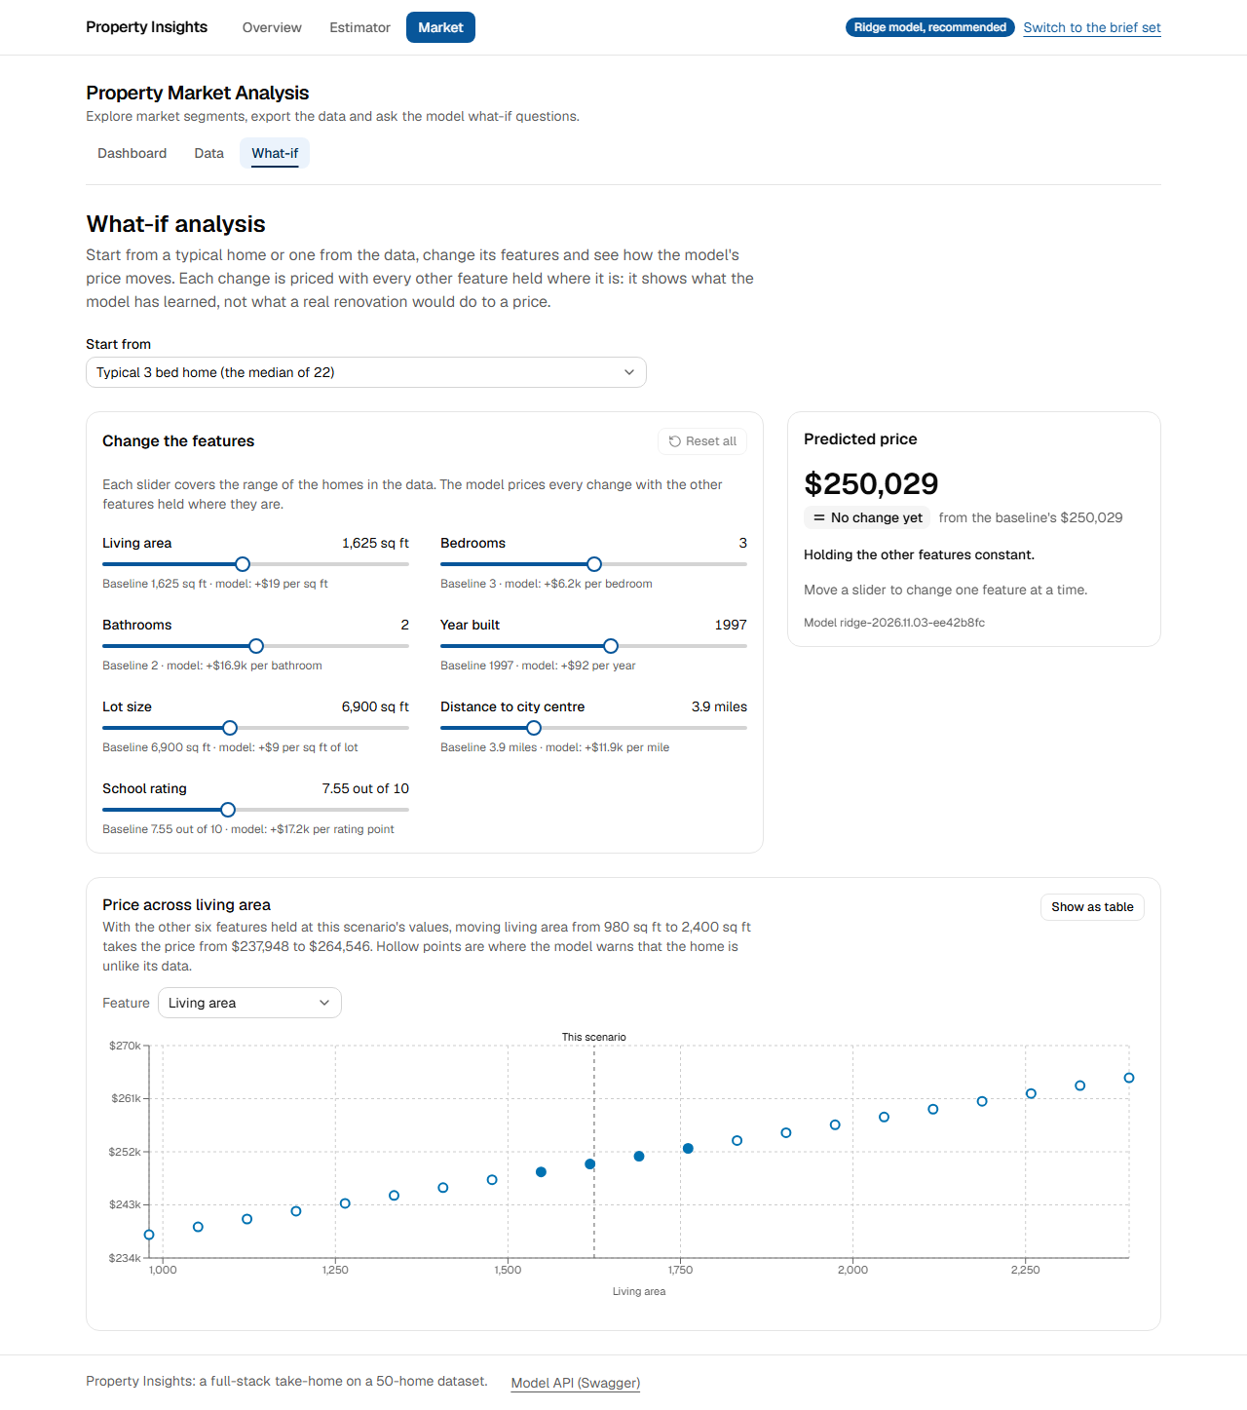
Figure 39. Ridge set: what-if with the line of the price across one feature's range. Page: Ridge set, /market/what-if?baseline=typical-3

M-4: Data export options: CSV and PDF
ID | Test | Expected | Actual | Result
AC-67 | CSV and PDF exports download | The filtered homes, in the table's order, under dated file names | property-market-2026-11-05.csv: 15 rows, first price row "7,2400,4,3.0,2010,10500,8.2,9.0,410000,170.83"; property-market-2026-11-05.pdf: starts %PDF-, 2922 bytes | Pass
E2E-17 | market.spec.ts: sorts, pages and searches the filtered homes, and exports them in that order | The CSV holds the filtered homes in the table's order | All its assertions passed | Pass
E2E-19 | market.spec.ts: the export Route Handler streams the PDF and refuses unknown formats | A real PDF, and 404 for unknown formats | All its assertions passed | Pass
Unit | ExportControllerTest | CSV rows, PDF bytes, filters described | 5 of 5 passed | Pass
SM-18 | market-api PDF export answers | The status and value CI's compose job checks for | HTTP 200 | Pass

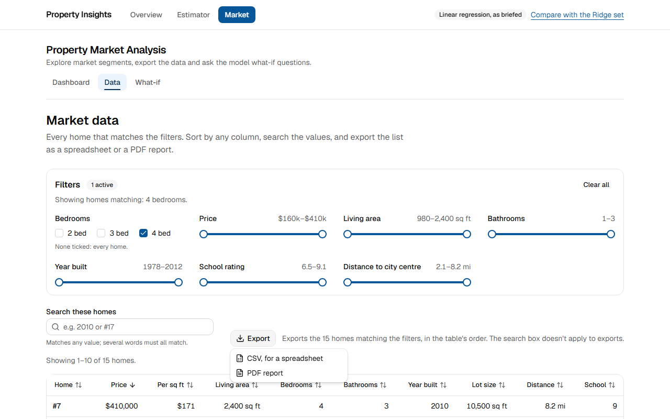
Figure 40. Data table filtered to 4 bed, sorted by price, with the export menu open. Page: /market/data?bedrooms=4&sort=price,desc

M-5: Responsive data tables with sorting and filtering
ID | Test | Expected | Actual | Result
E2E-17 | market.spec.ts: sorts, pages and searches the filtered homes, and exports them in that order | Sort, page and search work | All its assertions passed | Pass
E2E-20 | market.spec.ts: fits a phone: the table scrolls inside its box | It scrolls inside its box at 375 px | All its assertions passed | Pass
AC-45 | Sort, paging and search need no server call | They work on the rows the page already has | 0 network requests for sort + next page + search | Pass
Unit | property-table-model.test.ts | Sort, search and paging logic | 6 of 6 passed | Pass

M-6: REST API endpoints for market analysis
ID | Test | Expected | Actual | Result
SM-13 | market-api summary covers all 50 homes | The status and value CI's compose job checks for | HTTP 200, contains "count":50 | Pass
SM-14 | market-api segments by bedrooms: 22 homes in 3 bed | The status and value CI's compose job checks for | HTTP 200, contains "segment":"3 bed","count":22 | Pass
SM-17 | market-api Swagger keeps the /market-api prefix | The status and value CI's compose job checks for | HTTP 200, contains "url":"/market-api/v3/api-docs" | Pass
Unit | MarketControllerTest | Each endpoint answers correctly | 8 of 8 passed | Pass
Unit | ApiContractTest | Swagger, errors and request IDs | 5 of 5 passed | Pass

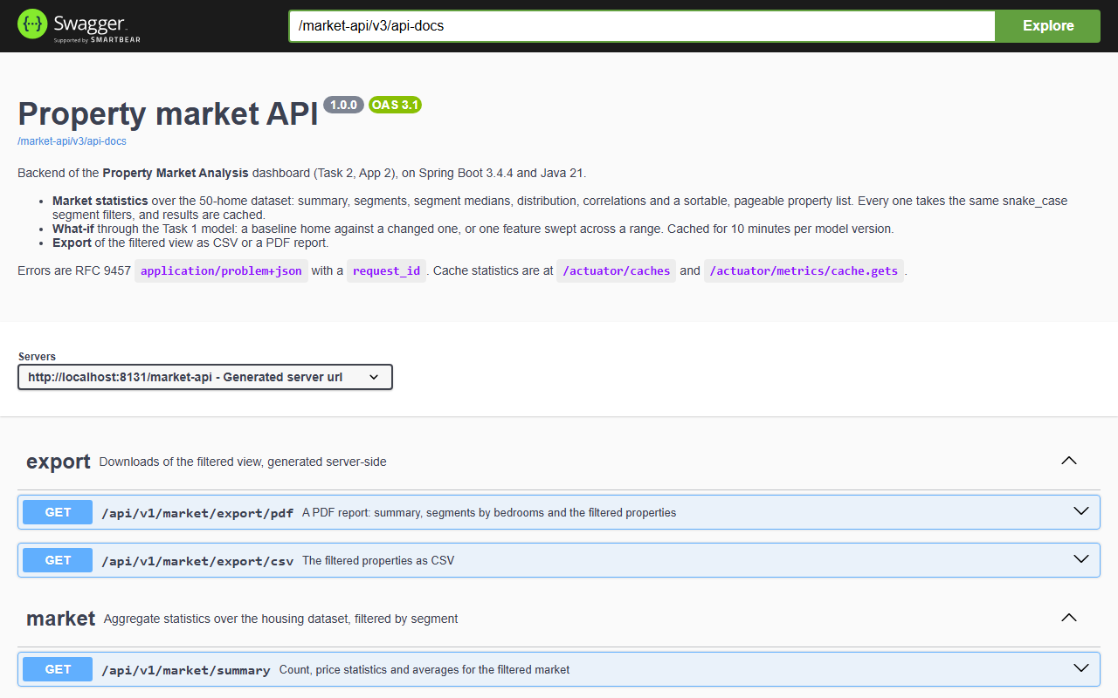
Figure 41. App 2 backend: market-api's Swagger UI (Spring Boot). Page: /market-api/swagger-ui/index.html

M-7: Aggregate statistics from the housing dataset
ID | Test | Expected | Actual | Result
AC-64 | Aggregate statistics from the dataset | Count 50, with mean, median, quartiles and price per sq ft | 50 homes; median $245,000, mean $264,600, quartiles $195,000 to $345,000; $155.09 per sq ft | Pass
Unit | MarketAnalyticsTest | Summary, segments and histograms | 6 of 6 passed | Pass
Unit | StatsTest | Quantiles and correlation | 3 of 3 passed | Pass
Unit | CsvPropertyLoaderTest | The dataset loads; bad data fails fast | 4 of 4 passed | Pass

M-8: Integrates with the ML model container
ID | Test | Expected | Actual | Result
SM-15 | Brief what-if: +500 sq ft moves the price by -51,458.20 | The status and value CI's compose job checks for | HTTP 200, contains "delta":-51458.2 | Pass
SM-16 | Ridge what-if uses the Ridge model | The status and value CI's compose job checks for | HTTP 200, contains "model_version":"ridge- | Pass
Unit | MlClientTest | Calls, retries and failure mapping | 7 of 7 passed | Pass
Unit | FeatureContractTest | The limits match ml-api's | 2 of 2 passed | Pass

M-9: Caching for performance optimisation
ID | Test | Expected | Actual | Result
AC-65 | HTTP caching on statistics | Cache-Control max-age=300, an ETag, and 304 when it matches | Cache-Control: max-age=300; ETag present: true; conditional request: HTTP 304 | Pass
AC-66 | Server caches are present and used | Caffeine caches listed; a repeated what-if is answered from the cache | caches: summary, distribution, correlations, segments, segmentMedians, modelInfo, whatIf, sensitivity, properties, filterOptions; first what-if 15 ms (HTTP 200), repeat 7 ms (HTTP 200); whatIf hits so far: 3 | Pass
Unit | MarketControllerTest: repeated queries | Repeats come from the cache | 1 of 1 passed | Pass
Unit | WhatIfControllerTest: repeated what-ifs | Repeats come from the cache | 1 of 1 passed | Pass
Unit | ExportControllerTest: ETags | Aggregates revalidate to 304 | 1 of 1 passed | Pass

6.5 Technical constraints and deliverables

C-1: Python 3.12+, FastAPI, Java 21, Spring Boot 3.4.4
ID | Test | Expected | Actual | Result
AC-61 | Python, FastAPI and scikit-learn as the brief asks | Python 3.12+, FastAPI, scikit-learn | ml-api: Python 3.12.16, FastAPI 0.162.0, scikit-learn 1.9.1; estimator-api: 3.12.16 0.162.0 | Pass
AC-62 | Java 21 and Spring Boot 3.4.4 as the brief asks | Java 21, Spring Boot 3.4.4 | openjdk version "21.0.13" 2026-10-20 LTS; Spring Boot 3.4.4 | Pass

C-2: Source on GitHub, and able to show it live
ID | Test | Expected | Actual | Result
AC-72 | Source is on GitHub and CI passes on main | A GitHub repository whose latest CI run on main succeeded | loming/property-insights (private); latest CI on main: success, commit 8b0a250, 2026-11-05 | Pass
AC-71 | The public demo answers | Both public hostnames serve their own model | hsbc.loming.com: HTTP 200, ols-2026.11.03-ee42b8fc; hsbc-ridge.loming.com: HTTP 200, ridge-2026.11.03-ee42b8fc | Pass

Appendix A: every automated test
All 274 tests from the suites, by name, with their results from this run. The measured checks (AC) appear in sections 5 and 6, and in full in Appendix B.

ml-api (pytest)
Test | Result
test_api.py (49)
test_health[ols] | Pass
test_health[ridge] | Pass
test_model_info_shape_depends_on_the_kind[ols] | Pass
test_model_info_shape_depends_on_the_kind[ridge] | Pass
test_predict_matches_the_documented_value[ols] | Pass
test_predict_matches_the_documented_value[ridge] | Pass
test_contributions_add_up_to_the_prediction[ols] | Pass
test_contributions_add_up_to_the_prediction[ridge] | Pass
test_batch_keeps_order_warns_on_the_extrapolating_rows_and_matches_single[ols] | Pass
test_batch_keeps_order_warns_on_the_extrapolating_rows_and_matches_single[ridge] | Pass
test_unusual_combination_warns[ols] | Pass
test_unusual_combination_warns[ridge] | Pass
test_ols_rejects_a_price_below_zero | Pass
test_ridge_prices_the_big_home_with_warnings | Pass
test_both_kinds_reject_extreme_input_priced_below_zero[ols] | Pass
test_both_kinds_reject_extreme_input_priced_below_zero[ridge] | Pass
test_invalid_fields_are_listed[ols-payload0-lot_size-Field required] | Pass
test_invalid_fields_are_listed[ols-payload1-sqft-Extra inputs are not permitted] | Pass
test_invalid_fields_are_listed[ols-payload2-square_footage-greater than or equal to 200] | Pass
test_invalid_fields_are_listed[ols-payload3-school_rating-less than or equal to 10] | Pass
test_invalid_fields_are_listed[ols-payload4-bathrooms-multiple of 0.5] | Pass
test_invalid_fields_are_listed[ols-payload5-bedrooms-valid integer] | Pass
test_invalid_fields_are_listed[ols-payload6-year_built-valid integer] | Pass
test_invalid_fields_are_listed[ridge-payload0-lot_size-Field required] | Pass
test_invalid_fields_are_listed[ridge-payload1-sqft-Extra inputs are not permitted] | Pass
test_invalid_fields_are_listed[ridge-payload2-square_footage-greater than or equal to 200] | Pass
test_invalid_fields_are_listed[ridge-payload3-school_rating-less than or equal to 10] | Pass
test_invalid_fields_are_listed[ridge-payload4-bathrooms-multiple of 0.5] | Pass
test_invalid_fields_are_listed[ridge-payload5-bedrooms-valid integer] | Pass
test_invalid_fields_are_listed[ridge-payload6-year_built-valid integer] | Pass
test_nan_is_rejected[ols] | Pass
test_nan_is_rejected[ridge] | Pass
test_batch_size_limits[ols-items0-at least 1 item] | Pass
test_batch_size_limits[ols-items1-at most 1000] | Pass
test_batch_size_limits[ridge-items0-at least 1 item] | Pass
test_batch_size_limits[ridge-items1-at most 1000] | Pass
test_batch_errors_name_the_item[ols] | Pass
test_batch_errors_name_the_item[ridge] | Pass
test_request_ids_are_echoed_or_generated[ols] | Pass
test_request_ids_are_echoed_or_generated[ridge] | Pass
test_unknown_route_and_wrong_method_are_problems[ols] | Pass
test_unknown_route_and_wrong_method_are_problems[ridge] | Pass
test_oversized_bodies_are_rejected_both_ways[ols] | Pass
test_oversized_bodies_are_rejected_both_ways[ridge] | Pass
test_behind_the_gateway_prefix | Pass
test_missing_model_reports_unavailable | Pass
test_unexpected_errors_are_problems_without_internals | Pass
test_openapi_documents_the_brief_endpoints[ols] | Pass
test_openapi_documents_the_brief_endpoints[ridge] | Pass
test_training.py (11)
test_ols_matches_the_planning_analysis | Pass
test_ridge_picks_the_smallest_alpha_that_passes_the_sign_gate | Pass
test_ridge_training_refuses_when_no_alpha_passes_the_gate | Pass
test_training_is_deterministic[ols] | Pass
test_training_is_deterministic[ridge] | Pass
test_metadata_records_the_training_ranges | Pass
test_bad_datasets_fail_fast[<lambda>-missing columns] | Pass
test_bad_datasets_fail_fast[<lambda>-non-numeric] | Pass
test_bad_datasets_fail_fast[<lambda>-null values] | Pass
test_bad_datasets_fail_fast[<lambda>-only 5 rows] | Pass
test_id_is_never_a_feature | Pass

estimator-api (pytest)
Test | Result
test_estimates.py (29)
test_create_prices_through_the_model_and_saves | Pass
test_model_warnings_are_saved | Pass
test_history_is_newest_first_and_paged | Pass
test_history_paging_limits[params0] | Pass
test_history_paging_limits[params1] | Pass
test_history_paging_limits[params2] | Pass
test_history_survives_a_restart | Pass
test_unknown_and_malformed_ids | Pass
test_compare_keeps_order_reports_missing_and_ranges | Pass
test_compare_validation | Pass
test_delete_one_and_all | Pass
test_invalid_input_is_rejected_before_any_model_call[payload0-features.lot_size] | Pass
test_invalid_input_is_rejected_before_any_model_call[payload1-features.sqft] | Pass
test_invalid_input_is_rejected_before_any_model_call[payload2-features.bathrooms] | Pass
test_invalid_input_is_rejected_before_any_model_call[payload3-features.year_built] | Pass
test_invalid_input_is_rejected_before_any_model_call[payload4-label] | Pass
test_invalid_input_is_rejected_before_any_model_call[payload5-label] | Pass
test_invalid_input_is_rejected_before_any_model_call[payload6-label] | Pass
test_invalid_input_is_rejected_before_any_model_call[payload7-extra] | Pass
test_invalid_input_is_rejected_before_any_model_call[payload8-features] | Pass
test_model_failures_map_to_problems_and_save_nothing[invalid-422-validation-error] | Pass
test_model_failures_map_to_problems_and_save_nothing[domain-422-outside-model-domain] | Pass
test_model_failures_map_to_problems_and_save_nothing[error-502-model-error] | Pass
test_model_failures_map_to_problems_and_save_nothing[garbage-502-model-error] | Pass
test_model_failures_map_to_problems_and_save_nothing[bad_shape-502-model-error] | Pass
test_model_failures_map_to_problems_and_save_nothing[no_model-503-model-unavailable] | Pass
test_model_failures_map_to_problems_and_save_nothing[down-503-model-unavailable] | Pass
test_model_failures_map_to_problems_and_save_nothing[slow-503-model-unavailable] | Pass
test_oversized_body | Pass
test_system.py (8)
test_model_info_is_passed_through_and_cached | Pass
test_model_info_unavailable_before_first_fetch | Pass
test_health_reports_the_model_service_without_failing | Pass
test_request_ids_are_echoed_or_generated | Pass
test_behind_the_gateway_prefix | Pass
test_unknown_routes_and_methods_are_problems | Pass
test_unexpected_errors_are_problems_without_internals | Pass
test_feature_limits_match_ml_api | Pass

market-api (JUnit)
Test | Result
MarketAnalyticsTest (6)
segmentMediansAreHomesTheModelCanPrice | Pass
segmentsAreBucketedAndOrdered | Pass
summary | Pass
noMatchesGiveAnEmptySummary | Pass
histogramBinsCoverTheRangeAndKeepTheTopEdge | Pass
propertiesSortAndPage | Pass
MarketFilterTest (4)
noCriteriaMatchesEverything | Pass
validation | Pass
boundsAreInclusive | Pass
bedroomOrderAndDuplicatesDontChangeTheCacheKey | Pass
StatsTest (3)
pearson | Pass
quantilesInterpolateLikeNumpy | Pass
roundsHalfUp | Pass
CsvPropertyLoaderTest (4)
failsFastOnABadNumberWithTheRow | Pass
skipsAByteOrderMark | Pass
failsFastOnAMissingColumn | Pass
loadsTheProvidedDataset | Pass
FeatureContractTest (2)
featureLimitsMatchMlApi | Pass
houseFeaturesValidatesTheSameLimits | Pass
ApiContractTest (5)
rootOpensSwagger | Pass
actuatorShowsCachesReadOnly | Pass
springsOwnErrorsAreProblemsToo | Pass
requestIdsAreEchoedOrGenerated | Pass
swaggerDocumentsTheFilterNamesThatBind | Pass
ExportControllerTest (5)
pdfIsAPdf | Pass
filtersAreDescribedInWords | Pass
exportsValidateTheirFilters | Pass
csvHasAHeaderAndTheFilteredRowsInOrder | Pass
aggregatesGetEtagsAndRevalidateTo304 | Pass
MarketControllerTest (8)
segmentsByBedrooms | Pass
invalidInputIsA400 | Pass
otherEndpoints | Pass
snakeCaseFiltersBind | Pass
repeatedQueriesAreServedFromTheCache | Pass
segmentMediansAreCompleteHomes | Pass
summaryOfTheWholeMarket | Pass
propertiesSortAndPage | Pass
WhatIfControllerTest (8)
sensitivitySweepsOneFeatureInOneCall | Pass
aHomeTheModelCantPriceIsNamed | Pass
houseFeaturesRoundSensitivityValues | Pass
repeatedWhatIfsAreCached | Pass
invalidInputIsRejectedBeforeAnyModelCall | Pass
whatIfPricesBothHomesInOneCallHoldingTheRestConstant | Pass
modelInfoIsPassedThroughAndCached | Pass
modelDownIsA503WithTheRequestId | Pass
MlClientTest (7)
modelInfo | Pass
noModelLoadedIsUnavailable | Pass
sendsSnakeCaseWithTheRequestIdAndParsesTheBatch | Pass
modelValidationErrorsPassThrough | Pass
connectionFailuresAreRetriedTwiceThenUnavailable | Pass
serverErrorsAndGarbageAreModelErrors | Pass
outsideModelDomainKeepsTheIndices | Pass

portal (Vitest)
Test | Result
compare-tray.test.ts (4)
compare tray adds each estimate once, up to four | Pass
compare tray removes, prunes and clears | Pass
compare tray waits for rehydrate() before reading storage, then saves changes | Pass
compare tray drops stored data that doesn't fit: bad ids, duplicates, more than four | Pass
features.test.ts (1)
features match ml-api has the same names, types and limits | Pass
format.test.ts (4)
format formats prices as whole US dollars | Pass
format formats numbers with up to two decimals, or a fixed number | Pass
format prints years without a thousands separator | Pass
format formats a timestamp in the given time zone, naming it | Pass
filters.test.ts (10)
parseFilters reads repeated and comma-separated bedrooms, deduped and sorted | Pass
parseFilters keeps valid ranges and drops what market-api would reject | Pass
parseFilters ignores an inverted range rather than failing the page | Pass
parseFilters round-trips through the query string in a fixed order | Pass
parseFilters knows every filter parameter, and only those | Pass
describeFilters says each active filter in words | Pass
describeFilters is empty without filters | Pass
sliderBounds widens the data's range to whole steps | Pass
sliderBounds keeps decimal steps exact | Pass
parseSort accepts market-api's sort fields and falls back to id order | Pass
property-table-model.test.ts (6)
sortRows sorts by the column, then by home number | Pass
sortRows leaves the input alone | Pass
nextSort starts a new column ascending and flips the current one | Pass
searchRows matches raw and formatted values, every word | Pass
pageOf slices a page and says which rows it holds | Pass
pageOf shows the last page for a page past the end, and copes with no rows | Pass
stats.test.ts (4)
niceTicks puts about five round ticks inside the range | Pass
niceTicks is never finer than the step | Pass
pearson measures a linear relationship | Pass
pearson is undefined for too few points or a flat series | Pass
what-if-model.test.ts (6)
baselines offers each segment's median home, then every listed home with its sale price | Pass
baselines picks the URL's baseline, else the typical 3-bed home | Pass
changesFrom keeps only the features that differ | Pass
effectsOf multiplies each change by its coefficient, so the effects add up to the change | Pass
describeModelError tells a refused home, a busy gateway and a missing model apart | Pass
sweepSteps uses every value a slider can take, up to 21 points | Pass
what-if-schema.test.ts (3)
whatIfRequestSchema accepts a baseline and any subset of changes | Pass
whatIfRequestSchema applies the model's limits and rejects unknown fields | Pass
sensitivityRequestSchema sweeps a known feature within its limits, in 2 to 50 steps | Pass
client.test.ts (8)
apiFetch calls the right backend with a request ID and returns the JSON | Pass
apiFetch keeps a path prefix in the base URL | Pass
apiFetch uses the data cache only when asked | Pass
apiFetch sends cached calls the same headers every time, or the data cache would never hit | Pass
apiFetch sends JSON bodies | Pass
apiFetch turns a problem+json response into an ApiError with its fields | Pass
apiFetch makes a generic problem from an error that isn't problem+json | Pass
apiFetch reports an unreachable or slow backend as a 503 problem | Pass
env.test.ts (4)
getServerEnv parses the backend URLs and defaults to the brief set | Pass
getServerEnv reads the Ridge set's settings | Pass
getServerEnv fails on first use, naming the bad variable | Pass
getServerEnv validates once and then reuses the result | Pass
action-result.test.ts (5)
toActionError maps the backend's field errors onto form fields | Pass
toActionError explains a price the model can't produce | Pass
toActionError treats an unreachable model or backend as temporary | Pass
toActionError keeps other failures generic, without internals | Pass
fieldErrorsFromZod keys errors by field path, first message per field | Pass
compare-ids.test.ts (4)
parseCompareIds reads comma-separated and repeated ids | Pass
parseCompareIds ignores anything that isn't a UUID, and duplicates | Pass
parseCompareIds keeps the first four | Pass
parseCompareIds round-trips through compareHref | Pass
estimate-title.test.ts (3)
estimateTitle uses the label when there is one | Pass
estimateTitle describes the home when there's no label | Pass
homeSummary lists size, rooms and age | Pass
schema.test.ts (5)
estimateSchema accepts the example home, with or without a label | Pass
estimateSchema treats a blank label as none | Pass
estimateSchema says what to enter for an empty field (the browser sends NaN) | Pass
estimateSchema enforces whole numbers, half steps and ranges | Pass
estimateSchema rejects multi-line and long labels | Pass

Browser tests (Playwright)
ID | Test | Result
estimator.spec.ts (7)
E2E-01 | prices the example home, shows the result and saves it to the history | Pass
E2E-02 | summarises invalid fields and moves focus to the first | Pass
E2E-03 | a click straight after typing a bad value isn't lost, though the field's message moves the buttons | Pass
E2E-04 | says when the model can't price a home | Pass
E2E-05 | the Ridge set prices the same home and shows what moves the estimate | Pass
E2E-06 | a saved estimate has its own page; an unknown id gets the not-found page | Pass
E2E-07 | compares two saved estimates, then deletes one | Pass
keyboard.spec.ts (6)
E2E-08 | estimate: Enter submits, an error takes focus, and the result goes to the comparison | Pass
E2E-09 | history: delete asks first, Escape keeps the estimate, and focus stays in the table | Pass
E2E-10 | compare tray: nothing hides behind it, and Clear keeps focus on the page | Pass
E2E-11 | market dashboard: filters and a chart's table | Pass
E2E-12 | market data: sorting, paging and the export menu | Pass
E2E-13 | what-if: the baseline, a slider and both resets leave focus where it can carry on | Pass
market.spec.ts (10)
E2E-14 | a shared link's filters apply to the controls and every widget | Pass
E2E-15 | the filter bar rewrites the URL, keeps focus, and clears | Pass
E2E-16 | says when no home matches | Pass
E2E-17 | sorts, pages and searches the filtered homes, and exports them in that order | Pass
E2E-18 | reloading the page reuses the portal's data cache instead of calling market-api again | Pass
E2E-19 | the export Route Handler streams the PDF and refuses unknown formats | Pass
E2E-20 | fits a phone: the table scrolls inside its box | Pass
E2E-21 | prices a change with the other features held constant, and explains it | Pass
E2E-22 | the Route Handler checks bodies against the model's limits | Pass
E2E-23 | the Ridge set adds the sensitivity line | Pass
resilience.spec.ts (3)
E2E-24 | its app shows its own error state; the other app and the shell keep working | Skip
E2E-39 | its app shows its own error state; the other app and the shell keep working (estimator-api stopped) | Pass
E2E-40 | its app shows its own error state; the other app and the shell keep working (market-api stopped) | Pass
shell.spec.ts (14)
E2E-25 | overview links both apps and reports the services | Pass
E2E-26 | the skip link is the first stop and moves focus to the content | Pass
E2E-27 | navigation between and within the apps marks the current page | Pass
E2E-28 | an unknown address gets the not-found page | Pass
E2E-29 | the Ridge set is labelled as such and serves the Ridge model | Pass
E2E-30 | fits a 375 px phone without sideways scrolling | Pass
E2E-31 | / | Pass
E2E-32 | /estimator | Pass
E2E-33 | /estimator/history | Pass
E2E-34 | /estimator/compare | Pass
E2E-35 | /market | Pass
E2E-36 | /market/data | Pass
E2E-37 | /market/what-if | Pass
E2E-38 | /no-such-page | Pass

Gateway smoke checks
ID | Check | Actual | Result
SM-01 | Brief Host reaches the OLS model | HTTP 200, contains "model_version":"ols- | Pass
SM-02 | Ridge Host reaches the Ridge model | HTTP 200, contains "model_version":"ridge- | Pass
SM-03 | POST /predict on the brief set returns the expected price | HTTP 200, contains "predicted_price":250879.73 | Pass
SM-04 | POST /predict on the Ridge set returns the expected price | HTTP 200, contains "predicted_price":250932.28 | Pass
SM-05 | ml-api Swagger UI is served behind the /ml-api prefix | HTTP 200, contains /ml-api/openapi.json | Pass
SM-06 | ml-api OpenAPI document names the /ml-api server | HTTP 200, contains "servers":[{"url":"/ml-api"}] | Pass
SM-07 | An unknown gateway path answers 404 | HTTP 404 | Pass
SM-08 | Brief estimator saves with the OLS model | HTTP 201, contains "model_version":"ols- | Pass
SM-09 | Ridge estimator saves with the Ridge model | HTTP 201, contains "model_version":"ridge- | Pass
SM-10 | Each set keeps its own history (brief total is 1) | HTTP 200, contains "total":1 | Pass
SM-11 | estimator-api Swagger UI is served behind its prefix | HTTP 200, contains /estimator-api/openapi.json | Pass
SM-12 | The gateway refuses clearing the whole history | HTTP 403 | Pass
SM-13 | market-api summary covers all 50 homes | HTTP 200, contains "count":50 | Pass
SM-14 | market-api segments by bedrooms: 22 homes in 3 bed | HTTP 200, contains "segment":"3 bed","count":22 | Pass
SM-15 | Brief what-if: +500 sq ft moves the price by -51,458.20 | HTTP 200, contains "delta":-51458.2 | Pass
SM-16 | Ridge what-if uses the Ridge model | HTTP 200, contains "model_version":"ridge- | Pass
SM-17 | market-api Swagger keeps the /market-api prefix | HTTP 200, contains "url":"/market-api/v3/api-docs" | Pass
SM-18 | market-api PDF export answers | HTTP 200 | Pass

Appendix B: every measured check
ID | Covers | Check | Actual | Result
AC-01 | TR-1a | All routes use the App Router | src/app has 8 pages, 3 layouts, 4 route handlers; pages folder present: false | Pass
AC-02 | TR-1b | Every page and layout is a Server Component | 0 of 11; 42 client files in total, all interactive parts | Pass
AC-03 | TR-1b | The backend API layer is marked server-only | src/lib/api/client.ts, src/lib/api/env.ts, src/lib/api/estimator.ts, src/lib/api/market.ts, src/lib/api/problem-response.ts, src/lib/api/status.ts | Pass
AC-04 | TR-1b | No server code reaches the browser bundle | searched 36 client chunks for 5 strings; found: none | Pass
AC-05 | TR-1c | /market/data arrives with its homes in the HTML | 12 price values in the raw HTML | Pass
AC-06 | TR-1c | /market arrives with its figures in the HTML | Median price: true; Price against living area: true | Pass
AC-07 | TR-1c | /estimator arrives with the model's training ranges | "Training data:" in HTML: true; model version present: true | Pass
AC-08 | TR-1c | /estimator/history arrives with the saved estimates | "Maple Court family home" in HTML: true | Pass
AC-09 | TR-1c, TR-1d | First load needs no client-side data fetch | /market: 0 data calls, 0 backend calls; /market/data: 0 data calls, 0 backend calls; /estimator: 0 data calls, 0 backend calls; /estimator/history: 0 data calls, 0 backend calls | Pass
AC-10 | TR-1d | A write goes through a Server Action | POST /estimator with Next-Action | Pass
AC-11 | TR-1d | The saved estimate shows at once (no stale cache) | 1 row found for the new label | Pass
AC-12 | TR-1d | Interactive calls go through a Route Handler | 1 POST to /api/market/what-if; 0 to market-api | Pass
AC-13 | TR-1e | Custom hooks are reused across components | All 11 hooks are used outside their own file (table below) | Pass
AC-14 | TR-2a | No page scrolls sideways at any width | 40 combinations, 0 with overflow | Pass
AC-15 | TR-2a | The headline figures reflow with the width | 375 px: 1, 768 px: 2, 1280 px: 4 | Pass
AC-16 | TR-2a | What-if layout changes with the width | 375 px: price above = true; 1280 px: beside = true | Pass
AC-17 | TR-2b | axe finds no WCAG 2.2 AA violations | 18 scans, 0 violations, 474 rule passes | Pass
AC-18 | TR-2b | Pages expose language, landmarks and one h1 | lang="en"; 1 main landmark; 3 labelled navs (Applications, Property Market Analysis sections, Table pages); 1 h1; title "Market data · Property Insights"; aria-current on 2 links | Pass
AC-19 | TR-2b | Sorting tells assistive technology | aria-sort="ascending" | Pass
AC-20 | TR-2b | Charts have a text alternative | aria-hidden chart wrappers: 1; tables in the figure: 1 | Pass
AC-21 | TR-2b, TR-2d | Animations respect the reduced-motion setting | With the setting on: all four stopped. With it off: all four ran (table below) | Pass
AC-22 | TR-2c | A route shows a skeleton while it loads | status text: "Loading the market analysis" | Pass
AC-23 | TR-2c | The form shows when it is working | text "Estimating…", disabled: true | Pass
AC-24 | TR-2c | Unknown addresses get a not-found page | HTTP 404, heading visible: true | Pass
AC-25 | TR-1d, TR-3c | The portal's data cache saves backend calls | After 5 loads of /market/data and 3 of /market/what-if (each already loaded once): 0 calls for filter options, 0 for properties, 0 for model info; the fetch cache grew by 0 entries | Pass
AC-26 | TR-2c | One failed widget doesn't blank the page | 1 widget error, filter bar visible: true, 3 charts still drawn | Pass
AC-27 | TR-2c, TR-3d | A widget's Try again recovers it | headline figures back; 0 widget errors left | Pass
AC-28 | TR-2c, P-0, P-4 | With estimator-api down, only its app is affected | error panel shown, navigation visible: true, other app clean: true | Pass
AC-29 | TR-2c, P-0, P-4 | With market-api down, only its app is affected | error panel shown, navigation visible: true, other app clean: true | Pass
AC-30 | TR-3d | estimator app recovers when its backend returns | no error panel: true | Pass
AC-31 | TR-3d | market app recovers when its backend returns | no error panel: true | Pass
AC-32 | TR-2d | Following a nav-bar link crossfades the page | page-fade ran for 180 ms and page-rise for 240 ms | Pass
AC-33 | TR-2d | A filter change updates in place | page-fade didn't run; the only animation was the progress bar (progress) | Pass
AC-34 | TR-2d, TR-3a | A filter change keeps the page on screen | checkbox ticked: true; results opacity: 0.6; old results still shown: true; aria-busy: true | Pass
AC-35 | TR-2e | Both apps share one design system | Identical on both apps: font Geist, the same primary colour and radius tokens, h1 24px, header 57 px, content width 1152 px | Pass
AC-36 | TR-3a | URL state survives a reload and can be shared | "Showing 1–10 of 15 homes.", aria-sort descending; after reload: "Showing 1–10 of 15 homes." | Pass
AC-37 | TR-3a | The compare tray stays in step across tabs | second tab went from "Comparing 1 of 4" to "Comparing 2 of 4" | Pass
AC-38 | TR-3a | The compare tray survives a reload | Comparing 2 of 4 after reload | Pass
AC-39 | TR-3a | Damaged stored state is dropped safely | tray shown: false; page errors: 0 | Pass
AC-40 | TR-3b | Invalid input is caught with useful messages | 3 fields need attention: "Enter the living area"; "Use steps of 0.5, such as 2 or 2.5"; "Enter at most 10 out of 10" | Pass
AC-41 | TR-3b, TR-2b | Errors are tied to their fields | focused: true; aria-invalid: true; aria-describedby: field-features-square_footage-hint field-features-square_footage-error | Pass
AC-42 | TR-3b, TR-3d | A server refusal lands on the form | alert shown; living area still 4100 | Pass
AC-43 | TR-3c | Slider moves are debounced | 1 request(s) for 6 key presses | Pass
AC-44 | TR-3c | Going back to a scenario costs nothing | 0 request(s) | Pass
AC-45 | TR-3c | Sort, paging and search need no server call | 0 network requests for sort + next page + search | Pass
AC-46 | TR-3c, TR-1d | The page streams | first bytes at 285 ms (has <html>: true), complete at 303 ms, 102829 bytes | Pass
AC-47 | TR-3d | Errors are problem+json with a request ID | HTTP 422, application/problem+json, X-Request-ID present: true, request_id in body: true | Pass
AC-48 | TR-3d | Route Handlers refuse bad bodies in the same format | HTTP 400, application/problem+json, detail: "The body must be JSON" | Pass
AC-49 | TR-3d | A failed export is reported in place | alert reads "The export didn't download", then "The market service can't be reached" | Pass
AC-50 | TR-3d, P-0 | With the model down, what-if says so | message and Try again shown; sliders still present | Pass
AC-51 | P-0 | The dashboard doesn't need the model | dashboard loaded | Pass
AC-52 | TR-3d, E-8 | A failed estimate saves nothing | history opens: true; saved total 4 | Pass
AC-53 | TR-3d | What-if recovers when the model returns | price shown | Pass
AC-54 | TR-4a, P-0 | A lint rule keeps the two apps apart | estimator importing market code refused: true; market importing the estimator API refused: true; market importing its own API allowed: true | Pass
AC-55 | TR-4a | Route files stay thin | 8 pages, longest 96 lines | Pass
AC-56 | TR-4a | The expected folders exist and hold code | src/app 32, src/components/ui 12, src/components/layout 7, src/components/form 2, src/features/estimator 21, src/features/market 23, src/hooks 6, src/lib/api 10, src/stores 2, e2e 6 | Pass
AC-57 | T1-1, T1-2, T1-3, T1-6 | ml-api offers the four endpoints in Swagger | /predict, /predict/batch, /model-info, /health | Pass
AC-58 | T1-1 | Batch predicts the 10 rows of the provided test file | HTTP 200, 10 predictions; warnings on rows 6, 8 | Pass
AC-59 | T1-2 | model-info returns coefficients and metrics | 7 coefficients; CV R² 0.972, RMSE 10540, MAE 7561 | Pass
AC-60 | T1-3 | health reports the loaded model | status ok; model loaded: true; version ols-2026.11.03-ee42b8fc | Pass
AC-61 | T1-4, C-1 | Python, FastAPI and scikit-learn as the brief asks | ml-api: Python 3.12.16, FastAPI 0.162.0, scikit-learn 1.9.1; estimator-api: 3.12.16 0.162.0 | Pass
AC-62 | C-1 | Java 21 and Spring Boot 3.4.4 as the brief asks | openjdk version "21.0.13" 2026-10-20 LTS; Spring Boot 3.4.4 | Pass
AC-63 | TR-2a, C-1 | The portal's stack | next 16.4.4, react 19.3.0, tailwindcss ^4 | Pass
AC-64 | M-7 | Aggregate statistics from the dataset | 50 homes; median $245,000, mean $264,600, quartiles $195,000 to $345,000; $155.09 per sq ft | Pass
AC-65 | M-9 | HTTP caching on statistics | Cache-Control: max-age=300; ETag present: true; conditional request: HTTP 304 | Pass
AC-66 | M-9 | Server caches are present and used | caches: summary, distribution, correlations, segments, segmentMedians, modelInfo, whatIf, sensitivity, properties, filterOptions; first what-if 15 ms (HTTP 200), repeat 7 ms (HTTP 200); whatIf hits so far: 3 | Pass
AC-67 | M-4 | CSV and PDF exports download | property-market-2026-11-05.csv: 15 rows, first price row "7,2400,4,3.0,2010,10500,8.2,9.0,410000,170.83"; property-market-2026-11-05.pdf: starts %PDF-, 2922 bytes | Pass
AC-68 | TR-2d, TR-2b | Page transitions switch off under reduced motion | page-fade 0 ms, page-rise 0 ms | Pass
AC-69 | TR-3b | Clicking submit straight after typing a bad value | error summary shown: true; the button moved 1 px while pressed | Pass
AC-70 | TR-3b | Clicking submit straight after correcting a value | estimate saved: true; the button moved 1 px while pressed | Pass
AC-71 | C-2, T1-6 | The public demo answers | hsbc.loming.com: HTTP 200, ols-2026.11.03-ee42b8fc; hsbc-ridge.loming.com: HTTP 200, ridge-2026.11.03-ee42b8fc | Pass
AC-72 | C-2 | Source is on GitHub and CI passes on main | loming/property-insights (private); latest CI on main: success, commit 8b0a250, 2026-11-05 | Pass
AC-73 | TR-1d, TR-3c | The estimator's model info comes from the data cache | 3 more loads of /estimator: 0 new model-info calls in estimator-api's log (6 before) | Pass
AC-74 | TR-3b | Clicking Reset straight after typing a bad value | School rating back to 7.6 (it started at 7.6); the button moved 1 px while pressed | Pass

Appendix C: the walkthrough video
A silent, captioned recording of the demo's steps, made by portal/scripts/record-walkthrough.mjs against the same test stack, with the resilience step on. It stopped and restarted that stack's ml-api, not the public demo's. Before recording, three estimates were added to the empty history, so the compare step had something to compare. Times are approximate.
Time | What's on screen
0:02 | Property Insights: Task 1's model API and two Task 2 apps, in two sets. This is the brief set: plain linear regression, as asked.
0:10 | Task 1, ml-api: FastAPI and scikit-learn, live through Swagger UI behind the gateway's /ml-api/ prefix.
0:18 | GET /model-info: coefficients in raw units, cross-validated metrics against a predict-the-mean baseline, and notes on reading them.
0:27 | POST /predict with the 4,100 sq ft example: plain least squares prices it at $0 or less, so the API answers 422 rather than clamping.
0:36 | POST /predict/batch with the 10 rows of the provided test file: predictions in input order, with warnings on rows 6 and 8.
0:45 | The Ridge set's ml-api: the same code trained as Ridge, every size and quality coefficient pointing the expected way.
0:56 | App 1, the Property Value Estimator: a form for the seven model inputs, starting from a typical home.
1:00 | Invalid input, submitted with Enter: an error summary links to each field, and focus moves to the first.
1:04 | Fixed and submitted: the estimate, the inputs as a table, and where the price sits among the 50 sales.
1:09 | Compare puts it in the tray; the history keeps every estimate, newest first.
1:16 | Side by side: the highest and lowest value in each row marked, and the prices and features charted.
1:24 | The same home on the Ridge set, which also shows what each feature adds to or takes from the average home's price.
1:33 | App 2, the Property Market Analysis (Spring Boot backend): every widget streams in on its own.
1:35 | Filters live in the URL under the names market-api takes, so a link shares the view, and the server applies them.
1:45 | The table keeps the filters: sortable headers, a search box, pages, and CSV or PDF export of what's filtered.
1:54 | What-if: start from the typical 3-bed home and change one feature at a time, the others held constant.
2:02 | Under plain least squares, more living area lowers the price: the page says why, and warns when the home leaves the data.
2:11 | The Ridge set: more living area raises the price, and a line shows the price across one feature's range.
2:23 | market-api's own Swagger UI, behind the /market-api/ prefix.
2:27 | Resilience: ml-api is stopped (docker compose stop ml-api)…
2:29 | …the brief set's estimator says the pricing service isn't responding, and saves nothing…
2:43 | …its market dashboard keeps working: it doesn't need the model…
2:46 | …what-if still shows the prices market-api has cached (10 minutes)…
2:54 | …but a new change needs the model, and the page says it isn't answering. The Ridge set is untouched.
3:05 | ml-api is back (docker compose start ml-api): Try again, and what-if prices the change.
3:10 | Code, tests, decisions and the live demo plan are in the repository's README and docs/.

Appendix D: how to run the suites
In a Bash shell such as Git Bash, each line from the repository root, with the stack running on its usual port. The browser tests save estimates and delete them afterwards, and the backend-down runs need containers stopped, so don't run those against the public demo while others are using it.
docker compose --profile ridge up -d --build --wait
cd ml-api && uv run pytest
cd estimator-api && uv run pytest
docker run --rm -v "${PWD}:/repo" -v market-api-m2:/root/.m2 -w /repo/market-api eclipse-temurin:21.0.13_9-jdk-resolute sh mvnw -B verify
cd portal && npm run lint && npm run typecheck && npm test && npm run build
cd portal && npx playwright test
docker compose stop market-api; docker compose restart portal; docker compose up -d --wait portal
cd portal && E2E_DOWN=market npx playwright test e2e/resilience.spec.ts

