ДЗ 9: Отказоустойчивость приложений

3 mysql slave (Конфигурация HAproxy) и 3 приложения (Конфигурация NGinx). Балансировка - RoundRobin.

В приложении хранение сессии изменено с “памяти” на mysql, чтобы запросы на разные экземпляры работали с одной сессией.
Нагрузка сделана K6 скриптом - запрос на получение профиля.

Процесс эксперимента

Работа всех приложений и mysql

HAproxy
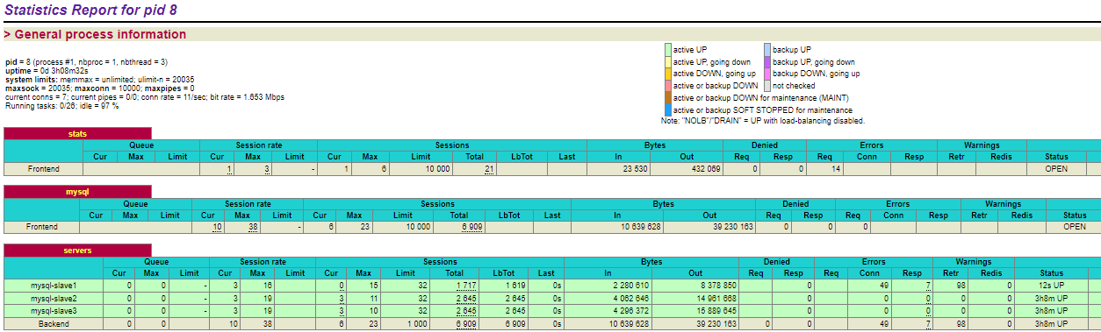

Отключение 1-го экземпляра mysql

NAproxy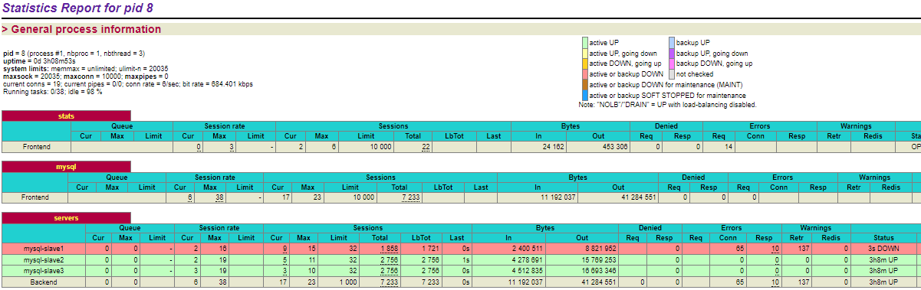

Лог
Запросы шли на 3 инстанса после отключения на 2 и 3:
{"log":"\u003c134\u003eJun 25 14:48:55 haproxy[8]: 192.168.2.5:42710 [25/Jun/2022:14:48:55.388] mysql servers/mysql-slave1 1/4/46 941 -- 7/7/6/1/0 0/0\n","stream":"stdout","time":"2022-06-25T14:48:55.434963298Z"}
{"log":"\u003c134\u003eJun 25 14:48:55 haproxy[8]: 192.168.2.5:41716 [25/Jun/2022:14:48:53.710] mysql servers/mysql-slave1 1/0/1852 23658 SD 7/7/6/0/0 0/0\n","stream":"stdout","time":"2022-06-25T14:48:55.562184075Z"}
{"log":"\u003c134\u003eJun 25 14:48:55 haproxy[8]: 192.168.2.5:42788 [25/Jun/2022:14:48:55.537] mysql servers/mysql-slave3 1/0/27 937 -- 6/6/5/3/0 0/0\n","stream":"stdout","time":"2022-06-25T14:48:55.566035416Z"}
{"log":"\u003c134\u003eJun 25 14:48:55 haproxy[8]: 192.168.2.5:42930 [25/Jun/2022:14:48:55.765] mysql servers/mysql-slave3 1/0/27 936 -- 9/9/8/3/0 0/0\n","stream":"stdout","time":"2022-06-25T14:48:55.79303396Z"}
{"log":"\u003c134\u003eJun 25 14:48:56 haproxy[8]: 192.168.2.5:42708 [25/Jun/2022:14:48:55.378] mysql servers/mysql-slave3 1/0/799 13070 -- 9/9/8/2/0 0/0\n","stream":"stdout","time":"2022-06-25T14:48:56.176968843Z"}
{"log":"\u003c134\u003eJun 25 14:48:56 haproxy[8]: 192.168.2.5:43268 [25/Jun/2022:14:48:56.246] mysql servers/mysql-slave3 1/0/72 936 -- 10/10/9/2/0 0/0\n","stream":"stdout","time":"2022-06-25T14:48:56.318664327Z"}
{"log":"\u003c134\u003eJun 25 14:48:56 haproxy[8]: 192.168.2.5:43316 [25/Jun/2022:14:48:56.326] mysql servers/mysql-slave2 1/0/29 937 -- 10/10/9/4/0 0/0\n","stream":"stdout","time":"2022-06-25T14:48:56.357474449Z"}
{"log":"\u003c134\u003eJun 25 14:48:57 haproxy[8]: 192.168.2.5:42800 [25/Jun/2022:14:48:55.573] mysql servers/mysql-slave1 1/-1/2002 0 SC 9/9/8/0/3 0/0\n","stream":"stdout","time":"2022-06-25T14:48:57.57567115Z"}
{"log":"\u003c134\u003eJun 25 14:49:02 haproxy[8]: 192.168.2.5:42948 [25/Jun/2022:14:48:55.785] mysql servers/mysql-slave1 1/-1/7002 0 SC 8/8/7/1/3 0/0\n","stream":"stdout","time":"2022-06-25T14:49:02.788956897Z"}
{"log":"\u003c134\u003eJun 25 14:49:03 haproxy[8]: 192.168.2.5:43280 [25/Jun/2022:14:48:56.265] mysql servers/mysql-slave1 1/-1/7008 0 SC 7/7/6/0/3 0/0\n","stream":"stdout","time":"2022-06-25T14:49:03.274352789Z"}
{"log":"[WARNING] (8) : Server servers/mysql-slave1 is DOWN, reason: Layer4 timeout, check duration: 2002ms. 2 active and 0 backup servers left. 0 sessions active, 0 requeued, 0 remaining in queue.\n","stream":"stderr","time":"2022-06-25T14:49:05.507655388Z"}
{"log":"\u003c129\u003eJun 25 14:49:05 haproxy[8]: Server servers/mysql-slave1 is DOWN, reason: Layer4 timeout, check duration: 2002ms. 2 active and 0 backup servers left. 0 sessions active, 0 requeued, 0 remaining in queue.\n","stream":"stdout","time":"2022-06-25T14:49:05.507783512Z"}
{"log":"\u003c134\u003eJun 25 14:49:24 haproxy[8]: 192.168.2.5:44330 [25/Jun/2022:14:49:24.558] mysql servers/mysql-slave3 1/0/33 939 -- 10/10/9/3/0 0/0\n","stream":"stdout","time":"2022-06-25T14:49:24.592291026Z"}
{"log":"\u003c134\u003eJun 25 14:49:24 haproxy[8]: 192.168.2.5:44348 [25/Jun/2022:14:49:24.580] mysql servers/mysql-slave3 1/0/28 944 -- 10/10/9/3/0 0/0\n","stream":"stdout","time":"2022-06-25T14:49:24.611035459Z"}
{"log":"\u003c134\u003eJun 25 14:49:24 haproxy[8]: 192.168.2.5:41006 [25/Jun/2022:14:48:53.036] mysql servers/mysql-slave2 1/2/31580 69027 -- 9/9/8/5/0 0/0\n","stream":"stdout","time":"2022-06-25T14:49:24.615671134Z"}
{"log":"\u003c134\u003eJun 25 14:49:24 haproxy[8]: 192.168.2.5:44354 [25/Jun/2022:14:49:24.589] mysql servers/mysql-slave2 1/0/55 2124 -- 8/8/7/4/0 0/0\n","stream":"stdout","time":"2022-06-25T14:49:24.645252199Z"}
{"log":"\u003c134\u003eJun 25 14:49:24 haproxy[8]: 192.168.2.5:42920 [25/Jun/2022:14:48:55.755] mysql servers/mysql-slave2 1/0/28900 61985 -- 7/7/6/3/0 0/0\n","stream":"stdout","time":"2022-06-25T14:49:24.656567084Z"}
{"log":"\u003c134\u003eJun 25 14:49:24 haproxy[8]: 192.168.2.5:44376 [25/Jun/2022:14:49:24.603] mysql servers/mysql-slave3 1/0/165 3358 -- 9/9/8/3/0 0/0\n","stream":"stdout","time":"2022-06-25T14:49:24.76882948Z"}
{"log":"\u003c134\u003eJun 25 14:49:24 haproxy[8]: 192.168.2.5:42232 [25/Jun/2022:14:48:54.553] mysql servers/mysql-slave3 1/0/30222 75088 -- 8/8/7/2/0 0/0\n","stream":"stdout","time":"2022-06-25T14:49:24.776060651Z"}
{"log":"\u003c134\u003eJun 25 14:49:24 haproxy[8]: 192.168.2.5:44502 [25/Jun/2022:14:49:24.755] mysql servers/mysql-slave2 1/0/39 1275 -- 8/8/7/4/0 0/0\n","stream":"stdout","time":"2022-06-25T14:49:24.795077157Z"}
{"log":"\u003c134\u003eJun 25 14:49:24 haproxy[8]: 192.168.2.5:44524 [25/Jun/2022:14:49:24.776] mysql servers/mysql-slave3 1/0/83 2117 -- 7/7/6/2/0 0/0\n","stream":"stdout","time":"2022-06-25T14:49:24.861285767Z"}
{"log":"\u003c134\u003eJun 25 14:49:24 haproxy[8]: 192.168.2.5:44606 [25/Jun/2022:14:49:24.871] mysql servers/mysql-slave2 1/0/25 942 -- 7/7/6/4/0 0/0\n","stream":"stdout","time":"2022-06-25T14:49:24.897666078Z"}
{"log":"\u003c134\u003eJun 25 14:49:25 haproxy[8]: 192.168.2.5:44476 [25/Jun/2022:14:49:24.714] mysql servers/mysql-slave3 1/0/373 7204 -- 7/7/6/2/0 0/0\n","stream":"stdout","time":"2022-06-25T14:49:25.089220374Z"}
{"log":"\u003c134\u003eJun 25 14:49:25 haproxy[8]: 192.168.2.5:43080 [25/Jun/2022:14:48:55.959] mysql servers/mysql-slave2 1/0/29341 24146 -- 9/9/8/5/0 0/0\n","stream":"stdout","time":"2022-06-25T14:49:25.301639262Z"}

Отключение 1-го экземпляра приложения
NGinx-лог
2022/06/25 17:50:24 [error] 3567#3567: *36148 upstream prematurely closed connection while reading response header from upstream, client: 127.0.0.1, server: , request: "GET /profile/?id=19 HTTP/1.1", upstream: "http://127.0.0.1:9082/profile/?id=19", host: "127.0.0.1:9080"

Итог
Запросы продолжали обрабатываться
running (5m05.7s), 00/20 VUs, 560 complete and 0 interrupted iterations
default ✗ [======================================] 20 VUs 5m0s
✓ logged in successfully
✗ retrieved profile
↳ 99% -- ✓ 27995 / ✗ 5
checks.........................: 99.98% ✓ 28555 ✗ 5
data_received..................: 419 MB 1.4 MB/s
data_sent......................: 4.4 MB 15 kB/s
http_req_blocked...............: avg=56.66µs min=1.12µs med=2.89µs max=142.38ms p(90)=4.57µs p(95)=5.66µs
http_req_connecting............: avg=48.64µs min=0s med=0s max=142.3ms p(90)=0s p(95)=0s
http_req_duration..............: avg=208.42ms min=8.48ms med=162.45ms max=15.64s p(90)=412.64ms p(95)=491.03ms
{ expected_response:true }...: avg=208.4ms min=8.48ms med=162.43ms max=15.64s p(90)=412.64ms p(95)=491.07ms
http_req_failed................: 0.01% ✓ 5 ✗ 29115
http_req_receiving.............: avg=6.56ms min=20.28µs med=232.3µs max=203.61ms p(90)=25.22ms p(95)=38.07ms
http_req_sending...............: avg=156.15µs min=5.92µs med=13.56µs max=232.45ms p(90)=20.15µs p(95)=38.25µs
http_req_tls_handshaking.......: avg=0s min=0s med=0s max=0s p(90)=0s p(95)=0s
http_req_waiting...............: avg=201.7ms min=8.4ms med=156.29ms max=15.64s p(90)=402.15ms p(95)=479.83ms
http_reqs......................: 29120 95.256149/s
iteration_duration.............: avg=10.86s min=5.72s med=10.47s max=27.77s p(90)=12.69s p(95)=14.99s
iterations.....................: 560 1.831849/s
vus............................: 9 min=9 max=20
vus_max........................: 20 min=20 max=20

Конфигурация HAproxy
global
maxconn 10000
log stdout local0 debug
defaults
log global
option tcplog
timeout connect 5000
timeout client 50000
timeout server 50000
frontend stats
mode http
bind *:4480
stats enable
stats uri /
frontend mysql
mode tcp
bind *:4400
default_backend servers
backend servers
balance roundrobin
server mysql-slave1 mysql-slave1:3306 check maxconn 32
server mysql-slave2 mysql-slave2:3306 check maxconn 32
server mysql-slave3 mysql-slave3:3306 check maxconn 32

Конфигурация NGinx

http {
upstream service {
server 127.0.0.1:9081;
server 127.0.0.1:9082;
server 127.0.0.1:9083;
}
server {
listen 0.0.0.0:9080;
location / {
proxy_pass http://service;
}
}
server {
listen 0.0.0.0:9079;
location /state {
stub_status on;
access_log on;
}
}
...
}

