**ДЗ-01: Prometheus, exporters**

**Установка/настройка БД**

apt install mariadb-server

apt install mariadb-client

mysql_secure_installation

mysql -u root -p

CREATE DATABASE joomladb;

CREATE USER 'joomladbuser'@'localhost' IDENTIFIED BY 'pas';

GRANT ALL ON joomladb.* TO 'joomladbuser'@'localhost' WITH GRANT OPTION;

Пользователь для exporter

CREATE USER 'exporter'@'localhost' IDENTIFIED BY 'pas' WITH MAX_USER_CONNECTIONS 3;

GRANT PROCESS, REPLICATION CLIENT, SELECT ON *.* TO 'exporter'@'localhost';

FLUSH PRIVILEGES;

EXIT;

**Установка PHP, PHP-FPM**

apt install php

apt install php-fpm php-mysql

apt install php8.2-zip php8.2-intl php8.2-xml php8.2-curl php8.2-mbstring php8.2-gd

**Установка Joomla**

unzip -d /var/www/joomla /tmp/Joomla_5.0.2-Stable-Full_Package.zip

chown -R www-data:www-data /var/www/joomla/

**Установка NGINX, настройка для Joomla**

apt update

apt install nginx

Конфиг:

/etc/nginx/sites-available/joomla.conf

server {

listen 81;

listen [::]:81;

root /var/www/joomla;

index index.php index.html index.htm;

server_name example.com www.example.com;

client_max_body_size 100M;

autoindex off;

location / {

try_files $uri $uri/ /index.php?$args;

}

# deny running scripts inside writable directories

location ~* /(images|cache|media|logs|tmp)/.*.(php|pl|py|jsp|asp|sh|cgi)$ {

return 403;

error_page 403 /403_error.html;

}

location ~ .php$ {

include snippets/fastcgi-php.conf;

fastcgi_pass unix:/run/php/php8.0-fpm.sock;

fastcgi_param SCRIPT_FILENAME $document_root$fastcgi_script_name;

include fastcgi_params;

}

}

ln -s /etc/nginx/sites-available/joomla.conf /etc/nginx/sites-enabled/

systemctl restart nginx.service

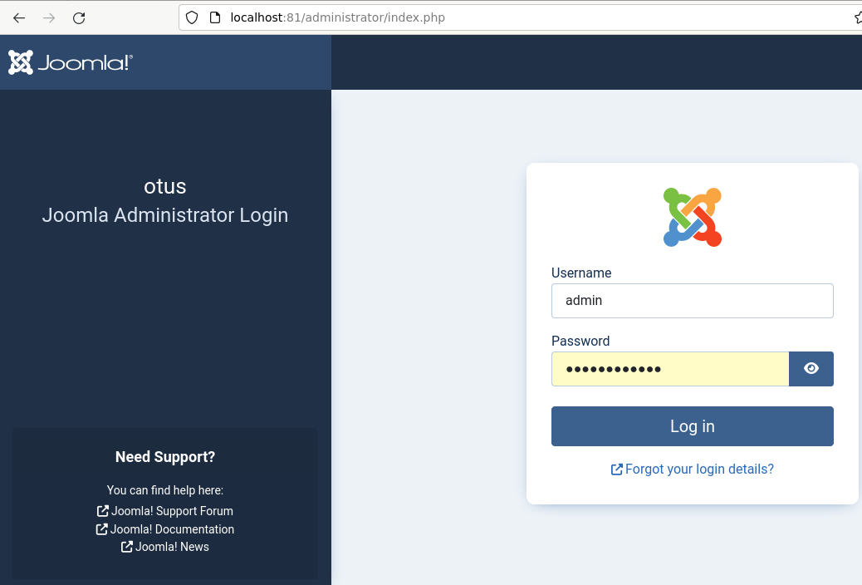

**Установка/настройка exporters**

apt-get install prometheus-node-exporter

http://localhost:9100/metrics

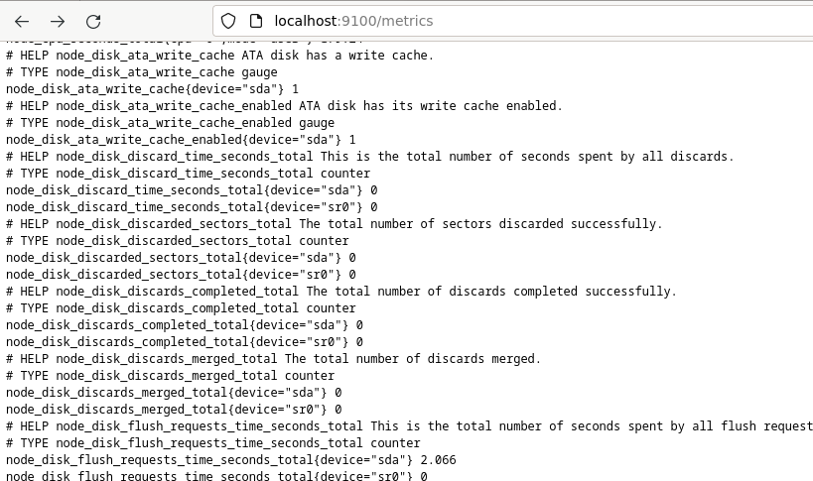

MySql exporter

<https://www.devopsschool.com/blog/install-and-configure-prometheus-mysql-exporter/>

apt-get install prometheus-mysqld-exporter

/etc/.mysqld_exporter.cnf

[client]

user=exporter

password=pas

chown root:prometheus /etc/.mysqld_exporter.cnf

Добавляем параметр для конфига при запуске сервиса /lib/systemd/system/prometheus-mysqld-exporter.service

--config.my-cnf /etc/.mysqld_exporter.cnf

systemctl daemon-reload

systemctl enable prometheus-mysqld-exporter

systemctl start prometheus-mysqld-exporter

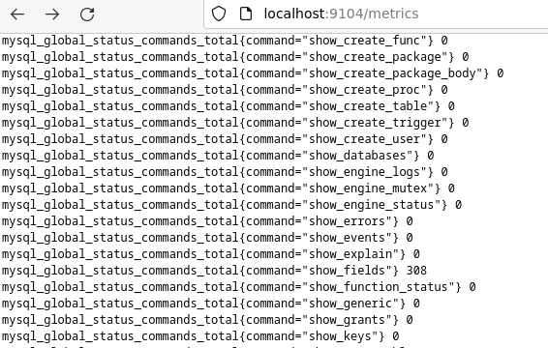

Blackbox exporter

<https://kirelos.com/how-to-monitor-website-performance-with-blackbox-exporter-and-grafana/>

Скачиваем, делаем кофиг для сервиса

wget https://github.com/prometheus/blackbox_exporter/releases/download/v0.24.0/blackbox_exporter-0.24.0.linux-amd64.tar.gz

tar -xzf blackbox_exporter-0.24.0.linux-amd64.tar.gz

[Unit]

Description=Blackbox Exporter Service

Wants=network-online.target

After=network-online.target

[Service]

Type=simple

User=root

Group=root

ExecStart=/etc/blackbox_eporter/blackbox_exporter --config.file==/etc/blackbox_eporter/blackbox.yml

[Install]

WantedBy=multi-user.target

systemctl daemon-reload

systemctl enable prometheus-blackbox-exporter

systemctl start prometheus-blackbox-exporter

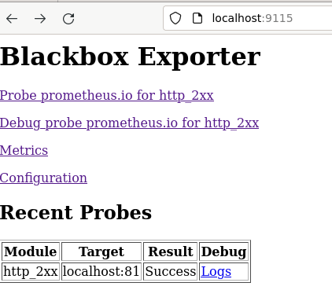

Один порт для метрик и аутентификация

Для использования одного порта добавил в NGIX настройки для перенаправления запросов

location /metrics/db/ {

proxy_pass http://localhost:9104/metrics;

}

location /metrics/node/ {

proxy_pass http://localhost:9100/metrics;

}

location /metrics/blackbox/ {

proxy_pass http://localhost:9115/;

}

И добавил базовую атентифкацию

htpasswd -c /etc/nginx/conf.d/.htpasswd prom

server{

...

auth_basic "Restricted Access!";

auth_basic_user_file /etc/nginx/conf.d/.htpasswd;

...

}

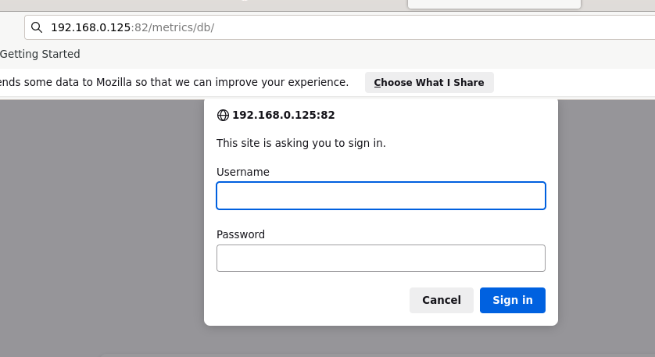

#### Настройка Prometheus

<https://computingforgeeks.com/how-to-install-prometheus-and-node-exporter-on-debian/>

groupadd --system prometheus

useradd -s /sbin/nologin --system -g prometheus prometheus

mkdir /var/lib/prometheus

for i in rules rules.d files_sd; do sudo mkdir -p /etc/prometheus/${i}; done

mkdir -p /tmp/prometheus &amp;&amp; cd /tmp/prometheus

curl -s https://api.github.com/repos/prometheus/prometheus/releases/latest|grep browser_download_url|grep linux-amd64|cut -d '"' -f 4|wget -qi -

tar xvf prometheus*.tar.gz

cd prometheus*/

mv prometheus promtool /usr/local/bin/

mv prometheus.yml /etc/prometheus/prometheus.yml

mv consoles/ console_libraries/ /etc/prometheus/

cd ~/

rm -rf /tmp/prometheus

Конфиг для сервиса

tee /etc/systemd/system/prometheus.service<<EOF

[Unit]

Description=Prometheus

Documentation=https://prometheus.io/docs/introduction/overview/

Wants=network-online.target

After=network-online.target

[Service]

Type=simple

User=prometheus

Group=prometheus

ExecReload=/bin/kill -HUP $MAINPID

ExecStart=/usr/local/bin/prometheus \

--config.file=/etc/prometheus/prometheus.yml \

--storage.tsdb.path=/var/lib/prometheus \

--web.console.templates=/etc/prometheus/consoles \

--web.console.libraries=/etc/prometheus/console_libraries \

--web.listen-address=0.0.0.0:9090 \

--web.external-url=

SyslogIdentifier=prometheus

Restart=always

[Install]

WantedBy=multi-user.target

EOF

for i in rules rules.d files_sd; do sudo chown -R prometheus:prometheus /etc/prometheus/${i}; done

for i in rules rules.d files_sd; do sudo chmod -R 775 /etc/prometheus/${i}; done

chown -R prometheus:prometheus /var/lib/prometheus/

Reload systemd daemon and start the service.

sudo systemctl daemon-reload

sudo systemctl start prometheus

sudo systemctl enable prometheus

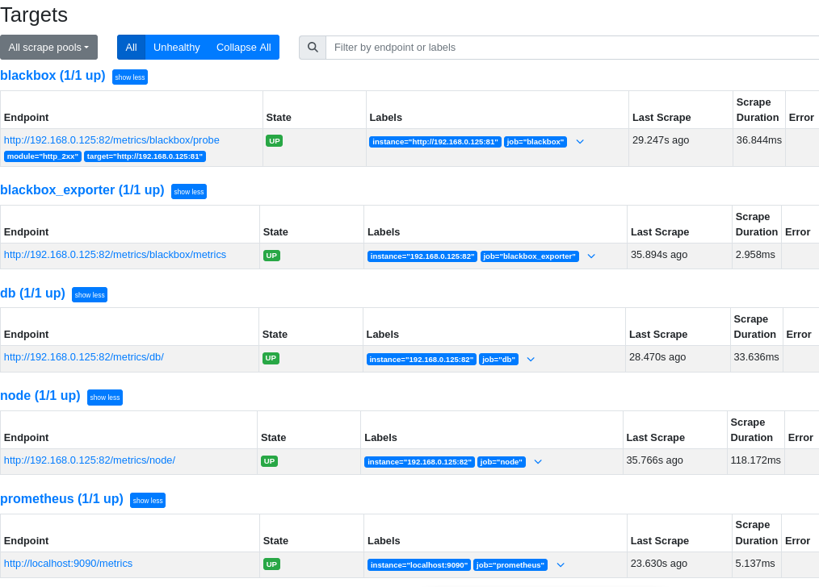

Конфиг

global:

scrape_interval: 15s

scrape_timeout: 10s

scrape_protocols:

- OpenMetricsText1.0.0

- OpenMetricsText0.0.1

- PrometheusText0.0.4

evaluation_interval: 15s

alerting:

alertmanagers:

- follow_redirects: true

enable_http2: true

scheme: http

timeout: 10s

api_version: v2

static_configs:

- targets: []

scrape_configs:

- job_name: prometheus

honor_timestamps: true

track_timestamps_staleness: false

scrape_interval: 15s

scrape_timeout: 10s

scrape_protocols:

- OpenMetricsText1.0.0

- OpenMetricsText0.0.1

- PrometheusText0.0.4

metrics_path: /metrics

scheme: http

enable_compression: true

follow_redirects: true

enable_http2: true

static_configs:

- targets:

- localhost:9090

- job_name: db

honor_timestamps: true

track_timestamps_staleness: false

scrape_interval: 15s

scrape_timeout: 10s

scrape_protocols:

- OpenMetricsText1.0.0

- OpenMetricsText0.0.1

- PrometheusText0.0.4

metrics_path: /metrics/db/

scheme: http

enable_compression: true

basic_auth:

username: prom

password: <secret>

follow_redirects: true

enable_http2: true

static_configs:

- targets:

- 192.168.0.125:82

- job_name: node

honor_timestamps: true

track_timestamps_staleness: false

scrape_interval: 15s

scrape_timeout: 10s

scrape_protocols:

- OpenMetricsText1.0.0

- OpenMetricsText0.0.1

- PrometheusText0.0.4

metrics_path: /metrics/node/

scheme: http

enable_compression: true

basic_auth:

username: prom

password: <secret>

follow_redirects: true

enable_http2: true

static_configs:

- targets:

- 192.168.0.125:82

- job_name: blackbox

honor_timestamps: true

track_timestamps_staleness: false

params:

module:

- http_2xx

scrape_interval: 15s

scrape_timeout: 10s

scrape_protocols:

- OpenMetricsText1.0.0

- OpenMetricsText0.0.1

- PrometheusText0.0.4

metrics_path: /metrics/blackbox/probe

scheme: http

enable_compression: true

basic_auth:

username: prom

password: <secret>

follow_redirects: true

enable_http2: true

relabel_configs:

- source_labels: [__address__]

separator: ;

regex: (.*)

target_label: __param_target

replacement: $1

action: replace

- source_labels: [__param_target]

separator: ;

regex: (.*)

target_label: instance

replacement: $1

action: replace

- separator: ;

regex: (.*)

target_label: __address__

replacement: 192.168.0.125:82

action: replace

static_configs:

- targets:

- http://192.168.0.125:81

- job_name: blackbox_exporter

honor_timestamps: true

track_timestamps_staleness: false

scrape_interval: 15s

scrape_timeout: 10s

scrape_protocols:

- OpenMetricsText1.0.0

- OpenMetricsText0.0.1

- PrometheusText0.0.4

metrics_path: /metrics/blackbox/metrics

scheme: http

enable_compression: true

basic_auth:

username: prom

password: <secret>

follow_redirects: true

enable_http2: true

static_configs:

- targets:

- 192.168.0.125:82