# Introduction where you discuss the business problem and who would be interested in this project

Milan is a city in northern Italy, capital of Lombardy, and the second-most populous city in Italy after Rome. Milan served as the capital of the Western Roman Empire, the Duchy of Milan and the Kingdom of Lombardy–Venetia. The city proper has a population of about 1.4 million while its metropolitan city has 3.26 million inhabitants. Its continuously built-up urban area, that stretches well beyond the boundaries of the administrative metropolitan city, is the fourth largest in the EU with 5.27 million inhabitants. The population within the wider Milan metropolitan area, also known as Greater Milan, is estimated at 8.2 million, making it by far the largest metropolitan area in Italy and the 4th largest in the EU. Milan is considered a leading alpha global city, with strengths in the field of the art, commerce, design, education, entertainment, fashion, finance, healthcare, media, services, research and tourism. Its business district hosts Italy's stock exchange (Italian: Borsa Italiana), and the headquarters of national and international banks and companies. In terms of GDP, it has the second-largest economy among EU cities after Paris and is the wealthiest among EU non-capital cities.

Milan is one of the best world cities to invest money, it has been recognized as one of the world's four fashion capitals thanks to several international events and fairs, including Milan Fashion Week and the Milan Furniture Fair, which are currently among the world's biggest in terms of revenue, visitors and growth. It hosted the Universal Exposition in 1906 and 2015. The city hosts numerous cultural institutions, academies and universities, with 11% of the national total enrolled students. Milan is the destination of 8 million overseas visitors every year, attracted by its museums and art galleries that include some of the most important collections in the world, including major works by Leonardo da Vinci. The city is served by many luxury hotels and is the fifth-most starred in the world by Michelin Guide. The city is home to two of Europe's most successful football teams, A.C. Milan and F.C. Internazionale, and one of Europe's main basketball teams, Olimpia Milano. Milan will host the 2026 Winter Olympics together with Cortina d'Ampezzo.

During the day and specifically during breakfast time (07:30 - 10:00) and lunch time (12:00 - 14:30) the areas with higher population density are struggling to manage the flow of people who want to treat themselves to a dessert.Within this scenario where the city continues to face a continuous population increase, we will go to analyze the possibility of opening a handicraft shop of sweets and coffee.

Milan has 9 town halls and our focus will be on Centro storico, Stazione centrale, Città studi, Porta vittoria, Vigentino, Barona, Baggio and Porta garibaldi.

# Data where you describe the data that will be used to solve the problem and the source of the data

* Wikipedia: list of all townhalls in Milan

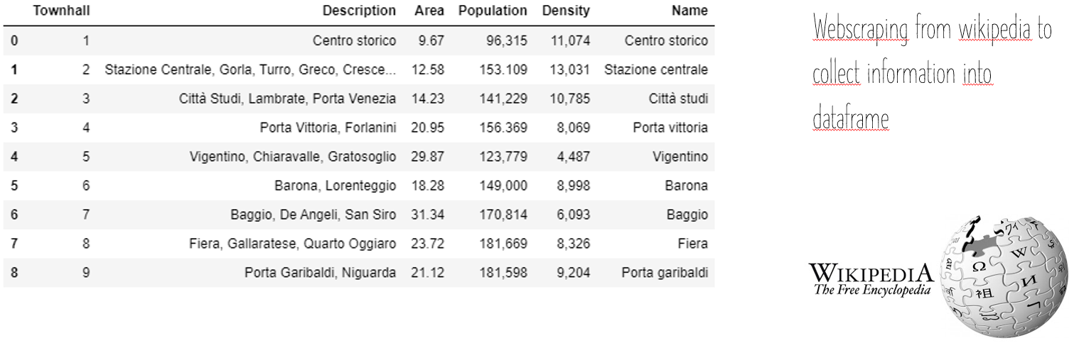

* Geopy: locating the coordinates of addresses, cities, countries and landmarks   
    
  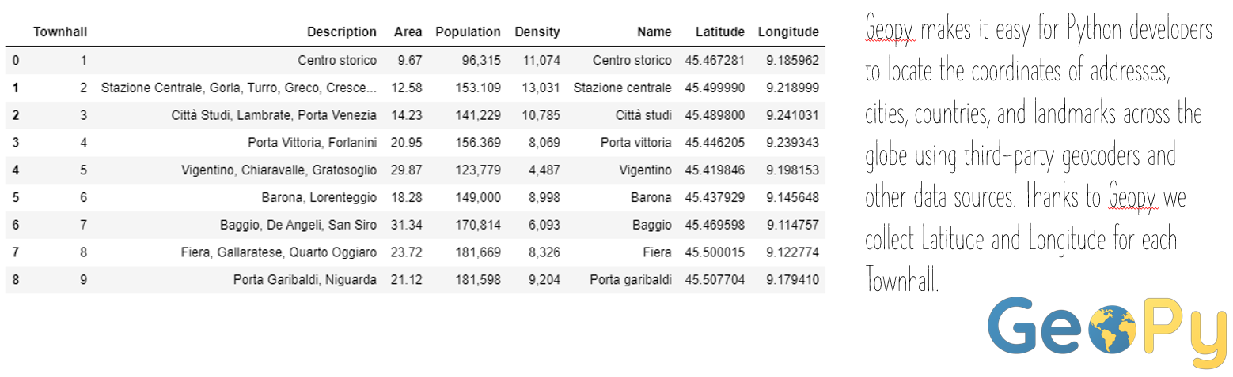
* [Mercato-immobiliare.info](http://www.mercato-immobiliare.info/): Average price (RealEstate)  
    
  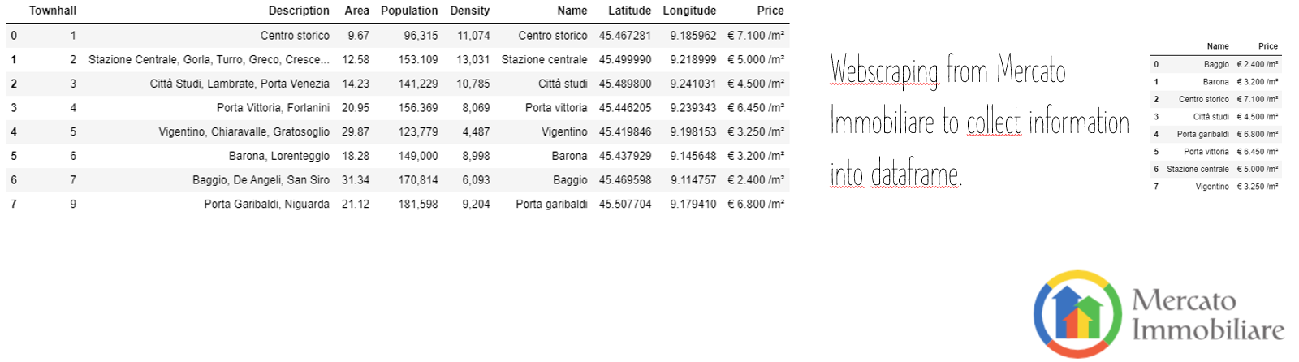
* Foursquare: Data of existing points of interests  
    
  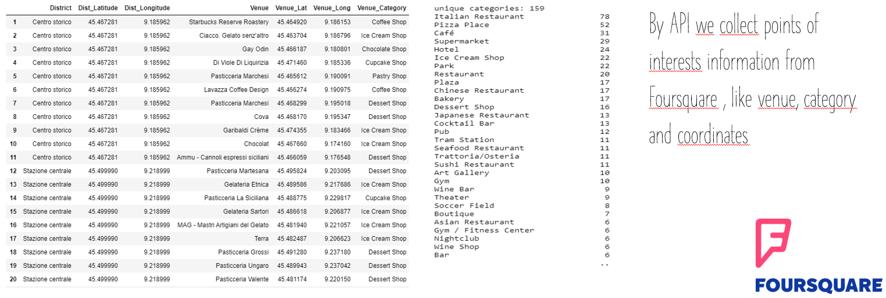

# Methodology section which represents the main component of the report where you discuss and describe any exploratory data analysis that you did, any inferential statistical testing that you performed, if any, and what machine learnings were used and why

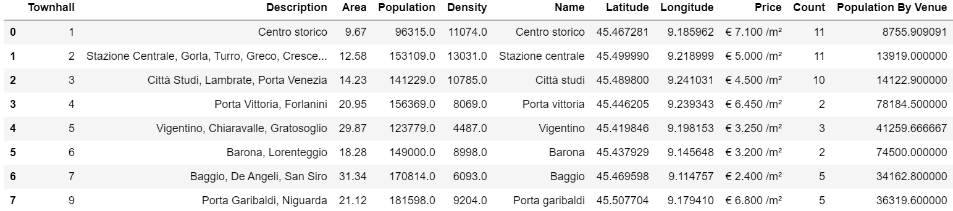

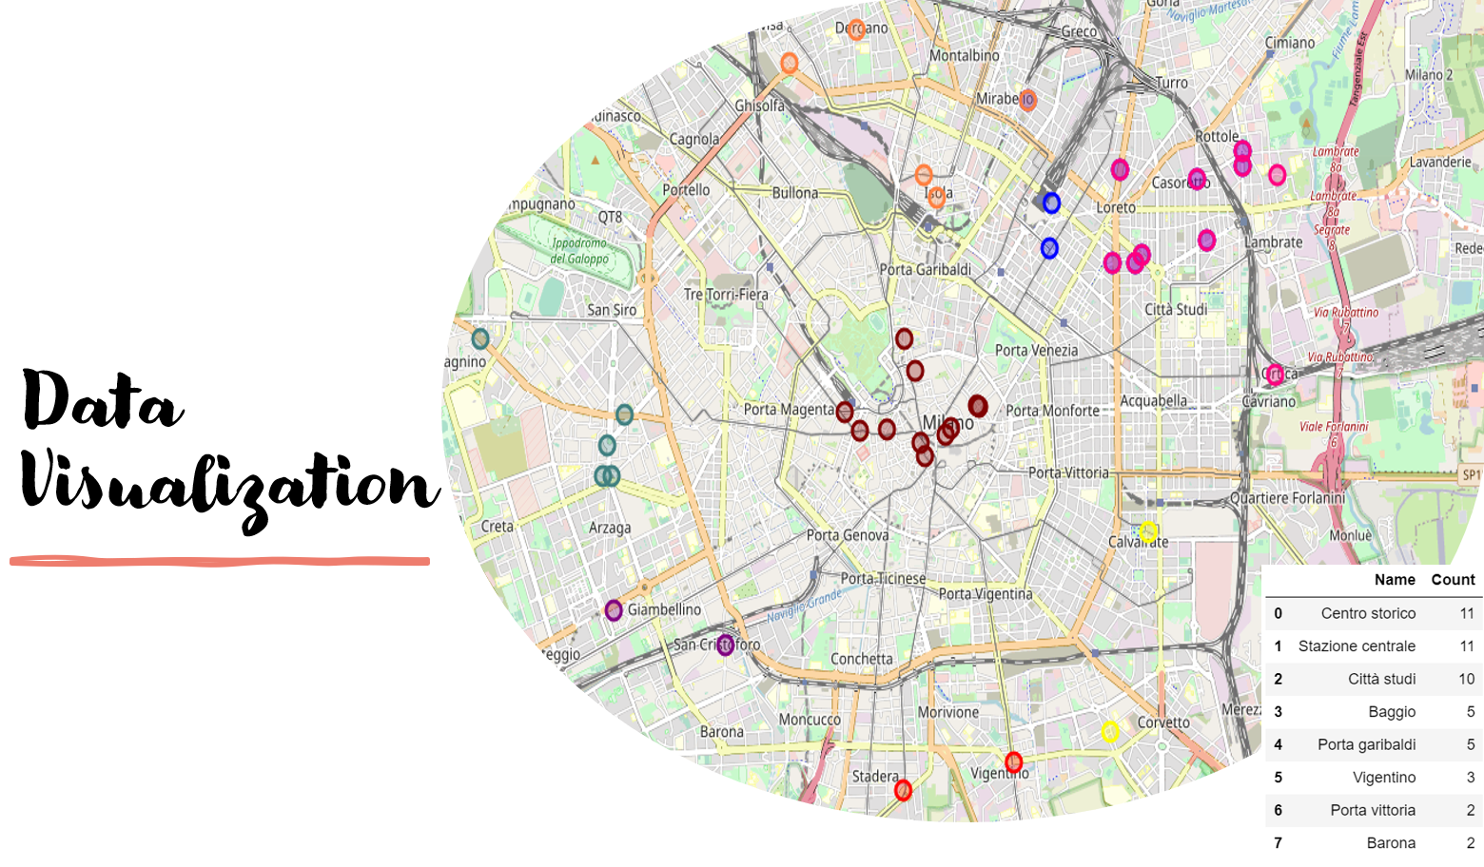

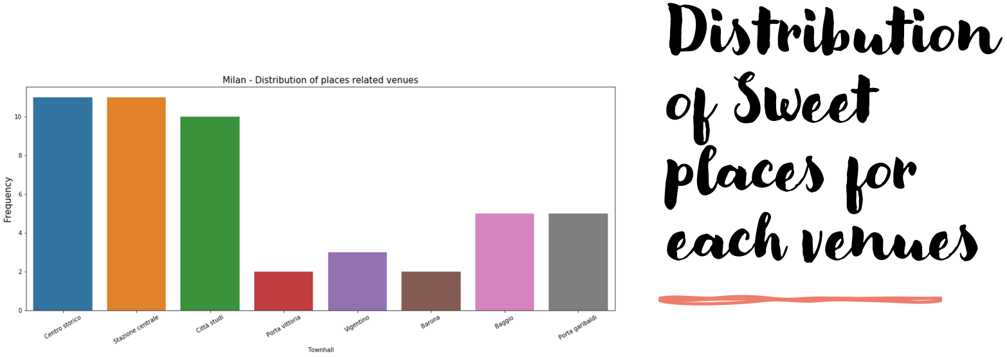

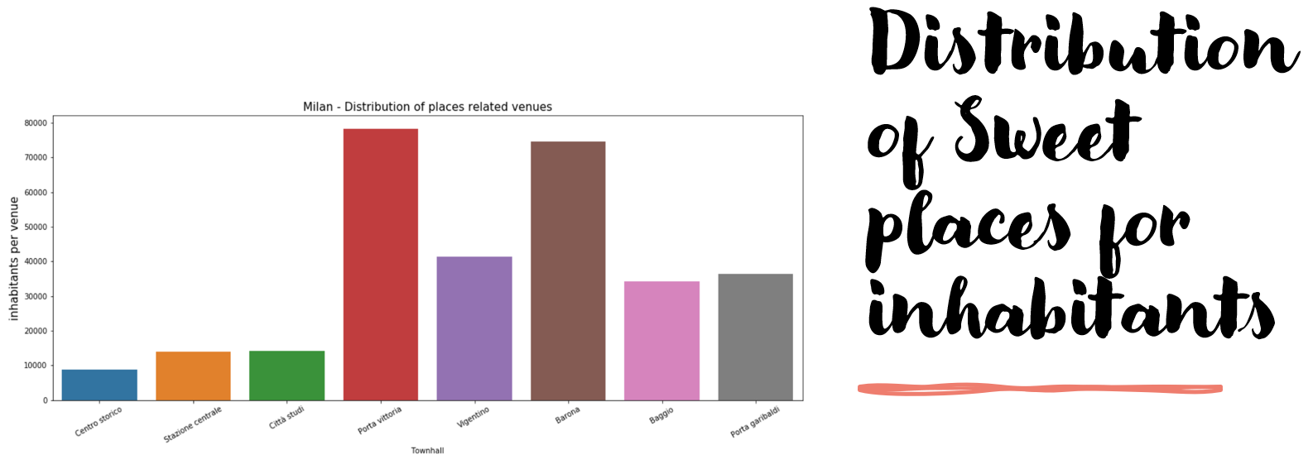

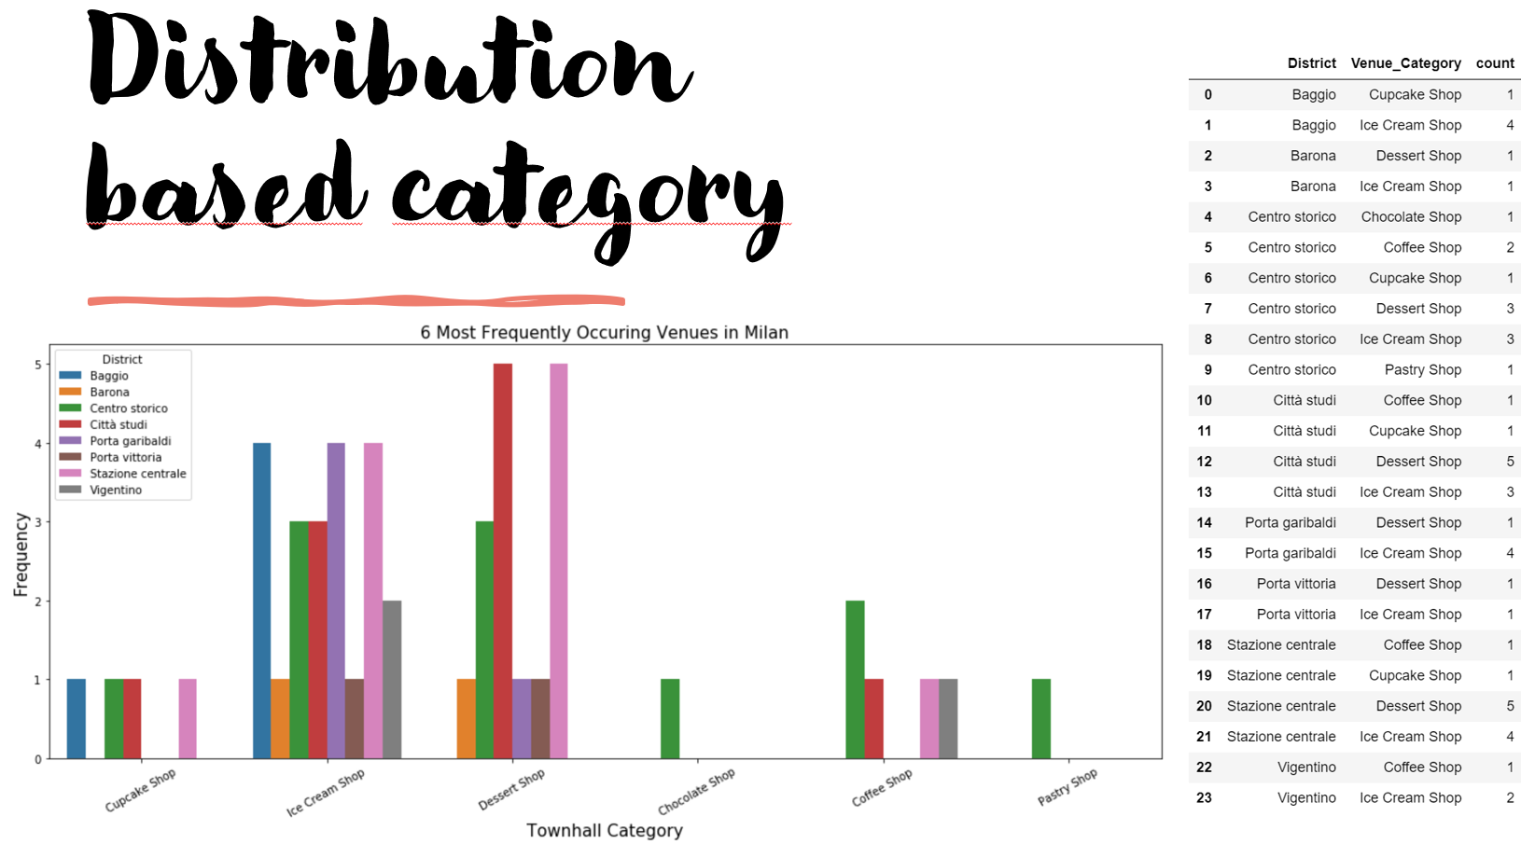

# Results section where you discuss the results

* Analysis shows that the number of places ( Cupcake, Ice Cream, Coffe, Chocolate, Dessert, Pastry) is quite low considering the population in Milan.
* Dessert & Ice Cream shops are the best category in Milan; these shops are concentrated in Stazione Centrale & Città Studi (North area of Milan).
* Porta Vittoria and Barona are the districts with the highest ratio inhabitants per townhall/venue (over than 70.000). Average real estate price shows Barona is cheaper than Porta Vittoria for 50% of the price.
* Porta Vittoria (Est Area) and Barona (South Area) are the districts with a small number of places in target.