Graph Theory Project
By Lucas Salvato
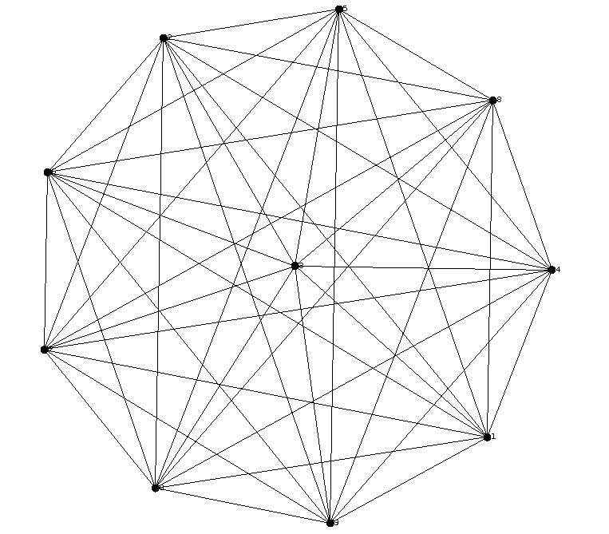

Table of Contents
Introduction 3
Installing 3
Instruction For Use 3
All The Application’s Actions 3
Create a Graph 4
Complete 4
Cycle 4
Print Graph Informations 5
Suppress Node 5
Complete 5
Cycle 5
Breadth First Search Algorithm 6
Dijkstra 7
Conclusion 7

Introduction

Installing

Instruction For Use

During the program utilization, you must choose action with a terminal menu, it’s really easy.
You just write the action’s id on the terminal menu to select the action.
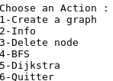
Menu Example
Action’s id
Action’s name

All The Application’s Actions

Create a Graph
In this application you can create two types of graph with the number of nodes chosen.

Complete
A complete graph consisting of vertices and line segments such that every line segments joins two vertices and every pair of vertices is connected by a line segment.
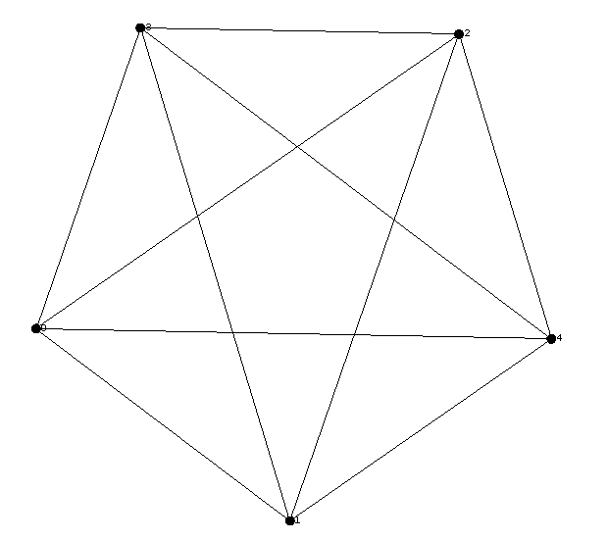
Complete graph with 5 nodes

Cycle
Cycle or circular graph is a graph thats consists of a single cycle. Every vertex has degree 2.
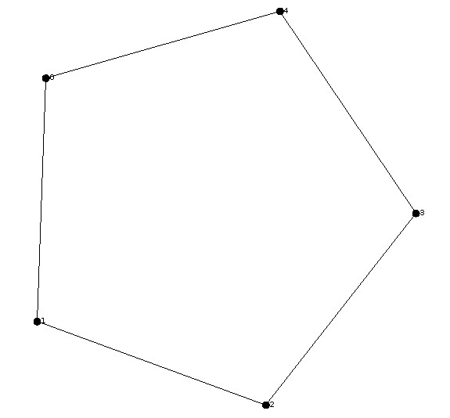
Cycle graph with 5 nodes

Print Graph Informations
You can print the informations of your graph choice, you find on this panel :
- The Graph’s name
- The Number of nodes
- The edges per nodes (“Node 1” - “Node 2”)
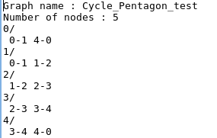
Information Panel example
Cycle graph with 5 nodes
Node’s name
Edge between two nodes

Suppress Node

Complete

Cycle

Breadth First Search Algorithm
BFS is a way to find all the vertices reachable from the a given source vertex, BFS travers a connected component of a given graph and defines a spanning tree.
BFS starts with the choosen vertex, which is at level 0. In the first stage, we visit all the vertices that are at the distance of one edge away. When we visit there, we paint as ”visited”, the vertices adjacent to the start vertex – these vertices are placed into level 1. In the second stage, we visit all the new vertices we can reach at the distance of two edges away from the source vertex. These new vertices, which are adjacent to level 1 vertices and not previously assigned to a level, are placed into level 2, and so on. The BFS terminates when every vertex has been visited.
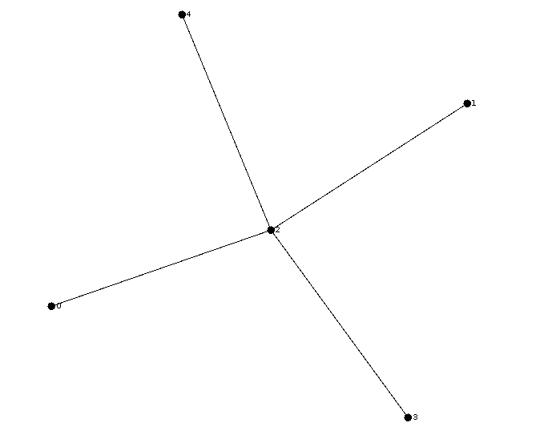
BFS on a complete graph, 2 is the source vertex

BFS on a cycle graph, 2 is the source vertex

Dijkstra

Conclusion

