CMPG 311
Project 1: Phase 2
Database Study for a Fast-Food restaurant
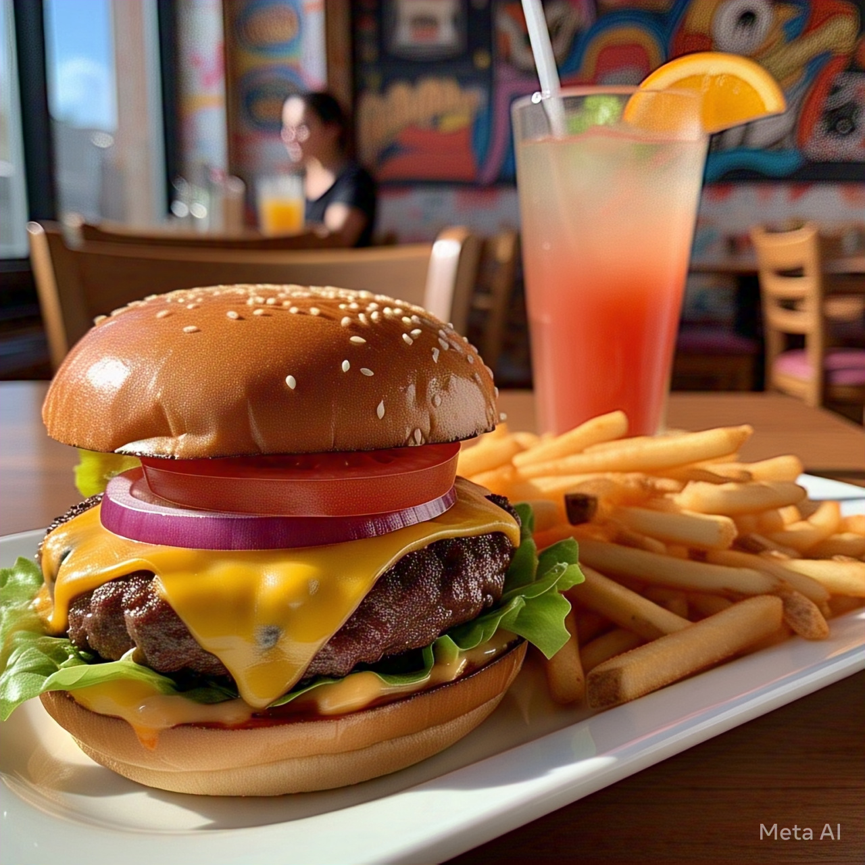

Contents
1. GROUP MEMBERS 3
1. Detailed Business Rules Derived from Company Operations 4
2. Entity-Relationship (ER) Diagram 5
2.1 ERD Details 5
2.2 ENTITY RELATIONSHIP DIAGRAM 7
3 . Logical Model 7

1. GROUP MEMBERS
Kayla Supra 37276204 – kaylasupra17@gmail.com

Londa Thulo 29457130 – 29457130@mynwu.ac.za


Wenzi Molomo 35337672 - 073 954 1966


Phase 2: Database Design for Yum-Yum Burgers

1. Detailed Business Rules Derived from Company Operations
Order Processing Rules:
- A customer order must contain at least one menu item.
- Orders cannot be modified once they enter the preparation phase.
- Orders must be completed within the standard preparation time (e.g., 10 minutes for fast food).
- Different menu items have different preparation times.
- Payment must be completed before an order is handed to the customer.
Cashier Rules:
- Cashiers must log all sales in the database.
- Refunds require manager approval.
- Discounts and promotions must be applied according to company policy.
Kitchen Rules:
- Kitchen staff must always follow food safety guidelines.
- Inventory levels must be updated when ingredients are used.
- Only authorized kitchen staff can prepare food orders.
Supplier Rules:
- Suppliers must deliver fresh ingredients based on pre-set schedules.
- Orders from suppliers must be approved by the manager.
- Low stock levels automatically trigger a reorder request.
Delivery Staff Rules:
- Delivery drivers must confirm order pickup and delivery in the system.
- Late deliveries beyond the expected time frame must be reported.
- Delivery staff must verify the customer’s details before handing over an order.
Employee Management Rules:
- Employees must clock in and out for each shift.
- Employees cannot work beyond the maximum allowed shift hours.

2. Entity-Relationship (ER) Diagram
(Include an ER diagram visual representation here)
Entities and Relationships:

2.1 ERD Details
Weak Entities
- Inventory can be considered weak since it relies on Supplier_ID for some of its data.
- Delivery could also be seen as weak since it requires Order_ID and Driver_ID to exist.

Bridge Entities
- Delivery acts as a bridge between Order and Employee (Driver).
Strong Relationships
- The Order and Customer relationship is strong since an order cannot exist without a customer.
- Employee and Delivery have a strong relationship because a driver must be assigned to a delivery.
Weak Relationships
- The Inventory and Supplier relationship is weak because Inventory depends on Supplier_ID but does not uniquely define the supplier.
Mandatory Relationships
- Order to Customer: An order must belong to a customer.
- Payment to Order: A payment must be linked to an order.
Super Entities
- Employee
- Payment
Subtype Entities
- Cashier
- Driver
- Chef
- Card
- Cash
Derived Attribute
- The total amount of an order is not stored directly but calculated from the sum of menu item prices and their quantities in Order_Menu.
Composite Key
- The primary key consists of two attributes (Order_ID, Item_ID), ensuring uniqueness for each menu item within a specific order.

2.2 ENTITY RELATIONSHIP DIAGRAM
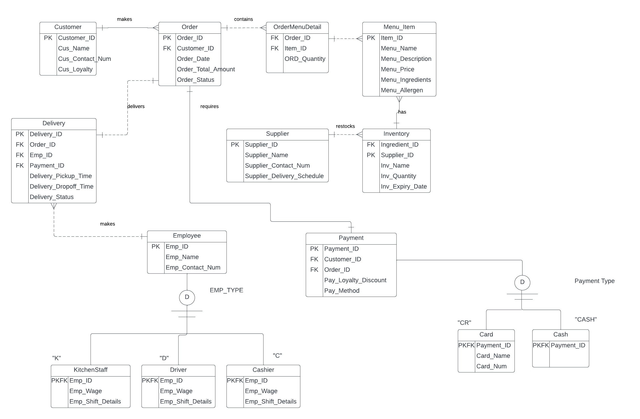

3 . Logical Model

- Customer (Customer_ID, Cus_Name, Cus_Contact_Num, Cus_Loyalty_Status)
- Order (Order_ID, Customer_ID, Timestamp, Status, Total Amount)
- Menu_Item (Item_ID, Menu_Name, Menu_Description, Menu_Price, Menu_Ingredients, Menu_Allergen)
- OrderMenuDetail(Order_ID, Item_ID, ORD_Quantity) (Bridge Entity resolving many-to-many Order-Menu relationship)
- Inventory (Ingredient_ID, Inv_Name, Inv_Quantity, Inv_Expiry_Date, Supplier_ID)
- Supplier (Supplier_ID, Supplier_Name, Supplier_Contact_Num, Supplier_Delivery_Schedule)
- Employee (Emp_ID, Emp_Name, Emp_Contact_Num)
- Delivery (Delivery_ID, Order_ID, Emp_ID, Delivery_Pickup_Time, Delivery_Dropoff_Time, Delivery_Status)
- Payment (Payment_ID, Order_ID, Pay_Method, Pay_Loyalty_Discount)
- Cash(Payment_ID, Card_Name, Card_Num)
- Card(Payment_ID)
- Driver (Emp_ID, Wage, Shift Details)
- KitchenStaff (Emp_ID, Wage, Shift Details)
- Cashier (Emp_ID, Wage, Shift Details)

