Friends aren’t food: pinyon jays show context-dependent numerical cognition

London M. Wolff1, Katherine Carey1, & Jeffrey R. Stevens1

1 Department of Psychology, Center for Brain, Biology & Behavior, University of Nebraska-Lincoln, Lincoln, NE, USA

Author note

London M. Wolff, <https://orcid.org/0000-0001-8359-2619>.

Jeffrey R. Stevens, <https://orcid.org/0000-0003-2375-1360>.

Correspondence concerning this article should be addressed to London M. Wolff, B83 East Stadium, University of Nebraska-Lincoln, Lincoln, NE, USA 68588. ORCID 0000-0001-8359-2619. E-mail: [lmwolff3@gmail.com](mailto:lmwolff3@gmail.com)

Abstract

Animals must often discriminate different quantities of objects in their environment, from food items to conspecifics. Yet we know little about how numerical cognitive abilities compare across different object types. Previous research shows individuals use both the numerical difference (large small) and numerical ratio (small/large) between two numbers to discriminate between them. This study investigates whether numerical difference and ratio predict preferences for quantities of food items and conspecifics in pinyon jays (*Gymnorhinus cyanocephalus*). In the food experiment, pinyon jays chose larger quantities of mealworms more when numerical differences were large and numerical ratios were small. However, numerical difference and ratio did not influence food choice independently. In the social experiment, when choosing between groups of conspecifics, pinyon jays did not prefer the larger over smaller group sizes and did not show numerical difference or ratio effects. Therefore, pinyon jays may use different cognitive processes when deciding between quantities of food items and conspecifics. While quantity was important for selecting food items, other factors such as individual identity may be more important for selecting social groups to join. Thus, the type of objects offered can drive the processes that animals use to choose among quantities.

*Keywords:* Corvid, Difference, Number, Quantity, Ratio

*Word count:* 2446

Friends aren’t food: pinyon jays show context-dependent numerical cognition

# Introduction

Many animal species have demonstrated the ability to quantify objects in their environment, including arthropods [1], fish [2–4], amphibians [5], birds [6–8], and mammals [9–12]. Quantification skills have strong adaptive value for survival and reproduction [10], playing roles in navigation, predator avoidance, territory defense, foraging, courtship, and mating [13–18]. Yet it remains unclear if the same cognitive processes apply across these different adaptive contexts.

One of the key cognitive processes proposed for quantification is the *approximate number system*, which involves the estimation of numerical quantity without relying on language or symbols [16,19]. The approximate number system is characterized by two key effects [20,21]. The *numerical distance effect* asserts that discrimination improves with increasing numerical difference between two values (i.e., mathematical difference between two numbers: 4 2 has a difference of 2). Discrimination becomes easier as the difference increases and the options become more dissimilar. The *numerical magnitude effect* asserts that discrimination worsens with increasing magnitude, which is equivalent to a decreasing numerical ratio (mathematical quotient between two numbers: 2/4 has a ratio of 0.5). Discrimination becomes more difficult as the numerical ratio approaches 1 and the options become more similar. Taken together, these two effects describe Weber’s Law [16], which indicates the use of approximate amounts rather than precise numbers.

Animals are sensitive to quantification across a range of object types [22,23]. Most of the tasks designed to measure numerical discrimination use food as quantifiable objects [11,12,24–26]. In line with the numerical distance effect, animals typically discriminate food quantities better when there are larger numerical differences [20,24,27,28] and smaller numerical ratios [20,29–32].

In addition to food, studies in fish have used numbers of conspecifics to assess quantification [2,33,34]. Many species prefer to be in larger groups, presumably because this dilutes their probability of being captured by predators [35,36]. Though some studies show an effect of both difference and ratio on social quantity preference [2,3], others only show an effect of ratio [33,37]. Little research has examined conspecific numerical choices in species other than fish.

The primary aim of the present study was to investigate how pinyon jays (*Gymnorhinus cyanocephalus*) use quantity information—specifically numerical difference and ratio—to choose between different quantities of food items or conspecifics. To address this aim, we offered pinyon jays a series of choices between smaller and larger numbers of either food or conspecifics. Our first hypothesis posits that pinyon jays will, on average, prefer larger over smaller numbers of food items and conspecifics. Our second hypothesis posits that pinyon jays will prefer more items when the quantities have higher numerical differences and lower numerical ratios. Our third hypothesis posits that both numerical difference and ratio will influence preference independently of each other. This distinction is important because difference and ratio are highly related: as difference increases, ratio decreases. Testing these hypotheses in two different object types investigates whether the same cognitive processes generalize across adaptive contexts.

# Methods

We conducted experiments to investigate quantification of both food and conspecifics. Each experiment was replicated with two sets of birds, where most birds experienced both the food and social experiment. Additional methods, videos, data analysis, and visuals are available in the supplementary material (<https://osf.io/g45nk/>).

## Subjects

Replicate 1: Eight pinyon jays (1 female) completed all rounds of the food experiment, and 10 jays (4 female) completed all rounds of the social experiment (Table S1). A further 17 jays (6 female) were used as stooge conspecifics in the social experiment. Two jays were dropped from the social experiment due to unrelated health concerns.

Replicate 2: Four pinyon jays (1 female) completed all rounds of the food experiment, and 10 jays (1 female) completed all rounds of the social experiment (Table S1). A further 12 jays (5 female) from the colony were used as stooge conspecifics in the social experiment.

The jays in the food experiment were housed in pairs, while the subjects in the social experiment were individually housed and the stooges were group housed. The subjects were not food restricted in either experiment.

## Food Experiment

### Apparatus.

The food experiment was conducted in a bird cage with three perches. The cage abutted a plastic stand with sliding trays that had dishes attached that could contain mealworms (Figure S1).

### Experimental Procedure.

At the beginning of each trial, the experimenter placed the appropriate number of mealworms in each of the dishes. The subject hopped forward to one of the front perches to signal choice. The experimenter then removed the opposite dish, and the subject had up to three minutes to consume the mealworms. Once the subject consumed all mealworms, the next trial began. Each bird experienced 10 repetitions for each of the 15 numerical pairs between 1 and 6 (Table S2). The side of the larger option was pseudo-randomized with no left or right runs longer than three in a row. The pairs were organized into blocks with one instance of each pair per block and order randomized within each block.

## Social Experiment

### Apparatus.

The apparatus was a Y maze where the subject entered a large chamber at the base of the maze and could choose one of two arms. Doors separated the entrance chamber from the arms, which had large bird cages at the ends that housed the stooge birds (Figure S2).

### Experimental Procedure.

The experimenter held the subject inside the apparatus and showed them each option for six seconds before releasing them into the entrance chamber. Once the subject crossed the threshold of one of the doors, both doors were gently closed. After three minutes elapsed, the handler collected the subject and returned them to their home cage.

Each subject experienced five trials (replicate 1) or ten trials (replicate 2) for each of the numerical pairs between 1 and 6 (replicate 1). For replicate 2, we used all numerical pairs between 1 and 6 except those that required more than 8 birds (due to the constraints on the number of stooge conspecifics; Table S2). The side of the larger option was pseudo-randomized with no left or right runs longer than three consecutive trials. The pairs were organized into blocks with one instance of each pair per block and pairs randomized within each block.

## Data Analysis

All data were analyzed using the same pre-registered analyses (<https://aspredicted.org/RVH_MNB>) in R version 4.2.2 [38]. To test the first hypothesis, whether pinyon jays prefer larger over smaller quantities of food items and conspecifics, we conducted frequentist and Bayesian one sample t-tests.

To test our second and third hypotheses, whether numerical difference and ratio predict preferences between smaller and larger options independently, we used generalized linear mixed-effects modeling. We used trial-level choices for either the larger or smaller option as the response variable. To investigate our hypotheses, we used model selection to compare which combination of random (subject, number pair, or both) and fixed (ratio, difference, or a combination of both) effects best describe each data set (food and social)(Table S3). We draw inferences based on Bayesian statistics (BF values) where a BF > 3 is sufficient evidence for the alternative hypothesis, BF < 1/3 is sufficient evidence for the null hypothesis, and 1/3 < BF < 3 indicate neither hypothesis has evidence supporting it, suggesting the sample size is too small to draw conclusions [39].

# Results

## Food Experiment

Our first hypothesis predicted that subjects would on average choose the larger number of mealworms over the smaller number across all of the numerical pairs. One sample t-tests provided sufficient evidence that preferences were above chance (50%) in both replicate 1 (, , ) and replicate 2 (, , ).

To test our second and third hypotheses, we used model selection on generalized linear mixed models. For both replicates, the best-fitting random effect structure was no random effect structure. For the fixed effect model comparison, the model with only the main effect of ratio best fit both data sets (Replicate 1: , Replicate 2: ). Thus, subjects in the food experiment used the ratio between the two numbers of mealworms to choose between options, with stronger preferences for larger options at smaller ratios (Figure ). The model with the main effect of difference showed evidence supporting stronger preferences for larger options at larger differences for replicate 1 but not replicate 2 (Replicate 1: , Replicate 2: ). Consequently, this only partially supports our second hypothesis (Figure ). Additionally, our third hypothesis was not supported, as the interaction model with difference and ratio was either indeterminate (Replicate 1: ) or was outperformed by the null model (Replicate 2: ) (see Tables S4 and S5 for full results).

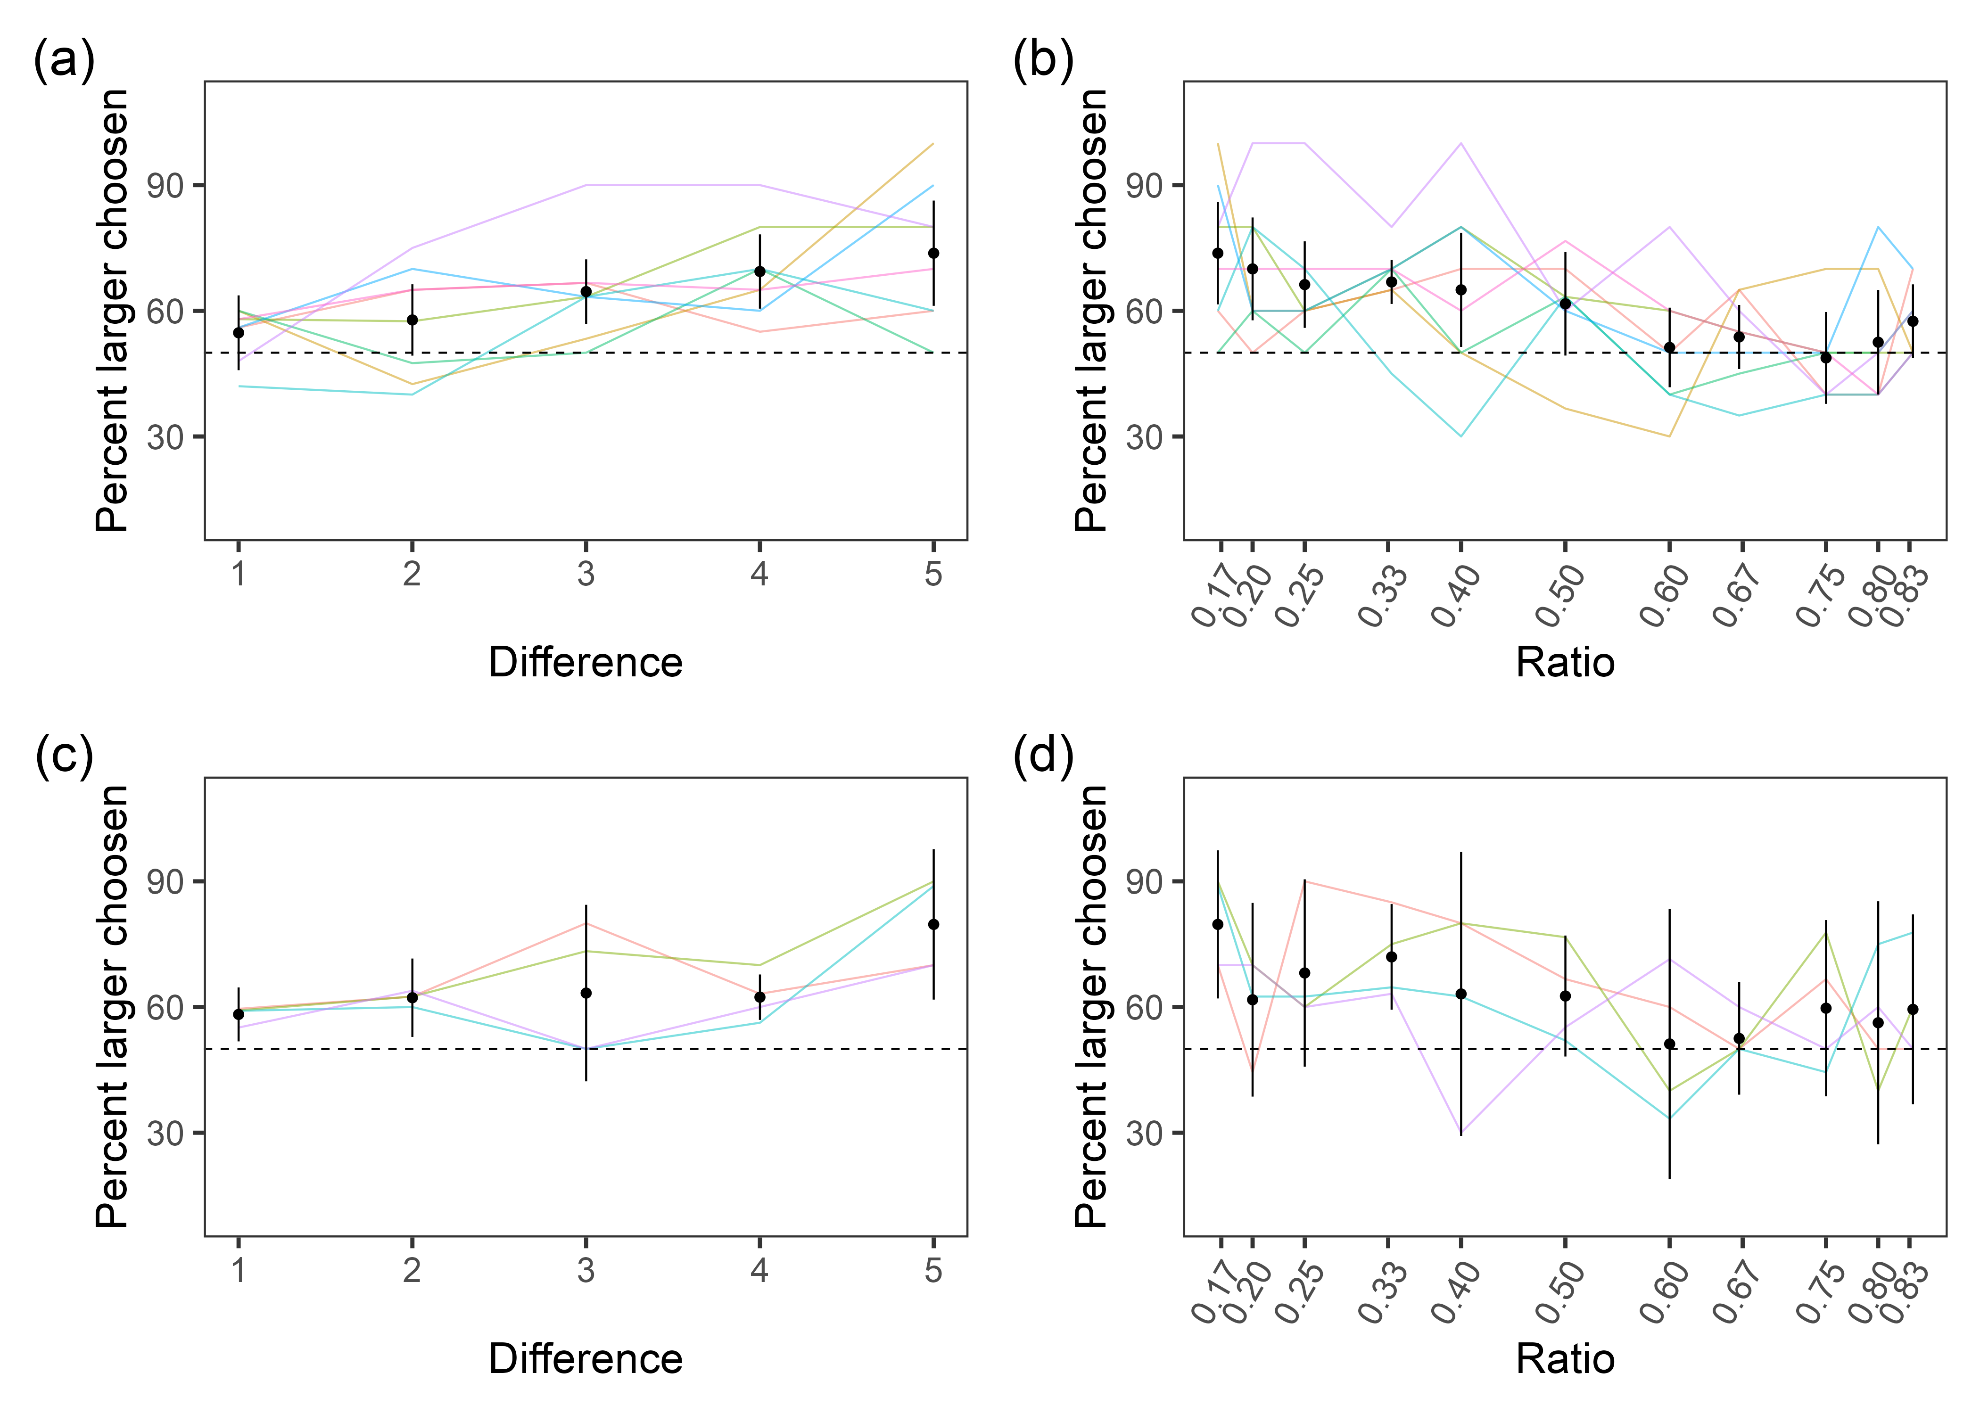

*Figure* *1.*  Food experiment difference and ratio results for both replicates. Mean preference for the larger option is shown on the y axis with the numerical difference or ratio values on the x axis. (a) Preference for larger per difference in replicate 1. (b) Preference for larger per ratio in replicate 1. (c) Preference for larger per difference in replicate 2. (d) Preference for larger per ratio in replicate 2. Dots represent mean values across subjects and trials. Error bars represent 95% within-subject confidence intervals. Lines represent individual subject data. Figure used with permission under a CC-BY4.0 license: Wolff et al. (2022); available at <https://doi.org/10.31234/osf.io/kxgwt>.

## Social Experiment

Hypothesis 1 predicted that subjects would choose the larger number of flock mates over the smaller. One sample t-tests provided evidence that our hypothesis was supported in replicate 1 (, 95% CI , , , ) but not supported in replicate 2 (, 95% CI , , , ).

For hypotheses 2 and 3, we again used model selection. Models with no random effect structure performed best. For fixed effects, the intercept only model best fit the data (Replicate 1: , Replicate 2: ), suggesting that neither ratio nor difference influenced choice. Because no model other than the intercept only had evidence suggesting that it was true, neither hypotheses 2 or 3 were supported by the data (Figure ).

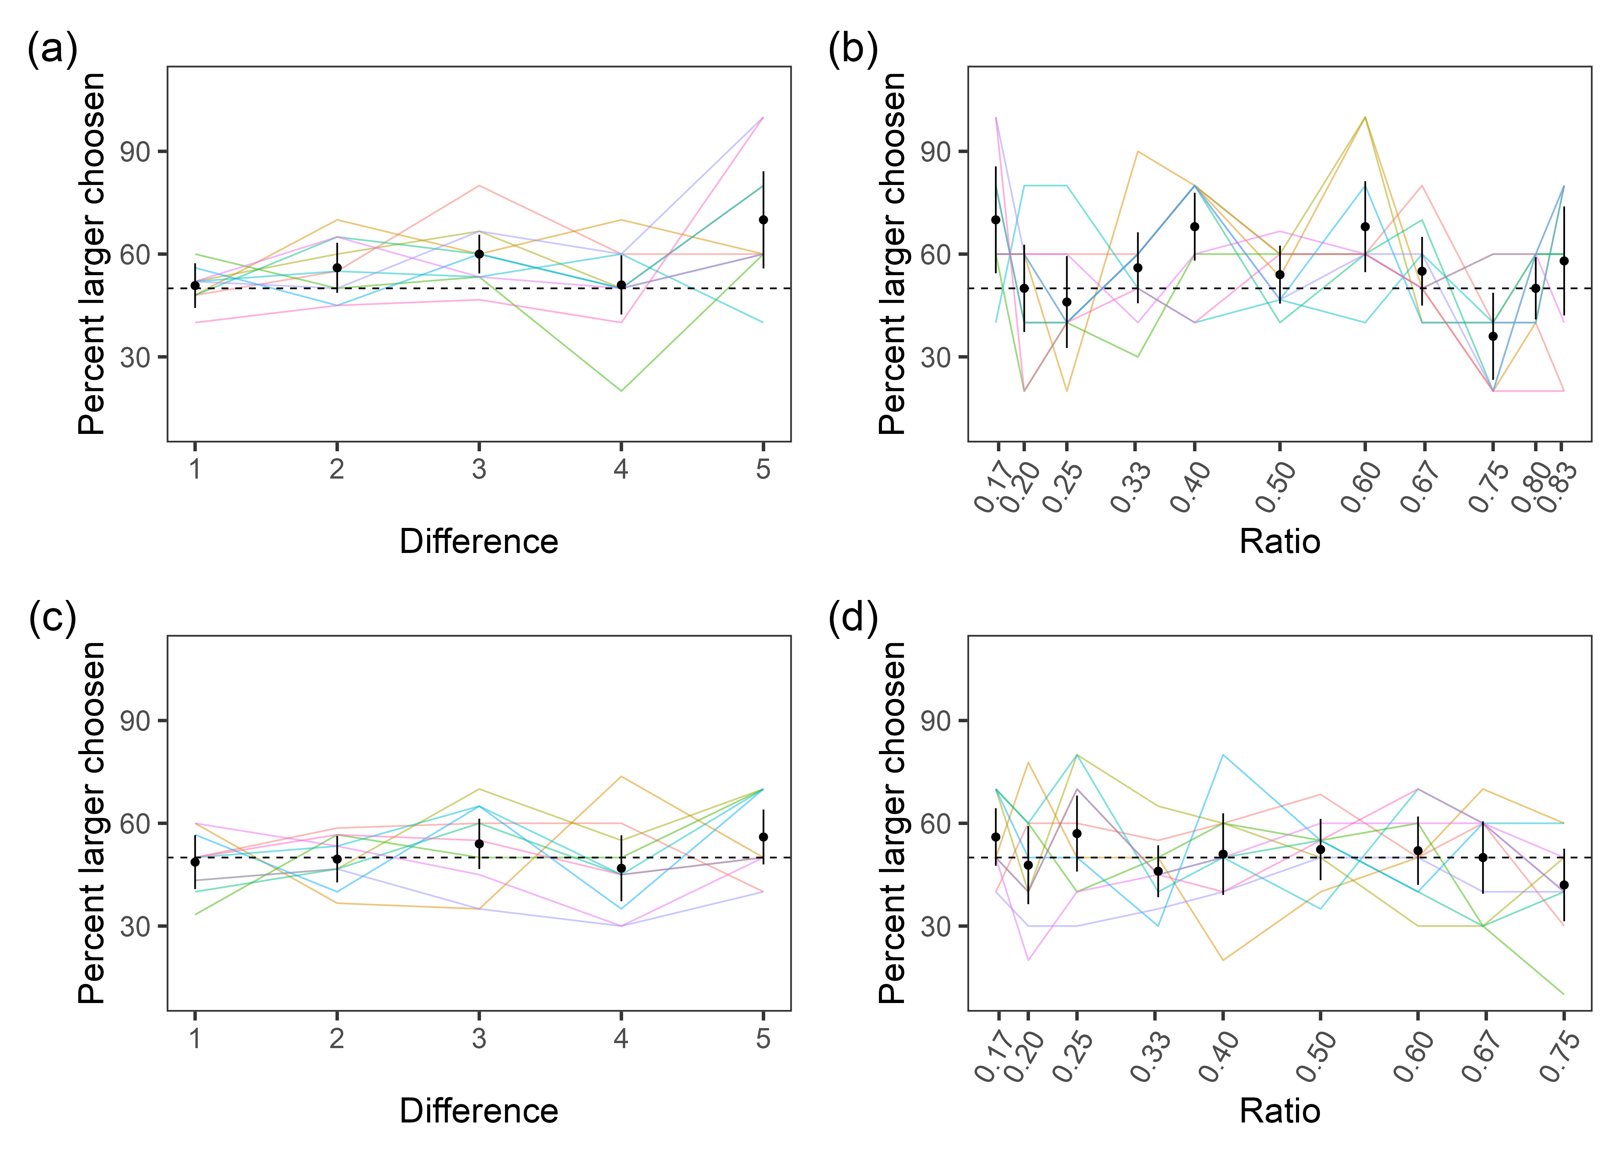

*Figure* *2.*  Social experiment difference and ratio results for both replicate 1 and 2. Mean preference for the larger option is shown on the y axis with the numerical difference or ratio values on the x axis. (a) Preference for larger per difference in replicate 1. (b) Preference for larger per ratio in replicate 1. (c) Preference for larger per difference in replicate 2. (d) Preference for larger per ratio in replicate 2. Dots represent mean values across subjects and trials. Error bars represent 95% within-subject confidence intervals. Lines represent individual subject data. Figure used with permission under a CC-BY4.0 license: Wolff et al. (2022); available at <https://doi.org/10.31234/osf.io/kxgwt>.

# Discussion

We examined pinyon jays’ quantitative abilities in choosing between different numbers of food items and social partners. Over all numerical pairs, birds chose the larger of the two options in the food experiment but not in the social experiment, partially confirming our first hypothesis. In the food experiment, smaller numerical ratios predicted the birds’ choices but only in the first replicate did larger differences predict birds’ choices, partially confirming our second hypothesis. In the social experiment, neither ratio nor difference predicted choice, contradicting our second hypothesis. In both the food and social experiments, difference and ratio did not independently predict choice, contradicting our third hypothesis.

In the food experiment, our pinyon jays preferred larger over smaller quantities more as the numerical ratios decrease, which aligns with previous corvid research demonstrating a numerical magnitude effect [20,24,27]. This provides evidence for pinyon jays using the approximate number system as a mechanism for quantification. While we did find evidence for the numerical distance effect in our first replicate, it seemed to be driven primarily by the ratio effect.

In the social experiment, neither ratio nor difference predicted choice, suggesting that pinyon jays do not employ a single mechanism across object types. This outcome is surprising, as previous quantification tasks with conspecifics in fish found effects of difference and ratio [2,3], suggesting that the mechanisms underlying quantification in food and social partners differ. The differences in numerical preference between food and social contexts may be due to different selective pressures. Both foraging techniques and flock size have consequences for evolutionary fitness, but they tackle different adaptive problems. Food consumption acts primarily via natural selection by enhancing survival. Flock size, however, is integral to both natural and sexual selection: natural selection in the form of predator avoidance and sexual selection in the form of mate preference. Joining a larger flock allows an animal to dilute their chances of being eaten by predators (i.e., the dilution effect) but also provides a larger pool of potential mates. For food items and predation risk, only number matters. But for mate preference or other social preferences, the identity of the partners matters.

One possible explanation for the lack of a ratio or difference effect for the social preference task is that individual identity of birds overrides the importance of number. An exploratory follow-up analysis of our data showed wide variation in preferences for groups that contained individual stooge birds (Figure S3; Table S6). Interestingly, choices do not differ depending on the sex of the stooge (see Supplementary Materials). Pinyon jays have complex, long-term bonds with other flock members and mates [40], which may make identity of group mates more important than sheer numbers. Moreover, the birds in our studies did not experience signals of predation danger during the experiment. Without pressure to dilute risk in larger groups, the birds may have ignored group size, allowing them to use other information such as social partner identity to determine choice.

Our study design does not allow us to pinpoint the exact features by which the birds make these quantitative choices. For the food preference tasks, the birds may choose larger *numbers* of food items or larger *amounts* of them. Using number involves tracking the quantity of individuated objects. However, in many cases, animals choose based on amount, which refers to other measures or proxies of quantity such as item size, surface area, volume, perimeter, and density [5,41–43]. It is possible that our jays used, for example, surface area to choose their food items. This is a reasonable criteria because surface area may be a better proxy of total calories than absolute number. Future work is needed to tease apart which features birds use to make quantitative decisions.

## Conclusion

This research investigated how pinyon jays assess quantities of food items and conspecifics in preference tasks. For food items, numerical ratio predicted their choices in both replicates while numerical difference predicted choice in only the first replicate, but neither ratio nor difference predicted choices in the social experiment. Though quantity is important for selecting food items, other factors such as flock mate identity may be more important for selecting social groups to join. Thus, in quantification situations, the type of objects to be quantified may drive the cognitive processes that animals use. Furthermore, many adaptive problems beyond foraging require sensitivity to quantities, and we encourage further exploration of numerical cognition of non-food objects.

## Acknowledgments

This research was funded by a National Science Foundation grant (NSF-1658837). We would like to thank Kylie Hughes, Toria Biancalana, Hailey Wilson, Bailey Wilson, Isaac Martinez, and Rachel Bruner for helping run the experiments and care for our birds.

## Author Contributions

**Wolff:** Conceptualization, Data Curation, Formal Analysis, Methodology, Project Administration, Resources, Software, Supervision, Validation, Visualization, Writing – Original Draft Preparation, Writing-review & editing. **Trevino:** Investigation, Project Administration, Resources, Visualization, Writing – Review & Editing. **Stevens:** Conceptualization, Formal Analysis, Funding Acquisition, Methodology, Investigation, Software, Supervision, Validation, Visualization, Writing – review & editing.

## Conflict of interest

The authors declared that no conflicts of interest exist.

## Data Availability

The data and analysis code are available at: <https://osf.io/g45nk/>.

## Ethics approval

All procedures were conducted in an ethical and responsible manner, in full compliance with all relevant codes of experimentation and legislation and were approved by the UNL Institutional Animal Care and Use Committee (protocols #1709 and #2059).

# References

1. Dacke M, Srinivasan MV. 2008 Evidence for counting in insects. *Animal Cognition* **11**, 683–689. (doi:[10.1007/s10071-008-0159-y](https://doi.org/10.1007/s10071-008-0159-y))

2. Agrillo C, Dadda M, Serena G, Bisazza A. 2008 Do fish count? Spontaneous discrimination of quantity in female mosquitofish. *Animal Cognition* **11**, 495–503. (doi:[10.1007/s10071-008-0140-9](https://doi.org/10.1007/s10071-008-0140-9))

3. Agrillo C, Dadda M. 2007 Discrimination of the larger shoal in the poeciliid fish Girardinus falcatus. *Ethology Ecology & Evolution* **19**, 145–157. (doi:[10.1080/08927014.2007.9522574](https://doi.org/10.1080/08927014.2007.9522574))

4. Agrillo C, Piffer L, Bisazza A. 2011 Number versus continuous quantity in numerosity judgments by fish. *Cognition* **119**, 281–287. (doi:[10.1016/j.cognition.2010.10.022](https://doi.org/10.1016/j.cognition.2010.10.022))

5. Uller C, Jaeger R, Guidry G, Martin C. 2003 Salamanders (Plethodon cinereus) go for more: Rudiments of number in an amphibian. *Animal Cognition* **6**, 105–112. (doi:[10.1007/s10071-003-0167-x](https://doi.org/10.1007/s10071-003-0167-x))

6. Xia L, Emmerton J, Siemann M, Delius JD. 2001 Pigeons (Columba livia) learn to link numerosities with symbols. *Journal of Comparative Psychology (Washington, D.C.: 1983)* **115**, 83–91. (doi:[10.1037/0735-7036.115.1.83](https://doi.org/10.1037/0735-7036.115.1.83))

7. Emmerton J, Renner JC. 2006 Scalar effects in the visual discrimination of numerosity by pigeons. *Learning & Behavior* **34**, 176–192. (doi:[10.3758/BF03193193](https://doi.org/10.3758/BF03193193))

8. Emmerton J, Renner JC. 2009 Local rather than global processing of visual arrays in numerosity discrimination by pigeons (Columba livia). *Animal Cognition* **12**, 511–526. (doi:[10.1007/s10071-009-0212-5](https://doi.org/10.1007/s10071-009-0212-5))

9. Vonk J, Beran MJ. 2012 Bears ‘count’ too: Quantity estimation and comparison in black bears, Ursus americanus. *Animal Behaviour* **84**, 231–238. (doi:[10.1016/j.anbehav.2012.05.001](https://doi.org/10.1016/j.anbehav.2012.05.001))

10. Nieder A. 2018 Evolution of cognitive and neural solutions enabling numerosity judgements: Lessons from primates and corvids. *Philosophical Transactions of the Royal Society B: Biological Sciences* **373**, 20160514. (doi:[10.1098/rstb.2016.0514](https://doi.org/10.1098/rstb.2016.0514))

11. Call J. 2000 Estimating and operating on discrete quantities in Orangutans (Pongo pygmaeus). *Journal of Comparative Psychology* **114**, 136–147. (doi:[10.1037/0735-7036.114.2.136](https://doi.org/10.1037/0735-7036.114.2.136))

12. Beran M. 2001 Summation and numerousness judgments of sequentially presented sets of items by chimpanzees (Pan troglodytes). *Journal of comparative psychology (Washington, D.C. : 1983)* **115**, 181–91. (doi:[10.1037//0735-7036.115.2.181](https://doi.org/10.1037//0735-7036.115.2.181))

13. White DJ, Ho L, Freed-Brown G. 2009 Counting Chicks Before They Hatch: Female Cowbirds Can Time Readiness of a Host Nest for Parasitism. *Psychological Science* **20**, 1140–1145. (doi:[10.1111/j.1467-9280.2009.02418.x](https://doi.org/10.1111/j.1467-9280.2009.02418.x))

14. Carazo P, Fernández-Perea R, Font E. 2012 Quantity Estimation Based on Numerical Cues in the Mealworm Beetle (Tenebrio molitor). *Frontiers in Psychology* **3**, 502. (doi:[10.3389/fpsyg.2012.00502](https://doi.org/10.3389/fpsyg.2012.00502))

15. Arak A. 1983 Vocal interactions, call matching and territoriality in a Sri Lankan treefrog, Philautus leucorhinus (Rhacophoridae). *Animal Behaviour* **31**, 292–302. (doi:[10.1016/S0003-3472(83)80199-7](https://doi.org/10.1016/S0003-3472(83)80199-7))

16. Nieder A. 2020 The Adaptive Value of Numerical Competence. *Trends in Ecology & Evolution* **35**, 605–617. (doi:[10.1016/j.tree.2020.02.009](https://doi.org/10.1016/j.tree.2020.02.009))

17. Agrillo C, Miletto Petrazzini ME, Bisazza A. 2017 Numerical abilities in fish: A methodological review. *Behavioural Processes* **141**, 161–171. (doi:[10.1016/j.beproc.2017.02.001](https://doi.org/10.1016/j.beproc.2017.02.001))

18. Yang T-I, Chiao C-C. 2016 Number sense and state-dependent valuation in cuttlefish. *Proceedings of the Royal Society B: Biological Sciences* **283**, 20161379. (doi:[10.1098/rspb.2016.1379](https://doi.org/10.1098/rspb.2016.1379))

19. Feigenson L, Dehaene S, Spelke E. 2004 Core systems of number. *Trends in Cognitive Sciences* **8**, 307–314. (doi:[10.1016/j.tics.2004.05.002](https://doi.org/10.1016/j.tics.2004.05.002))

20. Ditz HM, Nieder A. 2016 Numerosity representations in crows obey the Weber–Fechner law. *Proceedings of the Royal Society B: Biological Sciences* **283**, 20160083. (doi:[10.1098/rspb.2016.0083](https://doi.org/10.1098/rspb.2016.0083))

21. Dehaene S, Dehaene-Lambertz G, Cohen L. 1998 Abstract representations of numbers in the animal and human brain. *Trends in Neurosciences* **21**, 355–361. (doi:[10.1016/S0166-2236(98)01263-6](https://doi.org/10.1016/S0166-2236(98)01263-6))

22. Agrillo C, Beran MJ. 2013 [Number without language: Comparative psychology and the evolution of numerical cognition](https://www.academia.edu/6879466/Number_without_language_comparative_psychology_and_the_evolution_of_numerical_cognition). *Frontiers in psychology*

23. Agrillo C, Bisazza A. 2014 Spontaneous versus trained numerical abilities. A comparison between the two main tools to study numerical competence in non-human animals. *Journal of Neuroscience Methods* **234**, 82–91. (doi:[10.1016/j.jneumeth.2014.04.027](https://doi.org/10.1016/j.jneumeth.2014.04.027))

24. Kelly EM. 2016 Counting on your friends: The role of social environment on quantity discrimination. *Behavioural Processes* **128**, 9–16. (doi:[10.1016/j.beproc.2016.03.019](https://doi.org/10.1016/j.beproc.2016.03.019))

25. Scarf D, Hayne H, Colombo M. 2011 Pigeons on Par with Primates in Numerical Competence. *Science* (doi:[10.1126/science.1213357](https://doi.org/10.1126/science.1213357))

26. Rugani R, Cavazzana A, Vallortigara G, Regolin L. 2013 One, two, three, four, or is there something more? Numerical discrimination in day-old domestic chicks. *Animal Cognition* **16**, 557–564. (doi:[10.1007/s10071-012-0593-8](https://doi.org/10.1007/s10071-012-0593-8))

27. Tornick JK, Callahan ES, Gibson BM. 2015 An investigation of quantity discrimination in Clark’s nutcrackers (Nucifraga columbiana). *Journal of Comparative Psychology (Washington, D.C.: 1983)* **129**, 17–25. (doi:[10.1037/a0037863](https://doi.org/10.1037/a0037863))

28. Ditz HM, Nieder A. 2015 Neurons selective to the number of visual items in the corvid songbird endbrain. *Proceedings of the National Academy of Sciences* **112**, 7827–7832. (doi:[10.1073/pnas.1504245112](https://doi.org/10.1073/pnas.1504245112))

29. Cantlon JF, Brannon EM. 2006 Shared System for Ordering Small and Large Numbers in Monkeys and Humans. *Psychological Science* **17**, 401–406. (doi:[10.1111/j.1467-9280.2006.01719.x](https://doi.org/10.1111/j.1467-9280.2006.01719.x))

30. Merten K, Nieder A. 2009 Compressed scaling of abstract numerosity representations in adult humans and monkeys. *Journal of Cognitive Neuroscience* **21**, 333–346. (doi:[10.1162/jocn.2008.21032](https://doi.org/10.1162/jocn.2008.21032))

31. Hanus D, Call J. 2007 Discrete quantity judgments in the great apes (Pan paniscus, Pan troglodytes, Gorilla gorilla, Pongo pygmaeus): The effect of presenting whole sets versus item-by-item. *Journal of Comparative Psychology* **121**, 241–249. (doi:[10.1037/0735-7036.121.3.241](https://doi.org/10.1037/0735-7036.121.3.241))

32. Evans TA, Beran MJ, Harris EH, Rice DF. 2009 Quantity judgments of sequentially presented food items by capuchin monkeys (Cebus apella). *Animal Cognition* **12**, 97–105. (doi:[10.1007/s10071-008-0174-z](https://doi.org/10.1007/s10071-008-0174-z))

33. Buckingham JN, Wong BBM, Rosenthal GG. 2007 Shoaling decisions in female swordtails: How do fish gauge group size? *Behaviour* **144**, 1333–1346. (doi:[10.1163/156853907782418196](https://doi.org/10.1163/156853907782418196))

34. Gómez-Laplaza LM, Gerlai R. 2016 Discrimination of large quantities: Weber’s law and short-term memory in angelfish, Pterophyllum scalare. *Animal Behaviour* **112**, 29–37. (doi:[10.1016/j.anbehav.2015.10.022](https://doi.org/10.1016/j.anbehav.2015.10.022))

35. Krause J, Ruxton GD. 2002 *Living in Groups*. OUP Oxford.

36. Silk MJ, Croft DP, Tregenza T, Bearhop S. 2014 The importance of fission–fusion social group dynamics in birds. *Ibis* **156**, 701–715. (doi:[10.1111/ibi.12191](https://doi.org/10.1111/ibi.12191))

37. Gómez-Laplaza LM, Gerlai R. 2011 Can angelfish (Pterophyllum scalare) count? Discrimination between different shoal sizes follows Weber’s law. *Animal Cognition* **14**, 1–9. (doi:[10.1007/s10071-010-0337-6](https://doi.org/10.1007/s10071-010-0337-6))

38. R Core Team. 2022 *R: A language and environment for statistical computing*. Vienna, Austria: R Foundation for Statistical Computing. See <https://www.R-project.org/>.

39. Wagenmakers E-J *et al.* 2018 Bayesian inference for psychology. Part I: Theoretical advantages and practical ramifications. *Psychonomic Bulletin & Review* **25**, 35–57. (doi:[10.3758/s13423-017-1343-3](https://doi.org/10.3758/s13423-017-1343-3))

40. Marzluff JM, Balda RP. 1992 *The Pinyon Jay: Behavioral Ecology of a Colonial and Cooperative Corvid*. First Edition. London: Academic Press.

41. Menzel EW. 1960 Selection of food by size in the chimpanzee, and comparison with human judgments. *Science* **131**, 1527–1528. (doi:[10.1126/science.131.3412.1527](https://doi.org/10.1126/science.131.3412.1527))

42. Stevens JR, Wood JN, Hauser MD. 2007 When quantity trumps number: Discrimination experiments in cotton-top tamarins (Saguinus oedipus) and common marmosets (Callithrix jacchus). *Animal Cognition* **10**, 429–437. (doi:[10.1007/s10071-007-0081-8](https://doi.org/10.1007/s10071-007-0081-8))

43. Gómez-Laplaza LM, Romero L, Gerlai R. 2019 The role of item size on choosing contrasted food quantities in angelfish (Pterophyllum scalare). *Scientific Reports* **9**, 15305. (doi:[10.1038/s41598-019-51753-1](https://doi.org/10.1038/s41598-019-51753-1))