GODOT DOCS
making a
main_menu

Table of Contents
GUIDE – Making it 3
OPTIONAL TEST SCENE 4
FIGURES 5
CODES 6
CODE 2 (FIXED, EXPORTS, drag n drop Scenes) 7

GUIDE – Making it
- [OPTIONAL: Make folders in the directory:MISC,SCENES,SCRIPTS,TEXTURES]
- Open GODOT
- Make a new project
- Scene → User Control (Green circle)
- Rename User Control → MainMenu
- Add Child to main menu: TextureRect (CTRL+A)
- in texture rect: do the full rect thing (fig 1)
- Add a VboxContainer(renamed MenuButtons)
and Set its Anchors Preset to Center (fig 2)
BESIDES TextureRect.
- It should now look like
MainMenu/{ TextureRect,
VboxContainer }
- add buttons inside MenuButtons and in each button:
  - rename (button_start,button_options,button_quit)
  - (text property: self explanatory. Start/play for button_start)
----------------------------------------------------------------------------
- Attach Script to MainMenu , ( code 1)
& place script “res://SCRIPTS/main_menu.gd”
& place scene “res://SCENES/main_menu.tscn”
---------------------------------------------------------------------------- (fig 3)
- Select <BUTTON N>
  - NODE TAB (signals)
  - DOUBLE_CLICK pressed()
  - Select MainMenu
  - CLICK Connect
  - REPEAT FOR ALL BUTTONS. (N+1)
- This above will add code for each button_press. Don’t worry about that! It’s supposed to happen.
- Play (F5), now select main current scene when Godot Asks you.

The good thing about this approach is that its modular. That is, you can easily add in “plug in” modules.
Modules here being worlds. See (fig 4)

OPTIONAL TEST SCENE
Make new scene, 2d, and make a sprite2d,
copy icon.svg into TEXTURES/icon_dup.svg

then, drag icon_dup.svg to Texture (in inspector, having Sprite2d selected)

save the secene as
SCENES/test_scene.tscn

Then,
GO back to the main_menu scene, and click MainMenu node, and then
drag test_scene.tscn TO THE EMPTY “Start Scene <empty>” in Inspector

FIGURES
Fig 1 – texture rect thing
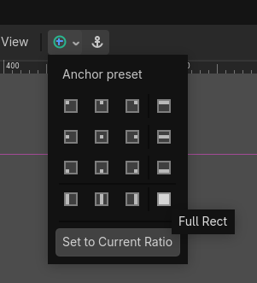

Figure 2 – anchor preset to center
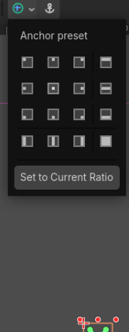

fig 3 – layout
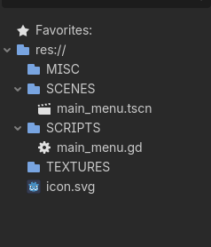

fig 4 – worlds
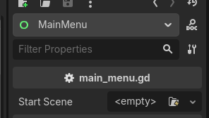

CODES
Code 1 – NOTE: fix the code, since you have dups if you don’t like..

extends Control

# This allows you to set the first level scene from the Inspector
@export var start_scene : PackedScene

func _on_start_button_pressed():
if start_scene:
get_tree().change_scene_to_packed(start_scene)
else:
print("No scene assigned to start_scene!")

func _on_options_button_pressed():
# You can add an options menu logic here later
print("Options opened")

func _on_quit_button_pressed():
get_tree().quit()

Fixed code for me at least
extends Control

# This allows you to set the first level scene from the Inspector
@export var start_scene : PackedScene

func _on_options_button_pressed():
# You can add an options menu logic here later
print("Options opened")

func _on_quit_button_pressed():
get_tree().quit()

func _on_button_start_pressed() -> void:
# moved from the above default CODE
# RE DO THIS FOR EACH THING THAT DOES IT.
## ADD a scene to each if clicked. options_scene.tscn? -> on_button_settings_pressed
if start_scene:
get_tree().change_scene_to_packed(start_scene)
else:
print("No scene assigned to start_scene!")

func _on_button_settings_pressed() -> void:
pass # Replace with function body.

func _on_button_quit_pressed() -> void:
pass # Replace with function body.

CODE 2 (FIXED, EXPORTS, drag n drop Scenes)
FIXED CODE 100% WITH EXPORTS
(drag n drop each scene : START_SCENE, SETTINGS_SCENE)
extends Control

# Exporting these makes the template reusable without touching code
@export var start_scene : PackedScene
@export var settings_scene : PackedScene # Link your settings menu here

func _on_button_start_pressed() -> void:
if start_scene:
get_tree().change_scene_to_packed(start_scene)
else:
print("Error: No start_scene assigned in the Inspector!")

func _on_button_settings_pressed() -> void:
if settings_scene:
get_tree().change_scene_to_packed(settings_scene)
else:
# For now, this just lets you know the button works
print("Settings menu coming soon...")

func _on_button_quit_pressed() -> void:
# This closes the application
get_tree().quit()

Remember to just, move the filled-function to the empty-function,
cuz when you pressed the signal ”pressed()” 2 times you make a new code
(if u cant select existing, that is)

