JHAVÉ Question System Proposal
By: Chris Gaffney

Purpose
The purpose of this system is to create a unified means for the handling of questions that will remove the need for the visualizers to have any knowledge of the Question Script.

Current Implementation
Originally questions were based on a set of interfaces defined in Animal. Questions were parsed within sub-classes of specific interfaces through the SetText method call. The API for these questions is littered with nonsensical methods. This system also allowed a poor encapsulation of the data, requiring visualizers to fill in some of the holes.
More recently an attempt was made to centralize the parsing of questions. However after examining it, I found that it is nothing more than moving the parsing of the script from the questions that implement the Animal interfaces from the implementation to a separate object. This really gains little to nothing on the older approach.

Rationale for a new system
The current implementations fall short on several counts. Primarily they all require the visualizers to know a good deal of the questions script and how to handle it. This means that any changes (including additions) to the question script means that modifications will have to be made in each of the visualizers. Secondly it also requires each visualizer to know how to instantiate each type of question and how to differentiate the types from the question script. This means that any change in the classes that implement the questions will require changes to all of the visualizers. It all puts a bulk of redundant logic in each visualizer.
The current implementation also depends on Animal classes. With the current uncertainty of Animal as a visualizer it could potentially be problematic to depend on Animals sources. Also since we are not allowed to modify those sources it could cause trouble in the creation of new visualizers. This would also has the effect that all of the visualizers have a dependency on Animal, which could definitely cause problems in the future.

Precepts of the Design
There are several precepts on the usage of Questions within the system and qualities of the Question Script that were taken into account during the design on the proposed system.

- Visualizers do not care what type of question they are dealing with they only need to know that they have a properly defined question.
- Different question types all share certain attributes which let them be handled similarly with a properly defined API.
- Though all questions can be handled properly with well defined API there are still subtle differences in the questions that require a properly defined contract for each type.
- There is a finite set of different types of questions.
- The Question Script can be seen as being independent of the actual Visualization Script. The only connection is the binding of certain questions (by ID) to particular snapshots.

UML Representation

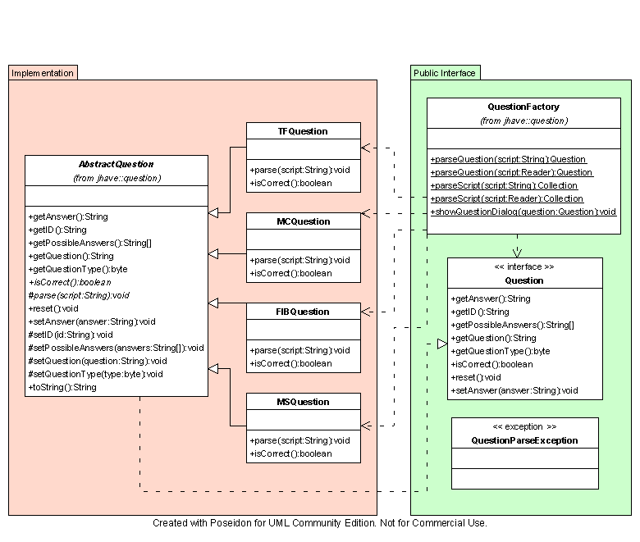

Class Description
There are three classes that Visualizers will have to deal with. These are grouped by the “Public Interface” group in the UML diagram. These are the representation of a question by the Question interface class, the primary means by which questions are parsed (Question Factory class), and an exception for parse errors. Since different types of questions are similar enough that they can be uniformly handled we only need to deal with the Question interface rather than each specific implementing class. This is a good example of polymorphism and programming to the interface not the implementation, which are both key elements of object oriented design.

Question
This class is the representation of a question as a Java class. There are several properties of questions that were taken into account, such that all questions have possible answers, a question, ability to answer the question, an ID, if the answer is correct, etc… Given that this definition may not be complete for all questions, a question type attribute is added to distinguish between types. This is effective because the different types of questions will generally stay the same, but the implementation of those types can change (as in the 3 changes in the past 2 years.)

QuestionFactory
The QuestionFactory class is a library of functions for the parsing and instantiation of Question objects. It has several functions which include a set for parsing all questions from a script and returns them as a collection and a set for parsing a single question. Each comes in two flavors, one that accepts an InputStream where the script is read from and the other which accepts a String representation of the question or script. Also in this class will be other methods dealing with questions such as for displaying a question dialog and in the future tools for creating a question script from an instance of a Question object or a set of Question objects. This makes the QuestionFactory class a high level Façade for the lower level implementation.

QuestionParseException
This API for this class is still up in the air. One of the goals of the exception is to be able to contain a set of all of the errors that occur in a Question Script. This means that during the parsing the errors will be recorded then skipped and this exception should contain a representation of each error in the script. This is similar to how a compiler works in that it doesn’t stop on the first error but reports all of them to make it easier for the authors of new scripts to debug their projects.

AbstractQuestion
Since all questions share several properties this class is setup to contain those properties and maximize reuse between the implementations. It implements all of the get methods that are defined in the Question interface as well as the isCorrect method and the reset method. The set methods are all protected so that they can only be accesed by implementing classes and allow for the setting of the values. These will be called in the implementation of the abstract parse method for each implementation. The reset method is implemented in the AbstractQuestion class because the resetting of a question is nothing more than setting the answer to a null or a value that designates an unspecified answer.

**Question
The FIBQuestion, MCQuestion, TFQuestion, and MSQuestion will all extend the AbstractQuestion class and will implement the parse method for parsing their specific QuestionScript.

Brief Example of how a Visualizer would use QuestionFactory

Below is an example method that a visualizer would have to parse its script. It is mostly java pseudo code (minus the calls to QuestionFactory). But it should illustrate one of the possible ways of using the QuestionFactory.

This example is one where the Visualizer knows that a question section starts with STARTQUESTION.

public void parse(InputStream script) throws VisualizerLoadException {
BufferedReader reader = // Create reader
String line = reader.readLine();
Collection questions = null;

// Read the script and parse it {
if(line.equals(“STARTQUESTIONS”)) {
try {
questions = QuestionFactory.parseScript(reader);
} catch (QuestionParseException e) {
// Print error messages
throw new VisualizerLoadException()
}
}
}
}

This is an example if the Visualizer does not know about STARTQUESTIONS

public void parse(InputStream script) throws VisualizerLoadException {
// Parse the Visualizers script
// Ignore anything that doesn’t make sense (i.e. STARTQUESTIONS)

Collection questions = null;
try {
questions = QuestionFactory.parseScript(script);
} catch (QuestionParseException e) {
// Print error messages
throw new VisualizerLoadException();
}

}

Multiple Selection Question
With the implementation and adaptation of a new question parsing and representation system this is a good time to add a new question type that is currently poorly implemented by using fill in the blank style questions. This missing contender is multiple selection questions, these are similar to the multiple choice question type, however it allows for more than one answer to be selected at once. These are often characterized by the phrase: “Select one or more of the following...”
The problem that this new question type is addressing is actually what most current fill in the blank questions try to accomplish. Several examples of this can be found in the Quick Sort for Animal script one of which is below:
FIBQUESTION "7"
"Which numbers in the array will swap next?"
ENDTEXT
ANSWER
"44 31"
"31 44"
ENDANSWER

As can be seen above, the question effectively asks the user to narrow down to 2 choices from several. The main problem with this is that distinguishing if the users answer is correct becomes nearly impossible due to the multitude of possible errors. For example a user could have the right answer but have put an extra space or two in the answer, or the user placed a period at the end as you would when writing a sentence. This is one of the fundamental flaws of the fill in the break question and with the deprecation of the test for a grade system there is no human eye checking these questions for correctness so they must be checked by the computer during the visualization.
The second fundamental problem with using the fill in the blank question style with these types of questions is that the number of possible correct answers grows exponentially with the number of correct answers. With only two correct answers the number is relatively small (2). But if the script author wants to have 6 correct answers there are a total of 720 possible combinations (math may be wrong… though it is a large number). Which can, if nothing else, be said to be inconvenient for the script creator to enter not to mention a waste of bandwidth. This number does not even take into account all of the possible variations of entry errors that could not be parsed or compensated for programmatically.

For multiple selection questions I propose the following syntax which looks similar to that of multiple choice questions:

MSQUESTION id
Question to user……..
ENDTEXT
Possible answer 1
ENDCHOICE
Possible answer 2
ENDCHOICE
Possible answer 3
ENDCHOICE
ANSWER
0 2
ENDANSWER

The answer section would be comprised of space delimited integers which signify the correct answers. This would be 0 based so the 0 in the above would signify that “Possible answer 1” was one of the correct answers.

