Traffic Lights Detection and Classification using Resnet50

In this project we are employing ResNet50 algorithm to detect and classify type of traffic light in both images and videos. To train Resnet50 we have utilized LISA Cropped Traffic light dataset and below are the output screens.

To run project double click on ‘run.bat’ file to get below screen

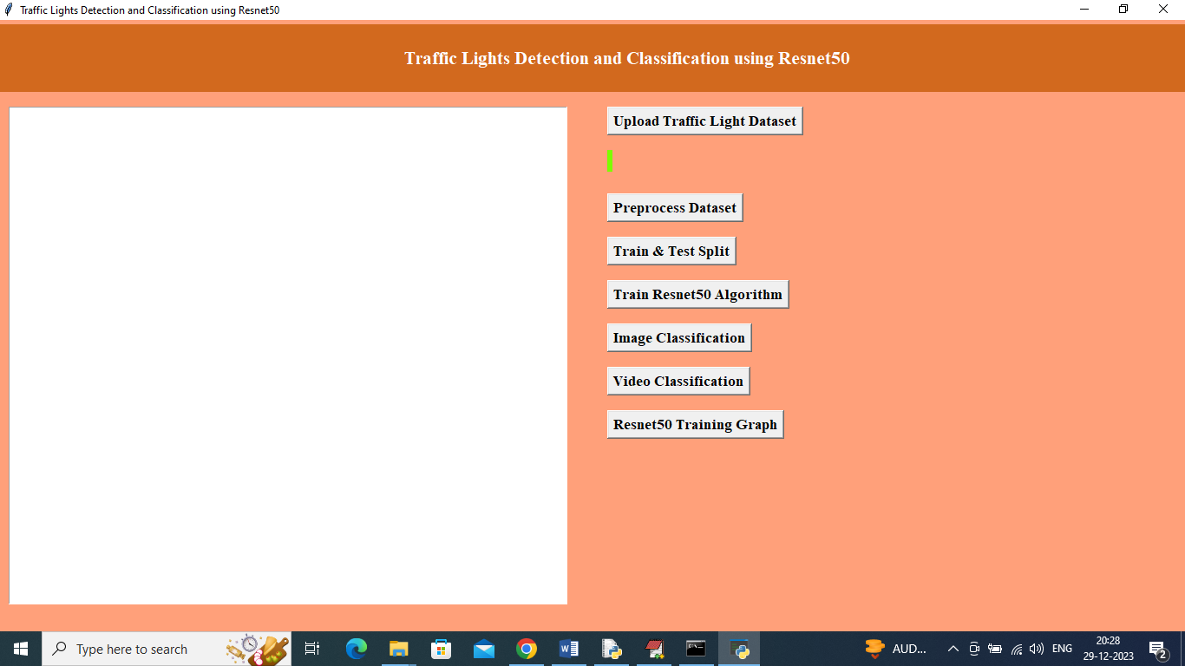

In above screen click on ‘Upload Traffic Light Dataset’ button to upload dataset and get below output

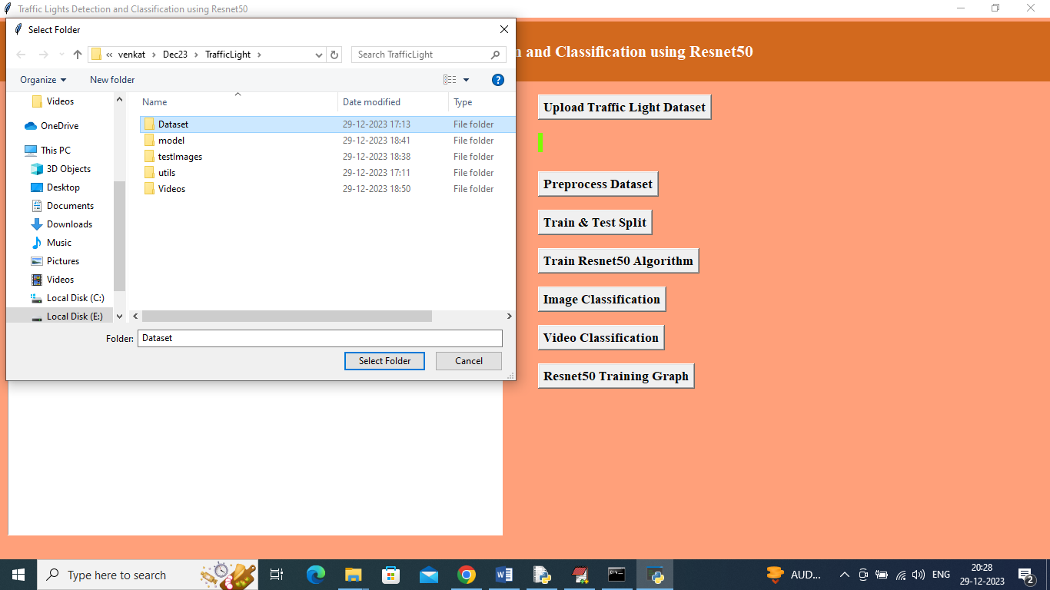

In above screen selecting and uploading traffic light dataset and then click on ‘Select Folder’ button to load dataset and get below output

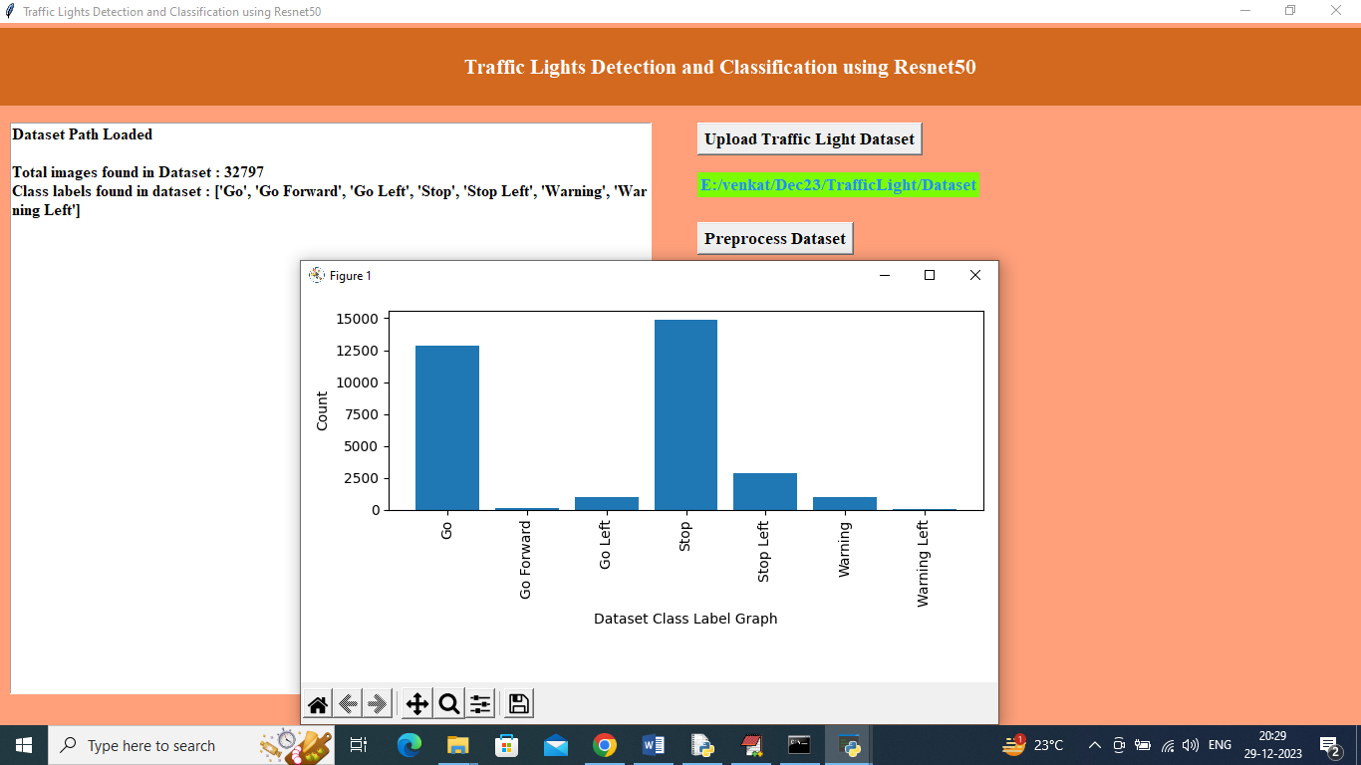

In above screen can see dataset loaded and then can see total number of images available in dataset and in graph can see different Traffic Light Names in x-axis and y-axis represents number of images available in that traffic light category and now close above graph and then click on ‘Pre-process Dataset’ button to normalized and shuffle images and then will get below output

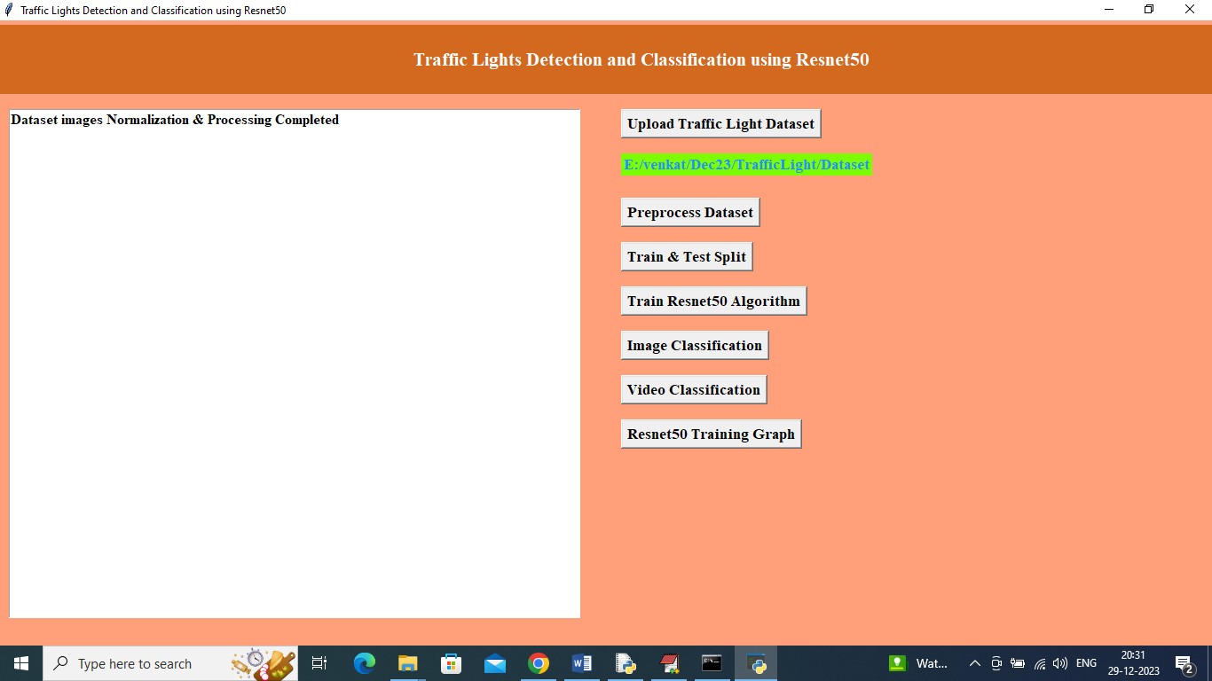

In above screen dataset process completed and now click on ‘Train & Test Split’ button to get below output

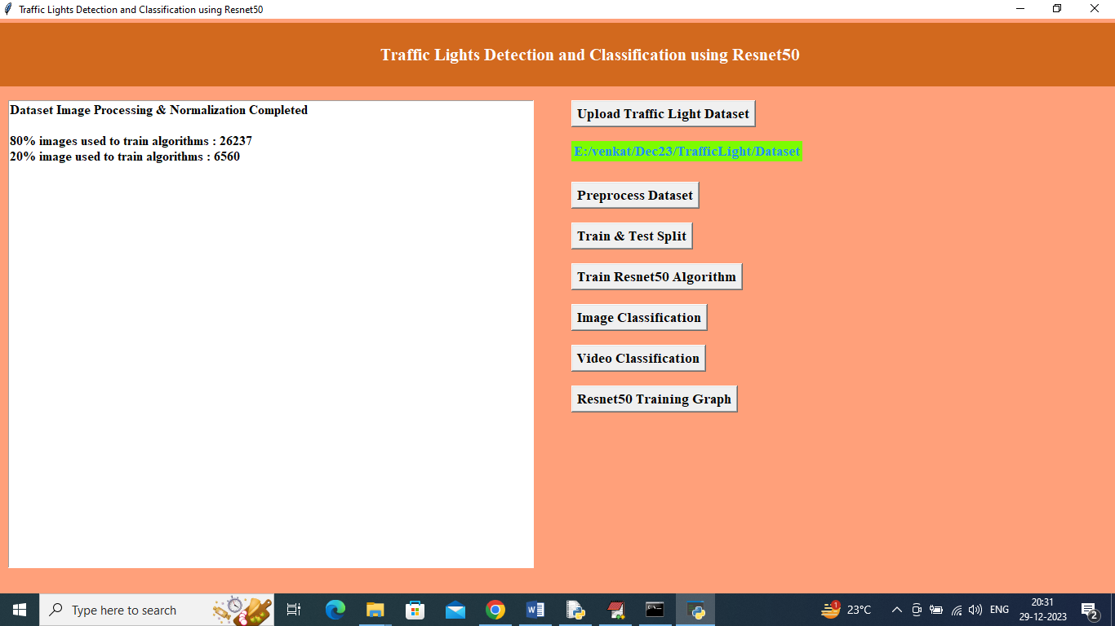

In above screen using 80% dataset images for training and 20% for testing and now click on ‘Train Resnet50 Algorithm’ button to train Resnet50 and get below output

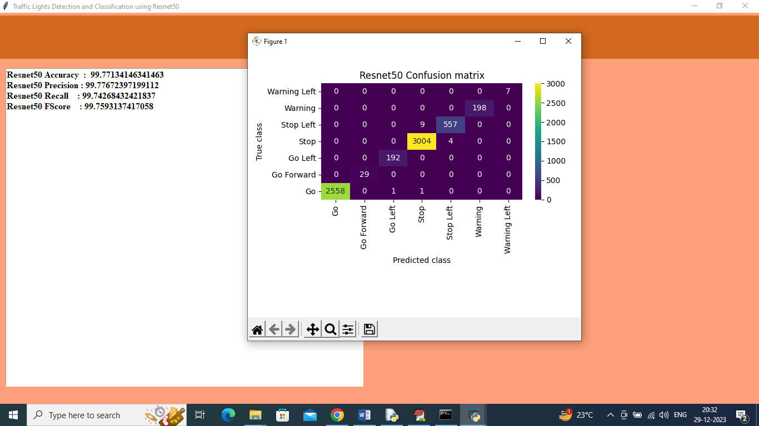

In above screen Resnet50 got 99% accuracy on test data and can see other metrics also and in confusion matrix graph x-axis represents “Predicted Labels” and y-axis represents True Labels and all different colour boxes in diagnol represents correct prediction count and all blue boxes represents incorrect prediction count which is 0 and now close above graph and then click on ‘Image Classification’ button to detect and classify traffic light from images

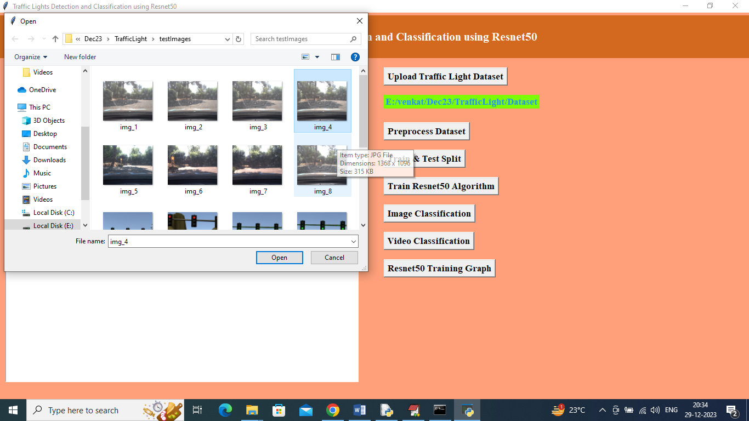

In above screen selecting and uploading ‘img_4.jpg’ image and then click on ‘Open’ button to get below output

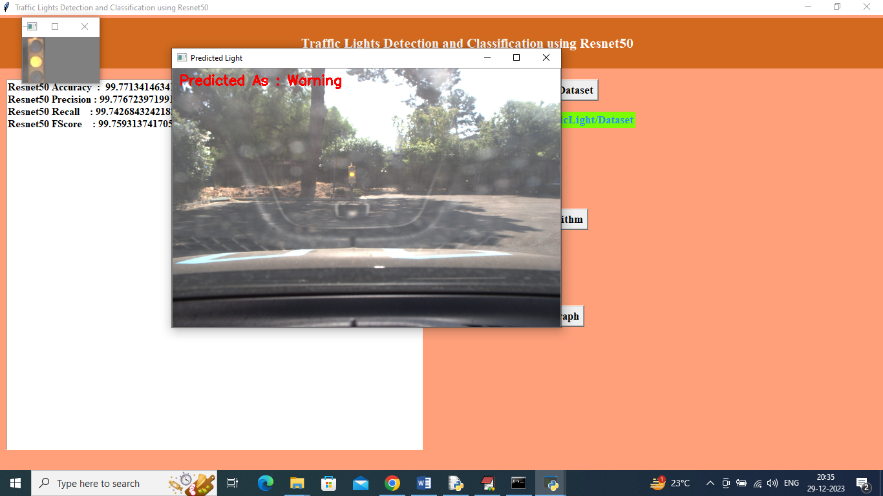

In above screen first image represents detected traffic light and second images represents original image and in second image in red colour text can see classified Traffic light as ‘Warning’ and now close above image and then upload other image

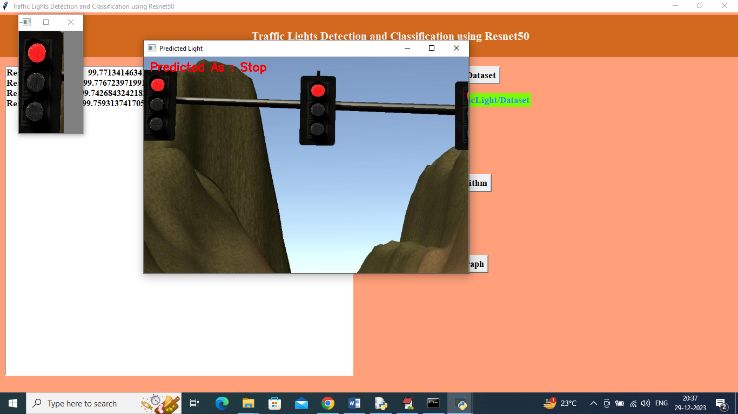

In above screen can see detected and classified traffic light as ‘Stop’

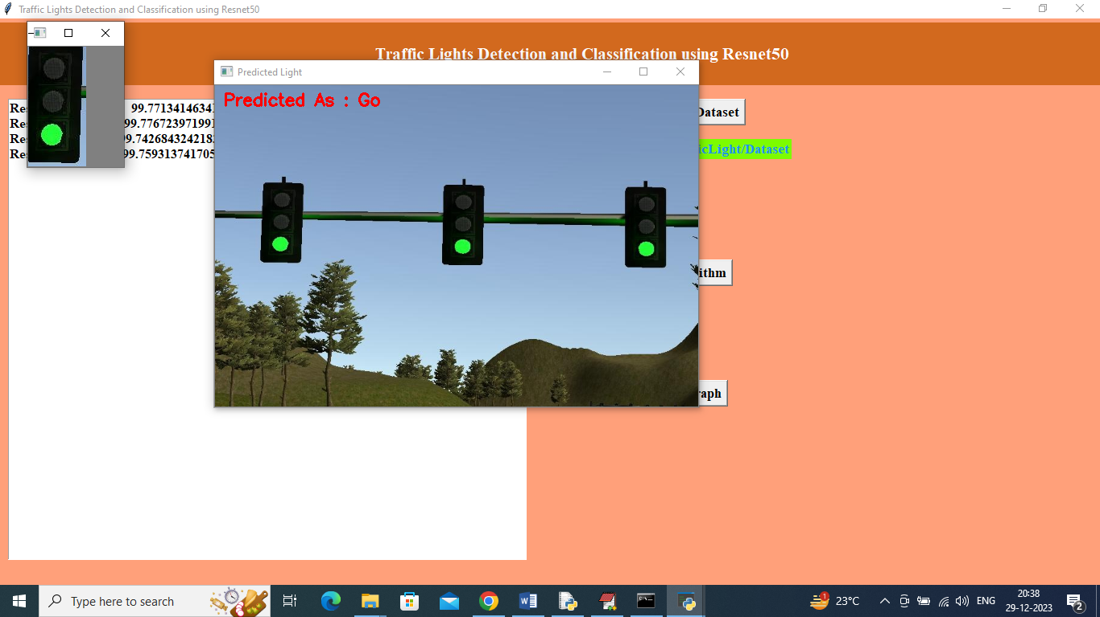

In above screen can see detected and classified output as ‘Go’ and now click on ‘Video Classification’ button to upload video and get below output

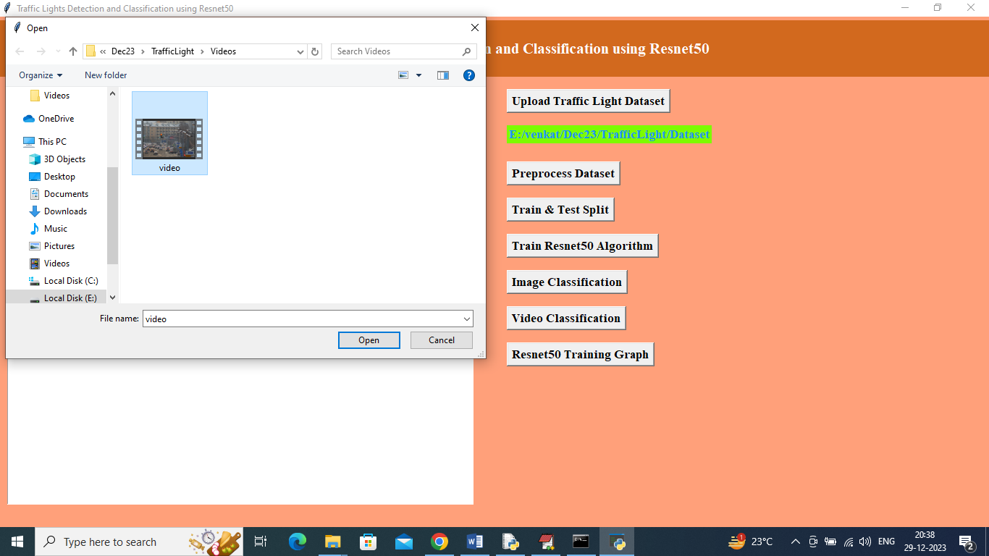

In above screen selecting and uploading video file and below are the detected output

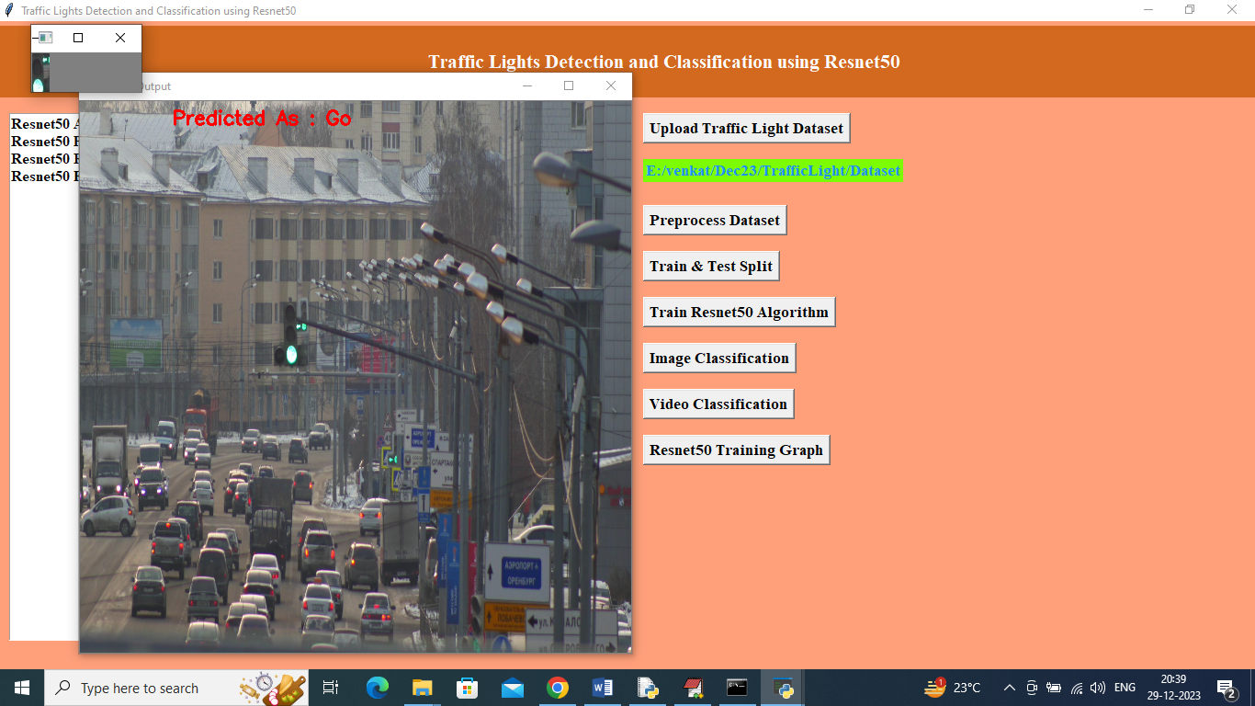

In above screen from video we can see detected traffic light in small panel and in red colour text can see classified traffic light as ‘Go’.

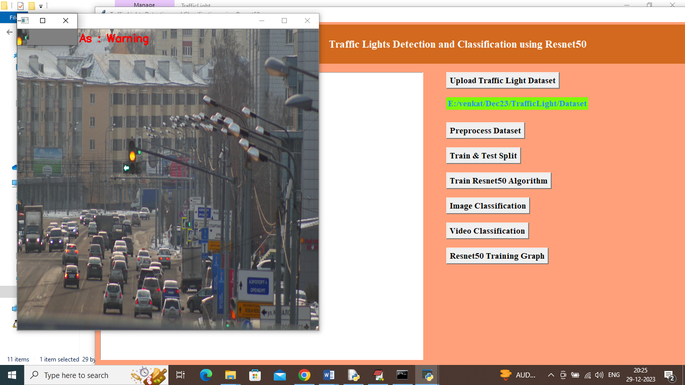

In above screen can see detected and classified traffic light as “Warning’ or ready to go and now click on ‘Resnet50 Training Graph’ button to get below graph

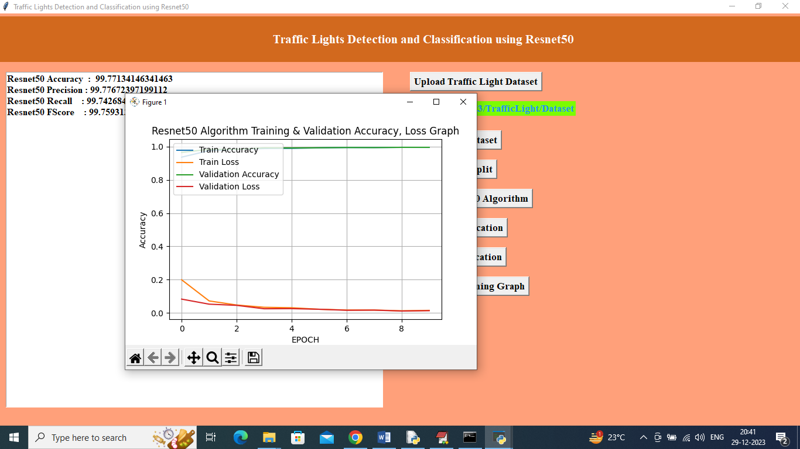

In above graph x-axis represents Resnet50 training epoch and y-axis represents accuracy and loss values and in above graph can see with each increasing epoch accuracy got increased and reached closer to 1 and loss got decrease and reached closer to 0.

Similarly you can upload and test other images