JVM Architecture
JVM stands for "Java Virtual Machine" and which is used to execute Java Byte Code.
1. Class loader Sub System.
2. Runtime Data Area.
3. Execution Engine.
1. Class loader Sub System.
This Class Loader Sub System will load the Byte Code(class) onto JVM, while loading the Class Loader Sub System internally uses the
1. Loader
2. linker
3. Initiate
- Loader
Loader will load the required files into current running program.
Note:- According to Java Developer the required files are available in the following three locations:
1.JavaLib 2."ext" folder 3. class path
To get the required files from these three locations the loader internally uses below SubLoaders
- Boot Strap Class Loader – it will load the required files from JavaLib.
- Extension Class Loader – it will load the required files from the "ext" folder.
- Application Class Loader – it will load the required files from the "classpath"
- Linker
The Linker will link the loaded files into current running program.
while Linking process the Linker internally uses the following components
1.Verify 2. Prepare 3. Resolve
- Verify:
Verify Component will perform verification process; in this process it checks the loaded and required files are same or not.
- 2. Prepare:
Prepare Component will perform decoding process; in this process it identifies the type of programming components. (Variable, method, class)
- 3. Resolve:
This Resolve component will identify the programming components are static or non-static based on "static" keyword.
- Initiate:
Initiate component will perform initialization process and in this process one memory is created known as "Runtime Data Area" and which is loaded with class.
2. Runtime Data Area
- Method Area
- Heap Area
- Java Stack Area
- PC Register Area
- Native Method Area
- Method Area
The memory block where the class is loaded is known as Method Area.
while class loading the static programming components of the class will get the memory within the class.
Once main () method got the memory within the class then it is automatically copied onto Java Stack Area to start the execution process.
once main () method copied onto Java Stack Area then it is identified by the Execution Engine and starts the execution process.
- Heap Area
The memory block where the objects are created is known as Heap Area
Behaviour of 'new' keyword:
This 'new' keyword will specify the execution control to create one reference part of Heap Area.
'new' keyword specifies the execution control to check the required class is available on Method Area or not.
'new' keyword will specify the execution control to find the non-static members of the class and bind to the reference. (bind to the reference means give memory at reference)
'new' keyword will specify the execution control to load the reference on to reference variable(ad) or Object name.
- Java Stack Area
The partition of java stack area where the method is copied for execution is known as Method Frame.
After Method execution completed, the related method frame will be destroyed automatically.
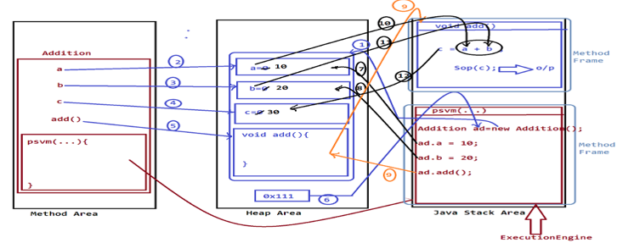
Java 8 features
Stable version of java (LTS- Long-Term Support) 8,11,17,21,25
Lambda Expressions, Functional Interfaces
Default Methods, Static Methods
Method References, Optional Class, forEach(), Stream API, Parallel Streams
Why Lambda Expressions Came?
It reduces boilerplate code, making it easier to read. It enables functional programming (stream api). There is no need to write the method name or return type, and you do not need to create a separate class—you can directly write the abstract method body. A lambda expression uses an anonymous class in Java, which is a class without a name that is created inline when it is needed only once.
interface Animal {
void sound();
}
public class Test {
public static void main (String [] args) {
Animal obj = new Animal () {
public void sound () {
System.out.println("Dog barks");
}
};
obj.sound();
} }
--------------------
public class ThreadLambdaExample {
public static void main (String[] args) {
Thread t1 = new Thread (() -> {
System.out.println("Thread is running using lambda");
});
t1.start();
}
}
Functional Interface
Exactly one abstract method and can add default, static methods.
Note: we cannot add normal and final method in functional interface
Because interface methods need to implements so final method not available for override
And in interface all methods are default abstract and variables are public static final
1. Predicate check condition, apply logics and return Boolean result.
Predicate<Integer> isEven = n -> n % 2 == 0;
Predicate<String> str=str->str.length()>5;
System.out.println(str.test(7) );
2. Function take input and return output
Function<Integer, Integer> mul = x -> x * x;
System.out.println(mul.apply(5));
3. Consumer take input and nothing return
Consumer<String> print = name -> System.out.println(name);
print.accept("Hello");
4. Supplier no input just returns something
Supplier<Double> randomValue = () -> Math.random();
System.out.println(randomValue.get());
5. BiPredicate same like predicate
BiPredicate<Integer, Integer> check = (a, b) -> a > b;
System.out.println(check.test(10, 5));
6. BiFunction
BiFunction<Integer, Integer, Integer> add = (a, b) -> a + b;
int result = add.apply(10, 20); System.out.println("Sum: " + result);
7. BiConsumer
BiConsumer<String, Integer> print = (name, age) ->
System.out.println(name + " " + age); print.accept("Rahul", 30);
8. UnaryOperator
Takes one input and returns the same type,It is a special case of Function.
UnaryOperator<Integer> square = x -> x * x;
System.out.println(square.apply(5));
9. BinaryOperator
Takes two inputs of same type and returns same type, It’s a special case of BiFunction.
BinaryOperator<Integer> add = (a, b) -> a + b;
System.out.println(add.apply(10, 20));

Q. in normal interface how many types of methods we can declared?
Abstract Methods is default type, default, static and private methods.
Final & normal methods not allowed.
public interface InterfaceAllMethods {
abstract void add();
static void dispaly() {
System.out.println("static method");
}
default void getData() {
System.out.println("default method");
welcome();
}
private void welcome() {
System.out.println("welcome in private method");
}
}
--------------------
class InterfaceMethodDemo implements InterfaceAllMethods{
@Override
public void add() {
System.out.println("data added by add method");
}
@Override
public void getData() {
InterfaceMethod.super.getData();//default method
}
}
public class MainClass {
public static void main(String[] args) {
InterfaceMethodDemo d=new InterfaceMethodDemo();
d.add(); d.getData();
InterfaceMethod.dispaly();//static method
List<Integer> list=Arrays.asList(1,2,3,4,5,6,7);
int sum= list.stream()
.reduce(0,Integer::sum);
System.out.println(sum);
} }
Java 9 features
Factory Methods for Collections, Try-With-Resources.
Diamond Operator Enhancement. Can use <> with anonymous class
Stream API Improvements: takeWhile(),dropWhile(),ofNullable()
Q. What are Factory Methods for Collections?
Reduce boilerplate code, create immutable collections (cannot perform add/remove or update data)
Avoid unnecessary object creation
List<String> list = List.of("A", "B", "C"); Set<Integer> set = Set.of(1, 2, 3, 4);
Map<Integer, String> map = Map.of(1, "A", 2, "B",);
Immutable we cannot add/remove and update elements and null not allowed.
Arrays.asList() – we can update value but add and remove not allowed.
Q. what is the use of Try-With-Resources?
The try-with-resources statement in Java is used to automatically close resources after use, so you don’t have to write manual cleanup code.
Before try-with-resources, you had to close resources manually.
try (BufferedReader br = new BufferedReader(new FileReader("file.txt"))) {
System.out.println(br.readLine());
} catch (Exception e) {
e.printStackTrace();
}
Q. what are others ways to closed resources?
The finally block is always executed, except if System.exit(0) is invoked in the try or catch block, or if the JVM crashes due to a fatal error.
s.close() – use this method to manually close resources.
AutoCloseable is an interface in java.lang that allows a resource to be closed automatically when execution leaves a try-with-resources block. And one close () to override.
class MyResource implements AutoCloseable {
public void use() {
System.out.println("Using resource");
}
@Override
public void close() {
System.out.println("Resource closed");
}
}
public class Test {
public static void main(String[] args) {
try (MyResource r = new MyResource()) {
r.use();
}
} }
Stream API Improvements:
takeWhile() - Takes elements from the start, stops as soon as condition becomes false
List<Integer> list = List.of(1, 2, 3, 4, 1, 2);
list.stream()
.takeWhile(n -> n < 4) .forEach(System.out::println);
dropWhile() - Drops elements from the start, stops dropping when condition becomes false
and then returns the remaining elements
List<Integer> list = List.of(1, 2, 3, 4, 1, 2);
list.stream()
.dropWhile(n -> n < 4).forEach(System.out::println);// 4 1 2
ofNullable()
Converts a value into a stream, if value is null then returns empty stream and avoids NullPointerException
Stream.ofNullable(null).forEach(System.out::println);
Java 10 features
Var variable - compiler automatically infers the type.
var name = "Santosh";
var age = 25;
var list = List.of(1,2,3); // List<Integer>
Note: used with local variable and value must be initialized
Java 12 features
Switch Expressions with yield keyword
int day = 2;
String result;
switch (day) {
case 1:
result = "Mon";
break;
default:
result = "Invalid";
}
New approach
public class switchExample {
public static void main(String[] args) {
int day = 2;
String result = switch (day) {
case 2 -> {
System.out.println("Processing...");
yield "Tuesday";
}
default -> "Other";
};
System.out.println("Day: " + result);
}
}
Yield – it is use to return a value
Java 13 features
Text Blocks (Preview Feature)
public class TextBlockExample {
public static void main(String[] args) {
String json = """
{
"name": "Rahul",
"age": 33
}
"""; System.out.println(json);
}
}
Java 14 features
Records (Preview Feature)
record Person(String name, int age) {}
public class RecordExample {
public static void main(String[] args) {
Person p = new Person("John", 25);
System.out.println(p.name());
System.out.println(p.age());
System.out.println(p);
}
}
When we use record it provides getter/constructor/equals/tostring/hashcode.
Java 15 features
1. Sealed Classes - restrict which classes can extend or implement a class.
Public sealed class interface Payment permits CardPayment,UpiPayment{}
Final class CardPayment implements Payment{}
Final class UpiPayment implements Payment{}
2. Pattern Matching for instanceof
if (obj instanceof String s) {
System.out.println(s.length());
}
Java 19 features
1. Virtual Threads
A virtual thread is a lightweight thread managed by the JVM, not directly by the OS.
It creates millions of threads and normal threads for 10,000 it get OutOfMemory errors because of OS managed but virtual threads get executed without any error.
A platform thread is a thread that is Managed by the operating system (OS) and each thread 1 OS.
Thread, Runnable and Executor Service are platform threads.
A thread pool is a group of pre-created threads that are reused to execute multiple tasks.
Instead of creating a new thread every time, you reuse existing threads for faster& more efficient.
Tasks are submitted so from thread pool it picked the task and execute it.
Example we created 10 size thread pool so task is divided into 10 threads for fast execution.
1. Creating a Virtual Thread with the Thread Class and the Thread.Builder Interface
Call the Thread.ofVirtual() method to create an instance of Thread.Builder for creating virtual threads.
public class VirtualThreadExample {
public static void main(String[] args) {
Runnable task = () -> {
System.out.println("Running: " + Thread.currentThread());
};
Thread vt = Thread.ofVirtual().start(task);
try {
vt.join();
} catch (InterruptedException e) {
e.printStackTrace();
} } }
--------------------------------------
public class VirtualThreadBuilderExample {
public static void main(String[] args) {
Runnable task = () -> {
System.out.println("Running in: " + Thread.currentThread());
};
// Create builder for virtual thread
Thread.Builder builder = Thread.ofVirtual().name("My-Virtual-Thread-", 1);
Thread vt = builder.unstarted(task); // Create thread (not started yet)
vt.start(); // Start thread
try {
vt.join();
} catch (InterruptedException e) {
e.printStackTrace();
} } }
------------------------------------
public class MultipleVirtualThreads {
public static void main(String[] args) {
for (int i = 1; i <= 5; i++) {
int taskId = i;
Thread.startVirtualThread(() -> {
System.out.println("Task " + taskId +
" running on " + Thread.currentThread());
});
}
} }
Java 21 features
Virtual thread, records and switch expression, getFirst(), getLast() and reversed().
public class VirtualThreadDemo {
public static void main(String[] args) {
Thread vt = Thread.startVirtualThread(() -> {
System.out.println("Hello Virtual Thread");
System.out.println("Running on: " + Thread.currentThread());
});
try {
vt.join();
} catch (InterruptedException e) {
e.printStackTrace();
}
System.out.println("Main thread finished");
}
}
Fork Join – it is designed for parallel processing. It helps break a big task into smaller tasks, process them in parallel, and then combine the results.
Fork - split task into smaller subtasks
Join - combine results of subtasks
ForkJoinPool – it manages thread pool to handle tasks.
Q. Future vs CompletableFuture
Future is an interface it introduces in java 5, represents the result of an asynchronous task
Result that will be available in the future after the task completed.
- Future interface used to check the status of a task (completed, running, or cancelled).
- It allows retrieving the result of a Callable once it’s done.
- Supports cancellation of tasks that are still running.
public class Test {
public static void main(String[] args) throws Exception {
Callable<Integer> task = () -> 10 + 20;
FutureTask<Integer> future = new FutureTask<>(task);
new Thread(future).start();
System.out.println(future.get()); // 30
} }
-----------------
public class Test {
public static void main(String[] args) throws Exception {
CompletableFuture<Integer> future = CompletableFuture.supplyAsync(() -> 10 + 20);
System.out.println(future.get());
} }
Main Methods of Future Interface
1. get() - waits for the result and returns it. Blocks until result is ready.
2. get(long timeout, TimeUnit unit) - waits for a specific time and blocks only for specified time
future.get(2, TimeUnit.SECONDS);
3. isDone() – checks if task is completed.
4. isCancelled() – checks if task was cancelled.
5. cancel(boolean) – cancels the task.
CompletableFuture is a class and used for asynchronous, non-blocking programming.
It allows you to run tasks in the background (non-blocking) and chaining multiple tasks, combines multiple tasks, or handle them without blocking the main thread.
runAsync() – runs task asynchronously, without returning a result.
supplyAsync() – to create an instance of CompletableFuture and return a result.
thenApply() – Takes result and returns modified result.
thenAccept() – Takes result but returns nothing.
thenRun() -- Runs after completion but does not use result.
thenApplyAsync() – Transforms result asynchronously.
thenCompose() – Used when function returns another CompletableFuture (flatMap).
thenAcceptAsync – asynchronously consumes result
thenCombine() – combines two futures.
exceptionally() -- handles error and returns fallback value.
handle() -- handles both success & failure.
complete() – manually set a result.
Java 25 features
1. use primitive data types in switch and instance of
int num = 2;
switch (num) {
case 1 -> System.out.println("One");
case 2 -> System.out.println("Two");
default -> System.out.println("Other");
}

2. Write logic before calling super or this keyword.
Child(int x) {
if (x < 0) throw new IllegalArgumentException();
super(x); // before java 25 super() & this() is first statement otherwise it will throw an error.
}
3. we can declare main class without creating class and also some changes with main method.
void main() { // or void main(String[] args)
System.out.println("Hello Java 25");
}
Note: no need to declare class and remove modifier, return type and static keyword from main method
Note: every new java version is release on every six months in March and September month.
Every two years stable version release
Translator – it is used to translate high level languages codes into low level language and vice versa.
Interpreters – it will translate the program line-by-line.
Compilers - it will translate the total program at-a-time.
Java History
James Gosling, Mike Sheridan, and Patrick Naughton initiated the Java language project in June 1991. The small team of sun engineers called Green Team.
JDK – java development kit
JVM – java virtual machine.
JRE – java runtime environment.
Java Compiler - it will translate source code into byte code.
Java Library - it provides Built-In components which are used in constructing application.
JVM -JVM will execute Java byte code.
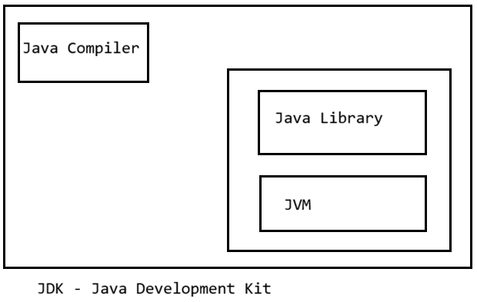
JRE – it having only java libraries and JVM and there is no java compiler part of JRE.
It is used part of web servers and application servers to execute web applications.
How to complier a java program
To compile use Javac Addition.java
To run it use Java Addition
Data types in java
1.Primitive Data Types.
2.NonPrimitive Data Types. Are class, String, interface, array and enum
byte – 1 byte (8 bits)
short – 2 bytes char – 2 byes
int – 4 bytes float – 4 bytes
long – 8 bytes double -8 byes
boolean 1 bit
enum (enumeration) is a special type used to define a fixed set of constants.
Use enum when values are limited and predefined so once defined cannot be modified.
enum Day {
MONDAY, TUESDAY, WEDNESDAY, THURSDAY, FRIDAY, SATURDAY, SUNDAY
}
Day day = Day.MONDAY; // only valid values allowed form declared enum.
Object Oriented Programming concept.
1. class & Object
2.Inheritance
3. Interface
4.Polymorphism
5. Encapsulation
6. Abstraction
real-time, project-based use cases of OOP concepts.
1. Class & object
Class – crate product, customer and order model class with basic details.
Object - Real instance (actual product, actual customer).
2. Inheritance
Create base class as Employee and child classes are manager, developers.
3. Interface
Payment Gateway Integration
Allow different payment methods like Card payment and upi payment.
If in future wants to add new payment methods without changing code. Like Credit card
interface Payment {
void pay(double amount);
}
class UPI implements Payment {
public void pay(double amount) {
System.out.println("Paid via UPI: " + amount);
}
}
class CreditCard implements Payment {
public void pay(double amount) {
System.out.println("Paid via Card: " + amount);
}
}
4. Polymorphism
class Notification {
void send() {
System.out.println("Sending notification");
}
}
class EmailNotification extends Notification {
void send() {
System.out.println("Sending Email");
}
}
class SMSNotification extends Notification {
void send() {
System.out.println("Sending SMS");
} }
Use case: Notification System
Use same method for different behaviours.
Polymorphism it allows one action to be performed in different ways.
5. Encapsulation
Use case: Bank Account System
Protect data using private variables so it prevents direct access to the sensitive information.
class BankAccount {
private double balance;
public void deposit(double amount) {
balance += amount;
}
public double getBalance() {
return balance;
}
}
6. Abstraction
1. Email Service
Send email without worrying about SMTP details. So we need SMTP server config, authentication.
2. Payment Gateway Integration so developer writes code for Card or UPI payment options and just give abstraction to use it.
3. Authentication – it internally checks user login credentials if validated then only allowed.
2. Use case: ATM Machine
User sees only required operation like withdraw and deposit but developers write code for it.
-----------------------------------------------------------------------------------------------------------------------------
Class & Objects
Class is collections of variables and methods. An object is a real instance of a class.
Types of variables.
1. Static variable
2. non-static variables.
- Static variable
The variables which are declared with static keyword are known as static variables or class variables.
static variables get memory within a class and access with class name and available until class is available on method area.
These Static variables are accessed by both static and non-static methods. Declared inside the class but always outside the methods or constructor otherwise it will throw an error.
- 2. non-static variables
The variables which are declared without static keyword are known as non-static variables.
1. Local Variables
Declared inside a method, constructor or block.
void test() {
int x = 10; // local variable
}
Stored in stack memory, each thread gets its own copy, can’t have default values - must be initialized. because every thread has its own stack, so local variables can’t be shared between threads.
Q. Stack memory vs heap memory
Stack memory is used for method execution and local variables. Each thread has its own stack.
Method call, Local variables, Method parameters and References to heap objects
Memory is allocated and deallocated automatically (LIFO – Last In First Out)
Very fast access and Thread-safe (each thread has its own stack) Limited size
StackOverflowError - due to deep recursion or infinite method calls
Heap memory is used for object storage and class-level data. It is shared among all threads.
Objects, Instance variables, Static variables, Arrays, OutOfMemoryError - heap is full
Memory is allocated dynamically, Slower than stack, Managed by GC and Large in size.
2. Instance Variables (Non-static Fields) – not a thread safe
Class Student {
String city;// instance variables
}
Stored in heap memory, each object gets its own copy
If multiple threads share the same object, instance variables can be modified simultaneously → race conditions.
To make them thread-safe, you must use: synchronized, volatile, Locks and Immutable objects.
3. Static Variables (Class Variables)- not a thread safe
Declared with the static keyword. static string city; Not declared inside method only in class level
Shared by all objects of the class, Stored in method area
Because static variables are shared globally across threads. If write operations occur- race conditions.
To make them thread-safe, use: synchronized, AtomicInteger, Atomic Long and Lock.
4. Final Variables – Thread safe
Declared with the final keyword. final int MAX = 100;
Value cannot be changed after assignment.
Because final variables are immutable, and immutability makes them naturally thread-safe.
How to add locks on variables
1. used synchronized keyword on method.
2. class Counter {
int count = 0;
private final Object lock = new Object();
void increment() {
synchronized(lock) {
count++;
} }
}
Static and non-static methods
Static methods can access static variables directly but cannot access instance variables.
Static methods call directly method in output statement.
Wrapper classes Use it in collection framework
The classes which are used to make Primitive datatypes available in the form of Objects are known as Wrapper Classes.
The process of binding primitive datatypes into Wrapper Class objects is known as Boxing Process.
1. Boxing process using Constructors
Integer ob1 = new Integer (12);
Integer ob2 = new Integer ("13");
valueOf() methods as a factory method which create objects.
2. Boxing process using valueOf()
Integer ob1 = Integer.valueOf(12);
Float ob2 = Float.valueOf(12.34f);
Character ob3 = Character.valueOf('A');
Auto Boxing The Boxing process which is performed automatically is known as Auto Boxing process.
Integer ob1 = 12;
Float ob2 = 12.34F;
Character ob3 = 'A';
Un-Boxing process The process of taking primitive datatypes out of Wrapper Class objects.
Public int intValue() , public char charValuer(), public float floatValue()
Integer ob1 = new Integer(12);
Float ob2 = new Float(12.34F);
Character ob3 = new Character('A');
Boolean ob4 = new Boolean(true);
//UnBoxing process
int i = ob1.intValue();
float f = ob2.floatValue();
char ch = ob3.charValue();
boolean b = ob4.booleanValue();
Auto Un-Boxing the Un-Boxing process which is performed automatically.
Integer ob1 = 12; Float ob2 = 12.34F; Character ob3 = 'A';
int i = ob1;
float f = ob2;
char ch = ob3;
String - The sequenced collection of characters which are represented in double quotes.
- String class
- String Buffer class
- String Builder class
String object generates Immutable object.
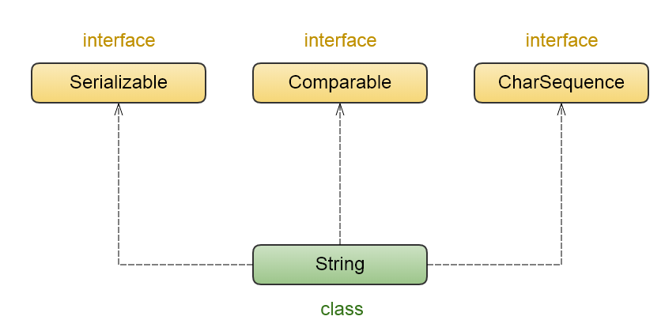
Create String using two ways
1. literal process
String s1 = "Santosh";
2. using new operator
String s2 =new String("Santosh");
When we create string using literal process so Java stores strings in a special memory area called String constant pool (inside heap)
Note: When we create strings using literals with the same content, Java creates only one object and reuses it for all references.
String s1 = "Santosh";
String s2 = "Santosh";
String s3 =new String("Santosh");
System.out.println(s1==s2); //true because it same content so it refers old object.
System.out.println(s2==s3); //false

String str1 =new String("Santosh");
String str2 =new String("Santosh");
System.out.println(str1==str2); //false because it check referance
What happens internally?
The JVM first checks the String Constant Pool. If "Santosh" is not found, it creates a new object and stores it in the pool. s1 refers to that object.
When "Santosh" is used again, the JVM reuses the same object, so s2 also refers to it.
What is String immutability?
String s = "Santosh";
s = s.concat(" Lone");
String object cannot be changed after it is created. when we changed object using contact it does not modify original object it creates seprates object and refer with new object
Note: When "Santosh" is concatenated with "Lone", a new String object "Santosh Lone" is created. The reference s is updated to this new object, while the original "Santosh" remains unchanged in the String Pool and is eligible for garbage collection if no references exist.
Garbage Collector does not run at a fixed time. It automatically clears memory when needed.
How many objects created using new operator?
String s2 = new String("Santosh");
Two objects created one in spring pool and second one in heap memory.
If "Santosh" is not already present, it creates one object in the String Pool.
Java decides it’s a string literal because of the quotes "Santosh", even though you used the new keyword. Anything written inside double quotes is a string literal.
Intern () – it is used to add object into string pool.
String s1 = new String("Santosh").intern();
String s1 = new String("Santosh");
String s2 = s1.intern();
We can create mutable objects using StringBuilder and String Buffer (synchronized).
The capacity of StringBuffer object increases dynamically by doubling the capacity and adding 2.
16-->(16+16+2)-->34-->(34+34+2)-->70...
The class which is declared with synchronized methods is known as Synchronized class.
The methods which are declared with synchronized keyword are known as Synchronized methods.
Q. What is transient keyword? - Prevents serialization of a field.
It is a keyword used to prevent a field from being serialized. When an object is serialized, all non-transient fields get saved but transient fields are skipped (their values are not saved).
To hide Sensitive data – Passwords, Bank details, Security tokens
Q. Explain volatile keyword, synchronized keyword.
volatile is a keyword used with variables.
When a variable is declared as volatile, its value is always read from the main memory, not from the thread's local cache. this ensures visibility of changes between multiple threads.
In multithreading, each thread may keep a cached copy of variables for speed.
If one thread updates a variable, another thread may still see old cached value - visibility problem.
Q. Drawbacks of using synchronized keyword?
Synchronized - when we add synchronized keyword on method so that method can access one Thread at a time.
If many threads try to access the synchronized code, they get blocked until the lock is released.
Long waiting times, potential application slowdown, misusing multiple synchronized blocks can cause deadlocks.
//Synchronized Method
public synchronized void increment() {
count++;
}
//Synchronized Block
public void increment() {
synchronized(this) {
count++;
}
}
Constructor is a method having the same name of the class and executed while object creation because the constructor call is available within the object creation syntax.

while declaring constructor we must not use return type because the constructors will have class return type by default.

this() is used to access the constructors from the same class.
'this' keyword is used when we have same variable names in Local variables and Instance variables.
class Student {
String name;
int age; // instance variable
Student(String name , int age) {
this.name = name;
this.age =age;
}
Student(String city){
this(city)
} }
super() is used to access the constructors from the Parent Class.
super keyword is used to access the variables and methods from the Parent Class.
Class Parent{
Parent(int x){}
}
Class Child extends Parent{
Child( int x, int y){
Super(x);
this.x=x;
}
}
Interface – An interface is used to achieve abstraction and multiple inheritance in Java.
Variables are public static final and Methods are public and abstract by default.
Interface ITest{
public static final int k=10;
public static final Display d = new Display();
public void add(int x, int y);
}
We can add abstract, static, default and private methods in interface.
Default and static method need not to implement
interface Demo {
void abstractMethod();
default void defaultMethod() {
System.out.println("Default method");
}
static void staticMethod() {
System.out.println("Static method");
}
private void helper() {
System.out.println("Private method");
}
}
Q. Callable vs runnable interface?
Runnable – only one run method, no return type. In java 1.
Cannot throw checked exceptions we need to handle using try catch block.
Callable – only one call method and return a result. In java 5
Can throw checked exceptions and handle with run method using throws
class MyCallable implements Callable<Integer> {
@Override
public Integer call() throws Exception {
return 10 + 20;
}
}
Note: class extends from another class or interface with another interface use extends keyword.
When class implementing interface so use implements keyword.
Set-of-programs collected together to perform defined action is known as application.
Application under execution is known as process.
The part of process is known as Task.
A thread allows your program to do multiple tasks at the same time (multitasking).
In the process of executing multiple tasks and some part of task is executed known as Thread.
Thread – it is the part of the task.

Q. Thread life cycle?
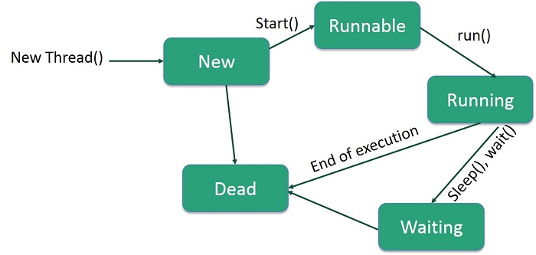
1. new
2. Runnable
3.Running
4. Blocked/waiting
5.Terminated/ Dead

1. New Thread
When a new thread is created, it is in the new state. In this state, the thread is not yet active and has not been allocated any system resources for execution.
2. Runnable
Once the start() method is called on a new thread, it enters the Runnable state.
In this state, the thread is ready to be executed by the JVM's thread scheduler and is waiting for CPU time. It might be actively running or waiting for its turn to run.
3. Running
A thread transitions from runnable to running when the thread scheduler allocates CPU time to it, and it begins executing its run() method.
4. Blocked/waiting
These states represent situations where a thread temporarily ceases execution and waits for a specific event or condition to occur.
Blocked: A thread enters the BLOCKED state when it's waiting to acquire a monitor lock to enter a synchronized block or method.
Waiting: A thread is in the WAITING state when it calls methods like Object.wait(), Thread.join
To wake up this thread used Object.notify(), Object.notifyAll()
Timed Waiting: A thread enters the TIMED_WAITING state when it calls methods like Thread.sleep()
5. Terminated / Dead
when its run() method completes execution, either normally or due to an unhandled exception. A terminated thread cannot be restarted.
How to create thread?
1. by extending from Thread class.
class MyThread extends Thread {
@Override
public void run() {
System.out.println("Thread is running");
} }
public class Main {
public static void main(String[] args) {
MyThread t = new MyThread();
t.start();
} }
2. By implementing Runnable
class MyTask implements Runnable {
@Override
public void run() {
System.out.println("Task running");
}
}
public class Main {
public static void main(String[] args) {
MyTask task = new MyTask();
Thread t = new Thread(task);
t.start();
}
}
-----------------------------------------------------------------
Thread creation using lambda expression for Runnable Interface
Public class ThreadDemo{
public static void main(String[] args) {
Runnable r= new Runnable(){
@Override
Public void run(){
System.out.println("Task running");
} };
r.run();
}}
Public class ThreadDemo{
public static void main(String[] args) {
Runnable r=()-> System.out.println("Task running");
r.run();
}
}
------------------------------------------------------------------------------
public class ThreadDemo {
public static void main(String[] args) {
Thread t = new Thread(new Runnable() {
@Override
public void run() {
System.out.println("Task running");
}
});
t.start(); // creates new thread
} }
------------------
Thread t = new Thread(() -> System.out.println("Task running"));
t.start();

3. using Executor Service interface
Executor Service is part of Java’s concurrency framework (java.util.concurrent) and is used to manage and control threads efficiently instead of creating threads manually.
In above cases by Thread & Runnable we manually manage thread creation and deletions but in executor service it manages all this stuff and it create pool for thread.
In old ways we cannot re-use thread, difficult to manage large number of threads and no control over thread lifecycle.
Executor Service creates thread pool and manages thread life cycle.
A thread pool is a group of pre-created threads that are reused to execute multiple tasks.
Instead of creating a new thread every time, you reuse existing threads for faster& more efficient.
Tasks are submitted so from thread pool it picked the task and execute it.
Example we created 10 size thread pool so task is divided into 10 threads for fast execution.
ExecutorService es = Executors.newFixedThreadPool(5); // create fixed pool
ExecutorService es = Executors.newCachedThreadPool();//creates threads as needed
ExecutorService es = Executors.newSingleThreadExecutor();// only one thread created
ScheduledExecutorService ses =Executors.newScheduledThreadPool(2);

Methods of executor service
es.execute() & es.submit() are used to send tasks to a thread pool.
1. execute() – Execute task (no result)
when you just want to run a task and you don’t care about the result
If an exception occurs it is handled by the thread’s UncaughtExceptionHandler
2. submit() - Execute task and return result
When you need a result, you want to check task status and want to handle exceptions properly
Accepts Runnable or Callable, returns a Future and Exceptions are captured and thrown when calling future.get()
3. shutdown() - Stops accepting new tasks but completes existing ones.
4. shutdownNow() - Attempts to stop all running tasks immediately.
5. isShutdown() - Check if shutdown initiated.
6. isTerminated() - Check if all tasks finished
7. awaitTermination() - Waits for tasks to finish (for given time)
8. invokeAll() - It is used when you want to submit multiple tasks together and wait until all of them finish execution. Blocks the calling thread. Waits until all tasks complete and Returns a List of Future objects. You have many independent tasks and want to execute them in parallel.
9. invokeAny()
executes a collection of tasks and returns the result of the first successfully completed task.
Tasks start running in parallel and other running tasks are cancelled if 1st completed.
Abstract Classe
The class which is declared with abstract keyword is known as abstract class.
We can declare abstract, normal, static and final methods in abstract class.
A class can only extend one abstract class (single inheritance).
using child class we can create object for abstract class.
Q. Why an abstract class has a constructor?
If we do not have constructor in abstract class so implementing class must initialize abstract class properties if 100 properties then create 100 properties constructor in child class to initialize it.
To initialize common variables, to provide a template or base for all subclasses.
To provide common code that all subclasses can share.
to force subclasses to implement some methods.
abstract class can implement one normal class but not more than one but interface can implement more than one.
Abstract class implement only one another abstract class not two classes.
while creating object for child class that time parent class instance variables initialize so it takes to much time to create object of abstract class.
Q. When to use Abstract Class?
When we want to provide some common code, variable to all subclasses. Logging, common methods. When we want to force subclasses to implement specific methods.
abstract class Animal {
abstract void sound();
void sleep() {
System.out.println("Sleeping...");
}
}
class Car extends Vehicle implements Engine { }
Abstract class - can implement multiple interfaces
One interface - can be implemented by many abstract classes (no limit)
Abstract class - can extend only one abstract class.
Q. What are the Thread-safe classes in Java Collections framework?
Below classes use synchronized methods, so every operation is thread-safe.
1. Vector 2. Hash table 3. Wrapper classes 4. Stack
5. Concurren tHashMap 6. CopyOnWriteArrayList 7. CopyOnWriteArraySet 8. ConcurrentSkipListMap
9. ConcurrentSkipListSet 10. BlockingQueue 11. ConcurrentLinkedQueue
Vector -Vector is a legacy class in Java used to store a dynamic array of objects.
It is similar to ArrayList, but thread-safe.
Like ArrayList, Vector expands automatically when more elements are added.
All methods of Vector are synchronized, meaning:
Only one thread can access a Vector method at a time.
Makes Vector safe for multi-thread environments but slow. initial 10 size increase by doubles when it’s got full. It allows duplicate and null and maintain order.
Hashtable- thread-safe It stores data using key–value pairs, similar to HashMap.
No null key and value allowed if added then get NullpointerException
Q. What happens if two threads start?
We can start two different threads at time but we cannot start same thread again so get compile time error.
Q. Extending Thread but NOT overriding run () then what happened?
Thread class already has a run () method and that is empty implementation run is empty.
Q. Implementing Runnable but NOT overriding run () What happens?
Runnable is a functional interface and it has run abstract run method. If run() is not overridden- compile-time error.
Q. what happened if not override run method?
If you do not override the run() method, the thread will start successfully, but no task will be executed. Because default implementation of run method is empty
Q. What happens if two threads try to update the same record?
Ans- occurs race condition because both trying to access same thread.
A race condition occurs when two or more threads access shared data at the same time, and the
final output depends on the order of execution, which is unpredictable.
To avoid this use synchronized method.
Cyclic Barrier is a synchronization mechanism that allows multiple threads to wait for each other at a common point before continuing further.
Once all threads reach the barrier, the barrier is broken and all threads continue execution.
Q. Why Session is NOT Thread-Safe in Hibernate
1. Session Contains Mutable State
Session stores data that changes during execution.
2. Session Uses First-Level Cache
Each Session has its own First Level Cache.
One thread read cache and another modify cache so race conditions occur.
3. Session Manages Transactions
If one thread commits transaction and another one rollback it, so it breaks ACID property.

Inner classes - declaring class within the class
class Outer {
private int data = 10;
class Inner {
void display() {
System.out.println("Data: " + data);
}
} }
1. Member Inner Class (Non-static Inner Class)
Defined inside a class, outside methods and requires outer class object to create inner class object.
class Outer {
class Inner {
void show() {
System.out.println("Member Inner Class");
} } }
class Test {
public static void main(String[] args) {
Outer o = new Outer();
Outer.Inner i = o.new Inner();
i.show();
} }
2. Static Nested Class
Declared with static keyword and cannot access non-static members directly.
Use case: When inner class does not need instance of outer class.
class Outer {
static class Inner {
void show() {
System.out.println("Static Nested Class");
} } }
class Test {
public static void main(String[] args) {
Outer.Inner i = new Outer.Inner();
i.show();
} }
3. Local Inner Class
Defined inside a method and cannot be accessed outside the method.
Use case: When class is needed only inside a method
class Outer {
void display() {
class LocalInner {
void msg() {
System.out.println("Local Inner Class");
}
}
LocalInner li = new LocalInner();
li.msg();
}
}
4. Anonymous Inner Class
No class name and it is used for one-time implementation.
Use case: Quick implementation (mostly used with interfaces like Runnable)
abstract class Animal {
abstract void sound();
}
class Test {
public static void main(String[] args) {
Animal a = new Animal() {
void sound() {
System.out.println("Dog barks");
}
};
a.sound();
} }
Polymorphism
The process in which the same programming component having different forms is known Poly Morphism.
- Dynamic Polymorphism
- Static Polymorphism
1. Dynamic Polymorphism
The Polymorphism which is exhibited at execution stage is known as Dynamic Polymorphism or Runtime Polymorphism.
Ex. Method Overriding
class Payment {
void pay() {
System.out.println("Generic payment");
}
}
class UPI extends Payment {
void pay() {
System.out.println("Pay using UPI");
}
}
class CreditCard extends Payment {
void pay() {
System.out.println("Pay using Credit Card");
}
}
class Test {
public static void main(String[] args) {
Payment p = new UPI();
p.pay(); // UPI payment
p = new CreditCard();
p.pay(); // Credit Card payment
} }
2.Static Polymorphism
The polymorphism which is exhibited at compilation stage is known as Static Polymorphism or Compile time polymorphism.
Ex. Method Overloading.
class Addition {
public void add(int x, int y) {
System.out.println("Sum1: " + (x + y));
}
public void add(int x, int y, int z) {
System.out.println("Sum2: " + (x + y + z));
}
}
public class Test {
public static void main(String[] args) {
Addition ad = new Addition();
ad.add(1, 2);
ad.add(1, 2, 3);
}
}
Exception Handling
Exception - The disturbance which is occurred from the application.
The process which is used to handle the exception is known as Exception handling process.
The following are the blocks used in Exception handling process:
- try
- catch
- finally
Try - 'try' block will hold the statements which are going to raise the exception.
Catch - The catch block will hold the reference of object thrown from the try block and the required msg is generated from the catch block.
Finally - 'finally' block is part of exception handling process, but executed independently without depending on exception.
Throwable is a class from 'java.lang' package and which is root of Exception Handling Process.
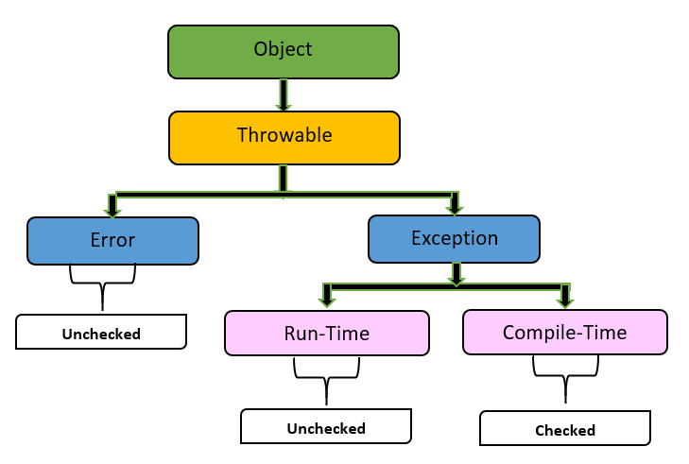
Error class - The disturbance which is occurred from the environment (JVM) is known as 'error'.
Exception class - 'java.lang.Exception' class is the parent class of all the exceptions raised from the application.
The exceptions which are raised from the application are categorized into two types:
- Un-Checked Exceptions
- Checked Exceptions
1. Un-Checked Exceptions / runtime exception
The exceptions which are not identified by the compiler at compilation stage, will be raised at execution stage are known as Un-Checked Exceptions or Runtime exceptions.
Ex. NullPointerException ,IllegalArgumentException ,ArrayIndexOutOfBoundsException
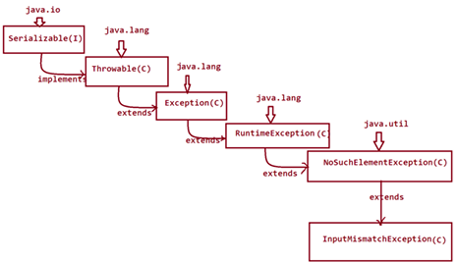
public class DException1 {
public static void main (String [] args) {
Scanner s = new Scanner (System.in);
try {
System.out.println("Enter the value:");
int v = s.nextInt();
int k = 44 / v;
System.out.println("The value k: " + k);
}
catch (InputMismatchException ime) {
System.out.println("Enter only Integer value...");
}
catch (ArithmeticException ae) {
System.out.println("Enter only NonZero value...");
}
finally {
s.close();
} } }
1. The class must be extended from Exception class
2. define condition to raise exception
class InvalidAgeException extends Exception {
public InvalidAgeException(String message) {
super(message);
}
}
public class TestCustomException {
static void checkAge(int age) throws InvalidAgeException {
if (age < 18) {
throw new InvalidAgeException("Age must be 18 or above");
} else {
System.out.println("Eligible to vote");
}
}
public static void main (String [] args) {
try {
checkAge(16);
} catch (InvalidAgeException e) {
System.out.println("Exception: " + e.getMessage());
} } }
2. Checked Exceptions / compile time
The exceptions which are identified by the compiler at compilation stage are known Checked Exceptions or Compile time exceptions.
Ex. ClassNotFoundException ,IOException ,SQLException , FileNotFoundException

Exceptions that are checked at compile time. It checks syntax errors.
Compiler forces you to handle them using try-catch or throws.

'throws' keyword specifies to ignore the exception from current method and raise at methods call.
when the exception is raised at method call then it is identified by the compiler at compilation stage and comes under checked exception or Compile time exception.
Exception propagation
In re-throwing process, the exception is moved from one method to another method is known as Exception Propagation.
Q. Explain Object class methods. Total 11 methods
Java.lang.Object package
1. getClass() - it is a final method of Object class. returns the runtime class of the object.
public final Class<?> getClass()
Demo obj = new Demo(); System.out.println(p.getClass());
Class<?> c = obj.getClass(); System.out.println(s.getClass().getName());
getClass() vs instanceof
instanceof - Checks whether an object belongs to a class OR any of its subclasses.
Works with inheritance & interfaces and Safe with null
Returns true for instances of the class and any of its subclasses.
Returns true for instances of the class and any of its subclasses.
class Animal {
System.out.println(“animal class”);
}
class Dog extends Animal { }
public class TypeCheckExample {
public static void main(String[] args) {
Animal dd = new Dog();
System.out.println(dd instanceof Animal); // Output: true
System.out.println(dd instanceof Dog); // Output: true
// getClass() checks the exact class
System.out.println(dd.getClass() == Animal.class); // Output: false
System.out.println(dd.getClass() == Dog.class); // Output: true
} }
2. hashCode() - returns a int hash value used in hash-based collections like HashMap, HashSet.
If equals() is overridden, hashCode() must also be overridden. Helps collections find objects fast
The hashCode() method is defined in java.lang.Object and is mainly used by hash-based collections like: hashmap, hashset, hashtable, ConcurrentHashMap
Note: If two objects are equal according to the equals() method, then their hashCode() must return the same.
if (obj1.equals(obj2)) {
obj1.hashCode() == obj2.hashCode(); // MUST be true
}
If hashCodes are equal, objects MAY or MAY NOT be equal
obj1.hashCode() == obj2.hashCode();
// obj1.equals(obj2) may be true or false
Why do we need hashCode()?
Hash-based collections work in two steps:
hashCode() -Identify the bucket
equals() - Identify the exact object in that bucket
If collision occurs in hashmap it uses equals(). two different objects - different hashCodes
Role: If you override equals(), you MUST override hashCode()
class Employee {
int id;
String name;
@Override
public boolean equals(Object ed) {
if (this == ed)
return true;
if (ed== null || getClass() != ed.getClass())
return false;
Employee e = (Employee) ed;
return id == e.id;
}
@Override
public int hashCode() {
return Integer.hashCode(id); or return id;
} }
3.equals (Object obj)
Used to compare the content of two objects.
public boolean equals(Object obj) {
return this == obj;
}
Compares memory references (same as ==). When used ==
s1.equals(s2)); content same return true, s1 == s2); //same data but created using new every time obj;
4.clone ()
protected Object clone () throws CloneNotSupportedException
it is used to creates a shallow copy of the object. Class must implement Cloneable.
Method must be overridden as public
class A implements Cloneable {
public Object clone () throws CloneNotSupportedException {
return super.clone();
} }
5. toString()
It used to represent a data in our choice.
6.finalize () - Deprecated since Java 9
Called by Garbage Collector before destroying an object.
JVM may never call finalize(), program may exit before GC runs because of this Memory leaks,
Inconsistent state to resolve this issue used try-with-resources -it closed all resources automatically.
try (FileReader fr = new FileReader("test.txt")) { } OR
try (
FileReader fr = new FileReader("input.txt");
BufferedReader br = new BufferedReader(fr)
) {
System.out.println(br.readLine());
} catch (IOException e) {
e.printStackTrace();
}
AutoCloseable is an interface in java.lang that allows a resource to be closed automatically when execution leaves a try-with-resources block. And one close() to override.
class MyResource implements AutoCloseable {
public void use() {
System.out.println("Using resource");
}
@Override
public void close() {
System.out.println("Resource closed");
}
}
public class Test {
public static void main(String[] args) {
try (MyResource r = new MyResource()) {
r.use();
} } }
7. wait () - Releases lock – used for Inter-thread communication
It makes the current thread pause execution until another thread signals it using notify() or notifyAll(). We used wait method in thread but this comes from object class there is no wait method in thread it’s form object class. Must be called inside synchronized block
synchronized (lock) {
lock.wait(); // waits forever until notified
}
8. wait (long timeout) -Thread waits for a specified time or until notified.
9. wait (long timeout, int nanos) - same but use extra nano seconds for waiting threads
10. notify ()
In this method notify asked one thread at a time to rejoin task of thread.
11. notifyAll()
This call all thread one by one to wake up and rejoin the task. call all threads but execute like first thread execute then next and same going on.

Collection framework in java.
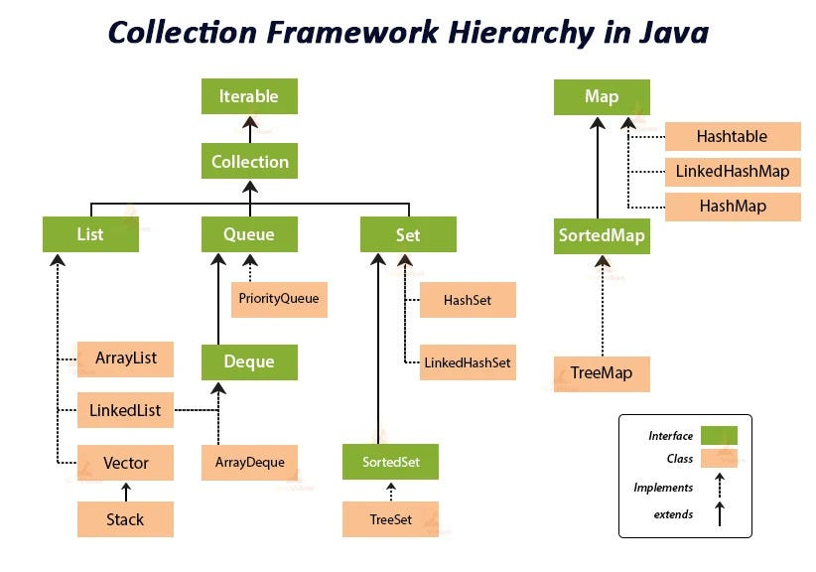
Array is collection of similar types of elements.
Array size once defined cannot be modified at runtime, because of this reason Arrays are not preferable to hold Dynamic data or runtime data.

Int a1[]={1,2,3,4};
int a2[]={11,22,33,44};
Integer arr[][]={a1,a2};

Collection is an interface and below are it’s implemetations.
I. Set
Duplicate not allowed, only one null allowed and no order follow.
HashSet – no order follow, only one null allowed, remove duplicate
Linked HashSet – insertion order and only one null allowed, remove duplicate
CopyOnWriteArraySet - Thread-safe, duplicate not allowed, only one null
fail-safe = mean separate list created for read and write operation after this action completed it
if other thread performs write operation then finally this copy list merged with original.
Set.of(1,2,3,4); - duplicate and null not allowed, Set.of is immutable so modification not allowed.
Tree Set – null value not allowed, ascending order, duplicate not allowed
II. List
organizes elements with index values and can hold duplicate elements.
Iterator<Integer> it=list.iterator();
while(it.hasNext()) {
System.out.print(it.next()+" ");
}
Array List – organizes elements in sequence (added directly by add method), multiple duplicate and null allowed. non synchronized class.
LinkedList – will hold elements in non-sequence and which is Non Synchronized class.
Multiple duplicate and null allowed.
Vector - organizes elements in Sequence but which is Synchronized class.
Stack – child class of vector use First-In-Last-Out or Last-In-First-Out. LIFO
CopyOnWriteArrayList – Thread-safe and fail-safe iteration List.of(1,2,3) Immutable
Arrays.asList() -add and remove not allowed, only update allowed
III. Queue
organizes elements based on the algorithm First-In-First-Out. Multiple duplicate and null allowed
Priority Queue – duplicate allowed but null not allowed, it inserted as priority(like ASC)
ConcurrentLinkedQueue – Thread-safe, fail-fast approach
Map<key, value>
organizes elements in the form of Key-value pairs.
HashMap – without any order but follow hash code to insert for numeric to save as ASC order because lower values hash code is less that why they appear first
Linked Hash Map – insertion order follow, null key allowed null values allowed
Tree Map – ascending order follow, null key not allowed null value allowed
Hash table - synchronized class and remaining all are non-synchronize class, null not allowed
ConcurrentHashMap – for Thread-safe.
Q. ArrayList vs LinkedList?
Array List = Default size 10 increase by 50% and size increase automatically when needed.
Best for searching because of data stored using index, duplicate and null allowed.
element are available in sequence, because of this reason when we add element by index, then elements are moved in backword direction and when we remove it by index the elements are moved forward direction. In this process some execution time wasted
LinkedList= in this data stored in doubly linked list format, add, remove operation good because data stored in doubly list and slow for searching element.
Time complexity for Array List
Add () - O(1)
Add (index) -O(n)
Get() - O(1)
Remove() - O(n)
Serach - O(n)
Time Complexity of List (ArrayList)
add(element) O(1)
add (index, element) O(n)
get(index) O(1)
set(element) O(1)
remove (index) O(n)
remove (object) O(n)
contain () O(n)
size () O(1)
Q. what is a Parallel Streaming?
A Parallel Stream is a stream that splits data into multiple chunks and processes them concurrently using multiple threads. It Uses multiple CPU cores
Internally uses ForkJoinPool.commonPool()
ForkJoinPool is a special type of thread pool introduced in Java 7 to efficiently execute parallel tasks that can be split (forked) into smaller subtasks and then combined (joined) to produce a final result.
list.parallelStream().forEachOrdered(System.out::println);
Q. difference between HashMap and Hashtable in Java.
HashMap – it stores values in key-values pairs and not thread safe and allows null and keys and values, does not a maintain order. HashMap is faster, because it is not synchronized.
Multiple threads can perform actions map object
Fail-fast – when one thread iterating records and other try to update it so we get concurrentModification Exception.
Hashtable is slower, because every method uses intrinsic lock (synchronized).
Stores data in key-value pairs and null keys & values are not allowed.
Hashtable is Synchronized it mean only one thread can access the object at a time so that entire hashtable object is blocked so other threads go into BLOCKED state.
Even read operation it applied locked on object
Lock on entire table it mean others threads are blocked so it cause performance issue.
Q. difference between HashMap and ConcurrentHashMap in Java.
ConcurrentHashMap is a class from java.util.concurrent that provides a thread-safe map with high performance in multi-threaded environments.
It applied locked on read/write operation not locked on read operation.
It is a bucket level lock default size is 16 buckets then all 16 buckets are in under locked.
Individual all 16 bucket get 16 threads to perform update operations. And no limit for read data.
concurrency Level (bucket level lock) – initial is 16 bucket and default concurrency also same.
If concurrency is 8 the locked on each two bucket if concurrency 32 so every bucket has two locked in 1st half locked and 2nd half locked and null key & value not allowed
before java 8 it applied locked on each segment that 16 segment(bucket)
after java 8 it use Red-Black Tree
CAS (Compare-And-Swap) – if bucket is empty then no locked. no locking except when resizing or collision that time locked applied.
Q. Fail-Fast vs Fail-Safe Iterators.
Fail-fast= While iterating data from collection and same time other thread tries to modify it that is concurrent modification. Array List, HashMap, Linked List, Queue
Fail-safe=while iteration list you iterate it from copy of list at that times any modification happened you only get data from copy object after that copy object also modified it.
Q. Difference between throw and throws?
Throws - Used inside a method to manually throw an exception.
It tells the compilers that this method might throw an exception and raised it when method calls.
Can declare multiple exceptions using commas.
public void myMethod() throws IOException, SQLException, ClassNotFoundException {
}
It is only used for checked exceptions. Unchecked exceptions do not require throws
Throw - used inside a method to manually throw an exception. We throw an exception object.
Can throw one exception at a time. It can throw both checked and unchecked exceptions.
Stops the current flow of execution immediately.
public void readData() throws IOException, SQLException {
if(someCondition) {
throw new IOException("File not found");
} else {
throw new SQLException("DB error");
}
}
Daemon thread is like background thread and it manage by JVM one user program completed then JVM check any thread is running if not then closed the excecution.
We can set user thread as daemnon thread by using setDaemon(true) once we did this JVM consider this is background thread and others thread is still running.
Q. A, B interfaces have the default display () method and one class implements both A, B without overriding default method then What happens?
Compile-time error. The code will NOT compile.
But when a class implements two interfaces with the same default method signature, Java cannot decide which implementation to use. This is called the Diamond Problem (default methods)
Q. what is a Diamond problem?
The Diamond Problem is an ambiguity issue in multiple inheritance where a class inherits the same method from two different parent paths, and the compiler/runtime cannot decide which one to use.
To resolve this same
Create one class with void display method and create interface add default display method.
Class extends from class and implements from interface.
interface A {
default void display() {}
}
interface B {
default void display() {}
}
class C implements A, B {
@Override
public void display() {
A.super.display(); // or B.super.display()
}
}
In above example if we do not call interface method using super then class’s own method always has the highest priority.
Q. what is the Deadlock?
A situation where two or more processes are unable to proceed because each is waiting for the other to release a resource.
Thread A locks Resource 1, Thread B locks Resource 2,
Thread A waits for Resource 2 (held by B), Thread B waits for Resource 1 (held by A).
To resolve this use separate task in separate sysnchronized method
Q. In what places have you used Java Streams in your projects?
Used streams to filter records based on conditions instead of writing loops.
Aggregations (sum, count, max, min) Grouping Data, Removing Duplicates, Sorting Collections
Q. How does pattern matching for instanceof simplify code?
Before Pattern Matching (Old Style)
if (obj instanceof String) {
String s = (String) obj;
System.out.println(s.length());
}
After Pattern Matching (New Style)
if (obj instanceof String s) {
System.out.println(s.length());
}
Q. Why HashMap allows one null key?
HashMap allows one null key because of how keys are identified, stored, and compared internally.
A HashMap cannot contain duplicate keys. All keys are checked using equals() method.
Two null keys are considered equal. Then overwrites the first value.
calling hashCode() on null would cause NullPointerException. Check null by below code
if (key == null)
hash = 0;
If multiple null keys were allowed: get(null) would become ambiguous.
Q. How HashSet avoids duplicates?
HashSet avoids duplicates by using hashing + equality checks internally.
HashSet is backed by a HashMap, Elements are stored as keys in the map
A dummy constant value is used as the map value
HashSet<String> set = new HashSet<>();
set.add("Java"); --- map.put("Java", PRESENT);
hashCode() calculated, If the bucket already has elements: hashcode, equals()
obj1.equals(obj2) returns true duplicate then not added, false added the entry.
Q. What is the purpose of weak, soft, and phantom references in Java memory management?
Object is collected only when JVM is low on memory
1. SoftReference- GC clears soft references before OutOfMemoryError
SoftReference<byte[]> cache = new SoftReference<>(new byte[10_000_000]);
byte[] data = cache.get(); // may be null
2. WeakReference
Object is collected as soon as it becomes weakly reachable, GC does not wait for memory pressure
WeakReference<Object> ref =new WeakReference<>(new Object());
System.gc(); ref.get(); // likely null WeakHashMap example
3. PhantomReference - Perform after GC and resource management
Q. What is a WeakHashMap in Java?
It is a special implementation of the Map interface where keys are stored using weak references.
This means entries can be automatically removed by the Garbage Collector (GC) when a key is no longer strongly referenced elsewhere in the application.
It is used to prevent memory leaks and allow automatic cleanup without manual removal
Q. Explain immutability and how to enforce it in Java.
Immutability means once an object is created, its state cannot be changed.
String, LocalDate and Wrapper classes have default immutable.
Q. Why use final keyword?
The final keyword in Java is used to restrict modification. It helps enforce immutability, security, and design clarity.
Final keyword Is used with variable, class, method
1. variable declared with final value must be once assigned, and that cannot be modified.
2. class declared as final so that cannot be available for implementations.
3. once method declared as final that method cannot be override.
Q. Can we write main method as public void static instead of public static void?
We can shaffle order of main method
Q. If there are no pointers in Java, then why do we get NullPointerException?
Java does not expose pointers like C/C++, but it uses references internally.
A NullPointerException occurs when a reference that points to nothing (null) is used to access an object or call a method. String name = null;
null means no object is associated with the reference, It does not point to any memory location
Q. why an Interface cannot be marked as final in Java?
final means cannot be extended so we get compile time error.
Q. Is it allowed to mark a method as transient?
No, transient keyword cannot be applied to methods in Java.
transient is used only for variables. Get compile time error for method
Q. What are the uses of Reflection in Java?
API - already developed class that can be reused for developing our class.
reflection API-- set of classes those are given to read class information at the time of program execution is called reflection api.
ex. creates employee class and creates another class as Dept in that we use Class.forName("Employee"); and access all features of employee in Dept class
Spring uses reflection to:
1. Create beans (Class.forName())
2. Inject dependencies (@Autowired)
3. Call methods annotated with @Transactional, @PostConstruct.
Q. How can we access private method and variable of a class from outside the class?
you cannot access a private method directly, but Java Reflection allows access at runtime.
class Demo {
private String name;
}
class Test {
private void show() {
System.out.println("Hello from private method");
}
}
public class Main {
public static void main(String[] args) throws Exception {
Demo1 d = new Demo1();
Class<?> cc = d.getClass();
Field f = cc.getDeclaredField("name");
f.setAccessible(true);
f.set(d, "lone");
System.out.println(f.get(d));

Test obj = new Test();
Method m = obj.getClass().getDeclaredMethod("show");
m.setAccessible(true);
m.invoke(obj);
}
}
Q. throw vs throws Keyword?
throw keyword - Used inside a method and throws one exception at a time.
Transfer control to the nearest catch block.
public class Demo {
public static void main(String[] args) {
int age = 15;
if (age < 18) {
throw new ArithmeticException("Not eligible");
}
System.out.println("Eligible");
}
}
throws keyword – used with method signature and declare multiple exception with method.
public class MultipleThrows {
static void check () throws ArithmeticException, NullPointerException {
int a = 10 / 0;
String s = null;
System.out.println(s.length());
}
public static void main (String [] args) {
try {
check ();
} catch (ArithmeticException | NullPointerException e) {
System.out.println("Exception caught: " + e);
} } }
public class StringBuilderData {
static void main() {
System.out.println(12+13+"jitesh");//25jitesh
System.out.println("jitesh"+12+13);// jitesh1213
StringBuilder sb=new StringBuilder("lone");
System.out.println(sb);
StringBuilder sb2=sb;
sb2.append("Santosh");
System.out.println(sb2);
System.out.println(sb2==sb);//true
}
}
A StringBuilder object is created with value "lone". And override to string method. o/p lone
sb2 is not a new object. It points to the same object as sb. so o/p will be loneSantosh.
== checks reference equality (same memory location).
both sb and sb2 point to the same object, result is: true
System.out.println(12+13+"jitesh");//25jitesh
First perform addition then string append so output is 25jitesh
System.out.println("jitesh"+12+13);// jitesh1213
If first string then numeric it not performs addition after string so output will be jitesh1213
Q. intermediate vs terminal operations?
Intermediate operations are operations that transform a stream into another stream.
They are lazy not execute immediately execute when it required.
Ex. Filter, map, flatMap, sorted, distinct, limit, peek, skip

Terminal operations are operations that produce a final result and trigger execution of the stream pipeline.
Ex. forEach, collect, reduce, count, min, max, findFirst, anyMatch(), noneMatch()

List<Integer> list = Arrays.asList(1, 2, 13, 4, 25, 47, 9, 31, 7, 41, 33);
List<Integer> result = list.stream()
.filter(x -> x > 2)
.map(x -> x / 2)
.distinct()
.sorted((a, b) -> b - a)
.limit(3).skip(2)
.collect(Collectors.toList());
System.out.println(result);

JPA (Java Persistence API) is a specification (set of rules/interfaces) for managing relational data in Java applications.
It does not provide implementation itself, so we need JPA providers like Hibernate ORM, EclipseLink, or TopLink to implement those specifications.
Note: using JPA we can switch hibernate to any other providers.
Q. explain hibernate?
Hibernate is an ORM framework that simplifies database operations.
ORM stands for Object Relational Mapping.
ORM is used to map Java objects (classes) to database tables automatically.
When perform session.save(emp). It automatically creates insert query
1. Hibernate Architecture
Java app –configuration–session factory –session–transaction –query –hibernate cache –database
1. Java application - actual application written by developers.
2. Configuration loads Hibernate settings.
Mostly hibernate.cfg.xml where mentioned all hibernate related details.
3. SessionFactory
It is a factory of Session objects. Created once per application
SessionFactory factory = cfg.buildSessionFactory();
Crate session, maintain 2nd level cache and stores mapping metadata
4. Session
Session represents connection between application and database.
It is the main interface used in Hibernate. Save(), update() , get(), delete()
Session session = factory.openSession();
Employee emp = new Employee();
emp.setName("Santosh");
session.save(emp);
5. Transaction
Transactions ensure data consistency and rollback capability.
6. Query
Hibernate provides 3 types of query mechanisms.
1. HQL (Hibernate Query Language)
Query q = session.createQuery("from Employee"); // direct write like from student
List<Employee> list = q.list();
2. Native SQL
Query q = session.createNativeQuery("select * from employee");
write like sql queries
7. Hibernate Cache
1. First Level Cache -L1 By default active
one cache one per hibernate session, if we fetch query again then one select query fired all request.
Exists only within a single session and destroyed when session is closed.
every object fetched or saved within a session is stored automatically in L1 cache.
Cache is not shared with other sessions
2. Second Level Cache-L2
It is used to store data at the Session Factory level so that multiple sessions can reuse the same data without hitting the database again.It helps improve application performance by reducing database queries.

Q. Fetch Types in hibernate?
1. Eager
related data is loaded immediately along with the parent entity.
When the main object is fetched, Hibernate automatically fetches the associated objects as well.
2. Lazy
related data is loaded only when it is accessed.
Hibernate does not fetch the associated entity until it is actually needed.
Relationship Default Fetch Type
@OneToOne Eager
@ManyToOne Eager
@OneToMany Lazy
@ManyToMany Lazy
Q. Cascade types in Hibernate?
Controls automatic operations between entities.
1. All - apply all operations persist, merge, remove
2. Persist – parent data saved child data also saved automatically.
3. Merge - parent data updated then child data also updated.
4. Remove - parent data deleted then data deleted from child as well.
5. Refresh - parent data refreshed from DB then child data also refreshed.
6. Detach - Detaches child when parent is detached from persistence context.
Detach = Remove object from Hibernate Session
@OneToMany(cascade = CascadeType.PERSIST)
private List<Employee> employees;
Q. explain Hibernate Lifecycle?
Lifecycle means the different states an object goes through from creation to deletion in the database.
Four phases of hibernate life cycle.
1. Transient State
Object created but not saved.
A Transient object is created using new keyword but not associated with Hibernate Session and not stored in the database.
User user = new User();
user.setName("Santosh"); it is only in JVM memory after save request it goes into DB.
2. Persistent State
When the object is associated with Hibernate Session, it becomes Persistent.
Object stored in database. Hibernate tracks changes automatically.
3. Detached State
Detach = Remove object from Hibernate Session
When the Session is closed, the object becomes Detached.
4. Removed State
When an object is deleted from database, it enters Removed state.
----------------------------------------------------------------------------------------------------------------------------------
Q. Invasive and non-invasive framework?
Non-invasive = we can develop classes without implementing any interface or classes.
Invasive= we can use existing classes to develop custom classes

Q. http status codes?
429 -- Too Many Requests 200 -- ok, successful.
201 -- new record created. 400 -- bad request --> wrong url
401 -- unauthorized --> check login details username or password wrong
403 -- forbidden --> it's like you don't have access to this module
404 -- not found --> this page is not found 503 -- service unavailable
405 -- method not allowed 415 -- unsupported media type
500 -- internal server error --> when n/d down, DB down, error in code
Spring boot
@SpringBootApplication – it is a main annotation to start the application.
@SpringBootApplication=@Configuration+@EnableAutoConfiguration+@ComponentScan
@Configuration
marks class as config and define multiple bean inside class and mark this annotation top on class
in that class only declare method and add @Bean on the top of that method.
@EnableAutoConfiguration
When we add dependency in our project it automatically pull all jar and all inter-related jar in classpath.
In maven-dependency folder all jar added
Check spring-boot-autoconfigure jar, open it there is multiple packages and at last one project.
META-INF/spring.factories
In this folder some configuration declare that tell which classes needs to active or not.
Spring.factories – declared all classes that need to activate or pull jars but this jar activate by certain conditions so used @ConditionalOnBean(Datasource.class) – only when class is exists
@ConditionalOnMissingBean - bean not already defined?
@ConditionalOnProperty - property enabled?
@ComponentScan
It is automatically detect and register Spring beans from specified packages.
It automatically scan package where main method is declared outside this package not consider for bean creation.
If we want other package also scan for this we need
@ComponentScan(basePackages = {"com.lone.ecom","com.lone.assitant”} )
To exclude package to scan
@ComponentScan( basePackages = "com.lone.ecom",
excludeFilters = @ComponentScan.Filter(Service.class) )
@ComponentScan(
basePackages = "com.app",
excludeFilters = @ComponentScan.Filter(
type = FilterType.ASSIGNABLE_TYPE, classes = MyService.class ) )
Q. @Componet vs @ Bean?
Inversion of Control IOC – it is managed object creation and deletion of the beans.
Dependency injection and life cycle of the bean.
@Component & @Bean – make object for that class or method return type.
@Component
Public class OrderService{ //2
Public void placeOrder(){
System.out.println( “Order created..”)
} }
@RestController{
Public class OrderController{
Private final OrderService orderService; //1
Public OrderController( OrderService orderService){
this.orderService= orderService
}
@PostMapping
Public String palceaorder(){
orderService.palceOrder()’
return “order placed”;
} } }
Note: when component scanning start it land into controller and check there is OrderService dependency then into OrderService class and again check if any other dependency to add if not then add
---------------------------------------
@Component
Public class PaymentClient
{
Private final String provider;
Private final int timeout;
Public PaymentClient(){
this.provider. provider;
this. Timeout= timeout;
}
Public void pay(){
System.out.println( “Payong using”+provider+” with timeout”+timeout );
} }
------------
@Component
Public class OrderService{ //2
Private final PaymentClient client;
Public OrderService( PaymentClient payClient){
This.payClient=client;
}
Public void placeOrder(){
= new PaymentClient(“upi”,5000);
System.out.println( “Order created..”)
} }
Note: when component scanning start it land into controller and check there is OrderService dependency then into OrderService class and again check if any other dependency so here is PaymentClient dependency then go into PaymentClient and check if any other so in that two variable are provide and timeout so again check dependency for this variable here is no class for those at this movement spring don’t know what values to pass it to create bean in this situation @component failed to create bean so use @bean instated of @Component

Solution for this create separate configuration class to create bean by our choice
@Componet
Public class AppConfig;

Public PaymentClient paymentClient(){
Return new PaymentClient(“upi”, 5000);
}
Q. how to change banner os spring application?
1. create banner.txt file writes something in that file to print it in console
2. Add below details in main class
public static void main(String[] args) {
SpringApplication app=new SpringApplication(BannerChangeApplication.class);
app.setBanner((env,source,out) ->
out.println(" =========welcome here ======="));
app.run(args);
} }
Q. Difference between @Component, @Service, @Repository.
@Component – used in every class to makes a Bean
@Service - specialization of @Component and represent it is deal with business methods.
@Repository -it represents this class deal with database and perform DB operations.
@Configuration - Indicates the class has Bean definitions.
Q. What is dependency injection?
Perform loose coupling when object required any class then auto inject in that class.
Construction Injection = all properties mandatory to inject
Setter injection =all properties optional to inject
Field Injection - Dependencies are injected directly into fields.
@Service
public class OrderService {
@Autowired
private PaymentService paymentService;
}
@Component
class Car {
private final Engine engine;
public Car(Engine engine) {
this.engine = engine;
}
}
@Component
class Car {
private Engine engine;
@Autowired
public void setEngine(Engine engine) {
this.engine = engine;
}
}
Q. Explain @Transactional — how it works internally and rollback rules.
@Transactional is used to manage database transactions automatically.
transaction follow ACID properties
A -Atomicity= ensures all operations in transaction are completed successfully.
if any operations failed then entire transaction is rolled back.
C -Consistency= ensures the DB state before and after transaction are consistent
I -Isolation = if multiple transactions are running in parallel, they do not interfere with each other
ex. multiple users can send money to account at time
D -Durability = ensures that committed transaction will never be lost despite of system failures
Used @Transactional on top of main class of service or add into method as well
It works only a public method
Q. What happens if a transactional operation fails?
Rollback happens for only runtime 7 error not for checked exception( IO,SQL Exception).

@Transactional(rollbackFor = IOException.class)
public void process() throws IOException {
saveData();
throw new IOException("File error");
}
Q. How do you read values from application.properties?
@Value("${spring.application.name}")
private String appName;
@Component
@ConfigurationProperties(prefix = "app")
public class AppProperties {
private String name;
private int timeout;
// getters & setters
}
@Autowired
private Environment env;
String appName = env.getProperty("spring.application.name");
Q.@ConfigurationProperties vs @Value?
@Value
Used to inject individual property values.
@Value does NOT support validation directly.

@Component
public class AppConfig {
@Value("${app.timeout}")
private int timeout;
@PostConstruct
public void validate() {
if (timeout < 1000) {
throw new IllegalArgumentException("app.timeout must be >= 1000");
}
} }

@ConfigurationProperties
Binds groups of related properties from class and Uses prefix-based mapping.
We can use notnull to validate values because of Validation Support available
@Component
@ConfigurationProperties(prefix = "app")
public class AppProperties {
private String name;
private int timeout;
// getters & setters all this detail present inside application.property file
}
Q. what are conditional annotations?
1.@ConditionalOnClass(DataSource.class)
Loads bean only if a class is present in classpath
2. @ConditionalOnMissingClass("com.mysql.cj.jdbc.Driver")
Loads bean only if class is NOT present
3. @ConditionalOnBean
Loads bean only if another bean exists
4. @ConditionalOnMissingBean
Loads bean if no other bean of same type exists
@Component
public class EmailService {
public void sendEmail() {
System.out.println("Email sent");
}
}
@Component
@ConditionalOnBean(EmailService.class)
public class NotificationService {
public NotificationService() {
System.out.println("NotificationService loaded");
}
}
5.@ConditionalOnProperty
Loads bean based on property value
6. @Profile
Custom Conditional Annotation
public class MyCondition implements Condition {
@Override
public boolean matches(ConditionContext context, AnnotatedTypeMetadata metadata) {
return context.getEnvironment().containsProperty("my.custom.enabled");
}
}
@Conditional(MyCondition.class)
@Bean
public CustomService customService() {
return new CustomService();
}

Q. Explain the lifecycle of spring bean?
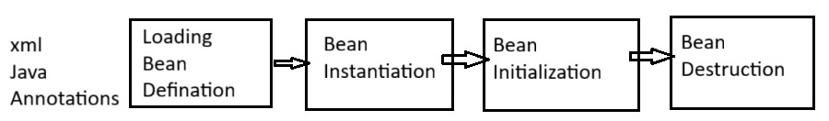
1. Loading bean definition
Spring reads the bean definitions from configuration sources (XML, Java annotations, or Java code) to understand how to create and manage the beans.
2. Bean Instantiation
Dependency injection
After instantiation, Spring injects any required dependencies into the bean, either through constructor injection, setter injection, or field injection (using annotations like @Autowired).
The Spring container creates an instance of the bean using its constructor or a factory method.
3. bean Initialization
A method annotated with @PostConstruct will be executed after dependency injection is completed.
4. Bean Destruction
When the Spring container is shut down, or a bean's scope dictates its end, the container performs cleanup operations. This can be achieved through:
Implementing the Disposable Bean interface and overriding the destroy () method.
Defining a custom destroy-method in XML configuration or using the @PreDestroy annotation.
Q. spring bean life cycle using annotations and java code?
Life cycle means keep tracks of various activities from birth to death.
1.Life cycle configuration using programmatic approach.
Class implements InitializingBean having afterPropertiesSet(), DisposableBean destroy() method.
@SpringBootApplication
public class SpringBeanLifeCycleApplication {
public static void main(String[] args) {
AnnotationConfigApplicationContext ctx=new AnnotationConfigApplicationContext(Student.class);
TeacherService bean=ctx.getBean(TeacherService.class);
Student std=ctx.getBean(Student.class);
System.out.println("ctx.close() call for closing the app or Beans");
ctx.close(); }
@Component
public class Student implements InitializingBean,DisposableBean{
@Override
public void afterPropertiesSet() throws Exception {
System.out.println("afterPropertiesSet method is executed..");
}
@Override
public void destroy() throws Exception {
System.out.println("destroy method is executed..using DisposableBean");
}
public Student() {
System.out.println("student is initialing..");
}
}

2. Spring bean life cycle configuration using annotations approach.
Add @PostConstruct on init() method for intialization and @PreDestroy on destroy method.
AnnotationConfigApplicationContextctx=new AnnotationConfigApplicationContext(Teacher.class);
TeacherService bean=ctx.getBean(TeacherService.class);
bean.tech();
System.out.println("ctx.close() call for closing the app or Beans");
ctx.close();
}
}
@Component
public class TeacherService{
private List<String> subjects;
@PostConstruct
public void init() {
System.out.println("init method is invoke using @PostConstruct");
subjects=new ArrayList<String>();
subjects.add("java");
subjects.add("SQL");
subjects.add("Python");
}
public TeacherService() {
System.out.println("Teacher is initializing...");
}
public void tech() {
for(String sub:subjects) {
System.out.println("Teaching.."+sub);
}
}
@PreDestroy
public void distroy() {
System.out.println("destroy method using @PreDestroy is excecuted..");
} }
Q. What are stereotype annotations?
This annotation automatically detects by spring at the time of component scanning.
@component @service @repository @controller @restcontroller
@Component - Marks a class as a Spring bean
@Repository - Used for interact with database layer.
@service – perform business operation add @Transactional when you have ACID property
@restcontroller - Handles web requests
Q. when to use @Required annotations?
When you want to ensure Spring sets a mandatory property via Setter Injection
Don’t use with constructor injection
public class Student { @Component
private String name; public class Car {
@Required private Engine engine;
public void setName(String name) {
this.name = name; public Car(Engine engine) {
} this.engine =engine;
} }
Note: in setter injection autowired required if not added then Spring will not call this setter.
public class Car {
@Autowired
Private Engine engine;// Field injection
Q. How do you enable asynchronous method execution in Spring Boot?
Add @EnableAsync to a configuration or main class.
Use @Async on a Method like send email
Q. how to asynchronous communication in monolithic application?
1. event-based communication
@EnableAsync
@SpringBootApplication
public class App {
}
----------------
public class OrderPlacedEvent {
private String orderId;
public OrderPlacedEvent(String orderId) {
this.orderId = orderId;
}
public String getOrderId() {
return orderId;
} }
@Service
public class OrderService {
@Autowired
private ApplicationEventPublisher publisher;
public String placeOrder() {
String orderId = UUID.randomUUID().toString();
System.out.println("Order created: " + orderId);
// Publish event
publisher.publishEvent(new OrderPlacedEvent(orderId));
System.out.println("Response returned immediately");
return orderId;
} }
----------------------------
@Service
public class PaymentService {
@Async
@EventListener
public void handleOrderPlaced(OrderPlacedEvent event) {
System.out.println("Processing payment for order: " + event.getOrderId());
}
System.out.println("Payment completed for order: " + event.getOrderId());
}
}
@RestController
@RequestMapping("/orders")
public class OrderController {
@Autowired
private OrderService orderService;

@PostMapping
public String createOrder() {
return orderService.placeOrder();
}
}
2. Using @Async Directly
@Service
public class OrderService {
@Autowired
private PaymentService paymentService;
public String placeOrder() {
String orderId = UUID.randomUUID().toString();
System.out.println("Order created: " + orderId);
paymentService.processPayment(orderId); // Async call
return orderId;
}
}
@Service
public class PaymentService {
@Async
public void processPayment(String orderId) {
System.out.println("Payment started for order: " + orderId);
//try catch block with delay
System.out.println("Payment completed for order: " + orderId);
} }
@PostMapping
public String createOrder() {
return orderService.placeOrder();
}
3. CompletableFuture
CompletableFuture.runAsync(() -> {
processPayment();
});
4. message queue
OrderService = Producer, PaymentService = Consumer
@Service
public class OrderService {
@Autowired
private RabbitTemplate rabbitTemplate;
public String placeOrder() {
String orderId = UUID.randomUUID().toString();
System.out.println("Order created: " + orderId);
rabbitTemplate.convertAndSend(RabbitConfig.EXCHANGE, RabbitConfig.ROUTING_KEY, orderId);
System.out.println("Message sent to queue");
return orderId;
}
}
------------------------------
@Service
public class PaymentService {
@RabbitListener(queues = RabbitConfig.QUEUE)
public void processPayment(String orderId) {
System.out.println("Processing payment for order: " + orderId);
System.out.println("Payment completed for order: " + orderId);
}
}
Q. RequestParam, PathVariable, RequestBody?
@RequestParam - Reads data from query parameters or form data.
http://localhost:4041/user/data?sno=101&sname=lone
@getMapping(“/data)
Public String showData(@RequestParam int sno,@RequestParam String sname){
System.out.println(sno+” “+sname);
Return “welcome”;
}
@PathVariable - Extracts values from URL path
http://localhost:4041/users/101
@GetMapping("/users/{id}")
public User getUser(@PathVariable Long id) {
return service.getUserById(id);
}
@RequestBody - Reads data from HTTP request body. Used when data want to saved.
@PostMapping("/users")
public User createUser(@RequestBody User user) {
return service.save(user);
}
PUT – use when full update needed.
Patch – use when partial data needs to updated.
Q. Difference between @Qualifier vs @Primary annotation in Spring?
Both @Qualifier and @Primary are used to resolve ambiguity when multiple beans of the same type are available in the Spring container.
@Primary - Marks one bean as the default choice. Used when no explicit qualifier is mentioned
@Qualifier -Explicitly tells Spring which bean to inject
public interface PaymentService
{
public void pay(int amt);
}

@Component("upi")
class UpiPayment implements PaymentService
{
@Override
public void payment(int amt){
System.out.println("Upi payment"+amt);
} }
@Component("card)
class CardPayment implements PaymentService{
public void payment(int amt){
System.out.println("card payment"+amt);
} }
@RestController
class HomeController{
private PaymentService service;
HomeController(PaymentService service){
this.service=service;
}
@GetMapping("pay")
public void paymentMode(){
service.payment();
}
}
Q. Types of Scopes in Spring?
1. Singleton (Default) - creates one bean for entire application
2. Prototype -new object is created for every time bean is requested.
3. Request Scope - one instance per HTTP request.
4. Session Scope - one instance per user session.
5. Application - one instance per Servlet Context.
6. WebSocket - one bean per WebSocket session.
Q. create custom annotation?
Note: always use @interface to create custom annotation
@Target(ElementType.METHOD) // where to use
@Retention(RetentionPolicy.RUNTIME) // available at runtime
public @interface LogExecutionTime {
}
@Service
public class MyService {
@LogExecutionTime
public void process() {
try {
Thread.sleep(2000);
} catch (Exception e) {}
} }

Spring MVC
1. model – it holds application data.
2. view – display the data to user for that use Json/Angular/React/JSP.
3. controller – handles http requests, call service layer and return response.
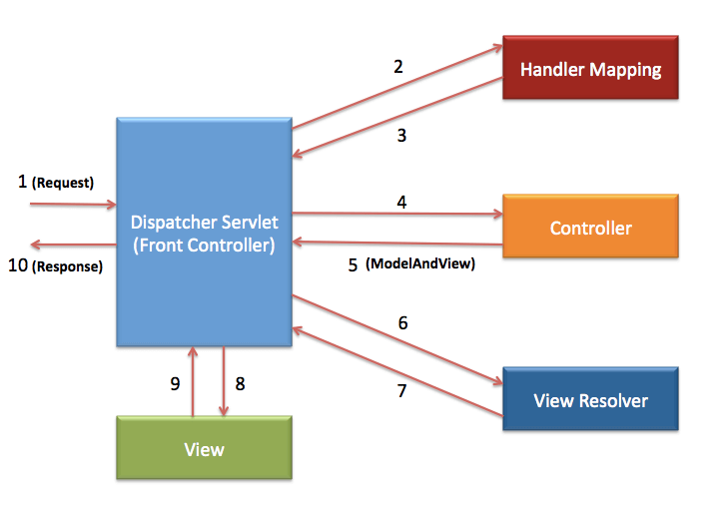
1. Dispatcher Servlet receives an incoming HTTP request.
2. Handler Mapping to identify which controller should handle the request based on the URL.
Once controller methods is determining dispatcher servlet calls the corresponding controller method
And which executes the necessary business logic and returns a ModelAndView object.
3. DispatcherServlet uses a ViewResolver to translate logical view names (e.g., "home") into actual physical files (e.g., /WEB-INF/views/home.jsp).
4. The final View is rendered with the model data and sent back as an HTTP response to the browser.
@RequestParam/@PathVariable: Extracts data from query parameters or URL segments.
@RequestParam: Binds query parameters (e.g., ?id=1) to method variables.
@PathVariable: Extracts values directly from the URL path (e.g., /users/{id}).

Data rendering – passing data from controller to view through dispatcher servlet using shared M/M.
Data Binding - passing data from view to controller [V-C]
Two types of data binding
1. ModelAttribute
@PostMapping(“/add”)
Public String addStudent(@ModelAttribute Student st){
}
2. @RequestParam – http://localhost:4040/std/data?sno=101&sname=santosh.
Bind view data to controller
<a href=”std/edit? No=101”> edit</a>
@GetMapping(“/data”)
Public String process(@RequestParam(“sno”) int no, @RequestParam String name){
System.out.println(no+” “+name);
return “show_data”;
}
Q. Controller vs RestController?
@Controller – it return html/thymleaf/JSP pages as view and want return as json return type then we need manually to add @ResponseBody on top of method.
@Controller
public class MyController {
@GetMapping("/home")
public String home() {
return "home"; // returns view (home.jsp / home.html)
}
@GetMapping("/data")
@ResponseBody
public String data() {
return "Hello"; // returns raw response (not view)
}
}
@RestController
Used for REST APIs (microservices, backend APIs), Returns data directly (JSON/XML)
@RestController
public class MyRestController {
@GetMapping("/data")
public Student data() {
return new Student(1, "Santosh", "Pune");
}
}
Spring AOP (Aspect-Oriented Programming) is used to handle cross-cutting concerns like logging, security, transactions, etc., without mixing them into business logic.
It allow you to add behaviour without modifying actual code.
@Aspect
Add it on the top of class where AOPs are defined.
@Aspect
@Component
public class LoggingAspect {
@Around("execution(* com.app.service.*.*(..))")
public Object log(ProceedingJoinPoint jp) throws Throwable {
System.out.println("Before method: " + jp.getSignature());
Object result = jp.proceed();
System.out.println("After method: " + jp.getSignature());
return result;
}
}
Join Point - Point where method execution happens.
A Join Point is a specific point during program execution.
Pointcut - Expression to select methods.
A Pointcut Expression is a filter (rule) that selects which join points to apply advice on.
@Aspect
@Component
public class LoggingAspect {
@Pointcut("execution(* com.app.service.*.*(..))")
public void serviceLayer() {}
@Before("serviceLayer()")
public void logBefore() {
System.out.println("Logging before method");
}
}
1. Advice
This is an action taken by an aspect at particular joint point.
Before – execute before the method call.
After – execute after the method call.
Around – call before and after execution.
Spring Interceptor
It is used to intercept http request & response in spring mvc application.
It allows you to modify request before reaching to controller and modify response and sent to DS.
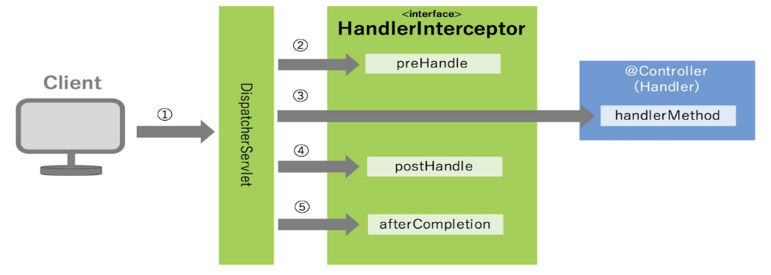
To enable interceptor we need to implement Handler interceptor in class.
public class MyInterceptor implements HandlerInterceptor {}
One we add this we get 3 methods.
preHandle() – modify request before reaching to controller.
postHandle() – modify response received from controller and send it to DS for view .
afterCompletion() – it is used to clean up resources.
To register our custom Interceptor we use WebMvcConfigurer and add addInterceptors()
@Configuration
public class WebConfig implements WebMvcConfigurer {
@Autowired
private MyInterceptor interceptor;
@Override
public void addInterceptors(InterceptorRegistry registry) {
registry.addInterceptor(interceptor)
.addPathPatterns("/api/**")
.excludePathPatterns("/login");
} }
Servlet Filter
a filter is part of the servlet api and is used in spring boot apps to handle pre-process requests (logging, authentication, validation), modify request/response and post-process responses.

Filter chain – we can create multiple filters and goes request through this filter before reaching to the Dispatcher servlet.

Filter Lifecycle Phases
- Initialization Phase – init ()
The container loads the servlet class into memory and creates an instance of it.
After instantiation, the container calls the init (ServletConfig config) method exactly once. It is used for one-time setup tasks like establishing database connections.
- 2. Request Processing Phase – doFilter ()
It is to intercept the request and response, process them, and decide whether to pass them forward.
like Pre-processing (logging, authentication, etc.), Pass request to next filter or resource and post-processing (modify response, logging, etc.)
- 3. Destruction Phase – destroy ()
Called once when the filter is removed or server is shutting down. Closing resources.
Client - Filter – Dispatcher Servlet - Controller - Service – Response.
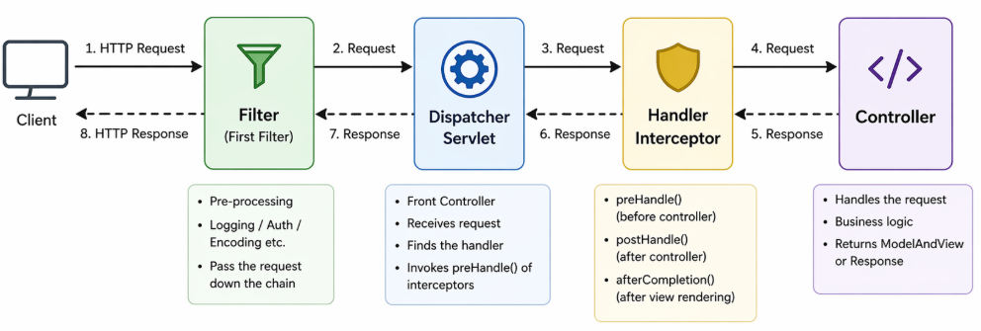
To add filter so we need to implements filter in user-defined class.
public class MyFilter implements Filter {
@Override
public void init(FilterConfig filterConfig) {
System.out.println("Filter initialized");
}
@Override
public void doFilter(ServletRequest request, ServletResponse response, FilterChain chain)
throws IOException, ServletException {

HttpServletRequest req = (HttpServletRequest) request;
System.out.println("Before request: " + req.getRequestURI());
chain.doFilter(request, response);
System.out.println("After response");
}
@Override
public void destroy() {
System.out.println("Filter destroyed");
}
}
Idempotency
If an API is idempotent, calling it again and again won’t change the final outcome after the first call.
It is use to prevent duplicate transactions.
We get default idempotency for some http methods.
GET, PUT, DELETE this are default in nature but POST & PATCH are not.
PUT - creates new resource each time
PATCH – partial update of the data.

How to Implement in Spring Boot.
1. Use Idempotency Key
Pass this key with header along with object
Create Idempotency class
@Entity @Data
public class IdempotencyRecord {
@Id
private String idempotencyKey;
@Lob
private String requestBody;
@Lob
private String responseBody;
private LocalDateTime createdDate = LocalDateTime.now();
}
@Service
public interface IBookService {
public String addBook(Book book,String key);
}
-------------------
@Override
public String addBook(Book book,String key) {
Optional<IdempotencyRecord> exist = idemRepo.findById(key);
if (exist.isPresent()) {
return exist.get().getResponseBody();
}
Book saved = repo.save(book);
String response = "Book saved with ID: " + saved.getBookId();
IdempotencyRecord rec=new IdempotencyRecord();
rec.setIdempotencyKey(key);
rec.setRequestBody(book.toString());
rec.setResponseBody(response);
idemRepo.save(rec);
return response;
}
--------------------
@PostMapping("/add")
public String addBook(@RequestBody Book book,@RequestHeader(value="Idempotency-key") String key) {
String res=service.addBook(book,key);
return res;
}
Q. difference between Crud vs JPA vs pagination repository?
- Crud Repository
Basic for CRUD operations only.
All basics methods related to save/find/delete
Save(), saveAll(), findById() , findAll(), deleteById(), deleteAll(), count()
public interface CrudRepository<Student, Integer>
Limitations
return only Iterable not a List and pagination not support.
Itearable – It supports only data retrieval and does not allow add or remove operations. Elements are accessed sequentially, random access by index is not possible, and it does not provide the total size or count.
List – we can add/remove or get records using index.
PagingAndSortingRepository
Extends all crud repository and give paging and sorting options.
Iterabel<T> findAll (Sort sort) -- Returns all entities sorted by the given options.
Page<T> findAll( Pagable pagable)
Returns a Page of entities meeting the paging restriction provided in the Pagable object.
- JPA Repository
It extends crud and pagingAndSorting repository.
Some extra in JPA
It returns both Iterable and List and paging batch operations, flush, saveAndFlush, deleteAllInBatch()
public interface IBookRepository extends JpaR+epository<Book, Integer> { }
Q. why we need custom logics in repository?
It is a common need when default Spring Data methods aren’t enough to performs operations.
To use joins, aggregate function and filter data by user wanted fields.
@Query("SELECT o FROM Order o JOIN o.items i WHERE i.price > :price")
List<Order> findExpensiveOrders(@Param("price") double price);
- finder methods.
- @Query methods
- @Query + @Modifying
1. Finder Methods
It is used for custom select operations and method start with fixed name as findBy.
Note: after find by keyword first letter always a capital and remaining normal.
List<User> findByName(String name); List<User> findByNameAndAge(String name, int age);

If finder methods return List<T> or Iterable<T> then it returns all columns values of the table.
Other than List or Iterable then it return only single or multiple columns.
2. @Query methods
For JPQL/HQL or native queries
@Query annotations added top of the method declarations in repository.
JPQL – Java Persistence Query Language.
It works with directly entity object not a DB table so use class name as table and field as column.
@Query("SELECT u FROM User u WHERE u.name =:name")
List<User> findByName(@Param("name") String name);

@Query("SELECT u FROM User u WHERE u.age > :age")
List<User> findUsersOlderThan(int age);

@Query("SELECT o FROM Order o JOIN o.user u WHERE u.name =:name")
List<Order> findOrdersByUserName(String name);
HQL - Hibernate Query Language
It is similar like JPQL, works on java object and field as column.
Native – it pure sql queries directly deal with DB table and columns.
3. @Query+ modifying
@Query only support select operations if want update use @Modifying along with @Query
Q. what is the use of @Repository annotation?
It is a stereotype annotation used to mark a class as a DAO and automatically detects it during scanning and creates beans of it.
Spring converts low-level database exceptions into Spring’s unified exceptions.
When SQL exception spring convert into DataAccessException so we get below error.
org.springframework.dao.DataAccessException <-- java.sql.SQLException
sometimes we don’t add @Repository, yet the bean is still created. Why?
Because Spring Data (JpaRepository) automatically creates the bean using proxy mechanism, even without @Repository.

When we extend JpaRepository, Spring, using @EnableJpaRepositories, scans all such interfaces, generates proxy implementations at runtime, and registers them as Spring beans.
Q. How to read values from application.properties?
@Value("${spring.application.name }")
private String appName;
@Autowired
private Environment env;
String name = env.getProperty("app.name");
@ConfigurationProperties – it is used to load all property based on common prefix.
app.name=MyApp
app.version=1.0
@Component
@ConfigurationProperties(prefix = "app")
public class AppConfig {
private String name;
private String version;
}
@PropertySource - Used when reading from custom property files.
@Configuration
@PropertySource("classpath:OrderInfo.properties")
public class ConfigClass {
}
@ConfigurationPropertiesScan
It is used in Spring Boot to automatically scan and register classes annotated with @ConfigurationProperties before this we add @Component to register bean but solve this problem.

POJO - plain old java class.
It is normal class that does not implement any technology or framework.
POJI - plain old java interface
It is normal interface that does not implement any technology or framework.
Java Beans – it is always use as helper class to carry data in the form of object either between two layers of the same class or between two different java application over the network.
Note: does not contain any business method
Rules: public class, implements from serializable, private non-static variables and getter/setter.
Spring beans
Java class whose object is creation/deletion is managed by spring container is called spring bean.
Q. Explain BeanFactory vs ApplicationContext?
BeanFactory – is very basic IOC container used for small scale application due to limited memory.
Beans are created only when requested because of lazy initialization.

BeanFactory factory = new ClassPathXmlApplicationContext("beans.xml");
Student s = (Student) factory.getBean("student");
Resource resource = new ClassPathResource("beans.xml");
BeanFactory factory = new XmlBeanFactory(resource);
ApplicationContext context = new ClassPathXmlApplicationContext("beans.xml");
ApplicationContext context = new FileSystemXmlApplicationContext("C:/config/beans.xml");
ApplicationContext context = new AnnotationConfigApplicationContext(AppConfig.class);
ApplicationContext context = new AnnotationConfigApplicationContext("com.nt");
ApplicationContext context = SpringApplication.run(MyApplication.class, args);
ApplicationContext = advanced version of BeanFactory with extra features.
It is used to create and manage bean, inject dependency and Eager loading mean created at startup.
Note: in beanFactory not support AOP, Event Handling System, Internationalization (i18n)
Singleton & prototype scopes where in ApplicationContext Request, Session, application,WebSocket
What is N+1 Problem?
we can get this problem in one to many relationship while retrieving all the data.
SELECT * FROM department; // first query
// hibernate generate below three queries.
SELECT * FROM employee WHERE department_id = 1;
SELECT * FROM employee WHERE department_id = 2;
SELECT * FROM employee WHERE department_id = 3;
Solution for this:
A. using "Join Fetch"
B. using @BatchSize(size=10)
It won't make only one query, but it will reduce it, as it will divide it into batches.
C. using @EntityGraph(attributepaths="addressList")
-used over methods (helpful in derived query)
------------------
@Query("SELECT a FROM Author a JOIN FETCH a.books")
List<Author> findAllWithBooks();
@OneToMany(mappedBy = "author", fetch = FetchType.LAZY)
@BatchSize(size = 10) // Fetch books for 10 authors at a time
private List<Book> books;
@EntityGraph(attributePaths = {"employees"})
List<Department> findAll();
Q. Explain Rest Template?
Rest Template is a synchronous HTTP client provided by Spring Framework used to call REST APIs from your Java backend.
Communicate from Order Service to payment service use rest template.
class OrderService {
PaymentService paymentService = new PaymentService();
public void placeOrder() {
paymentService.processPayment(); // synchronous call
} }
----------------------
@RestController
public class AddressConsumerController {
@Autowired
private RestTemplate temp;
@PostMapping("/add")
public ResponseEntity<?> addAddress(@RequestBody Address address) {
HttpHeaders header=new HttpHeaders();
header.setContentType(MediaType.APPLICATION_JSON);

HttpEntity<Address> req=new HttpEntity<>(address,header);
String url="http://localhost:4041/home/save";
ResponseEntity<?> res= temp.exchange(url, HttpMethod.POST, req, String.class);

System.out.println("response header "+res.getBody());
System.out.println("Response status code "+res.getStatusCode());
System.out.println("response status code value "+res.getStatusCodeValue());
System.out.println("response header "+res.getHeaders());
return new ResponseEntity<>(res.getBody(),HttpStatus.CREATED);
}
@GetMapping("/get/{id}")
public ResponseEntity<?> getAddessById(@PathVariable int id) {
String url = "http://localhost:4041/home/get/" + id;
ResponseEntity<?> res1= temp.exchange(url, HttpMethod.GET, null, String.class);
return ResponseEntity.ok(res1.getBody());
}
@GetMapping("/allData")
public ResponseEntity<?> getAllAddessData() {
String url = "http://localhost:4041/home/all" ;
ResponseEntity<?> res3= temp.exchange(url, HttpMethod.GET, null, String.class);
return ResponseEntity.ok(res3.getBody());
}
}
--------------------------------------------------------------------
@FeignClient("Book-Service")
public interface IBookFeignConsumer {
@PostMapping("/book/add")
public String addBook(@RequestBody Book book);

@GetMapping("/book/all")
public List<Book> findAllBooks();

@GetMapping("/book/get/{id}")
public Book getBookById(@PathVariable int id);
}
@RestController
@RequiredArgsConstructor
@Data
public class ConsumerController {
@Autowired
private IBookFeignConsumer client;
@PostMapping("/add-book")
public String addBook(@RequestBody Book book) {
return client.addBook(book);
}
@GetMapping("/all")
public List<Book> findAll(){
List<Book> list=client.findAllBooks();
return list;
}
@CircuitBreaker( name="Shopping-Service",fallbackMethod="bookFallBack")
@GetMapping("/book/{id}")//localhost:4042/book/get/2
public Book getBook(@PathVariable int id) {
Book book=client.getBookById(id);
return book;
}
public Book bookFallBack(int id, Exception e) {
System.out.println("fallback triggered "+e.getMessage());
return new Book(id,"Python",63.44);
} }
Q. How to enable Spring mail?
To enable email sending in Spring you mainly configure Spring Mail (JavaMailSender) and connect it to an SMTP server.
Add spring mail dependency and configure SMTP property file.
spring.mail.host=smtp.gmail.com
spring.mail.port=587
spring.mail.username=your-email@gmail.com
spring.mail.password=your-app-password

spring.mail.properties.mail.smtp.auth=true
spring.mail.properties.mail.smtp.starttls.enable=true
@Repository
public interface UserRepository extends JpaRepository<UserData, Long>{
UserData findByEmail(String email);
}
@Service
public class OTPService {
@Autowired
private JavaMailSender mailSender;
Map<String, String> otpStored=new HashMap<String, String>();
public OTPService(JavaMailSender mailSender) {
this.mailSender=mailSender;
}
public String generateOTP() {
return String.valueOf((int) (Math.random() * 900000)+100000);
}
public void sendOTPtoEmail(String email) {
String otp=generateOTP();
otpStored.put(email, otp) ;

SimpleMailMessage message=new SimpleMailMessage();
message.setTo(email);
message.setSubject("Your OTP code");
message.setText("Your OTP is: "+otp);
mailSender.send(message);
}
public boolean validateOtp(String email,String otp) {
return otp.equals(otpStored.get(email));
}
}
@RestController
public class EmailController {
@Autowired
private JavaMailSender mailSender;
@Autowired
private OTPService otpService;

@GetMapping("/send")
public String sendMail() {
try {
MimeMessage msg = mailSender.createMimeMessage();
MimeMessageHelper helper = new MimeMessageHelper(msg, true);
SimpleMailMessage message = new SimpleMailMessage();
message.setFrom("lonesantosh12@gmail.com");
// we can take same email id in both field
message.setTo("lonesantosh12@gmail.com");
message.setSubject("Email OTP Verification");
message.setText("This sent from spring application");
// single slash not supported used
helper.addAttachment("SpringSecurity.png",new File("D:\\lone\\ doc\\ SpringSecurity.png"));
mailSender.send(message);
return "sent successfully";
} catch (Exception e) {
throw new RuntimeException(e);
} }
@GetMapping("/attach")
public String sendMailWithAttachment() {
try {
MimeMessage msg = mailSender.createMimeMessage();
MimeMessageHelper helper = new MimeMessageHelper(msg, true);
SimpleMailMessage message = new SimpleMailMessage();
helper.setFrom("lonesantosh12@gmail.com");
helper.setTo("lonesantosh12@gmail.com");
helper.setSubject("Java email with attachment from spring application");
helper.setText("Please find the attached document below.");
// single slash not supported used //
helper.addAttachment("SpringSecurity.png",new File("D:\\lone\\ doc\\SpringSecurity.png"));
mailSender.send(msg);
return "attachment sent successfully";
} catch (Exception e) {
throw new RuntimeException(e);
} }
@PostMapping("/sendOTP")//localhost:4041/mail/sendOTP?email=lonesantosh12@gmail.com
public ResponseEntity<String> sendOtp(@RequestParam String email) {
otpService.sendOTPtoEmail(email);
return new ResponseEntity<String>("OTP sent succesfully",HttpStatus.OK);
}
@PostMapping("/validate")//localhost:4041/mail/validate?email=lone12@gmail.com&otp=999146
public ResponseEntity<String> validateEmailOTP(
@RequestParam String email,@RequestParam String otp) {
boolean isValid=otpService.validateOtp(email, otp);
if(isValid) {
return ResponseEntity.ok("OTP validate successfully"); //System.out.println("OTP validate successfully");
}else
{
return ResponseEntity.status(HttpStatus.BAD_REQUEST) .body("Invalid OTP");
} } }
Spring Scheduling
It is the process of executing given task or job either for one time or multiple time based on the given period of time or point of time.

Period of time – specifies the gap between two successive executions of the given task/job.
Ex. Monthly salary slips, bank statement, EMI remainder.
Point of time – executing the task at certain date, time and date.
Ex. 10.30 batch, schedular
@EnableScheduling – placed on the main class.
@Scheduled – placed on the business method.

@Scheduled( * * * * * *)
┌──────── second (0-59)
│ ┌────── minute (0-59)
│ │ ┌──── hour (0-23)
│ │ │ ┌── day of month (1-31)
│ │ │ │ ┌ month (1-12)
│ │ │ │ │ ┌ day of week (0-7) SAT-SUN
│ │ │ │ │ │
* * * * * *
@Component
public class ReportScheduler {
@Scheduled(initialDelay=2000, fixedDelay=3000)
public void generateDailyReport() {
System.out.println("Generating report ");
}
}
initialDelay - It defines how long to wait before the first execution of the task. Run only once when application start.
fixedDelay - It defines the delay between the end of one execution and the start of the next.
Note: the method where @Scheduled is placed must be zero-param method because IOC container cannot pass argument- values to method while calling.
@Scheduled(cron = "0/30 0 * * * *") run every 30 seconds.
@Scheduled(cron = "0 0/1 * * * *") – run every minute
@Scheduled(cron = "0 0 2 * * *") run at 2AM
@Scheduled(cron = "0 0 16 * * *") run at 4PM
@Scheduled(cron = "0 0/30 16 10 * *") run at 10-Mar 4.30PM (consider current month)
@Scheduled(cron = "0 0/30 16 10 5 *") run at 10-may 4.30PM here we pass 5 month
@Scheduled(cron = "0 0/30 16 10 * ?") run on every month 10 date on 4 PM & 4.30PM
@Scheduled(cron = "0 0/30 16 ? * SAT") run on every month Saturday on 4 PM & 4.30 PM
Spring batch
It is used to process large volumes of data efficiently.
It’s mainly used for batch processing, where data is processed in chunks instead of real time.
Takes data from one source file and processed it write into destination.
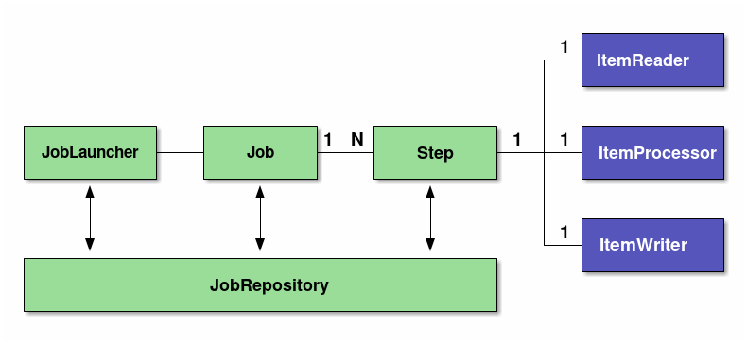
Job launcher
It launches a job either manually or using scheduling.
Job - A Job is the complete batch process so it contains one or more steps.
Step – every step contains 1 Item Reader, Item processor and Item writer.
Item Reader – read the data csv, text or xml.
Item Processor – process the data if required.
Item Writer – after processed data we need to store somewhere.
Job Repository
It handles all activities of job launcher, job, steps will be kept tracked by job repository
Which Is in-memory by default.
Chunk(100)
It mean’s that it reads first 100 records from source and process it and writes and again select next 100 records do same.
@Bean
public Step step1() {
return stepBuilderFactory.get("step1")
.<String, String>chunk(5)
.reader(reader())
.processor(processor())
.writer(writer())
.build();
}
ItemReader is the component responsible for reading data one item at a time from a source.
FlatFileItemReader – read it from csv or text.
StaxEventitemReader – read it from xml.
JdbcCursorItemReader – read it from database.
JsonItemReader – read it from json file.
ItemWriter is the component responsible for writing processed data to a destination.
FlatFileItemWriter – writes data into csv or text.
JdbcBatchItemWriter - writes data to database in batch.
JsonFileItemWriter – writes into json file.
Spring cache.
It is used to store frequently used data in memory so that your application doesn’t hit the database or external service every time. Improve performance & reduce repeated work.
Cache providers are Ehcache,Redis

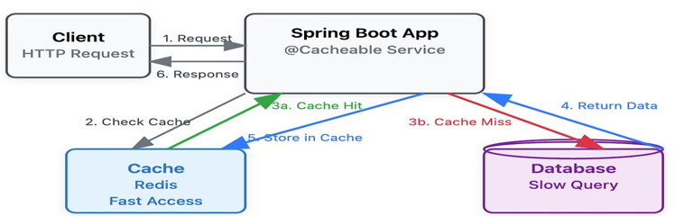

First time execute request and fetch it from database and stored in cache for next request take it from cache.
In-memory – each instance having a separate cache.
Distributed – single instance cache for entire application.
@Cacheable – get the request data and stored it into cache.
@CacheEvict – remove data from cache.
@CachePut – update data in cache.
@Cacheable("users")
public User getUser(int id) {
return repository.findById(id);
}
@CacheEvict(value = "users", key = "#id")
public void deleteUser(int id) {
repository.deleteById(id);
}
@CachePut(value = "users", key = "#user.id")
public User updateUser(User user) {
return repository.save(user);
}
Spring security
It helps protects api, web apps and microservices from unauthorized access, attacks and security threats.
Authentication – it is process of verifying who are you. Check login details
Authorization – it determines what you can do after login
Types of attacks.
1. SQL injection - Inject malicious SQL into queries
2. XSS (Cross-Site Scripting) - Inject scripts into web pages
3. CSRF (Cross-Site Request Forgery) - Tricks users into unwanted actions
4. File Upload Attacks - Upload malicious files (like shells)
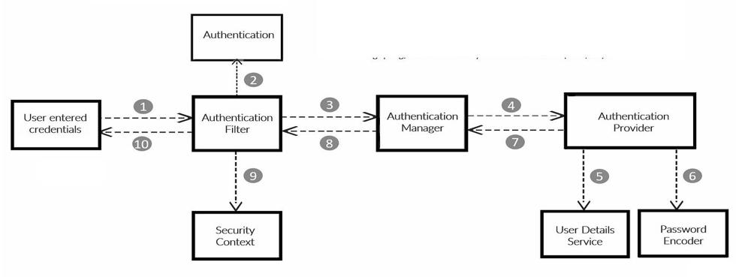
DelegatingFilterProxy is a special filter in the Spring framework that acts as a bridge between the Servlet container (like Tomcat) and spring application context.
DelegatingFilterProxy – SecurityFilterChain -- DispatcherServlet --- Spring Application
Security filter chain that is n numbers of security filters before reaching to dispatcher servlet.
Authentication Manager is the core component responsible for validating user credentials (like username/password, JWT, etc.).
Authentication Manager is bridge between security filters and Authentication provider to select which filter with which provider.
Provider Manager is the main implementation of Authentication Manager that is responsible for handling authentication requests.
It asks multiple authentication providers Can you authenticate this user?
Authentication provider is the component that actually checks whether the user’s credentials are correct.
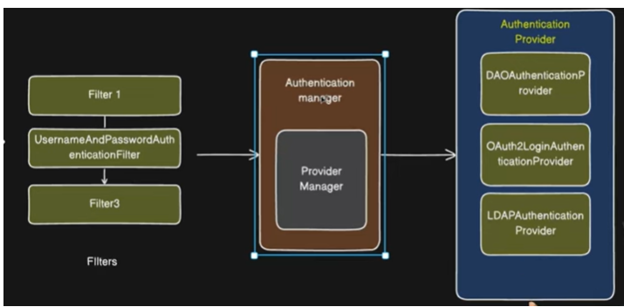

To use our choice authentication use securityFilterChain to create beans.
Types of authentications.
- Form-Based Authentication.
Form-based authentication is the default login mechanism in Spring Security, where a user submits a username and password through a login form, and Spring handles the rest.

After submitting the login details, the request reaches the UsernamePasswordAuthenticationFilter, which extracts the username and password. The request is then passed to the ProviderManager, which selects an appropriate AuthenticationProvider, typically the DaoAuthenticationProvider.

The DaoAuthenticationProvider calls the UserDetailsService to fetch user details from the database and validates the password using a password encoder. Once the authentication is successful, the authentication object is stored in the SecurityContextHolder, and the user is allowed to access the application.

If authentication fails, the SecurityContextHolder stores the failure details, and access is denied.
- 2. HTTP Basic Authentication
Credentials sent in HTTP header
1. DaoAuthenticationProvider
It is a built-in AuthenticationProvider used for username & password authentication from a database.
UserDetailsService is used to fetch user details from Database and gives it to authentication provider.
To save passwords in DB with encrypted password and while retrieving get correct password use Password Encode to encrypted with original one.
Return password need to be stored in somewhere so other part of application can use it.
Security context stored authentication object.
- 2. LDAP & OAuth2 Authentication Provider.
LDAP - Lightweight Directory Access Protocol
Central place to store and verify user login details they don’t provide to recover the old password always create new password.
OAuth2
It is an authorization framework that allows a user to give limited access to their data to another application without sharing their password.
Ex. Third party application to use their login credentials to login in any application
Login with Facebook, google
- 3. JWT Authentication Provider.
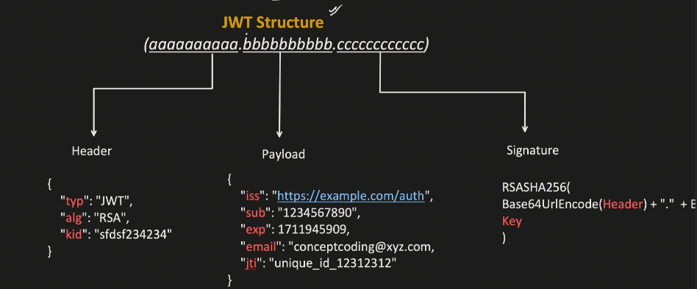
Header|Payload |Singnature
1. Header
Contains metadata information of the token.
It stored encryption algorithm use this algorithm to encrypt details
2.Payload
Actual information of client like name, when it issue, expire time, role admin or normal
3.signature
It validates the JWT token

CSRF (Cross-Site Request Forgery) -Prevents malicious requests
CORS - Allows frontend (Angular/React) to access backend
Q. Basic auth vs Bearer token vs JWT token?
Basic Auth - A very simple authentication mechanism where the client sends username + password in every request.
Bearer Token
A type of Authorization header used to send tokens.
Bearer is not a token, it’s just a way to send a token.
Maximum Session:
- if we are login in one browser and trying to login for the same user in different browser, then we will get error like maximun sessions of 1 for this principle exceeded.
sessionManagement(session->session.maximumSessions(1) .maxSessionsPreventsLogin(true))
Session Creation Policy:
A. If required: HttpSession only created when needed. (Default)
B. Always: HttpSession is always create. If already exist then use it.
C. Never: Do not create a session, but use if present.
D. Stateless: No session is created, used for stateless application.

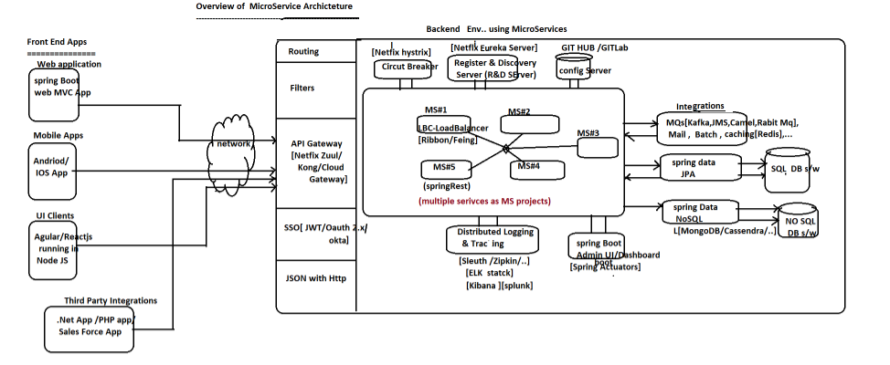
REST (Representational State Transfer) vs Microservice
Rest defines how systems communicate over HTTP using standard methods:
Get – fetch the data
Post – saved/create data
Put - update data
Patch – partial update
Delete – delete data
Stateless (no session stored on server), use http protocol and lightweight and simple.
Microservices is a software architecture style
It means building an application as a collection of small, independent services, each handling a specific business function.
Each service is independent, own database per service, communicate via APIs (REST, messaging, etc.)
Frontend Layer
These are entry points where users interact with the system and they use Angular, React, Spring web
Mobile apps or third party(.net)
Network Layer
Handles request routing from clients to backend
API Gateway/Filters & Routing/[SSO,JWT,OAuth2]
Service Discovery
Microservices must be published in a common place called Register & Discovery (R&D)
Like Eureka, Zookeeper or consul.
Config Server
The common properties with same values of multiple microservices can be placed outside the Microservice and that is called Config server. GitHub or GitLab.
Circuit Breaker
If any service gets failed then stops calling failed service and return fallback response.
Load Balancer
If any MS is having more demand, then we allow to create multiple instances dynamically.
Ex. Ribbin, Feign client, http load balancer
Load count/ current load
No of requests that are currently under processing by the service instance.
Load factor
Load Factor = current load/ max load.
Vertical Scaling
We can add software hardware infrastructure for existing application environment to make it ready for taking more request from clients.
Ex. Increasing shop capacity from 1000 sq.ft to 10,000 sq.ft
Horizontal scaling
We can take multiple copies of same application.
Ex. Keeping same shop in 10 different places.
Increasing no of ATM machine in different places.
Inter-Service Communication
Synchronous (REST) using Feign Client / Rest Template
Asynchronous (Messaging) using Kafka / RabbitMQ / JMS.
Eureka Server
It helps services find and communicate with each other dynamically without hardcoding URLs.
Each microservice registers itself with Eureka Server and call it from one service to another.
A load balancer distributes incoming requests across multiple instances of a service so that no load on single service. Ex. Feign client is best example to communicate and handle load balance.
circuit breaker is a design pattern that prevents your system from repeatedly calling a failing service, avoiding cascading failures.
1.Closed – normal state
All request go normally; failure service is monitored. The circuit breaker switch to the open state if failure threshold exceeds within a pre-defined amount of time.
2. Open state – failure service
When no of failure reaches a threshold, the circuit breaker switch to the open state, preventing request from reaching the service and proving fallback response.
3. Half-open
It allowed limited request to test if the service has recovered. If successful then it returns to closed,
If it fails then it returns to open.
resilience4j:
circuitbreaker:
instances:
paymentService:
failureRateThreshold: 50
minimumNumberOfCalls: 10
waitDurationInOpenState: 10s

retry:instances:paymentService:
maxAttempts: 3
waitDuration: 500ms
timelimiter: instances:
paymentService:
timeoutDuration: 3s

failureRateThreshold - percentage of failed requests to open the circuit.
10 requests, 50% mean 5 requests consider for failed. circuit opens
minimumNumberOfCalls - Minimum calls before circuit breaker starts evaluating
slidingWindowSize - Number of requests considered for failure calculation. Last 10 request.
Retry – retry before making service failure.
Rate Limiting - Limits incoming requests
@Service
public class OrderService {
@Autowired
private PaymentClient paymentClient;
@CircuitBreaker(name = "paymentService", fallbackMethod = "fallback")
@Retry(name = "paymentService")
@Bulkhead(name = "paymentService", type = Bulkhead.Type.THREADPOOL)
@TimeLimiter(name = "paymentService")
public CompletableFuture<String> placeOrder() {
return CompletableFuture.supplyAsync(() -> {
return paymentClient.makePayment();
});
}
public CompletableFuture<String> fallback(Throwable ex) {
return CompletableFuture.completedFuture("Payment service is down. Order in pending state.");
}
}
Actuator is used to monitor and manage your application in production.
It’s production ready end-point given by spring boot people to perform non-functional operations on the production environment.
Health - shows application health status like UP/Down
Info - custom app information
Metrics -shows performance metrics
Beans - Lists all Spring beans
ScheduledTasks – gives all @scheduled methods info
Threaddump – gives info about all the Deamon threads that are created and running continuously.
Mapping - gives all handler methods of rest controller like request path, method name, method type.
Headdump – gives memory details
Cache – gives info all cache managers that are configured in different parts of the application.
Metrics – gives info about properties list related to the current project.
Default actuator url - http://localhost:4041/actuator
To change default url
management.endpoints.web.base-path=/home – http://localhost:4041/home
to disable any actuator
management.endpoint.helth.enable=false
to enable certain actuator
management.endpoint.web.exposure.include=info,health
management.endpoint.web.exposure.include=* * mean activate all actuator
Kafka is a distributed system used for real-time data streaming and processing. It’s widely used to move large amounts of data between systems quickly and reliably.
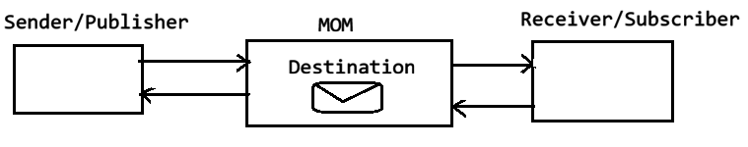
MOM -Message oriented middleware
Mom is software that acts as middle man between sender and receiver and it contain memory that is called Destination. Destination hold the messages sent by sender and delivered the same message to the receiver.
Ex. Active mq, rabit mq
Use-case.
Uber cab availability, goods deliver app stored availability status, live train running status,
Live cricket score status.
Log aggregation
collecting log messages generated by production environment and aggregating those messages.
Two ways of messaging-based communication
1. point to point
2. publisher and subscriber (PUB-SUB model)
- point to point
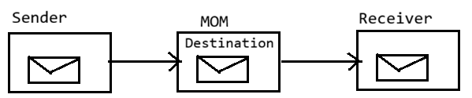
Here each message sent to destination by sender will have only one consumer/receiver.
Once consumer consumed message the message will be removed from destination.
- Pub-Sub Model
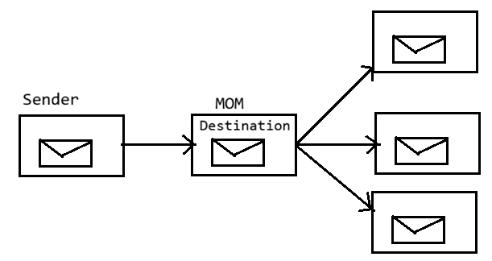
Here each message sent by publisher will go to the multiple subscriber who have done their subscription to the destination before sender publishes the messages.
Note: once message consumed by consumer the message will not be deleted from destination.
Messaging/message queue (MQ) can be implemented using two types of protocol.
1. using basic MQ protocol (BMQP)
For this we need to use JMS
2. using advanced MQ protocol (AMQP)
For this we need to use Rabit MQ, Active MQ, Apache kafka.
JMS- Jakarta messaging service
MOM contains destinations as logical memories to receiver and holds the messages.
In Point-to-point destination is called Queue.
In pub-sub model destination is called topic.
When to use Rabbit MQ and Active MQ?
RabbitMQ - is best when you want simplicity, speed, and flexible routing.
When you need fast message processing, system uses microservices communication.
Ex. Sending emails asynchronously, Order processing, notification services, Real-time task queue.
RabbitMQ uses AMQP protocol, which is very efficient and reliable.
ActiveMQ
ActiveMQ is better when you need enterprise-level features and Java integration.
You are working in a Java-heavy enterprise environment where JMS support and multiple protocols (such as AMQP, MQTT) are required. The system must integrate strongly with legacy systems and support complex enterprise messaging patterns.
Ex. Banking systems, Enterprise integration (ESB), Large-scale Java backend systems.

To enable PTP communication
Spring.jms.pub-sub-domain=false
True- enable pub-sub model
JmsTemplate is a helper class in Spring used to send (produce) messages to a queue or topic.
JMS Listener is used to receive (consume) messages asynchronously from a queue or topic.
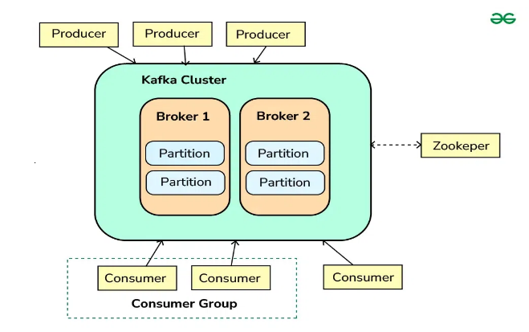
It takes the support of zookeeper to handle the Load balancing among the multiple instances of the messages broker software or MOM software.

1. Message broker/ broker server/MOM server
It behaves like MOM server to hold or receiver messages from the sender, to hold them as needed and deliver to consumer.

When kafka started one instance of message broker is created automatically and it can be increased as needed.
2. Collection of message broker instances together is called kafka cluster.
Zookeeper is responsible to manage broker instances by applying load balancer support called Bootstrap server.
Bootstrap server – it is responsible to create cluster having single instance and increasing as needed.
Kafka does not support PTP it supports only pub-sub model
partition is a sub-division of a topic that allows data to be stored and processed in parallel.
topic is split into multiple partitions, and each partition is an ordered log of messages.
Instead of storing all messages in one place, Kafka splits them to improve performance & scalability.
3. Offset -it is a unique number assigned to each message within a partition.
It helps to identify where a message is stored.
replication factor defines how many copies of each partition are stored across different brokers.
One is a default replication factor value if we have 3 replica factors mean 1 partition has 3 copies and that stored in 3 different brokers.
consumer group is a set of consumers that work together to read data from a topic.
Q. sender send message for A,B,C consumer but I want to my message for only B consumer?
Create A,B,C consumer groups so each message is processed only once within a group.
Q. What is a Dead Letter Queue (DLQ)?
A Dead Letter Queue (DLQ) in Kafka is a separate Kafka topic where failed or unprocessable messages are sent after retries are exhausted.
How to reprocess DLQ?
@KafkaListener(topics = "orders-topic.DLQ", groupId = "dlq-reprocessor")
public void reprocess(
ConsumerRecord<String, String> record) {
try {
String fixedMessage = fixMessage(record.value());
kafkaTemplate.send("orders-topic", fixedMessage);
} catch (Exception ex) {
log.error("Reprocessing failed for offset {}", record.offset(), ex);
}
}
Q. how to handle exception handling in monolithic application?
Below annotations not used that much but try catch block give us more control so we use it.
Use @ControllerAdvice or @RestControllerAdvice and logger as well
@RestControllerAdvice
public class GlobalExceptionHandler {
@ExceptionHandler(ResourceNotFoundException.class)
public ResponseEntity<?> handleNotFound(ResourceNotFoundException ex) {
return new ResponseEntity<>(ex.getMessage(), HttpStatus.NOT_FOUND);
}
@ExceptionHandler(Exception.class)
public ResponseEntity<?> handleGeneric(Exception ex) {
return new ResponseEntity<>("Something went wrong", HttpStatus.INTERNAL_SERVER_ERROR);
} }
Q. how do you handle if any service is failed in monolithic application?
A service can fail due to: DB, Null/logic error, External AP and Validation failure
Don’t expose DB or system errors directly. Show business errors
Use @Transactional if service is updating DB, @RestControllerAdvice and some logger.
Use Retry Mechanism
Q. how do you handle if any service is failed in Microservice application?
A microservice can fail due to:
Network timeout, Service down, High latency, DB failure and External API failure.
Circuit Breaker, Fallback, Retry Mechanism, Timeout Configuration, API Gateway Handling
Throttling - limiting the number of requests a user/client can make in a given time.
@Retry(name = "userService", fallbackMethod = "fallbackUser")
public String callService() {
return restTemplate.getForObject("http://USER-SERVICE/api/user", String.class);
} // retries 3 times before failing
resilience4j.retry.instances.userService.max-attempts=3 & wait-duration: 2s
.body("Something went wrong: " + ex.getMessage());
Q. How will you design rate-limiting for an API?
Rate limiting restricts the number of requests a client can make to an API within a time window.
It helps to prevent the overloading of servers by limiting the number of requests that can be made in a given time frame.
1.Scope: Decide what to limit (e.g., per user ID, IP address, API key, or a global limit).
2.Thresholds: Define the maximum number of requests allowed within a specific time frame (e.g., 100 requests per minute, 5 failed logins per hour).
1. Fixed Window algorithm 100 requests / minute
2. Sliding Window rate limiting is an algorithm used to control how many requests a client can make within a continuously moving time window.
3. Token Bucket
Every bucket has token and each request consume that token. If token empty then request drop.
Client – api gateway -rate limiter-redis -services.
spring.cloud.gateway.routes[0].id=user-service
spring.cloud.gateway.routes[0].uri=lb://USER-SERVICE
spring.cloud.gateway.routes[0].predicates[0]=Path=/users/**

spring.cloud.gateway.routes[0].filters[0]=RequestRateLimiter
spring.cloud.gateway.routes[0].filters[0].args.redis-rate-limiter.replenishRate=5
spring.cloud.gateway.routes[0].filters[0].args.redis-rate-limiter.burstCapacity=10
spring.cloud.gateway.routes[0].filters[0].args.redis-rate-limiter.requestedTokens=1
spring.cloud.gateway.routes[0].filters[0].args.key-resolver=#{@userKeyResolver}
Q. How do you implement the Saga Design Pattern in microservices?
What is saga?
The Saga Pattern is used in distributed systems to manage long-running, multi-step transactions without using a distributed ACID transaction.
Instead of a single big transaction, Saga breaks it into a series of local transactions across services.
1. Saga Pattern – Orchestration
It is a distributed transaction management pattern where a central orchestrator controls and coordinates the steps of a long-running business transaction across multiple microservices
Orchestrator - calls each service step-by-step and waits for response.
If any step fails - Orchestrator triggers compensating transactions.
A central component called the Saga Orchestrator tells each service what to do next and when to execute rollback.
2. Choreography Saga (Event-Driven) No central coordinator
Distributed transaction management where each service reacts to events from another service.
In this every service publishes an event like Order Created event.
When payment service is failed then all corelated services also rollback.
Q. How can you optimize database queries to improve performance?
1. create indexes on frequently used columns
2. Avoid select *
3. Use Proper Joins Instead of Subqueries
4. use pagination to show to user in page by page. (we limited records 10 or 20 in page)
5. batch processing
6. Avoid N+1 Query Problem
7. Caching and Connection Pooling of DB.
Q. Basic Structure of a Java Monolithic Application?
UI layer
Service Layer – build logic in this layer, dependency injection,validation,caching.
Repository Layer – interact with DB using JPA.
Q. on which method @Transactional annotations worked?
It worked only public method, in private method not worked.
Q. How to debug high CPU usage in a Java application in production?
1. first check CPU is high or not.
2. Identify Hot Threads
3. check with one is consuming high cpu.
Q. A, B interfaces have the display () default method and one class implements both A, B without overriding default method then What happens?
Compile-time error. The code will NOT compile.
But when a class implements two interfaces with the same default method signature, Java cannot decide which implementation to use. This is called the Diamond Problem (default methods).
Q. How do you implement API versioning in microservices?
@RestController
@RequestMapping("/api/v1/users")
public class UserControllerV1 {
@GetMapping
public String getUsers() {
return "Users V1";
}
}
-------------------------------------
@RestController
@RequestMapping("/api/v2/users")
public class UserControllerV2 {
@GetMapping
public String getUsers() {
return "Users V2 with new data";
} }
Or
@GetMapping(value = "/users", params = "version=1")
public String getUsersV1() {
return "Users V1";
}
@GetMapping(value = "/users", params = "version=2")
public String getUsersV2() {
return "Users V2";
}
Q. Why use final keyword?
The final keyword in Java is used to restrict modification. It helps enforce immutability, security, and design clarity.
Final keyword Is used with variable, class, method
1. variable declared with final value must be once assigned, and that cannot be modified.
2. class declared as final so that cannot be available for implementations.
3. once method declared as final that method cannot be override.
Q. why an Interface cannot be marked as final in Java?
final means cannot be extended so we get compile time error
Q. The code worked in the local environment but failed in production?
1. Environment Configuration Difference
Different database URL, Missing environment variables, Wrong API keys
2. Database Differences
Sometimes the database in production is not the same as local.
Missing tables, Different column names, Different data types.
Migration scripts not executed.
3. Dependency / Library Version Issues.
Your local machine may have different library versions than production.
Java 17 locally but Java 11 in production, Different Maven/Gradle dependencies.
4. File Path or Resource Issues
Local paths may work but not in production. In production (Linux server), this path does not exist.
5. OS Differences
Local machine: Windows, Production server: Linux
6. Permission Issues
No permission to access files or database, cannot write to a directory
Q. Why does the application run faster locally but slower in production?
1. Database Performance
In production the database has large data, while locally it has small data.
Queries may become slower without proper indexes.
2. Network Latency
Local environment runs on the same machine.
In production, requests travel through network, load balancer, APIs, which adds delay.
3. Server Configuration
Production server may have limited CPU, memory, or threads
Improper JVM configuration can slow the application.
4. Logging Overhead
Writing logs frequently can slow performance.
5. External API Calls
The application may call third-party services in production.
If those services are slow, the application response becomes slow.
6. Concurrency / High Traffic
Local environment usually has one user. Prod may have many users, causing thread contention.
Q. How do you debug an issue that occurs only in production?
1. Check Logs
First check application logs and server logs. Look for exceptions, error messages, or warnings.
2. Reproduce the Issue
Try to reproduce the issue in staging or local environment using the same data and configuration
3. Check Environment Differences
Compare local vs production configuration as below:
Database, Environment variables, Java version and Library versions
4. Monitor System Metrics
Check CPU, memory, disk usage, and thread usage. Tools like monitoring dashboards can help.
5. Enable Debug Logging
Temporarily enable detailed logs in production to capture more information.
6. Check Database Queries
analyze slow queries and check if indexes are missing.
7. Analyze Traffic / Load
Production may have high traffic that does not exist locally.
Check for thread blocking, deadlocks, or connection pool issues.
Q. What are environment variables?
Environment variables are external configuration values used by applications.
DB_URL, DB_PASSWORD, JWT_SECRET and API_KEY.
Q. What tools are used for logging in backend applications?
Log4j, Logback, SLF4J and ELK Stack (Elasticsearch, Logstash, Kibana)
Q. code deployment process?
1. Developer writes code and push into git repository for Pull Request / Code Review after it approved by manager that request marge with main branch.
2. When code is merged, the CI pipeline starts automatically.
Continuous Integration tool used – Jenkins, GitHub Actions and GitLab CI
3. Build stage
CI tool downloads the code and builds the project.
mvn clean install
4. run test cases -- CI pipeline runs automated tests.
5. Code Quality & Security Check
Tools check code quality and vulnerabilities. By using
SonarQube → code quality,Snyk → security scanning.
6. Build Docker Image
Application is packaged into a Docker container.
FROM openjdk:17
COPY target/app.jar app.jar
ENTRYPOINT ["java","-jar","/app.jar"]
Q. Types of indexes in Database?
index is also a db object created to improve performance of data accessing.
indexes are created on
1 columns that are frequently accessed in where clause.
2 columns that are used in join operation.
in TABLE SCAN oracle scans complete table to find the desired record.
in INDEX SCAN on avg oracle scans half of the table to find the desired record.
Types of indexes
1. simple index 2. composite index 3. unique index 4. function based index
simple index - created on single column
create index id1 on emp(sal);
2. composite index - created on multiple columns
Create index Id2 on emp (deptno, job);
SELECT * FROM emp WHERE deptno=10 and JOB='CLERK' ;
3. unique index
unique index doesn't allow duplicates into the column on which index is created.
Create unique index on emp (ename);
4. function-based index
index created on function. Create index Id3 on emp (lower(ename));
Q. How to Handle Memory Leak Issues in an Application?
Reasons of memory leak
1. A memory leak happens when objects that are no longer needed are still referenced, preventing the GC from reclaiming memory.
2. Static variables live for the entire application lifecycle and they not released memory.
3. resources not closed properly still open in the application.
Due to this application slows, crashes, or throws outOfMemoryError.
Use monitoring tools to detect memory leaks.
VisualVM, JConsole , Eclipse MAT using actuator heapdump
To fixed it use below concepts
1. removed unused object 2. Use try-with resource 4. Avoid static variables 4. Weak References
Q. API gateway properties?
spring.cloud.gateway.routes[0].id=user-service
//spring.cloud.gateway.routes[0].uri=http://localhost:8081
spring.cloud.gateway.routes[0].uri=lb://USER-SERVICE
spring.cloud.gateway.routes[0].predicates[0]=Path=/users/**
Q. how to resolve circular dependency?
Add @Lazy annotation on field or use setter method to inject it
Q. How will you design rate-limiting for an API?
Rate limiting restricts the number of requests a client can make to an API within a time window. It helps to prevent the overloading of servers by limiting the number of requests that can be made in a given time frame.
Q. how to writes join in spring application?
@Query("SELECT e FROM Employee e JOIN e.department d WHERE d.deptName = :name")
List<Employee> getEmployeesByDept(@Param("name") String name);
Q. What is the N+1 Select Problem?
we can get this problem in one to many relationship while retrieving all the data.
1. using "Join Fetch"
@Query("SELECT u FROM User u LEFT JOIN FETCH u.orders")
List findAllUsersWithOrders();
2. using @BatchSize(size=10)
it divides records into 10 batch like pagination It won't make only one query, but it will reduce it, as it will divide it into batches.
@OneToMany(mappedBy = "author", fetch = FetchType.LAZY)
@BatchSize(size = 10) // Fetch books for 10 authors at a time
private List books;
3. using @EntityGraph(attributepaths="addressList")
used over methods (helpful in derived query)
JUnit 5 (or JUnit 4) for unit testing, Mockito for mocking dependencies,
Q. What steps or processes do you follow for application deployment?
In my projects, application deployment follows a standard CI/CD pipeline to ensure reliability, repeatability, and minimal downtime.
1. writes code and push it into main git branch.
git add .
git commit -m "Add order pagination feature"
git push origin feature-branch
2. Pull Request & Code Review Create pull request-PR after review it and marge it with main.
Create docker file
FROM openjdk:17-jdk-slim
COPY target/app.jar app.jar
ENTRYPOINT ["java","-jar","app.jar"]
$ docker build -t order-service:1.0 .
$ docker run -p 8080:8080 order-service:1.0
$ docker push registry/order-service:1.0
Q. what are types of design pattern?
1. Creational Design Patterns.
2. Structural Design Patterns.
3. Behavioral Design Patterns
- Creational Design Patterns.
It focuses on object creation mechanisms.
Singleton - only one instance of a class
Factory Method - create objects without exposing creation logic
Abstract Factory - Factory of factories
Builder - Step-by-step object creation.
Prototype - Clone existing objects or each time new object created.
public class Singleton {
private static Singleton instance;
private Singleton() {}
public static Singleton getInstance() {
if (instance == null) {
instance = new Singleton();
}
return instance;
} }
//Builder pattern
public class User {
private String name;
private int age;
private String email;
private User(UserBuilder builder) {
this.name = builder.name;
this.age = builder.age;
this.email = builder.email;
}

// Getters only (immutable object)
public String getName() { return name; }
public int getAge() { return age; }
public String getEmail() { return email; }
// Static Builder Class
public static class UserBuilder {
private String name;
private int age;
private String email;

public UserBuilder setName(String name) {
this.name = name;
return this;
}
public UserBuilder setAge(int age) {
this.age = age;
return this;
}
public UserBuilder setEmail(String email) {
this.email = email;
return this;
}
public User build() {
return new User(this);
} } }
public class Main {
public static void main(String[] args) {
User user = new User.UserBuilder()
.setName("John")
.setAge(25)
.setEmail("john@example.com")
.build();
System.out.println(user.getName());
}
}
- Structural Design Patterns
It focuses on Class & object composition (structure)
These patterns define how classes and objects are combined to form larger systems.
Adapter – Convert one interface into another.
Bridge – Separate abstraction from implementation.
Composite – Tree structure (parent-child).
Decorator – Add behavior dynamically
Facade – Simplified interface.
Flyweight – Memory optimization
Proxy – Control access to object
- Behavioral Design Patterns
Focus on communication between objects.
Observer – One-to-many dependency (event-based)
Strategy – Select algorithm at runtime
Command – Encapsulate request as object
Chain of Responsibility – Pass request along chain
State – Change behavior based on state
Template Method – Define skeleton of algorithm
Iterator – Traverse collection
Interpreter – Language grammar handling

SQL –
A function returns a value and is usually used inside queries.
Create complex queries inside function and reuse it so it improves performance.
SELECT calculate_salary(employee_id) FROM employees;

A stored procedure performs actions and may or may not return values.
It includes multiple SQL statements, loops, and conditional logic.

When you use First time SQLPlus editor then use this query / as sysdba
select * from dba_users where username='ntsp715';
SELECT * FROM all_users; -- get all users
SELECT table_name FROM user_tables; --get all tables
alter session set "_oracle_script"=true;
create user ntsp715 identified by ntsp;
SQL>ALTER USER SYSTEM IDENTIFIED BY MANAGER;
Data types in SQL
Char(size) – used it when fixed length character. char(3) IND
VARCHAR2 - in VARCHAR2 extra bytes are released.
Long – allows character data upto 2GB
Clob - allows character data upto 4GB.
Number(4)- valid 1000 invalid 10000
Number(7,2) – it allows total 7 digit
valid 50000.50 in-valid 500000.50
Date – allows date& time
1. BFILE (binary file)
2. BLOB(binary large object)

CREATE TABLE emp
(
empid NUMBER(4),
ename VARCHAR2(10),
age NUMBER(2),
job VARCHAR2(10),
sal NUMBER(7,2),
hiredate DATE
);
desc emp – it shows the table structure.
insert into <tabname> values(v1,v2,v3);
insert into emp values(100,'sachin',40,'clerk',4000,'01-jan-20');
insert into emp values(101,'rohit',30,'manager',8000,sysdate);
insert into <tabname> values(&f1,&f2,&f3)
insert into emp
values(&empid,&ename,&age,&job,&sal,&hiredate);
insert into emp(empid,ename,age,hiredate)values(105,'phani',40,'12-mar-19');
select * from emp where job in ('clerk','manager');
select * from emp where empid in (100,103,105) ;
select * from emp where job not in ('clerk','manager');
select * from emp where job in ('clerk','manager')and sal>5000;
select * from emp where sal between 5000 and 10000;
select * from emp where age between 30 and 40;
select ename,sal*12 as annsal from emp ;
update emp set deptno = 20 where deptno=10;
delete from emp where (sysdate-hiredate)/365 > 40 ;
select * from emp
as of timestamp(sysdate - interval '5' minute);
alter table emp add(gender char(1));
alter table emp drop (gender);
alter table emp rename column comm to bonus ;
alter table emp modify (ename varchar2(20));
note:- column must be empty to decrease precision or scale.
drop table emp ;
truncate table emp; - deletes all the data from table but keeps structure release memory.
delete - deletes only data but not structure and will not release memory.
select * from emp where lower(ename)='santosh';
substr('hello welcome',7,4) => welc
substr('hello welcome',7) => welcome
substr('hello welcome',-4,3) => com
Q. employee list name starts with 's'?
select * from emp where ename like 's%' ;
select * from emp where substr(ename,1,1)='s' ;
q. employees name starts and ends with same char?
select * from emp where ename like 'a%a'
or
ename like 'b%b'
select * from emp where substr(ename,1,1) = substr(ename,-1,1);
LPAD('hello',10,'*') => *****hello
RPAD('hello',10,'*') => hello*****
RPAD('*',10,'*') => **********
Q. your a/c no XXXX8978 debited?
LPAD('X',4,'X')||SUBSTR(accno,-4,4)

LTRIM(' hello ') => 'hello '
RTRIM(' hello ') => ' hello'
TRIM(' hello ') => hello

REPLACE('hello','ell','abc') => habco
REPLACE('hello','l','abc') => heabcabco
REPLACE('hello','ell','') => ho
INSTR() - returns position of a char in a string.
INSTR('hello welcome','o') => 5
INSTR('hello welcome','x') => 0
INSTR('hello welcome','o',1,2) => 11
INSTR('hello welcome','e',1,3) => 13
INSTR('hello welcome','e',-1,2) => 8

select 1000 + '1000' from dual; => 2000
select * from emp where to_char(hiredate,'yyyy') = 1981 ;
select * from emp where to_char(hiredate,'yyyy') in (1980,1983,1985) ;
select * from emp where to_char(hiredate,'dy')='sun' ;
select sysdate + 10 from dual ; => 30-jan-21
select '20-mar-20' + 80 from dual ; => error
number + number => valid
date + number => valid
string + number => invalid
select to_date('20-mar-20') + 80 from dual; => 08-jun-20
select to_date('01/20/21','mm/dd/yy') + 40 from dual ; => 01-mar-21
select to_char(to_date('15-aug-1947'),'day') from dual ;
select 1000 + '1,000' from dual ; => error
select 1000 + to_number('1,000','9,999') from dual; => 2000
months_between() - returns no of months between two dates
select months_between(sysdate,'23-jan-20') from dual ;
last_day() :- returns last day of the month.
select last_day(sysdate) from dual ;
q. display 1st day of the next month?
select last_day(sysdate)+1 from dual ;
q. display current month 1st day?
so use previous month last day + 1
select last_day(add_months(sysdate,-1))+1 from dual ;
next_day() - returns next specified by from given date
select next_day(sysdate,'sunday') from dual ; => 31-jan-21
NVL() - used to convert null values.
ASCII() - returns ascii value of a given char.

rank & dense_rank
both functions are used to calculate ranks.
ranking always based on some column or expression.
rank functions accept only ordered data
sal rank dense_rank
5000 1 1
4000 2 2
3000 3 3
3000 3 3
3000 3 3
2000 6 4
2000 6 4
1000 8 5
SELECT empno,ename,sal,rank() over (order by sal DESC) as rnk FROM emp
SELECT empno,ename,sal,dense_rank() over (order by sal DESC) as rnk FROM emp ;
partition by clause is used to calculate ranks with in group.
for example to calculate ranks with in dept first we need to divide the table dept wise using partition by clause and apply dense_rank function on each partition instead of applying dense_rank function on whole table.
Q. display ranks of the employees with in dept based on sal and highest paid employee should get 1st rank ?

SELECT deptno,empno,ename,sal,
dense_rank() over (partition by deptno order by sal desc) as rnk FROM emp ;
date functions :- add_months,months_between,last_day,next_day
NO ENAME SAL DEPTNO
1 A 5000 10
2 B 6000 20 10 9000
3 C 7000 30 group by----> 20 8000
4 D 2000 20 30 7000
5 E 4000 10
GROUP BY clause converts detailed data into summarized data which is useful for analysis.
Syntax Execution
SELECT columns FROM
FROM tabname WHERE
[WHERE condition] GROUP BY
GROUP BY <colname> HAVING
[HAVING condition] SELECT
[ORDER BY <colname> [ASC/DESC]] ORDER BY

Q. display dept wise total salary?
SELECT deptno,SUM(sal) FROM emp
GROUP BY deptno ORDER BY 1 ASC ;
Q. display job wise no of employees where job=clerk,manager and no of employees > 3 ?
SELECT job,COUNT(*)
FROM emp
WHERE job IN ('CLERK','MANAGER')
GROUP BY job
HAVING COUNT(*) > 3 ;
-----------------------------------------------------------------------------------------------------
Joins
join is an operation performed to combine data stored in multiple tables. To combine data stored in two tables we need to join those two tables.

Types of joins :-
1 Equi Join / Inner Join
2 Outer Join
3 Non Equi Join
4 Self Join
5 Natural Join
6 Cross join or Cartisean Join

Equi Join/ Inner join
to perform equi join, between two there must be a common field and name of the common field need not to be same.
select ename,sal,dname,loc from emp,dept
where emp.deptno = dept.deptno ;

select e.ename,d.dname,d.loc from emp e,dept d
where e.deptno = d.deptno
and d.loc='new york';
1.Native style (oracle style)
2. ANSI style
ANSI style :- (American National Standard Institute)
SELECT e.ename,d.dname
FROM emp e INNER JOIN dept d
ON e.deptno = d.deptno ;
USING clause can be used when name of the common field is same.
outer join
equi join returns only matching records but cannot return unmatched records but to get unmatched records also perform outer join.

1 left outer join
2 right outer join
3 full outer join

Left Outer join - returns all rows (matched + unmatched) from left side table and matching rows from right side table.
Right Outer join - returns all rows from right side table and matching rows from left side table.
Full outer join -returns all rows from both tables.
left outer join
SELECT e.ename,d.dname
FROM emp e LEFT OUTER JOIN dept d
ON e.deptno = d.deptno ;
right outer join
SELECT e.ename,d.dname
FROM emp e RIGHT OUTER JOIN dept d
ON e.deptno = d.deptno ;
full outer join
SELECT e.ename,d.dname
FROM emp e FULL OUTER JOIN dept d
ON e.deptno = d.deptno ;
Q. generate company email id?
SELECT empno,ename,
SUBSTR(LOWER(ename),1,3)||SUBSTR(empno,1,3)||'@impetus.com' as emailid
FROM emp ;

Q. get records whose DOB is 2020?
select * from emp where to_char(dob,'YYYY')='2020';
Q. second max salary?
select max(sal) from emp where sal<(select max(sal) from emp);
select salary from emp order by salary desc
offset 1 fetch next 1 row only; //offset – to skip records //fetch next – return next records.
Q. concate first name, last name?
Select firstName || ‘’ lastName as fullName from emp;
Q. select those records whose DOB in march, april and Nov?
select * from emp where to_char(DOB,'MM') in (3,4,11);
Q. select records whose salary is as Atish?
select * from emp where sal=(select sal from emp where name='Atish');
Q. select emp data where salary is greater than 60000 and age between 30 to 35?
select * from emp
where sal>60000
and trunc(months_between(sysdate,DOB)/12) between 25 and 35;
Q. Find the 3rd maximum salary from a table?
select sal from emp order by sal desc
offset 2 row fetch next 1 row only;
Q. What are the differences between Oracle and MySQL?
Oracle DB – commercial use, very expensive licence, used in large scale application.
complex architecture, excellent for huge data handling, scalability is very high, security is advanced.
Strong ACID compliance, Linux and windows support.
MySQL DB- open source and owned by oracle, free and paid use. Medium scale application.
Architecture is simple.
Q. find salary of each department?
select dept, sum(sal) as totalSalary
from emp
group by dept;
Q. Avg salary of each department?
select dept,avg(sal) as totalSalary
from emp group by dept;
Q. find the employee with duplicate names?
select emp_name,count(*) from emp
group by emp_name
having count(*)>1;
Q. find the department who has more than 3 employees?
select emp_name,count(*)
from emp
group by emp_name
having count(*)>2;// above two all get and exact 2 not select
Q. find the employee whose salary is greater than their dept avg salary?
select e.emp_id,e.emp_name,e.dept,e.sal from emp e
where e.sal>(select avg(sal) from emp where dept=e.dept);
Q. find the employee who has joined in the last 30 days?
select * from emp where DOB >= sysdate - 30;
select * from emp where trunc( DOB) >=trunc(sysdate) - 30;

Q. Dept wise highest paid employee?
SELECT e.emp_id, e.emp_name, e.dept, e.sal
FROM emp e join (select dept,max(sal) as maxSal from emp group by dept) d
on e.dept=d.dept and e.sal=d.maxSal;
Q. find the highest occuring dept in the employee table?
select dept, count(*) as deptCount from emp
group by dept
order by deptcount desc
fetch first 1 row only;
Q. Display 10 min back data from emp?
SELECT * FROM emp AS OF TIMESTAMP(SYSDATE - INTERVAL '10' MINUTE);
INSERT INTO emp SELECT * FROM emp
AS OF TIMESTAMP(SYSDATE - INTERVAL '5' MINUTE);
Q. copy data from one table to another table?
insert into dept SELECT * FROM emp;
create table emp as select * from student;
Q. select employee whose name start with K?
select * from emp where emp_name like 'K%'
start with ‘k%’ ends with h ‘%h’
Q. generate email id of employee?
SELECT empno,ename,
SUBSTR(LOWER(ename),1,3)||SUBSTR(empno,1,3)||'@oracle.com' as emailid
FROM emp;
Q. display 1st day of the next month?
select trunc(add_months(sysdate,1),'mm') from dual;
Q. current and last month 1st day?
select trunc(add_months(sysdate,-1),'mm') from dual;
select trunc(sysdate,'mm') from dual;
Q. next month 1st Sunday? When add -1 so we will get last month 1st sunday
select next_day(trunc(add_months(sysdate,1),'MM')-1,'sunday') from dual;
select next_day(trunc(add_months(sysdate,-1),'MM')-1,'sunday') from dual;
Q. display current month last sunday ?
select next_day((last_day(sysdate))-7,'sunday') from dual;
Q. display duplicate records
Select emp no, ename, sal, count(*)
From emp
Group by empno,ename,sal
Having count(*)>1;
Q. get highest paid 5th row records?
select * from emp order by sal desc
offset 4 row fetch next 1 row only;
Q. display 1st 5 records?
select * from emp order by sal desc
fetch first 5 row only;
Q. join three table data?
SELECT e.emp_id, e.emp_name,
d.dept_name, s.salary
FROM emp e INNER JOIN dept d
ON e.dept_id = d.dept_id
INNER JOIN salary s ON e.emp_id = s.emp_id;
-----------------------------------------
SELECT e.emp_name, d.dept_name, s.salary
FROM emp e JOIN dept d ON e.dept_id = d.dept_id
JOIN salary s ON e.emp_id = s.emp_id
WHERE s.salary > 50000;
Q. display 1st day of the next month?
select trunc(add_months(sysdate,1),'mm') from dual;
Q. find the employee who has joined in the last 30 days?
select * from emp where DOB >= sysdate - 30;
select * from emp where trunc( DOB) >=trunc(sysdate) - 30;
Q. join three table data?
SELECT e.emp_id, e.emp_name,
d.dept_name, s.salary
FROM emp e INNER JOIN dept d
ON e.dept_id = d.dept_id
INNER JOIN salary s ON e.emp_id = s.emp_id;
-----------------------------------------
SELECT e.emp_name, d.dept_name, s.salary
FROM emp e JOIN dept d ON e.dept_id = d.dept_id
JOIN salary s ON e.emp_id = s.emp_id
WHERE s.salary > 50000;

Q. what you did in your project?
1.Incorrect Tax Calculation Bug rounding mode.half_up --round up with 4 digit
2.Duplicate Invoice Generation idempotency check
3. Invoice PDF Not Downloading Fixed file stream handling issue (InputStream was not closed). Implemented retry mechanism when S3 fetch failed.
4. Scheduler Not Triggering for Monthly Billing Cron job failed silently due to misconfigured timezone difference.
5.Wrong Currency Displayed on Invoice due to locale picked wrong currency (picked default USD due wrong locale capture from invoice) Enhancement

1. Added Email Notification for Failed Payments
2. Improved Invoice Search Performance Introduced indexing on invoice_date and customer_id. 3.Added Audit Logging for Billing Changes
4. Enhanced Payment Gateway Integration Incorrect mapping of invoice attributes (BU, GL code, Vendor, Amount, Cost Center, etc.)
Missing or incorrect configuration in workflow tables --> to check correct parameters (ex: BU, Amount, Cost Center, GL Code).
Add missing conditions (e.g., cost center logic not applied).

