Search 1: AI & Nutrition
PubMed Query: ("Artificial Intelligence" OR "AI") AND "Nutrition"
Explores artificial intelligence applications across nutrition science, including dietary assessment, personalized recommendations, and metabolic modeling.
9,212 | 2000–2026 | 2,141 | 1,238
Total Articles | Year Range | Unique Journals | Review Papers

Publication Overview
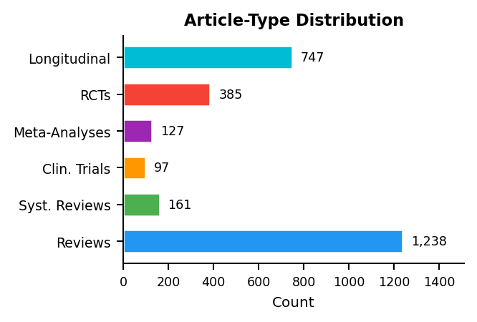 | 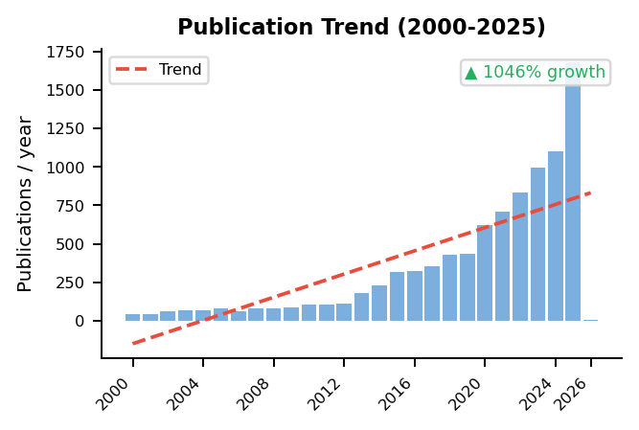

Research Cluster Analysis
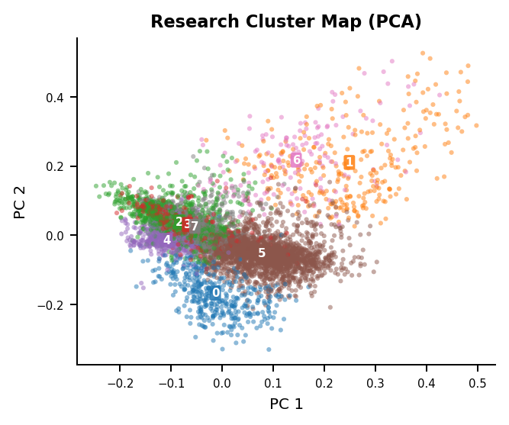 | Identified Research Themes  Cluster 5 (n=2,566)  cells, expression, mice, cell, study, associated  Cluster 7 (n=1,740)  health, data, study, ai, based, using  Cluster 2 (n=1,609)  patients, 95, risk, ci, study, associated  Cluster 0 (n=417)  hdl, cholesterol, apoa, apo, lipoprotein, ldl  Cluster 4 (n=382)  intake, dietary, vitamin, intakes, ai, food  Cluster 3 (n=289)  hiv, infected, associated, women, study, 95  Cluster 1 (n=281)  sup, cells, cell, mice, sub, patients  Cluster 6 (n=156)  sub, sup, study, using, cells, cell

Gap Analysis: Review Coverage of Research Topics
2 of 8 research clusters (25%) have cosine similarity < 0.30 to any review cluster:
- Cluster 1 (n=281): sup, cells, cell, mice, sub
- Cluster 6 (n=156): sub, sup, study, using, cells
MedScrape | AI-Assisted Systematic Literature Review | USMA Department of Mathematical Sciences | Generated: 2026-02-20

