Search 2: Precision Nutrition & Genetics
PubMed Query: "Precision Nutrition" AND ("Genetics" AND "Nutrition")
Investigates genotype-informed dietary strategies, nutrigenomics, and SNP-based personalized nutrition interventions.
490 | 2016–2025 | 212 | 114
Total Articles | Year Range | Unique Journals | Review Papers

Publication Overview
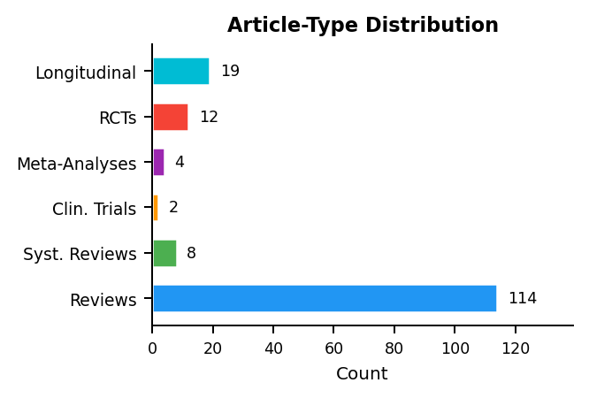 | 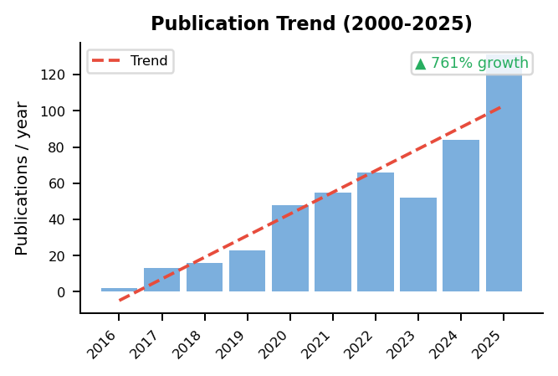

Research Cluster Analysis
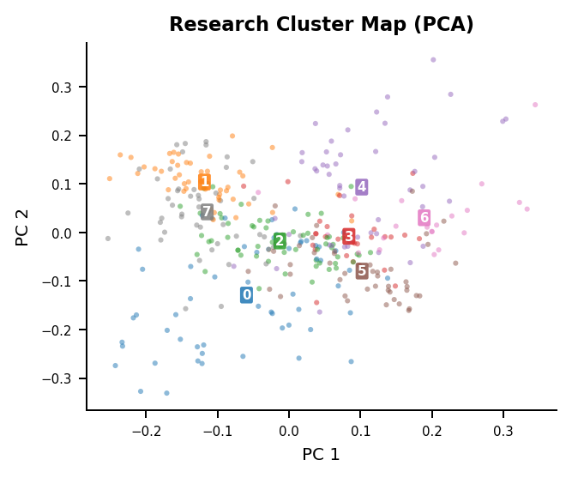 | Identified Research Themes  Cluster 2 (n=56)  expression, mice, diet, gene, obesity, mir  Cluster 0 (n=56)  gut, microbiota, diet, study, acid, mice  Cluster 7 (n=53)  genetic, dietary, associated, nutrition, health, precision  Cluster 4 (n=47)  sup, cells, detection, cancer, cell, intestinal  Cluster 1 (n=46)  risk, intake, associated, study, dietary, genotype  Cluster 5 (n=45)  group, significantly, 05, expression, groups, growth  Cluster 3 (n=27)  sub, cells, vitamin, induced, expression, 12  Cluster 6 (n=21)  iron, sup, mice, hepcidin, ferroptosis, expression

Gap Analysis: Review Coverage of Research Topics
4 of 8 research clusters (50%) have cosine similarity < 0.30 to any review cluster:
- Cluster 3 (n=27): sub, cells, vitamin, induced, expression
- Cluster 4 (n=47): sup, cells, detection, cancer, cell
- Cluster 5 (n=45): group, significantly, 05, expression, groups
- Cluster 6 (n=21): iron, sup, mice, hepcidin, ferroptosis
MedScrape | AI-Assisted Systematic Literature Review | USMA Department of Mathematical Sciences | Generated: 2026-02-20

