Search 3: Precision Nutrition & Exercise
PubMed Query: "Precision Nutrition" AND ("Exercise" AND "Nutrition")
Examines individualized nutrition-exercise interactions, sport-specific dietary prescriptions, and performance optimization through personalized fueling.
151 | 2008–2025 | 85 | 39
Total Articles | Year Range | Unique Journals | Review Papers

Publication Overview
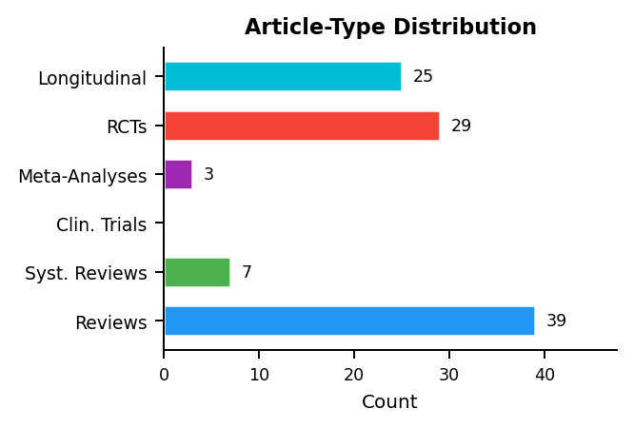 | 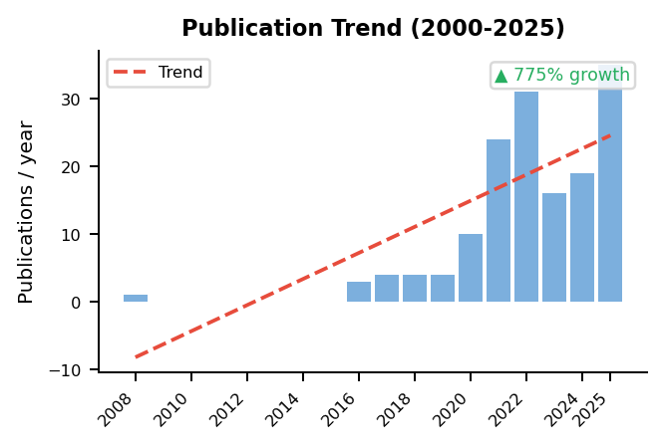

Research Cluster Analysis
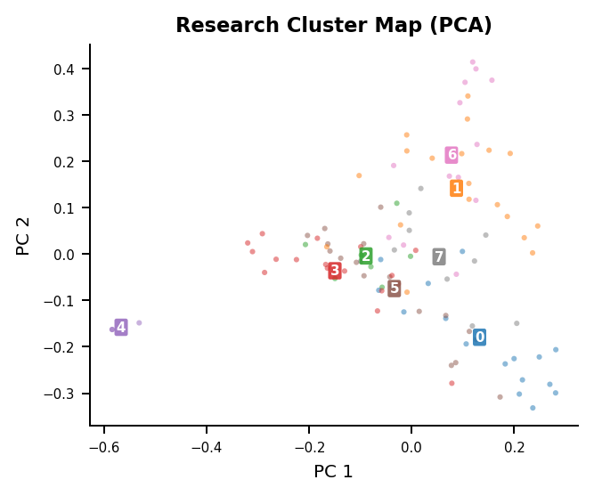 | Identified Research Themes  Cluster 1 (n=19)  activity, physical, diet, participants, body, mediterranean  Cluster 3 (n=17)  sub, nutrition, precision, health, fat, dietary  Cluster 0 (n=17)  weight, sup, diet, loss, gi, participants  Cluster 5 (n=17)  weight, loss, study, health, data, participants  Cluster 6 (n=13)  pa, activity, physical, group, 95, nafld  Cluster 7 (n=10)  intake, dietary, eating, bmi, behavior, stress  Cluster 2 (n=7)  bone, responders, hrqol, dietary, precision, chronic  Cluster 4 (n=3)  doi, corrects, article, 3389, 10, fnut

Gap Analysis: Review Coverage of Research Topics
4 of 8 research clusters (50%) have cosine similarity < 0.30 to any review cluster:
- Cluster 0 (n=17): weight, sup, diet, loss, gi
- Cluster 2 (n=7): bone, responders, hrqol, dietary, precision
- Cluster 4 (n=3): doi, corrects, article, 3389, 10
- Cluster 7 (n=10): intake, dietary, eating, bmi, behavior
MedScrape | AI-Assisted Systematic Literature Review | USMA Department of Mathematical Sciences | Generated: 2026-02-20

